Deadlock Analysis and Prevention
Case Study: Centralized Computing Server (Processes P1–P4)

1. System Description
The server manages three types of non-shareable, single-use resources: two Database Connections (DB1, DB2), two Network Printers (PR1, PR2), and one Backup Storage Device (BS1). Four processes compete for these resources as summarized below.
Process | Resources Held | Resources Requested
P1 | DB1 | PR1
P2 | PR1 | BS1
P3 | BS1 | DB2
P4 | DB2 | DB1

Note that PR2 remains completely idle throughout — its availability does not help, because no waiting process is requesting a printer instance; each process is blocked on a specific resource type that is already held by someone else.

2. Resource Allocation Graph (RAG)
A Resource Allocation Graph represents processes as circles and resource instances as rectangles. A solid arrow from a resource to a process is an allocation edge ("this resource is held by this process"). A dashed arrow from a process to a resource is a request edge ("this process is waiting for this resource").
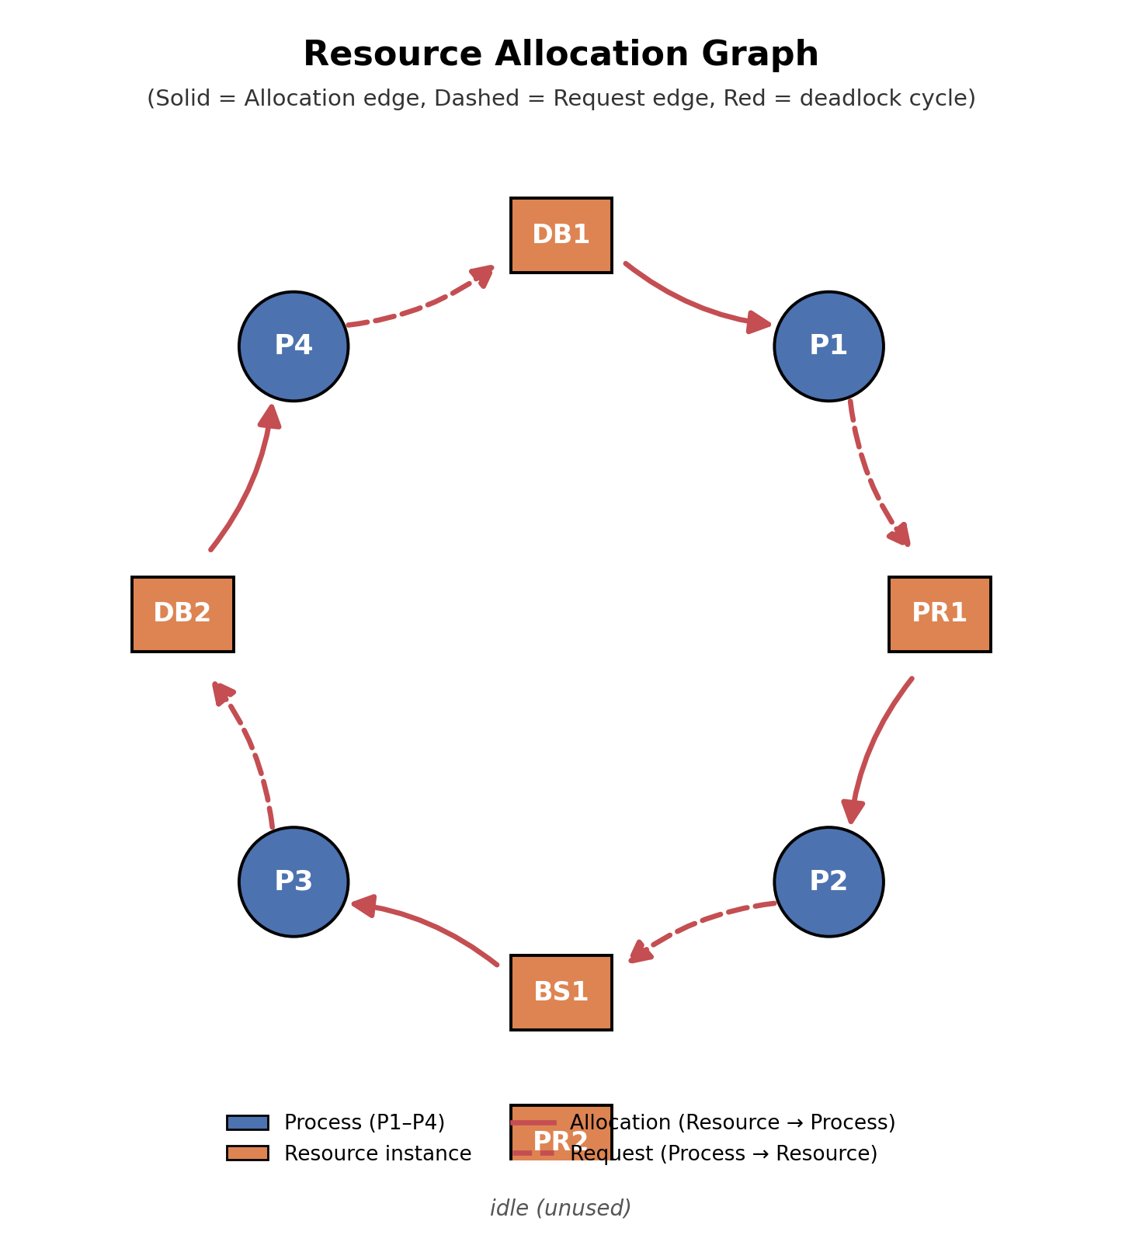
Figure 1: Resource Allocation Graph for the four processes. The red cycle DB1→P1→PR1→P2→BS1→P3→DB2→P4→DB1 is the deadlock.
Edges in the graph, drawn directly from the administrator's table:
- Allocation edges: DB1→P1, PR1→P2, BS1→P3, DB2→P4
- Request edges: P1→PR1, P2→BS1, P3→DB2, P4→DB1

3. Deadlock Analysis

3.1 Cycle detection
Tracing the graph from P1: P1 waits for PR1, which is held by P2; P2 waits for BS1, held by P3; P3 waits for DB2, held by P4; P4 waits for DB1, held by P1. This closes the loop back to P1:
P1 → PR1 → P2 → BS1 → P3 → DB2 → P4 → DB1 → P1
Every resource named in this cycle (DB1, DB2, PR1, BS1) has exactly one instance involved in the wait, and every process in the cycle (P1–P4) is blocked. Because each resource type here is being treated as a single requested unit with no alternate free instance able to satisfy the pending request (PR2 is idle but irrelevant, since nobody is requesting "any printer" — P1 specifically needs the instance P2 holds, and the DB pool is fully committed), a cycle in the RAG is both necessary and sufficient for deadlock in this situation.

3.2 Confirming there is no way out
The problem statement states explicitly that no process releases an allocated resource while waiting. This removes the possibility of the system resolving itself: each process is permanently blocked, holding what it has and waiting forever for a resource that will never be freed, since the process holding it is itself blocked.
Conclusion: the system is in a genuine deadlock involving all four processes (P1, P2, P3, P4) and four resources (DB1, DB2, PR1, BS1). PR2 is uninvolved and sits idle.

4. The Four Necessary Conditions for Deadlock
A deadlock can only arise if all four of the following conditions (Coffman conditions) hold simultaneously. Each is checked against this case:

4.1 Mutual Exclusion
At least one resource must be held in a non-shareable mode — only one process may use it at a time. Database connections, printers, and the backup device are all exclusive-use resources here: e.g., DB1 is held solely by P1, and no other process can use it concurrently. Condition satisfied.

4.2 Hold and Wait
A process must be holding at least one resource while requesting another. Every process in the cycle does exactly this — for example, P2 holds PR1 while simultaneously waiting for BS1. Condition satisfied.

4.3 No Preemption
Resources cannot be forcibly taken from a process; they can only be released voluntarily. The problem explicitly states no process releases its allocated resource while waiting, so the operating system is not stepping in to reclaim DB1, DB2, PR1, or BS1 from their current holders. Condition satisfied.

4.4 Circular Wait
There must exist a closed chain of processes, each waiting for a resource held by the next. This is precisely the cycle found in Section 3.1: P1→P2→P3→P4→P1. Condition satisfied.
Because all four conditions hold at once, deadlock is confirmed independently of the graph-cycle argument — the two methods corroborate each other.

5. Prevention and Avoidance Techniques
Deadlocks can be handled in four broad ways: prevention (deny one of the four conditions structurally), avoidance (grant requests dynamically only if they leave the system in a safe state), detection and recovery (let deadlocks occur, then detect and break them), or ignoring the problem (the "ostrich algorithm"). The prevention strategies map directly onto the four Coffman conditions.

5.1 Attacking Mutual Exclusion
In principle, making resources shareable removes this condition. In practice this is not viable for DB connections, printers, or backup devices — they are inherently exclusive-use hardware/software resources, and pretending otherwise would corrupt data or output. This technique is generally not usable for this scenario.

5.2 Attacking Hold and Wait
Two common approaches:
- Require each process to request and be granted all resources it will ever need before it starts executing (no incremental requests).
- Require a process to release all currently held resources before requesting a new one.
Applied here, P2 would have to request PR1 and BS1 together up front, or release PR1 before asking for BS1. This does eliminate the condition but tends to cause low resource utilization and starvation, since a process may hold a printer for a long time even while idle, waiting for the backup device to become free.

5.3 Attacking No Preemption
Allow the OS to forcibly reclaim a resource from a waiting process (and roll that process back) if it cannot get what it needs. For example, DB1 could be pre-empted from P1 and handed to P4. This works well for easily-saved/restored resources (CPU registers, memory) but is difficult or unsafe for the resources in this scenario: pre-empting a database connection mid-transaction or a backup device mid-write risks data corruption, and pre-empting a printer mid-job wastes paper/output.

5.4 Attacking Circular Wait
Impose a strict global ordering on all resource types, and require every process to request resources in strictly increasing order. For example: DB1 (1) < DB2 (2) < PR1 (3) < PR2 (4) < BS1 (5). A process holding a resource of order n may only request resources with order greater than n. This directly breaks the cycle: P4 (holding DB2, order 2) would be forbidden from requesting DB1 (order 1) — it would instead have had to acquire DB1 before DB2, closing off the exact edge that completed the deadlock cycle. This technique is low-overhead, requires no runtime prediction of future needs, and fits cleanly onto a fixed resource catalog like this server's. It is generally regarded as the most practical prevention technique.

5.5 Deadlock Avoidance (Banker's Algorithm)
Rather than statically forbidding a condition, avoidance grants a request only if the resulting state is still "safe" (there exists some ordering in which all processes can still finish). This requires each process to declare its maximum resource needs in advance, and the OS to run a safety check before every allocation. It is more flexible than prevention but adds runtime overhead and requires advance knowledge of maximum claims, which is often unrealistic for ad hoc application workloads on a shared server.

5.6 Detection and Recovery
Allow the system to allocate resources freely, but periodically run a cycle-detection algorithm over the wait-for graph (exactly the analysis performed in Section 3). If a cycle is found, recover by preempting a resource from one of the cycle's processes, or by aborting one or more processes in the cycle (e.g., killing P2, which releases PR1 and lets the cycle unwind, freeing P1, then P4, then P3). This has low overhead when deadlocks are rare, but the recovery step (aborting work, restarting transactions) can be costly, and this is the approach that would have been used to unblock the server in this incident.

6. Comparative Evaluation and Recommendation
Technique | Mechanism | Overhead | Fit for this server
Deny mutual exclusion | Make resources shareable | N/A | Not viable — resources must stay exclusive
Deny hold-and-wait | Request all resources up front / release before requesting | Low runtime, high idle waste | Poor — low utilization, starvation risk
Deny no-preemption | Force-reclaim resources, roll back process | Moderate–high (rollback cost) | Poor — risks corrupting DB/backup/print jobs
Deny circular wait | Global resource ordering | Very low | Best fit — simple, fixed resource catalog
Avoidance (Banker's) | Safety check before each allocation | Ongoing, needs max-claim data | Fair, but needs advance usage declarations
Detection + recovery | Periodic cycle check, then abort/preempt | Low until triggered, then costly | Good safety net alongside prevention

Recommendation
For this server, resource-ordering (attacking circular wait) is the recommended primary strategy: the resource catalog is small and fixed (DB1, DB2, PR1, PR2, BS1), so a global order is easy to define and enforce, it requires no advance knowledge of maximum claims (unlike the Banker's Algorithm), and it does not force premature acquisition of all resources or unsafe preemption of exclusive hardware. Concretely, assigning the order DB1 < DB2 < PR1 < PR2 < BS1 and requiring every process to request resources in increasing order would have prevented this exact incident: P4 would have been required to acquire DB1 before DB2, so it could never end up holding DB2 while waiting on DB1, which is the edge that closed the cycle.
As a complementary safety net, the OS should still run periodic deadlock detection (wait-for graph cycle checks) so that any deadlock arising from an unanticipated interaction — or from a component that cannot follow the ordering rule — is caught and resolved automatically (e.g., by aborting the youngest process in the cycle) rather than requiring a manual administrator intervention as happened in this incident.

