Robert Jamerson

Module 1 Activity

<http://robjamersonlampserver.centralus.cloudapp.azure.com/module_01/activity/mod1_activity.html>

<https://github.com/RobJamerson/CIS3801C-Class>

Bitnami LAMP Server:

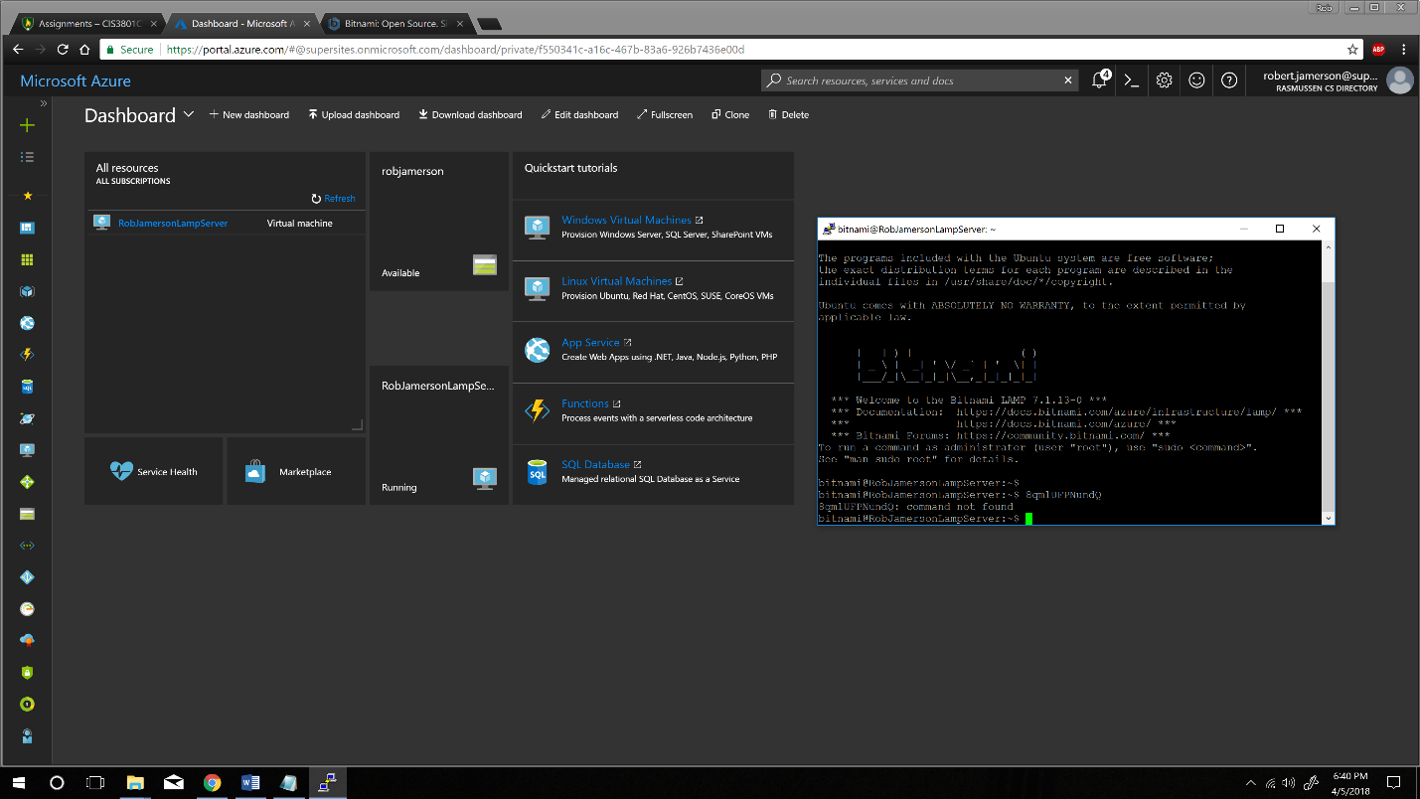

Phpmyadmin database:

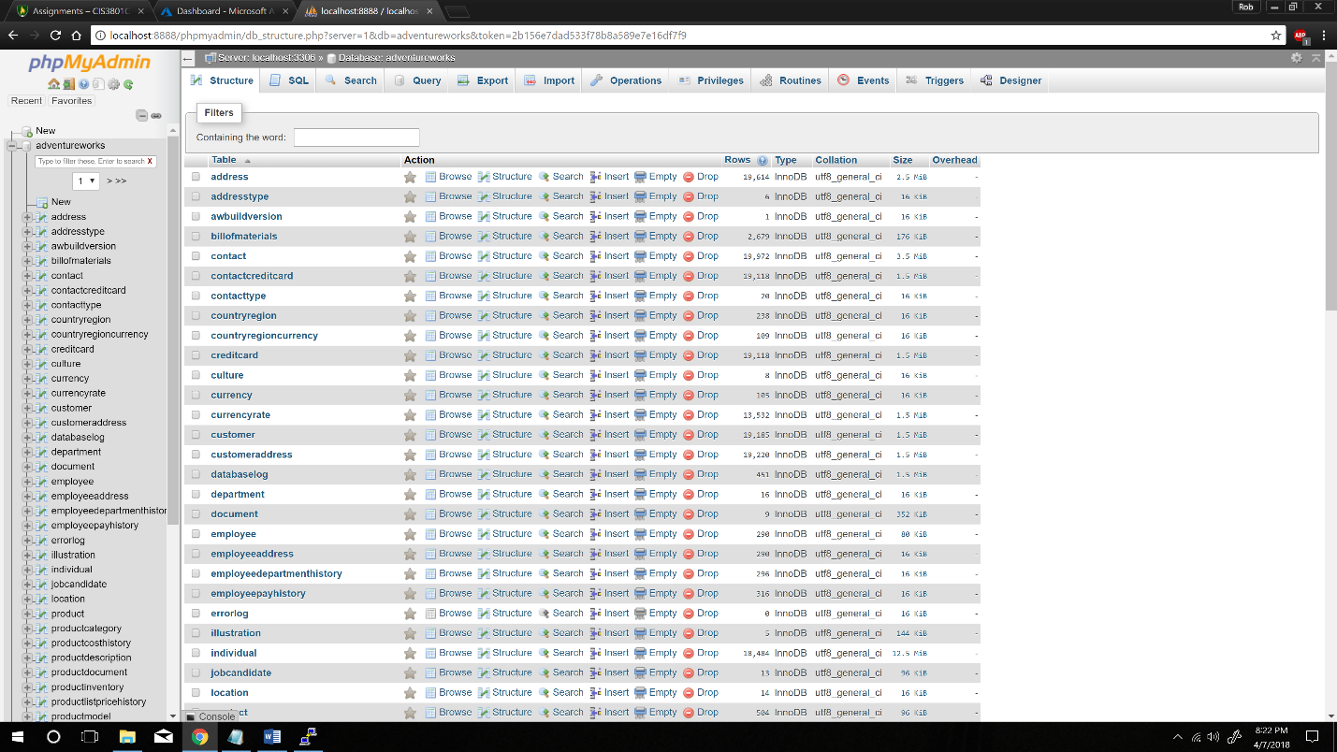

Atom:

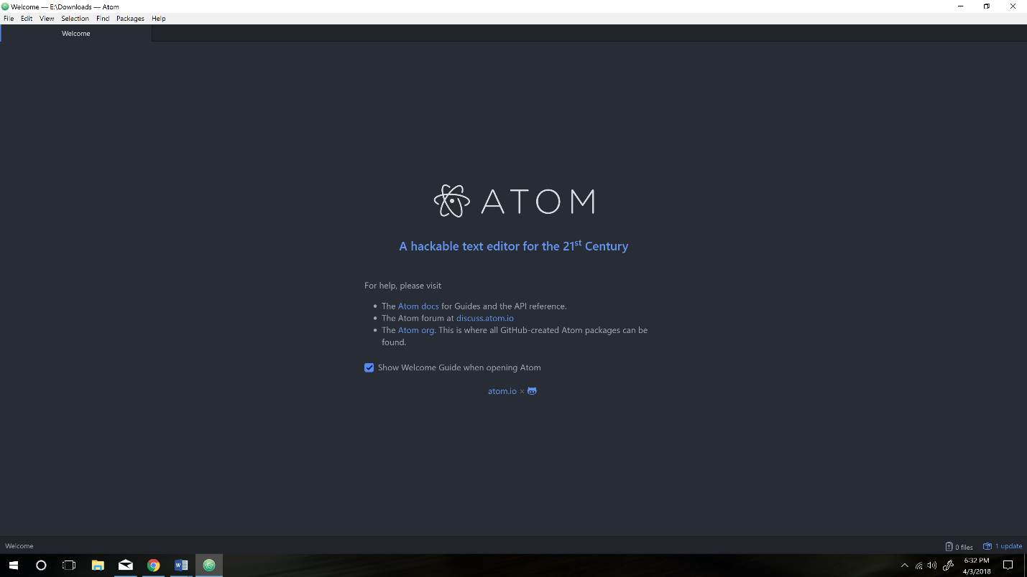

GitHub:

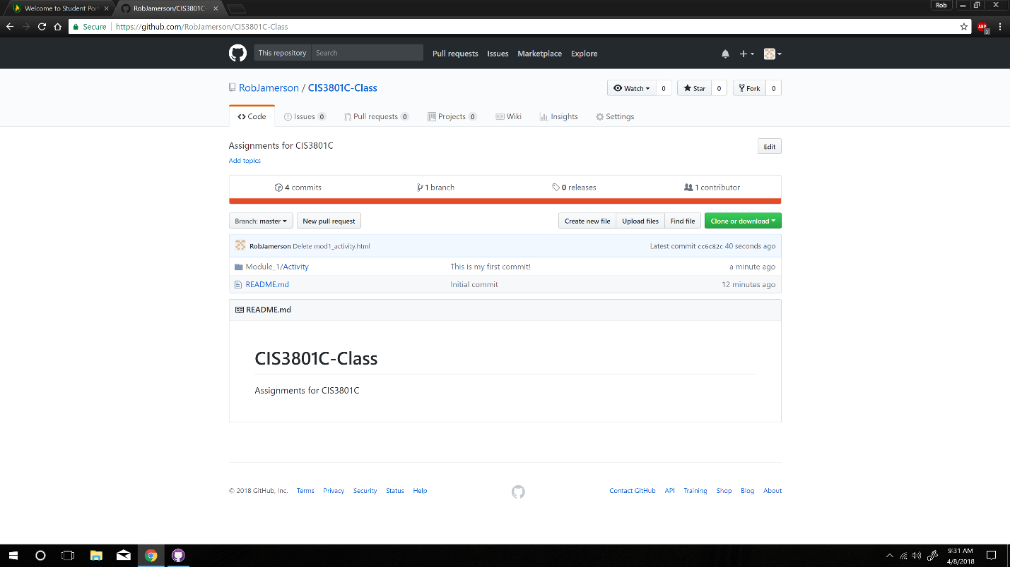

Hello World Webpage:

