Robert Jamerson

Module 5 Activity

Galaxy S5: The site looks like it has resized fairly well for the Galaxy S5. The only change would be to have the navigation links resize a little bit smaller to fit on one line.

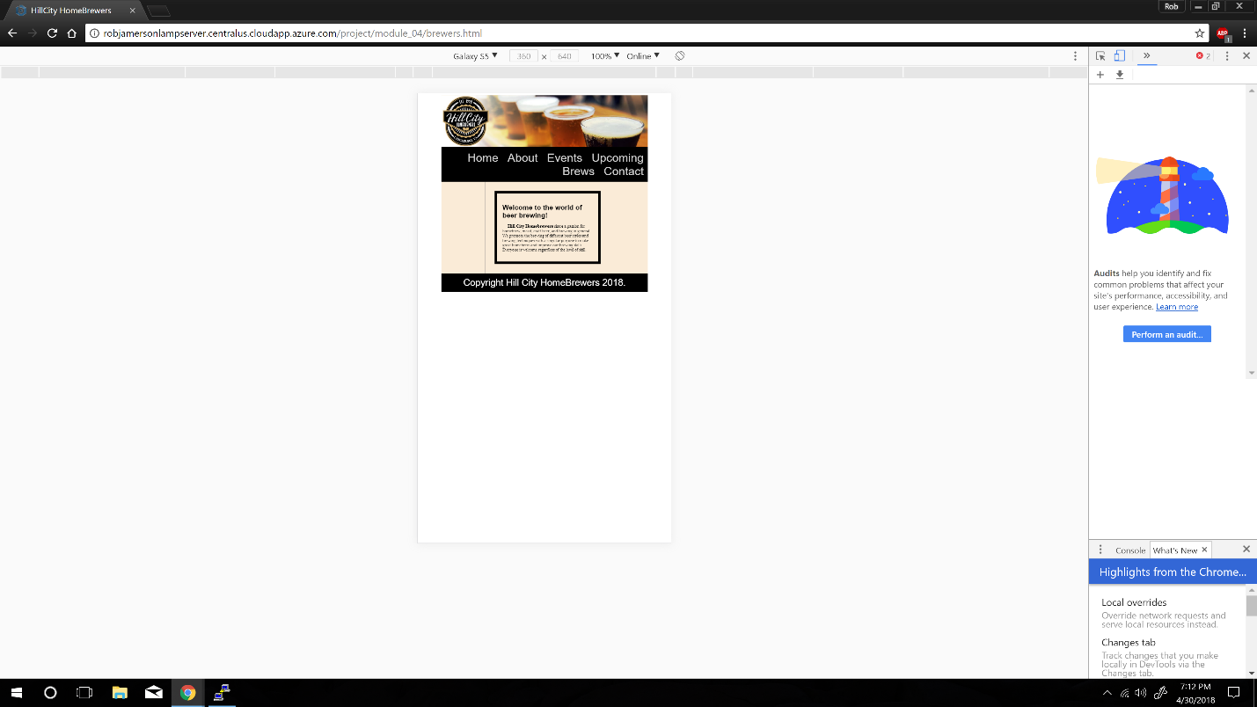

iPad Pro: Size resized very well for the iPad Pro Tablet. No changes needed.

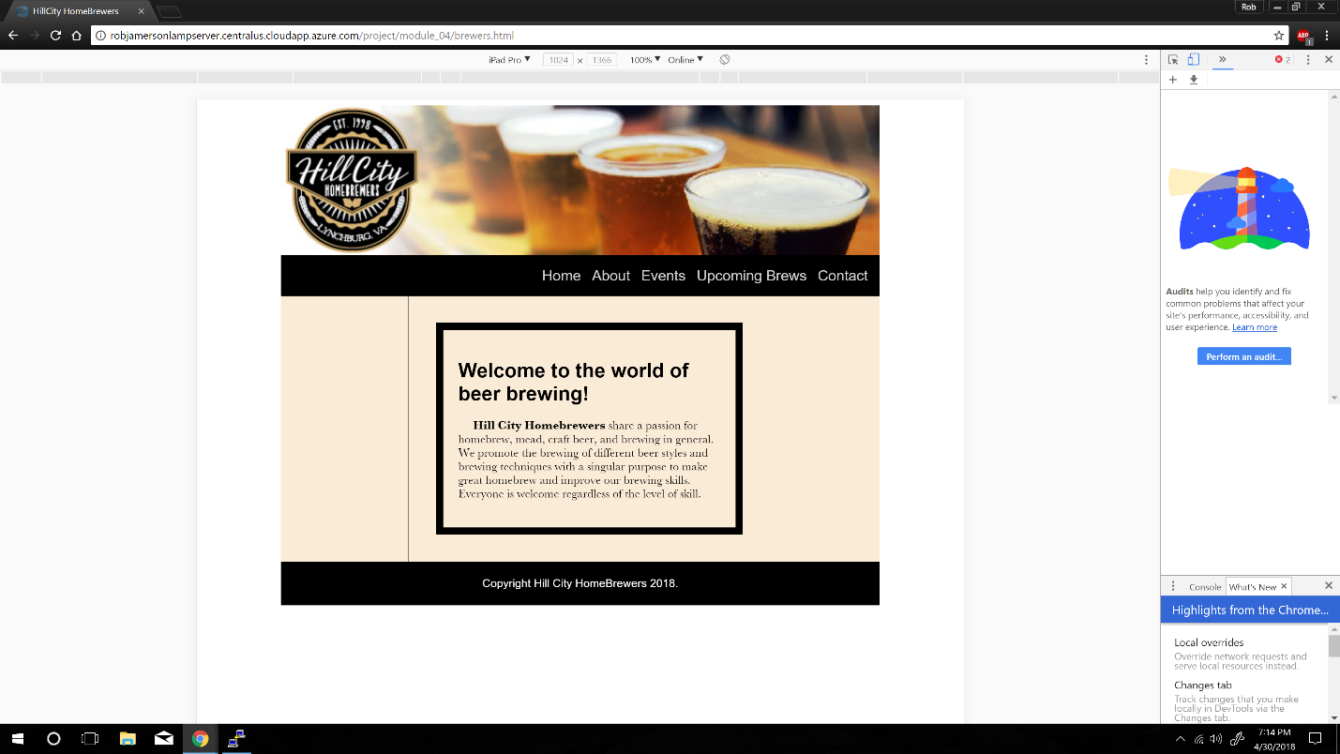

iPhone 6/7/8 Plus: Just as with the Galaxy S5, I would have to resize the navigation bar links to fit on one line.

