Robert Jamerson

Module 5 Project

I changed the color of the calender below. It was white before, this makes it mesh with the site’s layout.

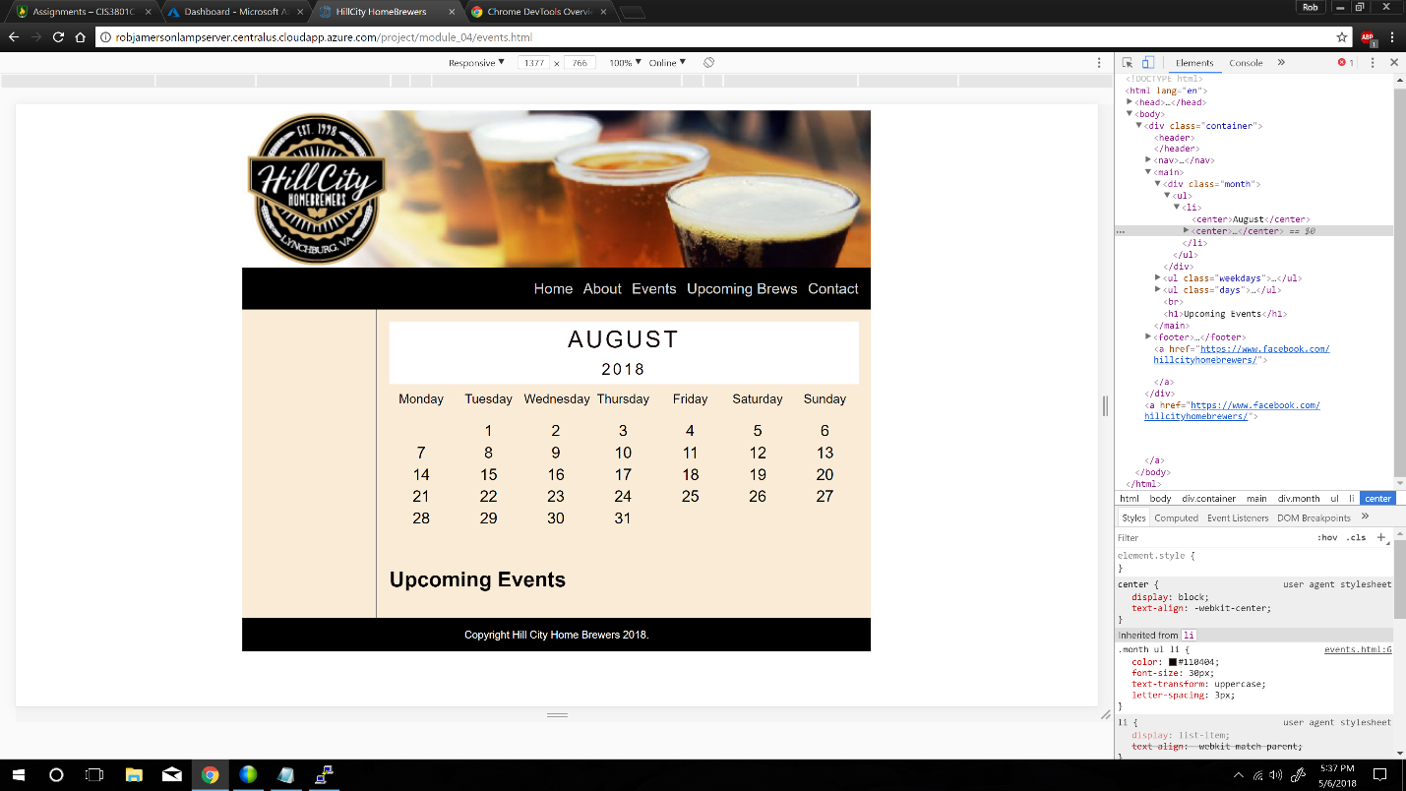

I changed the size of the header font “Welcome to the world of beer brewing!” and changed the font to serif. I think it looks better than the bigger font I had before. I would be willing to change this for the final site.

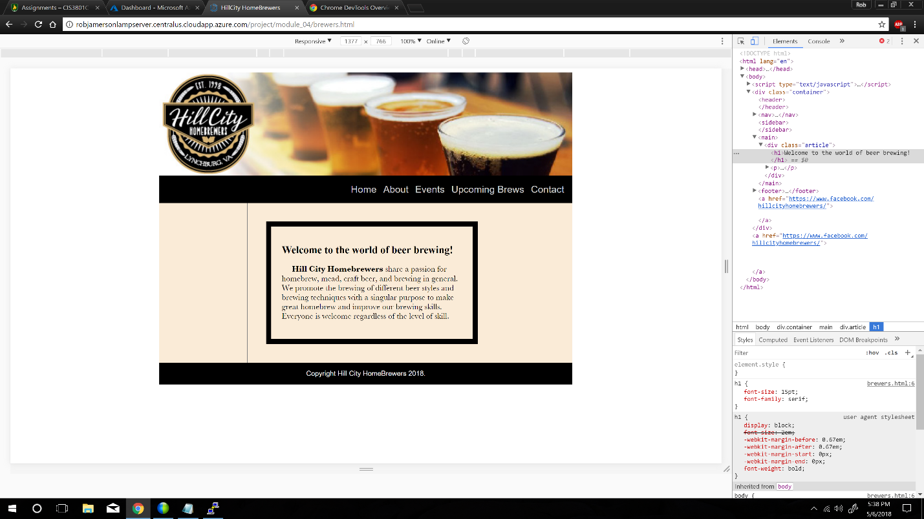

I experimented with changing the background color to a darker shade. I’m not sure I like it though.

