MicroPasts Technical Note 2 (2014)
Photo-Masking for 3D Models of Artefacts

Andrew Bevan, Robert Kaleta, Chiara Bonacchi, Adi Keinan-Schoonbaert

1. Introduction
These working notes follow on from those that focused on capturing photographs suitable for the creation of 3D models via Structure-from-Motion (SfM). SfM is shorthand for several related steps known as Structure-from-motion/multiview-stereo and more loosely referred to either as 3D photogrammetry or computer vision. Regardless of the preferred term, the approach creates 3D colour-realistic models from a series of overlapping digital photographs. These overlaps and different angles of photo-capture allow the reconstruction of the original positions of the cameras that took the photos, without needing to describe these positions carefully from the outset.

Certain kinds of SfM software produce better results when the object of interest is isolated from the rest of the photograph via a masking procedure (in particular this is the case with the commercial software package PhotoScan). A mask has the effect of excluding certain parts of the image from the SfM feature-matching process, and/or subsequent model-building steps. Masking can in principle involve either drawing a vector polygon around each object in a photo or providing a raster binary (i.e. black and white) mask. It is laborious to create masks, but they nonetheless produce better, cleaner models than simply asking the software to distinguish cleanly between object and the background all on its own (at least in the present state of the art). This is especially true for objects that require capture in two stages (where the object is, for example, flipped over half way through) or is photographed on a turntable (where the background again moves relative to the object).

These notes take you through a photo-masking workflow in two different software packages: the commercial package Photoshop (section 2) and the open source package GIMP (section 3). It most cases, you should therefore only need to go through one of these sections.

N.B. Just as a technical aside, the MicroPasts crowd-sourcing application for photo-masking achieves a very similar result to the one discussed below, but in a different way. It asks contributors to draw vector polygons around the object visible in each photograph. Several contributors (currently 5) each draw the required polygon for the same photo and then we run an offline script to read in each polygon and convert it to a binary raster mask (i.e. a black/white image the same size as the original photo). The average of these different contributed masks for a given photo then represents a ‘probabilistic’ mask, from which we can produce a final binary version (e.g. where 3 out 5 masks are in agreement). This process can be further scripted to run through many photographs automatically.

2. Steps in Adobe Photoshop
2.1. Make a copy of the image and rename the copy so that it has the same name as the original but with a “_mask” ending. So for example, our copy of the image named IMG_0451.JPG would be called IMG_0451_mask.JPG.

2.2. Then open up your _mask image in Photoshop. The first thing to do is to make sure that you have pure white chosen as the foreground and pure black as the background on colour picker at the bottom of your Tools bar. The set-up you are looking for is like this:
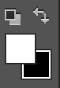

2.3. Now use the Rectangular Marquee Tool (at the top of the same button bar) to draw a box around the image. Your screen should now look similar to the one below:

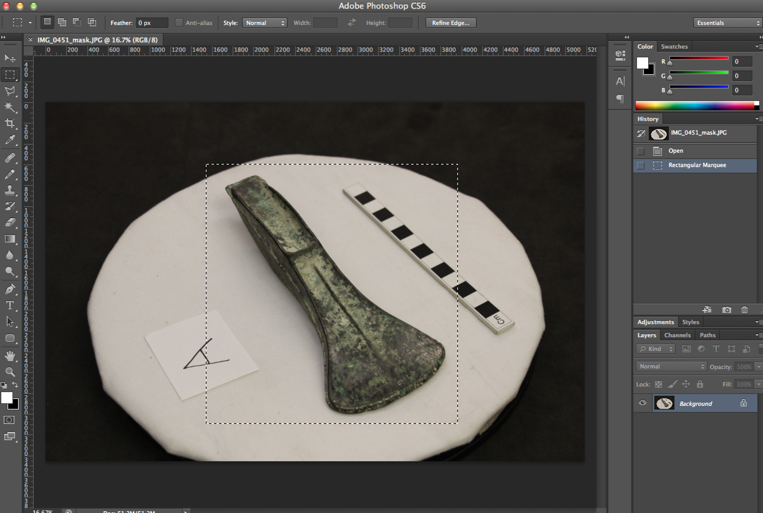

2.4. Now select SHIFT-CTRL-I (or on MacOSX SHIFT-CMD-I) to switch the selection to the inverse (or you could choose Select→Inverse from the top menu).

2.5. Hit the Delete button and you should bring up a dialogue that allows you to fill the selected area with either foreground or background colour. Make sure to choose background colour (black) and click OK. You screen should now look like this:

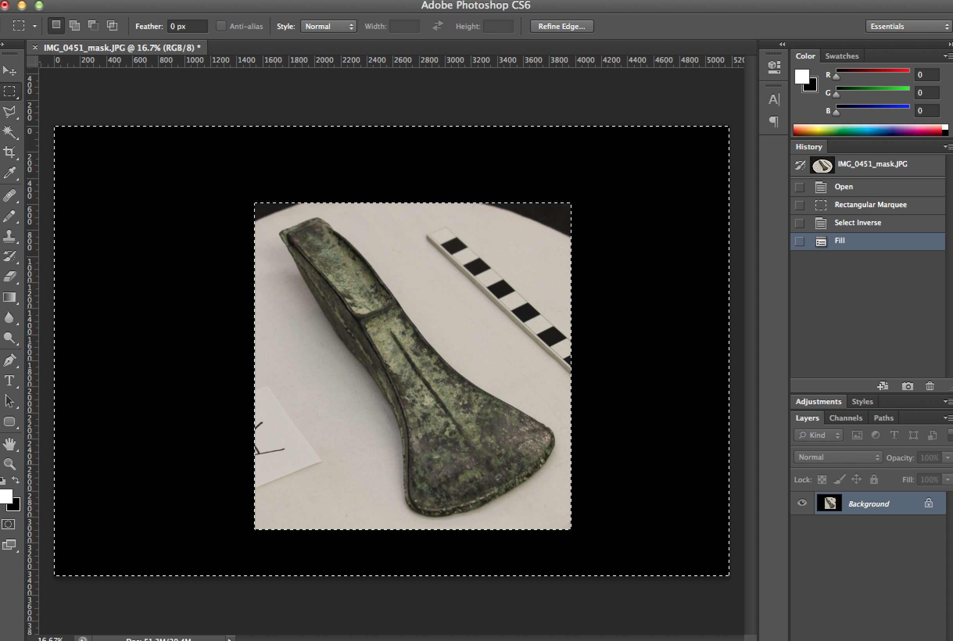

2.6. Now click CTRL-A (or CMD-A on MacOSX) to select the whole image and then zoom in a little (hint: holding SHIFT and hitting the + button twice is about enough zoom for our purposes, but you could alternatively use the magnifying glass tool). Your screen should now look a little like this one:

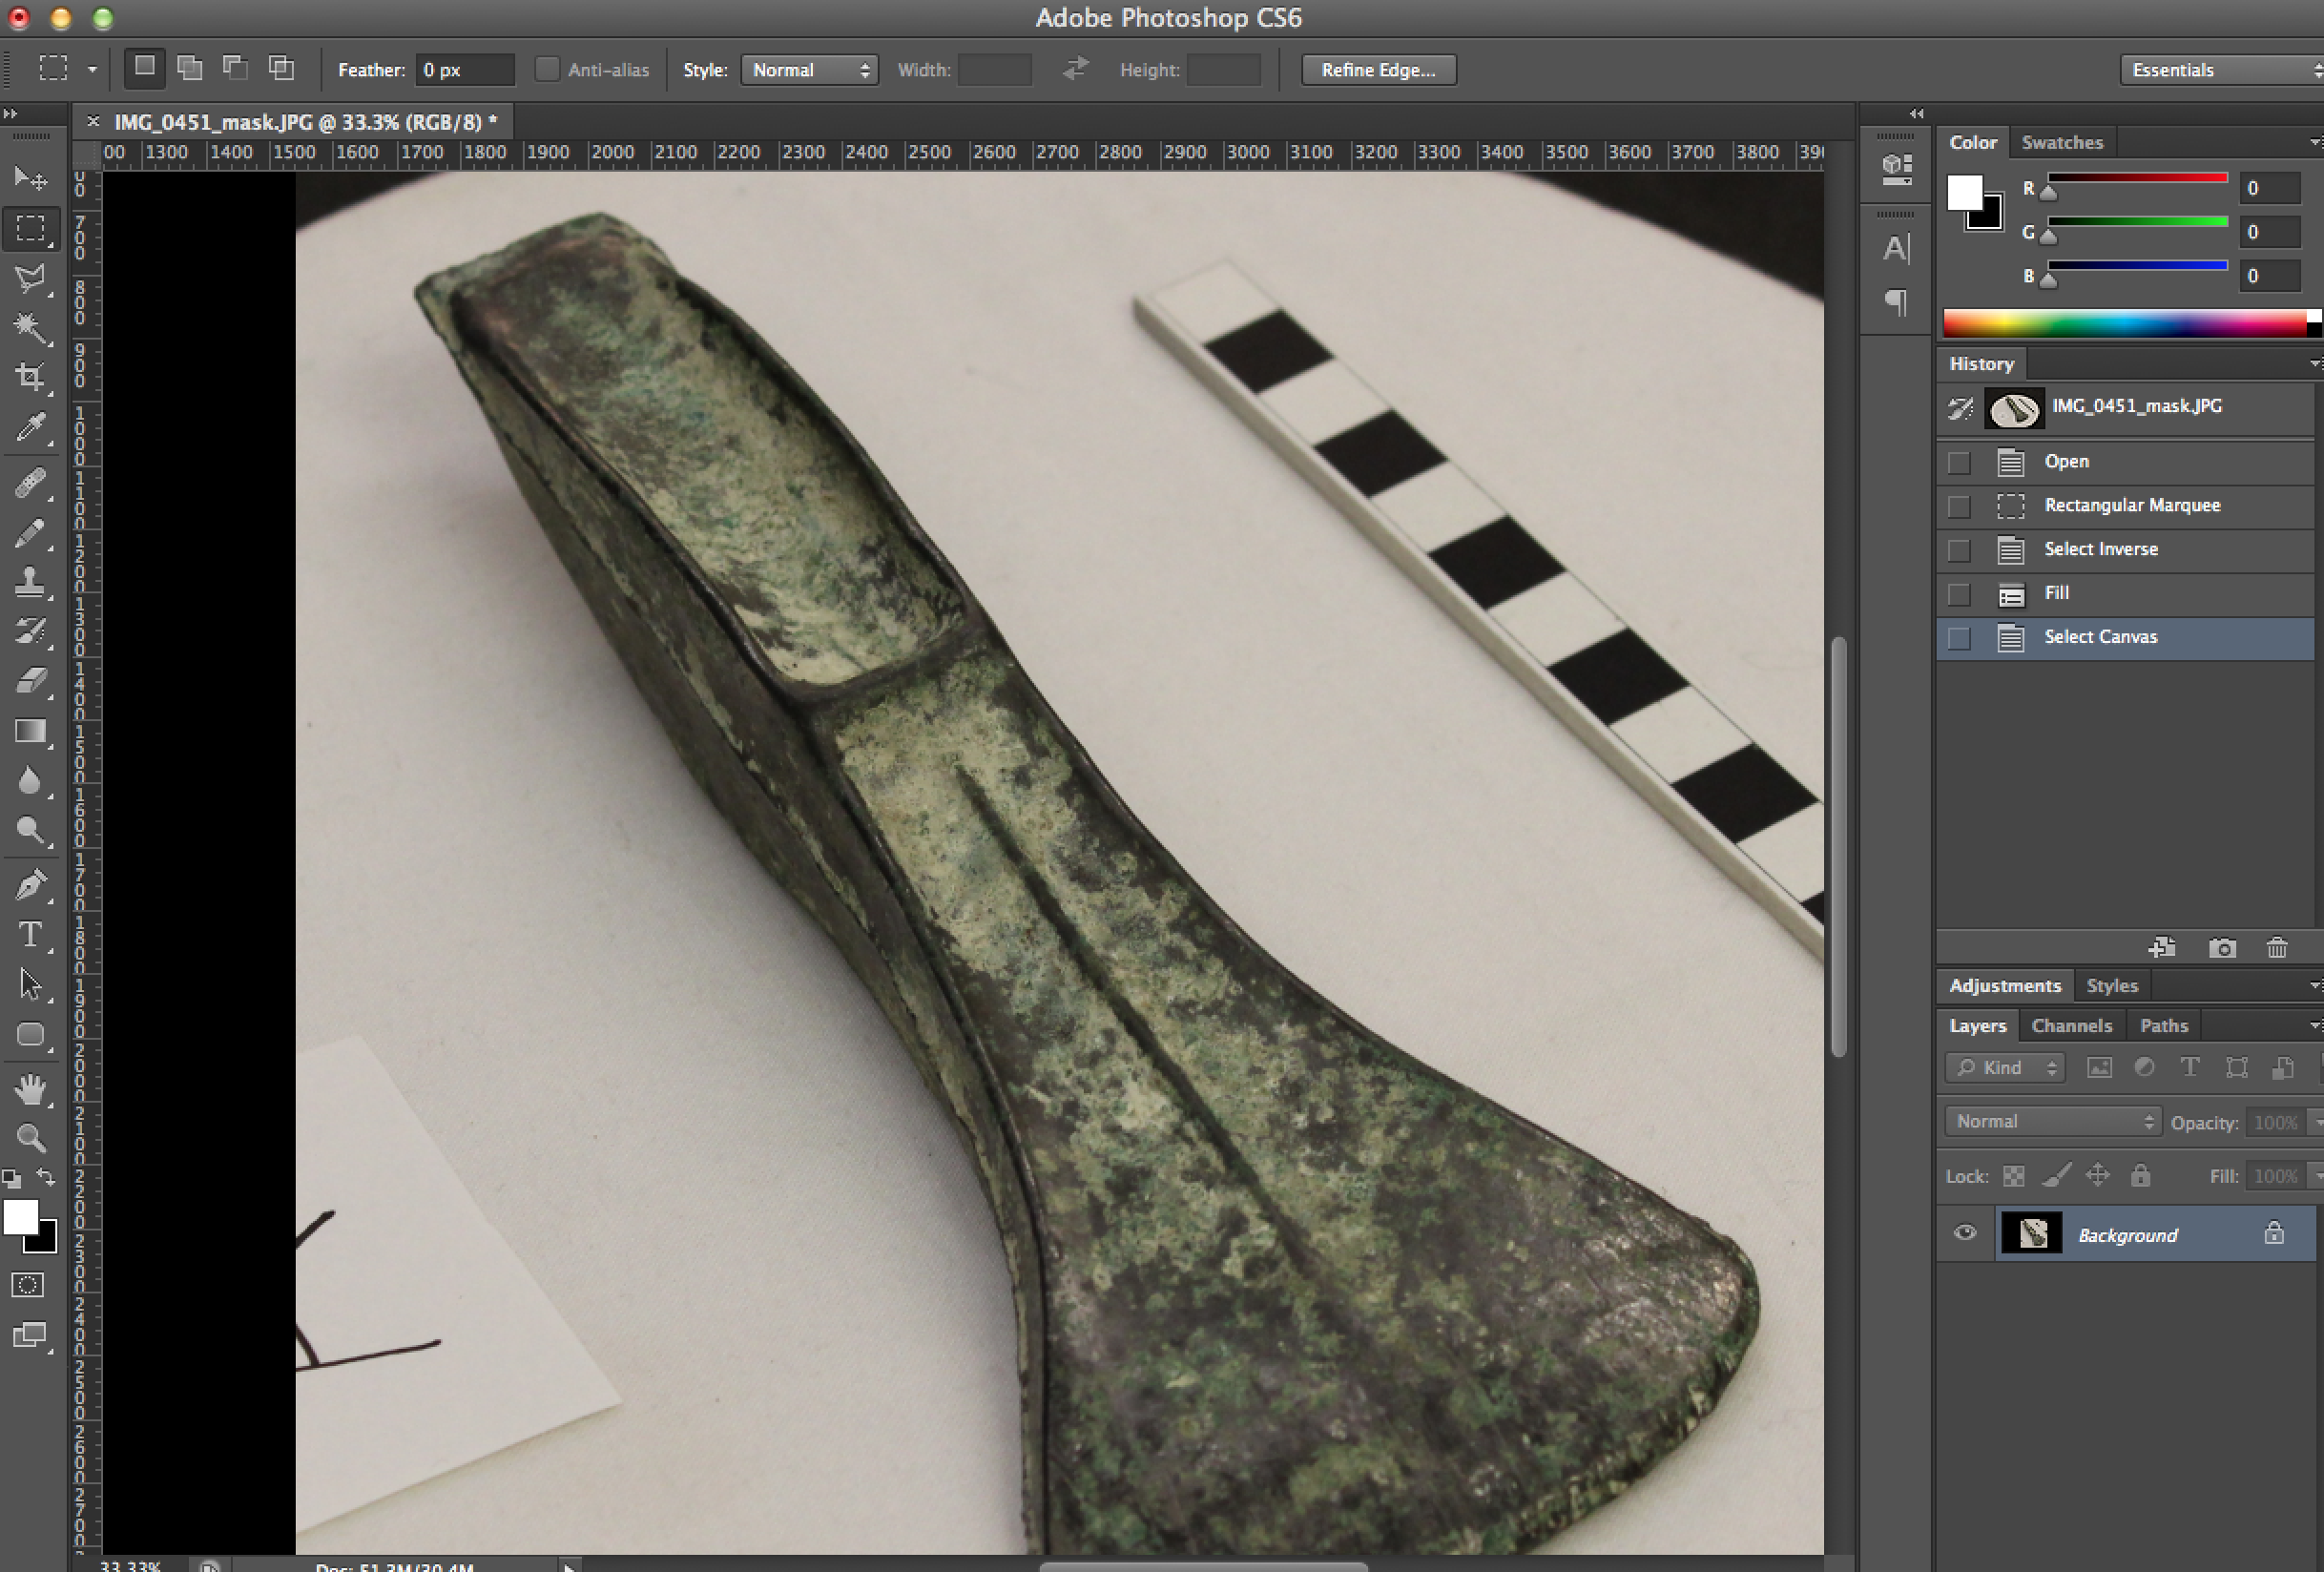

2.7. Now select the Eraser tool and make sure that its “Mode” (which is usually to be found in a set of options showing in the middle towards the top of your Photoshop window) is set to “Block”. We are going to erase fairly roughly around the outline of the object, making sure to ‘bite’ slightly into the object so as to leave no border (N.B. If one part of the object is unusually blurry then you could even consider masking that out as well, but hopefully this will not be necessary if a good photographic strategy was used). Here is an example:

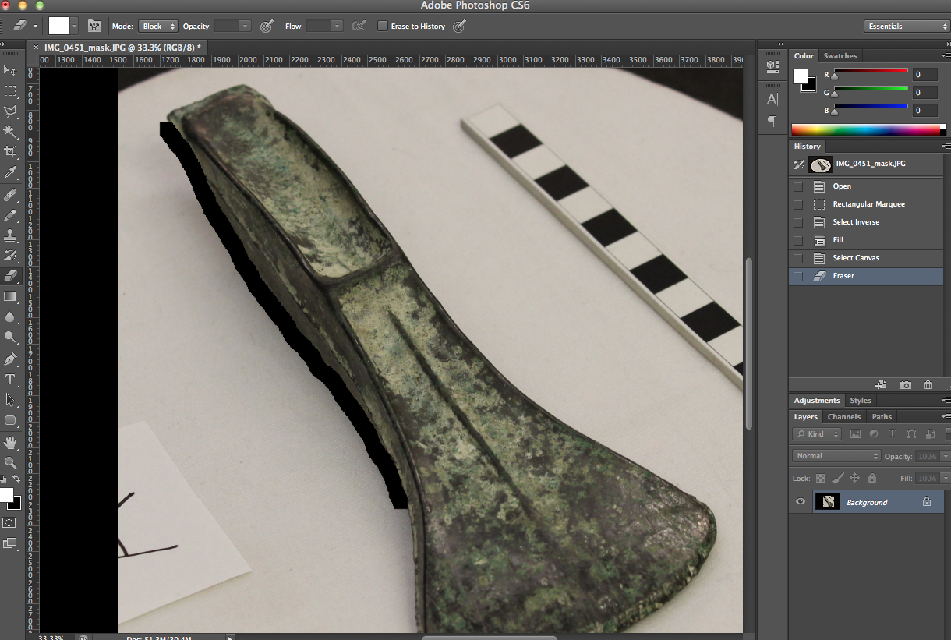

2.8. The number of photos involved in the 3D modelling provides enough redundancy so that erasing a tiny bit of the edge of the object in one photo does not matter and this avoids providing too much noisy background to the model-building algorithm. However, this rule-of-thumb does NOT apply to very thin edges of an object. In our example this exception would apply to the cutting edge of the axe. If it is clearly visible then the edge should be preserved as much as possible. This can be achieved by zooming in onto the edge, decreasing the size of the eraser using the Tool Options bar, and carefully erasing the background in a way which preserves the cutting edge. See an example below:

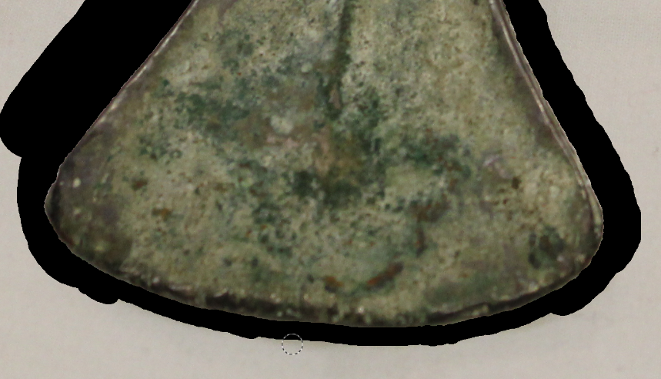

2.9. For the rest of the axe you can bite into the object a bit when you erase. Go all the way around the object and your screen should look like this one:

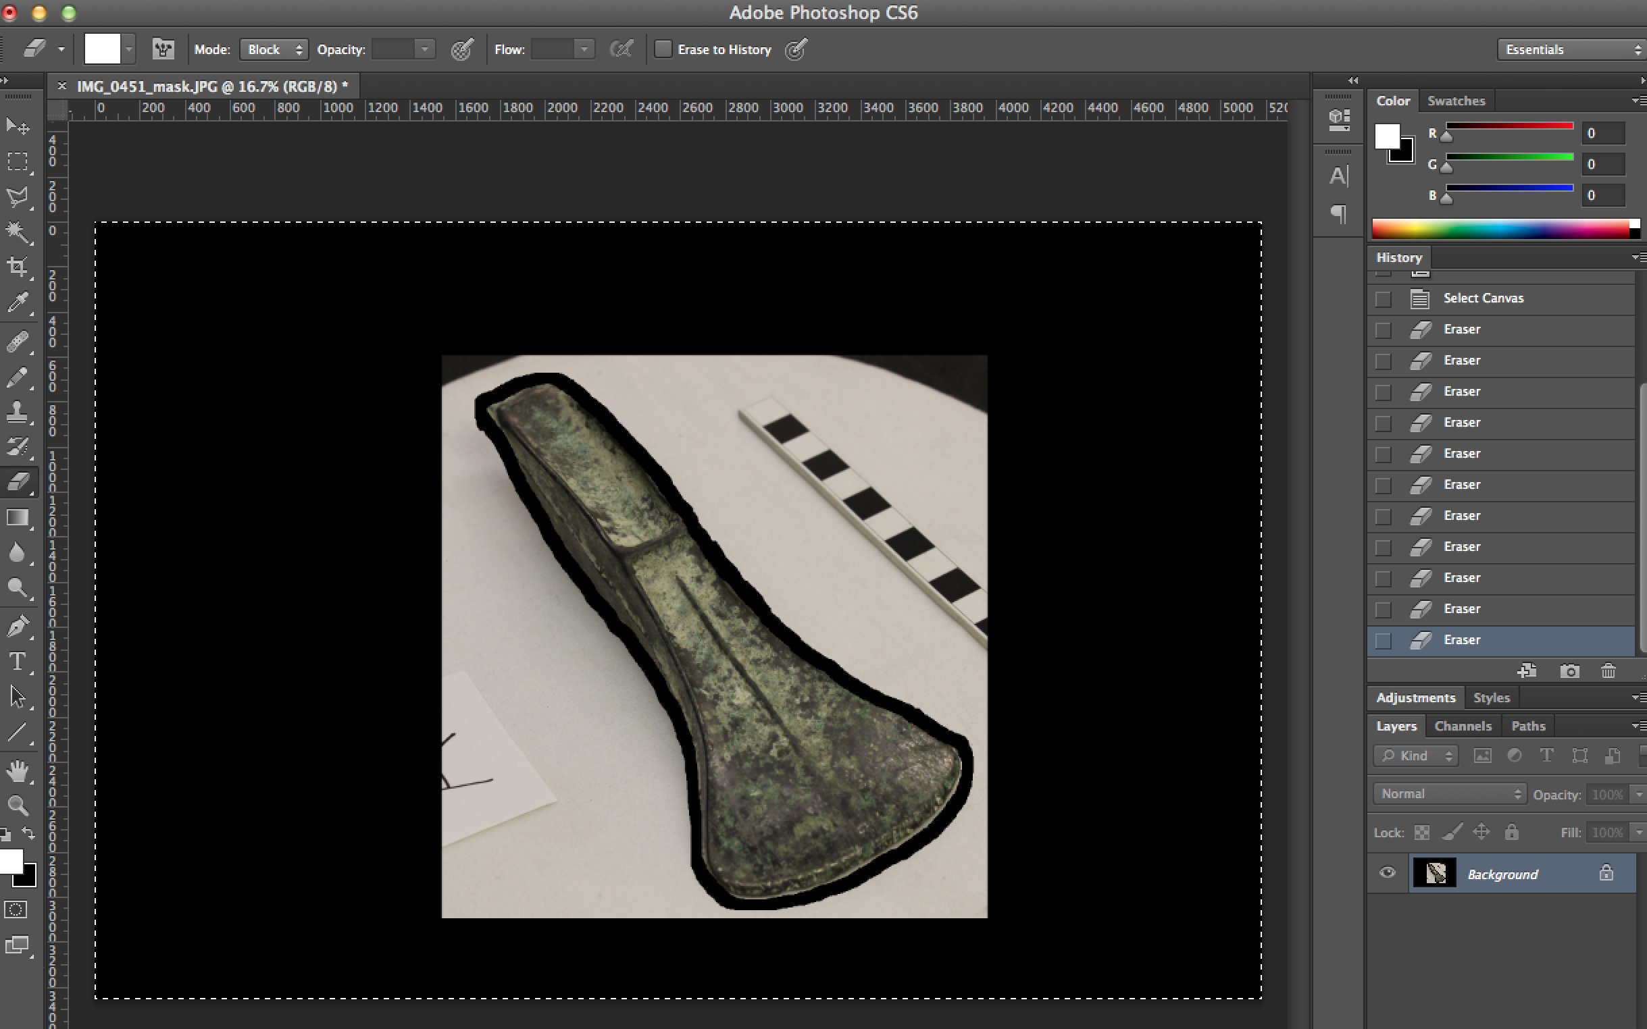

2.10. Now we merely have to remove the rest of the background that falls between the erased outline and the rest of the black space. The cleanest way to do this (which leaves no little bits of unerased pixels) is to use the polygon Lasso Tool  and lasso this area in one or more efforts, clicking each time you want to add a corner to your selection polygon and running careful down the erased corridor your created next to the object edge. Then press Delete and fill the selected polygon with background colour (black, as above). If you repeat this process you should end up with a screen such as the one below:

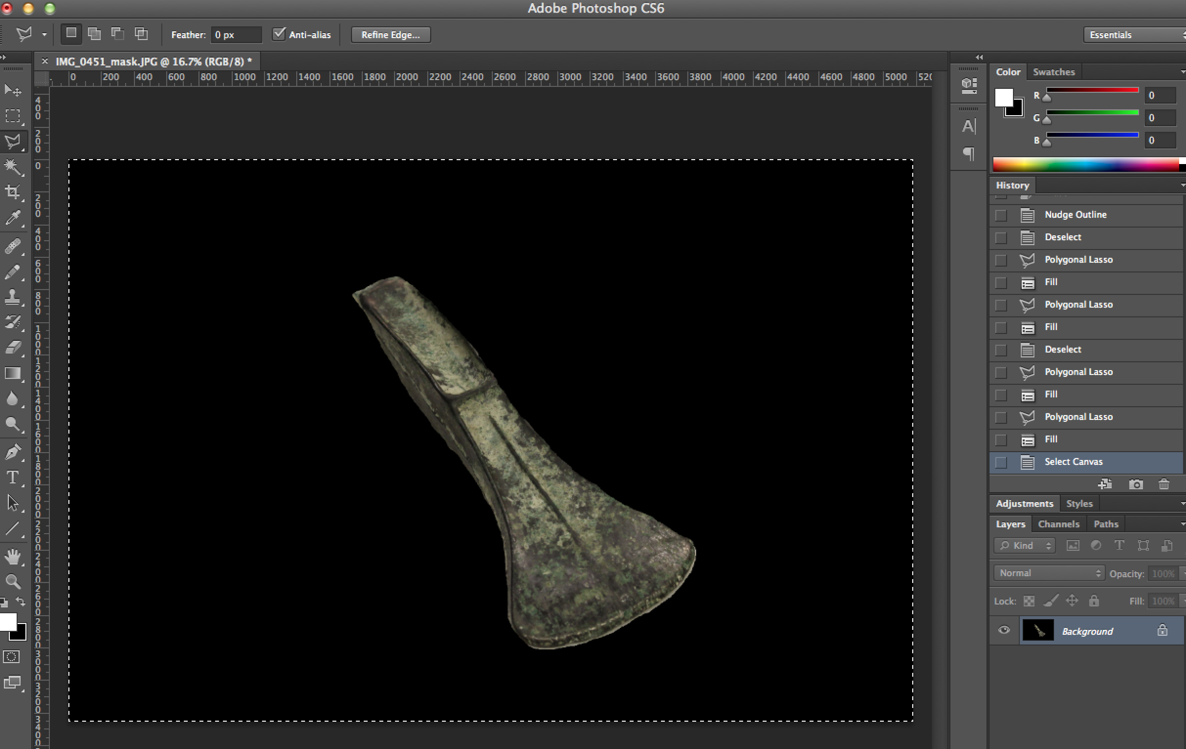

2.11. We now have isolated the object. Note that this process would be slightly different if our purpose was not 3D modelling but instead the isolation of an object to combine it with others in a composite image, adding it to a presentation slide etc. In the latter cases, we would want to use a ‘soft’ (not a block) eraser and be far more careful with the edges of the object (it would also be better to erase on a separate copied layer, rather than on the background layer, as we could then switch between different kinds of background). However for our purposes here, the current result is a good one. Now use the Magic Wand tool.  Set its Tolerance to 2 (pixels, option toward top of your screen probably) and then select the black area you have been erasing.

2.12. Now again choose SHIFT-CTRL-I (or on MacOSX SHIFT-CMD-I) to switch the selection to the inverse (or you could choose Select→Inverse from the top menu), meaning that you now have the object itself selected. Hit the Delete button and you should bring up a dialogue that allows you to fill the selected area with either foreground or background colour. Make sure to choose foreground colour (white) and click OK. Your screen should now look like this:

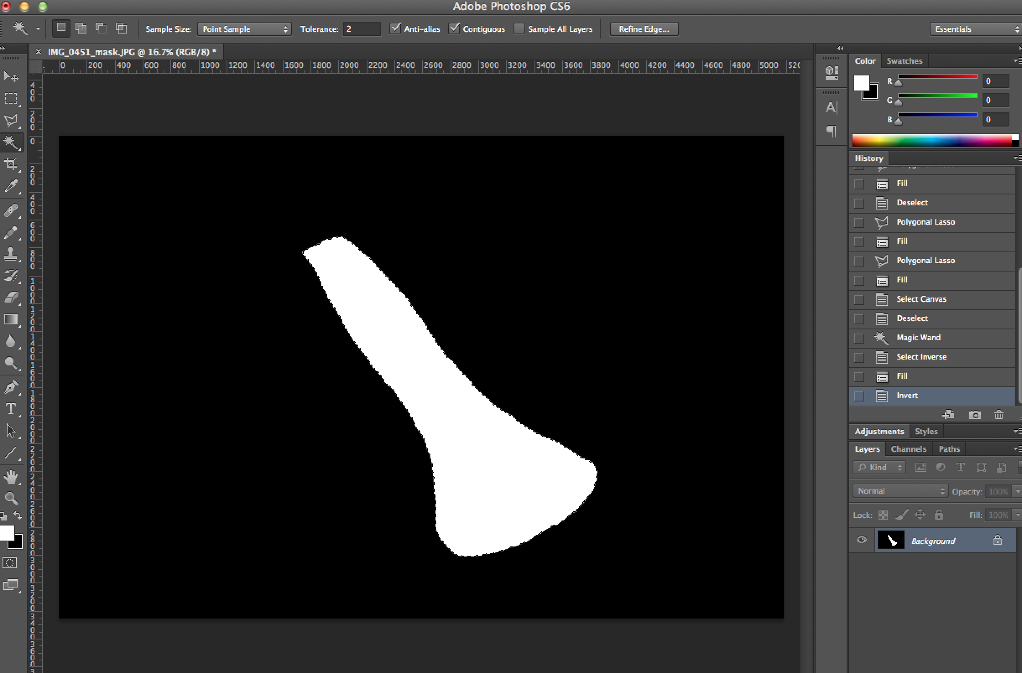

2.13. We now have what we want – a binary (black and white) mask for our object. The last step is to choose Image→Mode→Greyscale (accepting the warning) to discard the colour information and make a smaller file. Then save your image (if you are asked for JPEG options then a ‘Quality’ of about 8 would be fine here).

3. Steps in GIMP
3.1. Make a copy of the image and rename the copy so that it has the same name as the original but with a “_mask” ending. So for example, our copy of the image named IMG_0470.JPG would be called IMG_0470_mask.JPG.

3.2. Open the _mask image in GIMP and make sure that you have pure white chosen as the foreground and pure black as the background on colour picker in the Tools bar. Here’s how it should look like:

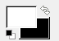

3.3. Click on the Rectangle Select Tool from the tool bar (note that the tool bar might not be in the same position as the one in the picture below) and draw a box around the object. Your screen should now look similar to the one below:

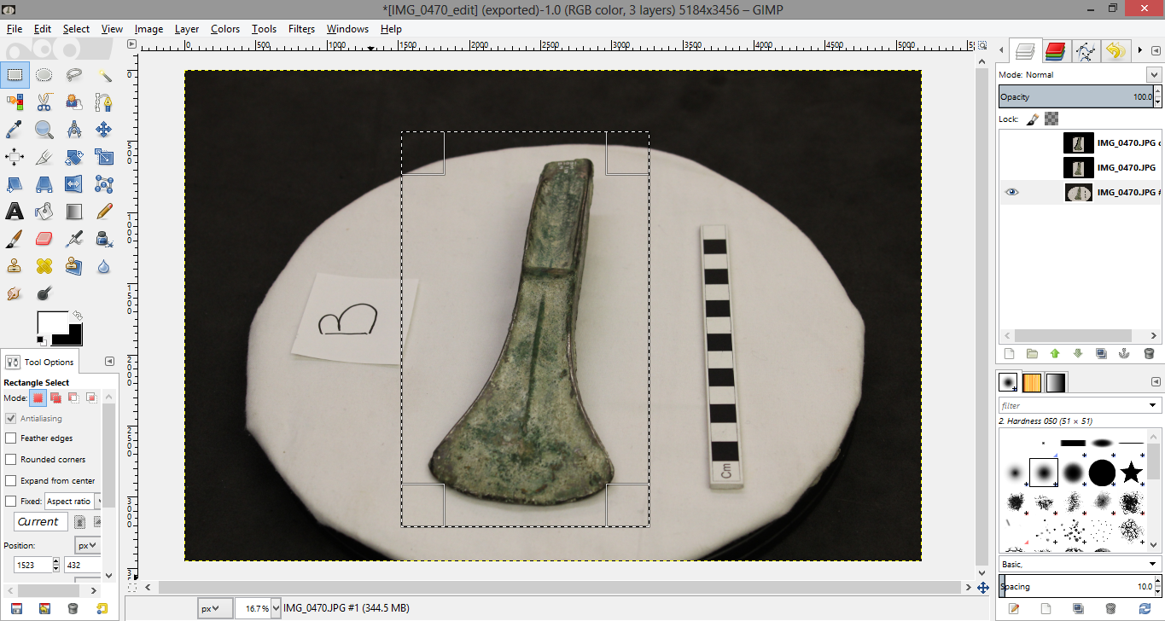

3.4. Now press CTRL-I (or on MacOSX CMD-I) or choose Select→Inverse from the top menu to inverse the selection.

3.5. Hit the Delete button which will fill the outside area with the background colour (black). Your screen should now look like this:

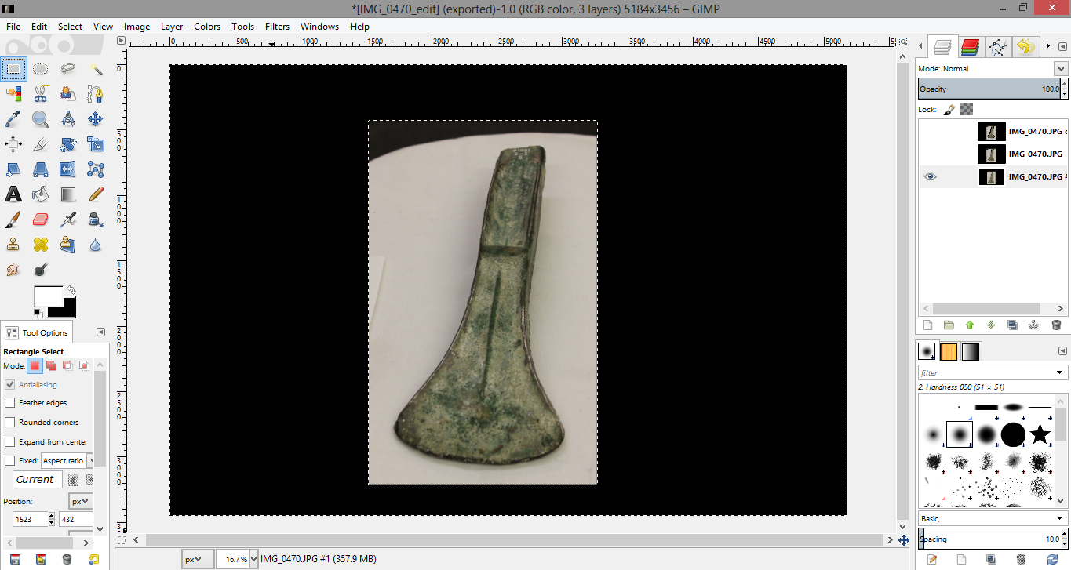

3.6. Now press CTRL-A (or on MacOSX CMD-A) to select the whole image again and then zoom in a little either using the + button or the magnifying glass from the tool box. Your screen should now look a little like this one:

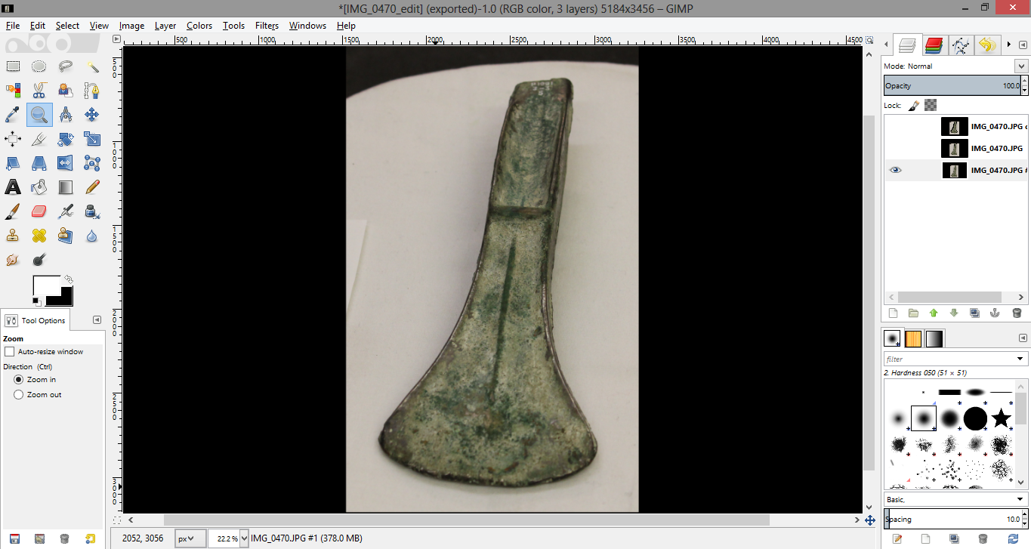

3.7. Select the Eraser tool making sure that the Hard Edge option in the Tool Options bar is ticked and begin to erase an outline of the axe leaving no border around it. This might mean that you slightly cut into the axe’s edge (N.B. If one part of the object is unusually blurry then you could even consider masking that out as well, but hopefully this will not be necessary if a good photographic strategy was used).

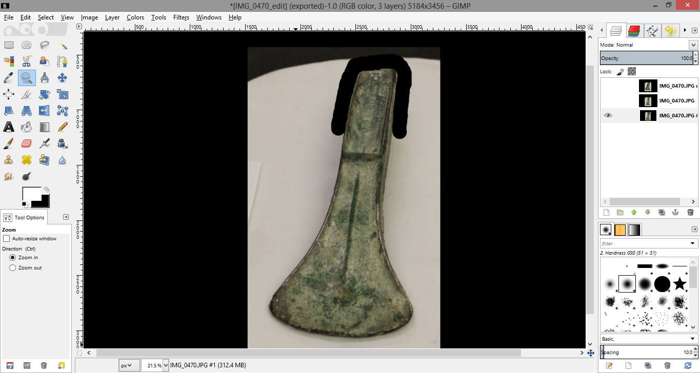

3.8. The number of photos involved in the 3D modelling provides enough redundancy so that erasing a tiny bit of the edge of the object in one photo does not matter and this avoids providing too much noisy background to the model-building algorithm. However, this rule-of-thumb does NOT apply to very thin edges of an object. In our example this exception would apply to the cutting edge of the axe. If it is clearly visible then the edge should be preserved as much as possible. This can be achieved by zooming in onto the edge, decreasing the size of the eraser using the Tool Options bar, and carefully erasing the background in a way which preserves the cutting edge. See an example below:

3.9. At the end your screen should look like this:

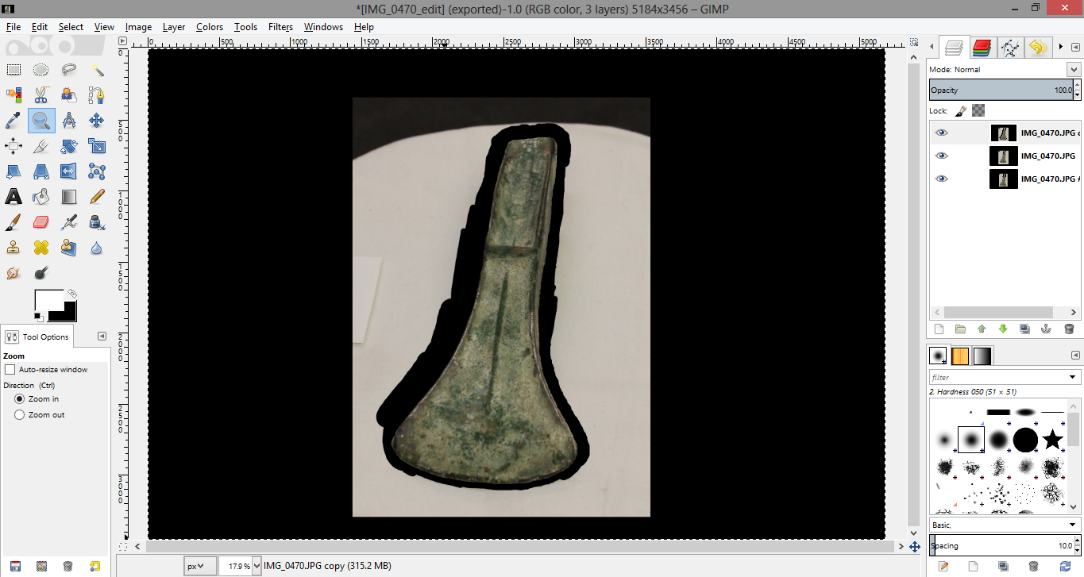

3.10. Now we just have to remove the rest of the background that falls between the erased outline and the rest of the black space. The cleanest way to do this (which leaves no little bits of unerased pixels) is with the Free Select Tool . Use it to trace the outline of the object, staying within the erased area. Your screen should now look something like this:

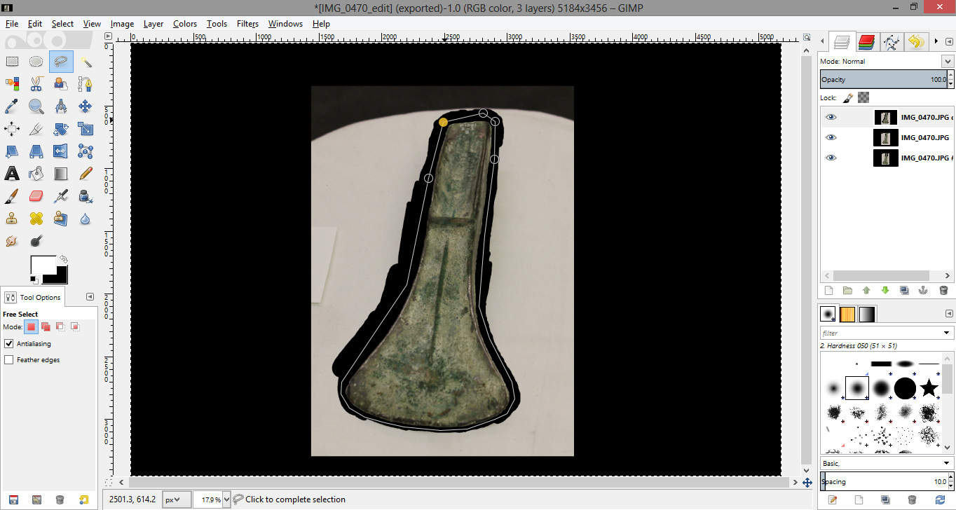

3.11. Press CTRL-I (or on MacOSX CMD-I) and then Delete to remove the remaining background and fill it with the background colour. You should end up with a screen such as the one below:

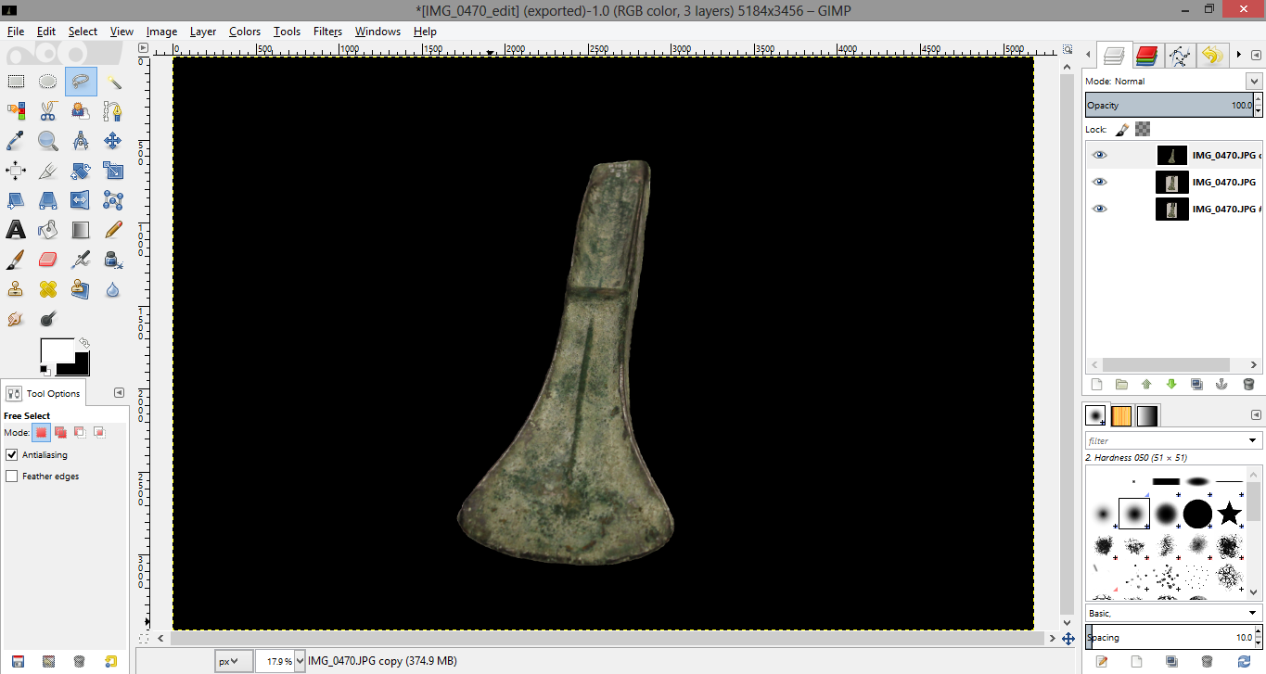

3.12. Use the Fuzzy Select Tool  with the Threshold set to 2 and “Select by” set to Composite, and then click anywhere inside the black area.

3.13. Next, press CTRL-I (or on MacOSX CMD-I) to switch the selection to the inverse, meaning that you now have the object itself selected. Switch the colours in the Colour Picker box so that white is the background colour: .
Finally, hit the Delete button which will fill the selected space with the new background colour (white). The final result should look like this:

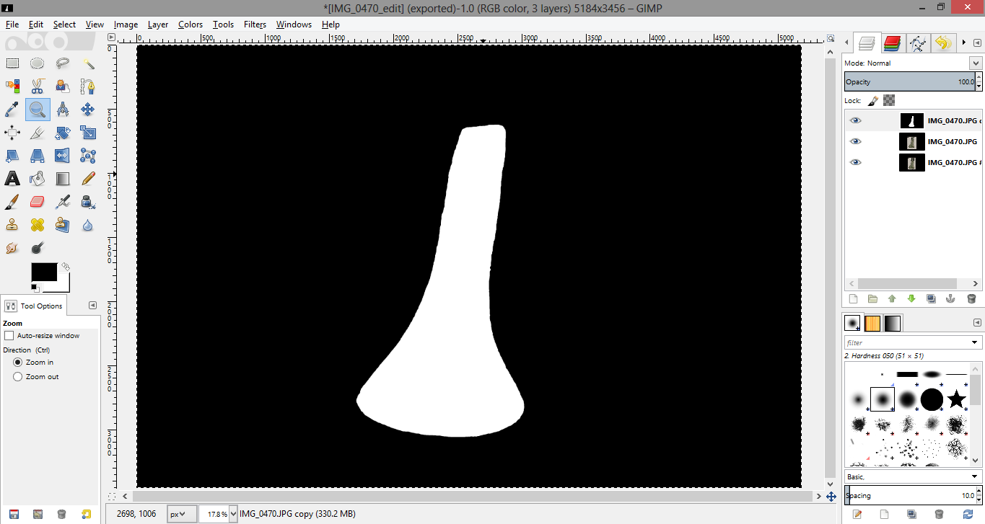

3.14. The last step is to turn the image into a binary (black and white) mask for our object. For this choose Image→Mode→Greyscale which discards the colour information and makes a smaller file. To save the image select Export as… from the File bar on top of the screen and save it as a JPEG with Quality of about 90.

