MicroPasts Technical Note 1 (2014)
Photographic Strategy for 3D Models of Artefacts
Robert Kaleta, Andrew Bevan, Adi Keinan-Schoonbaert, Chiara Bonacchi

Photographing archaeological objects in order to construct 3D models is now (since the advent of SfM approaches) a relatively straightforward task. Put simply, it mainly involves taking a sufficient number of good quality overlapping images. The notes below explain how this can be achieved in just a few steps, starting with the basics and adding in some more advanced issues to think about at the end.

1. Basic Method
This first part describes the general principles behind SfM data capture which will allow you to take sufficiently good photographs that you can create your own 3D models. If you are comfortable with more technical camera jargon, we also recommend reading the Advanced Methods section below.

Camera and Data Capture
Most digital cameras, even those in modern mobile phones, can capture high quality images suitable for SfM.

Structure-from-motion relies on multiple photographs of an object which are then combined into a 3D model. The simplest way to achieve this is to place on object on top of a simple background and take lots of overlapping photographs (e.g. 20-30, although this should be taken as a minimum for reliable results...the more the better) from slightly different positions, then flip the object over onto its other side and repeat. Always try to put a scale bar or object of known size (e.g. a modern coin) in the photograph so that the resulting 3D object can be correctly sized afterwards.

Do not photograph the object in way which will only capture one of its faces, for example from above, as the images will not have enough depth and overlap to create a 3d model.

A slightly more involved method, but one that creates consistently good models is to mount your camera on a tripod and place your object on a turn-table (the latter are very cheap and many people have them already have them in the kitchen for cakes, etc). Try to rotate the object by about 20° each time, as this will produce about 20 photographs per side of an object and ensure sufficient overlap between each image. It is sometimes also useful to put a label in the view so that you can add background information about the object, and also distinguish at what point in the photographic sequence the object was flipped over onto its other side. (e.g. side ‘A’ and then side ‘B’).

Overlap between sides
If your object has to be flipped to capture its other side the software used to create the models will need a degree of overlap between the shared surfaces to be able to “glue” the two (or more) parts together. This relies on manual identification of markers visible in both sets of photographs and along the entire object. In the example below the markers (green) include the registration number and any characteristic patterns of corrosion. To make this part of the process easier it is important to expose a sufficient amount of the shared surfaces in each photograph. The best way to achieve that is by having the camera at a relatively low angle in relation to the object, however be careful not to only capture one face of the object or distort it.

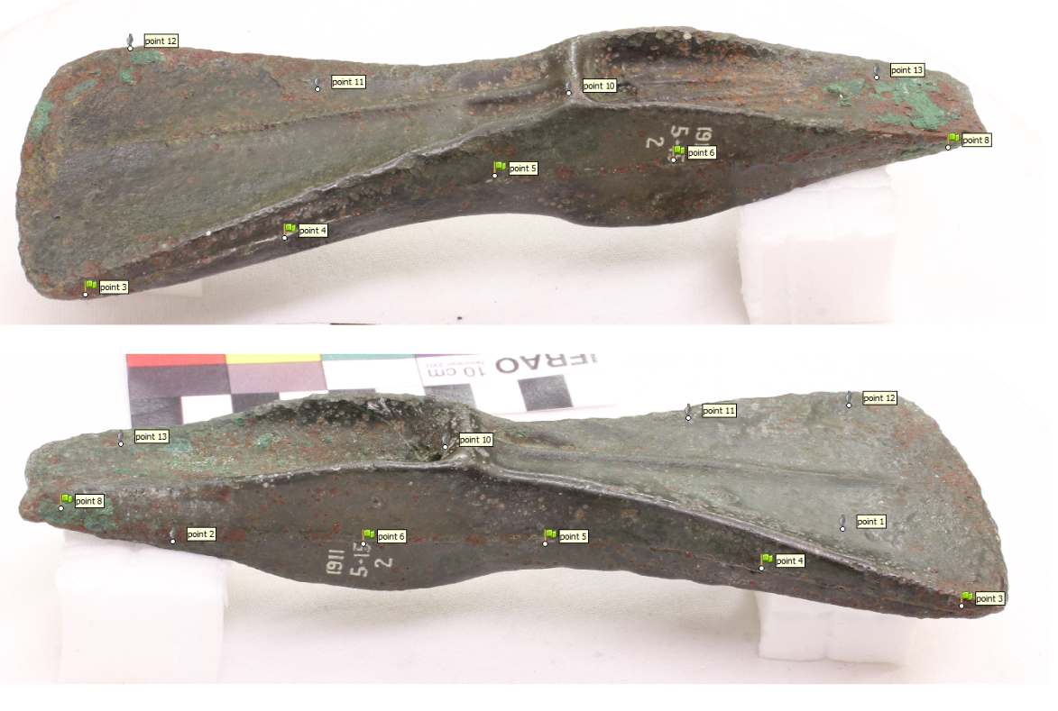
Shared markers (green) between two sides of the object are easier to identify if the surface is well exposed.

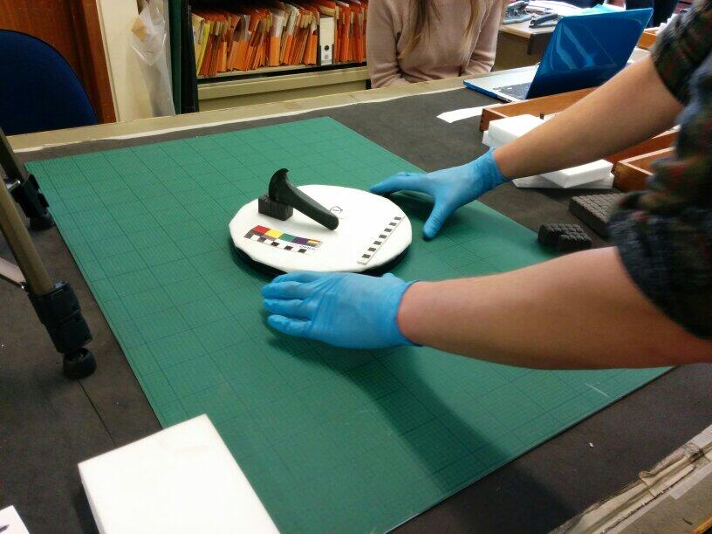

Placing the object on a turn-table with scale bars and a colour-scale next to it.
The turntable is not crucial, but a scale is important, so the 3D model can be correctly sized.

Lighting and Focus
Diffused light which does not produce harsh shadows and lights the object evenly is ideal. This effect can be achieved with natural light on an overcast day or in a well-lit room. An alternative model is to place the object in a light-box if you have such equipment, but it is worth stressing that whilst such a set-up may achieve optimal results, it is certainly not necessary. Try not to use the flash on your camera (unless you have a diffuser) as this is likely to create shadows on the object.

Auto focus is fine but try to place the object in the middle of the frame to ensure that the camera focuses in the same place each time a photograph is taken.

2. Advanced Methods
While the basic methodology outlined above will produce a perfectly acceptable model, better and more consistent results can be achieved if you follow the points below.

Camera and Camera Settings
To achieve optimal results and be able to control all variables affecting the model’s quality, a digital SLR camera is the best choice. DSLR cameras allow you to find the balance between depth of field and amount of light in the picture, which ultimately produces higher quality models.

Use the Manual setting on your camera if it has it. If it does not, then you will have to trust the camera to make the right decision regarding depth of field and exposure. Fortunately most modern camera are smart enough to produce good photographs, providing that the object is well lit. If you have access to a tripod and a shutter release we would recommend using those as it will allow you to set low shutter speeds and small aperture (high F-number) without blurring the picture.
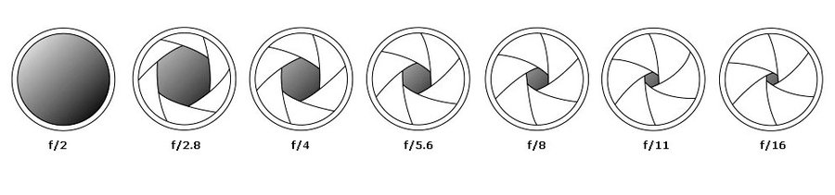
For the best results when using manual settings, you have to find a balance between the aperture (F-number) and shutter speed. The F-number determines how much light enters the camera. The higher the number the less light goes through the lens, however it also produces an image which is sharp throughout. A small F-number will result in large parts of the image being out of focus. We would recommend a setting of F8 or more.

Once you have set the F-number you will have to adjust the shutter speed to ensure that the image is light enough. A high F value has to be counteracted with a slower shutter speed, for example 1/50 of a second. If you do not want to decrease the shutter speed too much, consider increasing the ISO number which improves your camera’s light sensitivity but might marginally decrease your image’s quality.

To find optimal camera settings for your object, it is worth experimenting with different set-ups. Begin by setting your F-number to at least F8 and decreasing your shutter speed to 1/125 sec. Initially keep the ISO as low as possible. Next take a series of shots, changing the shutter speed in each photograph and keeping F constant until the image is well exposed. If you cannot achieve that, increase the ISO number and repeat the process until you have found the perfect settings. Remember that low shutter speed might require the camera to be set on a tripod as otherwise the images will be blurry.

Zoom and Focus
If you can, avoid zooming in and out from the object because this modifies the lens distortion involved and adds a further level of complexity for the 3D model camera reconstruction step. If you need to zoom in or out, it is perhaps better to do this by physically moving the camera closer or further away. Also, try to avoid wide angle lenses as these will also distort the image.

As stated previously auto-focus is perfectly acceptable for SfM data capture. However more advanced users are advised to manually select the focus point (ideally central) as the camera might not make the best selection on its own, leading to a shift in the images' sharpness between each shot.

Additional points

You need to achieve something called ‘parallax’ and the key to this is motion, as the term ‘structure-from-motion’ implies. If you are using a tripod and a turn-table, you can rotate the object instead of moving the camera. Otherwise you need to move around the object and take multiple photos at different ranges and angles to the object. Take shots every 10-20 degrees and be systematic about this. Certain objects can be captured in one go without flipping them over or looking at their interior. Most however require distinct phases of acquisition which are then brought together during modeling. A good example, would be photographing a pottery jar, where you might capture the outside in one go, then flip it over to capture the jar base, and then conceivably go on to deal with the interior (although interiors are notoriously difficult for any modeling approach be it photograph-based or with a laser scanner).

Very good photographers also sometimes try to white-balance or colour-balance sets of photographs to ensure that the same colours are faithfully and consistently rendered in all photographs. and there are various ways to do this. Once simple approach is to put a standardised colour scale in the view (as above) to ensure that the photograph colours could (if desired) be standardised via image manipulation software such as Photoshop or GIMP.

SfM methods struggle with objects with a very regular, repeated pattern (e.g. basketry). If that is the case, consider putting a few other objects in the scene (that are different from one another, and smaller than the object you are interested in) as a way of anchoring the camera and aiding the reconstruction process. Of course, you will need to not mask these objects out during any-photo-masking step. Objects with translucent surfaces can also be difficult, as reflections can be mistaken for meaningful features at the point of camera reconstruction. Likewise, objects with shiny surfaces can be problematic. If you are photographing museum objects, you are unlikely to want or be able to try solutions such as dusting the object with talcum powder to make it less shiny, so the best solution in those cases is probably to try to set up as diffuse and uniform a set of light sources as possible.

