# Pymaceuticals Test Data Analysis

Three significant observations have been made of the SCC Test Data provided.

Observation 1:

The data set included 13 rows of test data which appeared to be two different drug tests made on the same test host (mouse ID g989).

This was considered a problem because there is insufficient information to determine which results apply to which drug. As such, all 13 test results for g989 were removed prior to deeper analysis of the results.

Pymaceuticals Inc - Squamous Cell Carcinoma (SCC) Study Drug Trials

___________________________________________________________________

Drug Name Hosts Tested

_________ ____________

Ketapril 25

Naftisol 25

Ramicane 25

Propriva 25

Stelasyn 25

Ceftamin 25

Infubinol 25

Placebo 25

Zoniferol 25

Capomulin 25

Name: Drug, dtype: int64

______________________

Trial Drug Count: 10

Total Hosts Tested: 250

Trial Start Conditions

______________________

Initial Tumor Volume (mm3) @ Time Point Zero: 45.00

Time Point Test Interval (days): 5

Trial End Conditions

____________________

Time Point Tests Per Drug Trial (Max Intervals): 10

Trial Duration (Max Days): 45

Minimum Final Tumor Volume (mm3): 22.05

Mean Final Tumor Volume (mm3): 50.46

Maximum Final Tumor Volume (mm3): 78.57

Timepoint Tumor Volume (mm3) Metastatic Sites

count 1906.000000 1906.000000 1906.000000

mean 19.538300 50.468120 1.018363

std 14.064786 8.869571 1.135991

min 0.000000 22.050126 0.000000

25% 5.000000 45.000000 0.000000

50% 20.000000 48.991921 1.000000

75% 30.000000 56.288484 2.000000

max 45.000000 78.567014 4.000000

Mouse ID Drug

count 250 250

unique 249 10

top g989 Ketapril

freq 2 25

Hosts Exceeding Maximum Number of 10 Interval Tests:

HostID #Tests

______ ______

g989 13

Name: Mouse ID, dtype: int64

Rejected 13 Test Rows of 1893 Total Test Rows

Drug Trial Results

__________________

First 18 Test Rows of 1880 Total Test Rows

Out[2]:

|  | **Mouse ID** | **Drug** | **Timepoint** | **Tumor Volume (mm3)** | **Metastatic Sites** |
| --- | --- | --- | --- | --- | --- |
| **0** | f234 | Stelasyn | 0 | 45.000000 | 0 |
| **1** | f234 | Stelasyn | 5 | 47.313491 | 0 |
| **2** | f234 | Stelasyn | 10 | 47.904324 | 0 |
| **3** | f234 | Stelasyn | 15 | 48.735197 | 1 |
| **4** | f234 | Stelasyn | 20 | 51.112713 | 2 |
| **5** | f234 | Stelasyn | 25 | 52.178602 | 2 |
| **6** | f234 | Stelasyn | 30 | 56.873817 | 2 |
| **7** | f234 | Stelasyn | 35 | 57.748758 | 2 |
| **8** | x402 | Stelasyn | 0 | 45.000000 | 0 |
| **9** | x402 | Stelasyn | 5 | 46.327570 | 1 |
| **10** | x402 | Stelasyn | 10 | 46.886962 | 1 |
| **11** | x402 | Stelasyn | 15 | 49.119948 | 1 |
| **12** | x402 | Stelasyn | 20 | 50.414750 | 2 |
| **13** | x402 | Stelasyn | 25 | 52.431737 | 2 |
| **14** | x402 | Stelasyn | 30 | 54.351585 | 3 |
| **15** | x402 | Stelasyn | 35 | 55.240962 | 3 |
| **16** | x402 | Stelasyn | 40 | 56.691723 | 3 |
| **17** | x402 | Stelasyn | 45 | 61.619606 | 3 |

Observation 2:

The results data indicated that two drugs (Capomulin and Ramicane) exhibited significantly lower average tumor volumes compared with the Placebo and all other drugs tested on hosts.

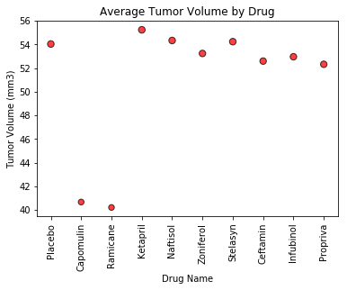

This is particularly evident in the Interval Test data displayed below, which exhibits significantly reduced tumor volumes across almost all interval tests.

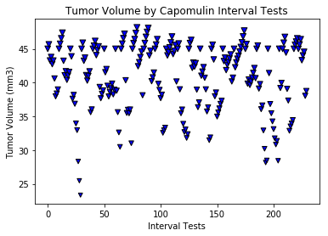

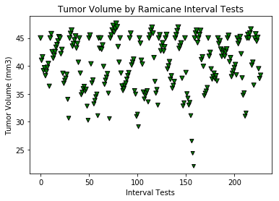

Whereas the Placebo Interval Tests indicate significant increase in tumor volume for all interval tests.

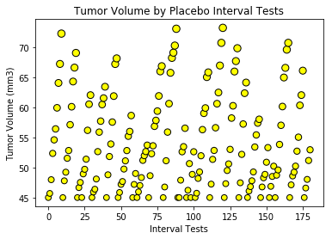

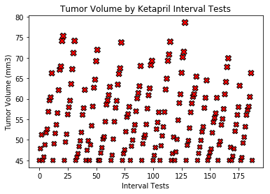

Observation 3:

Additional analysis supports the success rate of Capomulin and Ramicane with respect to significantly less Average and Maximum Metastatic spreads, at least 80% survivability rates, and almost 50% reduction in tumor volume. Compared with some drugs like Infubinol and Propriva which appear to have exacerbated Squamous Cell Carcinoma growth and lethality which in some cases exceeded the Placebo.



