**WeatherPy Analysis**

KEY OBSERVATIONS

1. Higher temperatures are between the tropical latitudes of -23.5 (Capricorn) to 23.5 (Cancer).

Much lower temperatures in the higher latitudes compared with the lower latitudes - there happens to be more cities in the most northern latitudes compared with the southern latitudes (based on land mass)

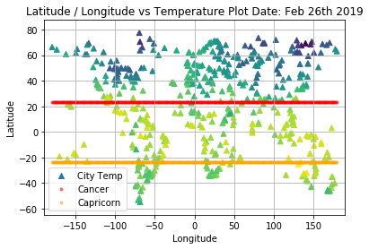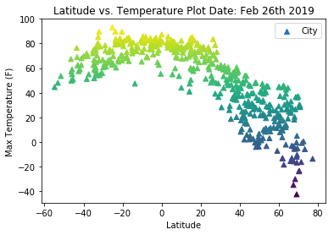

1. Higher humidity levels concentrated between the tropical latitudes - less air movement and more evaporation contribute to increased humidity

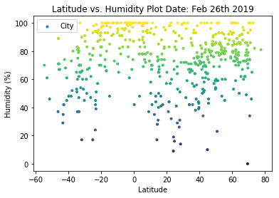

Clouds typically form over large water bodies and are subject to wind movements / air pressure changes – cloud movements are sporadic and more prevalent over oceans, less likely to concentrate over cities or specific latitudes

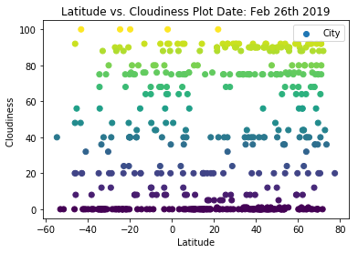

1. Wind speeds are currently below 10 m/s between the tropical latitudes - winds also create wind chill in colder regions

More extreme winds in the extreme latitudes - high winds create wind chill in colder regions, and also move cold air to other latitudes

