<https://www.freightwaves.com/news/federal-regulation/government-shutdown-impacts-airline-industry>

# [Government shutdown impacts U.S. airline industry](https://www.freightwaves.com/news/federal-regulation/government-shutdown-impacts-airline-industry)

[January 14, 2019](https://www.freightwaves.com/news/federal-regulation/government-shutdown-impacts-airline-industry) [Henry Carmichael](https://www.freightwaves.com/news?author=5c3f8e23b8a045ac2accc82a)

Because of the now record-breaking partial government shutdown, the U.S. aviation industry is beginning to feel the consequences of lapsed federal funding.

A coalition of 34 aviation industry groups ranging from the [Air Line Pilots Association](http://www.alpa.org/) to the U.S. Travel Association sent a letter to President Trump and congressional leaders, urging an end to the longest government shutdown.

In part, the letter states, "This partial shutdown has already inflicted real damage to our nation’s aviation system and the impacts will only worsen over time. We urge you to act quickly to resolve these issues.'' The letter highlights 11 major areas of concern affecting travel.

The [Airports Council International](https://aci.aero/) (ACI) was one of the 34 groups signing the letter. ACI had previously reached out to the President regarding the shutdown.

“Federal staffing and other resource shortfalls brought on by this shutdown threaten existing and new air service to communities across the country, harming air travelers, businesses, and regional economies all over America,” ACI’s earlier letter said. “A true national crisis would develop if we cripple the U.S. aviation system in this manner.”

Two unions for flight attendants, the [Association of Flight Attendants-CW](https://www.afacwa.org/), AFL-CIO and the [Association of Professional Flight Attendants](https://www.apfa.org/), echoed the concerns in their own appeal to the government. It said its members and the traveling public are "less safe and secure'' due to the impact of the shutdown.

The greatest impact that the [Federal Aviation Administration](https://www.faa.gov/) (FAA) is facing from the shutdown comes from a slowdown in hiring new workers. While the 25,000 air traffic controllers are exempt from furloughs, training for new controllers has been suspended, which may  lead to a shortage of controllers. Additionally, new pilot training certifications have stopped at a time when commercial airline pilots are in short supply.

At the same time, airports have seen longer lines stemming from [Transportation Safety Administration](https://www.tsa.gov/) (TSA) workers calling in “sick” due to not being paid. The situation is powerful enough to impact the overall functionality of major U.S. airports. For example, [Miami International’s](http://www.miami-airport.com/) (MIA) spokesman Greg Chin announced that one of its terminals would be partially closed over the weekend.

“Due to an increased number of TSA screeners not reporting to work, we decided to take this precautionary step and relocate about 12 flights to adjoining concourses in the afternoons,” said Chin, responding to concerns that not enough screeners would be available to manage MIA’s 11 checkpoints.

U.S. air carriers are also facing the impact of 4,000 FAA inspectors being furloughed by the shutdown. Southwest Airlines [(LUV: NYSE)](https://www.barchart.com/stocks/quotes/LUV) planned to begin flights from four California cities to four cities in Hawaii in the spring, a first for the airline. However, Southwest’s Boeing [(BA: NYSE)](https://www.barchart.com/stocks/quotes/BA) 737 aircraft require Extended-range Twin-engine Operational Performance Standards (ETOPS), a rule which permits twin-engine aircraft to fly routes on only one engine for a period of time from the nearest airport suitable for emergency landing (or in this case, over expansive bodies of water). CEO Gary Kelly sent a letter to employees saying the shutdown will likely delay plans for the company to begin flights.

Meanwhile, Delta Air Lines [(DAL: NYSE)](https://www.barchart.com/stocks/quotes/DAL) is planning to commence operations with its newest aircraft on January 31. The Canadian-designed A220 (formerly Bombardier [(BBD-TSX)](https://www.barchart.com/stocks/quotes/BBD-B.TO) C-Series) is being marketed to U.S. airlines by aviation giant Airbus with Delta as its launch customer. The C-Series is an advanced small, long-range jet designed to capture the market for flying to small airports across the U.S. Unfortunately for Delta, it cannot put these planes into commercial operation without the approval of furloughed FAA inspectors.

A proposed solution to aviation industry uncertainty that has been brought forward previously (and given new life by the shutdown) is to privatize the FAA. Lawmakers have suggested moving air traffic controllers out of federal authority to a non-for-profit entity that would be overseen by industry members. This would theoretically insulate the FAA from government inefficiencies and allow the agency to change with the economy.

“Many other industrialized countries have separated their air traffic control functions from government,” a White House’s budget fact sheet reported. “There, air traffic service providers work with private capital markets to modernize technology and facilities in a more iterative way that focuses on driving stakeholder benefits. It is time for the United States to follow suit.”

If the government shutdown persists, a true point of pressure for the FAA could come on February 3, when an influx of corporate jets and private planes descend on Atlanta for Super Bowl LIII.

<https://www.vox.com/the-goods/2019/1/16/18183634/tsa-government-shutdown-travel-flying>

# A guide to air travel during the government shutdown

## **How flights and security lines are being affected.**

By [Aditi Shrikant](https://www.vox.com/authors/aditi-shrikant)[aditi@vox.com](mailto:aditi@vox.com)  Updated Jan 17, 2019, 10:55am EST

[SHARE](https://www.vox.com/the-goods/2019/1/16/18183634/tsa-government-shutdown-travel-flying)

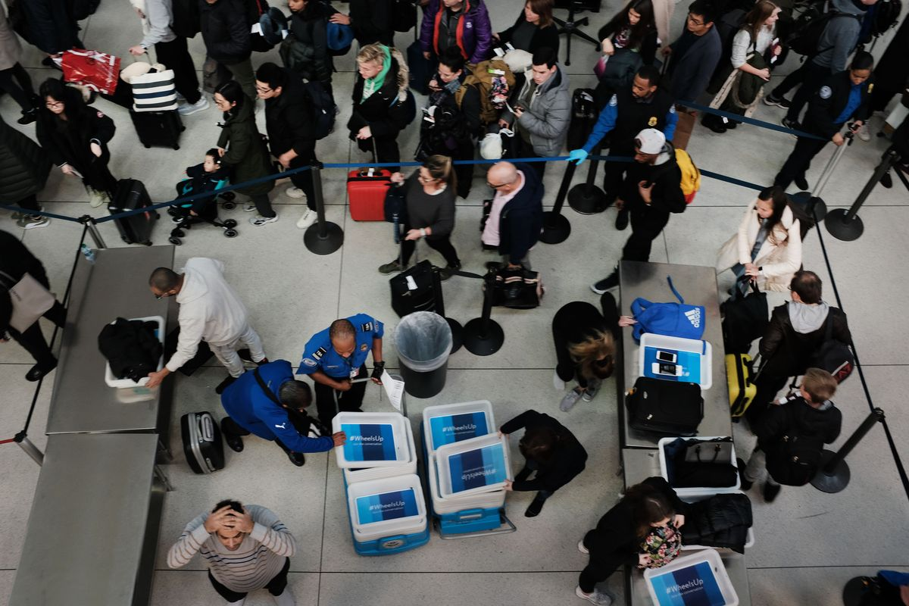Spencer Platt/Getty Images

As the longest [**government shutdown in US history continues**](https://www.vox.com/2019/1/3/18165728/new-congress-2019-democrats-government-shutdown), Americans are restructuring their travel plans. National parks are either [**closed, trashed, or both**](https://www.vox.com/the-goods/2019/1/10/18177478/joshua-tree-national-park-government-shutdown), museum doors [**remain shut**](https://www.vox.com/the-goods/2019/1/9/18175918/government-shutdown-grand-canyon-vacation-travel), and some people have even had to reschedule their [**weddings**](https://www.vox.com/the-goods/2019/1/15/18178995/government-shutdown-weddings-events).

But the place where perhaps the greatest number of people are feeling the effects of the partial shutdown is at the airport, [**which is stressful**](https://www.vox.com/the-goods/2018/11/2/18055830/air-rage-ryanair-flying-airlines) even when functioning at full capacity.

Transportation Security Administration agents are deemed “essential” employees and therefore must report to work even when they aren’t guaranteed a paycheck, and since they haven’t been getting paid, many are [**calling out sick**](https://www.vox.com/the-goods/2019/1/7/18172253/government-shutdown-build-the-wall-airport-security). [**According to TSA**](https://www.tsa.gov/news/releases/2019/01/15/tsa-statement-checkpoint-operations-january-15), unscheduled absences of TSA agents reached 6.8 percent on January 14 and 6.1 percent on the 15th, significantly higher than what they were on these same days last year. The lack of staffing has led to both security and convenience concerns for flyers. Here are answers to a few questions you might have if you plan to take a trip sometime soon.

### How is the shutdown affecting agents?

TSA agents make up 51,000 of the 420,000 federal employees who are deemed “essential,” and while they will be paid for their work eventually, they have no clue when exactly that day will come.

[**According to WNYC**](http://gothamist.com/2019/01/04/tsa_shutdown_trump_wall.php?sf97276243=1), the TSA is one of the lowest-paying federal agencies; the typical starting salary of an agent is $17,000 ([**other estimates say**](https://www.federallawenforcement.org/tsa/) it’s closer to $25,000). Many agents may not be able to afford child care, or they may be finding cash-paying jobs while the government is shut down, as the last regular paycheck was not sent.

And with President Trump declaring that the shutdown could last for [**“months” or even “years,”**](https://www.vox.com/policy-and-politics/2019/1/4/18168893/government-shutdown-how-long-trump) it’s easy to see why many are calling out or looking for other options. [**On January 11, the TSA**](https://www.cnn.com/2019/01/12/us/tsa-employees-government-shutdown-pay/index.html) announced that it would provide a day’s worth of pay to those who were on duty the day the shutdown was announced, plus a $500 bonus for working over the holiday season. As of the evening of January 16, however, [**no employees have received the bonus**](https://www.buzzfeednews.com/article/nidhiprakash/tsa-workers-bonus-pay-government-shutdown) and some haven’t gotten their full day’s worth of pay. If this money ever arrives, it may help with the collective [**$438 million worth of mortgage and rent payments**](https://www.marketwatch.com/story/unpaid-federal-workers-owe-more-than-400-million-in-mortgage-and-rent-payments-this-month-2019-01-08) unpaid federal employees owe this month, but it still isn’t much.

So hard going through the airport today. I looked into the eyes of our workers who deserve better. A TSA officer said: "Don't stop fighting. Keep it up." I broke down & felt the weight of the responsibility on me. I will never become numb to the human impact. We must end this.

### Is airport security worse?

Although TSA spokesperson Michael Bilello [**tweeted**](https://twitter.com/TSA_Bilello/status/1084825476219187200), “security standards remain uncompromised at our nation’s airports,” some alarming information has suggested otherwise.

On January 2, 11 days into the shutdown, a Delta Airlines passenger took a loaded gun through security at the Hartsfield-Jackson Atlanta International Airport and onto a Tokyo-bound flight. The passenger,[**who claimed they simply forgot the firearm was in their bag**](https://www.cnn.com/2019/01/13/us/tsa-gun-flight/index.html), discovered the gun and alerted the authorities, who met them in Japan when the plane landed.

About 5 percent of TSA employees nationwide did not report to work on the day of the incident, but Bilello says the breach of security had nothing to do with low staffing or the shutdown; it happened, he said, because “standard procedures were not followed.” [**According to TSA**](https://www.tsa.gov/blog/2018/01/29/tsa-year-review-record-amount-firearms-discovered-2017), in 2017, 3,957 firearms were recovered in carry-on bags at American airports and 84 percent of them were loaded.

Although this specific case is both extreme and murky, president of the national TSA employee union Hydrick Thomas told [**CNN**](https://www.cnn.com/2019/01/04/politics/shutdown-tsa-screening/index.html) that the number of TSA callouts “will definitely affect the flying public who we [are] sworn to protect.”

On January 14, one out of every 13 airport screeners (employees who screen passengers and luggage at security checkpoints)nationwide didn’t come into work. [**According to CNN’s sources**](https://www.cnn.com/2019/01/04/politics/shutdown-tsa-screening/index.html), the screeners will likely do fewer random pat-downs, bag inspections, and other screenings. That could create a potential security vulnerability — an ironic, if potentially dangerous, situation given that the root cause of the shutdown is a fight over people coming into the country.

### Are airport lines longer?

Short answer: maybe. Although it depends on the airport, many major hubs have reported longer lines. “While national average wait times are within normal TSA times of 30 minutes for standard lanes ... some airports experienced longer than usual wait times,” [**TSA said in a statement**](https://www.tsa.gov/news/releases/2019/01/15/tsa-statement-checkpoint-operations-january-15).

At Hartsfield-Jackson Atlanta on January 15, travelers waited more than an hour in security lines. And at Dallas Love Field Airport, travelers waited 44 minutes.

[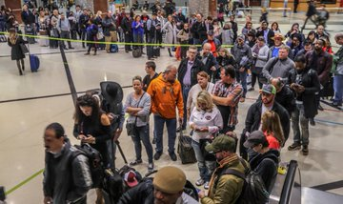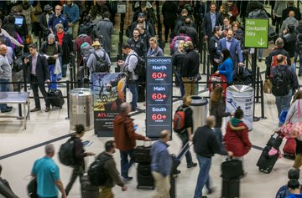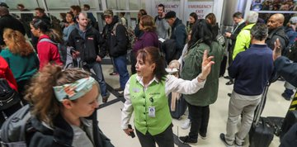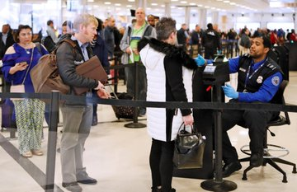](https://twitter.com/ajc/status/1085586238151843840/photo/1)

Some airports have closed terminals due to lack of staffing and are filtering more travelers through fewer checkpoints. The [**George Bush Intercontinental Airport in Houston**](https://www.chron.com/business/bizfeed/article/TSA-closes-security-checkpoint-at-IAH-Terminal-B-13530619.php) closed a checkpoint in Terminal B due to low staffing, funneling those passengers to terminals C and E. Over the weekend, [**Miami International Airport**](https://www.foxnews.com/travel/miami-airport-closes-terminal-government-bites) closed checkpoints in Terminal G and diverted passengers to other terminals, also citing low staffing.

Last week at New York’s LaGuardia Airport, employees and flyers were confronted with “endless lines,” [**ABC News**](https://abcnews.go.com/US/massive-lines-york-city-airport-amid-worries-government/story?id=60195032) reported. At Terminal C, which houses Delta, passengers waited [**90 minutes**](https://www.forbes.com/sites/grantmartin/2019/01/07/airport-security-lines-grow-across-the-nation-as-tsa-sickout-continues/#4eb6144e65ba) in security lines. A similar situation arose at the [**Seattle-Tacoma International Airport**](https://www.kiro7.com/news/local/passengers-at-seatac-miss-flights-as-tsa-agents-call-out-sick-amid-government-shutdown/900020161), which was already dealing with a TSA agent shortage.

[Twitter Ads info and privacy](https://support.twitter.com/articles/20175256)

### Are flights getting delayed or canceled?

Not yet. Flight delays may be caused by winter storms across the Midwest, but so far, the government shutdown has not led to widespread delays or cancellations. [**Southwest Airlines**](https://www.usatoday.com/story/travel/flights/2019/01/14/southwest-airlines-hawaii-flights-government-shutdown/2571146002/)was supposed to start flying to Hawaii early this year, but the shutdown has kept the company from pursuing that route.

There is, however, potential for future delays because of [**air traffic controllers**](https://qz.com/1522138/us-government-shutdowns-effect-on-air-travel/). Air traffic controllers are also essential employees, and therefore have also been working without paychecks. If they start calling in sick, the government may have to limit the amount of air traffic, but it hasn’t come to that yet

<https://www.ajc.com/news/world/will-airports-affected-possible-partial-government-shutdown/wQRRXS5s5By3daQFnz12bN/>

# Will airports be affected by possible partial government shutdown?

**Dec 21, 2018**

**By**

* [**Najja Parker**](https://www.ajc.com/online/contacts/najja-parker/I2xMe8RgXXyfpu3aKXQNON/)**, The Atlanta Journal-Constitution**

As the deadline to approve funding for several government agencies nears, so does the possibility of a partial shutdown.

**»**[**RELATED: Here’s what could happen during a partial government shutdown**](https://www.ajc.com/news/world/here-what-could-happen-during-partial-government-shutdown/KRrbOJA7Qo3PZA3k2gC7gK/)

If Congress doesn’t pass a funding bill, which must be signed by the president, a partial shutdown could occur, which could cause many federal agencies to be disrupted.

Wondering about air travel? Here’s what you should know.

Air travel services should continue to operate without interruptions as well as customs and border agents. Amtrak, a government-owned corporation, would also function as usual.

» [**RELATED: How metro Atlanta parks could be disrupted by government shutdown**](https://www.ajc.com/news/local/how-metro-atlanta-parks-could-disrupted-government-shutdown/giMcPhPmxld2dAcDCqH9jK/)

That’s because employees under the Federal Aviation Administration and Transportation Service Administration are considered essential. They are necessary to protect life and property, such as processing passengers, [USA Today reported](https://www.usatoday.com/story/travel/2018/01/20/airlines-keep-flying-during-government-shutdown-because-controllers-checkpoint-officers-essential/1050912001/).

These employees may not be paid on time though.

More than 50,000 TSA agents and more than 50,000 customs and border protection agents would be working without pay, [according to a fact sheet released by the Democratic staff of the Senate Appropriations Committee](https://www.appropriations.senate.gov/news/minority/projected-impacts-of-a-trump-shutdown). These essential employees are typically paid retroactively whenever Congress approves a funding bill.

If you’re curious about the federal departments and services that would be impacted, take a look [here](https://www.ajc.com/news/world/here-what-could-happen-during-partial-government-shutdown/KRrbOJA7Qo3PZA3k2gC7gK/).

<https://nbaa.org/aircraft-operations/the-government-shutdown-and-business-aviation/impact-of-the-government-shutdown-on-general-aviation/>

# Impact of the Government Shutdown on General Aviation

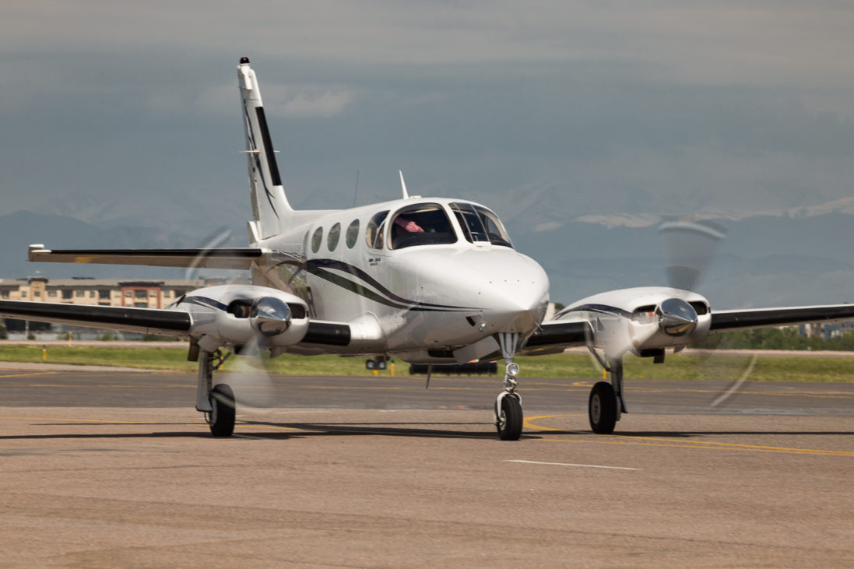

**[](http://twitter.com/share?url=https://nbaa.org/aircraft-operations/the-government-shutdown-and-business-aviation/impact-of-the-government-shutdown-on-general-aviation/&text=Impact%20of%20the%20Government%20Shutdown%20on%20General%20Aviation%20)[](http://www.facebook.com/sharer.php?u=https://nbaa.org/aircraft-operations/the-government-shutdown-and-business-aviation/impact-of-the-government-shutdown-on-general-aviation/)[](http://www.linkedin.com/shareArticle?mini=true&url=https://nbaa.org/aircraft-operations/the-government-shutdown-and-business-aviation/impact-of-the-government-shutdown-on-general-aviation/)[](mailto:?subject=Impact%20of%20the%20Government%20Shutdown%20on%20General%20Aviation&body=%20https://nbaa.org/aircraft-operations/the-government-shutdown-and-business-aviation/impact-of-the-government-shutdown-on-general-aviation/)[](https://nbaa.org/aircraft-operations/the-government-shutdown-and-business-aviation/impact-of-the-government-shutdown-on-general-aviation/)**

Updated January 25, 2019

On Jan. 25, President Trump signed legislation to re-open those portions of the government impacted by the shutdown until Feb. 15. During this period House and Senate negotiators will work towards an agreement on border security and funding for the Department of Homeland Security.

The following is a summary of key impacts that general aviation faced during the shutdown which began on Dec. 21, 2018.

[Review the Department of Transportation Shutdown Plan](https://nbaa.org/wp-content/uploads/aircraft-operations/dot-shutdown-plan-011119.pdf) (Updated Jan. 11)

### **Federal Aviation Administration (FAA)**

While critical FAA functions including air traffic control services, safety oversight and the FAA Registry are continuing to function, numerous activities at FAA are suspended.

#### **FAA Registry**

With passage of the FAA Reauthorization Act of 2018, the FAA Registry in Oklahoma City has been deemed essential and will **remain open during a government shutdown**. During a shutdown, the registry should be able to continue operating as normal. This means that most aircraft registrations, renewals and other critical registry functions will operate as normal.

However, the FAA Aeronautical Central Counsel office, which is involved in certain registry functions is subject to the government shutdown and not operating. This means that the office cannot give legal opinions on registrations involving non-citizen trusts or owner trusts. Also, FAA legal opinions on certain LLCs, corporations and other complex ownership structures are not available during the shutdown.

#### **Additional FAA Functions Impacted by Shutdown**

On Jan. 15, the FAA announced that a number of aviation safety inspectors will be returning to work to perform safety-critical functions. Initial reports indicate no new certification work will occur, and recalled employees will focus primarily on safety surveillance. This means that tasks such as adding new aircraft to OpSpecs or issuing new pilot certificate ratings will likely not occur even with the recalled inspectors back at work.

Revisions to existing manuals, training programs and other requests submitted before the shutdown may be reviewed as time permits.

While numerous FAA functions have ceased during the shutdown, the following suspended activities are likely of most interest to NBAA members.

* Issuance of airmen certificates
* FAA issuance of ferry or special flight permits (Certain DARs might still be able to issue permits)
* FAA knowledge tests (i.e. written exams) can be taken, but results will be delayed until the government reopens
* Renewal of training center evaluator/simulator qualifications
* Adding or modifying aircraft and personnel listed on OpSpecs of a commercial operator
* Other FSDO functions such as seeking new letters of authorization or modifying current authorizations
* Approval of exemptions for unmanned aerial systems operations
* Aviation rulemaking
* Development, operational testing, and evaluation of NextGen technologies
* Most administrative support functions not required for support of life and safety

### **Customs and Border Protection (CBP)**

CBP is affected only with overtime arrivals, much like what happened with sequestration. Operators should communicate directly with their port of entry to clarify any local port impacts on proposed arrival times, especially if the flight proposes to arrive after normal business hours.

NBAA has received reports that shipments of CBP User Fee decals are delayed during the shutdown. CBP has advised that operators who have not yet received a decal can verify their compliance by producing:

* an electronic or printed order history (available to the operator immediately after application is made)
* or an electronic or printed order receipt (available after the order has been processed by DTOPS).

In addition, CBP is not processing new border overflight exemptions, so only operators with unexpired exemptions can overfly their first southern border crossing airport. The personnel that manage GA issues related to the Advance Passenger Information System (APIS) have also been furloughed due to the shutdown.

Finally, the Department of Homeland Security has canceled interviews for travelers trying to enroll in the Global Entry program.

### **Transportation Security Administration (TSA)**

TSA is working normal business hours. This includes administrative functions needed to support TSA waiver applications and approval process that support foreign registered aircraft and the DCA Access Standard Security Program (DASSP). Additionally, the coordination needed with FAA for DCA slots remain operational.

### **Department of Transportation (DOT)**

The DOT will suspend all non-essential legal functions related to acquisitions, aviation licensing, regulatory policies, and FOIA, including:

* Notices of Consistency
* US Air Carrier Frequency Allocations
* US Air Carrier Charter Allocations
* US Carrier International Route Authority
* DOT Part 375 Exemptions
* Foreign Air Carrier Exemptions

<https://www.cnbc.com/2019/01/16/united-ceo-worried-about-shutdown-but-impact-not-yet-significant.html>

# United CEO worried about shutdown but impact not yet 'significant'

* United CEO Oscar Munoz said the impact from the partial government shutdown is not yet "significant."
* Munoz's comments come a day after Delta's CEO said the shutdown is costing the airline $25 million this month.
* The shutdown is delaying the launch of new planes and hurting some airline bookings.

[Leslie Josephs](https://www.cnbc.com/leslie-josephs/) | [@lesliejosephs](https://twitter.com/lesliejosephs)

Published 9:08 AM ET Wed, 16 Jan 2019  Updated 4:16 PM ET Wed, 16 Jan 2019CNBC.com

|  |  |  |  |  |  |  |  |  |  |  |  |  |  |  |  |  |  |  |  |
| --- | --- | --- | --- | --- | --- | --- | --- | --- | --- | --- | --- | --- | --- | --- | --- | --- | --- | --- | --- |
| |  |  |  | | --- | --- | --- | |  |  |  | | |  |  |  | | --- | --- | --- | |  |  |  | | |  |  |  | | --- | --- | --- | |  |  |  | | |  |  |  | | --- | --- | --- | |  |  |  | | |  |  |  | | --- | --- | --- | |  |  |  | |

[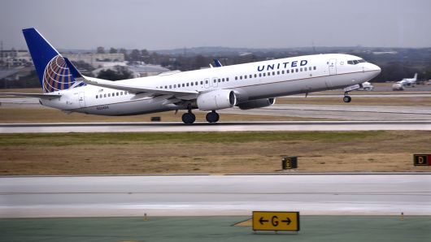](https://www.cnbc.com/2019/01/16/united-ceo-worried-about-shutdown-but-impact-not-yet-significant.html)

Robert Alexander | Archive Photos | Getty Images

A United Airlines Boeing 737 passenger jet takes off at San Antonio International Airport in Texas.

[United Airlines](https://www.cnbc.com/quotes/?symbol=UAL) CEO Oscar Munoz on Wednesday said the airline is getting worried about the partial U.S. government shutdown as it drags on but added that the company isn't yet seeing a "significant" impact on bookings.

Munoz's comments come a day after the CEO of rival [Delta Air Lines](https://www.cnbc.com/quotes/?symbol=DAL), Ed Bastian, said the shutdown that began Dec. 22 will cost the airline $25 million this month.

"There is some impact there," Munoz told CNBC's [Phil LeBeau](https://www.cnbc.com/phil-lebeau/) in an interview Wednesday. "It's not discernible and it's not significant. Clearly the longer this goes, of course there's going to be impact, and we do worry about that."

United, which reported [strong profits and revenue](https://www.cnbc.com/2019/01/15/united-airlines-beats-fourth-quarter-revenue-profit-estimates.html) after the market closed Tuesday, runs a hub out of Washington Dulles International Airport. Munoz said the airline provided a broader revenue growth estimate — between flat to up 3 percent — than usual because executives don't yet know the impact of the shutdown.

On Tuesday, Delta's Bastian [said the airline is losing $25 million in revenue this month alone](https://www.cnbc.com/2019/01/15/delta-ceo-government-shutdown-is-costing-the-airline-25-million-this-month.html) because fewer government employees and contractors are traveling.

[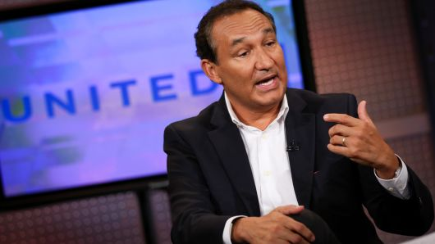](https://www.cnbc.com/2019/01/16/united-ceo-worried-about-shutdown-but-impact-not-yet-significant.html)

Adam Jeffery | CNBC

Oscar Munoz, CEO of United Airlines.

The aviation industry has been among the most vocal in demanding an end to the shutdown, the result of an impasse between [President Donald Trump](https://www.cnbc.com/donald-trump/) and lawmakers over funding for a wall along the southern U.S. border.

[Transportation Security Administration](https://www.cnbc.com/tsa/) officers, air traffic controllers and federal safety inspectors are among the some 420,000 government employees who are deemed essential and have been ordered to work without a regular paycheck. Major airports in Atlanta, Miami, Houston and Washington, D.C., this week said they closed passenger screening lanes or checkpoints as more TSA officers than usual were absent.

Additionally, airlines need federal safety inspectors to debut new aircraft. Delta said it will likely delay its Jan. 31 debut of its brand-new Airbus A220, a plane it's using to [court business travelers with bigger seats and windows](https://www.cnbc.com/2018/10/12/delta-to-debut-once-disputed-jets-in-new-york-this-winter.html). [Southwest Airlines](https://www.cnbc.com/quotes/?symbol=LUV) expects to delay the start of its first [service to Hawaii](https://www.cnbc.com/2018/05/03/hawaiian-airlines-shares-fall-after-southwest-plans-low-fares-between-islands.html) that's still waiting on governmental approval.

[Leslie Josephs](https://www.cnbc.com/leslie-josephs/)

[Leslie Josephs](https://www.cnbc.com/leslie-josephs/)Airline Reporter for CNBC.com

## **RELATED SECURITIES**

| Symbol | Price |  | Change | %Change |
| --- | --- | --- | --- | --- |
| [LUV](https://www.cnbc.com/quotes/?symbol=LUV) | 53.62 |  | -0.69 | -1.27% |
| [DAL](https://www.cnbc.com/quotes/?symbol=DAL) | 51.52 |  | 0.04 | 0.08% |
| [UAL](https://www.cnbc.com/quotes/?symbol=UAL) | 89.43 |  | 0.59 | 0.66 |

<https://www.nytimes.com/2019/01/23/business/airlines-government-shutdown.html>

# *Airlines, Too, Are Hit When Government Workers Are Grounded*

A flight leaving Reagan National Airport in Arlington, Va. The government shutdown is affecting airlines’ bottom lines, with American Airlines losing the most revenue so far.CreditDoug Mills/The New York Times

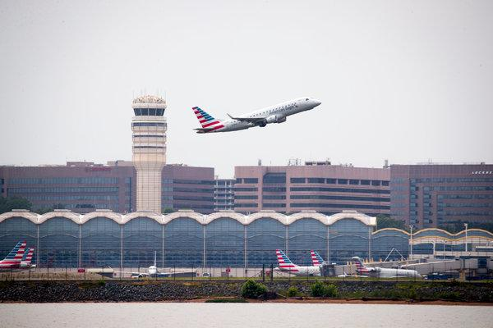

Image

A flight leaving Reagan National Airport in Arlington, Va. The government shutdown is affecting airlines’ bottom lines, with American Airlines losing the most revenue so far.CreditCreditDoug Mills/The New York Times

**By**[**Zach Wichter**](https://www.nytimes.com/by/zach-wichter)

* Jan. 23, 2019

It’s not just airport security lines and [control tower workers](https://www.nytimes.com/2019/01/23/us/shutdown-airports-security.html?module=inline) that are affected by the federal government shutdown. Airlines, too, are being hit.

The industry as a whole lost about $105 million in revenue in the first month of the shutdown, according to data from the consulting firm ICF. That figure represents only the loss of revenue from some government employees not taking work trips.

The shutdown began more than a month ago, on Dec. 22, and legislators have largely remained deadlocked over how to end the impasse. [Dueling bills in the Senate](https://www.nytimes.com/2019/01/22/us/politics/government-shutdown-senate.html?module=inline) and other proposals in the House seem unlikely to restore funding to reopen the government in the immediate future.

“In the context of the airlines’ total revenue, this is a drop in the bucket,” said Samuel Engel, a senior vice president and lead of the aviation practice at ICF. “One major storm can cut airlines’ revenue more than a month’s lost government travel, but a storm doesn’t continue month after month,” he added in an email.

Mr. Engel said that ICF’s data did not include travel by private citizens like government contractors or lobbyists, or leisure travel to Washington.

“What these numbers don’t capture is the degree to which the economy is being affected more broadly by the consequences of the shutdown,” he said.

Airlines for America, an industry trade group, said in a [letter to lawmakers](http://airlines.org/wp-content/uploads/2019/01/Aviation-Shutdown-Impacts-Letter_01.16.19.pdf) this month that the shutdown had more than just economic effects for airlines. It hinders operators from bringing new planes into service and has delayed a variety of safety inspections and certifications for aircraft and airline employees.

“We urge elected leaders to resolve or address these impacts quickly to ensure that travelers can continue flying, cargo can be delivered on time, the American economy can keep growing and our skies remain safe,” Airlines for America said in a statement.

American Airlines, which carries the largest share of government workers and has lost the most revenue, will see a shortfall of 1.2 percent in its total monthly revenue, according to ICF.

## Editors’ Picks

losses could increase by 10 or 20 percent if the shutdown continues beyond this month, because January is generally a slow travel period, according to ICF’s data.

American, United Airlines and Delta Air Lines accounted for nearly 90 percent of the industry’s total losses because most employees on government business fly on one of those three carriers.

Mr. Engel said airlines faced a bigger problem, though, with demand for flights declining over all.

“A relative softening of demand,” he said, goes beyond the effects of the shutdown.