**TeamBAM_ETL_Project**

**ACME Defense Customer Locations**

OBJECTIVE:

The ACME Defense Company needs to create a database of all military sites it will provide services to. In order to do this, they require an API that provides lists of sites by which customer organization it belongs to (command), region in which it is located, and type of RVCT product required to be serviced. In each case, the output will be a list of all the filtered sites, thier specific location in latitude and longitude coordinates, and the quantity of RVCT products by type requiring service.

In order to do its job, ACME needs specific location information for each customer location identified in the following tables (from the PDF file).

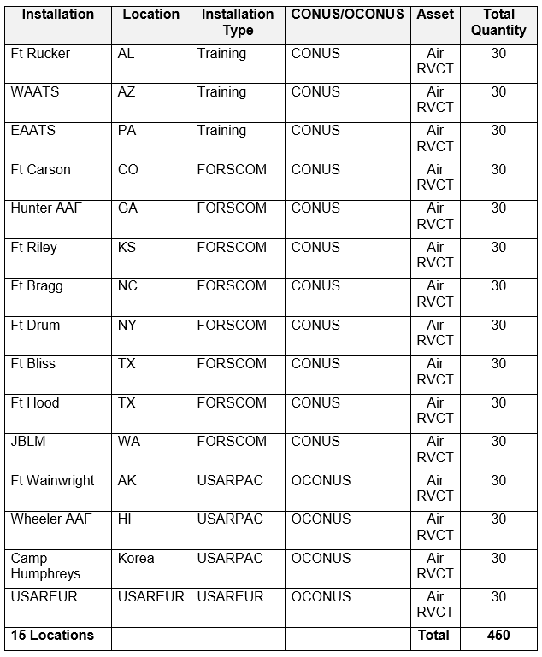

**Table 1: Maximum Active Component Air RVCT and Semi Immersive Persistent Training Capability**

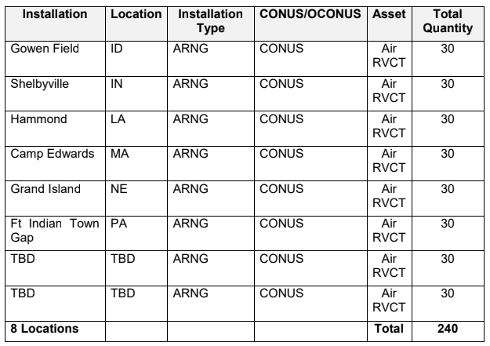

**Table 2: Maximum Air RVCT Guard and Reserve Capability**

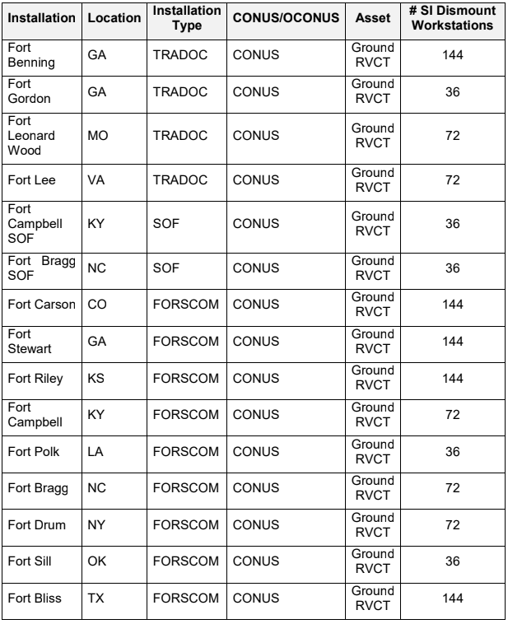

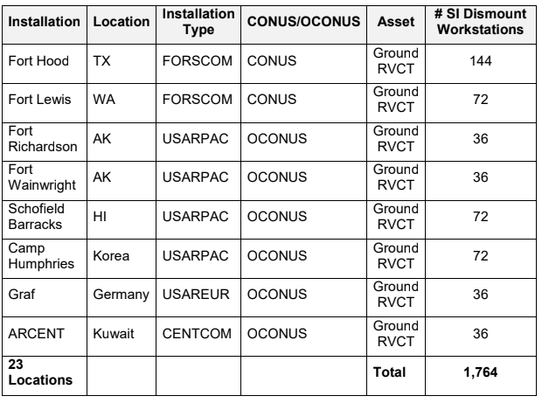

**Table 3: Maximum Active Component Ground RVCT and Semi Immersive Dismounted Soldier Workstation Training Capability**

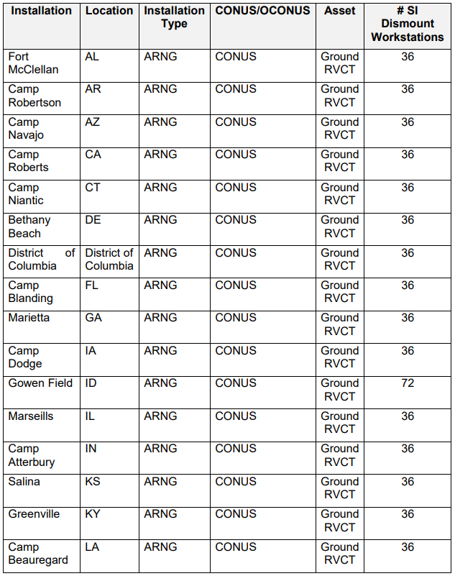

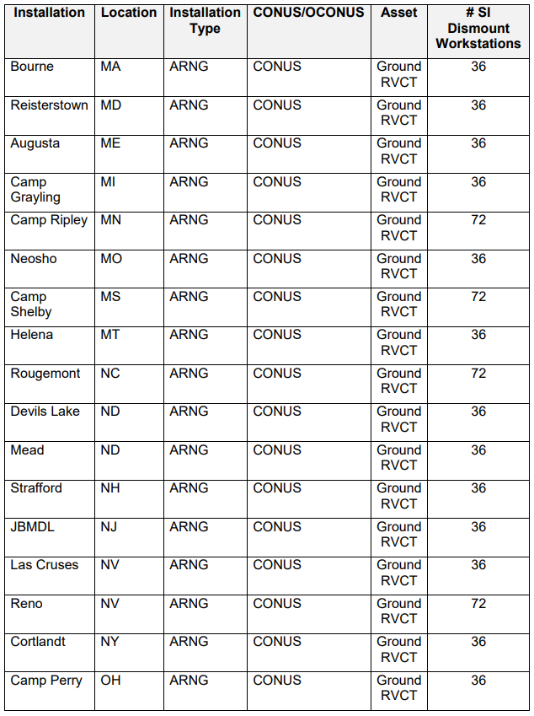

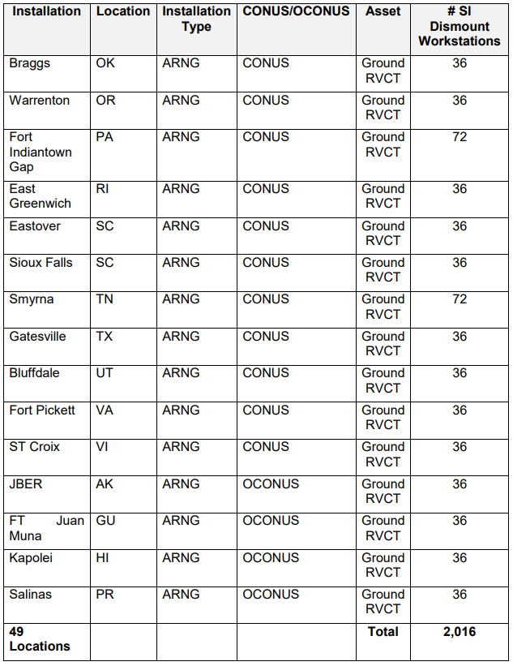

**Table 4: Maximum Ground RVCT and Semi-immersive Dismounted Soldier Army Reserve and Army National Guard Capability**

Unfortunately, the only location data provided by the customer was in the following map. So we will need to scrape the specific location data from the World Wide Web.

**Diagram 1: Military Installations**

APPROACH:

The tables of customer location and product information were dumped from a pdf file to a text file. ACME has taken the first step to convert the data to a CSV file but it has table formatting that needs to be cleaned up.

Team BAM has been contracted to extract the supplied base data, correlate it with location information (lat,long), and load it into an SQL database they can then use to query bases by state and region, and return the location information accordingly.

TEAM TASKS:

1. EXTRACT & TRANSFORM 1: Rob will use Python and Pandas to extract the data from the CSV file and export all entries out to correctly formatted CSV files for each column.
2. EXTRACT & TRANSFORM 2: Rob will import all CSV file data into a dataframe and export all entries out to a formatted CSV.
3. EXTRACT & TRANSFORM 3: Mike will use web scraping (Beautiful Soup) via a Google Search URL for each base location (name/state) into the dataframe, using Base Name and State. He will then convert the dataframe to a dictionary and export as 'Base_Locations.csv'.
4. LOAD 1: Lillian will import the Base_Locations.csv into MySQL and create the SQL queries required to recreate the Base_Locations table.
5. LOAD 2: Lillian will create a query for showing all sites (base name, lat/long, type, quantity) by either state, command, region, or type.
6. LOAD 3: Lillian will recreate the Base_Locations table and populate a SQLite database that Flask can use from the repo directory.
7. REPORT: Rob will create a Flask based website to provide all of the results pulled from the SQLite database file using Lillian’s queries now in Python.
8. REPORT: Team will compile the final report to include the following;

a) Sample data imports

b) Formatting challenges and methods

c) Output data format

d) Jupyter python code

e) Google Search scrape method - search on '{ base_name } {state} lat long' and extract latitude, longitude from tag div class="Z0LcW"

f) MySQl recreate schema SQL - show create table 'base_location'

1. BONUS: Flask based API for search by state, command, region, or type
2. BONUS: Use PyPDF2 to extract table data from the pdf file

REPORTED CHALLENGES:

Rob:

Mike:

Lillian: