|  |  |
| --- | --- |
| **Procedure Title** | *Remotely Accessing Lab Computers from the Web* |
| **Date** | 4/20/2020 |

**Procedure**

1. Go to: <https://719-license.main.ad.rit.edu/> which will bring up our server for student remoting.
2. In the main window click on the **GO** button under “Student Remote Access” which will bring up a list of the lab computers.
3. On the next page if the lab computers are not displayed automatically, click on the green bar near the top of the screen which will display all lab computers.
4. Look through the list for a computer that is not currently in use which can be determined by the “Status” row and under “Address” click **Connect**.
5. A window should appear asking to open a .rdp file with the chosen computer name. Regardless of what browser you are using, when it asks what you want to do with the file, choose open. If it automatically goes to your download folder then simply double-click it to launch.
6. If a warning window appears like the one below you can ignore it and click **Connect**.

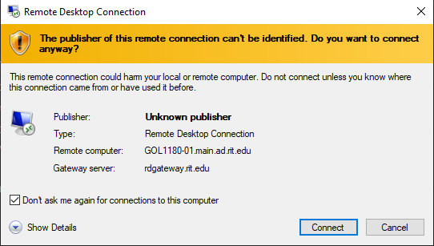

1. You should now be prompted to give your RIT username and password to gain access to the computer. When doing so make sure to include **MAIN\** in your username otherwise it won’t connect.
   1. ex: MAIN\abc1234