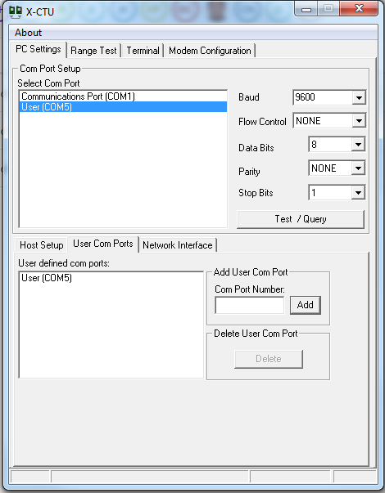

* Launch the software, which configures and tests the XBee’s radio.
* In X-CTU, under the PC Settings tab, select the port you identified in the previous step and set the connection properties to 9,600bps, 8 bit, no parity, 1 stop bit, no flow control (or 96008N1). Click the *Test/Query* button. A pop-up window should tell you that the communication was OK.
* Check Devices and Printers for the virtual com port used and add it in the Com Port Number box.
* Go to Modem Configuration- **Restore**.-Restores modem to factory defaults.
* Go to Modem Configuration- **Read**.-Displays modems settings.
* Enter the Pan-ID 1000, (all other settings ok) and hit **Write**

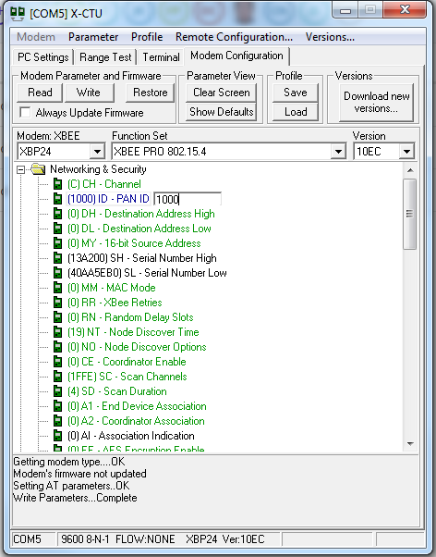

* Unplug the XBee module and repeat the upgrade for your other modules. You can hot-swap if you’re careful: unplug the adapter from the cable first, gently swap modules, and plug in the adapter again. Then run *Test/Query*, *Read*, and *Write* from X-CTU.
* Use the terminal to send numbers 1-9 to select 1 of the 9 different BCC modes.

