To do:
- check form of beta regression equations and rum model – emailed phil about RUM and most of the way there. Beta regression Im doing some reading. I’m 99% sure I’m doing it correctly.
- Work out where/ how to put tables – you might see me refer to tables of e.g. beta regression coefficients. I’ll put these in I’m not trying to work out the best way to get LaTeX to play with word. Worst case I’ll just do them manually in word.
- Finish two appendices – 1 on the training of the monkeys, showing some results over time/ the bid targeting task. 2 on the exclusion criteria for trials. This is very basic, it’s just trials with impossibly small reaction times, too long bidding times (>3 standard deviations from mean), and also removes sessions with less than 60 completed trials.
- Change figures to svg and relabel axes to make bigger – easy stuff to do one weekend
- Stats test between bundle choice estimate and distribution of bdm bids – t test? Have enquired with people who know more about statistics than me
Synopsis:
Chapter that details the behavioural results of the BDM (and binary choice) tasks.
Comes after into (chapter 1) and theoretical treatment of the bdm (chapter 2).
Main goal is to prove that a) monkeys can do the BDM, therefore it’s worth studying the ephys of monkeys doing the bdm and b) explore why and how they make their bids (to a limited extent- I don’t see the thesis as a behavioural thesis though clearly we have some interesting behavioural data!).
I think the text needs a bit of work still but can always be edited later. Stuff like adjustments to make figures clearer etc. are always appreciated but again not a huge concern for me atm. I think the main thing is if there are any analyses/figures/etc. wanted in this chapter that I haven’t added. Actually anylsing and producing and writing up new figures isn’t much work at all but thinking up a new figure is.
Text in bold and red are notes for me to change things.

Chapter 3 – Non-Human Primate Behaviour on the BDM Task
In the second chapter of this thesis, we described a second-price auction task in which participants reveal their utility for any good on a single trial basis. We concluded the chapter discussing the budding neuroscientific literature of human functional imaging studies employing the BDM. Needless to say, it is a far simpler task to train a human (even one laying in an MRI machine) to perform second-price auctions than a model organism. This chapter details the task design, training, and behavioural results of two adult rhesus macaques on a task consisting of repeated BDM auction trials using liquid budgets and rewards.
Materials and Methods
Below we discuss the task design, equipment required, and model non-human primates used to gather data during the project, attempting to provide the reasoning behind any decision. All items discussed can be assumed to be consistent throughout the various experiments in the remainder of this thesis, unless otherwise specified.
Task Design
The epochs of the BDM tasks are displayed in figure 1. Animals sat in front of a task screen (figure 1a) were presented with a cue indicating the beginning of a trial at time 0. After a fixed delay of 1.2 seconds, a large fractal was displayed on the left-hand side of the task screen (figure 1b). This fractal indicated the offered good on any single auction trial, corresponding to a fixed amount of blackcurrant juice reward. The magnitude of juice represented by the fractal was learnt via repeated experience over multiple sessions using the same offered goods. During this period, the monkey was required to be bother touching the joystick and to keep it ‘centered’ i.e. in a vertical upright position. If either of these requirements were violated, the monkey ‘failed’ the trial and received neither juice reward nor ‘budget’ water and incurred a time penalty of the time remaining on the trial plus two extra seconds.
Another 1.2 seconds after the display of the good to be offered in the trial, a large, black and white, hatched bar was presented on the right-hand side of the screen, crossed by an orthogonal, thinner purple bar. The black and white bar represented the bidding range from 0% (minimum bid, bottom of the bar) to 100% (maximum bid, top of the bar) of the budget liquid. This bar can be thought of as analogous to those presented in figure 2 of the previous chapter.
The purple bar crossing the ‘budget bar’ represents the monkey bid and appears at a random location on the vertical axis of the budget bar. Such ‘random starts’ of the bid position were found to give rise to consistent inter-session mean bids in the original training of the monkeys (Al-Mohammad, 2017). During this epoch, the monkey has four seconds within which to place their bid vertically using the up/down axis of the joystick. Bids were considered ‘placed’ when there had been no movement of the bidding indicator (see equation 3.1) within the last second. This placement period of 1 second was shortened for monkey V to 700ms to improve behaviour. Past this point, any movement of the joystick had no effect on the task. To ensure attention to the task and encourage swift decision making, if no movement was detected within the first second of possible bidding, the monkey failed the trial and incurred the same penalty two second + time remaining penalty described above until the trial was repeated with the same offered good.
After the four seconds bidding epoch finishes, a second, green bar appears representing the computer bid, drawn randomly as described in chapter 2 of this thesis. As with any BDM auction tasks, the monkey ‘wins’ the auction if it’s bid is greater than that of the computer and loses if it is not. If the monkey has won the trial, it is also signalled by the segment of the budget bar below the computer’s bid flipping horizontally, to indicate the budget that has been paid by the monkey.
1.5 seconds after the result of the trial is revealed the monkey is rewarded with juice in the case that it has won the trial. A further 1.5 seconds later, whatever remains of the monkey’s water budget is delivered to the monkey. In between trials, a variable 2.5-3.5 second blank inter-trial-interval is interleaved between trials. This summary of a single trial of the BDM task is illustrated in figure 1c.
All the behavioural data shown here are from sessions completed by the two monkeys over July 2019-November 2020. We limit our analysis to behavioural data obtained during the neuronal recording phase of the task during which the magnitudes of juice offered to the monkeys, and the magnitude of the water budget, were held constant.
Equipment
Monkey’s were seated in a (Crist Instruments) inside of a darkened, sound-reducing booth for the duration of the task sessions to reduce distractions. While within the booth, monkeys and their interaction with the task were monitored using two CCTV cameras.
Attached to the front of the chair was a joystick (custom-made, Biotronix workshop, Department of Psychology, University of Cambridge) which the monkey could reach through a window in the front panel of the chair. The joystick permitted movement across two dimensions (left/right, and up/down) which changed the resistance, and therefore voltage, across the joystick circuit. This change is voltage is used for control of stimuli that indicated the monkey’s bid (BDM task) or choice (a binary choice task described later). The joystick was also touch-sensitive to record whether the monkey was holding the joystick at any time, emitting a binary voltage signal. Joystick position and touch data were digitised to the computer via a National Instruments Data Acquisition Card (PCI-6229). Movement of stimuli controlled by the joystick was defined by
Equation 3.1
$$x_{t+Δt} = \left\{\begin{aligned}x_{t}+GV_{t} if {|V}_{t}|>V_{τ} \\ x_{t } if |V_{t}|<V_{τ}\end{aligned}\right.$$

The position of an object controlled by the joystick remains at position ($x_{t}$) if the absolute change in voltage ($V$) produced by deflection of the joystick at time $t$ is less than a voltage threshold ($V_{τ}$). Otherwise, it is updated to the original position plus the change in voltage across the joystick circuit multiplied by a gain constant $G$. The maximum speed of the bidding indicator is capped at 46% of the total bidding range per second for both monkeys. The thresholds and gains for each joystick vary slightly, so is regularly tested on the task by the human experimenters for consistency.
Stimuli were presented to the monkeys on a computer monitor placed 70cm in front of the monkeys at head height. These stimuli were produced and displayed using a custom-built software suite (MATisse; Hickman, 2017), utilising the Psychophysics Toolbox (Kleiner et al., 2007) for MATLAB (MATLAB, 2017). Computers were run using the Windows 10 operating system. Juice and water delivery to the animals was mediated via gravity and the opening of solenoid valves (SCB262C068; ASCO).
Data Analysis
All analysis presented here was done in R 4.0.2 (‘Taking Off Again’; R Core Team, 2020) on a 64 bit windows machine. Notebooks for analysis are published by the author (DoctoRate; Hickman 2020). Graphics were made using the ggplot2 package (Wickham, 2016) and the vast majority of munging was carried out using tidyverse grammar (Wickham et al., 2019).
Wilcoxon and Spearman’s rank tests were carried out using functions from the inbuilt stats package. K-means clustering of joystick movement was also done using a function from this package. Beta regressions were carried out using functions from the betareg package (Cribari-Neto & Zeileis, 2010), after the distribution of monkey’s bids were fitted using the fitdistrplus package (Delignette-Muller & Dutang, 2015) and checked using the gamlss packages (Stasinopoulos & Rigby, 2007). Models were selected primarily based off minimising the Akaike information criteria (Akaike, 1974) using the formula
$$AIC = 2k - 2ln(\hat{L})$$
Where k (the number of parameters) for the beta distribution selected is 2 and $\hat{L}$ represents the maximum value for the model’s likelihood function.
Random utility models were fitted in R using the mlogit package which is described and explained in Train, 2009.
Animals
All experiments and data in this thesis were gathered from two adult rhesus macaques (Maccaca mulatta), referred to as monkey U and monkey V. Both monkeys had been trained on a similar BDM auction task previously (referred to as 'Monkey A' and 'Monkey B' in Al-Mohammad & Schultz, 2019), though due to time between projects, differing needs of the experiments (e.g. head-fixing of monkeys), and subtle changes to the task, both were retrained in the period October 2017-July 2018. Monkeys had both been previously trained on the auction tasks presented here and an equivalent binary-choice ‘bundle choice’ task. For more details of the training see Al-Mohammad & Schultz, 2019 and appendix 3.1.
Both primates were born in captivity at the Medical Research Council’s Centre for Macaques at Porton Down in the United Kingdom (monkey U: 2010-02-10, monkey V: 2011-06-08) and were housed within the departmental facilities. Both were group-housed at various times prior to and during the duration of this project, but due to separate incidents were singularly housed for much of the time this data was recorded. The weights of each monkey recorded weekly for the duration of project is shown in figure 2.
Rhesus macaques are the most widely distributed non-human primate species, being found across most of continental Asia (Singh et al., 2020). They are the most commonly used non-human primate animal model in the neuroscientific literature (Capitanio & Emborg, 2008) due to their dexterity and ability to reproduce complex decisions, such as in economic decision-making tasks (Ferrari-Toniolo et al., 2020; Fiorillo et al., 2003; Grabenhorst et al., 2012; Padoa-Schioppa & Assad, 2006).
To incentivise participation in the tasks, primates were fluid restricted for 6 days per week (from Saturday evening until Friday afternoon), during which time the majority of liquid available to the monkeys was earned through behavioural tasks. For the remainder of the week, primates had unrestricted access to fluid, and were also given unrestricted access on any days where they were not worked on the task, following any surgeries, and also for at least one full week every months.
Rhesus Macaques show Significant Rank Ordering by Offer Level
Over the course of these projects, the two monkeys faced at least 80,000 BDM trials each. We restrict our analysis to the sessions completed during the neuronal recording phase of the project, where offered goods were static and monkeys were consistently tested on the BDM. We also use objective selection criteria to remove trials where we have reason to believe either monkey was not sufficiently engaged with the task. These are discussed in appendix 3.2.
During the recording phase of the project, monkey U completed 233 sessions, averaging 130.6 trials per session (standard deviation: 34.3), whereas monkey V completed 174 BDM sessions and on average also completed 130.6 trials per session (standard deviation: 30.0). After the removal of trials as outlined in appendix 3.2, we are left with 163 and 142 sessions for monkey U and monkey V respectively, with an average of 115.9 and 114.3 trials completed in each session (figure 3.3c-e).
This is fewer trials than we had hoped for during recording from dopamine neurons; for a set of 3 fractals shown, we will have data from fewer than 40 bids made by the monkey. During the initial months of the project we aimed to train monkeys to complete at least 200 trials of the BDM for any behavioural testing session, which we frequently achieved (figure 3.3a-b). The reduction in the number of trials successfully completed by each monkey during the neuronal recording phase (figure 3.3e) is thought to be due to 3 factors: Primarily, a reduction in trials completed was seen in monkey U once we began head-fixation training in preparation for neuronal recording. Once recording, the identification of putative dopamine neurons takes time and the receipt of an unexpected liquid reward, both of which might reduce to desire of the monkey to later work on the task (see the opening of chapter 4 for more detail on the neuronal recording procedure).
Finally, the relatively low number of trials completed by the monkeys may have been in part due to the large liquid payout per trial. Total expected liquid received per trial is derived in chapter 2 and varies by bid (see figure 2.3), but for a minimum expected volume, a monkey who bids the maximum for the lowest magnitude of juice can anticipate half the bidding range (0.6ml) of water and the magnitude of juice reward. Even on the theoretical very ‘worst’ trials where both the monkey and computer bid near the maximum for this lowest juice magnitude offer, the monkeys will be certain to receive the juice reward (0.2ml for monkey U, 0.3ml for monkey V) which is commensurate with other studies of non-human primate decision making (Ferrari-Toniolo et al., 2020; Pastor-Bernier et al., 2017) plus a negligible amount of the remaining water budget.
In contrast, on particularly lucky trials where the monkey wins the high value fractal and only pays a negligible amount of their budget, the animal can receive 1.2ml of their water budget and the magnitude of juice offered (0.7ml for monkey U, 1.7ml for monkey V). As derived in chapter 2, the cost of misbehaviour is proportional to the utility (proportional to the magnitude) of the juice reward offer and the size of the water budget with which to bid. However, increasing the utility of these necessarily will decrease the time it takes for a monkey to become sated on liquid and thus decrease future performance. Striking a delicate balance in this trade-off between accurate behaviour per trial and number of trials is likely to be key to any future non-human auction experiments. As previously noted however, one of the key benefits of auction paradigms is that they reveal the utility of the organism for an offered good on each individual trial and so (in contrast to binary choices, see figure 2.1) there is no reduction in accuracy or resolution to the utility estimate from a reduced number of trials. Indeed, it may be the case that fewer trials with greater incentive for a subject to behave truthfully (larger signal-to-noise ration) generates the optimal statistical power for such experiments (Perugini et al., 2018).
Given that the only dimensions by which the offered goods varied was magnitude of liquid, we expected a monotonic relationship between the liquid volume and utility of offered goods to the monkey. As the animal’s optimal bid for any good is exactly equal to their utility for that good, we therefore expected a monotonic relationship between magnitude of offered juice and bids placed by the monkey. Figure 3.4a shows that over more than 15,000 bids each, monkeys show such a behaviour, with the population of bids significantly differing by the magnitude of the offered juice on a trial (‘reward offer level’), tested using a Wilcoxon signed-rank test (Bonferroni-corrected p-values < 0.0001). Effect sizes for the reward level on all bids were reasonable (0.35-0.74) and are reported in table 3.1. On a session-by-session basis, the mean bid per reward level was rank ordered in all but 3 of 305 sessions (161/163 for monkey U and 141/142 for monkey V) with the distributions of mean bid per session shown in figure 3.4b. A Wilcoxon signed-rank test showed significance in the distributions of these mean bids per session (Bonferroni-corrected p-values < 0.0001) and greater effect size than for the pooled bids (0.61-0.86; table 3.4).
We also tested whether intra-session bids we significantly different between reward levels using a Wilcoxon signed-rank test. Uncorrected p-values showed statistical significance at p < 0.05 between the highest magnitude reward level and the lowest in almost all sessions completed by each monkey (0.988 for monkey U, 1.0 for monkey V; figure 3.4c) and also between the middle reward level and the lowest (0.957 for monkey U, 0.986 for monkey V). Fewer sessions showed such significant differences in the distribution of monkey bids between the highest and medium reward magnitudes for both monkeys (0.81 for monkey U, 0.852 for monkey V), an effect that can also be clearly seen in the distribution of bids in figures 3.4a and 3.4b.
There are two explanations of this effect we find convincing. Firstly, the monkey’s bids are artificially limited: they cannot bid above the entirety of the water budget. In addition, the data for figure 3.4 we have removed trials where the monkey has bid at the bottom or the top of the budget. This limited bidding range naturally compresses the bidding space. It is possible, though unlikely, that comparing the true (i.e. budget unlimited) distribution of bids, this effect would disappear.
Secondly, this may be an effect of the marginal utility of juice. In chapter 1 we introduce the concept of the St Petersburg paradox and its solution that an increase of monetary value (amount of juice) has a greater utility to a poor man than a rich one. For each linear increase in juice volume we offer the monkey, we might expect there to be less and less utility added to the offer and thus a deacceleration of bids.
Given this non-linearity in the rise of marginal utility, we also investigated the rank-ordering of bids within single sessions using a Spearman’s rank correlation test. Spearman’s rank allows us to investigate the extent to which there is a monotonic relationship between the reward offer and the bid without assuming linearity in this relationship. In figure 3.4d we show that monkeys maintain a reasonably steady ρ between 0.5 and 0.75 with averages indicated by dashed lines at 0.632 (monkey U) and 0.672 (monkey V). This is slightly lower than previously reported figures (Al-Mohammad & Schultz, 2019), likely due to the behavioural effects of head-fixed recording and the reduced number of trials per session.
Monkeys show two distinct patterns of bidding behaviour
Monkeys interact with the task via the vertical movement of a bidding indicator which is controlled by moving a joystick towards or away from them. This movement takes place entirely within the ‘bidding’ epoch of the task (figure 3.1) and can be separated into 3 separate stages:
- At the start of the bidding epoch the budget bar appears, crossed by bidding indicator bar that appears at a point on the budget that is randomly drawn from a uniform distribution. The monkey must first react to the start of the epoch and the position of the bidding bar before moving the joystick. This reaction time will be variable across monkeys; in the BDM, our monkeys seem to have a reaction time at around 500ms (figure a2.1). We observe little effect of the reward level or the monkey’s bid (i.e. the utility of the offer) on the reaction time (figure a2.2 and table a2.1).
- Monkeys then move the joystick towards or away from them to adjust their bid to the desired level. The time from the start of the epoch to this point is referred to as the “bid place time” in figure 3.5a, and this time minus the reaction time is referred to as the “time spent moving joystick” in figure 3.5b. Both monkeys had easily enough time in the bidding phase to make bids, with monkey U taking an average of 2254ms (standard deviation of 360ms) and monkey V taking an average of 2463ms (standard deviation of 451ms) to place bids. With roughly 500ms reaction times each, monkey U spent an average of 1735ms (standard deviation of 348ms) and monkey V an average of 1930ms (standard deviation of 455ms) moving the joystick to reach their desired bid level.
- Once satisfied with their bid, monkeys must then hold the bidding bar at a constant level for either 1 second (monkey U) or 700ms (monkey V) before the end of the bidding epoch.
Given the random position of the starts, we had expected that the time spent moving the bidding bar by each monkey to correlate strongly with the difference between the starting bid level and the final bid made. However, in figure 3.5b its possible to see that this isn’t the whole story: there is the hint at two distributions (especially for monkey U) of joystick moving times.
We investigated the bidding activity of the monkeys in figures 3.6 and 3.7 showing the time quantities plotted in figure 3.5 against two movement quantities. “Total bidding movement” refers to the gross bidding movement of the monkey, whereas “net bidding movement” refers to only the difference between the final and the starting bids. To save space, both of these values have been plotted as their modular values. For instance, if the monkey moved their bid down 10% of the total bidding range before moving their bid up 5% towards its initial starting position, the net bidding movement would be 5% while the total bidding movement would be 15%. Figure 3.6 shows the relationship between time spent bidding and bidding movements coloured by the reward level, and 3.7 shows the same relationships coloured by the final monkey bid.
For both monkeys, the time to place bid and the total bidding movement were strongly correlated as expected (linear model R² of 0.60 and 0.72 for Monkeys U and V respectively, p < 0.0001). The speed of the bid indicator bar is limited so to move further takes more time. However, it is also clear from the net bidding plots that there are distinct clusters of bidding activity: a ‘slower’ cluster comprised of different reward levels and final bids with little correlation between net movement and movement time, and at least one other cluster that where a relationship exists between net movement and movement time (see bottom left panels).
The coordinates from the bottom left panels are used to train a k-means clustering algorithm. Cluster number is informed using the ‘elbow-method’ using the within cluster sum of squares per number of clusters to find an inflection point where additional clusters provide little extra variance explained (figure 3.8a). Using this and our priors we settled on three clusters which are identified per monkey using a k-means algorithm (figure 3.8b). Cluster numbers have been modified to be consistent between monkeys and net bidding movement has been plotted as its true value (c.f. figures 3.6 and 3.7 where the modular value is used).
Three clear clusters can be seen per monkey. In two clusters, the monkey moves their bid quickly towards a desired value. In cluster 1 (purple) where the monkey moves the bar efficiently down the budget towards a final bid and cluster 3 (green) where the monkey does the opposite, moving a bidding bar up towards its final value. In cluster 2, the monkey does neither. The net bidding movement tends to be smaller but take longer than in the other two clusters.
This mystery is resolved in plot 3.9 where the individual trials movements are shown in multiple plots arranged by reward level and starting bid decile. Movements of the bidding bar are coloured by cluster as in figure 3.8. Both monkeys show similar bidding behaviour, quickly moving the joystick down or up to final bids that are further from the initial starting bid (purple cluster 1, top left and green cluster 3, bottom right of each panel). When the starting bid of a trial is closer to the monkey’s preferred final bid however, they tend to make large movements either up (monkey U) or down (monkey V) towards the extreme of the budget bar before returning the bid to its final position near where it started. This may be because to make a bid the monkey is required to move the bidding indicator bar from its initial position. It may also be the case that, although both monkeys are able to precisely target bids when forced to (see appendix 3.1), it is easier to make larger movements than finer ones. Instead of a fiddly small adjustment of the joystick, monkeys may save frustration by making larger movements of the joystick. If so, it may be interesting for future studies to see if and how this affects the accuracy of the monkey’s bids. As previously mentioned, it may be beneficial for any further work on animals performing the BDM to gather more accurate data from fewer trials with a greater cost of misbehaviour which should punish any inaccurate behaviour.
Figure 3.9 also shows the mean monkey bid per reward level (dotted line) and per reward level and starting bid tenth (dashed line). The effect of the starting bid on the monkey’s bid for an offered reward can be seen in the deviation of these two lines across different deciles of starting bid. This relationship is further explored in figure 3.10 where a clear effect of the bid starting at the monkey’s mean bid (dashed line) for a reward level can be seen. There is a discontinuity of monkey’s final bids at the point where the starting bid is roughly equal to the population mean of a monkey’s final bid for a given juice reward. In figure 3.10b) its possible to see how monkeys go from slightly bidding above their mean bid for an offered reward at the starting bid decile below this mean bid, to slightly underbidding as the starting bid is raised into the next decile.
We might have expected the inverse relationship to this (that monkeys bid higher when the starting bid is high and vice versa) given the potential effort costs of moving the joystick to change the cursor position (Burrell, 2019). It seems in this project that the speed of movement possible and the lack of resistance on the joystick seems to have negated this; the bidding itself requires little effort from the monkeys.
Modelling monkey’s final bids
Given that both the reward level offered, and the initial location of the bidding bar affect the monkey’s final bid, we wanted to quantify the relative effect sizes of these and of other variables of importance. In total we selected 5 variables that were assumed to have relevance for a monkeys bids, the reward level and the starting bid, along with the total liquid (water and juice) in ml that each monkey had received up until a trial on any day, the randomly drawn computer bid on the previous trial, and whether or not the monkey won the previous trial. The distributions of each of these variables, colour by reward level) is shown in figure 3.11 where no variables show a strong co-varying relationship other than the computer bid and result of the previous trial.
To regress these variables against the monkey’s bid on any trial, a beta distribution regression was carried out with the form:
Equation 3.2
$$monkey's bid | monkey \sim β_{1}(reward level) + β_{2}(starting bid) + β_{3}(total liquid) + β_{4}(last trial computer bid) + β_{5}(last trial monkey win) + ε$$
A beta regression model was chosen as the monkey’s bids fall in the range $(0,1)$. To confirm the choice of model, we also fitted a range of distributions to the monkey’s bids, which showed a beta distribution fit to have the lowest Akaike information criteria (AIC) and largest log likelihood. Tables for the tests of distributions are shown in figure 3.11c and the parameters for the optimal fitted beta distribution are shown in figure3.11d. In figures 3.12a-c the empirically observed monkey bids and compared to these fitted beta distributions for each monkey. Quantile-quantile (Q-Q), CDF distribution, and theoretical vs actual proportion (P-P) plots are shown for both of these models. In each model, but especially for monkey V, observed points show a clear relationship with the theoretical predicted points, strongly suggesting that these beta distributions capture some of the pattern of bidding, and that a beta regression is a rational statistical choice.
Before performing regressions, all variables except monkey bid (which is naturally constrained to the range $(0,1)$) were rescaled using the formula
Equation 3.3
$$A = (a-a_{min}) / (a_{max}-a_{min})$$
Where a variable a is transformed into the rescaled variable A.
All beta regressions carried out used a log link-function. Our main focus in this chapter is to show the relative influence of various features of the data rather than their absolute predicted effect. Therefore we do not provide the absolute effects of a change by 1 unit of any unscaled feature $a$, though this can be calculated thus:
Equation3. 4
$$Δ\hat{y}= \frac{e^{(β_{0} + β_{a})}}{1 + e^{(β_{0} + β_{a})} }-\frac{e^{β_{0}}}{1 + e^{β_{0}}}$$
The two beta regressions produced by equation 3.2 are plotted in figure 3.13a (monkey U McFadden pseudo-R² = 0.316; monkey V McFadden pseudo-R² = 0.374) showing the dominant effect of the reward level offered on the monkey’s bid (monkey U: $β_{1}$ = 1.49±0.019, Z-score = 77.5, p < 0.0001; monkey V: $β_{1}$ = 1.72±0.018, Z-score = 97.7, p < 0.0001). This is to be expected given the results already presented in figure 3.4. For both monkeys, the higher the reward level (i.e. the magnitude of juice offered), the greater the expected bid.
Both monkeys also show a negative coefficient for the starting bid position (monkey U: $β_{2}$ = -0.074±0.025, Z-score = -3.0, p = 0.0029; monkey V: $β_{2}$ = -0.326±0.024, Z-score = -13.9, p < 0.0001) indicating that when the starting bid was higher, the monkey’s final bid tended to be lower. We discussed the reasons for counterintuitive finding in the previous section and in figures 3.5-3.10.
The results of the last trial had a subtle but statistically significant effect for both monkeys with the randomly drawn computer bid on the last trial (monkey U: $β_{3}$ = 0.235±0.031, Z-score = 7.7, p < 0.0001; monkey V: $β_{3}$ = 0.144±0.031, Z-score = 4.7, p < 0.0001 ) and if the monkey won the last trial (monkey U: $β_{4}$= 0.189±0.017, Z-score = 10.9, p < 0.0001 ; monkey V: $β_{4}$ = 0.094±0.018, Z-score = 5.3, p < 0.0001 ) tending to cause an increase in subsequent bid. The intuition behind the former effect is simple: a high randomly drawn bid might signal to the monkey that the distribution of bids it is facing has changed, especially if there have been multiple above average opposing bids in the recent past. Outside of the laboratory setting, opponent’s bids within an auction signal information about the true worth of an auctioned good (Milgrom & Weber, 1982); we review the literature on how a rational participant should incorporate other bidder’s values in appendix 1.1.
That the monkeys tending to bid higher than otherwise expected if they won the last trial is more difficult to rationalise. We might have expected the reverse phenomena to occur, that monkeys who win an auction trial would decrease their subsequent bid in line with findings about ‘hot hand’ effects in psychology (Gilovich et al., 1985). This effect observes that people who succeed at a task with certain, relatively fixed, probability believe that they will then have a greater chance of succeeding in the subsequent attempt (e.g. sportsmen who make a difficult shot will believe they will also make the next, similarly difficult, shot they make), even when attempts are independent. Participants in first-price auctions might believe that they have a higher chance of winning subsequent auctions and thus shade their bid to lower costs incurred in the event of a win. In theory the BDM has no such advantage as the dominant strategy is always to bid one’s true value (see chapter 2).
When regressions are performed grouped by monkey and date (figure3.13b and figure 3.13c), the dominance of the reward level on bid is clear is to see. Data is smoothed to the mean coefficient estimate of the last 5 sessions in figure 3.13c where reward juice offer is clearly separable from other variables of interest. This parameter had the greatest positive coefficient in 137/163 sessions for monkey U and 111/142 sessions for monkey V.
The total amount of liquid a monkey has received has a much more variable, though generally prominent, and positive, aggregate effect on bids. The high variance in this parameters estimated coefficient might be because, although the amount of liquid the monkey receives in task is carefully recorded, this is not exactly equal to their level of liquid deprivation. For example, liquids given to the monkey to incentivise their leaving the cage or whilst their craniotomy chamber is cleaned prior to recording is imprecise and at the whim of the experimenter (though of course we tried to keep this consistent across days and sessions where possible), and monkeys may be more or less liquid deprived due to factors entirely outside of the experiments control, for instance the intensity of sunlight into their housing area, or energy expended since the last session.
The results of the last trial were mostly insignificant on a single session level with only a fraction of total sessions showing significance at (uncorrected for multiple comparisons) p < 0.05. For monkey U only 11/163 sessions showed a statistically significant regressor for the computer bid on the last trial but with a low average coefficient (mean $β_{3}$ of significant sessions = 0.154), and a further 11/163 sessions had a significant relationship between monkey bid and whether or not the monkey won the last trial (again with a low average relationship, $β_{4}$ = -0.018). Monkey V showed similar results with 11/142 sessions showing a significant relationship between the monkey’s bid and the previous computer bid and 13/142 showing a significant relationship between the monkey’s bid and the result of the last trial (for significant sessions, mean $β_{3}$ = 0.076, mean $β_{4}$ = -0.025).
Finally, there was evidence for systematic starting bid effect on the monkey’s final bid for monkey V across multiple sessions, with all but one session revealing a negative estimate for the relationship between starting bid and final bid. For monkey U, the effect of the starting bid on their eventual bid for an offer was more variable across the year spent recording data (figure 3.13c).
Single fractal sessions
To control for the dominant effect of reward level and to remove any framing effects, we also recorded from the two monkeys facing only one reward level per session. Monkeys were repeatedly shown the medium level reward with the same representative fractal and juice amount offered as when that fractal was present with the two other (higher and lower) reward levels (i.e. 0.45ml for monkey U and 1.0ml for monkey V). Otherwise the task remained unchanged and as in figure 3.1.
Every bid made by the primates is plotted as a boxplot in figure 3.14a. Though a Wilcoxon test for mean ranks showed significant differences (p < 0.0001 for monkey V, p = 0.004 for monkey U), visual inspection of the distributions led us to believe that this significance arises from overpowering of the tests. Testing using Cohen’s d statistic confirmed this returning a ‘small’ difference (0.4666) for monkey V and a ‘negligible’ difference (0.0771) for monkey U. Plotting the mean session bids for the medium reward level showed visually similar results (figure 3.14b). Due to the aggregation of data, the difference in medians was only significant for monkey V (p < 0.0001, Cohen’s d 1.0449). These differences could be due to task independence effects (e.g. without the framing of the lower and higher value rewards offered, monkey’s bids might change), but seems likely to at least in part be a temporal effect. In figure 3.14c the mean monkey bid for the middle reward level is plotted over time. Sessions where only one reward level was offered are again plotted in block colour in comparison to semi-transparent plotting of sessions where all 3 fractals were offered to the monkey (plotted for the last month before switching of tasks). Though the population mean bids for each context are not negligibly different (dotted and dashed lines), the mean bids for each monkey continue roughly where they ended for session in which 3 fractals were shown. Differences computed by a Wilcoxon test were not significant (p = 0.716) for mean medium fractal bids made by monkey U and Cohen’s d statistic was again negligible (0.0237).
As before, the distribution of bids were fitted to a beta distribution, showing a good agreement between theoretical and empirical observations (figure 3.15). A beta regression of the same form as equation 3.2 was used to investigate the various coefficients of features in our data, except for the removal of the first independent term, the reward juice offer, which was equal across the dataset.
Equation 3.5
$$monkey's bid | monkey | medium reward only \sim β_{1}(starting bid) + β_{2}(total liquid) + β_{3}(last trial computer bid) + β_{4}(last trial monkey win) + ε$$
The estimates for the four selected coefficients for a beta regression of all bids split by monkey are shown in figure 3.16a. As with the regression for all three reward levels, only the starting bid and the total liquid received seem to have a prominent effect. For monkey U, the results on the last trial were significant at p < 0.05 (last trial win = 0.0003, last trial computer bid = 0.0364) though with reasonably low coefficient estimates (0.172±0.048 and 0.175±0.084 respectively). There was no noticeable effect of the total liquid acquired by the monkey within the session on his bids (p = 0.486, coefficient estimate = -0.054±0.077). Only the starting bid seemed to significantly influence the bids of monkey U in this context (p < 0.0001, coefficient estimate = -0.649±0.055).
For monkey V, the total liquid received was by far the dominant feature with an estimate of 1.47±0.066 (p < 0.0001). Though the estimates other parameters showed significance (last trial win: p < 0.0001, estimate = 0.165±0.040; last trial computer bid: p = 0.0368, estimate = 0.126±0.060; starting bid: p = 0.0004, estimate = 0.162±0.043), the estimated betas were comparatively low.
Similar results were seen when regressions were performed grouped by monkey and date (figure 3.16b). For monkey U only the starting bid (14/22) and total liquid (9/22) were significant regressors on a single session level. For monkey V, the total liquid the monkey had received in the task was significant for 21 of the total 22 sessions, whereas the starting bid (3/22), last trial computer bid (2/22), and last trial win (1/22) generally did not significantly influence bids. Interestingly, as with figure 3.13b, total liquid was by far the most variable feature between sessions, perhaps for the same reasons as hypothesised above. The estimates of coefficients from this regression and plotted over time in figure 3.16c. In comparison to figure 3.13c, these estimates are not smoothed over multiple sessions.
Comparison of behaviour between auction and binary choice paradigms
Given that both monkeys seemed capable of understanding and performing the BDM task, we were naturally interested in how the results of the BDM compared to those elicited from binary choice tasks. Monkeys were also trained on a similar task in which they could decide between a ‘bundle’ comprising of a juice reward offer and some amount of water, or 1.2ml of water (corresponding to the full budget of the BDM task; figure 3.17c). Amounts of juice in the reward bundle were signified by the same fractals as used in the BDM task and corresponded to the same volume and concentration of a juice (figure 3.17b). The water in the bundle varied between 0.12 and 1.2ml of water, in 0.12ml (i.e. 10% of the BDM bidding range) increments. The primates made choices on this task using the left/right axis of the joystick, that is, orthogonal to the movements made to select their bid in the BDM.
This task can be thought as mathematically (but perhaps not mechanically) identical to a BDM auction where the participant bids second. Instead of indicating the level of a bid, the subject simply has to say whether they want to bid above (choose bundle of juice and some water) or below (choose simply retaining the full ‘budget’ of water) a hypothetical computer’s bid. As the winner of any BDM auction pays the second price bidding anywhere above an imagined bid results in the same outcome: the bidder wins the offered good (juice) and pays the randomly drawn bid. Therefore, the water that is subtracted from a possible maximum of 1.2ml of water in a bundle can be thought of as such a pseudo-bid. To encourage this consistency in tasks, the stimuli representing the amounts of water offered were presented as similarly between this ‘bundle choice’ task and the BDM (figure3.17b), where a reversal of a hatching pattern indicated the water withheld from the monkey from the full 1.2ml budget. In addition, the epoch times and the hardware used were also kept identical between tasks.
The only extra requirement for monkeys during this task was that the bid had to be placed (using the same criteria as for the BDM) at least 5% of the screen’s width away from the centre of the screen to signify the half of the screen containing the offer the monkey wished to select.
Data from this bundle choice task is filtered using the same methods as data from the BDM task (see appendix 3.2). In addition, the first sessions monkeys performed on this task were removed as these were the first occasions monkeys had performed such a binary choice task in many months. Two such sessions were removed for Monkey U (the first bundle choice sessions in October 2019 and in September 2020) and one was removed for Monkey V (the first bundle choice session in October 2020).
Monkeys were able to make bids using the joystick well within the time required (figure 3.18a), without a consistent ending location preferred for the marker. From figure 3.18a it is also clear that we were able to gather many more trials (n = 2267 from 23 sessions) from monkey U than from monkey V (n = 714 trials from 6 separate sessions). Shortly after starting this phase of the project, the cranial implant (see chapter 4) on monkey V unexpectedly failed and the animal had to be sacrificed per Home Office Project Licence guidelines. We analyse and discuss the results from monkey V alongside those from monkey U, though will caveat that the data from this monkey is much less complete.
The bid placement and reaction times of the monkeys did not vary significantly with the juice offered in a bundle on a two-way ANOVA test (Bonferroni-corrected p < 0.00625; bid placement time: monkey U: F = 0.478, p = 0.489, monkey V: F = 1.84, p = 0.175, reaction time: monkey U: F = 0.495, p = 0.482, monkey V: F = 5.52, p = 0.019). The bidding time for monkey V was significantly correlated with the water offered in a bundle (F = 25.2, p < 0.0001), though no other timing event was (bid placement time: monkey U: F = 0.578, p = 0.447, reaction time: monkey U: F = 3.84, p = 0.0502, monkey V: F = 0.266, p = 0.606). A linear model estimates the size of this bidding time effect on monkey V to be a change of roughly 170ms difference in bidding time across the entire range of bundle offers (coefficient estimate = 169.58±33.81, p < 0.0001), and so we are led to believe this is an effect of overpowered tests. For visual inspection of the distribution of reaction and bidding times by juice and water volumes offered in bundles, see figure 3.18b.
To compare the utility of the identical fractal stimuli indicating an equivalent volume of juice across the BDM auction task and bundle choice tasks, a psychometric curve of the probability of a monkey choosing any given bundle over the full budget volume of water was produced (figure 3.19). For either monkey, the total fraction that any bundle option was chosen is plotted against the amount of water the monkey had to sacrifice to choose that bundle. For instance, if a monkey choose a bundle of an amount of juice and 0.78ml of water, they had to sacrifice 0.42ml (1.2ml – 0.78ml) of extra water they would have received if they choose the ‘budget’ option.
Both monkeys show clear rank ordering in the average amount of water they are willing to forgo to select an amount of juice. The low reward level requires greater amounts of water to be present in a bundle for that bundle to be of equal average utility to the monkey as the 1.2ml of water present in the budget. The aggregate choice data was then fitted with a logistic function (solid lines). The amount of water a monkey would be willing to sacrifice for a given volume of juice with a 0.5 probability could be interpolated from this function, giving the equivalent of the BDM’s ‘willingness-to-pay’. As discussed in chapter 1 of this thesis, the is also referred to as the ‘indifference point’ of bundle task.
For monkey U, indifference points were roughly evenly spaced across the bidding range, with a low and approximately even standard error of the fit (low volume juice offer = 0.219±0.011ml, medium volume juice offer = 0.417±0.013ml, high volume juice offer = 0.680±0.020ml).
For monkey V, choice fractions were much more variable, with large and overlapping standard errors for bundles of equivalent water volumes. This was likely due to the lower number of trials carried out by monkey V before premature termination of the experiment, with the limited data collected representing the first bundle choice sessions the monkey had performed for over a year and since implantation of the craniotomy chamber. Nevertheless, we were able to calculate the following indifference points using the same method as for monkey U: low volume juice offer = 0.288±0.022ml, medium volume juice offer = 0.577±0.032ml, high volume juice offer = 1.264±0.208ml. Note the comparatively larger standard errors of these estimates than those for monkey U, and especially for the higher volume reward option, for which the indifference point minus the standard error of the mean is outside the tested range (>1).
We also used a logistic function to measure the effect of selected variables on monkey’s choices. Unlike for the BDM, we use the regression to predict the chance of a monkey picking the option presented on a certain side of the screen (the right sided option). The regression then gives us the estimates of the coefficients for the defined variables, plus an error term which roughly corresponds to the monkey’s bias in choosing options presented on one side of the screen over those presented on the other. The side that bundles appear on is semi-random but is balanced over multiple sessions so monkeys will have faced the same bundle choices on either side of the screen in roughly equal proportions. Both monkeys made choices using their right arms which have asymmetric biomechanical efforts, which are known to influence choices in humans (Cos et al., 2011). Our logistic regression on all trials completed by the monkeys took the following form:
Equation 3.6
$$p(choose right option) | monkey \sim β_{0}+ β_{1}(juice offered) + β_{2}(bundle water offered) + β_{3}(last trial chose right) + β_{4}(last trial chose bundle) + ε$$
Where the juice and water offers refer to the difference between the liquids offered on the right side of the screen compared to the left. The variables for the last trial are both binary variables indicating if the monkey chose the right side of the screen or the bundle on the last trial. $β_{0}$ refers to the intercept of the regression which corresponds to the monkey’s side bias as discussed. The results of this regression over all trials is shown in figure 3.20a.
By far the dominant features for monkey’s choices were the amounts of liquid offered (p < 0.0001, monkey U: $β_{1}$ = 22.7±0.313, $β_{2}$ = 24.1±0.259; monkey V: $β_{1}$ = 12.8±0.388, $β_{2}$ = 12.1±0.540). By contrast, the choices made on the last trial had a negligible relationship with the monkey’s subsequent choices (chose right last trial: monkey U: p = 0.994, $β_{3}$ = -0.0001±0.124; monkey V: p = 0.410, $β_{3}$ = 0.221±0.269; chose bundle last trial: monkey U: p = 0.445, $β_{4}$ = -0.094±0.123; monkey V: p = 0.129, $β_{4}$ = -0.417±0.274).
Monkey U was negligibly right-biased (p = 0.080, $β_{0}$ = 0.192±0.110), whereas monkey V showed a significant, though small left bias (p < 0.0001, $β_{0}$ = -1.21±0.260). Performing a regression of the same form as equation 3.6, but grouping by monkey and session date paints a more modest picture of this side bias. Only 3 of the 23 sessions performed by monkey U had a significant within-session side bias, and only 3 of the 6 bundle-choice sessions for monkey V showed a left-sided bias. These minor biases seemed to diminish over time (figure 3.20c) which may reflect the monkey’s adjustment to the new task context after over a year of training solely on the BDM task.
As recording dopaminergic neuron activity during the BDM task was the main focus of this project, training on the bundle-choice task was sparse. In figure 3.20c we plot the regression coefficient estimates by session number rather than date as for monkey U sessions took place in October-November 2019 and September-October 2020. These two blocks of sessions are delineated with a dotted line. Thought the juice and water offers are by far the dominant feature in both blocks of sessions, it is perhaps interesting that $β_{2}$ is generally larger than $β_{1}$in sessions completed in 2019, but the reverse is true for the sessions completed a year later. This may reflect small changes in monkeys juice preference over long periods of experimentation.
I may do some random utility modelling in here. I don’t think it’s strictly necessary for our hypotheses but we have the data so it would be nice to properly model the utility the monkey’s receive per unit of water. This is currently in progress but I don’t think it makes any substantial difference to the main hypothesis of the thesis or chapter.
Plot 3 – random utility model?
Plot 4 – satiety shift of utility curve
Comparing the indifference points elicited by the bundle choice task to the mean willingness-to-pay (WTP) per session for each reward level shows a potentially interesting effect of task on reward evaluation behaviour. For both monkeys, behavioural reports of utility for a given volume of juice was generally lower in the bundle choice task STATS TEST – T-TEST?. Previous research into monkey’s behaviour on the BDM task found no significant differences in these WTP estimates (Al-Mohammad & Schultz, 2019), however, such divergence might not be unexpected. Behavioural economic research into human performance of equivalent tasks finds divergence in the WTP derived from non-hypothetical auction and choice experiments, though these experiments consistently report a higher WTP elicited from choice experiments than from auctions (Banerji et al., 2013; Hamukwala et al., 2019; Lusk & Schroeder, 2006). Due to the nature of non-hypothetical choices made by human participants, these studies compare the mean WTP of multiple subjects for a given auction and choice set in comparison to ours, in which single monkeys make many economic decisions.
Our data is limited by the scope of this project, and by the early termination of one of the monkeys, but we strongly feel such potential divergences of WTP estimates warrant further investigation. Ideally, monkeys trained on interleaved auction and choice trials could account for the trade off in human studies between the number of individual WTP estimates for an auction/choice, the hypothetical nature of many such choices, and the pooling of WTP estimates between individuals. Furthermore, if such findings provide support that preferences are constructed ad punctum in the experimental context which they are presented (Slovic, 1995), what then is the implication for the neuronal processes which abstract the value of stimuli away from (e.g.) the fractal presented? If the dopaminergic neurons of the midbrain are a ‘reward retina’ (Schultz, 2009), is the utility of a good reflected in the activity of these neurons also task dependent, and if not, where do such effects arise?
Nevertheless, the differences in WTP elicited between tasks in this study are relatively minor. The differences in WTP may arise simply due to task dependent effects, e.g. the relative complexity of the BDM. In such auction tasks, the monkey can only find an optimal strategy by exploring the bidspace and comparing their predicted and experienced utility on a trial-by-trial basis. This is in stark contrast to the bundle choice task where the monkeys received exactly what they chose.
To compare these experienced utilities, we take the WTP as estimated from the bundle choice task as a ‘ground truth’ of the value of each reward volume in terms of water. We define the potential ‘optimal’ utility a monkey could experience as the utility they receive (in common currency units of water) if they bid this amount on every single trial across the ~1 year span we report auction task data from (figure 3.23b). The fraction of this optimal utility a monkey actually experienced on a session by session basis is plotted in brown per reward level. Median experienced utility tends to match this potential optimal utility well (Monkey U: lowest reward level: 98.8%, medium reward level: 98.3%, highest reward level: 98.5%; monkey V: lowest reward level: 98.4%, medium reward level: 98.9%, highest reward level: 94.5%).
Per trial, the difference in utility experienced by the monkeys from their BDM bids, compared to what they would have experienced if they always bid the estimated WTP from the bundle choice was small. Had monkeys bid their fitted choice WTP on every single BDM trial, they would have received the equivalent utility of 1.342±0.030ml (monkey U) and 1.616±0.031ml (monkey V; falling to 1.344±0.020ml when excluding the highest reward level) of water per trial on average. This difference in received utility per trial reflects the difference in valuation of the offered juice volumes. In comparison, monkey’s actual bids resulted in the receipt of an average of 1.317±0.038ml (monkey U) and 1.562±0.032ml (monkey V, 1.323±0.023 when excluding the highest reward level) water utils worth. The difference between optimal and realised utility per trial is therefore only a fraction of that of a single millilitre of water. Monkey U lost out on an average of 0.025±0.013ml utils worth of water per trial compared to his WTP as estimated by the bundle choice task, and monkey V 0.053±0.021ml (removing the highest reward level trials gives similar results to monkey U, 0.020±0.08ml per trial).
This experienced utility is also compared to a hypothetical random bidder (purple bars, figure 3.23b). Such a randomly bidding monkey would have experienced significantly less utility per trial (one-way ANOVA, monkey U: F_{2,18892} = 951.6, p < 0.001; monkey V: F_{2,11105} = 428.3, p < 0.0001), though still would only have missed out on a relatively small water-volume utilities worth per trial (monkey U: 0.067±0.008ml, monkey V: 0.055±0.007ml). The small incentive per trial for monkeys to bid their true utility for an offered good reflects the shallow cost of misbehaviour function, a known limitation of the BDM as presented in this project (see chapter 2).
The comparison of monkey’s behaviour on the BDM and bundle choice tasks suggests that both are feasible mechanisms to elicit utility reports from animals. Having validated the BDM auction task in macaques, we spend the next chapter discussing the activity of recorded single putative dopaminergic neurons from the animal’s midbrains during this task. We expect that the activity of these neurons to reflect the utility calculations the monkeys must perform in order to maximise their returns of liquids during auctions trials (Stauffer et al., 2014), and therefore, to be able to correlate this utility-dependent response with the monkey’s bidding choices on a single trial level.

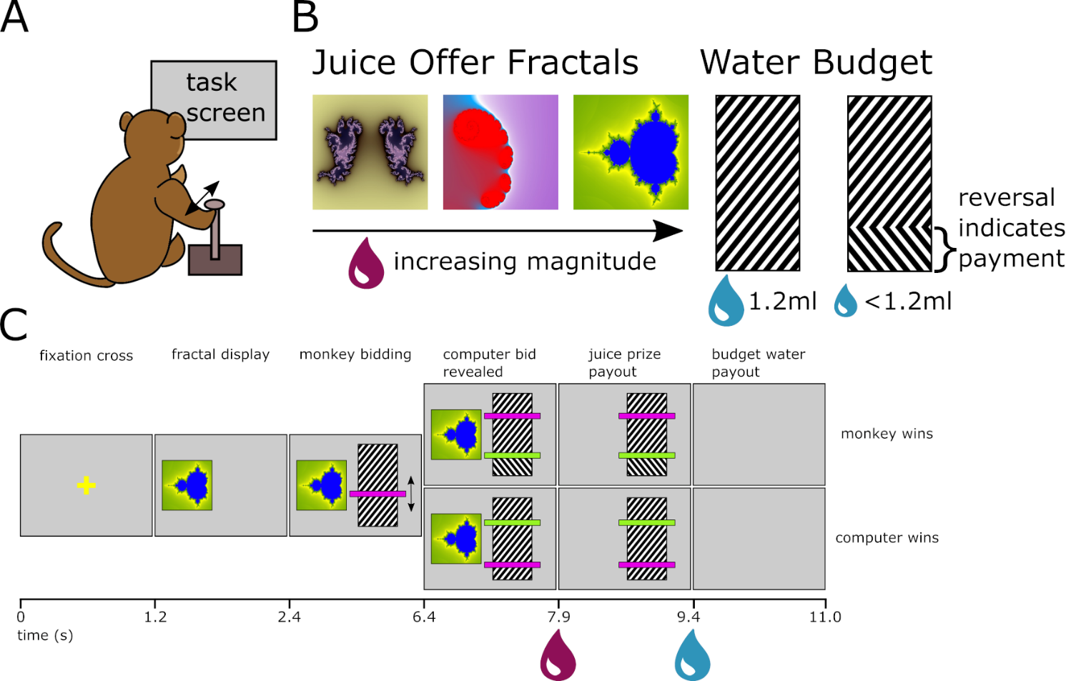
Figure 3.1a-c) The components of the BDM task used in this thesis. A) The monkey uses a joystick to interact with the task presented on a computer screen at head height 70cm from itself. To manipulate their bid the monkey moves the joystick towards or away from them (‘up/down’). B) the payouts of any trial of the task are defined by the juice offer fractal (indicating a certain magnitude of blackcurrant juice of constant concentration) to be bid for, and the water budget. A ‘full’ budget represents 1.2ml of water. Any payment a monkey makes on a winning auction trial is subtracted from this and indicating by a reversal of hatching. C) The epochs of the BDM task as seen by the monkey (not to scale; task does not include arrows in ‘monkey bidding’ epoch). Times are in seconds and indicate the change of the display and the delivery of liquids to the monkey. When the computer bid is revealed trials are fall into ‘monkey wins’ and ‘computer wins’ categories. Where the monkey’s bid (purple) is higher than the random computer bid (green), the monkey wins and pays for the juice offer. In comparison, when the monkey’s bid is lower than the computer’s bid the monkey retains the full 1.2ml water budget but does not receive any juice. After each trial, a random 2.5-3.5 second intertrial interval is interleaved.

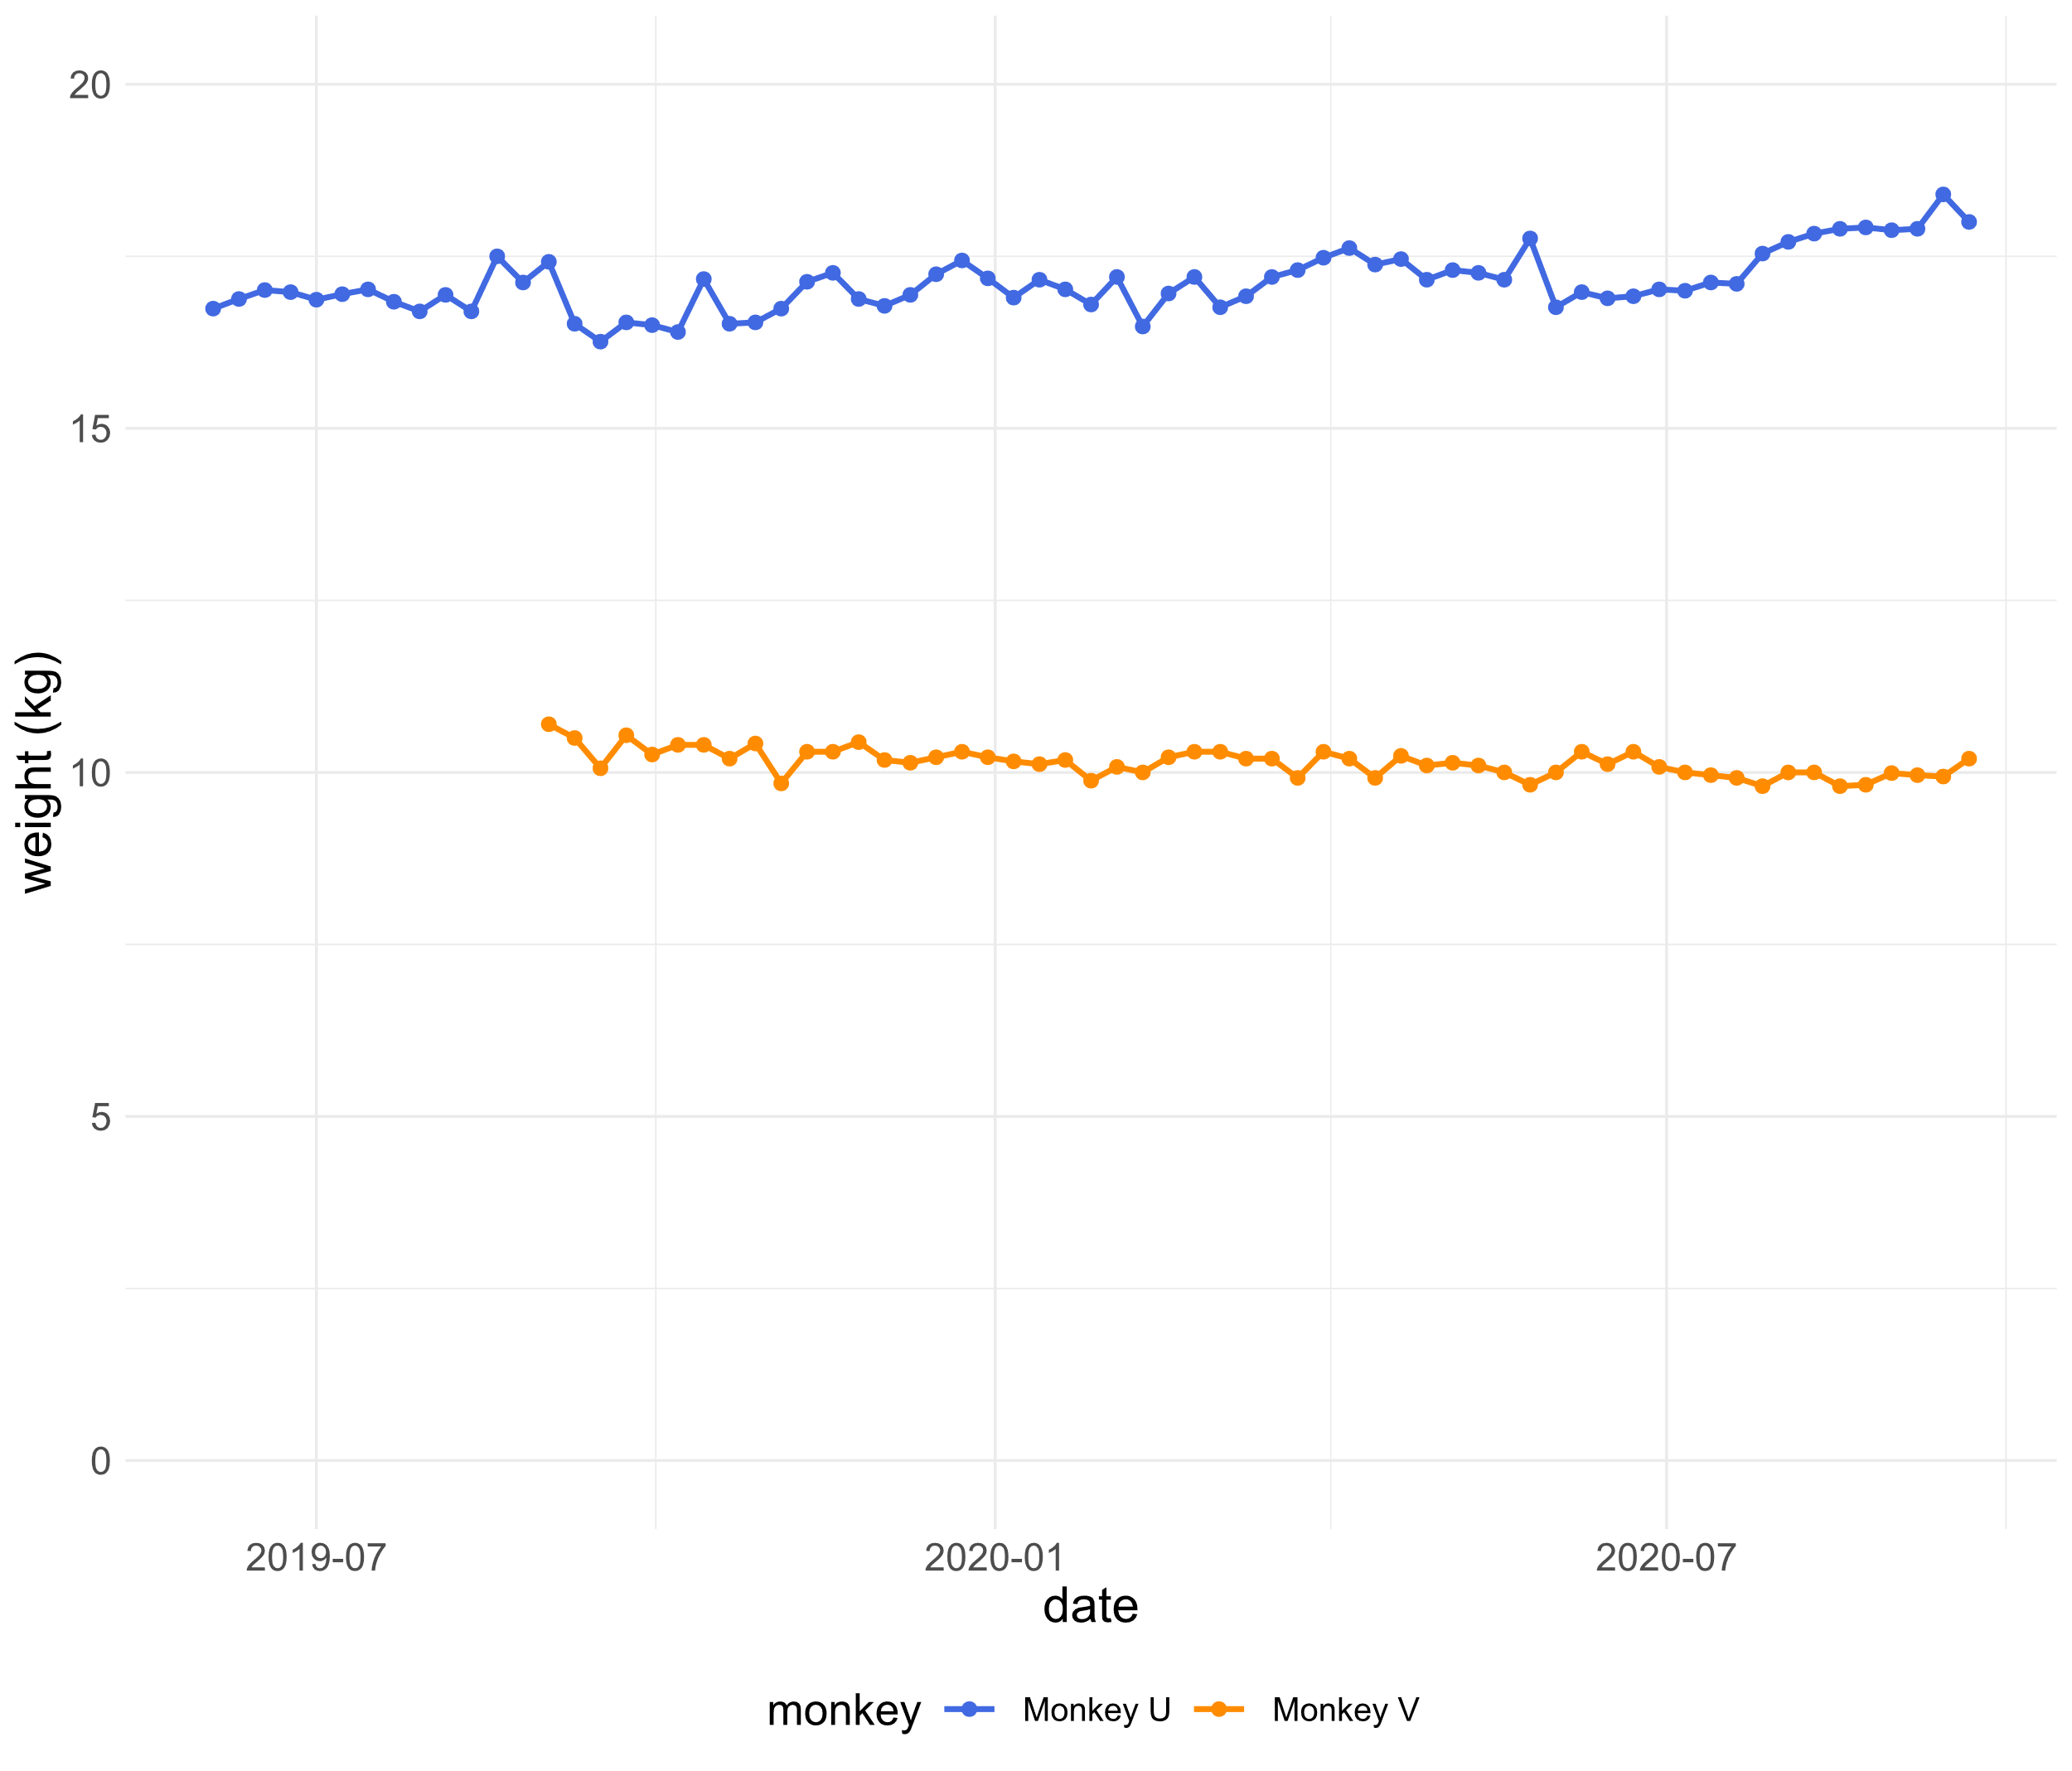
Figure 3.2 The weights of the two monkeys over the recording phase of the project. Monkeys were weighed prior to task performance on a weekly basis. The weights of the two monkeys remained steady of the entirety of the project. Monkey U was relatively large and heavy and monkey V relatively small and skinny, but both were within the normal physiological range for Macaca mulatta primates. The weights of the monkeys were used to calculate the liquid supplement given to each after experiments to maintain a minimum level of liquid deprivation.
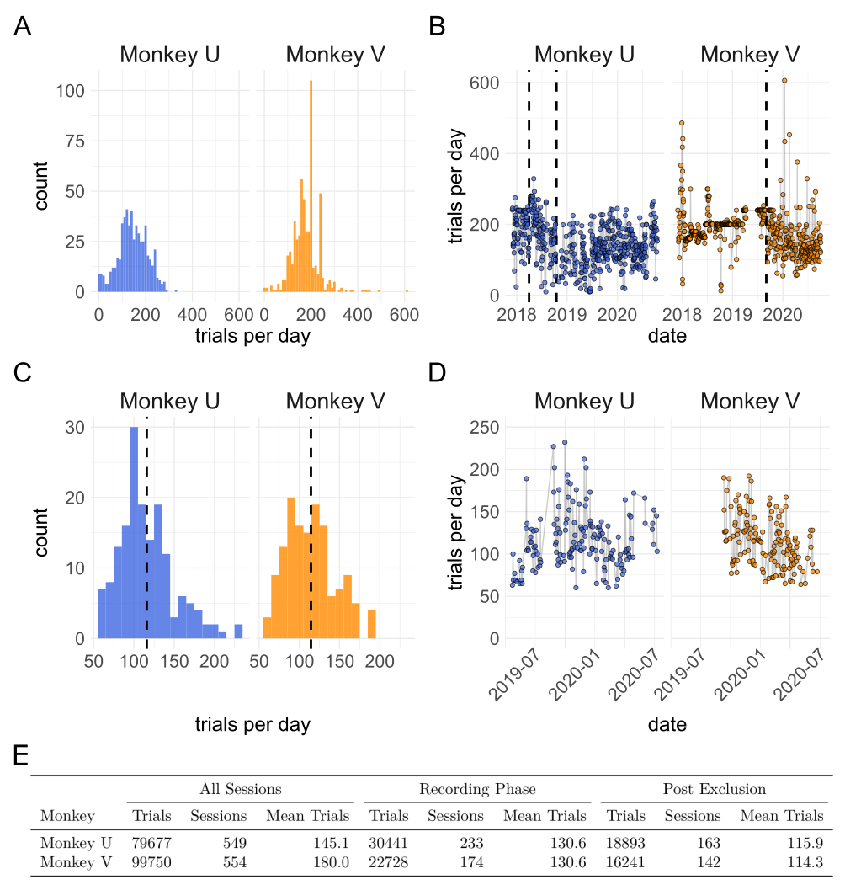
Figure 3.3a-e) Performance of two monkeys on the BDM task over the duration of this project. Two monkeys (‘U’ and ‘V’) were trained on the BDM (see Al-Mohammad & Schultz, 2019 and appendix 3.1). Once trained, monkeys performed BDM in 5 sessions per week completing a range of trials per session (A). ‘Complete’ trials indicate that monkeys successfully made bids which were compared against a randomly drawn computer bid and paid out. Incomplete trials resulted in an error timeout and no receipt of juice or water budget. Peaks for both monkeys occur at 200 and 240 trials where sessions were halted by the experimenter to maintain behaviour on subsequent sessions. B) During the initial retraining phase of the project, which aimed for monkeys to complete at least 200 trials per session which they regularly achieved. Dashed lines for Monkey U refer firstly (April 2018) to the initiation of head fixed training and later (October 2018) to the surgical implantation of a recording chamber. The single dashed line for Monkey V (September 2019) refers to the surgical implantation of headbars and a recording chamber after which the monkey was immediately trained to perform auctions while head-fixed. C) BDM trials from the neuronal recording phase of the project were filtered to exclude trials and sessions using a priori criteria (appendix 3.2) resulting in a smaller number of sessions and trials per session. Dashed line indicated mean number of trials (115.9 for Monkey U and 114.3 for Monkey V). D) shows how the number of ‘good’ BDM trials per session varies over time during this phase. In E) the number of trials and sessions are shown for the whole of the project (‘All Sessions’), the neuronal recording phase of ~1 year per monkey (‘Recording Phase’) and of filtered ‘good’ trials completed during the recording phase filtered as in appendix 3.2 (‘Post Exclusion’).
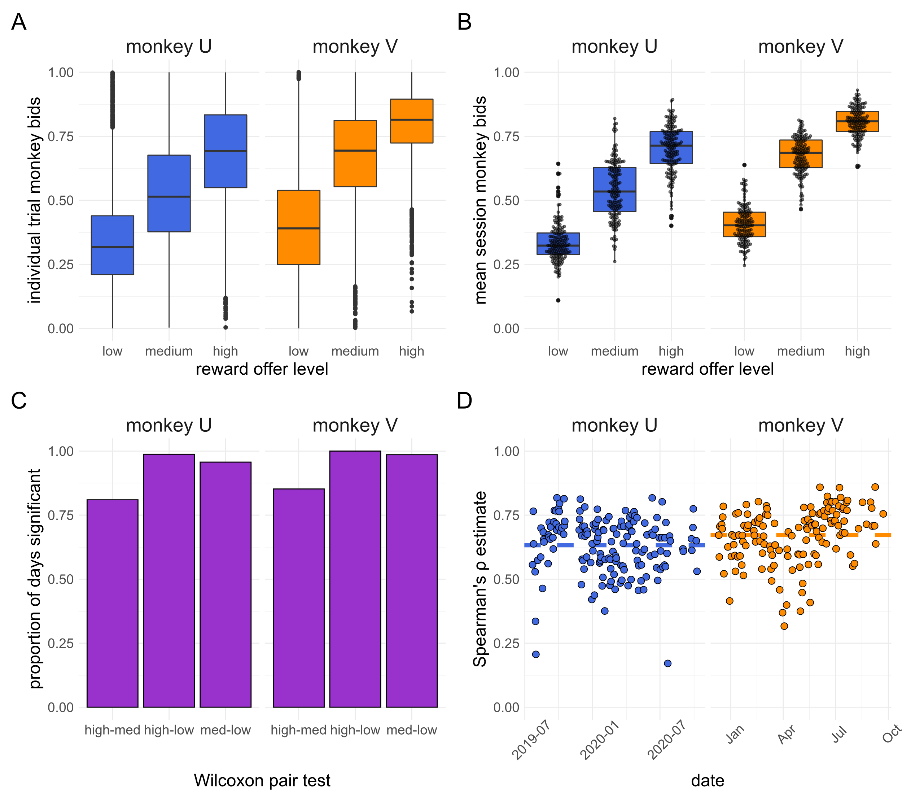
Figure 3.4a-d) Monkeys show rank ordered bidding on the BDM auction task. A) boxplots of each individual bid made by either monkey during the recording phase, post exclusion (n = 18893 for Monkey U; 16241 for Monkey V). Bids are separated by monkey and by the level of the reward offer into ‘high’, ‘medium’, and ‘low’ categories whose magnitude varied by monkey but were consistent across the entire phase (0.2, 0.45, 0.7ml Monkey U; 0.3, 1.0, 1.7ml Monkey V). B) boxplots of the mean bid per reward level per session (n = 163 for Monkey U; 142 for Monkey V) for each monkey. Individual mean session bids are overlaid in a beeswarm. Stars for plots A and B indicate significance for all corrected pairwise Wilcoxon comparisons p < 0.0001. C) the proportion of individual sessions for which a one-sided Wilcoxon test (uncorrected) between all bids made by a monkey showed significant differences (p < 0.05) in the level of the bid. X axis shows reward offer levels tested between, ‘low’, ‘med’ (medium), and ‘high’. D) Estimate of the Spearman’s ρ between the reward offer level and the monkey’s bids per date. Dashed lines indicate mean Spearman’s ρ over the entire period (0.632 for Monkey U; 0.672 for Monkey V).

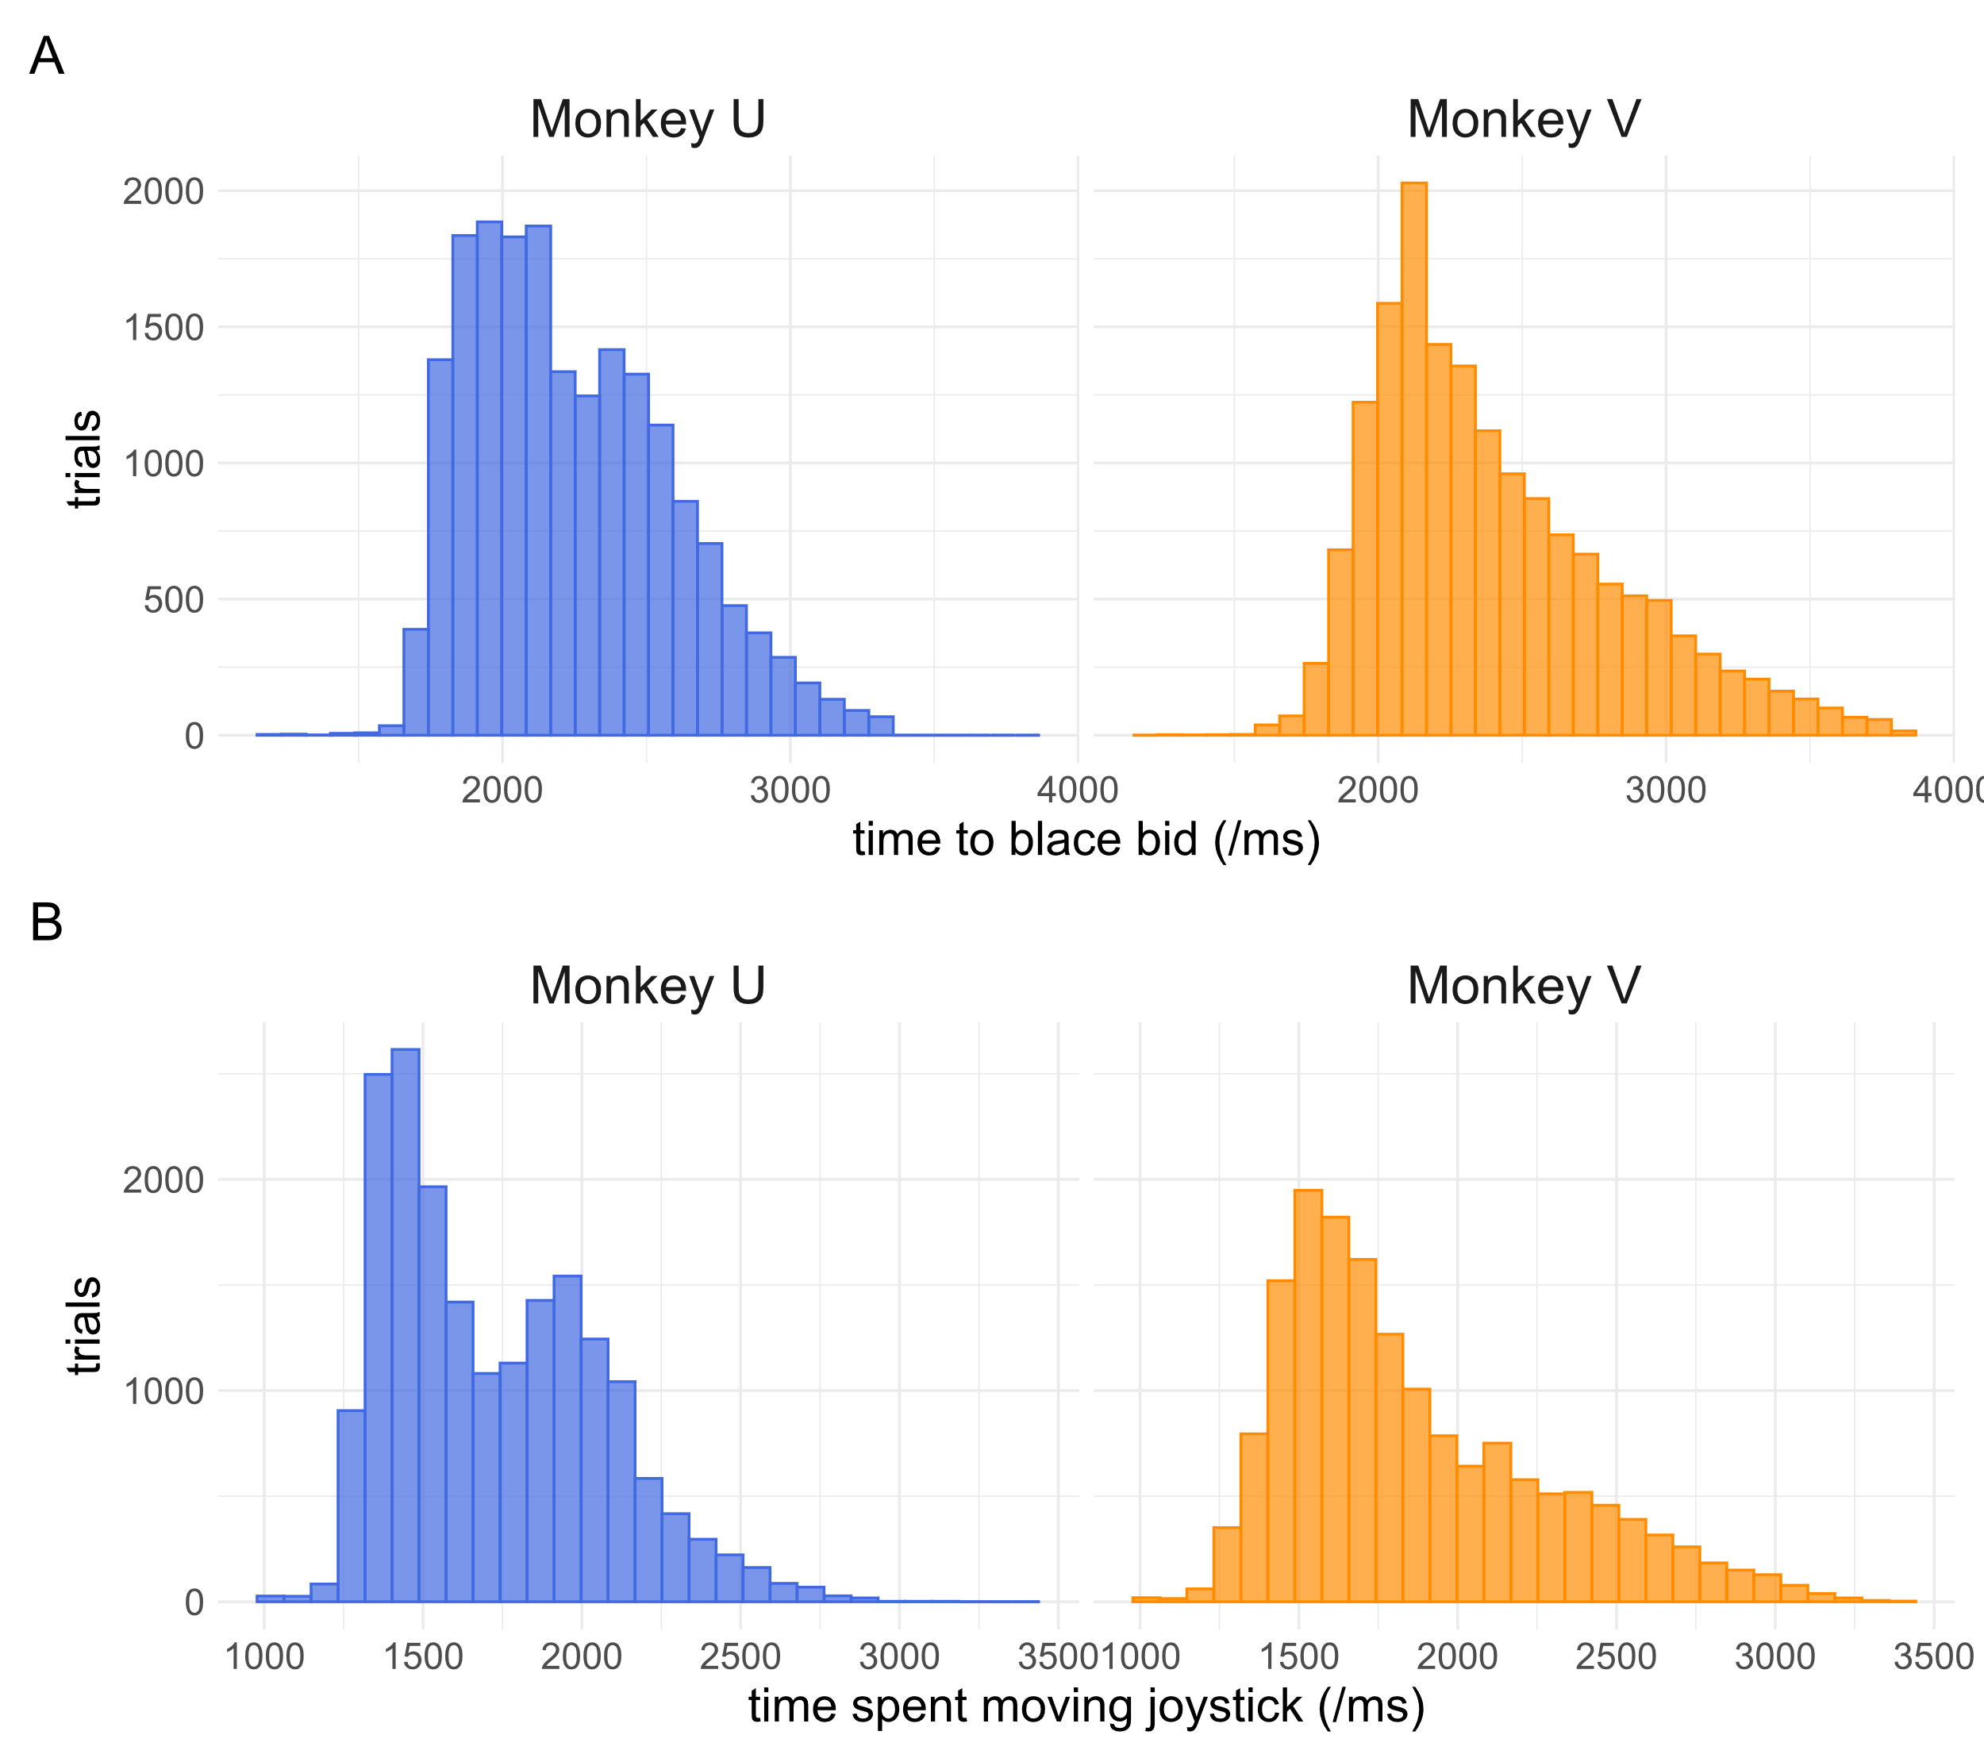
CHANGE COUNT TO TRIAL COUNT ON FIGS INC 3.3 Figure 3.5a-b) Monkey joystick behaviour while completing the BDM task. Trained monkeys were able to quickly move bids to their preferred locations. A) The total time spent moving a bid from the beginning of the bidding epoch. Monkey U was slightly faster to make bids in general. This graph does not include the time the joystick had to be held still to ‘place’ bids (see methods). Note the slightly longer tail for Monkey V whose ‘placement time’ was reduced from 1 second to 700ms. When considering the total time spent moving the joystick (i.e. from the first movement of the bidding indicator to the last) monkeys, especially Monkey U, show behaviour that seems to fall more into two populations of ‘fast’ and ‘slow’ bids (B).

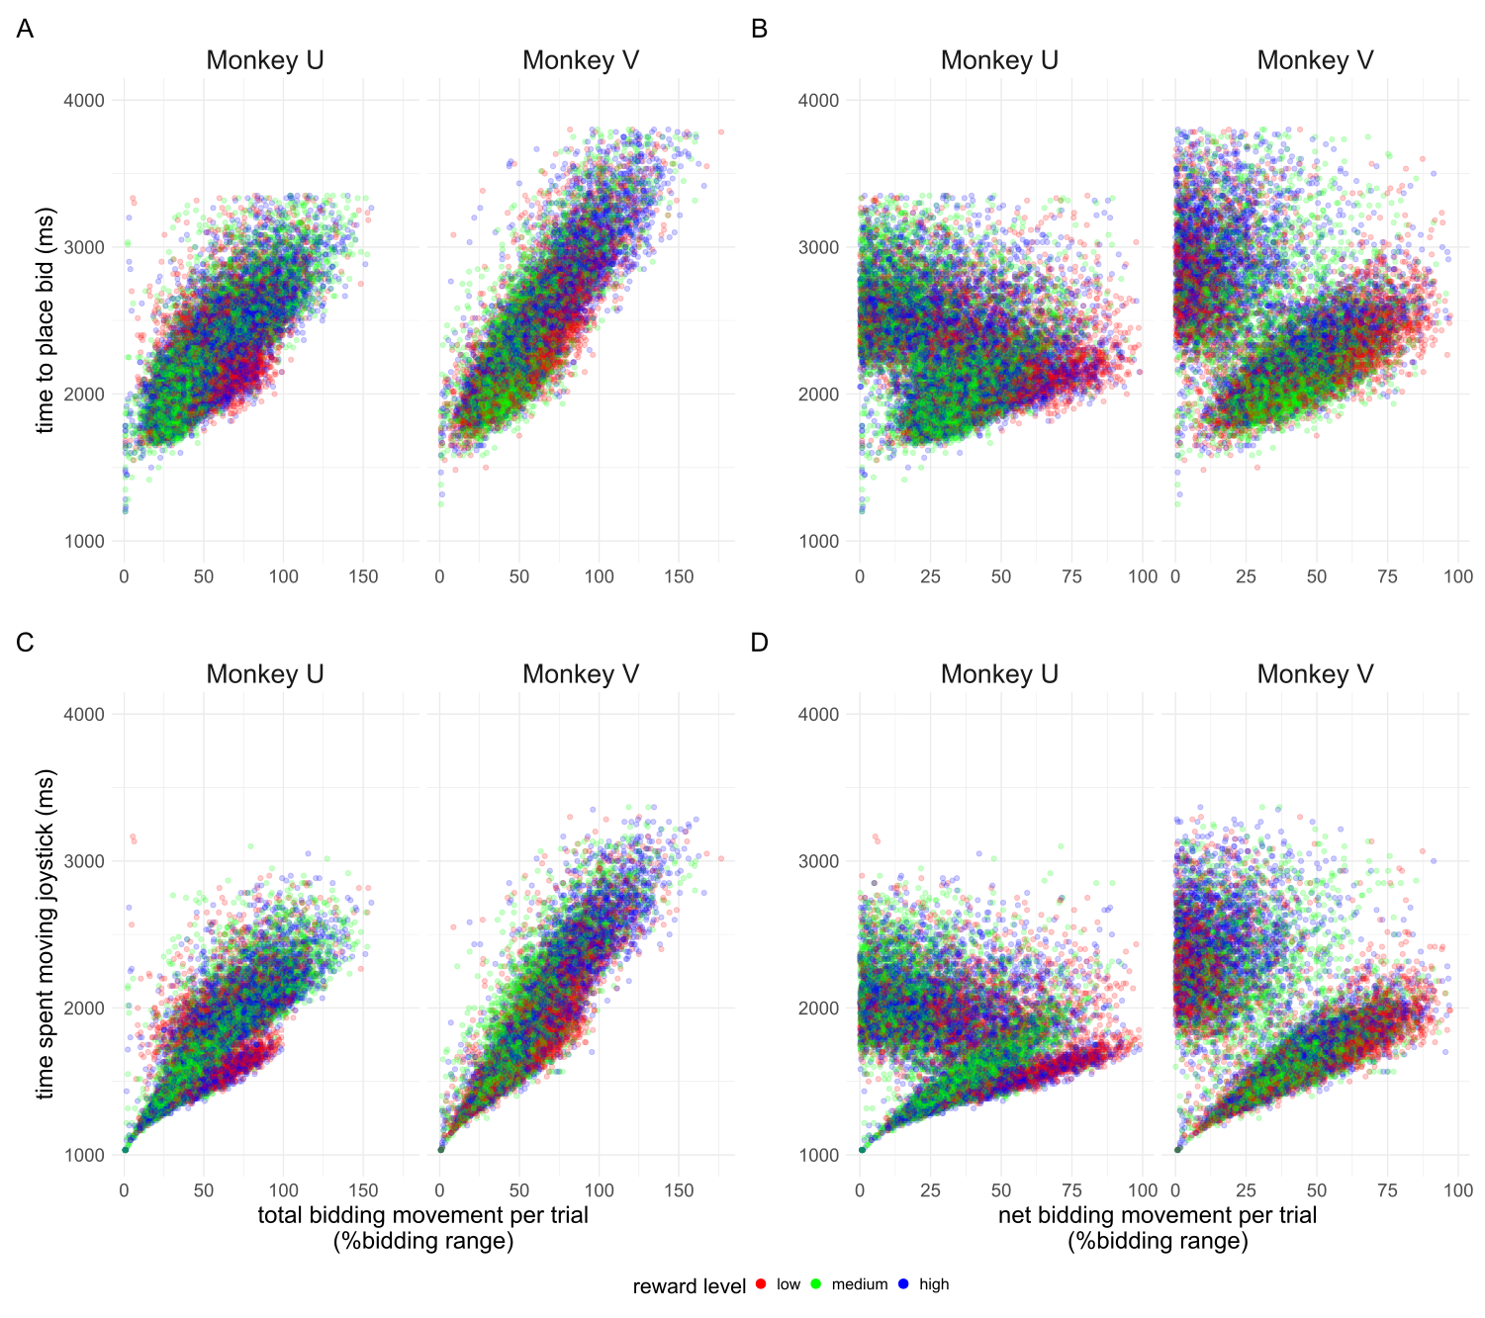
Figure 3.6 Distinct clusters of bidding activity can be seen when studying the relationship between the time spent moving the joystick and the net bidding movement per trial. For each monkey, the time to place bid and time spent moving the joystick (see figure 3.5) are plotted against the gross (total) bidding movement or the net bidding movement. Both x axis are plotted as modular values. Points are coloured by the reward level offered in the trial. Both monkeys show similar patterns of strong correlation between time to place bids and total bidding movement, and clusters of patterns between time spent moving the joystick and net bidding movement.

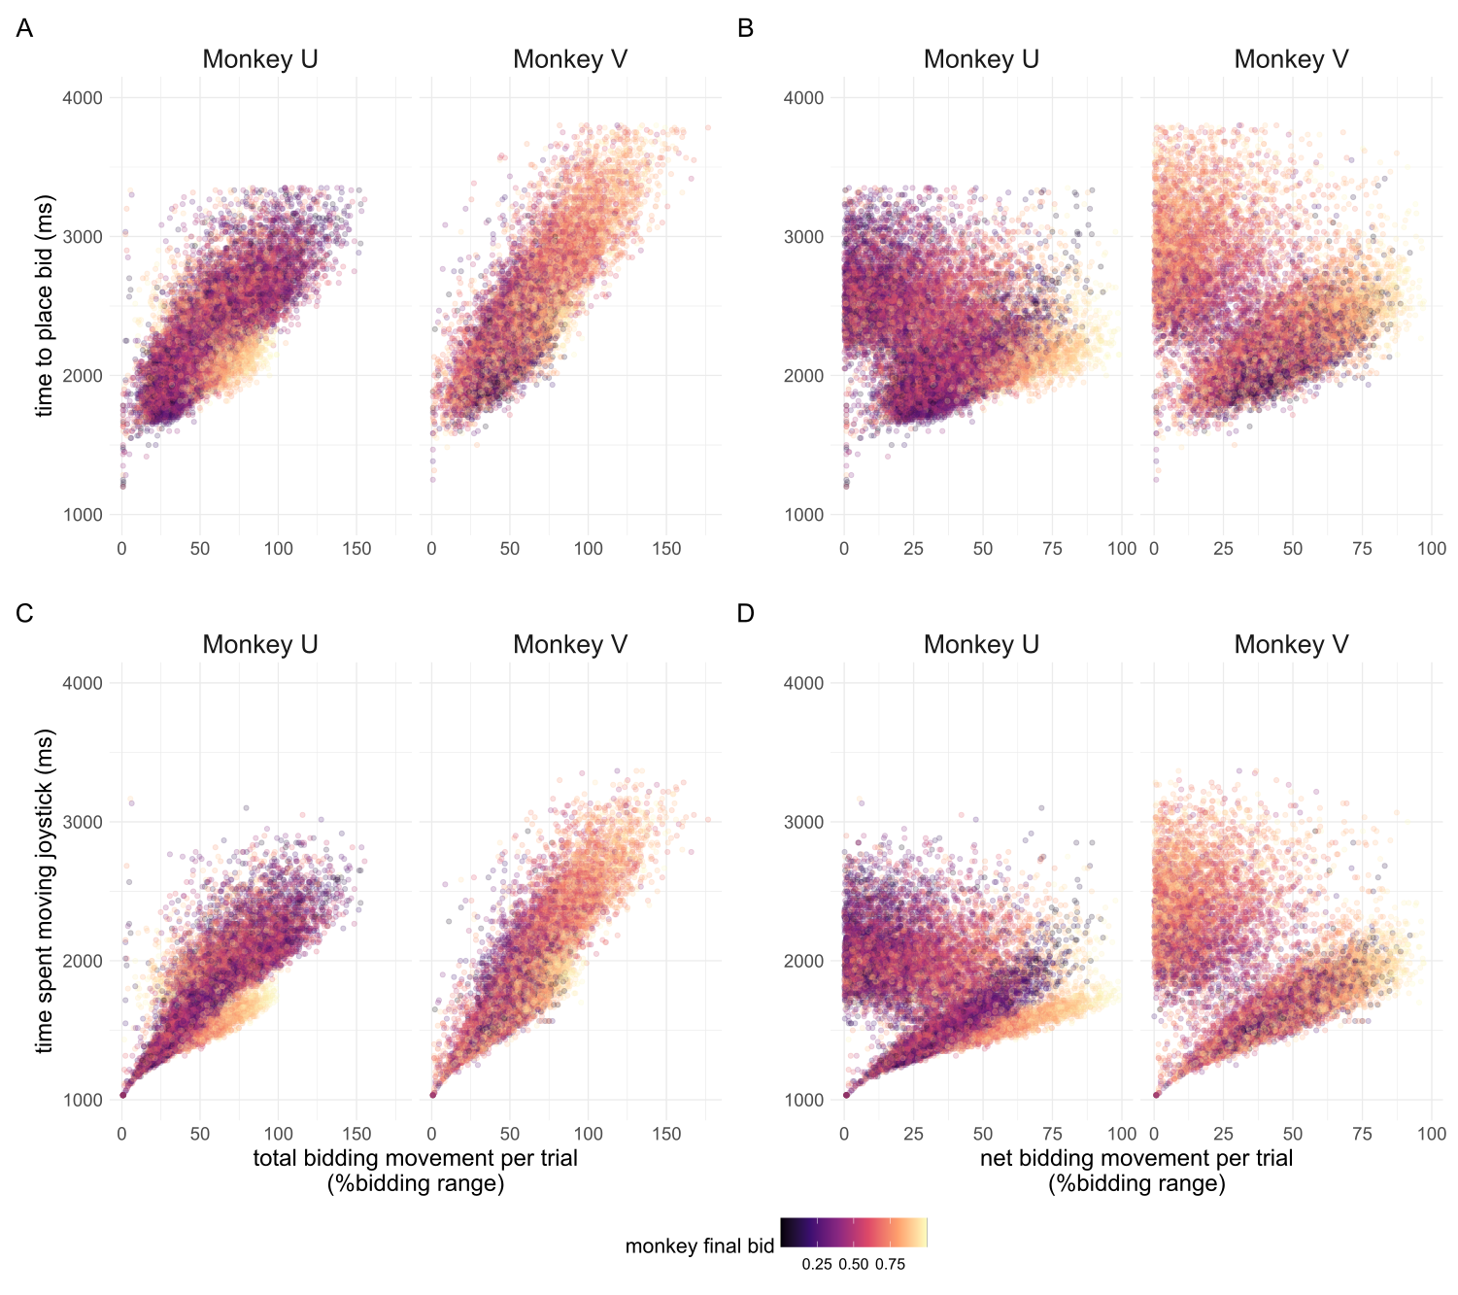
Figure 3.7 Distinct clusters of bidding activity can be seen when studying the relationship between the time spent moving the joystick and the net bidding movement per trial. Points plotted as in figure 3.6 but are coloured by the monkey’s final bid from low (yellow) to high (purple).

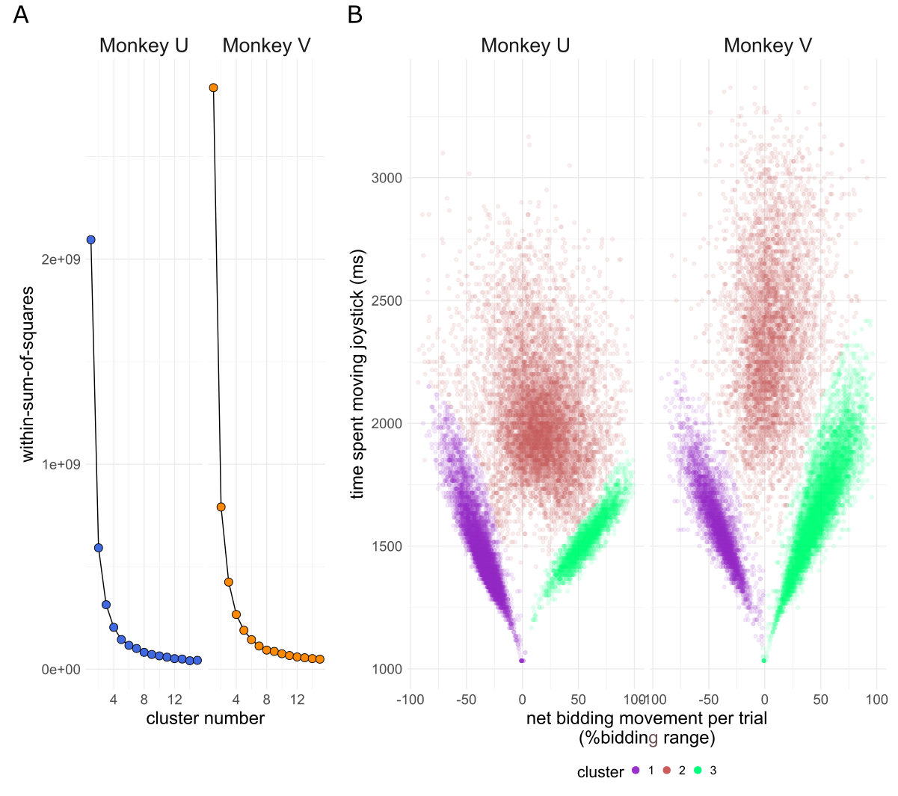
Figure 3.8a-b) Clustering of monkey bidding behaviour. A) Bidding behaviour using the time spent moving the joystick and net bidding movement (see figures 3.6 and 3.7) as coordinates is used to train a k-means clustering algorithm. Within cluster sum of squares is used to identify an elbow in the variance explained by the addition of clusters which confirms the priors of 3 clusters in the data. B) Individual bids are shown as in figures 3.6 and 3.7, coloured by their cluster as determined using k-means clustering. Clusters numbers have been rearranged for consistency between monkeys.
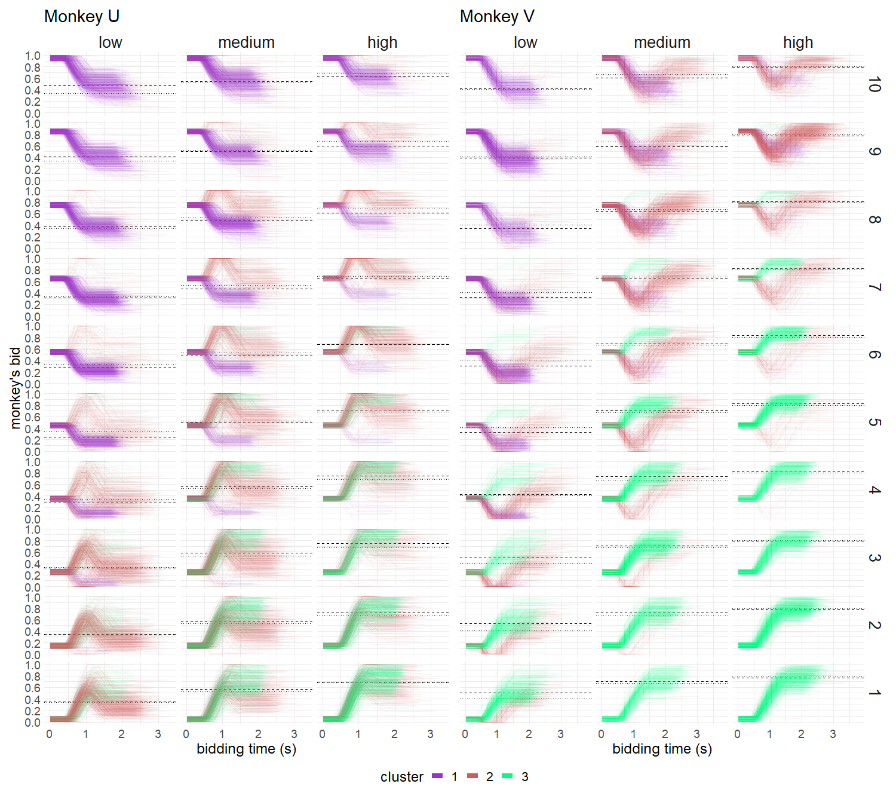
Figure 3.9 Individual bids made by monkeys coloured by cluster. Clusters from figure 3.8 are imposed on traces of the bidding indicator bars movement over time. Trials per monkey are spit by reward level offered and by the starting bid decile, where 1 is the lowest (bid starting in 0-10% of the budget bar). Dotted lines indicate the mean monkey bid per reward level, compared to dashed lines which indicate mean monkey bid per reward level and starting bid decile.

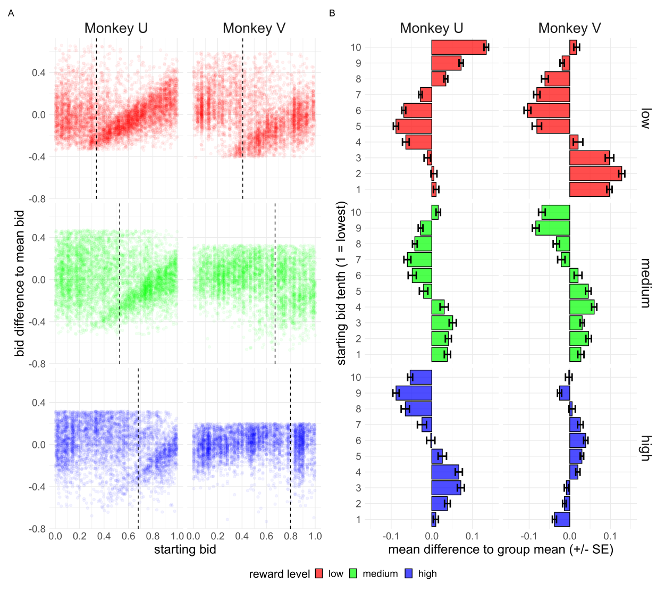
Figure 3.10a-b) The effect of the randomly drawn starting bid on the monkey’s final bid. A) The difference of a monkey’s final bid to the mean final bid per reward level is shown against the randomly drawn starting bid of the trial. The mean bid per reward level is also indicated via a vertical dashed line. B) The difference between the mean bid per reward level and starting bid decile is compared to the mean bid per reward level. I.e. the mean effect of the starting decile on the monkey’s final bid. Negative values indicate that the starting bid decile leads the monkey to bid lower than would be expect, and vice versa. Error bars are standard error of the mean.

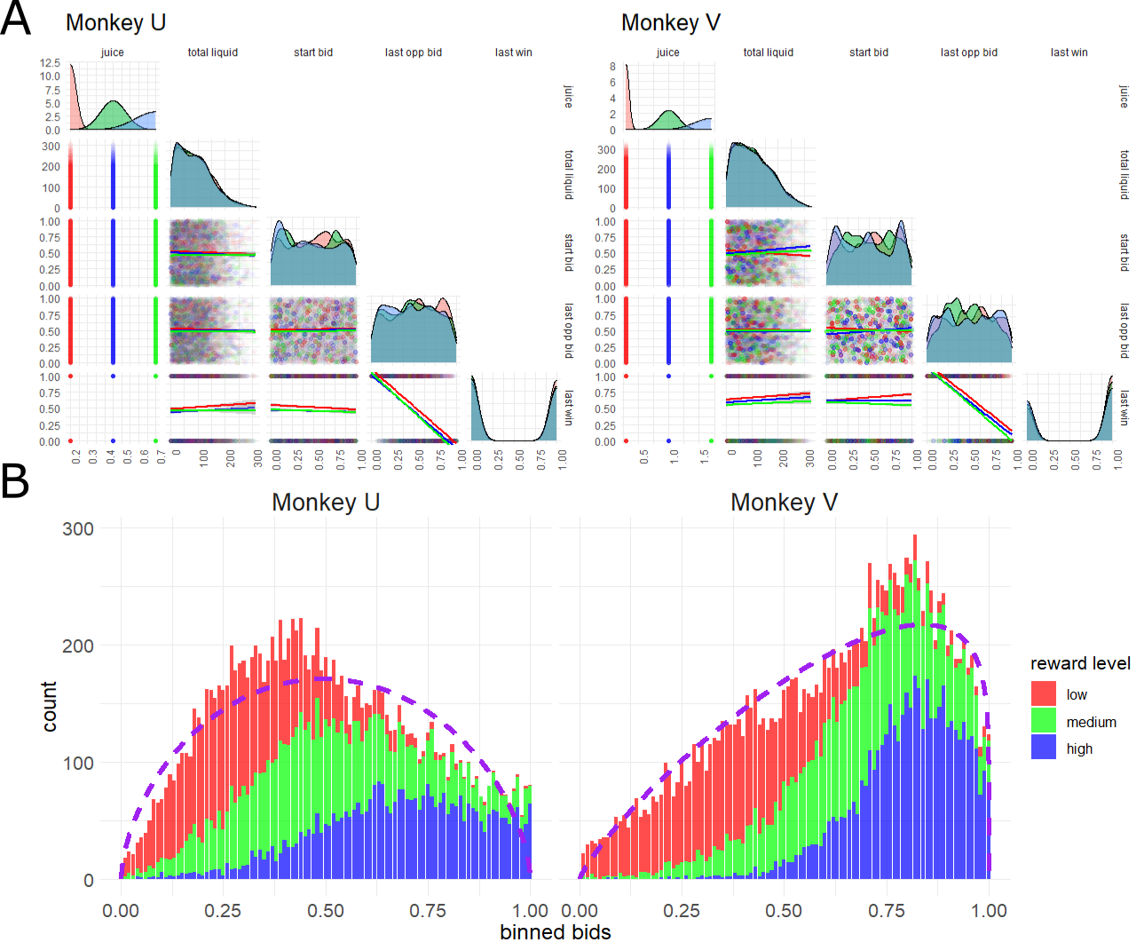
Figure 3.11a-b) The distribution of independent and dependent variables selected for the BDM task. In a) the distributions (diagonal) of each selected independent variable is shown coloured by reward level (red = lowest magnitude juice, green = middle, blue = highest). ‘juice’ refers to the ml of juice offered at each level; ‘total liquid’ is the total ml of liquid the monkey has received that day; ‘start bid’ is the randomly drawn starting bid of the trial; ‘last opp bid’ refers to the randomly drawn computer bid on the last trial; ‘last win’ is a binary variable indicating if the monkey won (1) or lost (0) the last trial. Note, variable names have been changed here compared to figure 3.12 in the interest of space. No variables show strong co-correlation (dots and best fit linear model plots) except for the last computer bid and whether the monkey won the last trial, as would be expected. B) the distribution of monkey bids coloured by the reward level as in a) is bound in the range (0,1), i.e. between 0 and 1 not inclusive. The two monkeys show a clearly different distribution in bids due to the different amounts of liquid offered and the monkeys private utility functions. Dashed purple lines indicates the fit of a beta distribution to the monkey’s bidding data.

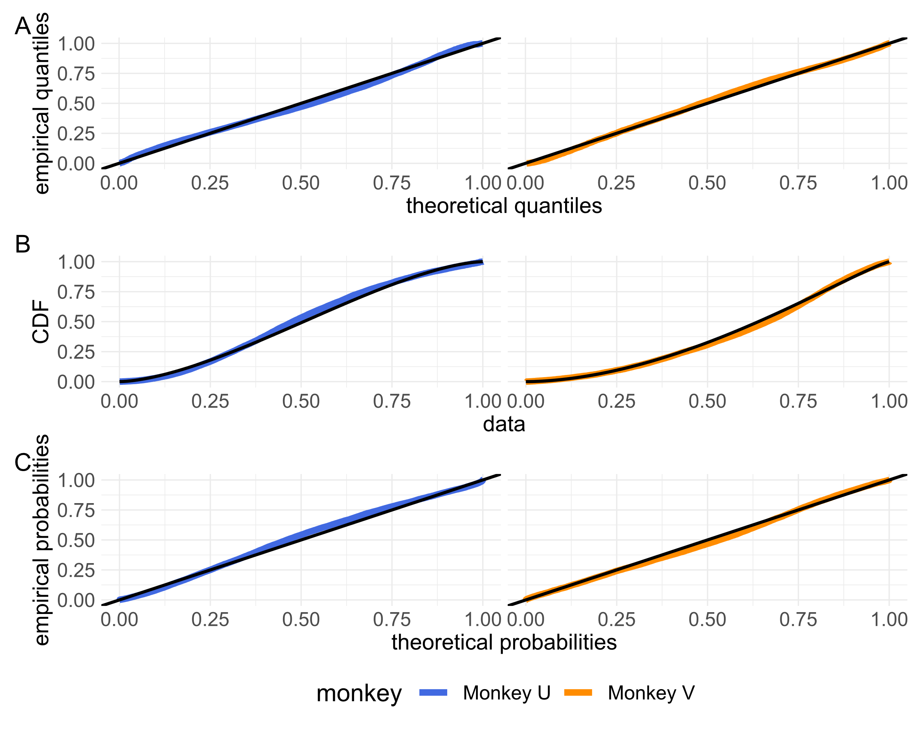
Figure 3.12a-c) Agreement between the distribution of monkey bids and the fitted beta distributions. A) Quantile-quantile plots of monkey’s bids against the fitted beta distributions of figure 3.11b) (parameters in table 3.11c). Perfect fit is shown as a black line along x=y. B) The cumulative distribution function (CDF) of observed (colour) and theoretical (black) points are plotted next to each other. C) Probability-probability plots of the CDF of observed and theoretically beta distributed monkey’s bids plotted against each other. For all plots, colour refers to monkey whose bids are plotted. All plots show good agreement between empirically observed bids and those expected given the fitted beta distributions (i.e. where the coloured lines fall reasonably along black lines).
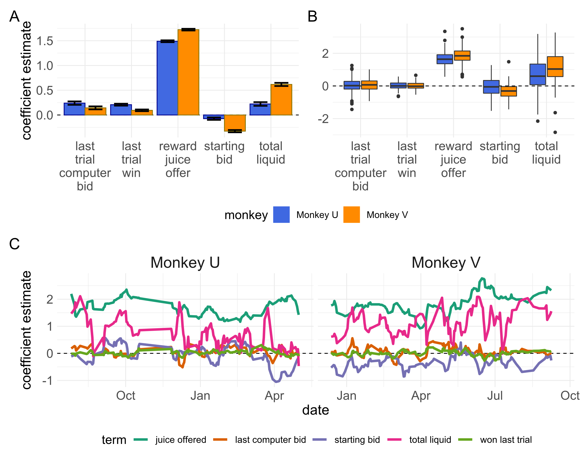
Figure 3.13a-c) results of beta distribution regressions on relevant task variables. A) Coefficient estimates for a regression of relevant task variables against monkey bids for all trials separated by monkey. Error bars represent +/- standard error. For both monkeys, the reward level offered was the dominant variable in guiding monkey’s bids as expected. Both monkeys also showed an inverse relationship with the starting bid (though much more so for monkey V). Monkey V also showed a much greater effect of aggregate bid increasing as the monkey received more liquid over successive trials (i.e. was sated). B) Coefficient estimates for identical regressions grouped by both monkey and session date. Boxplots show similar findings as the single regression carried out in a). In every session, reward level was a significant variable in determining monkey’s bid. The total liquid received shows the greatest variability in effect over multiple sessions. In c) regression coefficients from b) are plotted by date, showing the relationship over time. Lines are smoothed by taking the mean coefficient estimate over the last 5 sessions.

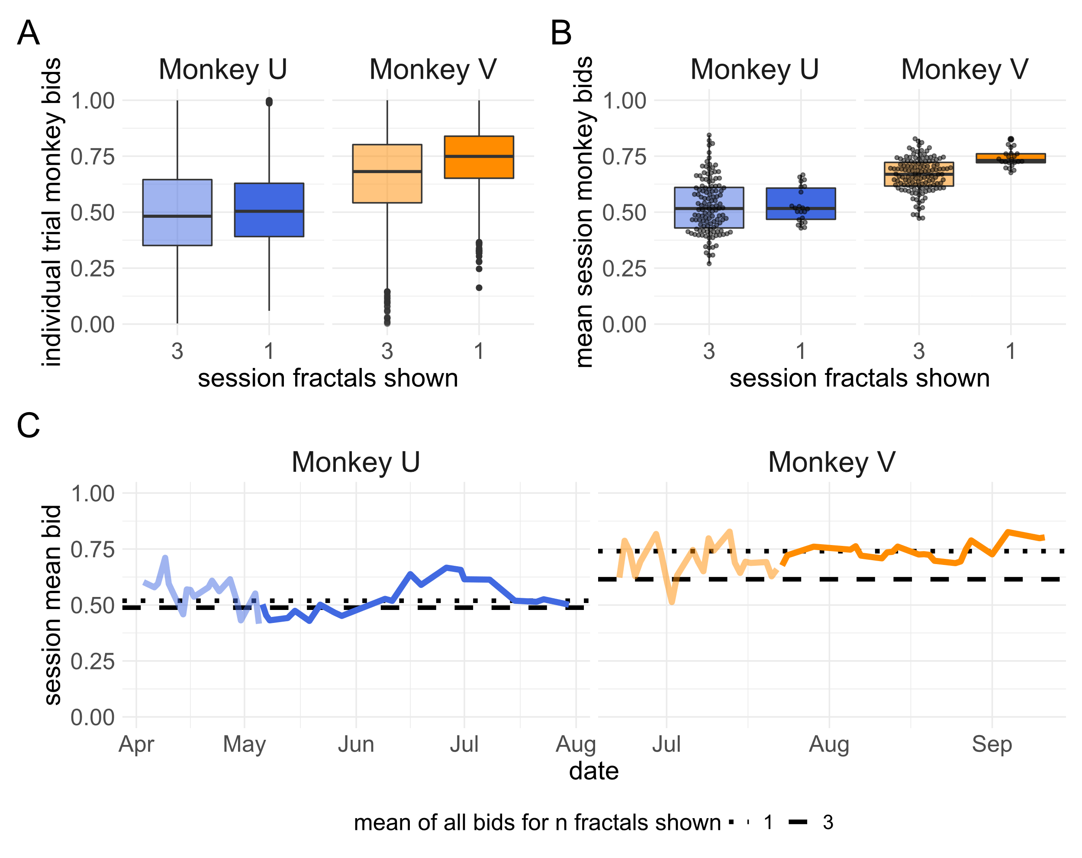
Figure 3.14a-c) The distribution of monkey’s bids when only the medium reward level fractal is show. A) the distribution of monkey bids from n = 2228 (monkey U) and 2724 (monkey V) trials on sessions where only the medium fractal was shown (opaque boxplot). These are compared to the distribution of all bids made for only the medium fractal in sessions where all 3 reward levels were presented to the monkey (n = 4665 for monkey U, n = 4628 for monkey V) in the semi-transparent boxplot. B) the mean session bid for the medium reward level fractal is shown for sessions where only the medium reward level fractal is offered to the monkey (n = 22 for both monkeys) is compared to the mean session bid for the medium reward level fractal in sessions where all 3 are shown to the monkey (n = 163 for monkey U and 142 for monkey V). The mean bid for each of these 22 sessions per monkey is shown over time in c) (opaque line). The mean bid for the medium reward level fractal on sessions with 3 presented fractals for the month prior to changing the task is shown in the semi-transparent line. Note: the reward juice volumes associated with the middle fractal are different between monkeys (0.45ml for monkey U, 1.0ml for monkey V) but the same between conditions.

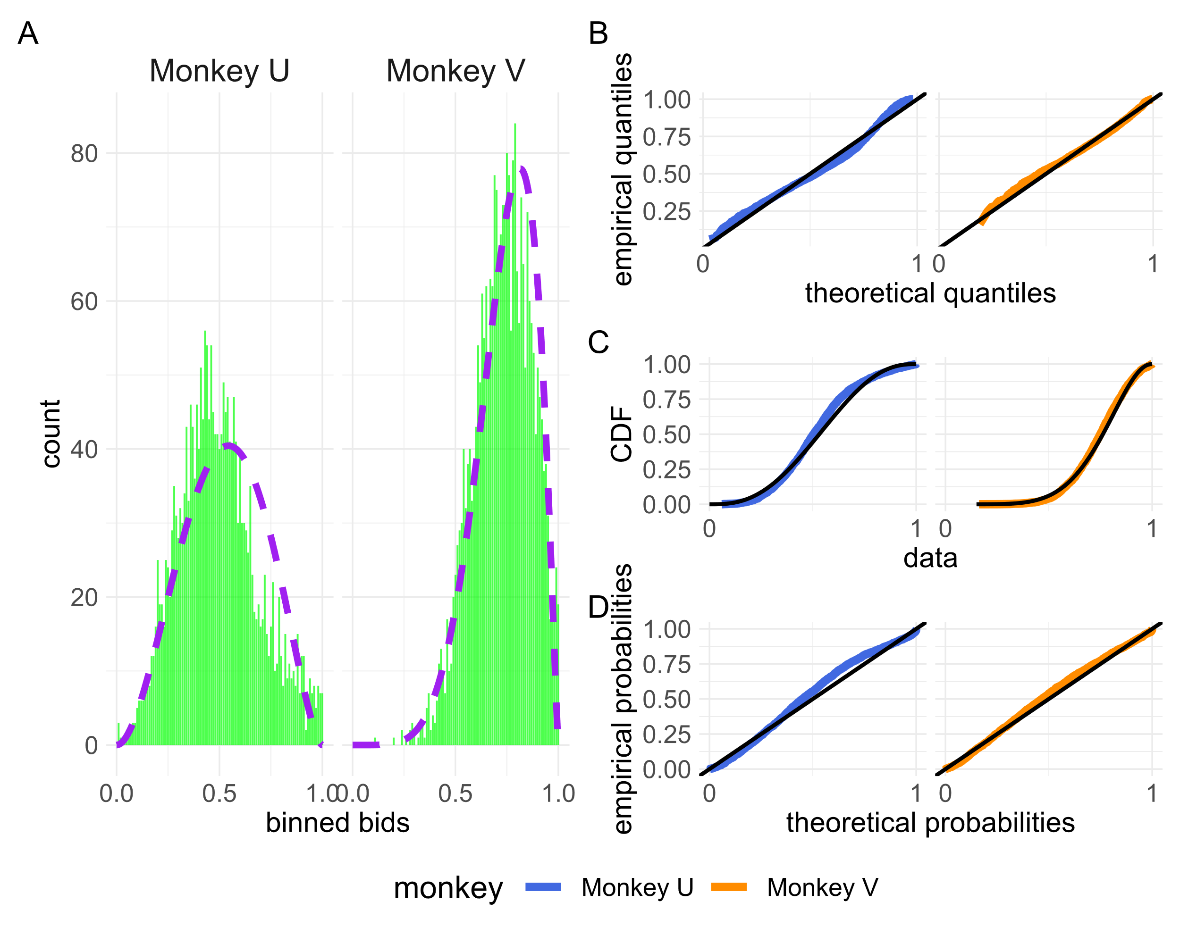
Figure 3.15 the distribution of monkey bids for sessions where only the medium reward level fractal is presented. A) binned bids are shown in a figure equivalent to 3.11b for the two monkeys over the 22 sessions where only the middle fractal was shown. A beta distribution (purple) was fitted to each monkey’s bids. For monkey U this fitted distribution took the form α = 2.97, β = 2.65. For monkey V the fitted distribution took the form α = 6.49, β = 2.25. B-D) empirical vs theoretical observations from the distribution of monkey’s bids and the fitted beta distributions are plotted as in figure 3.12. Again, both theoretical distributions captured much of the observed distribution of bids.

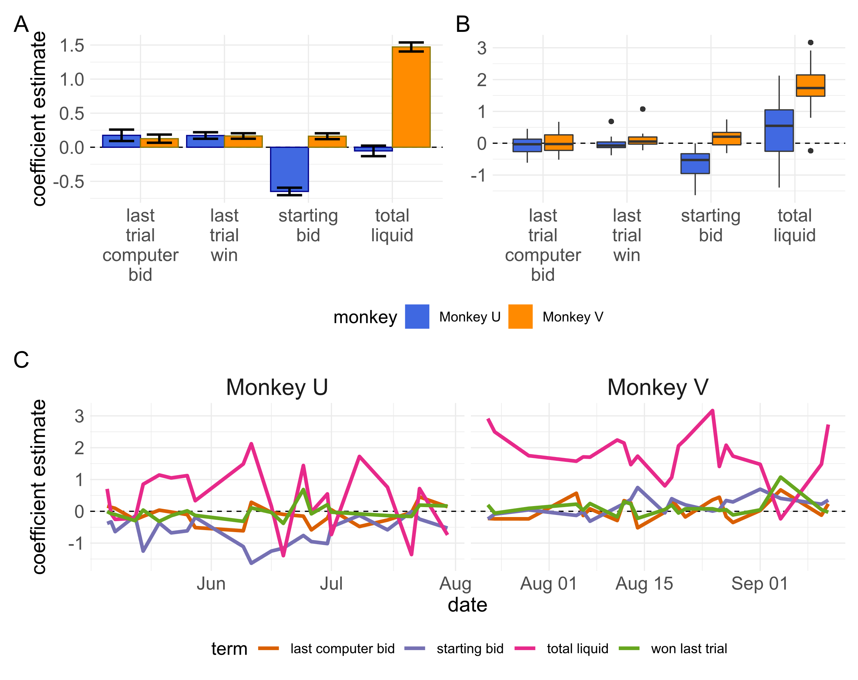
Figure 3.16a-c) results of beta distribution regressions on relevant task variables for sessions where only the medium reward level fractal is presented to each monkey. Regressions are identical to those performed for figure 3.13 except for the exclusion of the now invariant reward juice offered feature. In c) estimated coefficients are plotted per session date and not smoothed as in figure 3.13c).

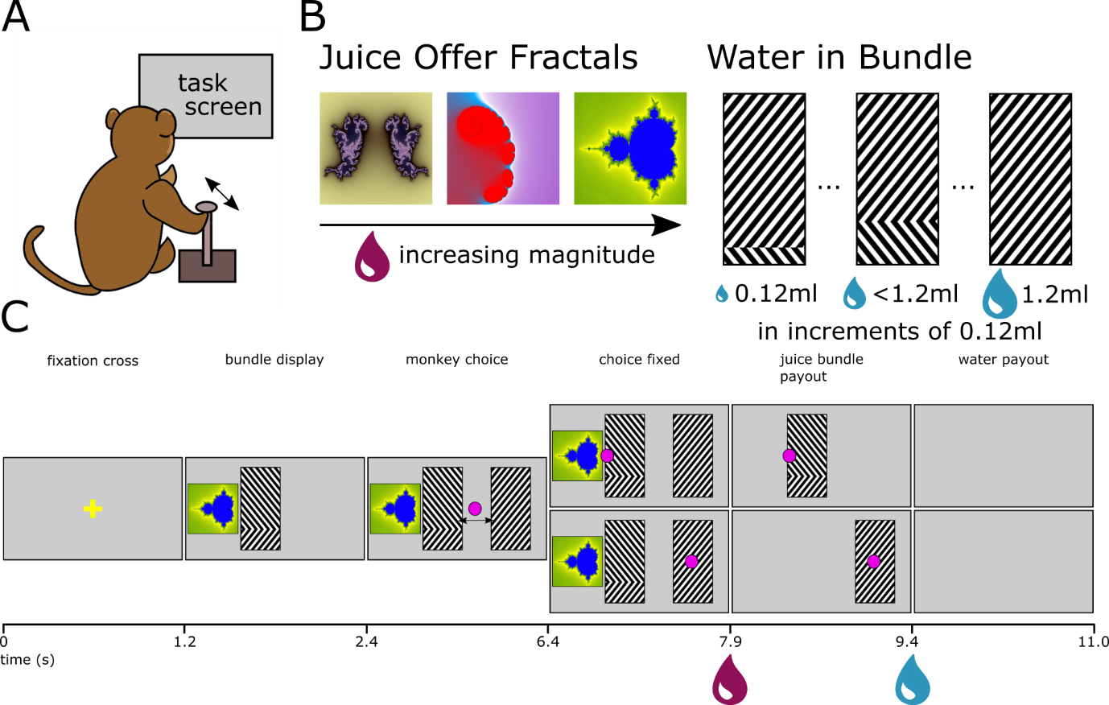
Figure 3.17a-c) The bundle choice task is equivalent to a second-price auction where the monkey bids second. A) monkeys in the same experimental set up as the BDM make choices using the left/right axis of the same joystick. B) task components are the same as presented in the BDM task. Fractals used to signify a juice reward offer are the same and correspond to the same volumes of juice as in the BDM. Amounts of water are indicated by a grating pattern as in the BDM. For every trial, a choice is presented between a juice reward and some amount of water, or a full 1.2ml of water. Bundles can be comprised of between 0.12ml and 1.2ml or water in 0.12ml increments. C) The full task progression is presented (c.f. figure 3.1). Times between epochs are the same as in the BDM and liquids are delivered to the monkey at the same points in either task.

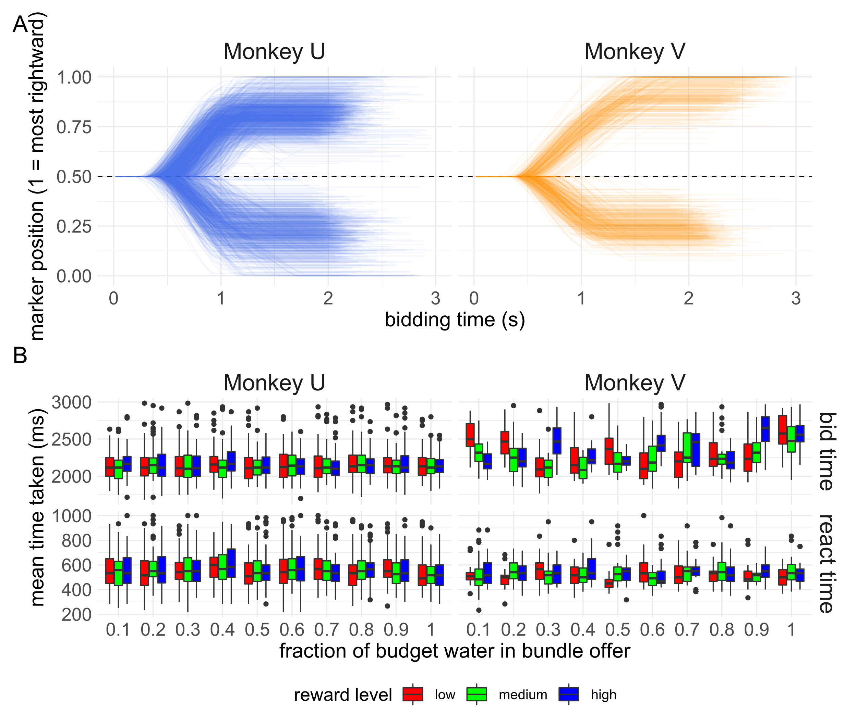
Figure 3.18a-b) Monkeys were able to quickly and reliably make choices in the bundle choice task. A) traces of the relative marker position during all bundle-choice trials for both monkeys. The markers starts each trial in the centre of the screen (0.5) and monkeys can either move it to the right (towards 1.0) or the left (towards 0 on the plot). Both monkeys were able to quickly move the marker to well within the required area of bidding (>5% of the screen’s width distance from the initial, centred, position). Monkey U performed 2267 trials over 23 sessions. Monkey V performed 714 trials over 6 sessions. B) Median reaction times (‘react time’) and time to place choices (‘choice time’) did not vary by either the level of juice (colours) or the amount of water offered (x axis) of the bundle for Monkey U. For Monkey V, the time spent bidding was significantly correlated with the amount of water offered in the bundle, though with a small effect size.

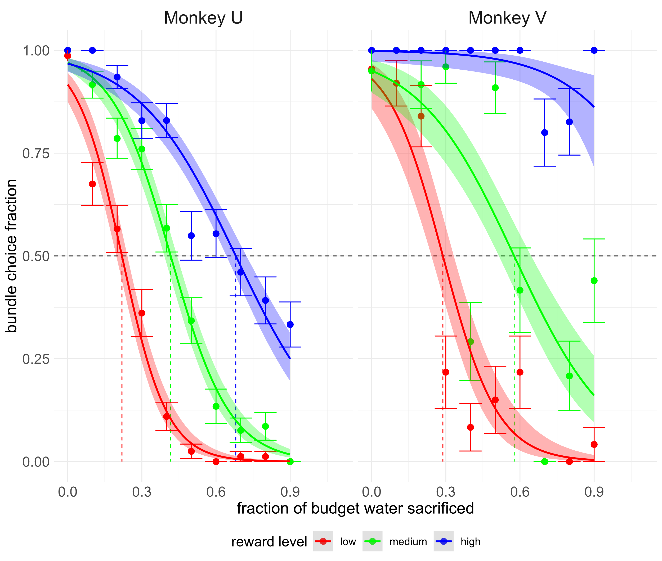
Figure 3.19 Monkeys showed rank-ordered indifference points on the bundle choice task. The fraction (±standard error of mean) of times the monkey chooses the bundle when offered an amount of juice and water is calculated, where 1 indicates that the monkey always chooses that bundle over the budget offer of 1.2ml of water. A logistic function is then fitted to the monkey’s choices (lines) indicating the estimated number of times a monkey would pick a hypothetical bundle of reward level plus some fraction of 1.2ml of water. Shaded area indicates standard error of the mean of this function. The monkey’s willingness-to-pay for a particular bundle in terms of water is then assumed to be the point on the x axis that this psychometric function crosses the 0.5 mark. See chapter 1 and figure 1.1 for more on this ‘indifference point’. Dashed lines coloured by the reward level indicate the indifference points from bundles offered to monkeys.

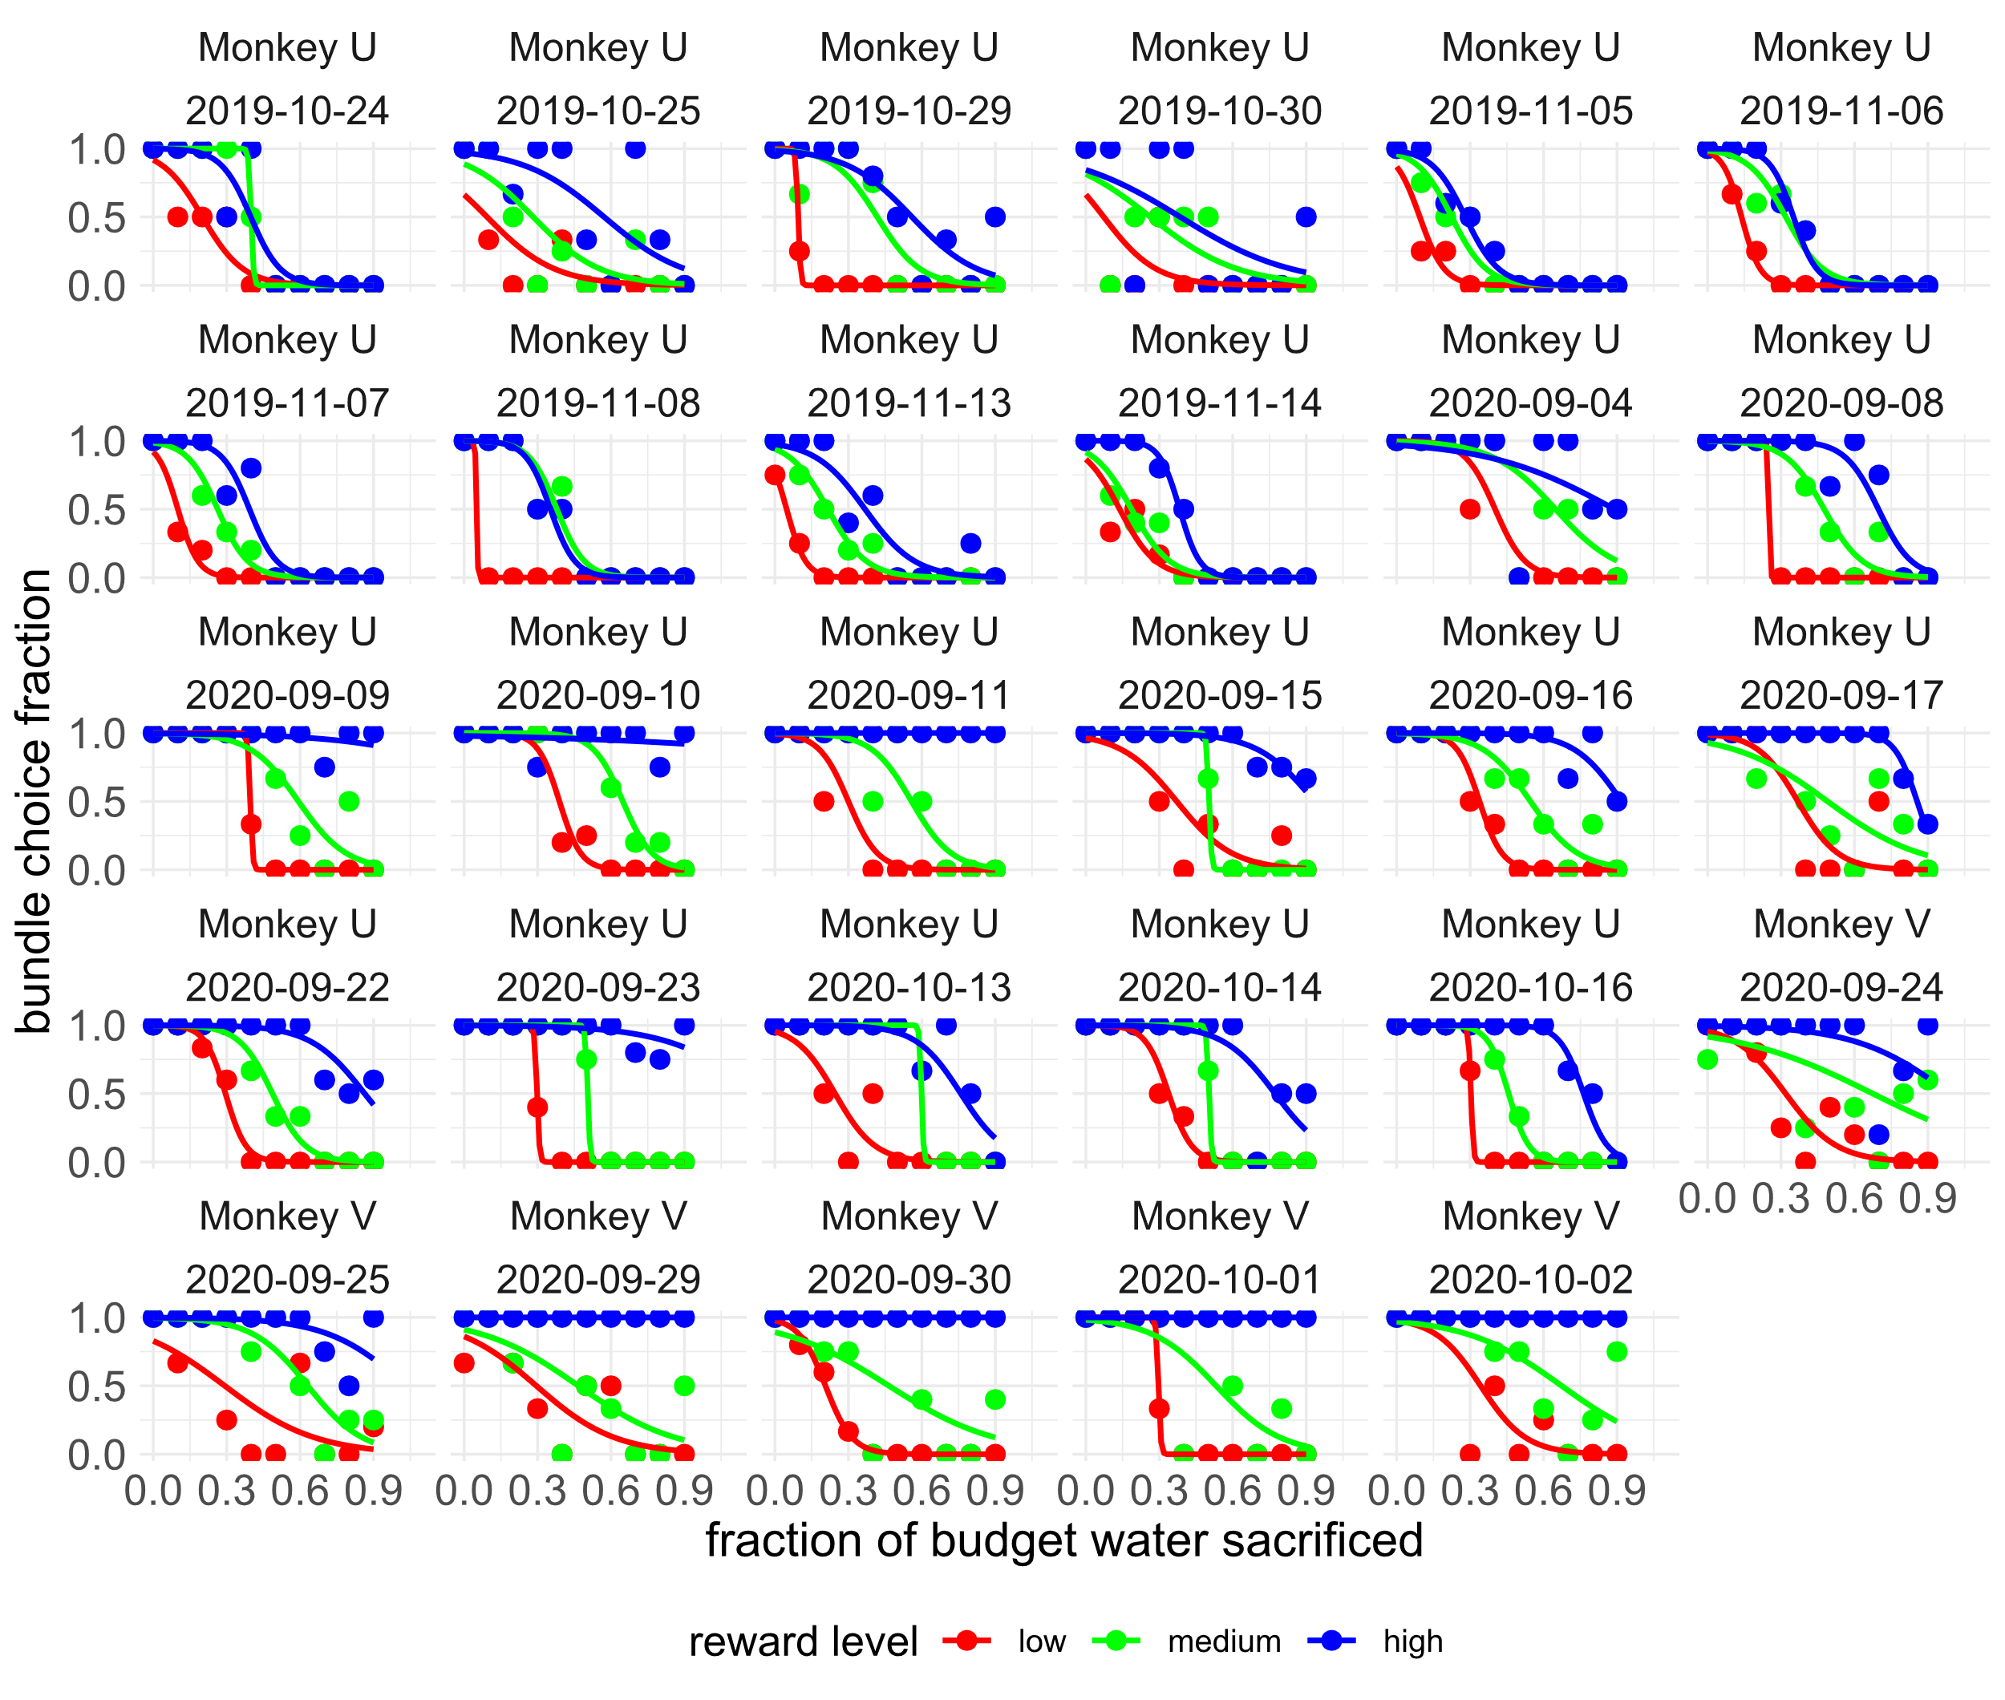
Figure 3.20 Monkeys binary choice data presents a noisier picture. All binary choice sessions per monkey included in analysis are plotted as in figure 3.19 (indifference lines and standard error of mean on the logistic fit have been removed in the interest of clarity). The stochasticity of fits is clear and due to the limited number of trials completed by monkeys (Monkey U: mean trials per session = 98.6, standard deviation of trials per session = 33.9, Monkey V: mean trials = 119, standard deviation = 18.9). There are 30 categories of juice and bundle water that can be offered to the monkeys so over ~100 trials, an animal might only see a bundle offer a limited number of times.

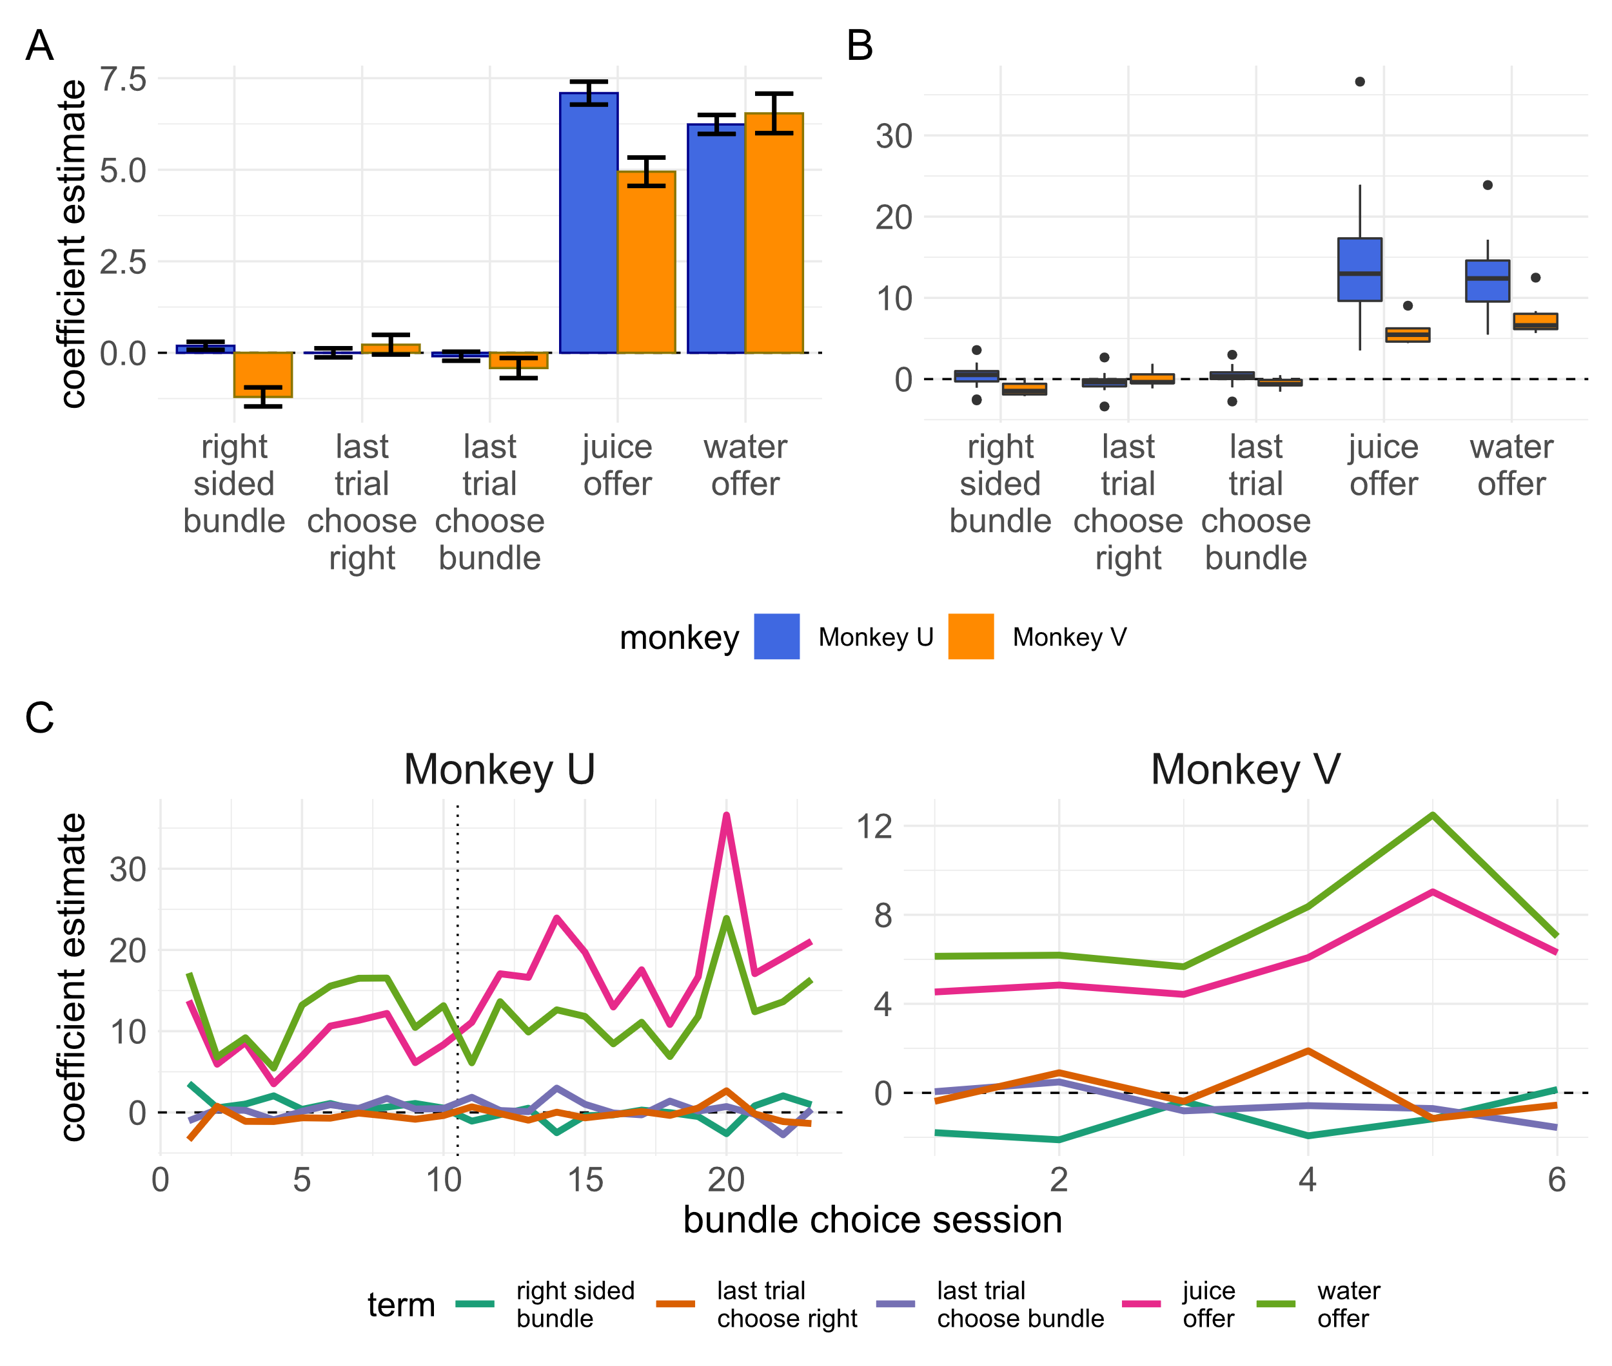
Figure 3.21a-c) the results of a logistic regression on monkey’s choices on the bundle choice task. A) Coefficient estimates for a regression of relevant task variables against monkey choices for all trials separated by monkey. Error bars represent +/- standard error. Both monkeys show similar dominance of the difference in juice and water offered in the bundle when deciding between bundles or a full ‘budget’ of water. Though significant, the coefficient estimates for the results on the last trial were negligibly small. As the regression is on the probability of choosing the right-sided option, the intercept corresponds to the bias in the monkeys choice of sides and has been relabelled here. Monkey U showed a small but consistent right-sided bias whereas monkey V showed a larger left-sided bias. B) Coefficient estimates for identical regressions grouped by both monkey and session date. Boxplots show similar findings as the single regression carried out in a). In every session, the features that best predicted the monkey’s choice on a trial were the offers of water and juice in the bundle. In c) regression coefficients from b) are plotted by session number ordered by date, showing the relationship over time. Session number rather than date is used as for monkey U there were large periods between the sessions on the bundle choice task due to the focus on gathering data from monkeys performing BDM auctions. The split in session date is shown using a dotted line for monkey U. Sessions before the line take place in October-November 2019, and sessions after take place in September-October 2020. For monkey V, all sessions take place in September-October 2020.

RANDOM UTILITY MODEL FIGURE – IN PROGRESS

FIGURE 3.22
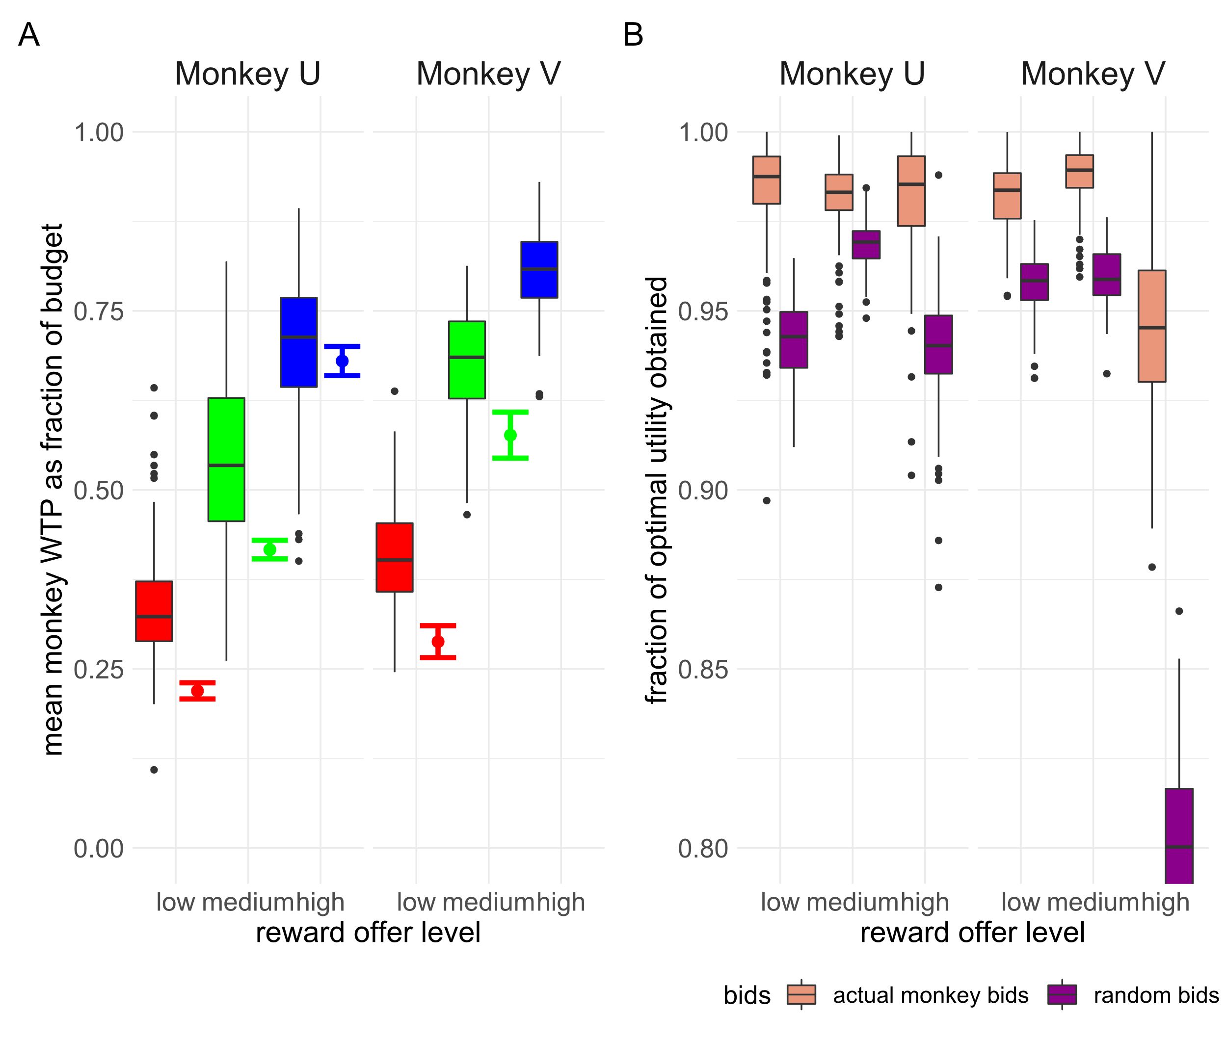
Figure 3.23a-b) Monkeys bids on the BDM compared to indifference points elicited from the bundle choice task. A) Mean monkey bids per BDM session are plotted as boxplots as in figure 3.14b, coloured by reward level. The bundle choice indifference points for the same reward levels as plotted in figure 3.19 ± the standard error of the fitted binomial function are shown to the right of each of these boxplots. Both are expressed as a fraction of the budget monkeys are willing to forgo in order to obtain juice reward, where 1 indicated willingness to miss out 1.2ml of water. The binomial fit for the largest juice volume for monkey V is above the range of the graph. B) Taking these indifference points as the utility of the juice in terms of units of water, we calculate the total utility available to a hyper rational monkey that always bid this value (1.0). The total utility actually obtained by monkeys per session in terms of water is then calculated and shown per reward level (brown boxplots) as a fraction of this ‘optimal utility’. This is compared to hypothetical utility the monkeys would have experienced if their bids were drawn at random following a uniform distribution across the possible bidding range (purple boxplots).

Efforts are made to make notebooks reproducible and code readable though due to time constraints results may vary. Contact the author for data and/or clarification of code.
Changes in the task consisted primarily of reducing the number of task epochs and shortening of the bidding epoch to shorten the overall task time and the removal of any stimuli not considered absolutely necessary for behaviour (e.g. changing of bidding bars to indicate the finalisation of bids, and the occlusion of the budget bar to indicate payment).
Imprecision due to data not included before the rewrite of the software for the task in the first two months of the project. Total trials numbers broken down by monkey, task, and completed are shown in figure 3e.
Not strictly true as it depends on the magnitudes of rewards but for both monkeys in this project the lowest magnitude fractal during the recording phase represented 0.2 and 0.3ml of juice respectively.
For a graphical example of distributions of utility (i.e. assumed bids for the BDM), see the appendix on Random Utility Theory in appendix 1.1 (figure a1.3).
Note- we do not include the intercepts of both regressions in figure 3.13. For Monkey U the intercept of the beta regression on all bids is -0.95992±0.03262 and for Monkey V the intercept is -0.49961±0.03053. By task design, the monkey’s bids are censored to 0 and the maximum of the bidding range (1). Though in theory a monkey could be motivated to bid at either extreme, such bidding tended to signal probable poor performance (see appendix 3.2) and so all such trials were excluded before analysis. For regressions including such data, typically a Tobit regression is preferred (Tobin, 1956). The negative intercepts from these regressions do not refer to the prediction of the monkey bids by the models when all selected variables are equal to 0. See equation 3.4. For the fitted regressions, such predictions are 0.183 for Monkey U and 0.295 for Monkey V.
See Cohen, 1992 for definition of effect size terminology.
Even if we expected the BDM and bundle choice tasks to give exactly equivalent WTP estimates, we would not expect the monkey to bid exactly the same value on every trial of the BDM. Utility is stochastic and indeed, one of the guiding ideas behind the experiments in this thesis is the limitation of aggregating choices over a whole session of discrete choice tasks versus trial-by-trial reports of utility from auction tasks. We compare the bids made to a hypothetical utility ‘ground truth’ from the bundle choice simply to show the limited difference the small changes in WTP make to the actual experience of the monkeys.

