**25ºC, light vs darkness**

|  |  |  |  |  |  |  |  |
| --- | --- | --- | --- | --- | --- | --- | --- |
| ID | Term_Description | Fold_Enrichment | occurrence | lowest_p | highest_p | Up_regulated | Down_regulated |
| dok00290 | Valine, leucine and isoleucine biosynthesis | 16,17554859 | 10 | 3,67645E-08 | 3,67645E-08 | ilvA, leuB, ilvB, ilvN, ilvC |  |
| dok00770 | Pantothenate and CoA biosynthesis | 9,705329154 | 10 | 5,48473E-07 | 5,48473E-07 | ilvB, ilvN, ilvC |  |
| dok00906 | Carotenoid biosynthesis | 26,68965517 | 10 | 9,1811E-07 | 9,1811E-07 | crtB, crtI, crtZ |  |
| dok00660 | C5-Branched dibasic acid metabolism | 15,25123153 | 10 | 8,02469E-06 | 8,02469E-06 | ilvB, ilvN, leuB |  |
| dok00920 | Sulfur metabolism | 5,931034483 | 9 | 0,001773172 | 0,001773172 | cysH |  |
| dok00650 | Butanoate metabolism | 8,896551724 | 10 | 0,006602721 | 0,006602721 | ilvB, ilvN |  |
| dok00260 | Glycine, serine and threonine metabolism | 3,094452774 | 9 | 0,029742908 | 0,029742908 | gcvP, ilvA |  |

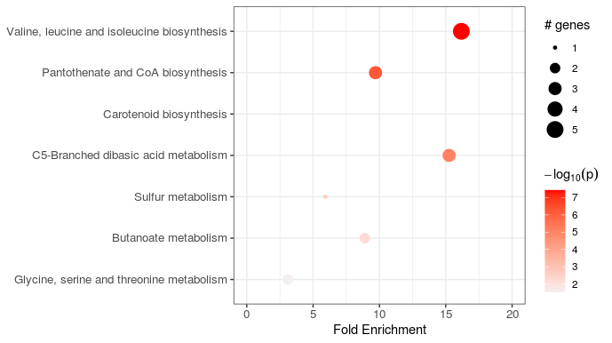

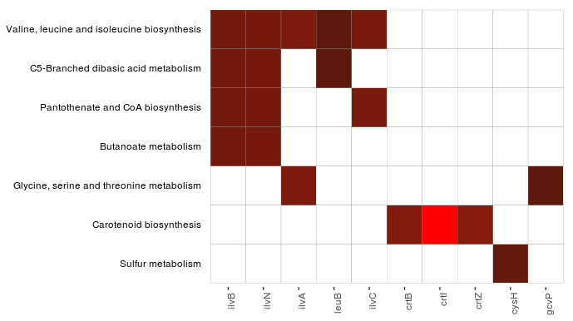

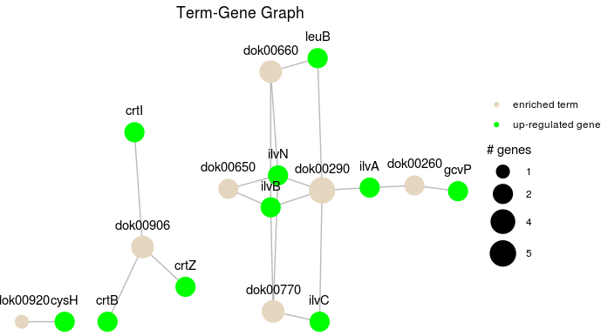

**10ºC, light vs darkness**

|  |  |  |  |  |  |  |  |
| --- | --- | --- | --- | --- | --- | --- | --- |
| ID | Term_Description | Fold_Enrichment | occurrence | lowest_p | highest_p | Up_regulated | Down_regulated |
| dok00906 | Carotenoid biosynthesis | 533.793.103.448.276 | 10 | 9,18E+07 | 9,18E+07 | crtB, crtI, crtZ |  |
| dok00520 | Amino sugar and nucleotide sugar metabolism | 418.661.257.606.491 | 3 | 0.0160195096864136 | 0.0160195096864136 | manA1 |  |

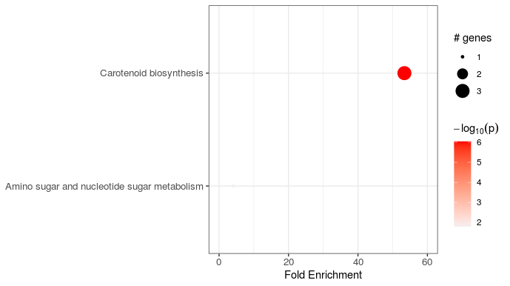

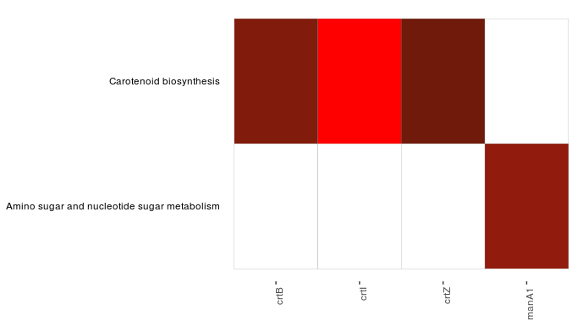

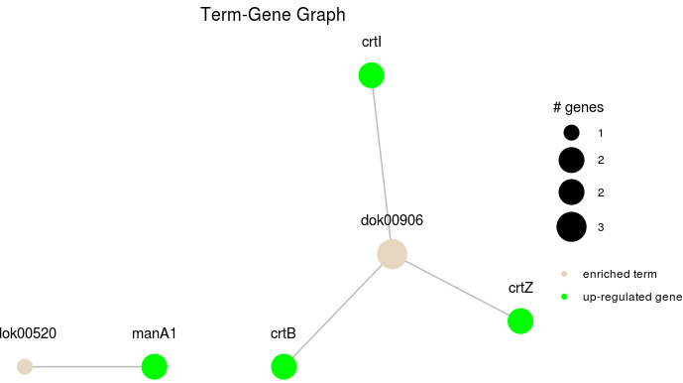

**18ºC, light vs darkness**

|  |  |  |  |  |  |  |  |
| --- | --- | --- | --- | --- | --- | --- | --- |
| ID | Term_Description | Fold_Enrichment | occurrence | lowest_p | highest_p | Up_regulated | Down_regulated |
| dok03010 | Ribosome | 244.294.367.471.977 | 10 | 4,99E-11 | 3,77E-09 | rpsP, rpsU, rpmE, rpmF, rpmH | rpsA, rpsD, rpsH, rpsM, rpsN, rpsR, rplA, rplB, rplN, rplO, rpmA, rpmD |
| dok00290 | Valine, leucine and isoleucine biosynthesis | 346.192.552.834.619 | 10 | 3,11E+06 | 3,11E+06 |  | leuD, leuB, ilvN, ilvC, ilvD |
| dok00230 | Purine metabolism | 105.051.533.273.953 | 10 | 6,61E+07 | 6,61E+07 | purD, apt, adk1 | purA |
| dok00010 | Glycolysis / Gluconeogenesis | 114.243.542.435.424 | 10 | 0.000109189412088702 | 0.000170516303319331 |  | fbaA, eno, pckA |
| dok00670 | One carbon pool by folate | 138.477.021.133.848 | 10 | 0.000781799735624311 | 0.000781799735624311 |  | thyA, metF |
| dok00770 | Pantothenate and CoA biosynthesis | 276.954.042.267.695 | 10 | 0.00111360160057986 | 0.00111360160057986 | coaD | ilvN, ilvC, ilvD |
| dok00260 | Glycine, serine and threonine metabolism | 0.993422108134125 | 10 | 0.00817337753271376 | 0.00817337753271376 | gcvP | thrC, pssA |
| dok00660 | C5-Branched dibasic acid metabolism | 435.213.494.992.093 | 10 | 0.0368050976111366 | 0.0368050976111366 |  | ilvN, sucC, leuD, leuB |

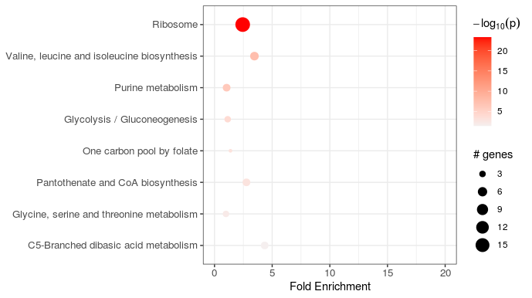

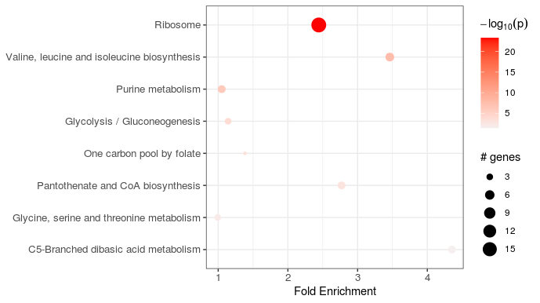

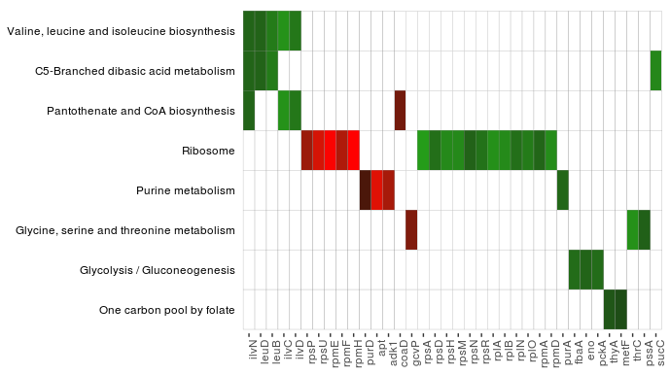

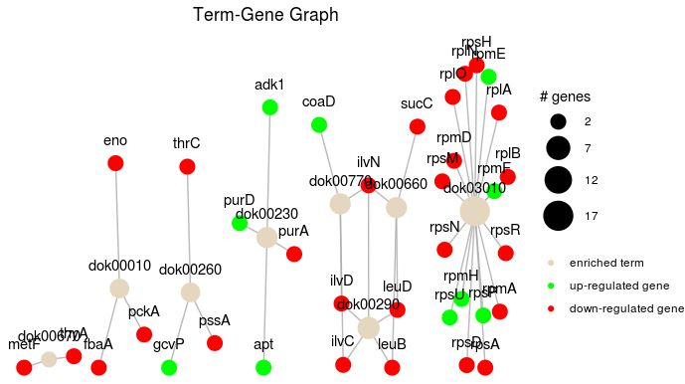

**Laura Gómez, 18ºC**

|  |  |  |  |  |  |  |  |
| --- | --- | --- | --- | --- | --- | --- | --- |
| ID | Term_Description | Fold_Enrichment | occurrence | lowest_p | highest_p | Up_regulated | Down_regulated |
| dok00290 | Valine, leucine and isoleucine biosynthesis | 5.3952948010456 | 10 | 2.50739366760625e-20 | 2.50739366760625e-20 |  | ilvA, leuC, leuD, leuB, ilvB, ilvN, ilvC, ilvD, leuA |
| dok00660 | C5-Branched dibasic acid metabolism | 4.71017800091283 | 10 | 1.42520641717612e-09 | 1.42520641717612e-09 |  | ilvB, ilvN, leuC, leuD, leuB |
| dok00770 | Pantothenate and CoA biosynthesis | 2.99738600058089 | 10 | 3.11011931330963e-08 | 3.11011931330963e-08 |  | ilvB, ilvN, ilvC, ilvD, panB |
| dok00230 | Purine metabolism | 1.36432742095406 | 10 | 7.70670693602391e-06 | 7.70670693602391e-06 | guaB | purB, purA, adk3, cysN, cysD |
| dok00970 | Aminoacyl-tRNA biosynthesis | 1.19895440023236 | 10 | 5.54675880359782e-05 | 5.54675880359782e-05 |  | serS, leuS, pheS, trpS |
| dok00620 | Pyruvate metabolism | 0.659424920127796 | 10 | 0.0035526421367329 | 0.0102745725665893 | pyc | leuA |
| dok00250 | Alanine, aspartate and glutamate metabolism | 1.38826298974273 | 10 | 0.00640746114147434 | 0.00640746114147434 | carB | purA, purB, gdhA |
| dok00450 | Selenocompound metabolism | 4.3961661341853 | 10 | 0.0164428039683376 | 0.0164428039683376 |  | metH, trxB, cysN, cysD |
| dok00650 | Butanoate metabolism | 1.64856230031949 | 10 | 0.030574203892156 | 0.0489465113214559 |  | ilvB, ilvN |
| dok00670 | One carbon pool by folate | 1.19895440023236 | 1 | 0.0449111956319503 | 0.0449111956319503 |  | metH, metF |

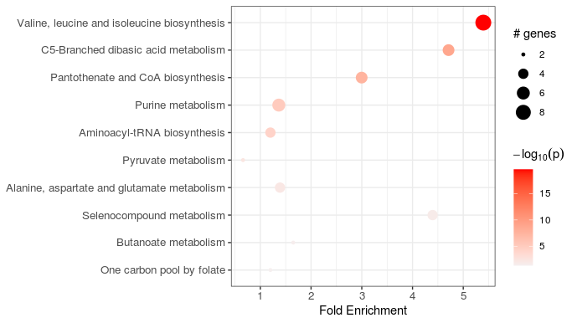

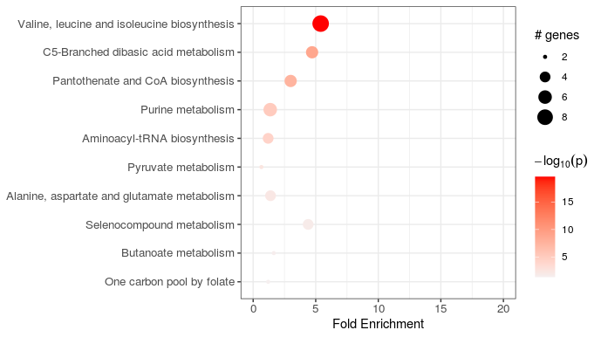

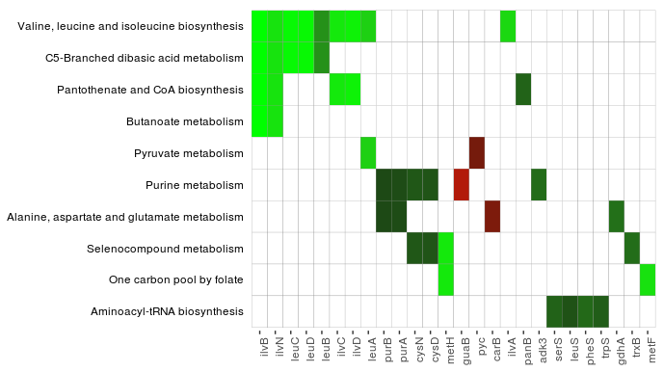

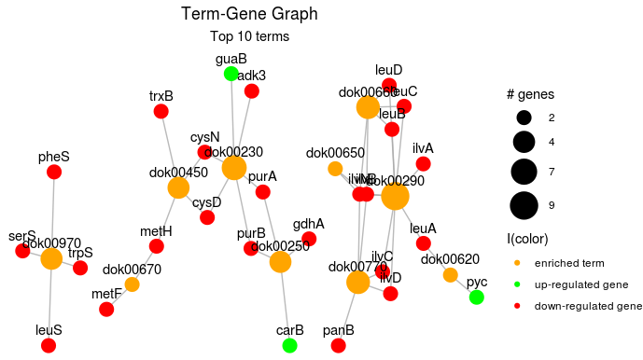

**34ºC, light vs darkness**

|  |  |  |  |  |  |  |  |
| --- | --- | --- | --- | --- | --- | --- | --- |
| ID | Term_Description | Fold_Enrichment | occurrence | lowest_p | highest_p | Up_regulated | Down_regulated |
| dok00906 | Carotenoid biosynthesis | 234.545.454.545.455 | 10 | 9,18E+07 | 9,18E+07 | crtB, crtI, crtZ |  |

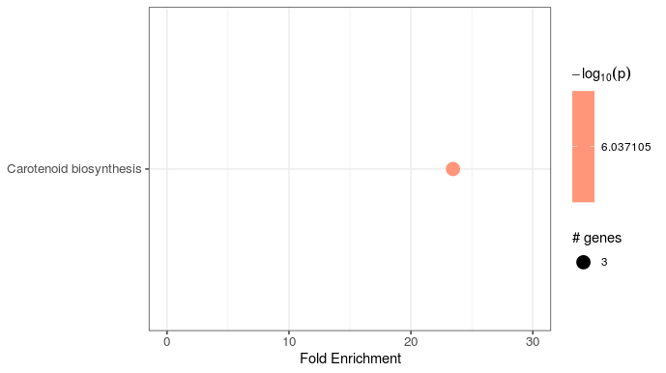

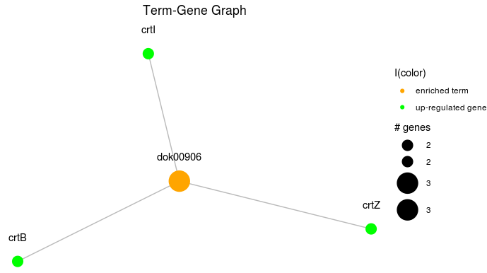

**darkness, 25ºC vs 10ºC**

|  |  |  |  |  |  |  |  |
| --- | --- | --- | --- | --- | --- | --- | --- |
| ID | Term_Description | Fold_Enrichment | occurrence | lowest_p | highest_p | Up_regulated | Down_regulated |
| dok03010 | Ribosome | 108.881.816.103.677 | 4 | 4,46E-06 | 5,02E-02 |  | rpsA, rpsB, rpsC, rpsF, rpsG, rpsI, rpsJ, rpsL, rpsN, rpsP, rpsR, rplB, rplC, rplD, rplE, rplL, rplI, rplJ, rplM, rplN, rplO, rplP, rplQ, rplV, rplW, rplX, rplY, rpmB, rpmC, rpmF |
| dok00230 | Purine metabolism | 0.862293922936016 | 2 | 1,23E+08 | 3,21E+09 | adk1, cysN, cysD | prsA, purF, purD, purT, purL, surE, guaB, pykF, relA, adk3 |
| dok00970 | Aminoacyl-tRNA biosynthesis | 113.666.017.114.293 | 2 | 0.00631507536436049 | 0.00752501261483071 | asnS, ileS | gltX, alaS, aspS, glyS, valS, lysS, argS, proS, pheS, pheT, trpS |

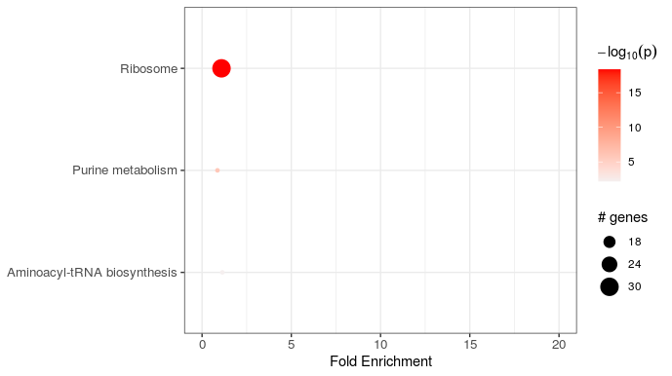

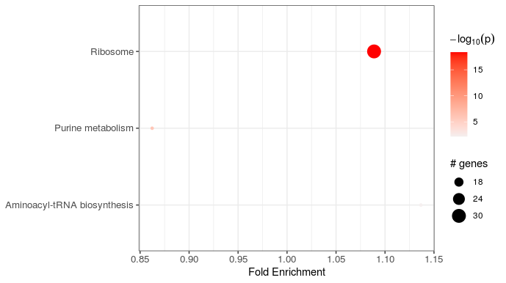

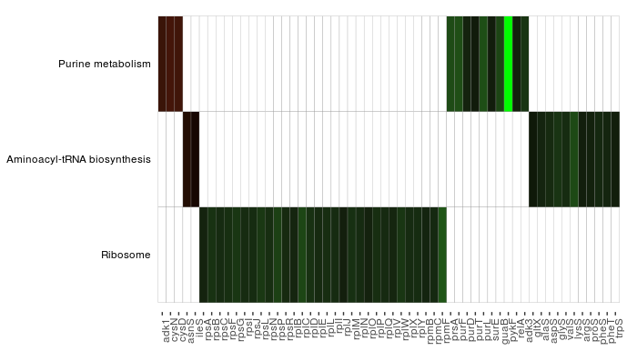

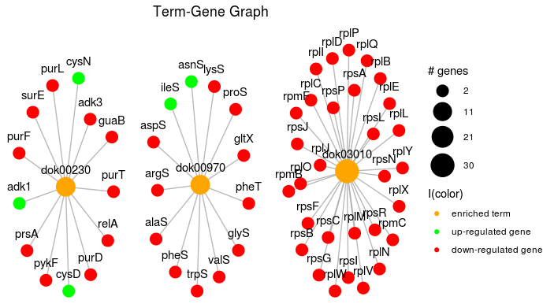

**light, 25ºC vs 10ºC**

|  |  |  |  |  |  |  |  |
| --- | --- | --- | --- | --- | --- | --- | --- |
| ID | Term_Description | Fold_Enrichment | occurrence | lowest_p | highest_p | Up_regulated | Down_regulated |
| dok03010 | Ribosome | 118.107.021.342.406 | 5 | 1,14E-04 | 3,77E-03 | rplT, rpmA, rpmI | rpsA, rpsB, rpsC, rpsF, rpsG, rpsH, rpsI, rpsJ, rpsL, rpsN, rpsP, rpsQ, rpsR, rpsS, rplB, rplC, rplD, rplE, rplF, rplI, rplJ, rplM, rplN, rplO, rplP, rplQ, rplR, rplV, rplW, rplX, rplY, rpmB, rpmC, rpmF |
| dok00230 | Purine metabolism | 0.991746749576032 | 2 | 2,30E+08 | 2,30E+08 | purN, ndk, gmk, dgt, adk1, cysN, cysD | prsA, purF, purD, purL, apt, surE, guaB, pykF, relA, adk3 |
| dok00970 | Aminoacyl-tRNA biosynthesis | 0.999701937406855 | 2 | 0.0104393300171329 | 0.0104393300171329 | asnS, thrS, ileS | alaS, aspS, glyS, valS, lysS, argS, proS, pheS, pheT, trpS |

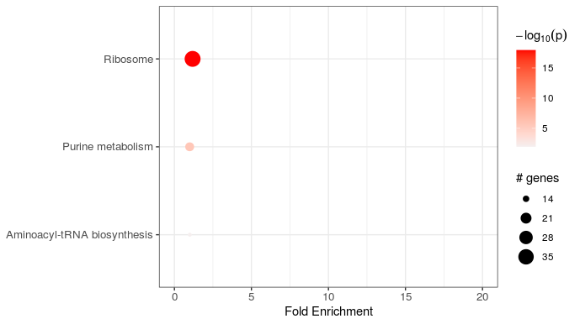

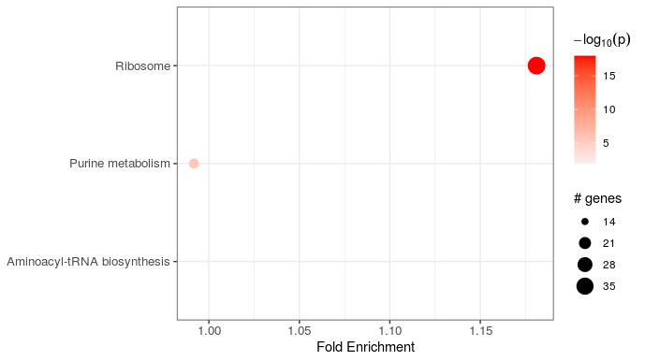

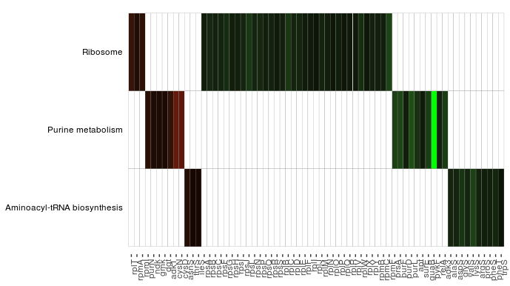

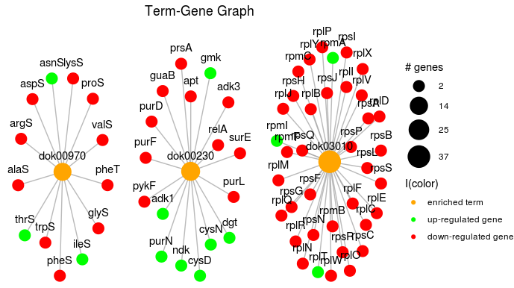

**darkness, 25ºC vs 18ºC**

|  |  |  |  |  |  |  |  |
| --- | --- | --- | --- | --- | --- | --- | --- |
| ID | Term_Description | Fold_Enrichment | occurrence | lowest_p | highest_p | Up_regulated | Down_regulated |
| dok00010 | Glycolysis / Gluconeogenesis | 182.978.723.404.255 | 10 | 8,02E-11 | 1,73E-01 | pgi, fbp, gapA3, pckA | pfkA, fbaA, tpiA, gapA1, pgk, pgm, eno, pykF, pdhA, pdhB, pdhC |
| dok00230 | Purine metabolism | 117.779.408.168.256 | 10 | 3,30E+04 | 6,19E+08 | ndk, gmk, ppx, purA, adk1, cysN, cysD | prsA, purD, purL, apt, surE, guaB, pykF |
| dok00620 | Pyruvate metabolism | 134.184.397.163.121 | 10 | 3,54E+07 | 7,68E+07 | accA, accB, accC, pyc, mdh, pckA | pdhA, pdhB, pdhC, pykF, ppc |
| dok00051 | Fructose and mannose metabolism | 170.780.141.843.972 | 10 | 4,12E+07 | 0.00540958145912889 | fcl, fbp | manA1, pfkA, fbaA, tpiA, rpiB |
| dok00680 | Methane metabolism | 182.978.723.404.255 | 10 | 1,28E+07 | 0.000161543195090933 | mdh, fbp | eno, ppc, fbaA, pfkA, pgm, serA1, serC |
| dok00660 | C5-Branched dibasic acid metabolism | 209.118.541.033.435 | 10 | 9,14E+08 | 1,49E+09 | sucD | ilvB, ilvN, leuC, leuD, leuB |
| dok00270 | Cysteine and methionine metabolism | 141.246.733.855.916 | 1 | 2,50E+09 | 2,50E+09 | cysE3, ahcY, mdh, cysM | metH, thrA, asd, metX, metY, serA1, serC |
| dok00290 | Valine, leucine and isoleucine biosynthesis | 155.254.674.403.611 | 10 | 8,45E+09 | 0.000136786513142485 |  | ilvA, leuC, leuD, leuB, ilvB, ilvN, ilvC |
| dok00030 | Pentose phosphate pathway | 146.382.978.723.404 | 10 | 0.000342312005578821 | 0.019957510903353 | pgi, fbp | pgl, gnd, rpiB, prsA, gntK, fbaA, pfkA |
| dok00020 | Citrate cycle (TCA cycle) | 128.406.121.687.197 | 10 | 0.000952488609896571 | 0.00153313812375711 | icd, sucD, mdh, pyc, pckA | sdhA, sdhB, pdhA, pdhB, pdhC |
| dok00970 | Aminoacyl-tRNA biosynthesis | 0.776273372018053 | 10 | 0.00226031853556834 | 0.00631507536436049 | asnS, ileS | alaS, glyS, valS, lysS, pheT |
| dok00240 | Pyrimidine metabolism | 127.289.546.716.004 | 10 | 0.00272125248813441 | 0.00758806981160506 | carA, pyrB, pyrC1, pyrD, pyrE, ndk, pyrG, udp, pyrR1, dut | surE, cdd |
| dok00250 | Alanine, aspartate and glutamate metabolism | 179.768.570.362.075 | 1 | 0.0415822765769998 | 0.0415822765769998 | purA, pyrB, gdhA, carA | ansA1, ansA3, asnB, ald1, ald5, argG, argH, gltS3, gltD, glnA |

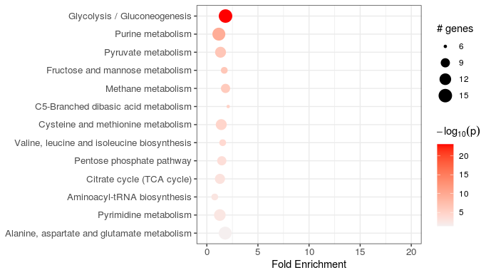

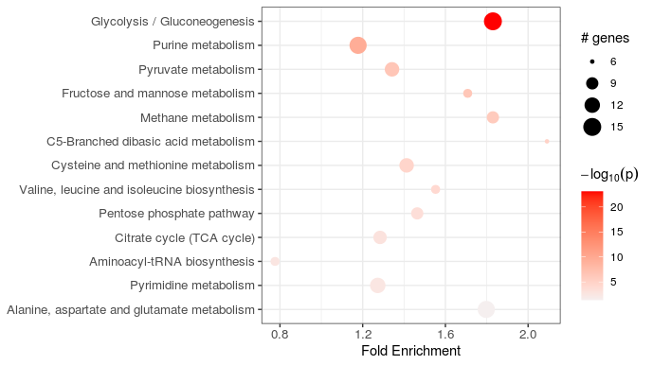

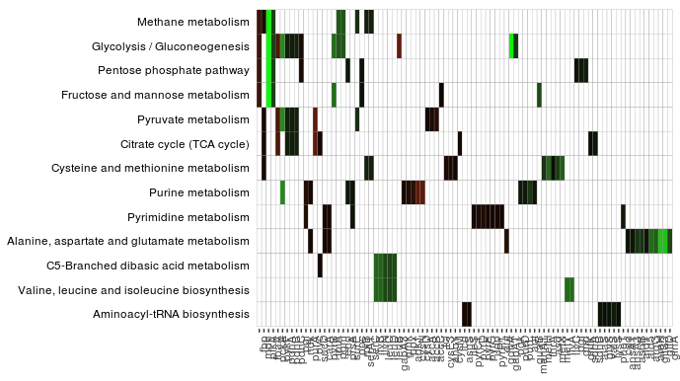

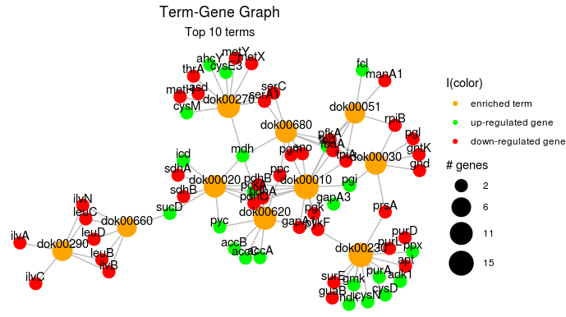

**light, 25ºC vs 18ºC**

|  |  |  |  |  |  |  |  |
| --- | --- | --- | --- | --- | --- | --- | --- |
| ID | Term_Description | Fold_Enrichment | occurrence | lowest_p | highest_p | Up_regulated | Down_regulated |
| dok03010 | Ribosome | 121.087.791.676.918 | 10 | 1,53E-04 | 4,61E+01 | rpsA, rpsB, rpsD, rpsE, rpsH, rpsI, rpsK, rpsM, rpsN, rpsS, rplA, rplB, rplE, rplF, rplJ, rplN, rplO, rplP, rplR, rplS, rplU, rplV, rplX, rpmA, rpmC, rpmD | rpsP, rpsU, rpmE, rpmF, rpmH |
| dok00010 | Glycolysis / Gluconeogenesis | 175.967.903.711.133 | 7 | 2,13E+02 | 1,55E+03 | pgi, fbp, gap, gapA3, lpd, pckA | pfkA, fbaA, tpiA, gapA1, pgk, pgm, eno, pykF, pdhA, pdhB, pdhC |
| dok00230 | Purine metabolism | 114.218.517.621.831 | 8 | 1,21E+04 | 1,26E+05 | purN, purK, punA, ndk, gmk, ppx, purA, cysN, cysD | purD, purL, apt, pykF, relA, cyaA, adk3 |
| dok00660 | C5-Branched dibasic acid metabolism | 207.021.063.189.569 | 7 | 1,85E+09 | 2,29E+09 | sucC, sucD | ilvB, ilvN, leuC, leuD, leuB |
| dok00020 | Citrate cycle (TCA cycle) | 152.541.836.034.419 | 5 | 4,48E+09 | 4,48E+09 | icd, sucB, lpd, sucD, sucC, fumC, mdh, mqo, pyc, pckA | sdhB, pdhA, pdhB, pdhC |
| dok00250 | Alanine, aspartate and glutamate metabolism | 119.854.299.741.329 | 5 | 4,48E+09 | 4,48E+09 | purA, gdhA, carA | asnB, ald1, ald5, argG, argH, gltS3, gltD, glnA |
| dok00620 | Pyruvate metabolism | 165.616.850.551.655 | 9 | 7,74E+09 | 0.00236671209694939 | lpd, accA, accB, accC, accD, pyc, mdh, mqo, fumC, pckA, phbA | pdhA, pdhB, pdhC, pykF, ppc |
| dok00290 | Valine, leucine and isoleucine biosynthesis | 150.560.773.228.777 | 7 | 0.000170516303319331 | 0.000210062511786141 |  | ilvA, leuC, leuD, leuB, ilvB, ilvN, ilvC, ilvD |
| dok00680 | Methane metabolism | 189.769.307.923.771 | 7 | 0.000254183598241683 | 0.00031301171351574 | glyA, mdh, fbp | eno, ppc, fbaA, pfkA, pgm, serA1, serA3, serC |
| dok00240 | Pyrimidine metabolism | 0.900091579085081 | 8 | 0.00520534547256621 | 0.00903838533741486 | carA, pyrD, pyrE, pyrH, ndk, pyrG, udp, dut, punA | cdd |
| dok03018 | RNA degradation | 115.011.701.771.983 | 7 | 0.00529600142452394 | 0.00616512232191096 | pnp, recQ3, ppk1 | eno, pfkA |
| dok00051 | Fructose and mannose metabolism | 124.212.637.913.741 | 7 | 0.00751892085842476 | 0.00874964680071002 | manA3, fbp | manA1, pfkA, fbaA, tpiA |
| dok00030 | Pentose phosphate pathway | 138.014.042.126.379 | 7 | 0.0276384955637031 | 0.0321038861994681 | pgi, eda, kdgK, fbp | zwf, gnd, talC, gntK, fbaA, pfkA |
| dok00910 | Nitrogen metabolism | 207.021.063.189.569 | 5 | 0.0444566312120834 | 0.0444566312120834 | gdhA | glnA, gltS3, gltD |

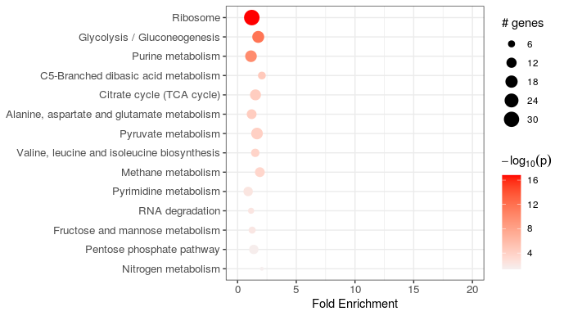

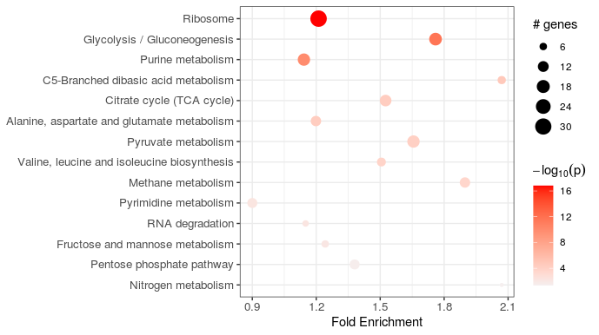

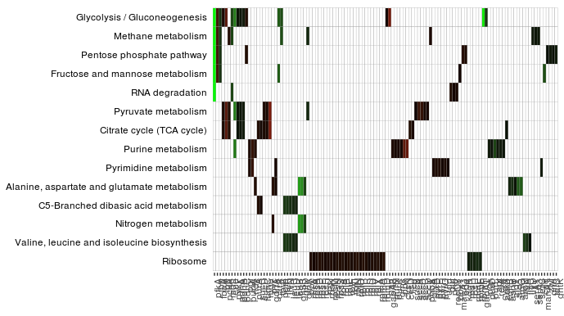

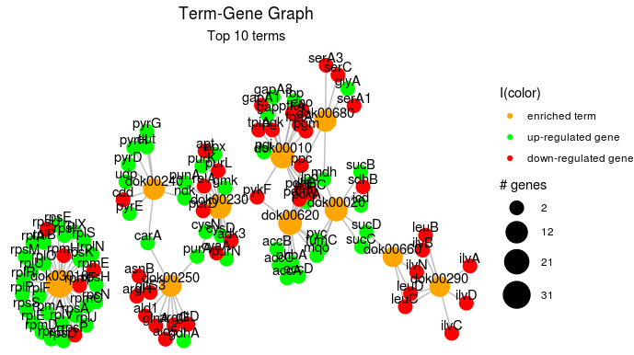

**darkness, 25ºC vs 34ºC**

|  |  |  |  |  |  |  |  |
| --- | --- | --- | --- | --- | --- | --- | --- |
| ID | Term_Description | Fold_Enrichment | occurrence | lowest_p | highest_p | Up_regulated | ID |
| dok03010 | Ribosome | 148.186.439.217.713 | 10 | 1,12E-40 | 3,21E-34 | rpsA, rpsB, rpsC, rpsD, rpsE, rpsF, rpsG, rpsH, rpsI, rpsK, rpsL, rpsM, rpsN, rpsO, rpsP, rpsQ, rpsR, rpsS, rpsT, rplA, rplB, rplD, rplE, rplF, rplL, rplI, rplJ, rplK, rplM, rplN, rplO, rplP, rplQ, rplR, rplS, rplT, rplU, rplV, rplW, rplX, rplY, rpmA, rpmB, rpmC, rpmD, rpmE, rpmF, rpmG, rpmH, rpmI | dok03010 |
| dok03020 | RNA polymerase | 157.077.625.570.776 | 1 | 0.000658983958261769 | 0.000658983958261769 | rpoA, rpoB, rpoC | dok03020 |

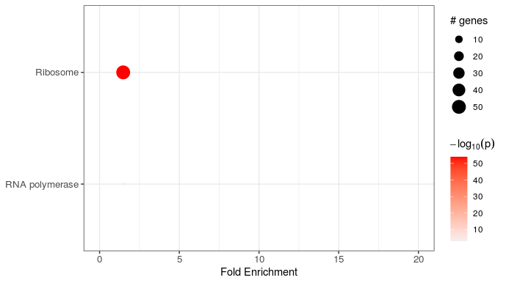

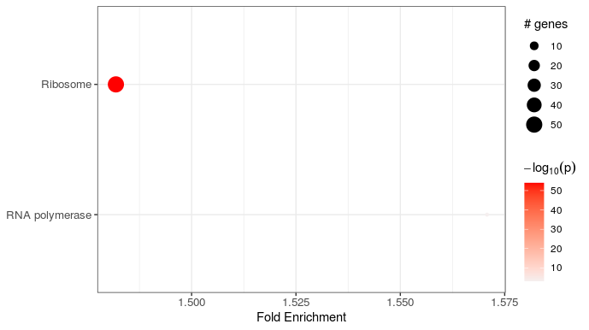

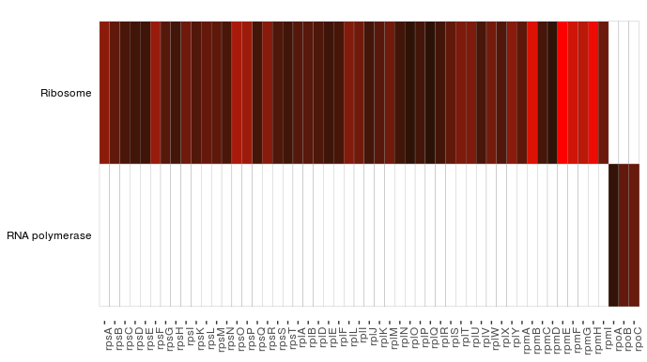

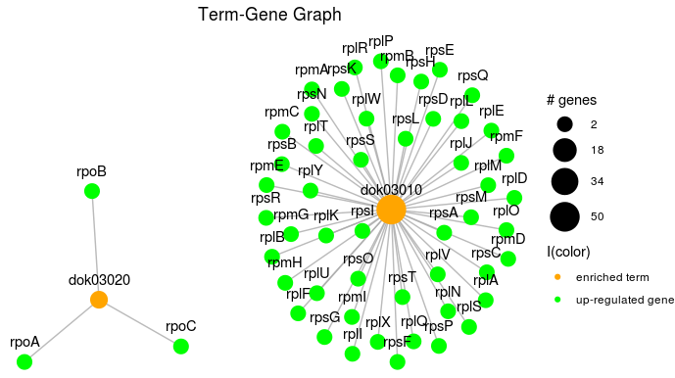

**light, 25ºC vs 34ºC**

|  |  |  |  |  |  |  |  |
| --- | --- | --- | --- | --- | --- | --- | --- |
| ID | Term_Description | Fold_Enrichment | occurrence | lowest_p | highest_p | Up_regulated | ID |
| dok03010 | Ribosome | 152.895.551.004.401 | 10 | 1,72E-67 | 1,91E-61 | rpsA, rpsB, rpsC, rpsD, rpsE, rpsF, rpsG, rpsH, rpsI, rpsJ, rpsK, rpsL, rpsM, rpsN, rpsO, rpsP, rpsQ, rpsR, rpsS, rplA, rplB, rplC, rplD, rplE, rplF, rplL, rplI, rplJ, rplK, rplM, rplN, rplO, rplP, rplQ, rplR, rplS, rplT, rplU, rplV, rplW, rplX, rplY, rpmA, rpmB, rpmC, rpmD, rpmE, rpmF, rpmG, rpmH, rpmI | dok03010 |
| dok03020 | RNA polymerase | 158.891.454.965.358 | 10 | 0.00206592618970741 | 0.00239162958510613 | rpoA, rpoB, rpoC | dok03020 |

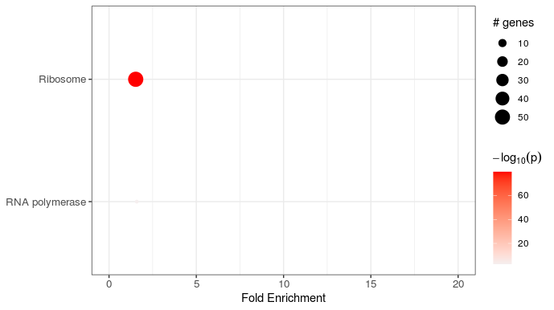

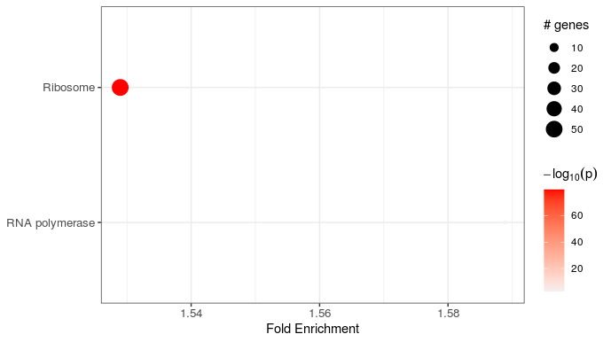

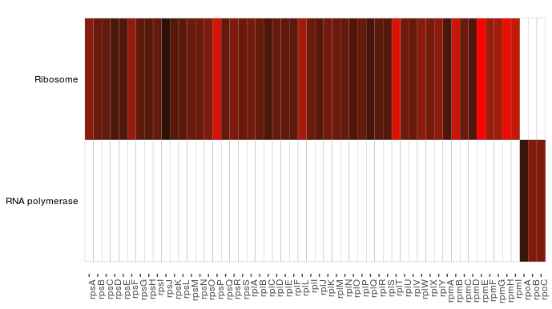

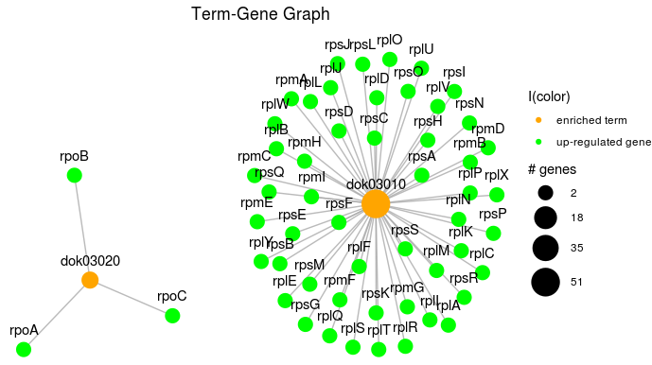

**darkness, 10ºC vs 34ºC**

|  |  |  |  |  |  |  |  |
| --- | --- | --- | --- | --- | --- | --- | --- |
| ID | Term_Description | Fold_Enrichment | occurrence | lowest_p | highest_p | Up_regulated | Down_regulated |
| dok03010 | Ribosome | 141.662.853.605.362 | 10 | 1,56E-64 | 4,79E-62 | rpsA, rpsB, rpsC, rpsD, rpsE, rpsF, rpsG, rpsH, rpsI, rpsJ, rpsK, rpsL, rpsM, rpsN, rpsO, rpsP, rpsQ, rpsR, rpsS, rplA, rplB, rplC, rplD, rplE, rplF, rplL, rplI, rplJ, rplK, rplM, rplN, rplO, rplP, rplQ, rplR, rplS, rplT, rplU, rplV, rplW, rplX, rplY, rpmA, rpmB, rpmC, rpmD, rpmE, rpmF, rpmG, rpmH, rpmI |  |
| dok03020 | RNA polymerase | 147.218.259.629.101 | 10 | 0.00227952194830428 | 0.00239162958510613 | rpoA, rpoB, rpoC |  |

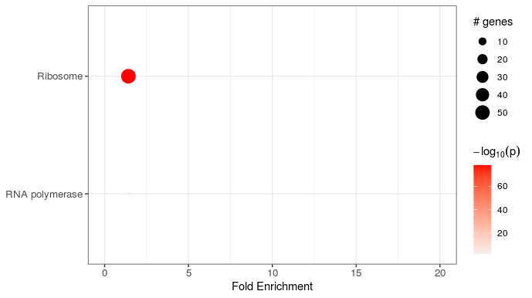

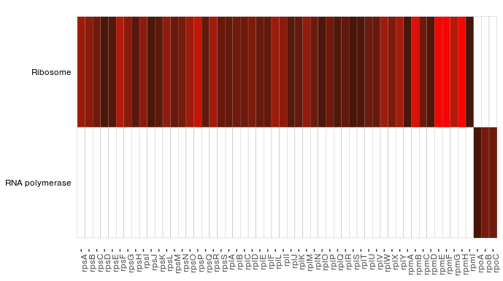



**light, 10ºC vs 34ºC**

|  |  |  |  |  |  |  |  |
| --- | --- | --- | --- | --- | --- | --- | --- |
| ID | Term_Description | Fold_Enrichment | occurrence | lowest_p | highest_p | Up_regulated | Down_regulated |
| dok03010 | Ribosome | 1.37828813847826 | 10 | 2.58635374255771e-77 | 1.21720164055047e-73 | rpsA, rpsB, rpsC, rpsD, rpsE, rpsF, rpsG, rpsH, rpsI, rpsJ, rpsK, rpsL, rpsM, rpsN, rpsO, rpsP, rpsQ, rpsR, rpsS, rplA, rplB, rplC, rplD, rplE, rplF, rplL, rplI, rplJ, rplK, rplM, rplN, rplO, rplP, rplQ, rplR, rplS, rplT, rplU, rplV, rplW, rplX, rplY, rpmA, rpmB, rpmC, rpmD, rpmE, rpmF, rpmG, rpmH, rpmI |  |
| dok03020 | RNA polymerase | 1.4323386537127 | 10 | 0.00206592618970741 | 0.00239162958510613 | rpoA, rpoB, rpoC |  |

