## CLIENT-SERVER CHAT APPLICATION

### Server

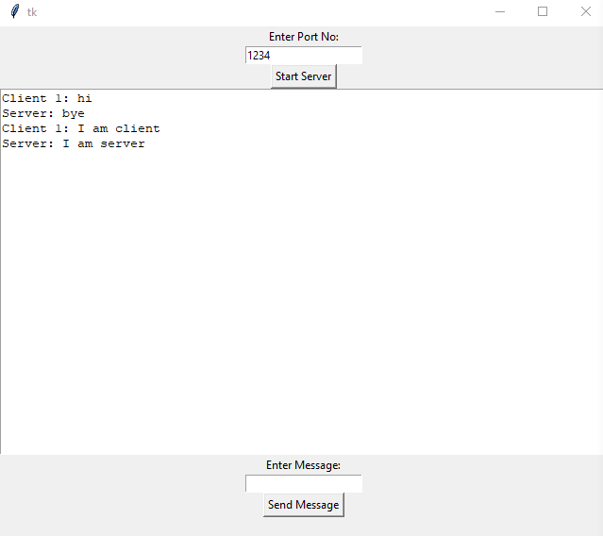

### Client

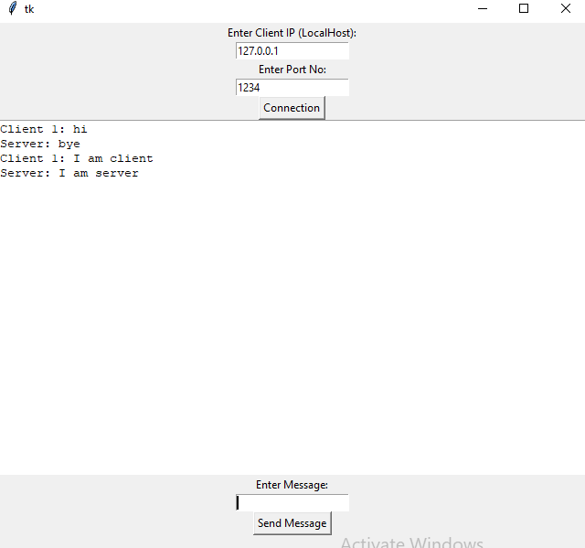

#### Client on console

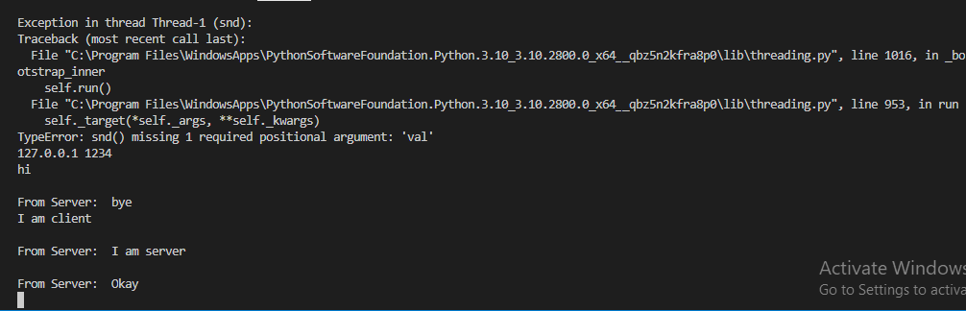

Server on console

