**Name: Robanpreet singh**

**ID: 3157655**

**Title: Canteen Management**

**Call Discussion with Client: Jatin**

I am writing the matter call record with Jatin. He has his canteen for food items. he needs a software to maintain the records in the canteen. He wants to maintain all the parts in his business where he is facing so many problems to maintain the record. he always wastes so much time to find the maintain record on manually. so he has to face so many difficulties to maintain the record for future. So he needs an application for the record maintence.

**Task 2 - Define and document requirements**

Requirement of The Software

Scope of Work

*Features: I am going to create software of on Canteen Management System. Which will be fully automated and roban can maintain and store the data for future. He can see all the customers and Items through this application online. This application would be fully secure. Data will be saved in the future efficiently. And no unauthorized person can make changes in it. So Application would be very effective and efficiency.*

*Functional Requirements: Demanded requirements by end user:-*

1. *He wants customer module save update and delete and list of customers to view.*
2. *Then he wants categories module in the software.*
3. *He wants invntories module in the software.*
4. *He wants the record of items.*
5. *He wants login and logout facility in the software.*

*Non-functional requirements:*

1. System should be secure.
2. System should be portable.
3. Performance of system should be good.
4. System should be flexible.
5. System should be reliable.

Time: It will take minimum 17 days to complete.

The 4 essential steps of the Risk Management Process are:

1. Identify the risk.
2. Assess the risk.
3. Treat the risk.
4. Monitor and Report on the risk.

Cost: $400

Project management:- When considering whether or not you have a project on your hands, there are some things to keep in mind. First, is it a project or an ongoing operation? Second, if it is a project, who are the stakeholders? And third, what characteristics distinguish this endeavor as a project?

Projects have several characteristics:

1. Projects are unique.
2. Projects are temporary in nature and have a definite beginning and ending date.
3. Projects are completed when the project goals are achieved or it’s determined the project is no longer viable.

**Task 3 - Design mockups**

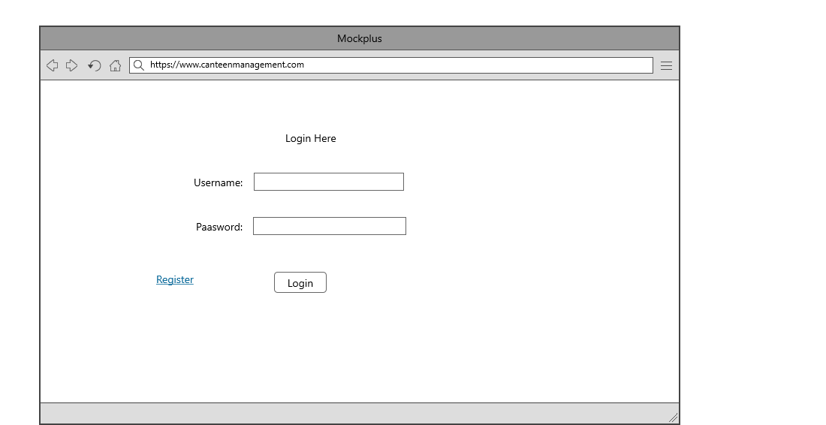

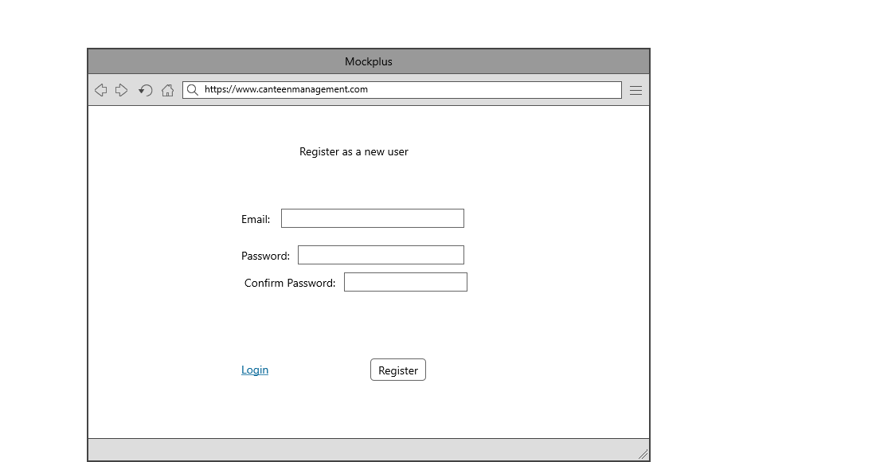

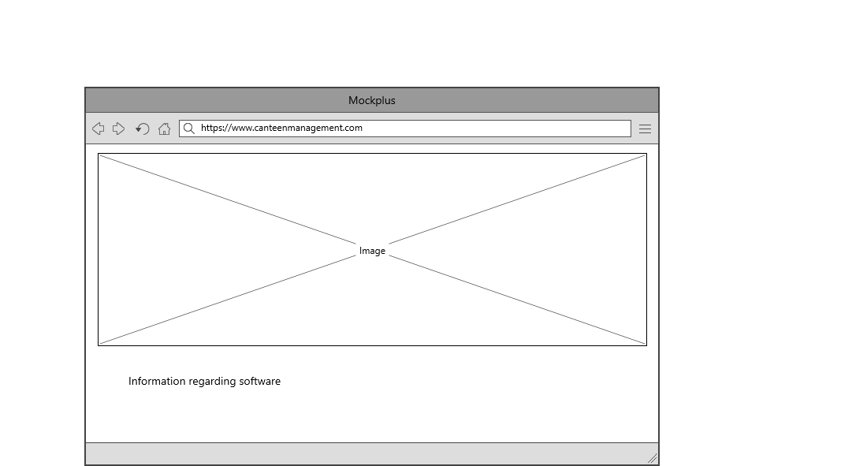

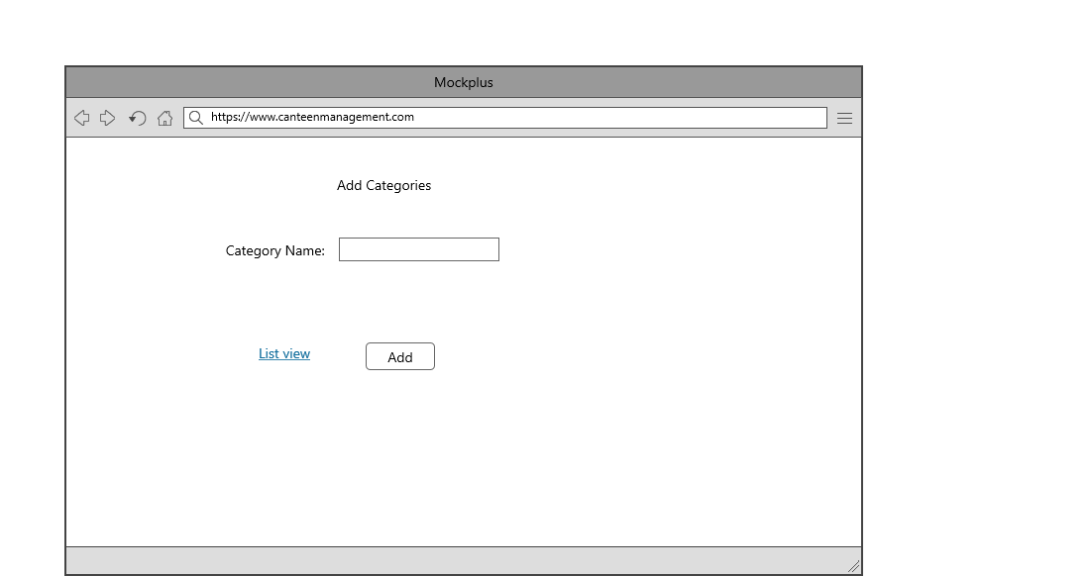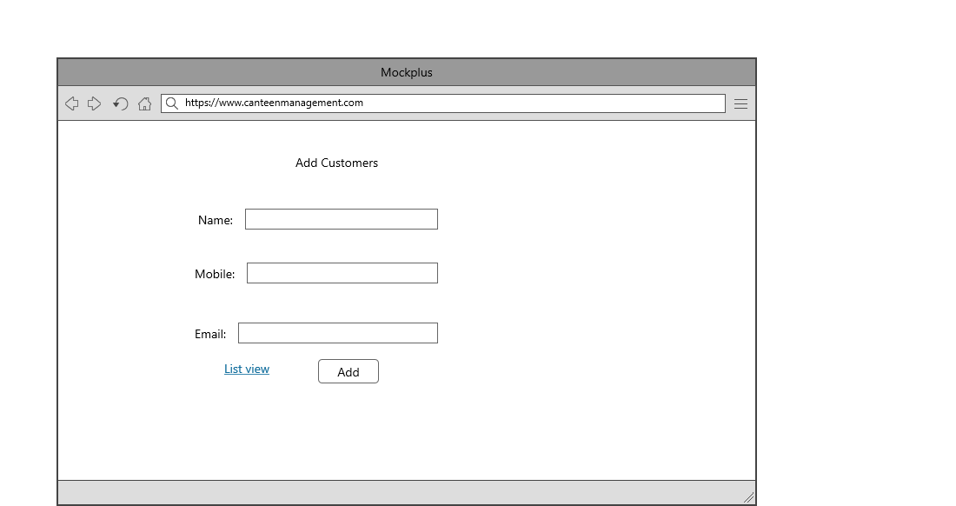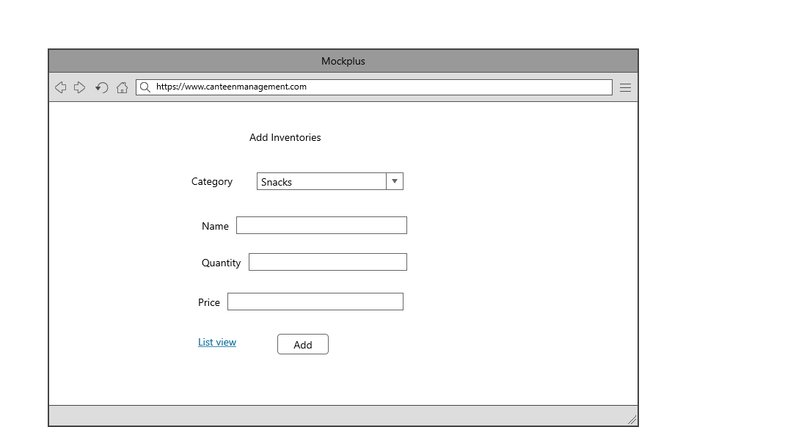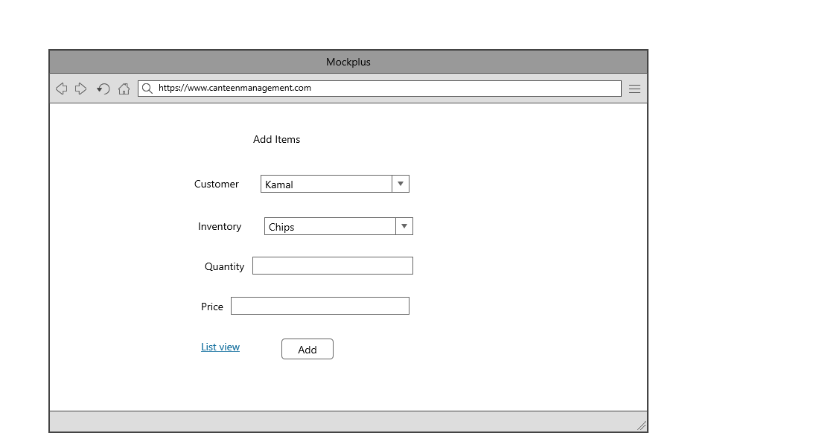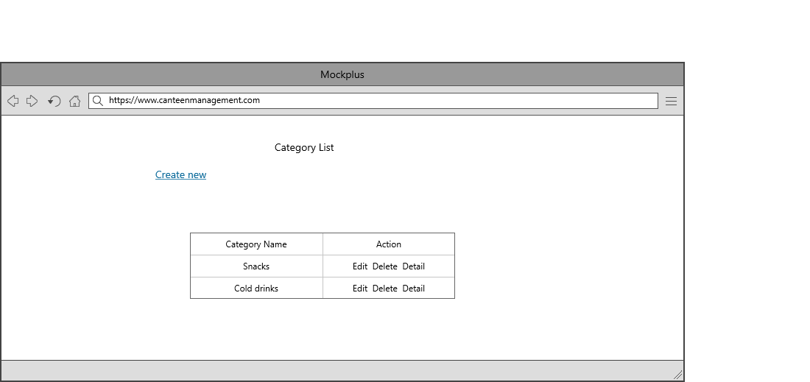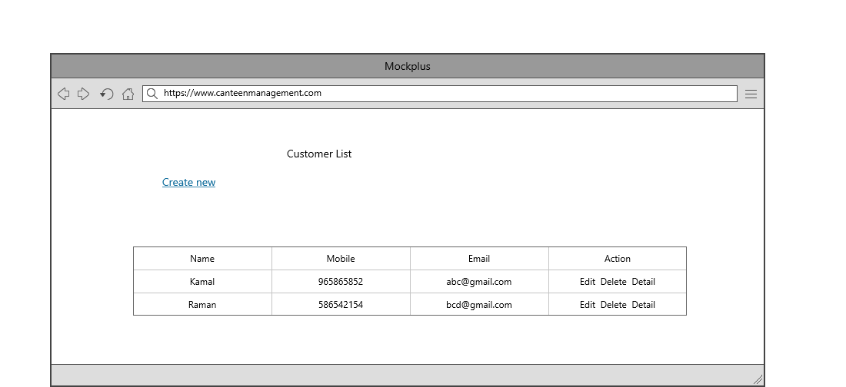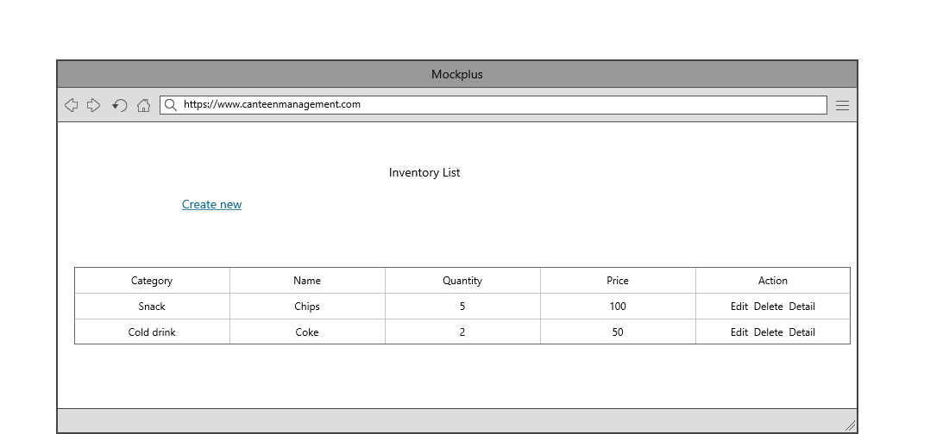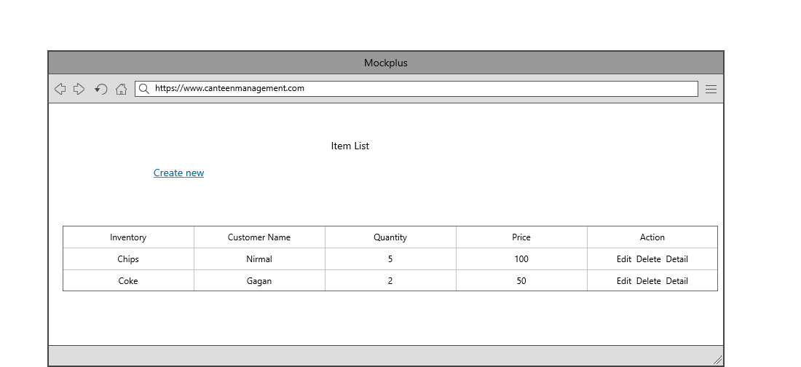

## Task 5- usability testing

|  |  |  |  |  |  |
| --- | --- | --- | --- | --- | --- |
| **User #** | **Login form** | **Customer form** | **Items Module** | **Pass / Fail / Not executed / Suspended** | **Reviews** |
| Jatin | Login form is working fine | Customer form is looking beautiful and as expected. | As Expected perfect | Pass | All modules are upon our expectations |
| Manjit | Login form design sould more attractive. | Ok | should some changes and expand more | Pass | Login form should be more attractive |
| Anil | Login form is working as expected | Very nice | Ok | Pass | Login form is putting good impression to the software. |
| Kunal | Login form is nice | good | Excellent | Pass | nice |

**Task 6 - Meet with your client**

Client Meeting:

|  |
| --- |
| Meeting Details |
| * Date and time: 25-Oct-2021 * Location: Newzealand |
| Attendees: Jatin and Roban |
| Agenda: Discussion of Software of Canteen management system |
| Discussion (Important Points): He wants neat and clean software which will work effectively |
| My To Dos (Actions): Firstly I have to make the mockups of the application. Then Starting the application after the next meeting. |
| Questions requiring Follow- Up: Discussion of the mock ups |
| Comments: Jatin is good person and he described regarding software very wisely. |
| Next meeting  Date and Time: 1- Nov-2021 1:00 Pm  Location: Newzealand  Agenda: Showing the mock ups to the client and discussion about further development. |

**Appendix 3**

**Client Review Form**

My developer’s name: Robanpreet

This form is intended to let you review the communication skills of your developer for this assignment. Your review will partly count towards their final mark. Do not take into account technical skills.

# Grading scale

You must grade your developer for each item listed in the tables below. 1 being the lowest, 5 the highest.

|  |  |  |  |  |
| --- | --- | --- | --- | --- |
| **1** | **2** | **3** | **4** | **5** |
| Strongly disagree | Disagree | Ok | Agree | Strongly agree |

# Review your developer

|  |  |  |
| --- | --- | --- |
| **Item** | **Grade** | **Comment** |
| Communicated clearly and effectively | 3 |  |
| Kept you informed of the progress | 2 |  |
| Met timelines | 3 |  |
| Responded promptly to problems | 5 |  |
| Met overall project objectives | 4 |  |
| Was open to new ideas and suggestions | 1 |  |
| Was easy to work with | 2 |  |

Comments

Provide any extra comments on your developer’s communication skills and professionalism.

## Signed by Client

|  |  |
| --- | --- |
| **Signature: Jatin** | **Date: 14-nov-2021** |
| **Name: Robanpreet** | **Title:Canteen Management System** |
| **Contact details (email/Tel):** | |

**Task 8 - Software development life cycle stages**

**Planning :-**

1. Define the problem and scope of existing system.
2. Overview the new system and determine its objectives.
3. Confirm project feasibility and produce the project Schedule.
4. During this phase, threats, constraints, integration and security of system are also considered.
5. A feasibility report for the entire project is created at the end of this phase.

**Requirement :-**

1. Gather, analyze, and validate the information.
2. Define the requirements and prototypes for new system.
3. Evaluate the alternatives and prioritize the requirements.
4. Examine the information needs of end-user and enhances the system goal.
5. A Software Requirement Specification (SRS) document, which specifies the software, hardware, functional, and network requirements of the system is prepared at the end of this phase.

**Software Design and prototyping :-**

1. Includes the design of application, network, databases, user interfaces, and system interfaces.
2. Transform the SRS document into logical structure, which contains detailed and complete set of specifications that can be implemented in a programming language.
3. Create a contingency, training, maintenance, and operation plan.
4. Review the proposed design. Ensure that the final design must meet the requirements stated in SRS document.
5. Finally, prepare a design document which will be used during next phases.

**Screenshots**

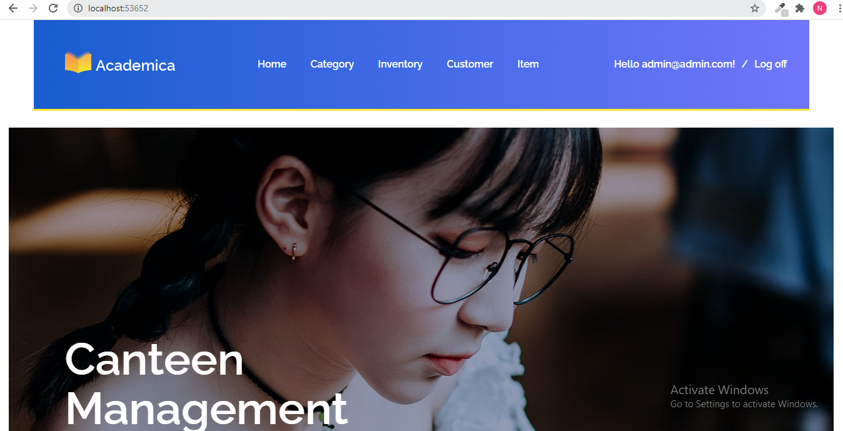

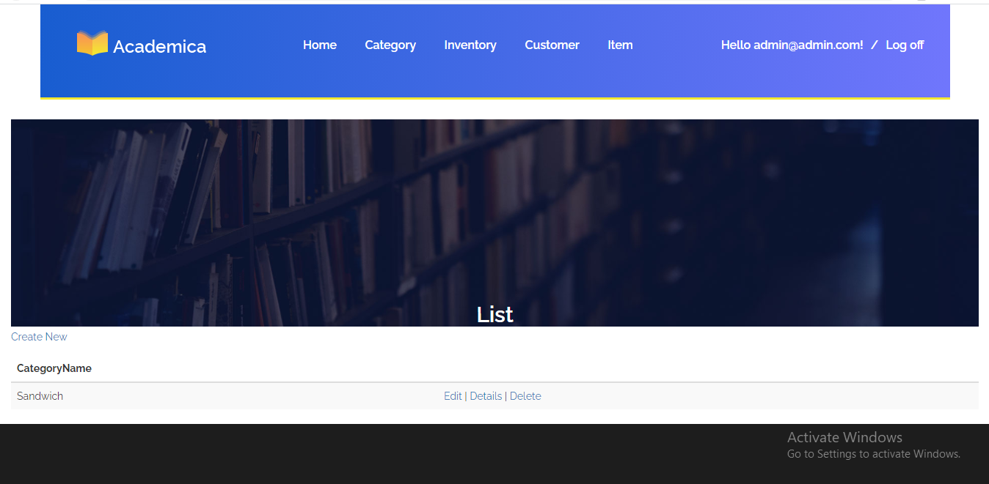

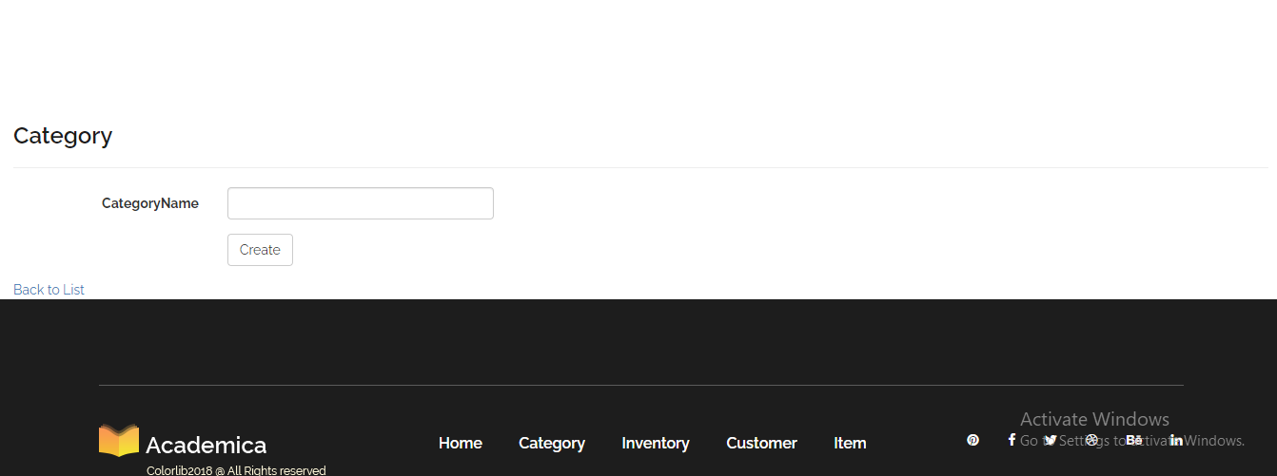

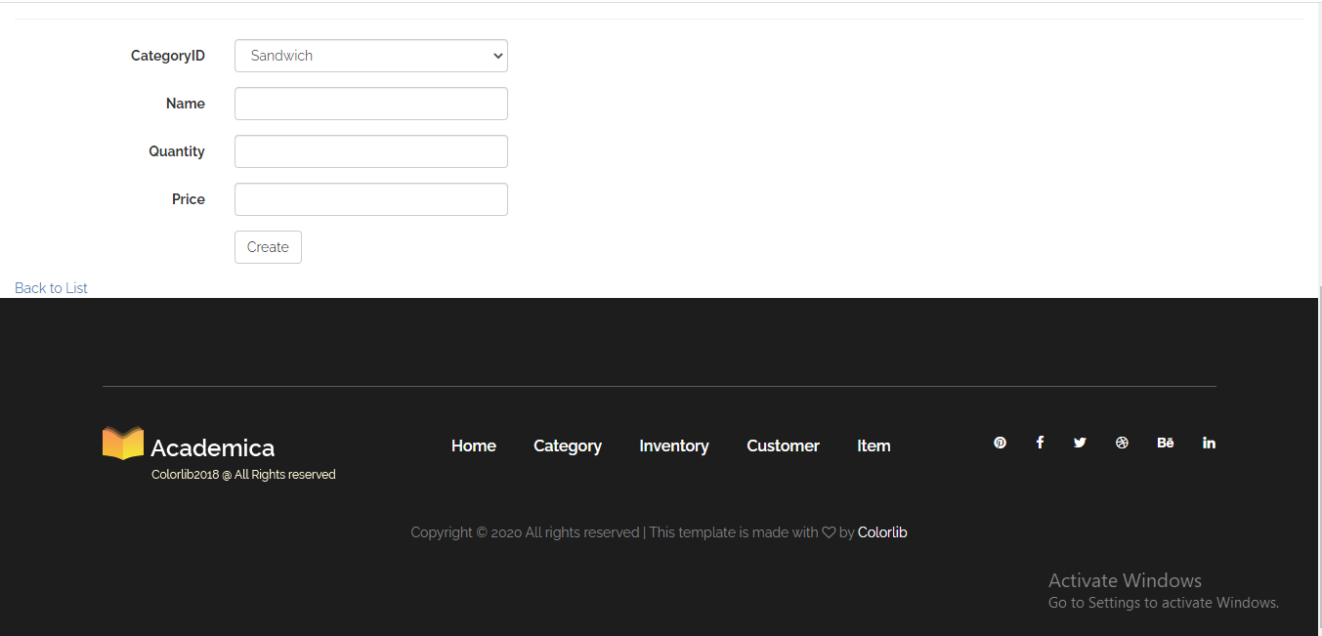

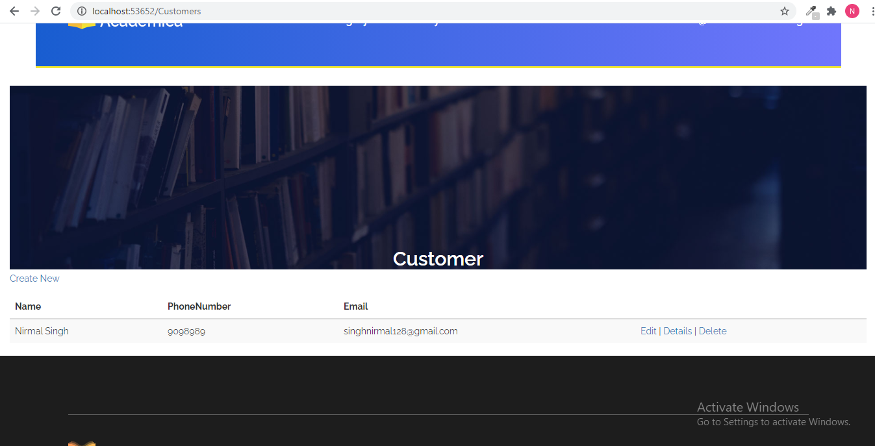

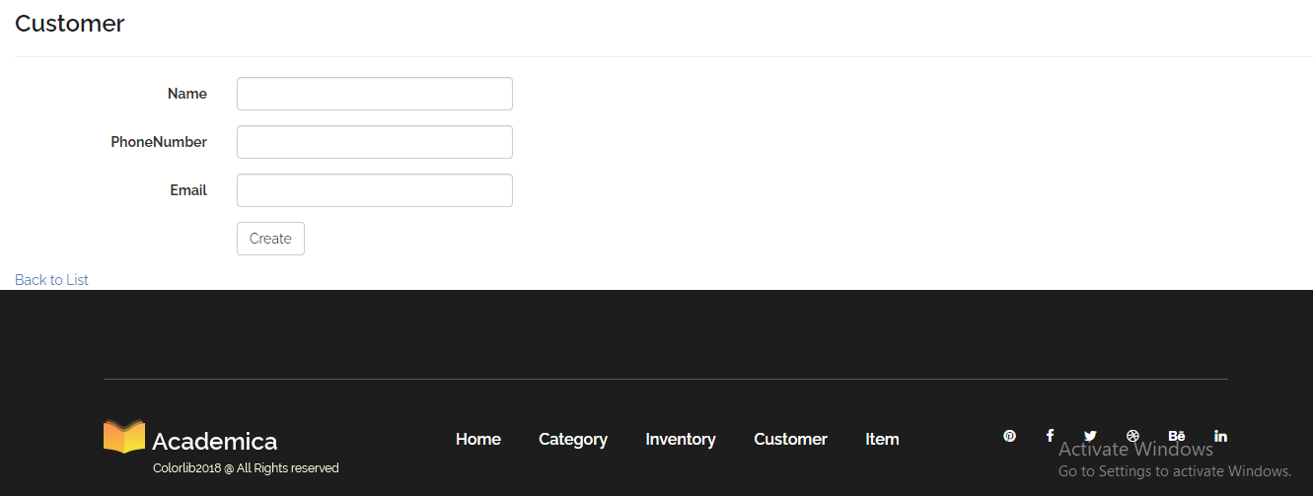

**Software Development:**

1. Implement the design into source code through coding.
2. Combine all the modules together into training environment that detects errors and defects.
3. A test report which contains errors is prepared through test plan that includes test related tasks such as test case generation, testing criteria, and resource allocation for testing.
4. Integrate the information system into its environment and install the new system.

**Testing:**

1. Include all the activities such as phone support or physical on-site support for users that is required once the system is installing.
2. Implement the changes that software might undergo over a period of time, or implement any new requirements after the software is deployed at the customer location.
3. It also includes handling the residual errors and resolve any issues that may exist in the system even after the testing phase.
4. Maintenance and support may be needed for a longer time for large systems and for a short time for smaller systems.

**Task 9- Project management**

The project evaluation process uses systemic analysis to gather data and reveal the effectiveness and efficiency of your management. This crucial exercise keeps projects on track and informs stakeholders of progress.

Every aspect of the project is measured to determine if it’s proceeding as planned, and if not, inform how project parts be improved. Basically, you’re asking the project a series of questions designed to discover what is working, what can be improved and whether the project is in fact useful. Tools like project dashboards and trackers help in the evaluation process by making key data readily available.

The project evaluation process has been around as long as there have been projects to evaluate. But when it comes to the science of project management, project evaluation can be broken down into three main types: pre-project evaluation, ongoing evaluation and post-project evaluation. So, let’s look at the project evaluation process, what it entails and how you can improve your technique.