AI Lab 5



Session: 2022 – 2026

# Submitted by:

Robass Atif 2022-CS-150

# Submitted to:

Mr. Numan Shafi

Department of Computer Science

**University of Engineering and Technology Lahore Pakistan**

# Task 01

# 

# Output

# 

# 

# Task 02

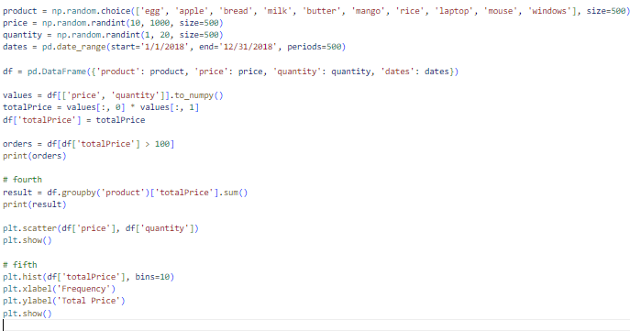

# Output

# 

# 

# Task 03

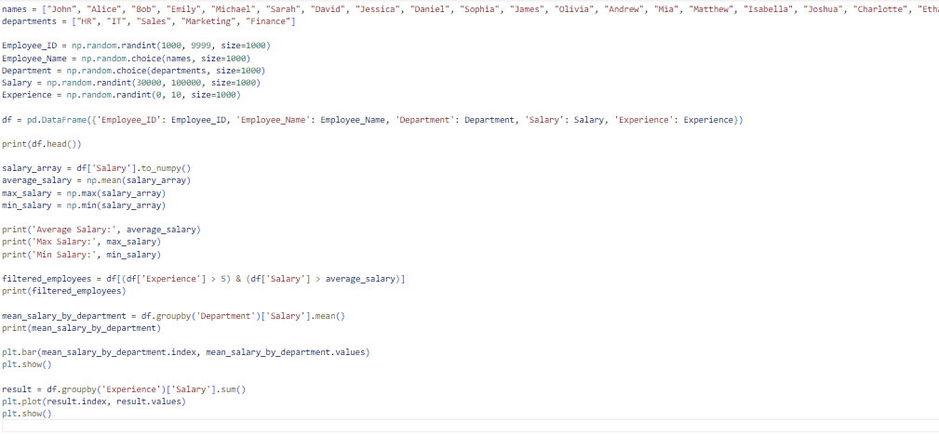

# Output

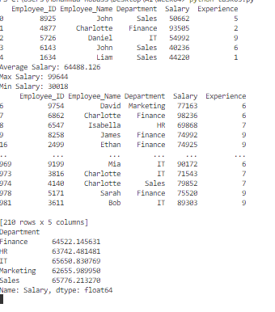

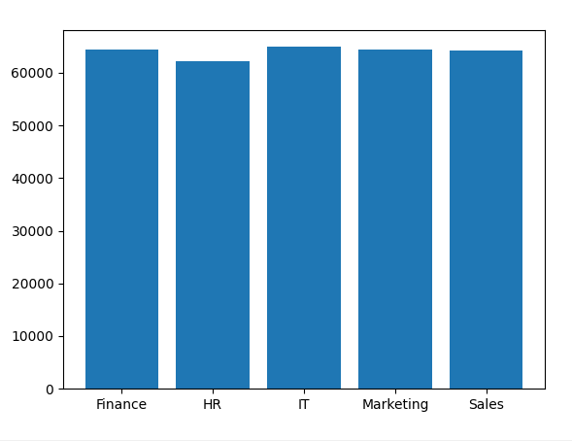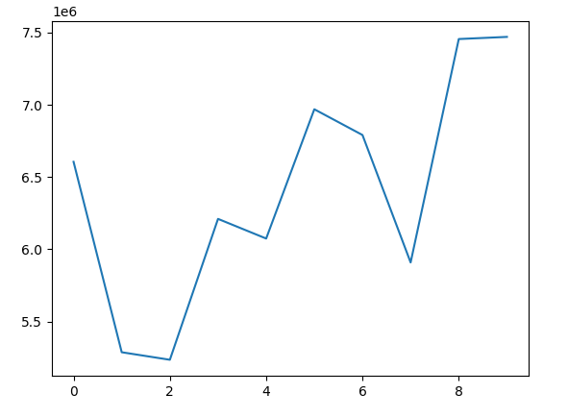

# Task 04

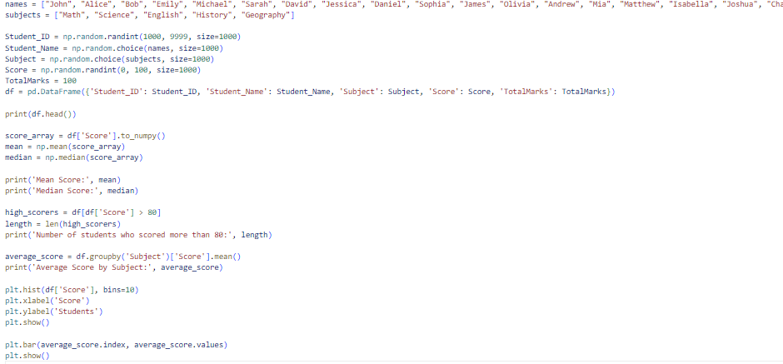

# Output

# 

# 

# Task 05

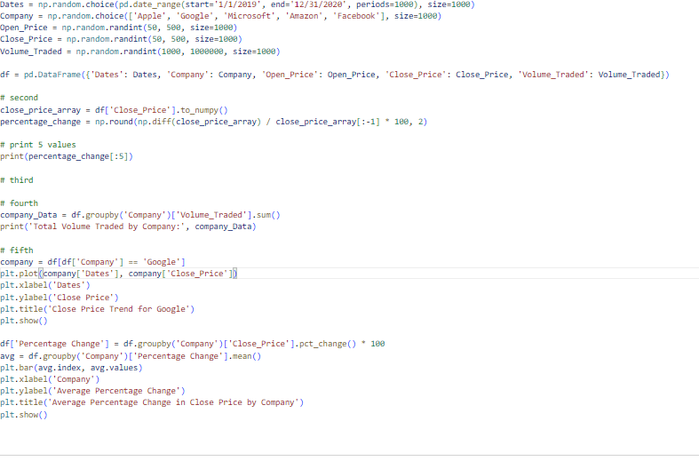

# Output

