This repository contains 2 scripts for analyzing single molecule time traces with a method called Single molecule Kinetic Analysis of RNA Transient Structure (SiM-KARTS). The original incarnation was written by Mario Blanco, during his time working in Nils Walter’s Lab at the University of Michigan. This method was originally published in Nature Communications in 2016 (doi: 10.1038/ncomms9976). The Burst Analysis portion of this code (as is attributed in the code itself) was taken from the article by Gourévitch, B. & Eggermont, in the Journal of Neuroscience Methods in 2007 (doi: 10.1016/j.jneumeth.2006.09.024). The script to calculate the Fano factor came from the Walter lab and was created by Mario Blanco and Paul Lund and was also initially described in the aforementioned Nature Communications paper.

*GlobalBurstAnalysis_Production_Protocol*: Is a script written in MATLAB that accepts the idealized traces of the FP fluorescence intensity and returns the plots, and .txt files, of the dwell times of the unbound state (inter spike interval, or ISI) in both histogram and cumulative density function format. The data can be taken from the .txt files and can be fit with your desired curve fitting software. Data input format should be as a column in comma separated value format with a file extension of .dat.

*Fano_Calc_formatted*: Is a script written in MATLAB that accepts idealized traces of the FP fluorescence intensity and returns the calculated Fano Factor for multiple time windows. Data input format should be as a column in comma separated value format with a file extension of .dat. The error bounds are calculated with an inverse gamma function, which means that they are proportional to the total number of transitions (to a point). To improve the confidence interval, increase the number of traces.

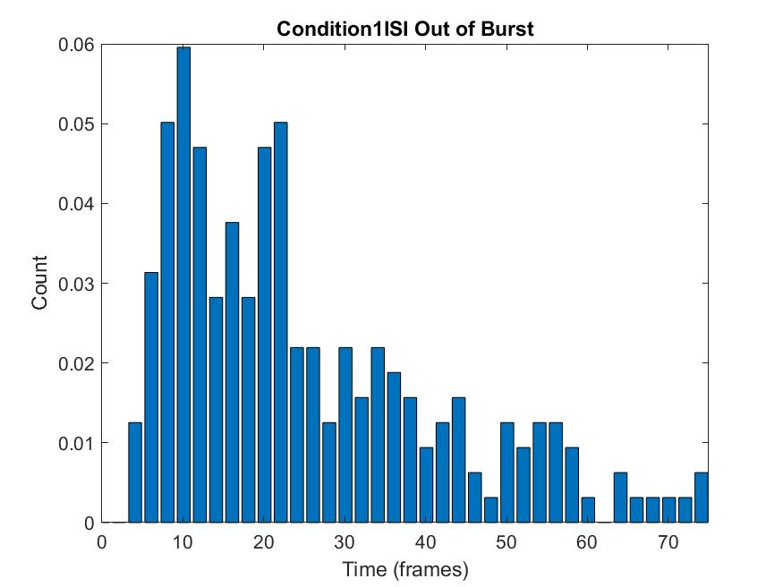

Figure Output of *GlobalBurstAnalysis_Production_Protocol*, This is a graphic that automatically is produced by the *GlobalBurstAnalysis_Production_Protocol* script. It is a histogram of the Inter-spike intervals, ISI, outside of the Burst (the conformation that is less amenable to FP binding). The raw histogram data is produced in *.txt format for easy import in to curve fitting software.

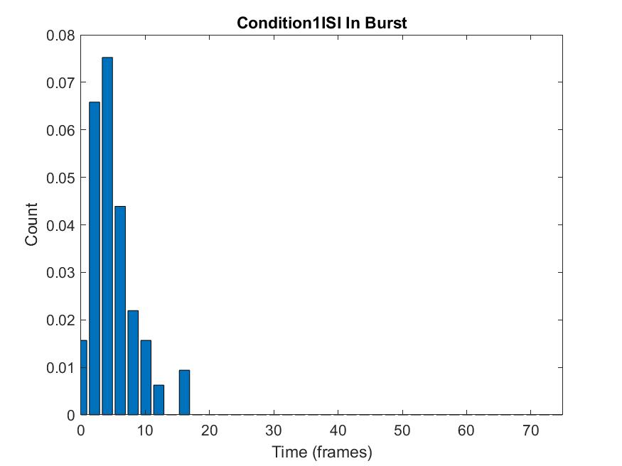

Figure *2* Output of *GlobalBurstAnalysis_Production_Protocol*, This is a graphic that automatically is produced by the *GlobalBurstAnalysis_Production_Protocol* script. It is a histogram of the Inter-spike intervals, ISI, inside of the Burst (the conformation that more less amenable to FP binding). The raw histogram data is produced in *.txt format for easy import in to curve fitting software.

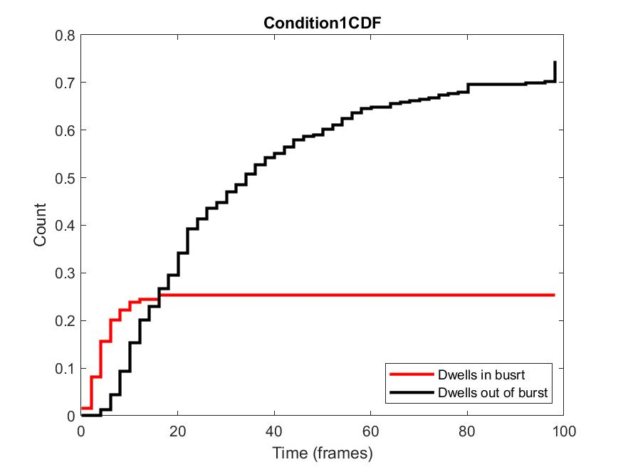

Figure Output of *GlobalBurstAnalysis_Production_Protocol*, This is a graphic that automatically is produced by the *GlobalBurstAnalysis_Production_Protocol* script. It is a cumulative histogram of the Inter-spike intervals in and out of the burst.