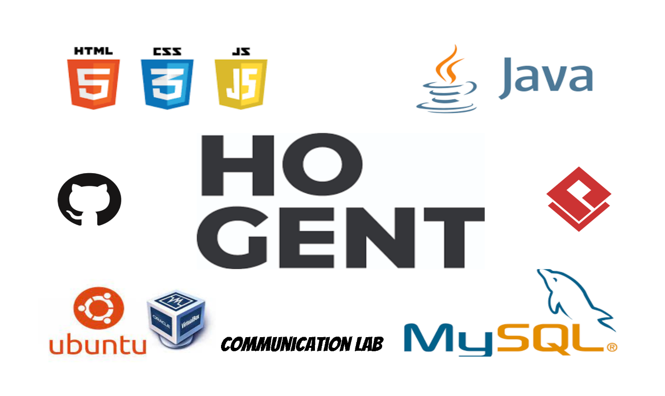

Inhoudsopgave: Datum: 13/05/2024

1 Skills lab – Unit 1: 3

1.1 Writing business mails: 3

1.2 Telephoning – business context: 3

2 Skills lab – Unit 2: 4

2.1 Linking words: 4

2.2 Comparing and contrasting: 4

2.3 Holding a meeting: 4

2.4 Hold a debate: 4

3 Skills lab – Unit 3: 5

3.1 Confirming and making arrangements: 5

3.2 Diplomatic language usage: 5

4 Skills lab – Unit 4: 6

4.1 Cross-cultural communication: 6

4.2 Opinion piece: 6

4.3 Use of modal verbs: 6

4.4 Use of conditionals: 6

5 Skills lab – Unit 5: 7

5.1 Type of graphs: 7

5.2 Prepositions: 7

5.3 Tenses: 7

5.4 False friends: 7

5.5 Difference between describing and interpreting trends: 7

6 Skills lab – Unit 6: 8

6.1 Negotiations: 8

6.2 Language for negotiations: 8

6.3 Writing an momo: 8

# Skills lab – Unit 1:

## Writing business mails:

## Telephoning – business context:

Answering the phone:

Good morning. This **is *_name_ _surname_*** from ***_company-name_***. How can I help you?

The reason for calling:

Could I speak to ***_name-you-want-to-call_*** please?

Is Mr./Mss. ***_name-you-want-to-call_*** available?

Who would

# Skills lab – Unit 2:

## Linking words:

## Comparing and contrasting:

## Holding a meeting:

## Hold a debate:

# Skills lab – Unit 3:

## Confirming and making arrangements:

## Diplomatic language usage:

# Skills lab – Unit 4:

## Cross-cultural communication:

## Opinion piece:

## Use of modal verbs:

## Use of conditionals:

# Skills lab – Unit 5:

## Type of graphs:

## Prepositions:

## Tenses:

## False friends:

## Difference between describing and interpreting trends:

# Skills lab – Unit 6:

## Negotiations:

## Language for negotiations:

## Writing an momo: