## LECTURE 5 (2022)

Blood Analysis

**Blood**: is a highly specialized tissue composed of more than 4,000 different kinds of components. Four of the most important ones are red cells, white cells, platelets, and plasma.

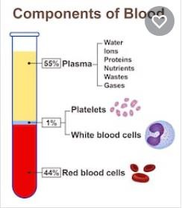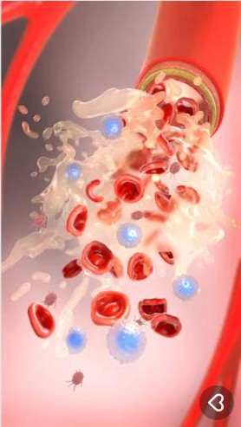

## Blood responsible of:

- **Transporting oxygen and nutrients** to cells and **getting rid of carbon dioxide, ammonia, and other waste products**.

-In addition, it plays a vital role **in immune system** and **in maintaining a relatively constant body temperature**

1. **Red Cells** or **erythrocytes**, are relatively large microscopic cells without nuclei. Red cells normally make up 40-50% of the total blood volume. They transport oxygen from the lungs to all of the living tissues of the body and carry away carbon dioxide. The red cells are produced continuously in bone marrow from [**stem cells**](http://anthro.palomar.edu/blood/glossary.htm#stem_cells)at a rate of about 2-3 million cells per second.

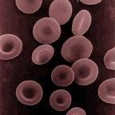

**Human erythrocytes or "red cells" (cell diameter about .0003 inches)**

**Hemoglobin** is the gas transporting [**protein**](http://anthro.palomar.edu/blood/glossary.htm#proteins)molecule that makes up 95% of a red cell. Each red cell has about 270,000,000 iron-rich hemoglobin molecules. People who are anemic generally have a deficiency in red cells, and subsequently feel fatigued due to a shortage of oxygen. The red color of blood is primarily due to oxygenated red cells. Human fetal hemoglobin molecules differ from those produced by adults in the number of amino acid chains.

# White Cells

[**White**](https://www.boundless.com/physiology/definition/white-blood-cell)[**blood**](https://www.boundless.com/physiology/definition/white-blood-cell) **cells, or leukocytes,** exist in variable numbers and types but make up a very small part of blood's volume--normally only about 1% in healthy people.

Leukocytes are not limited to blood. They most notably in the spleen, liver, and lymphglands. Most are **produced in bone marrow** from the same kind of stem cells that produce red blood cells. Others **are produced in the thymus gland**, which is at the base of the neck.

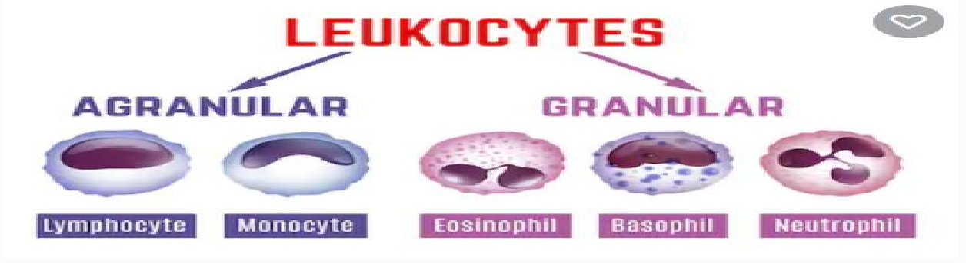

Some white cells are involved in defending the body against both infectious disease and foreign materials. There are several different types of white blood cells. They all have many things in common but are all distinct in form and function. A major distinguishing feature is the presence of granules; white blood cells are often characterized as granulocytes or agranulocytes.

## A-Granulocytes

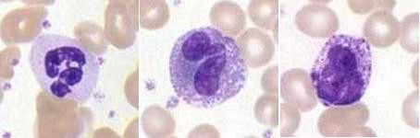

Granulocytes, also known as polymorphonuclear leukocytes are characterized by differently stained granules as viewed in their [cytoplasm](https://www.boundless.com/physiology/definition/cytoplasm) under light microscopy. These granules **are membrane-bound enzymes** that act primarily in the digestion of endocytic particles. There are three types of granulocytes:

**- Neutrophils** defend against bacterial or fungal [infection](https://www.boundless.com/physiology/definition/infection) and other very small inflammatory [processes](https://www.boundless.com/physiology/definition/process). They are usually the first responders to microbial infection; their activity and death in large numbers forms pus.

**-Eosinophils** primarily deal with parasitic infections. They are also the predominant inflammatory cells in allergic reactions.

**-Basophils** are chiefly responsible for allergic and [antigen](https://www.boundless.com/physiology/definition/antigen) response by releasing the chemical histamine, which causes dilation of the blood vessels.

## B-Agranulocytes

Agranulocytes, or mononuclear leukocytes, are leukocytes characterized by absence of granules in their cytoplasm. Agranulocytes **contain** [**lysosomes**](https://www.boundless.com/physiology/definition/lysosome)which are small vesicles containing [**digestive enzymes**](https://www.boundless.com/physiology/definition/digestive-enzymes)that break down any foreign matter that are endocytic by the cell. A granulocytes cells include:

## Lymphocytes: they are three types :

* + - B-lymphocytes, which produce [antibodies](https://www.boundless.com/physiology/definition/antibody) in the [humoral](https://www.boundless.com/physiology/definition/humoral) immune response.
    - T-lymphocytes which participate in the cell-mediated immune response.
    - The null group which contains natural killer cells; [cytotoxic](https://www.boundless.com/physiology/definition/cytotoxic) cells that participate in the innate immune response.

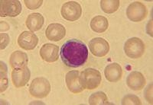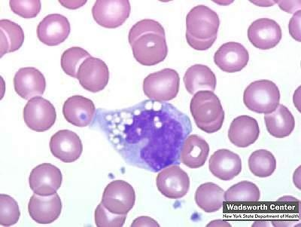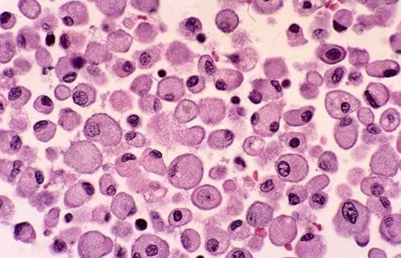

**2-Monocytes:** present pieces of [pathogens](https://www.boundless.com/physiology/definition/pathogen) to [T cells](https://www.boundless.com/physiology/definition/t-cells) so that the pathogens may be recognized again and killed, or so that an antibody response may be mounted.

**3- Macrophages**: are monocytes that have migrated out of the blood stream into the body tissues. They take up and destroy necrotic cell debris and foreign material including viruses, bacteria, and tattoo ink.

**3-Platelets**

**Platelets , or thrombocytes** , are cell fragments without nuclei that work with **blood clotting chemicals** at the site of wounds ,by **adhering to the walls** of blood vessels, and plugging the rupture in the [vascular](http://anthro.palomar.edu/blood/glossary.htm#vascular) wall. They also can release **coagulating chemicals** which cause clots to form in the blood that can plug up narrowed blood vessels. **Thirteen different** blood clotting factors, in addition to platelets, need to interact for clotting to occur. They do so in a cascading manner, one factor triggering another. Hemophiliacs lack the ability to produce blood factor 8 or 9.

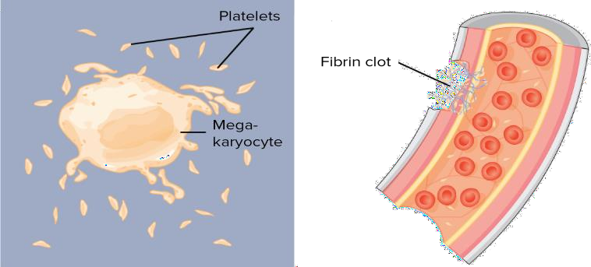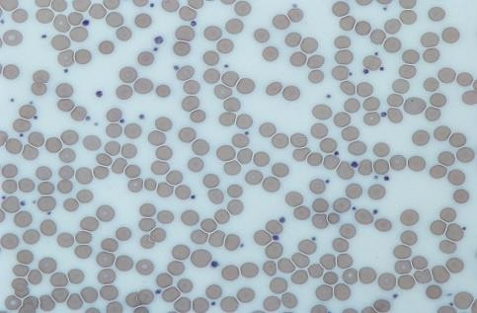

Platelets are not equally effective in clotting blood throughout the entire day. The body's circadian rhythm system (its internal biological clock) causes the peak of platelet activation in the morning. This is one of the main reasons that strokes and heart attacks are more common in the morning. Recent research has shown that platelets also help fight infections by **releasing proteins that kill invading bacteria** and some other microorganisms. In addition, platelets stimulate the immune system. Individual platelets are about 1/3 the size of red cells. They have a lifespan of 9-10 days. Like the red and white blood cells.

# Plasma

**Plasma:** is the relatively clear, yellow tinted water (92%), sugar, fat, protein and salt solution which carries the red cells, white cells, and platelets. Normally, 55% of our blood's volume is made up of plasma.

Plasma helps maintain blood pressure and regulates bodytemperature. Plasma brings nourishment to them and removes the waste products of [metabolism](http://anthro.palomar.edu/blood/glossary.htm#metabolism). It contains a complex mix of substances used by the body to perform important functions.These substances include minerals, salts, hormones and proteins.

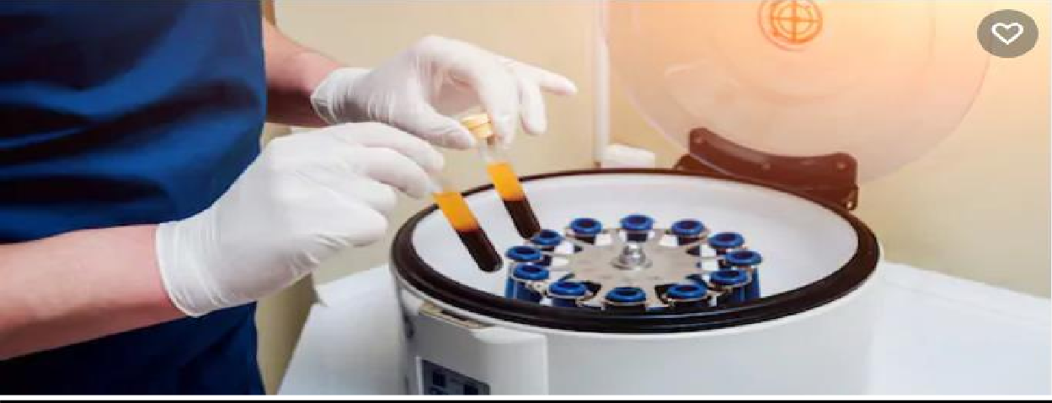

**Three important proteins found in plasma are:**

* 1. **Albumin**
  2. **Globulin**
  3. **Fibrinogen**
     + **plasma salts**, the salts present in plasma include [**sodium**](http://science.jrank.org/pages/6222/Sodium.html), potassium, [**calcium**](http://science.jrank.org/pages/1120/Calcium.html), [**magnesium**](http://science.jrank.org/pages/4064/Magnesium.html), **chloride, and bicarbonate**. These salts function in many important body processes. Calcium functions in muscle contraction; sodium, chloride, and potassium function in nerve impulse transmission in nerve cells; and bicarbonate regulates [**pH**](http://science.jrank.org/pages/5127/pH.html). These salts are also called **electrolytes.** An imbalance of electrolytes, which can be caused by dehydration, can be a serious medical condition. Many gastrointestinal illnesses, such as [**cholera**](http://science.jrank.org/pages/1453/Cholera.html)**,** cause a loss of electrolytes through severe diarrhea.
     + **plasma contains nutrients** include amino acids, glucose, or sugars; and [**fatty**](http://science.jrank.org/pages/2663/Fatty-Acids.html)[**acids**](http://science.jrank.org/pages/2663/Fatty-Acids.html)and [**glycerol**](http://science.jrank.org/pages/3065/Glycerol.html), the components of lipids (fats). In addition to nutrients, plasma also contains enzymes, or small proteins that function in [**chemical**](http://science.jrank.org/pages/1389/Chemical-Reactions.html)[**reactions**](http://science.jrank.org/pages/1389/Chemical-Reactions.html), and hormones, which are transported from [**glands**](http://science.jrank.org/pages/3055/Glands.html)to body tissues. These waste products include creatinine, uric acid, and ammonium salts. Blood transports these waste products from the body tissues to the kidneys, where they are filtered from the blood and excreted in the urine.

**Blood tests**

A **blood test** is a [laboratory](https://en.wikipedia.org/wiki/Medical_laboratory) analysis performed on a [blood](https://en.wikipedia.org/wiki/Blood) sample that is usually extracted from a [vein](https://en.wikipedia.org/wiki/Vein) in the arm using a [needle](https://en.wikipedia.org/wiki/Hypodermic_needle), or via [finger -prick](https://en.wikipedia.org/wiki/Fingerprick). Multiple tests for specific blood components (such as a [glucose test](https://en.wikipedia.org/wiki/Glucose_test) or a cholesterol test) are often grouped together into one [test panel](https://en.wikipedia.org/wiki/Test_panel) called a **blood panel** or **blood work**. Blood tests are often used in [health care](https://en.wikipedia.org/wiki/Health_care) to determine [physiological](https://en.wikipedia.org/wiki/Physiological) and [biochemical](https://en.wikipedia.org/wiki/Biochemical) states, such as [disease](https://en.wikipedia.org/wiki/Disease), [mineral](https://en.wikipedia.org/wiki/Mineral) content, [pharmaceutical drug](https://en.wikipedia.org/wiki/Pharmaceutical_drug) effectiveness, and organ function. Typical [clinical](https://en.wikipedia.org/wiki/Medicine#Clinical_practice) blood panels include a[basic](https://en.wikipedia.org/wiki/Basic_metabolic_panel) [metabolic panel](https://en.wikipedia.org/wiki/Basic_metabolic_panel) or a [complete blood count](https://en.wikipedia.org/wiki/Complete_blood_count). Blood tests are also used in [drug](https://en.wikipedia.org/wiki/Drug_test) [tests](https://en.wikipedia.org/wiki/Drug_test) to detect drug abuse.

## Blood Specimen Collection and Processing

[**Venipuncture**](https://en.wikipedia.org/wiki/Venipuncture)is useful as it is a [**minimally invasive**](https://en.wikipedia.org/wiki/Invasiveness_of_surgical_procedures)way to obtain [cells](https://en.wikipedia.org/wiki/Cell_(biology)) and [extracellular fluid](https://en.wikipedia.org/wiki/Extracellular_fluid) ([plasma](https://en.wikipedia.org/wiki/Blood_plasma)) from the body for analysis. The state of the bloods stream is affected by many medical conditions. For these reasons, blood tests are the most commonly performed [medical tests](https://en.wikipedia.org/wiki/Medical_test).

If only a few drops of blood are needed, a [fingerstick](https://en.wikipedia.org/wiki/Fingerstick) is performed instead of drawing blood from a vein.

[**Phlebotomists**](https://en.wikipedia.org/wiki/Phlebotomist)**:** a [laboratory practitioners](https://en.wikipedia.org/wiki/Medical_laboratory) and [nurses](https://en.wikipedia.org/wiki/Nurse) are those charged with patient blood extraction. However, in special circumstances, and emergency situations, [paramedics](https://en.wikipedia.org/wiki/Paramedic) and [physicians](https://en.wikipedia.org/wiki/Physician) sometimes extract blood. Also, [respiratory](https://en.wikipedia.org/wiki/Respiratory_therapist) [therapists](https://en.wikipedia.org/wiki/Respiratory_therapist) are trained to extract arterial blood to examine [arterial blood gases](https://en.wikipedia.org/wiki/Arterial_blood_gas).

## Complete Blood Count

The complete blood count, or CBC, lists a number of many important values. Typically, it includes the following:

## White Blood Count (WBC).

White blood cells are larger than red blood cells, but there are fewer of them in numbers. In infection, an increased number of white blood cells are sent from the bone marrow to attack the bacteria or virus that is causing the infection. An increased number of white blood cells may occur with mild infections, appendicitis, pregnancy, leukemia, hemmorrhage and hemolysis. People with a low WBC are more likely to catch colds or other infectious diseases. Low WBC counts may be seen in overwhelming infections like mumps, lupus, cirrohsis of the liver and cancer. In addition, radiation therapy and certain types of drug therapy tend to lower the WBC.

## Red Blood Count (RBC).

Red blood cells are the most common type of cell in the blood ,body contains millions upon millions of these disc-shaped cells. The cells contain hemoglobin which carries oxygen and carbon dioxide throughout the body .Measuring hemoglobin gives an exact picture of the ability of the blood to carry oxygen. The oxygen is used by the cells to produce energy.

# The RBC determines if the number of red blood cells in the body is low (called anemia) or high (called polycythemia).

## Common causes of an abnormal RBC include :

* Iron deficiency (anemia) due to chronic blood loss (i.e. menstruation, small amounts of bleeding due to colon cancer), acute blood loss (i.e. acute bleeding ulcer, trauma), and hereditary disorders (i.e. sickle cell anemia).
* Signs and symptoms of anemia (paleness, shortness of breath, fatigue) will start to show when the hemoglobin is too low. In general, females have lower red blood counts and hemoglobin values than men.
* Polycythemia is relatively uncommon.

.

## Hemoglobin Concentration (HGB).

The purpose of this test is to determine the ratio of plasma (clear liquid part of the blood) to red cells in the blood .

## Hematocrit measurement

The **hematocrit** (**Ht** or **HCT**), British English spelling (**haematocrit**), also known as **packed cell volume** (**PCV**) or **erythrocyte volume fraction** (EVF), is the [volume percentage](https://en.wikipedia.org/wiki/Volume_percent) (%) of [red blood cells](https://en.wikipedia.org/wiki/Red_blood_cell) in [blood](https://en.wikipedia.org/wiki/Blood). It is normally 45% for men and 40% for women. It is considered an integral part of a person's [complete blood](https://en.wikipedia.org/wiki/Complete_blood_count) [count](https://en.wikipedia.org/wiki/Complete_blood_count) results.

## MCV (Mean Cell Volume:

Measure the average size of red blood cells. In patients with [anemia](https://en.wikipedia.org/wiki/Anemia), it is the MCV measurement that allows classification as either a [microcytic anemia](https://en.wikipedia.org/wiki/Microcytic_anemia) (MCV below normal range), [normocytic anemia](https://en.wikipedia.org/wiki/Normocytic_anemia) (MCV within normal range) or [macrocytic anemia](https://en.wikipedia.org/wiki/Macrocytic_anemia) (MCV above normal range).

## MCH (Mean Cell Hemoglobin):

Reflects the average weight of hemoglobin found in the red blood cell. ("normochromic") in macrocytic anemias (due to larger **cell** size, though the **hemoglobin** amount or **MCH** is high, the concentration remains normal).

## MCHC (Mean Cell Hemoglobin Concentration):

The mean corpuscular hemoglobin concentration (MCHC) is the average concentration of hemoglobin in red blood cells.

## RDW (Red Cell Distribution Width):

Red cell distribution width (RDW) is a parameter that measures variation in red blood cell size or red blood cell volume.

## MPV (Mean Platelet Volume):

Reflect the average volume of platelet. Platelets are the smallest type of cell found in the blood.

## Platelet count.

Platelet counts are often done in bruising or in surgery. The platelet count may change with bleeding disorders, heart disease, diabetes, inflammatory disorders, and anemia.

## Erythrocyte Sedimentation Rate (ESR)

Also called an ESR or sedimentation rate test, measures the speed at which red blood cells settle to the bottom of an upright glass test tube. This measurement is important because when abnormal proteins are present in the blood, typically due to inflammation or infection, they cause red blood cells to clump together and sink more quickly, which results in a high ESR value. The ESR is useful in detecting inflammation in the body that may be caused by infection, some cancers, and certain autoimmune diseases such as [juvenile idiopathic arthritis](http://kidshealth.org/parent/medical/arthritis/jra.html), [lupus](http://kidshealth.org/parent/medical/arthritis/lupus.html), and [Kawasaki disease](http://kidshealth.org/parent/medical/heart/kawasaki.html). The ESR alone can't be used to diagnose any one specific disease, however.

# Blood typing

Is a test that determines a person’s blood type. The test is essential in blood transfusion or in donate blood. Not all blood types are compatible, so it is important to blood group to ensure that in transfusion the body doesn’t make antibodies to attack the donor blood.

## The Blood Types

The ABO blood typing system groups blood into one of four categories:

* **O: type O** individuals can donate blood to anyone, but can receive blood only from other type O individuals.
* **A: type A** individuals can donate to other type A individuals and type AB individuals. Type A individuals can receive blood only from other type A individuals and type O individuals.
* **B: type B** individuals can donate blood to other B individuals and AB individuals. Type B individuals can receive blood only from type B individuals and type O individuals.
* **AB: type AB** individuals can give blood only to other AB individuals, but can receive blood of any type.

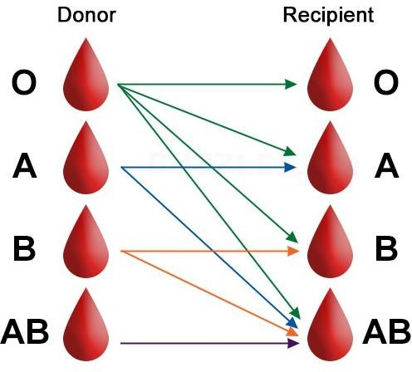

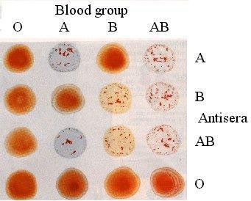

# The Rh factor blood grouping system:

* + **Rh+**: People with Rh-positive blood have Rh antigens on the surface of their red blood cells. People with Rh+ blood can receive Rh+ or Rh- blood.
  + **Rh-**: People with Rh-negative blood do not have Rh antigens. People with Rh- blood can receive only blood that is also Rh-.

Together, the ABO and Rh grouping systems yield your complete blood type. There are eight possible types: O+, O-, A+, A-, B+, B-, AB+, and AB-.