Sequence Diagram for a player placing a piece
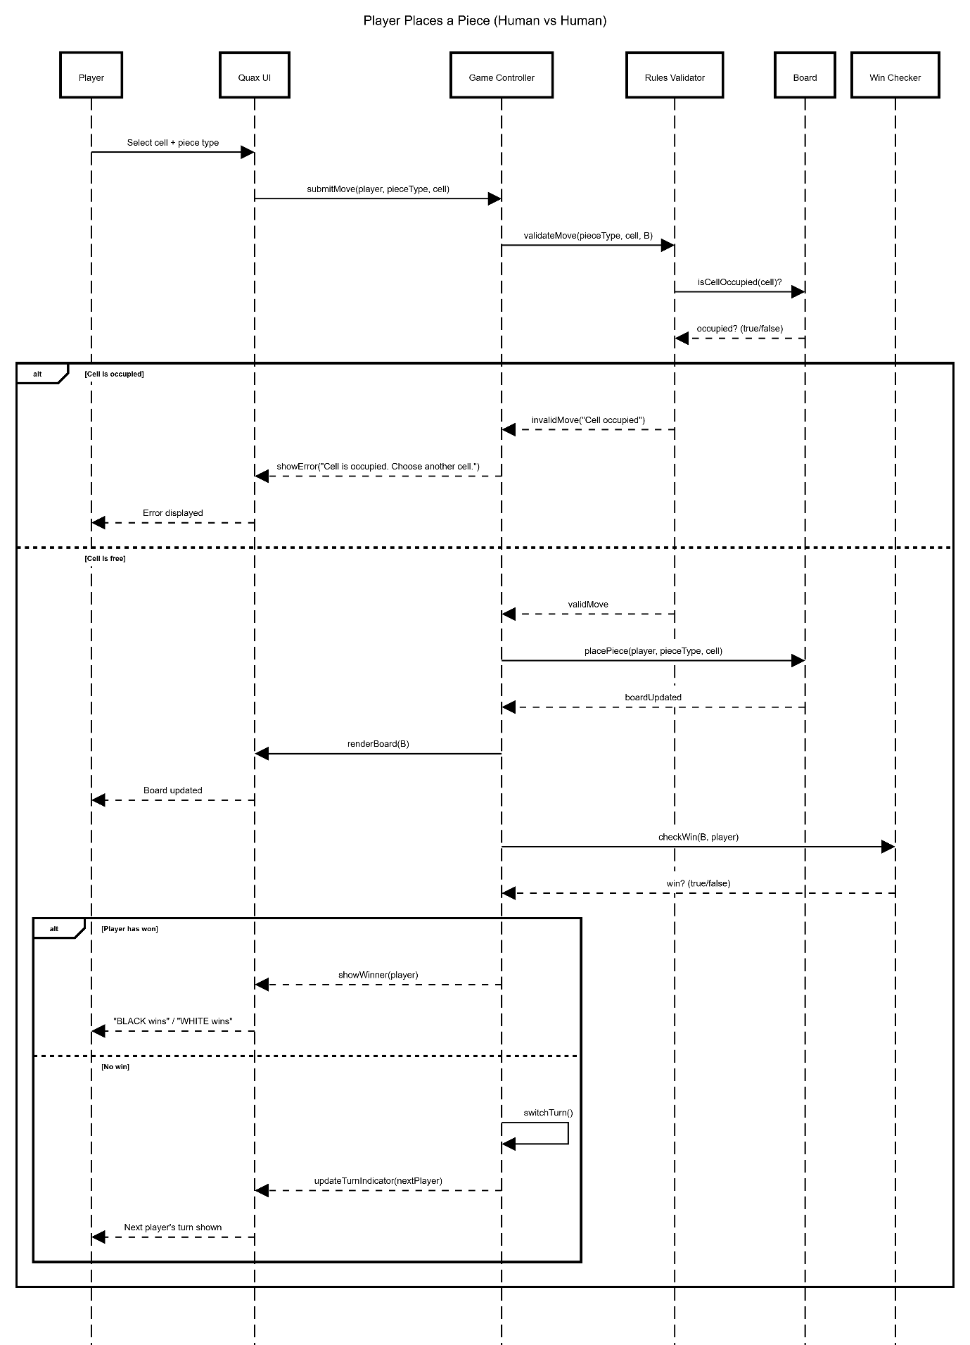

UML Class Diagram

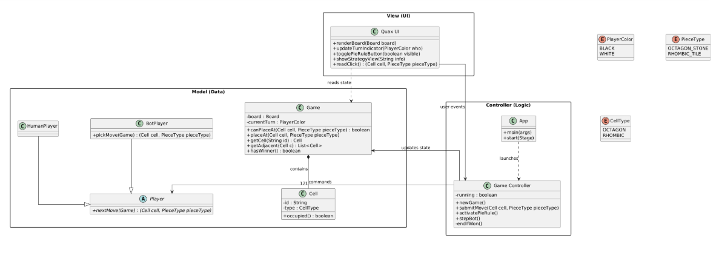
Architectural Style
We adopted a Model-View-Controller (MVC) pattern for our project. We chose this as Quax is a GUI based interactive game, and MVC is well-suited to this style of game, where we have a model of the board (game state, e.g. which cells are occupied, etc), the view of the UI for the user (the board, whose turn it is, Pie rule, etc), and the controller for user interaction (placing a piece, validating moves, switching turns etc). Separating these areas (UI, user interaction and game rules) makes the application easier to understand and maintain.

Sequence Diagram
Our sequence diagram explains a use case for where a player places a piece on the board:
1. The player acts through the UI by selecting a cell and piece type.
2. The application validates the move (e.g., cell not occupied).
3. If the move is invalid, the UI shows an error. If the move is valid, the board is updated.
4. The application then checks for a win. If no one has won, it switches turns and updates the indicator. If someone has won, it displays the winner.

Class Diagram
Our high-level class diagram shows major application components (such as UI, Contoller and Model elements). The relationships show which area uses the other (such as UI communicating with the controller, the controller updating the model, and the UI reading the model to render to the user).

