QuaxBoard - User Manual

1. Purpose of this manual
This user manual explains how to launch and play the final Human vs Bot version of QuaxBoard. It also includes screenshots showing the main gameplay features: launching the board, making a move, bot response, Show Strategy, Hide Strategy, and the winner overlay.

2. Software requirements
For this section, software requirements means the software needed to run the game. The final game itself follows the Quax functional requirements for Human vs Bot mode.
Requirement | Version / Notes
JDK | Java Development Kit 21
JavaFX SDK | JavaFX SDK 21 or a compatible JavaFX 21.x version
Operating system | Windows, macOS, or Linux with Java 21 and JavaFX installed
Executable file | 1QuaxBoard-1.0-SNAPSHOT.jar

3. Launch instructions
Open a terminal or command prompt in the folder containing the JAR file. Use the command below. Replace the JavaFX SDK path and JAR file name if your local folder or final JAR name is different.

Windows example:
java --module-path "C:\path\to\javafx-sdk-21\lib" --add-modules javafx.controls,javafx.fxml --enable-native-access=javafx.graphics -jar 1QuaxBoard-1.0-SNAPSHOT.jar
macOS/Linux example:
java --module-path ~/javafx-sdk-21/lib --add-modules javafx.controls,javafx.fxml --enable-native-access=javafx.graphics -jar 1QuaxBoard-1.0-SNAPSHOT.jar
The QuaxBoard window should open and display the Human vs Bot game board.

4. How to play
- The game launches in Human vs Bot mode.
- The human player controls BLACK and the bot controls WHITE.
- BLACK wins by forming a connected chain from the top edge to the bottom edge.
- WHITE wins by forming a connected chain from the left edge to the right edge.
- On the human turn, click any empty octagon or rhombus to place a BLACK piece.
- After the human move, the bot automatically places a WHITE piece.
- Occupied cells cannot be played again.
- When a player completes their connection, the game displays BLACK WINS or WHITE WINS.

5. Show Strategy and Hide Strategy
The Show Strategy button is included to make the bot strategy visible during demonstration and testing. When enabled, the game shows a text explanation of the bot strategy. When the bot has selected a move, the chosen cell is highlighted on the board.
- Click Show Strategy to display the bot strategy explanation.
- The strategy text may describe a winning move, blocking move, chain extension, or disruption.
- The green highlight shows the move the bot is considering or has chosen.
- Click Hide Strategy to remove the strategy display.
6. Screenshots
The screenshots below show how to launch and play the final Human vs Bot version.
Screenshot 1 - Launch screen
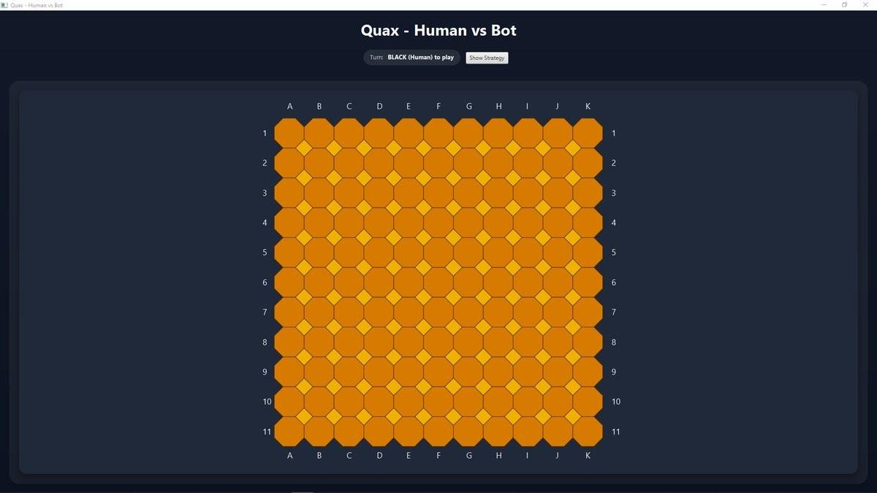
The initial Human vs Bot board after launching the JAR.

Screenshot 2 - Human move and bot response 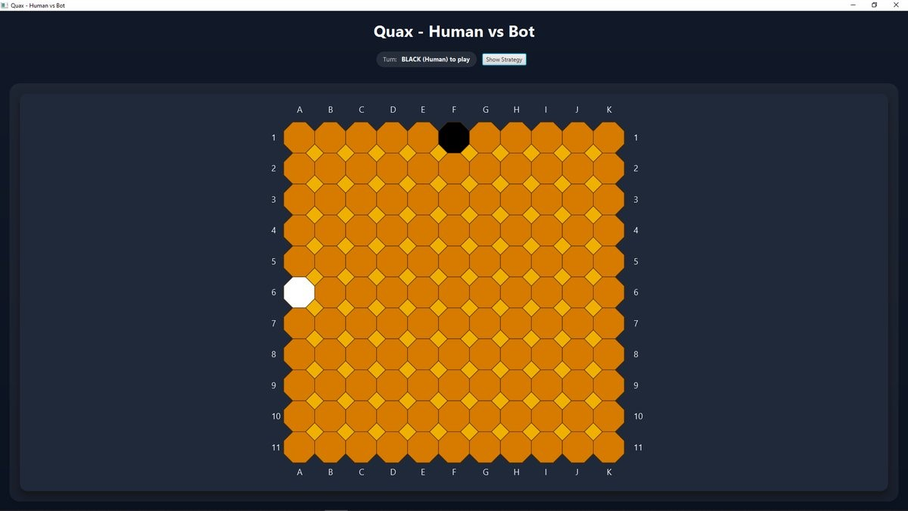
A BLACK human move followed by an automatic WHITE bot move.

Screenshot 3 - Show Strategy enabled
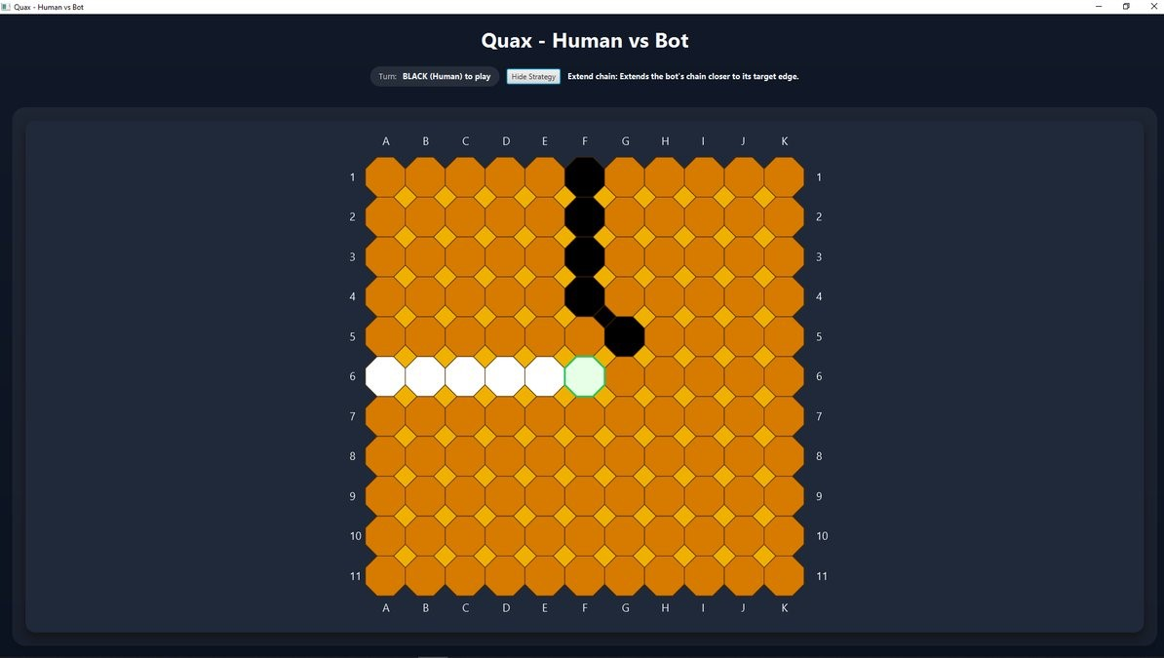
The strategy explanation and highlighted bot move.
Screenshot 4 - Hide Strategy
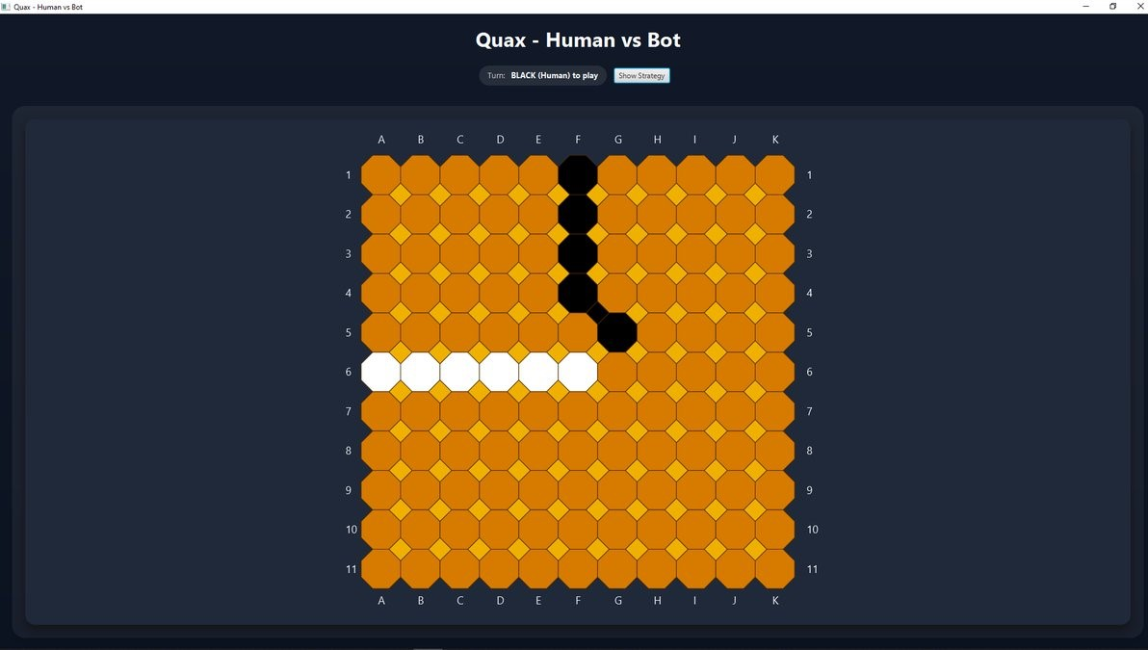
The board after the strategy display has been disabled.

Screenshot 5 - Winner overlay
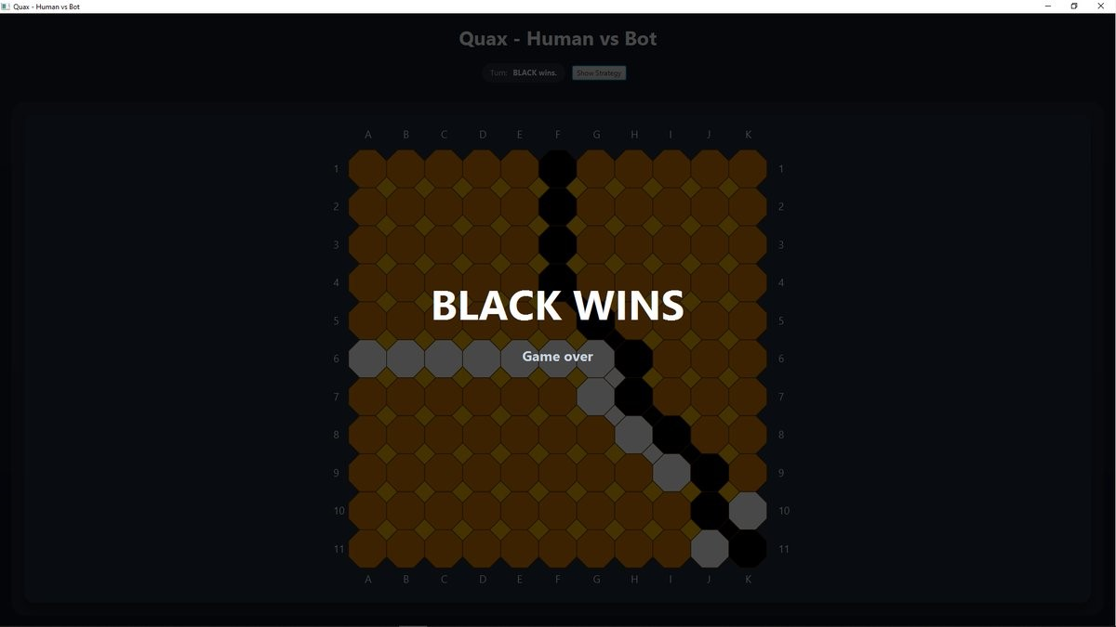
The game over screen showing BLACK WINS or WHITE WINS.

7. Troubleshooting
Problem | Suggested fix
java is not recognized | Install JDK 21 and ensure the Java bin folder is on your PATH.
JavaFX runtime components are missing | Use the full launch command with --module-path pointing to the JavaFX SDK lib folder.
JAR file not found | Check that the terminal is open in the same folder as the JAR, or provide the full path to the JAR.
Board does not open | Check that the JavaFX path is correct and that the JAR file name matches the command.

