**Two students appeared at an examination. One of them secured 9 marks more than the other and his marks was 56% of the sum of their marks. The marks obtained by them are:**

**Answer: 42, 33**

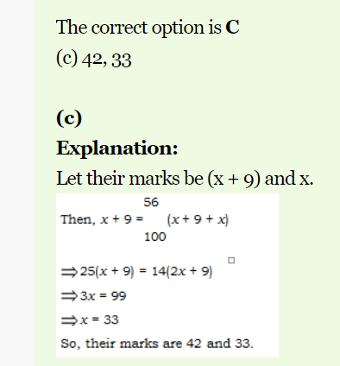

**Two students appeared at an examination. A secured 50 marks more than B. 50% of the sum of marks secured by both A and B is equal to 100. The individual marks secured by A and B is respectively:**

Answer: The correct option is A

**125, 75**

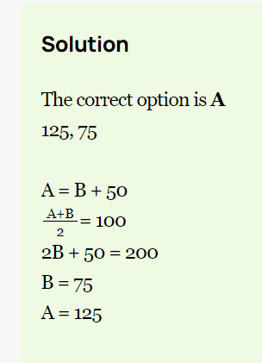

**If Jim's work shift starts at 8:45 a.m. and Jim arrives to work at 9:13 a.m., how many minutes late was Jim?\***

From 8:45 to 9 is 15 minutes  
From 9 to 9:13 is 13 minutes

**28 minutes**

**Jack usually mows his lawn in 4 hours. Marilyn can mow the same yard in 3 hours. How much time would it take for them to mow the lawn together?**

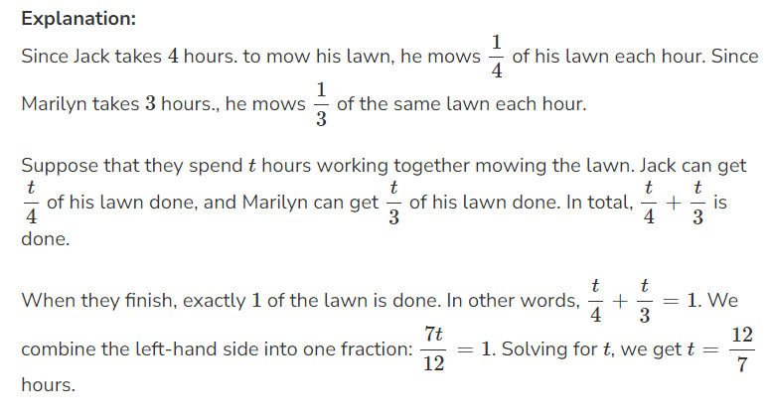

**Jim and Craig, working together, can mow the lawn in 3 hours. Working alone, Craig takes three times as long as Jim. How many hours does it take Jim to mow the lawn alone?**

Let J represent the number of hours it takes Jim to mow the lawn alone, and C represent the number of hours it takes Craig to mow the lawn alone. We know that Craig takes three times as long as Jim, so we have C = 3J.

The formula to find the combined work rate is 1/J + 1/C = 1/T, where T is the total time to complete the task when working together. Substituting the known values we get 1/J + 1/(3J) = 1/3.

3/3J + 1/3J = 1/3

4/3J = 1/3; J = 4 hours

**Adrian works in New York City and makes $42 per hour. She works in an office and must get her suit dry cleaned every day for $75. If she wants to make at least $260 a day, how many hours must she work?**

She needs to work in hour: 260 / 42 = 6.19 hour

Suit dry cleaned cost hour: 75/42 = 1.78 hour

Total she needs to work = 6.19+1.78 = 7.970 hour to need $260 per day

**Worker A completes a task in 8 days and worker B completes the same task in 10 days. If both A and B work together, in how many days they will complete the task?**

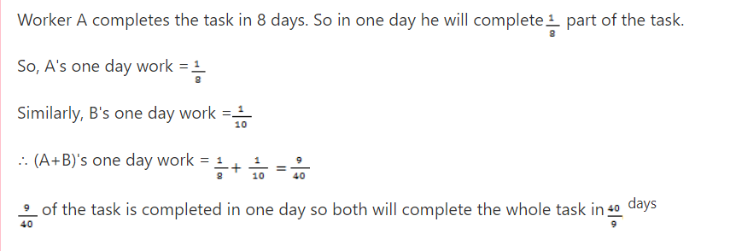

A soccer team played 160 games and won 65 percent of them. How many games did it win?

**Ans: 104**

50% - of 160 = 80

10% 0f 160 = 16

5% of 160 = 8

Total = 80+16+8 = 104

32 is 40 percent of what number?

Answer: 80

**A pipe can fill a tank in 6 hours and another pipe can empty the tank in 12 hours. If both the pipes are opened at the same time, the tank can be filled in**

Tank filled in one hour by filling pipe= (1/6)

Tank emptied in one hour by second pipe= (1/12)

Tank filled in one hour when both pipes are opened= (1/6)-(1/12) = 1/12

So, total time to taken to fill the tank when both pipes are opened is 12 hours.

**OR**

x×1/6−x×1/12=1*𝑥×1/6−𝑥×1/12=1* *(because 1 tank has to be filled)*

⟹x/12=1*⟹𝑥/12=1*

⟹x=12*⟹𝑥=12* hrs.

**A shopkeeper sold an article for Rs. 2500. If the cost price of the article is 2000, find the profit percent.**

C.P. = Rs. 2000

S.P. = Rs. 2500

Profit or Gain = S.P. -C.P.

= 2500 - 2000 = 500

Apply formula: Profit % =Profit ∗100  
 C.P.  
 =500 ∗100 =25 %  
 2000

**A 60 liter mixture of milk and water contains 10% water. How much water must be added to make 20% water in the mixture?**

Water = 60 - 54 = 6 liters

Let water to be added = x liters

Now, 6+x = 20%  
 60+x

6+x = 1   
 60+x 5

30 + 5x = 60+x

30 - 60 = x ? 5x

- 30 = - 4x

x =30 =7.5 liters  
 4

**A running man crosses a bridge of length 500 meters in 4 minutes. At what speed he is running?**

**If the average price of four pairs of shoes is $50, and three of those pairs of shoes are priced at $35, $40 and $55, what is the price of the fourth pair of shoe?**

(35+40+55+x)/4=50; 130+x=50*4; 130+x=200; x=200-130 x=70

**A customer buys four products priced at $18, $22, $35 and $40 from the same store. The customer returns the most expensive product and gets a refund for that one product. How much money did the customer end up spending at that store?**

75

**Cindy gets paid a 5% commission for selling furniture. If Cindy's goal is to earn $4,000 per month in Commission checks, how much furniture does she need to sell per month to reach her goal 80000**

Let X @ 5% = 4000

4000/5*100= 80000

**At Ben's Butcher Shop *99* pounds of chopped meat is being divided into packages each weighing *2.5* pounds. How many pounds of meat are left when there isn't enough to make another whole package?**

99 pounds÷2.5 pounds/package=39.6

2.5 * 39 = 97.5 > 99-97.5 = **Ans: 1.5**

**15 people working 5 hours per day can make 30 units of product in 10days. Assuming all other factors remaining constant, in how many days can 10 people make 10 units of the product if each of them works 10 hours per day?**

**15p 5 hour 30 unit 10 day**

**10p 10 hour 10 unit**

M1.D1.T1.W2=M2.D2.T2.W1*𝑀1.𝐷1.𝑇1.𝑊2=𝑀2.𝐷2.𝑇2.𝑊1*

Or,15×10×5×10=10×x×10×30*𝑂𝑟,15×10×5×10=10×𝑥×10×30*

Or,7500=3000x*𝑂𝑟,7500=3000𝑥*

Or,x=2.5

**The average of 7 consecutive numbers is 20. What is the largest of these numbers?**

Solution: Let the 7 consecutive numbers be x, x + 1, x + 2, x + 3, x + 4, x + 5 and x + 6,

As per the given condition;

[x + (x + 1) + (x + 2) + (x + 3) + (x + 4) + (x + 5) + (x + 6)] / 7 = 20

⇒ 7x + 21 = 140

⇒ 7x = 119

⇒ x =17

The largest number = x + 6 = 23.

**What is the compound interest on Rs. 2500 for 2 years at rate of interest 4% per annum?**

2500 * 4% = 100 -> 2500+100=2600 * 4% = 104, 100+104=204

**The average of 10 numbers is 23. If each number is increased by 4, what will the new average be?**

Sum of 10 number is 10 * 23 = 230,

If increase by 4 then 10 * 4 = 40, so 40 + 230 = 270 /10 = 27 the new average.

**The average of 50 numbers is 20. If two numbers 37 and 43 are discarded, find the average of the remaining numbers.**

Average of 50 numbers = 20

Sum of 50 numbers = 20 x 50 = 1000

Sum of discarded numbers = 37 + 43 = 80

Sum of remaining numbers = 1000 – 80 = 920

Now, total remaining numbers = 50 – 2 = 48

Average of remaining numbers = 920/48 = 19.17

**The average age of three boys is 15 years and their ages are in proportion 3:5:7. What is the age in years of the youngest boy?**

(3x + 5x + 7x) / 3 = 15, then x = 3, then 3*3 = 9 is the answer.

**The average weight of a group of seven boys is 56 kg. The individual weights (in kg) of six of them are 52, 57, 55, 60, 59 and 55. Find the weight of the seventh boy.**

56 * 7 = 392, 52+57+55+60+59 = 338, 392-338 = 54Kg

**If 16% of 40% of a number is 8, then find the number.**

16/100 * 40 /100 * X = 8

So, X = (8 × 100 × 100) / (16 × 40) = 125

**What percentage of 2/7 is 1/35 ?**

Let X% of 2/7 is 1/35.

∴ [(2/7) / 100] × X = 1/35

⇒ X = (1/35) × (7/2) × 100

= 10%

**A fruit seller had some apples. He sells 40% apples and still has 420 apples. Originally, he had how many apples?**

That means 60% apple is 420, then 1% apple is 420/60, then 40% apple is 420/60*40 = 280, so total = 280+420 = 700

**Out of two numbers, 40% of the greater number is equal to 60% of the smaller. If the sum of the numbers is 150, then the greater number is?**

Let the greater number is X, so smaller is 150 – X

So, 40% of X = 60% of (150 – X), x = 90 Answer

**I am three times as old as my son. Five years later I shall be two and a half times as old as my son. What is my age?**

Solution: Let X, and Y, So now X = 3Y, 5 years after => X+3 = 5/2 (Y+5)

So X is = 45, Y = 15.

**In an election between two candidates, one got 55% of the total valid votes. 20% of the votes were invalid. If the total number of votes was 7500, the number of valid votes that the other candidate got, was**

Valid Vote is 100 – 20 = 80%., 7500 X 80% = 6000

6000 * 55% = 3300

6000 – 3300 = 2700 is the Answer.

**If a number x is 10% less than another number y and y is 10% more than 125, then x is equal to**

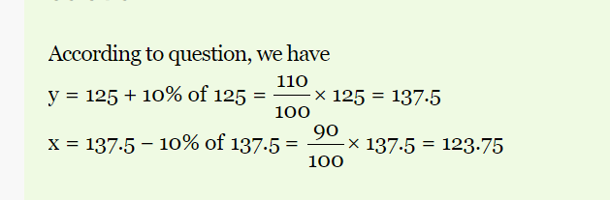

**If number x is 20% less than another number y and y is 40% more than 100, then find out the value of x.**

**112 is answer: 100 + 100 X 40% = 140, 20% of 140 is 28, so 140 – 28 = 112.**

|  |
| --- |
| **In an examination, 35% of the students passed and 455 failed. How many students appeared for the examiantion?** |

Student passed: 35%, Failed 100-35=65%.

Then X * 65% = 455, 65X = 45500, X = 45500/65 = 700

Answer: 700

**If A's salary is 25% higher than B's salary, then how much percent is B's salary lower than that of A's?**

B = 100 + 100 X 25% => 125, A = 25/125 X 100% = 20%

**Raman’s salary was decreased by 50% and subsequently increased by 50%. How much percent does he loss?**

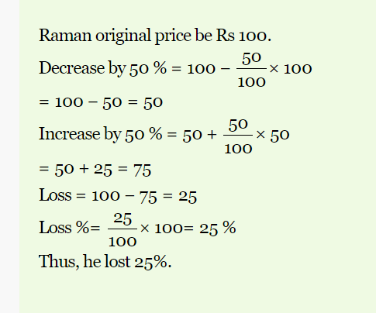

**How many litres of pure acid are there in 8 litres of a 20% solution?**