|  |  |
| --- | --- |
| 2020/3/16 | Initial ver1.0, |
| 2020/3/19 | Svm.cpp, linear.cpp different between Ubuntu and win7 |
| 2020/4/15 | (1)Dk2_linadapt4_sec9.cpp :  Use linear_model, adaptive threshold in central area + fixed threshold in boundary area  (2) new makefile |

1.

Ocr code : t1_20200316_4.cpp

Including code : svm.h, svm.cpp

Execute file : dk2_ocr_scain

2. put scan in image : /home/root/scan_in/

File name : org%d_1.bmp

3. SVM model : cv_tw_model.txt

4. OCR output report : cv_det_tw.txt

5. opencv directory : (opencv_3.4.3)

/usr/lib/

6. build core_img with opencv

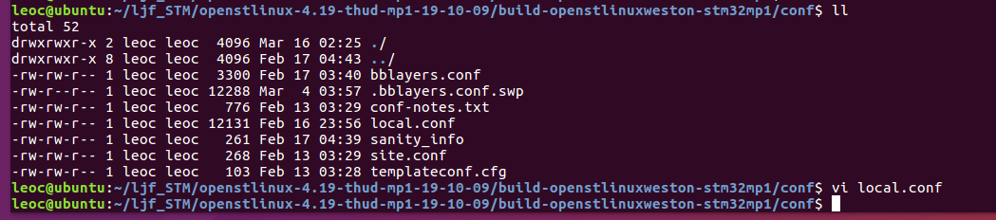

Add

CORE_IMAGE_EXTRA_INSTALL +=”opencv” in local.conf

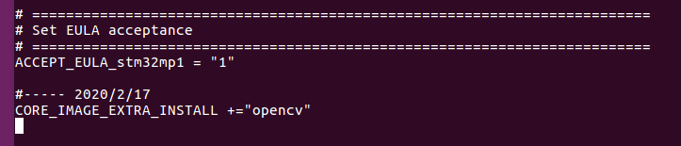

7.

Win 7 :

old_locale = _strdup(old_locale);

Ubuntu :

old_locale = strdup(old_locale);

//======== 2020/4/15

1. use linear model

Add new files:

(1) Daxpy.c, ddot.c, dnrm2.c, dscal.c

(2) linear.cpp, tron.cpp

(3) blas.h, blasp.h, linear.h, tron.h

2. new golden linear model : cv_tw_model_linear.txt

3. modified “makefile”

4.

Main code : dk2_linadapt4_sec9.cpp

put scan in image : /home/root/dk2_test2/tw_base/

File name : org%d_1.bmp

Ocr result : cv_det_tw_595_769.txt