The Turn
Your cup is turned
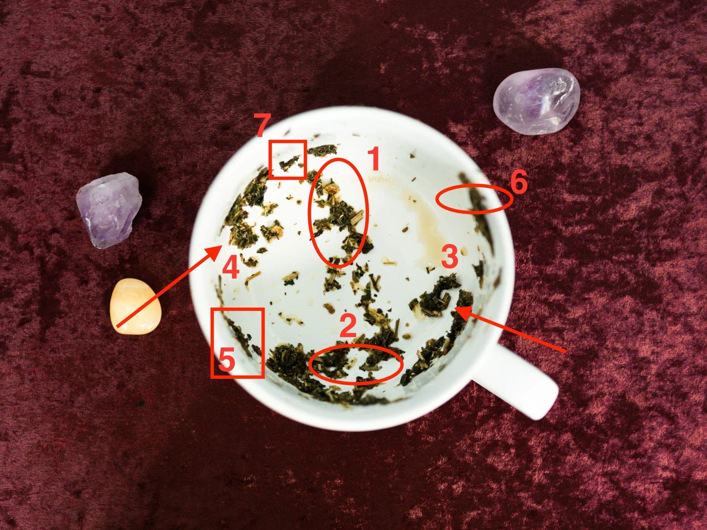
The Turned Handle — he answers, but flat
A tea-leaf reading by Evelyn Cross

Your cup is turned
Your cup, turned and read: the handle, the rim, the base, and seven leaves marked in red.
Dear,
Your cup’s turned. I read it late last night and again first thing this morning, and I’ll tell you now it isn’t a neat cup. The leaves came down in loose clumps, the way they always do, and reading them means looking hard at where each one sits. I’ve marked your seven in red and numbered them, so you can find each one on the photo as I go.
Your cup reads as a Turned Handle. What runs between you and him is still open, and it’s gone thin: he answers, and there’s nothing in it. I’ll show you where the cup says so, right beside your handle.
Some of what follows will sound as if it’s arguing with my letter, the bird most of all. Read it through before you decide it is.

How a cup is read
My letter gave you the seven leaves but not where they sat, and where they sit is the part with the timing in it. Three things decide it, and I’ll use your cup to show you each.
The handle is you. Whatever sits close to the handle is close to you. Whatever sits across the cup is as far from you as it gets: people you haven’t met, or things you’ve let slide so far off they’re as good as strangers. Your handle’s at the lower right of the photo. The nearest leaf to it is the tree, mark 3, sitting just above it. Hold on to that tree. Most of your reading turns on it.
Height is time. The rim and the band just under it are the days: a fortnight either side of now, just gone or just coming. The further down the wall a leaf runs, the further back it goes. Halfway down is two months. The base is what’s buried, older than anything you’ve noticed. A leaf with a tail trailing down the wall has a history, and the tail tells me how long it is.
The first light sets the order. Seven leaves at three days a leaf: twenty-one days. The leaves tell me what each stretch is about, and how close to you and how far back each thing sits. They don’t tell me which stretch comes first, because leaves don’t land in a queue. The cup does. When I first turn a cup, I tip it slowly toward the light, and the whole cup reads from the mark that catches the light first. A woman whose man has gone flat has to stop doing a different thing first from a woman whose man runs hot and cold, so the same seven leaves come to her in a different order. In yours the light caught the bare stalks of the tree, mark 3, just above your handle. That’s a turned handle.
Those three are the whole method, and I’ll show you the working at every leaf.

The bird, and how long he’s been going
The bird gave me more bother than anything else in the cup, and I’d rather tell you that than pretend it read itself.
He’s mark 1, across the cup from your handle, toward the top of the photo. His head’s easy to find: a bright, pale-gold fleck up under the rim, with a dark clump below it for the body. The tail’s the trouble. It’s smaller bits of leaf trailing down the wall behind him, and the further down they go, the smaller and further apart they get, until they run into the loose specks scattered all over your base.
At midnight I couldn’t see where he stopped and the specks began. This morning I tipped the cup to the window and turned it round three times, slowly, before I could see it: the last piece still in line with the rest of him sits almost exactly halfway down the wall. Below that, the bits lie every which way. They’re specks, and they’re not his.
A bird under the rim is a fortnight old. A bird at the base was in flight before you’d noticed anything. And a bird’s age is read from the tail, because the tail’s the last of it to leave the branch. The head’s only where he’s got to.
He started going about two months ago, and whatever started it isn’t the last three weeks.
The last three weeks are the head: the flat replies, the “yeah, fine”, the messages you’ve read four times looking for something in them. That’s where he’s got to, not where he started. So you can stop going over your own last few messages for the thing that switched him off. It’s not in there.
Now look at where he sits. My letter said the far side of a cup belongs to somebody you haven’t met. Your bird’s over there, a long way from your handle, and in your case that’s exactly how he answers: promptly, politely, like a man you’ve never met.
My letter said a bird near the rim and a bird down by the base would have you doing two opposite things this week. Here’s what I meant by it: a fortnight-old bird you’d talk to now, and one from the base you’d leave be. Two months sits between. Set enough that saying it now lands as pressure, fresh enough that it lands well on the right day. In your cup that day comes sooner than in most.
Your cup
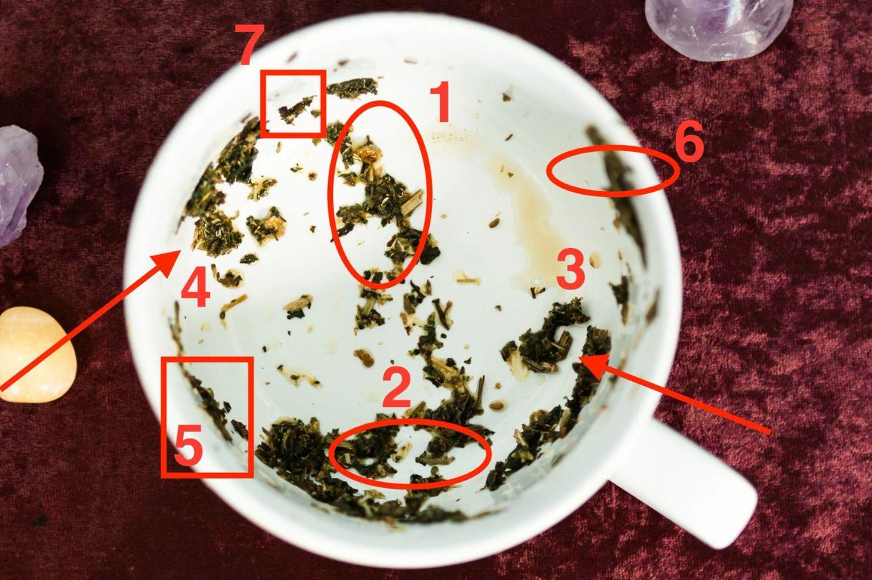
Your cup, the one I read for my letter, from above: my seven marks numbered in red, and the handle at the lower right.

Where your seven landed
Leaf | Where it sits | Days | What that makes it
2 · The broken heart | low, just left of your handle, in the dark band near the base | 1–3 | You, now. Older than the flat replies
1 · The bird | across the cup from your handle; head up under the rim, tail halfway down | 4–6 | Him going. Two months, and still going
4 · The boat | far left wall, the far side from your handle; mid-wall | 7–9 | The exchange you already have. On his side, going nowhere
6 · The lighthouse | upper right, on your handle’s side; just under the rim, on its own | 10–12 | Your fixed point. Close, and not him
5 · The bridge | lower left, right up under the rim; between the heart and the boat | 13–15 | The way across. Early in your days
3 · The withering tree | just above your handle, the nearest mark to you; mid-wall, a trail running down | 16–18 | The contact. Every branch there, the stalks bare
7 · The butterfly | top left, on the rim, nearly opposite your handle; the highest leaf | 19–21 | Change in you. Already started
Look at the bottom row, dear. The butterfly’s the highest leaf in your cup, sitting on the rim itself, which makes it the nearest in time. And it’s nearly opposite your handle, where I’d expect to find somebody you haven’t met. The somebody is you, once this is done. The first real change in all this is yours, and it’s already started. It’s last in the days because you only see it once it’s finished.

Your cup: the Turned Handle
Here’s what I promised you, beside your handle.
Find mark 3 on the photo, just above the handle. Of all seven, it’s the nearest leaf to you, and near the handle means close to you and there every day. That’s right, isn’t it? He answers, every day. Now look at what the leaf is: a dark, branching clump with bare stalks sticking out of it. The branches are all there. The stalks that reach out from it are bare.
A turned handle looks exactly like that. Everything’s still joined up, and whatever reaches out from it comes to you with nothing on it.
My letter called the tree the honest symbol, and in your cup it’s honest twice over. It says the foundation has thinned, not collapsed. And it says the contact’s whole: one clump, stalks and all.
Then look across the cup at his two leaves. The bird’s toward the top, a long way from your handle, and the boat’s on the far left wall. He’s writing to you from the far side of your cup. You’ve been reading his tone for evidence. Tone’s the first thing to go flat when a man’s elsewhere in himself. A man who’s elsewhere in himself still answers messages. He answers them exactly like that.
Yours is the better situation to be in, though it doesn’t feel it. Nothing’s been cut, and nothing’s broken. He’s switched something off in himself, and the contact’s still standing right by your handle with every branch on it.
So your days take their own shape, and here’s why they run in the order they do. Contact already exists, which means you don’t have to build it. You have to change what it carries.
The heart comes first, because it’s yours: three days to stop answering flat with flat. The bird comes next, because his head’s up under the rim and he’s still going: three days of not pulling. Then straight to the boat at the front of the second week. The boat’s the exchange you already have, sitting over on his side, and you don’t need a small ordinary message to get it started; you’ve had those every day for two months. The lighthouse follows, because it’s on your side of the cup and up near the rim, close to you and close in time, and you’ll want it under your feet before you speak. The bridge comes on days 13 to 15, early, because you’ve been in touch every day and the far bank’s been within reach the whole time. And the tree comes after the bridge, not before, because the tree is what the bridge waters, and water takes days to reach the root.
One warning belongs to your cup and no other. It’s in days 4 to 6. Don’t skip it.

How much is recoverable
In my letter I said the question that settles this isn’t whether there’s somebody else. It’s how long he’s been going, and how much of that you can get back. How long is two months. Here’s how much.
Nearly all of it. Here’s why, so you know it’s the cup talking and not me being nice.
The contact’s recoverable. The tree beside your handle has its stalks, every one, still on the clump. Bare, and all there. Nothing in your cup has been cut.
The weight’s recoverable. Your stalks have lost their leaf, and every one of them is still on the tree. Leaf grows back on a branch that’s still attached.
What you had before is recoverable. A thin trail of leaf runs down the wall from your tree toward the base. That’s its root, and it goes a long way back, and in your cup it’s still being watered every day: the ordinary messages he still answers.
What’s not recoverable is the two months of flat messages. Nobody’s going to go back and send you the warm versions, and going over them with him (“why have you been so off with me?”) is the one sure way to lose the rest. Leave them where they are.
I won’t promise you he’s coming back. Recoverable means what’s in the cup is still there to be got back. In yours, nearly all of it is.

Your twenty-one days
Day 1 is the first evening after you read this. Not a date. Count from this evening.
Every stretch gets its instruction from its leaf, from what the leaf is and where it sits, and I’ll give you the leaf first. My letter said the cup had the weeks in it. Here they are, and one of them has a day and an hour on it.

Days 1–3 · the broken heart · Quiet: answer warm, leave first
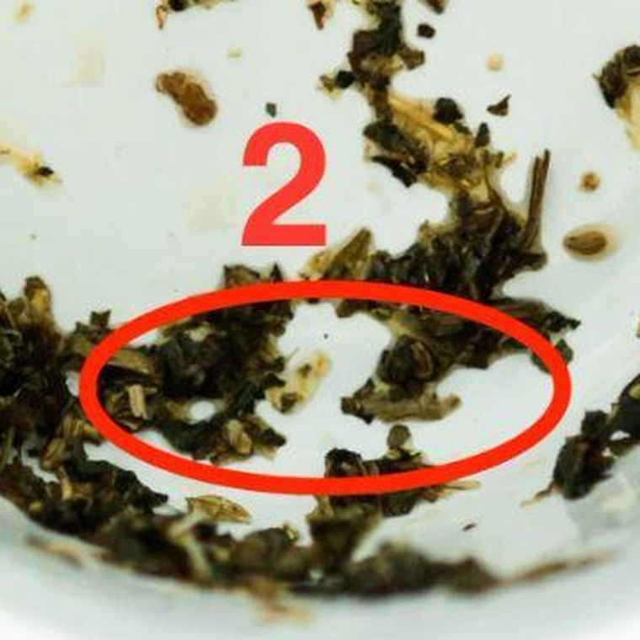
Mark 2, the broken heart: low in the cup, just left of your handle.
Two dark clumps side by side with a pale gap of china between them, low down in the dark band of leaf near the base, just left of your handle. Near the handle is you. Low down means it’s been building for longer than the flat replies have.
Push the halves of a wet broken leaf back together and they don’t join. One slides over the other and you lose the shape of both. You leave them lie and let the cup dry round them.
In your cup the gap isn’t a silence. It’s between how warm you are and how flat he is. You don’t close it by going flat to match him, and you don’t close it by pouring in extra warmth to get some back. Both are pushing the halves together.
So for three days you start nothing. When he writes, answer warmly and briefly, and be the one who ends it. A bit warmer than he wrote, and a good deal shorter than you’d like.
What goes wrong here is answering flat back. You match his tone because it feels like dignity. Two flat replies make the whole thing flatter, and now you’re both waiting for the other one to warm up.
This week: when you answer, leave off the question you’d normally tack on the end to keep him talking. The tacked-on question is you reaching across the gap.

Days 4–6 · the bird · Quiet: no tests
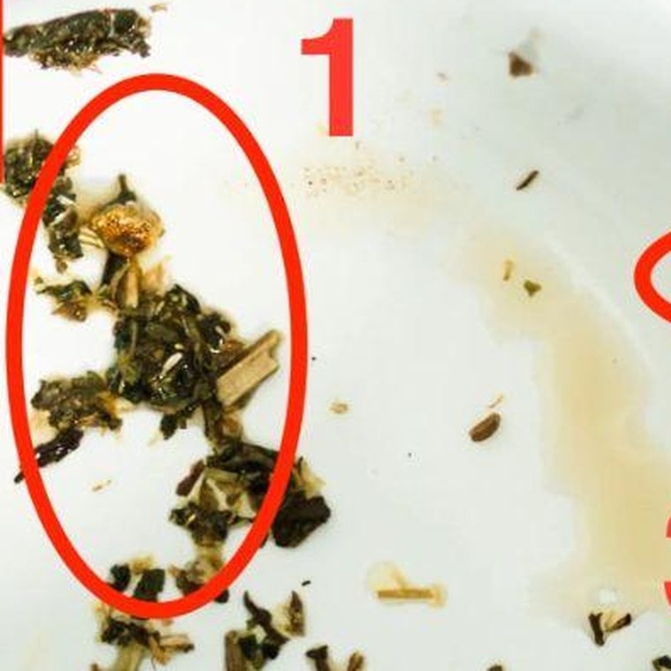
Mark 1, the bird: across the cup from your handle, head up under the rim.
Across the cup, his head’s up under the rim and the rest of him trails down the wall behind it: the shape of something on its way up and out. Up under the rim is the days, so the going’s still happening, now.
You can’t call a bird back out of the air. You can wait it out or you can chase it, and chasing drives it further, because to a bird anything coming up behind is a reason to keep going.
When he’s still writing, chasing looks different. It’s the extra question, the “you seem quiet”, the joke sent to see if he laughs. Every one of those is a pull, and a man mid-flight feels every pull.
So you keep doing what you did on days 1 to 3. Nothing started. Warm, brief, and you leave first. Ending it first, every time, is the whole of days four to six.
These six quiet days are the hardest thing in your twenty-one. Not answering is easy when nobody’s writing. Leaving first every evening, when you want to keep him there, is the work.
What goes wrong here is the test. A turned handle tempts a woman into the small experiment: a reply held back on purpose, a message left on read, something to see whether he notices. He’ll notice. It’ll read as the first interesting thing you’ve done in a month, and it’ll work for about four days. Then you’re in a game instead of a relationship. Don’t test him. The bridge does the job properly, and it’s only a week and a bit away.
This week: close each exchange with something warm and final. “Night, sleep well.” Then nothing more from you until he writes again.

Days 7–9 · the boat · Ask: one real question
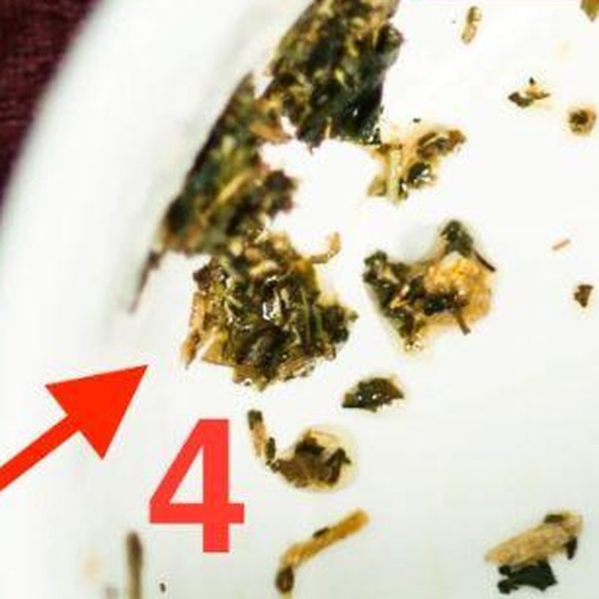
Mark 4, the boat: on the far left wall, the far side from your handle.
On the far left wall, the far side from your handle, a loose group of clumps lying low and spread out, the way a hull sits in the water. It’s halfway down the wall, so the weather between you is about as old as the bird. The boat’s the one leaf of the seven that carries two people, and yours is sitting still on his side of the cup.
When a rower brings an oar back for the next stroke, she turns the blade flat so it skims over the water. A flat blade goes through the whole stroke and pulls nothing. Turn it square and it bites, and the boat moves.
Your exchange is exactly that. Both oars flat. He answers, you answer, and the boat goes through every motion without moving an inch. You don’t need more contact. You need one stroke with the blade square.
So you ask him something real about himself. Not about the two of you: about whatever the last two months have actually been about for him. The job, his dad, the move, whatever he’s been somewhere else in. One question, as its own message. Then let him answer at his own length and don’t fill the gaps.
His answer will be the longest thing he’s sent you in weeks.
What goes wrong here is answering his long answer with a long answer about you. He tells you something real, and you take it as the opening you’ve been waiting for and say how hard the last month’s been. Your blade’s square and his is flat again.
This week: ask it on day 7 or 8. If he answers at length, ask one more thing about what he said, and then you’re the one who ends it. If he answers short, leave it short.

Days 10–12 · the lighthouse · Go to your fixed point
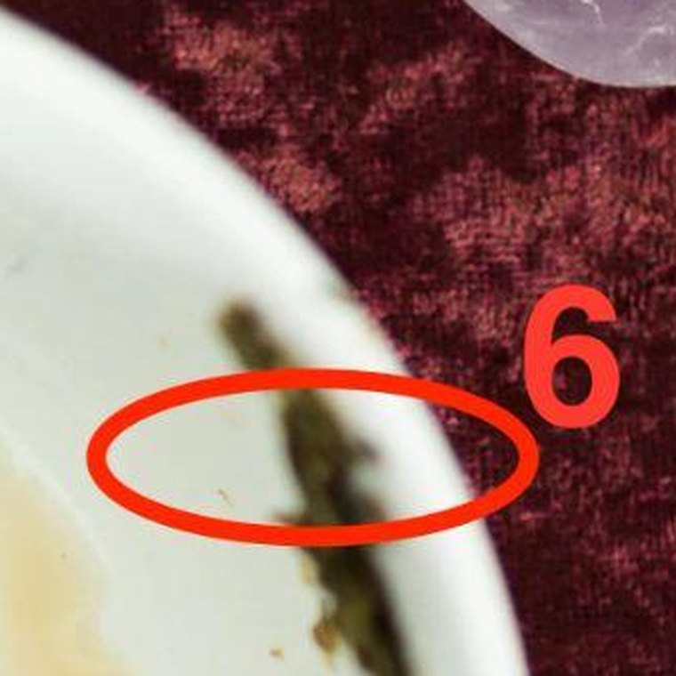
Mark 6, the lighthouse: upper right, on your handle’s side, just under the rim.
Upper right, on your handle’s side of the cup, just under the rim and above the pale tea stain: one thin upright streak of leaf, standing on its own in clean china. Everything else near your handle sits in a clump. The lighthouse stands by itself, and nothing touches it.
Near the handle means close to you, and just under the rim means now. Your fixed point’s been a few inches from you the whole time. My letter said you’ve been navigating by a moving point, and the moving point’s over on the far side of the cup with his head up under the rim.
A lighthouse doesn’t go to ships. It stays put, it’s lit, and ships find their way by it.
Your lighthouse is your fixed point: the friend, the sister, the work, the choir, whatever held you level before any of this. For two months you’ve been on call, phone face up on the table at dinner. The lighthouse is the one leaf on your side of the cup he isn’t tangled up in.
So these three days are for one real evening with your fixed point. Not to talk about him. If he writes while you’re out, you answer when you’re home, warmly and briefly, the way you would any other day. You’re not making a point. You were out.
What goes wrong here is taking him with you: the phone face up beside your glass, answering him from the table.
This week: fix the evening for day 10 or 11, and have it done before day 13. The bridge comes next, and it goes better from a woman who’s just spent an evening somewhere he isn’t.

Days 13–15 · the bridge · Speak: day 14
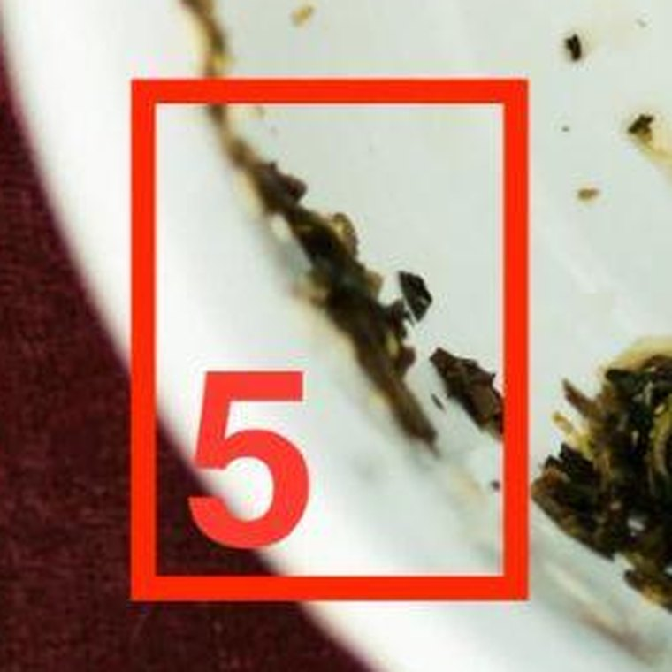
Mark 5, the bridge: lower left, right up under the rim.
Lower left, right up under the rim: a thin line of leaf lying along the edge of the cup. Going round the cup, it sits between your heart and the boat, between your side and his, and higher than either of them.
The bridge is what you bought: the stretch where what you say lands as an invitation and not as pressure. A week earlier, the same words would have been an exit.
A bridge spans a gap, and it can be walked from either end. So you build a short one and stand on your side of it. Yours is thin, one line of leaf, and a thin bridge carries one thing.
You reach it earlier than most women do, because you’ve been in touch every day. The far bank’s been within reach all along.
What you say is one thing, plainly and briefly. Something true about what you want, with no case attached, no history, and no request for an answer.
Your day is day 14. Send it early in the evening, between six and eight.
A bridge carries its weight at the middle of its span, so the middle of its three days carries the message. And look at the bridge and the lighthouse: both sit just under your rim, one each side of the cup, the bridge at the lower left and the lighthouse at the upper right. Leaves at the same height keep the same hour, and a lighthouse is lit at dusk. So it goes as the lamps come on, and never after nine.
In your cup there’s one more rule, and it comes from where the bridge sits. It isn’t part of the heart or part of the boat. It sits between them and above them, a leaf of its own. Send it on its own. Not as the last line of a chat about his day, and not as an answer to something he’s sent. If he’s written that afternoon, answer him the usual way when it comes in, and send this later, separately, as its own message.
What goes wrong here is tucking it in. “Anyway, also, I’ve been meaning to say.” It arrives inside the flat back-and-forth, it gets a flat reply, and you decide it didn’t work. And if you add the paragraph that explains it, you’ve built the bridge he walks away over.
This week: write it on day 13. Cut it to a third of what you first wrote, keeping the sentence that says what you want. On day 14, send it between six and eight, then put the phone away for the evening. On day 15, answer whatever he’s said the way you’d answer anything, and don’t mention it.

Days 16–18 · the withering tree · Quiet: let it soak in
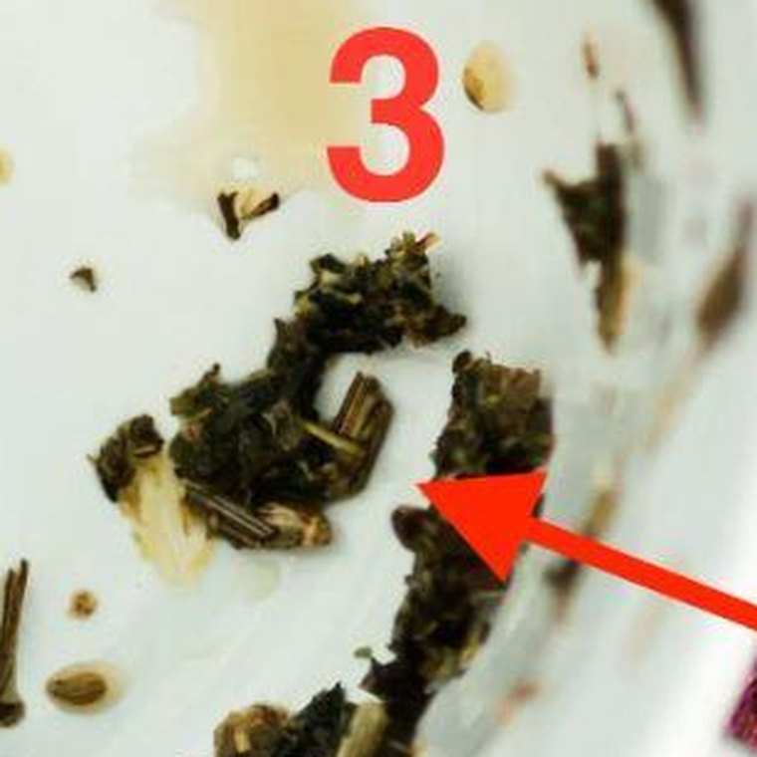
Mark 3, the withering tree: just above your handle, the nearest mark to you.
Just above your handle, the tree you’ve already met: a dark, branching clump with bare stalks sticking out of it, and a thin trail of leaf running down from it toward the base. The stalks are the contact. The trail’s the root.
A tree like that is withering, not dying, and you water it at the root. Water at the root takes days to climb to the top. Keep pouring because the top hasn’t changed by morning and you drown the root.
Day 14 was water at the root. It’ll take these three days to climb, and the stalks won’t look any different while it does. Meanwhile your root’s still getting its ordinary watering: the photos, the “how was your day”, the small stuff he still answers. Keep that going exactly as it was.
So nothing new from you about the two of you. Answer what he sends, warmly and at his length. Don’t refer back.
What goes wrong here is the second pour. “Did you see what I said?” “I hope that wasn’t too much.” Each one’s a jug of water on a root that’s already wet.
This week: if he sends a photo, answer the photo. If he asks about your day, tell him about your day. Let the ordinary be ordinary for three days.

Days 19–21 · the butterfly · Look back
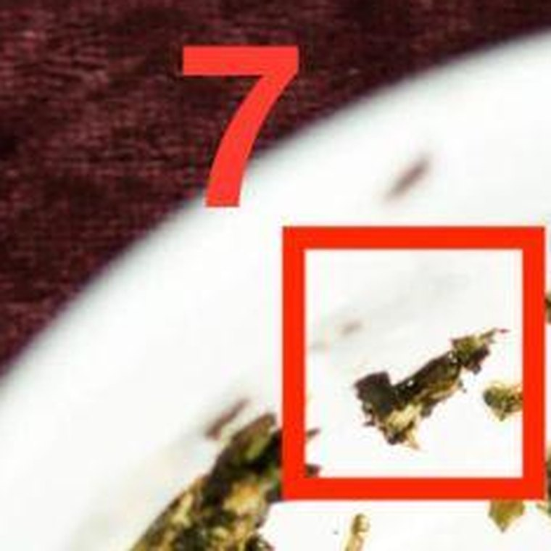
Mark 7, the butterfly: top left, on the rim, the highest leaf in the cup.
Top left, sitting on the rim itself and higher than anything else in your cup: a small fleck with two lobes, two small wings. It’s nearly opposite your handle, on the side of the cup I keep for somebody you haven’t met.
A butterfly does its changing inside a closed case where nobody can watch. By the time the wings show, the change is finished, and the coming out is just the last of it.
There’s no instruction toward him in these three days. Whatever he’s said since day 14, answer it the way you’ve been answering everything.
The change is yours, and it’s already happened. You stopped reading his tone for evidence. You answered flat with warm and left first, without once testing him. You asked one real question. You sent the one message, on its own, at the right hour. The woman who did all that is the somebody you hadn’t met.
Whatever he does with any of it, that part’s yours, and it doesn’t reverse.
What goes wrong here is going back to reading his tone: picking over his replies since day 14 for warmth. That habit’s the case the butterfly’s just come out of.
This week: on day 21, delete the long drafts. Every version of the day 14 message that was longer than the one you sent. A butterfly leaves its case on the branch and doesn’t go back for it.

Three things to expect
One: warm and brief will feel like going flat yourself. It isn’t. Flat is what he’s been doing. Warm and short is a different thing, and you’ll doubt it most on day five. Women in your cup who give up give up on day five, with a long message sent to prove they’re not cold.
Two: he’ll go flatter first, then ask if you’re all right. For the first few days his replies get shorter still. Then, around day five or six, he’ll ask whether everything’s okay, or say you seem busy. It’s the first question with any weight in it that he’s asked you in weeks. Answer it warmly in one line (“I’m good, honestly”) and end it first. Don’t use it as the opening to say everything. The day for that is day 14.
Three: one person’s going to talk you out of this. Somebody close to you, and you know who, will hear that a tea reader has given you a three-week plan and say: “He answers you, doesn’t he? So just tell him how you feel.” They’ll mean it kindly. They’ve watched you be unhappy and they want it over.
Telling him is day 14. It’s in the days. What they’re suggesting is doing it tonight, which is the one thing this reading is here to stop, and exactly what the woman in my letter did. Right words, wrong week, and four months to make it back.
Don’t argue with them. Don’t tell them what you’re doing.

What this reading cannot do
One honest limit, and then I’ll let you go.
Everything above is about what you say and when. Leaves are good for that.
There are marks in your cup I’ve left out of the table, because they aren’t symbols. Down on the base, below the end of the bird’s tail, there’s a scatter of loose specks, too small and too broken to make any shape. The base is what’s buried.
My letter said the bird doesn’t tell me whether there’s somebody else, and the specks don’t either. If there’s a second presence in this, that’s where she’d be: under everything, too broken up for me to name. If there isn’t, they’re specks.
The days above work around it either way. I can tell you the shape of this and what to say. I can’t make anything stop. Making something stop is a different kind of work, and it isn’t this one. I’ll write to you about it another time, if it turns out to matter.

Keep to the days, dear, and don’t start drafting for day 14 on day 3.
You stopped guessing when you had a sequence. Everything after this is just following it. Your calendar is on the next page.
— Evelyn

And this is yours to put on a door
The reading above is the thing to read. This is the thing to look at.
Print it, or copy it onto a card, and put it somewhere you’ll see it without having to look for it. The inside of a kitchen cupboard is a good place. Not the fridge, where other people read it.

Your twenty-one days
Day 1 is the first evening after you read this. Cross each day off before bed.
○ quiet: you start nothing, you answer warm and brief, and you leave first · ● you send one thing
Days | Leaf |  | The word | What it means
1–3 | the broken heart | ○ | QUIET | Start nothing. Answer warm and brief, and end it first
4–6 | the bird | ○ | QUIET | Leave first, every time. No tests, no held-back replies
7–9 | the boat | ● | ASK | One real question about him, day 7 or 8, as its own message
10–12 | the lighthouse | ○ | AWAY | One real evening with your fixed point, done before day 13
13–15 | the bridge | ● | SPEAK | Day 14, between six and eight in the evening. One plain thing, sent on its own
16–18 | the withering tree | ○ | QUIET | Nothing new about you two. Answer the ordinary. Don’t refer back
19–21 | the butterfly | ○ | LOOK BACK | What changed in you. On day 21, delete the long drafts

How to use it on a bad night
Your bad night won’t come because he’s silent. It’ll come because he’s written, flat again, and you’ve had enough of warm and brief. It’ll be around day five. Another one comes on day 15 or 16, when he hasn’t mentioned what you said on day 14.
On that evening, go and look at the door. Find the day. Read the word next to it, and do that and nothing more.
If it says QUIET, you start nothing tonight. What you’re feeling is the day it is, and that day feels exactly like this for every woman who’s done these days. It isn’t news about him. It’s an evening with a number on it.
Answer him warmly if he’s written, end it first, and go to bed. Cross it off, because you got through it.

One rule
Don’t read ahead to day 14. You’ll want to start drafting it in the first week, while every flat message is fresh. That’s how the thing you send on day 14 arrives carrying all of them. Cross the days off. Don’t work ahead.

On the twenty-second day
Take it off the door. The days are finished, whatever’s happened, and a calendar left up past its last day stops being a calendar.

