The Turn
Your cup is turned
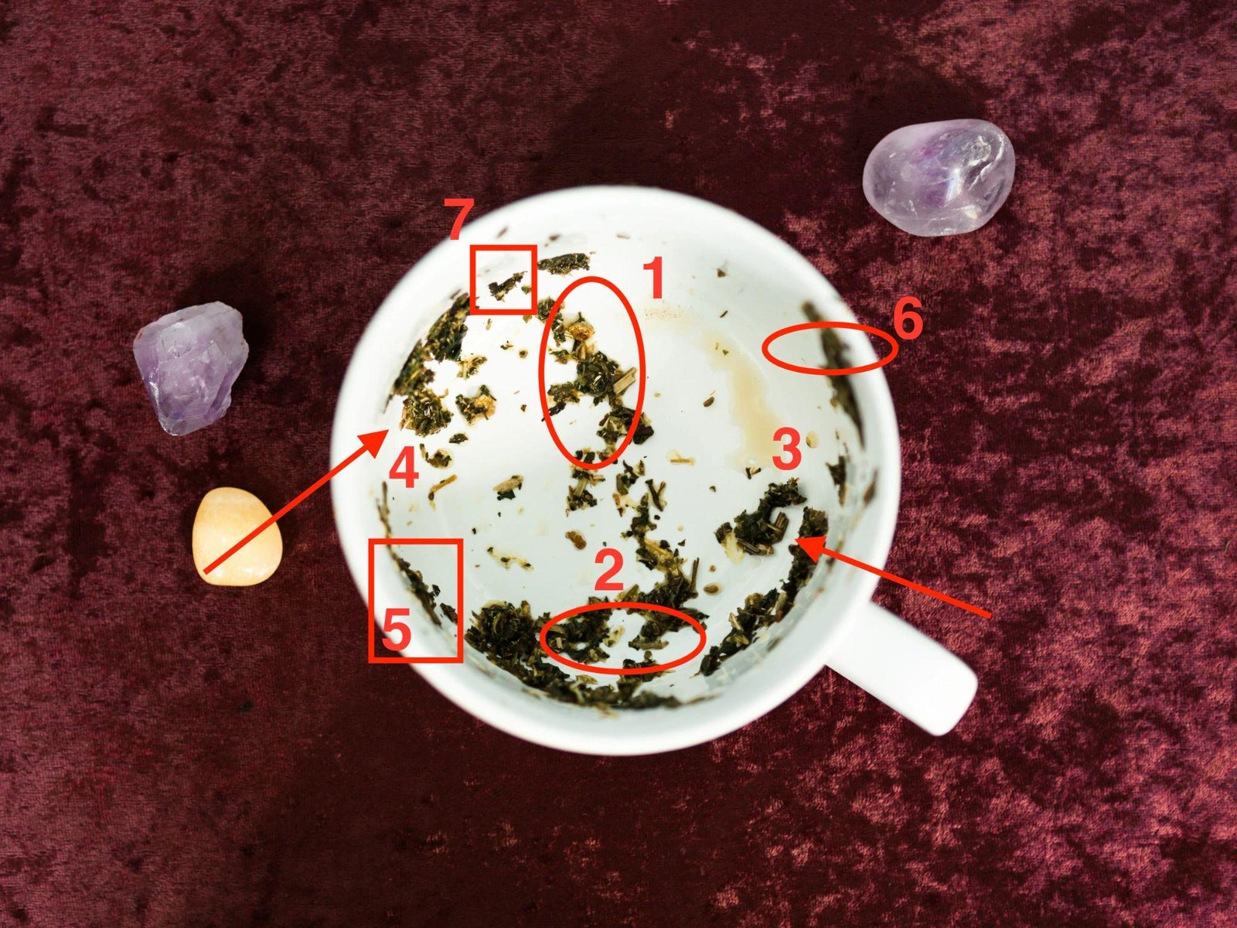
The Divided Rim — hot and cold
A tea-leaf reading by Evelyn Cross

Your cup is turned
Your cup, turned and read: the handle, the rim, the base, and seven leaves marked in red.
Dear,
Your cup’s turned, and I’ve been through it twice. Once last night with the lamp pulled down low over the kitchen table, and again this morning by the window, because there was one leaf I didn’t trust myself on at midnight. I’ll tell you which one when we get to it. I’ve marked your seven in red and numbered them, so you can find each one on the photo as I go.
Yours is a Divided Rim. If you ticked that box on the way in, you’ll know why it fits. If you didn’t tick anything, the cup’s done it for you: the heart in it came down in two halves with bare china between them, just left of your handle, and a heart in two halves is hot and cold.
A couple of things below will look as if they argue with my letter. The bird, mostly. Read to the end before you decide they do.

How a cup is read
In my letter I gave you the seven leaves, but I hadn’t turned the cup, so you had the what and none of the where. I look at three things in every cup.
The handle is you. A leaf close to the handle is close to you: yours, or right on top of you. A leaf across the cup is as far from you as the cup allows. That side belongs to people you haven’t met, and to things you’ve let drift so far off they’re as good as strangers. Your handle’s at the lower right of the photo. Three of your seven sit close to it: the tree, mark 3, just above it; the heart, mark 2, just left of it; and the lighthouse, mark 6, a little further round at the upper right.
Height is time. The rim and the band just under it hold the days: a fortnight either side of now, the near future and the near past. Below that, the further down a leaf runs, the further back it reaches. Halfway down is a couple of months. The base is what’s buried, there before you noticed anything. A leaf that trails down the wall has a history, and how far it trails tells me how long.
The man sets the order. Seven leaves, three days each: twenty-one days. The leaves tell me what each stretch is about, whose it is, and how near or far back it sits. They don’t tell me which stretch comes first, because leaves don’t land in a queue. The order comes from the man you’re dealing with. A woman whose man runs hot and cold has to stop a different thing first from a woman whose man has gone flat, so the same seven leaves reach her in a different order. If you ticked the Divided Rim, you told me which man you’ve got. If you didn’t, the heart told me. Either way I’ve read your days in the hot-and-cold order, and I’ll show you why it runs as it does.
So each of your seven has a whose, a how long, and a place in the order. I’ll show my working as I go.

The bird, and how long he’s been going
I’ll be straight with you about this one, because it’s the leaf I nearly got wrong.
Your bird is mark 1, across the cup from your handle, toward the top of the photo. His head’s a bright, pale-gold fleck up under the rim, with a dark clump below it for the body. If I’d stopped at the head, I’d have told you he started going a fortnight ago, and you’d have believed me.
But a bird’s more than its head. Under the body, smaller bits of leaf trail down the wall, smaller and further apart the lower they go, until they run into the loose specks scattered across your base. At midnight I couldn’t tell where the tail ended and the specks began, so I turned the cup three times before I’d say, the last time this morning with the window behind me. The last piece still in line with the rest of him sits almost exactly halfway down. Below that the bits lie every which way, and they’re specks.
A bird near the rim is a fortnight old. A bird at the base has been going since before you noticed anything at all. Yours runs from the rim to halfway, so I had to choose which end to read.
I read it from the tail. When a bird takes off, the tail’s the last part of it to leave the branch, so in a cup the tail marks where the flying started. The head only tells you how far he’s got.
He started going about two months ago, and whatever started it has nothing to do with the last three weeks.
The last three weeks are the head, the part you’ve been living in and going over at night. They aren’t where this began. You’ve been trying to fix something two months old with what happened last week, and when it didn’t work you blamed the way you’d handled it.
You didn’t handle it badly, dear. You were working on the wrong end of the bird.
And look where he sits: across the cup, on the side my letter said belongs to somebody you haven’t met. On his cold days, that’s exactly who you’re talking to.
My letter said a fortnight-old bird and a bird from the base would have you doing two opposite things this week. Here’s what I meant: a fortnight-old one you’d speak to straight away, and one from the base you’d leave alone. Two months is neither: set hard enough that speaking now lands as pressure, recent enough that the right words on the right day still get through. So your days start quiet, and the bridge waits for day 17.
Your cup
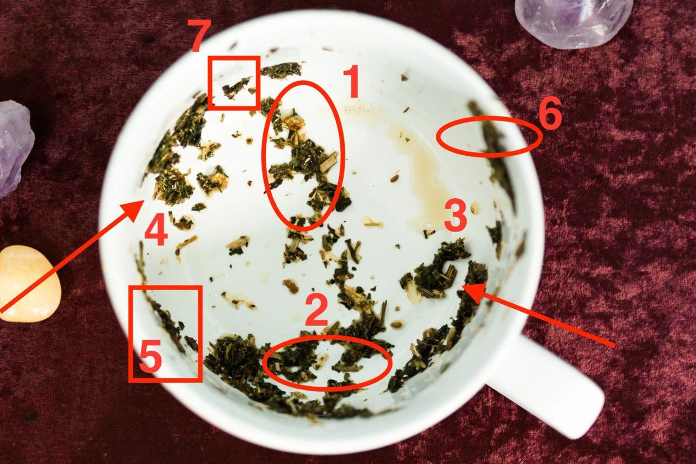
Your cup, the one I read for my letter, from above: my seven marks numbered in red, and the handle at the lower right.

Where your seven landed
Leaf | Where it sits | Days | What that makes it
2 · The broken heart | low, just left of your handle, in the dark band near the base | 1–3 | You, now. Two halves, bare china between
1 · The bird | across the cup from your handle; head up under the rim, tail halfway down | 4–6 | Him going. Two months, still going
3 · The withering tree | just above your handle, the nearest mark to you; mid-wall, a trail running down | 7–9 | What you had before. Bare stalks, a long root
4 · The boat | far left wall, the far side from your handle; mid-wall | 10–12 | Your shared weather. On his side
6 · The lighthouse | upper right, on your handle’s side; just under the rim, on its own | 13–15 | Your fixed point. Steady, close, and not him
5 · The bridge | lower left, right up under the rim; between the heart and the boat | 16–18 | The way across. Reachable, not built yet
7 · The butterfly | top left, on the rim, nearly opposite your handle; the highest leaf | 19–21 | Change in you. Already started
Read that last row twice, dear. The butterfly’s the highest thing in your cup, and highest means nearest, so the first change that actually arrives isn’t his. It’s yours, and it’s under way already. It sits nearly opposite your handle, where I’d look for somebody you haven’t met, and that’s you at the end of these days. It comes last because you can’t see it until it’s finished.

Your cup: the Divided Rim
Here’s the heart I promised you.
Find mark 2 on the photo, low down and just left of your handle. Two dark clumps sit side by side, and between them there’s a gap of pale, bare china. Two halves of one heart, with nothing joining them. In your cup, that’s where the divide is.
The two halves are his two temperatures as they land on you: the evening he’s entirely himself, and the evening you could be anyone. The gap is where you’ve been living, the hours between one and the other, waiting to see which man writes.
You’ve looked for the pattern in his hot and cold and you can’t find it. Look at the gap. It’s bare china. There’s no pattern sitting in it for you to find, and you can stop looking tonight.
The heart’s low, too, down in the thick band of leaf near the base. Low means settled. The swing’s been running long enough to sink in, which is why it feels like the weather now and not like something he’s doing.
Is it you? No. The heart sits by your handle because that’s where the swing lands, not where it starts. Where it starts is across the cup, with the bird. And the leaf my letter gave the hot and cold to, the tree, sits right beside your handle: thinned and bare at the stalks, and still one clump. If the swing came from something you’d done, I’d expect that tree broken apart, and it isn’t.
So the swing is in him, driven by something in his own week that you aren’t being told about. You’ve gone back over the cold days looking for what you did differently. You didn’t do anything differently.
Here’s the part you can use. A hot-and-cold pattern gets fed by the way it’s answered. Warm days get rewarded with long, quick replies. Cold days get met with reaching: the extra message, the “everything okay?”. Both teach him that his temperature sets yours.
So one instruction runs under every stretch below. Answer the hot day and the cold day the same. Same warmth, same length, same speed, whichever man writes that evening.
Then the order, and why it runs the way it does. Your heart comes first, because it’s yours: three days of being level while the swing finds nothing to feed on. The bird’s next, because his head’s up under the rim and the going’s happening now: you let it. Then the tree, because it’s the nearest leaf to your handle and the first thing you can actually reach: one small, ordinary message, at the root. A man who runs hot and cold will answer the ordinary on a cold day when he won’t answer anything serious. Only once the ordinary’s been answered do you go across to the boat, on his side, and ask about his weather. Then the lighthouse, close on your side, so you step onto the bridge from solid ground. Then the bridge. The butterfly closes it.
Your quiet comes first, and it’s long: nine days with nothing new from you, bar one small message about nothing. Being level whatever he does is what starves the swing.

How much is recoverable
My letter said the question that decides this isn’t whether there’s somebody else. It’s how long he’s been going, and how much of that is recoverable. How long is two months. Here’s how much.
Most of it. I’ll take it leaf by leaf, so you can see I’m not just being kind.
The warmth is recoverable. Look at the heart again. Both halves are there, side by side, both dark and solid. A man who’s entirely himself with you on some days hasn’t gone the whole way, and your cup kept his warm half as solid as his cold one.
What you had before is recoverable. A thin trail of leaf runs down the wall from your tree toward the base. That’s its root, and it goes a long way back. The way you talked before the relationship turned into a subject is still there, all the way down.
The two months are recoverable. A tail halfway down the wall is set, but it isn’t buried. None of your seven is lying on the base, and only the base is out of reach.
The ease isn’t. Your tree’s stalks are bare. The leaves that dropped off don’t go back on the branch, and those leaves were the easy part, when it ran by itself and neither of you had to think about it. Whatever grows up there again will be new, and it grows from the root.
Recoverable doesn’t mean he’s coming back, and I’m not going to promise you that. It means the thing’s still there to be got back. In your cup, most of it is.

Your twenty-one days
Count from the first evening after you read this. Not from a date. From this evening.
Each stretch takes its instruction from its leaf, from what the leaf is and where it sits, and I’ll give you the leaf first. I told you the cup had the weeks in it. It does. One message matters more than all the rest, and it has a day and an hour on it.

Days 1–3 · the broken heart · Say nothing
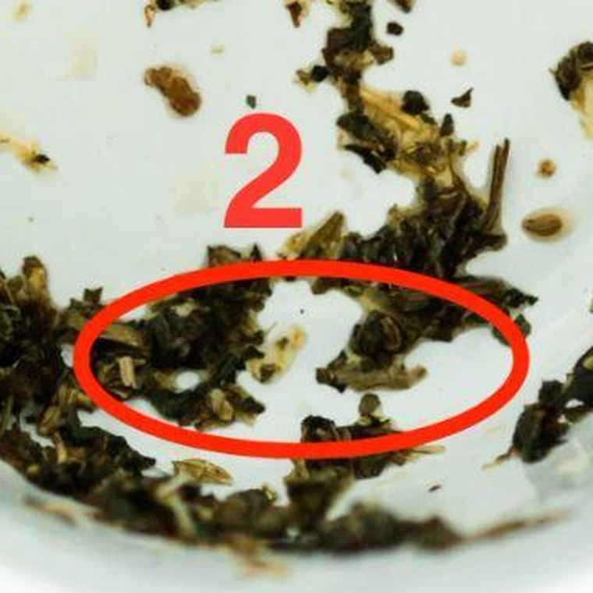
Mark 2, the broken heart: low in the cup, just left of your handle.
The two halves you’ve already seen, low by your handle with bare china between them. Near the handle makes this one you, and now.
When a wet leaf breaks in a cup and you push the halves back together, they don’t join. One slides over the other and you lose the shape of both. You leave them where they’ve fallen and let the cup dry round them.
So you don’t close gaps this week. Not the gap with him, and not the one left by the last conversation that ended badly. You send nothing. If he writes, answer warmly and briefly, and don’t add a question to keep it going. The Divided Rim rule starts here. Warm on day 2, you answer warm and short. Cold on day 3, you answer warm and short. The two replies should look like they came from the same woman on the same evening.
What goes wrong here is the softener. Two good days, and on the third you send “hope your week’s going okay”, because it doesn’t feel like breaking anything. You’ve pushed the halves back together.
This week: leave the last conversation where it fell, too. Don’t scroll back up to reread his last message for tone. Rereading pushes the halves together in your head.

Days 4–6 · the bird · Let the distance be distance
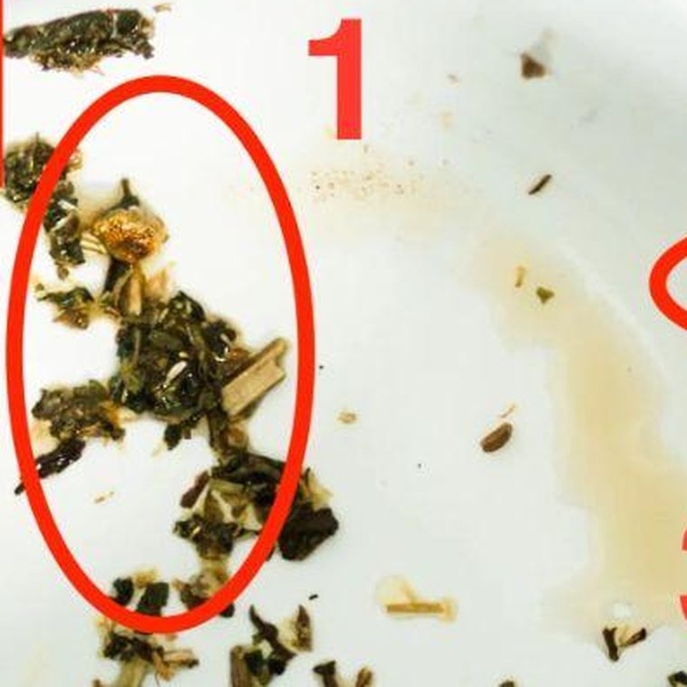
Mark 1, the bird: across the cup from your handle, head up under the rim.
You know the tail already. For these three days it’s the head that matters, up under the rim with the rest of him trailing down the wall behind it. That’s the shape of a bird on its way up and out, and his head’s in the days.
You can’t call a bird back out of the air. You can wait it out, or you can chase it, and chasing only drives it on, because anything coming up behind a bird is a reason to keep going.
Anything you send in this stretch is chasing, whatever it says, because a man in the middle of going reads every message as a pull.
So you start nothing. If he starts something, be entirely normal, and be the one who ends the conversation first, with no ceremony and no reason given. “Right, I’m going to get on. Night.” And go.
Ending it first is the whole of days four to six.
With his head up in the days, these are the days his temperature swings hardest. Your end doesn’t move with him. You’re warm, you’re brief, and you’re the one who leaves.
What goes wrong here is answering the warm day properly. He sends something that sounds like the old him, and in your relief you answer at length, straight away, with a question back. He’s just learned that warm gets rewarded.
This week: each time you end a conversation first, put the phone face down straight after. You don’t stand at the window watching a bird go.

Days 7–9 · the withering tree · One small ordinary thing
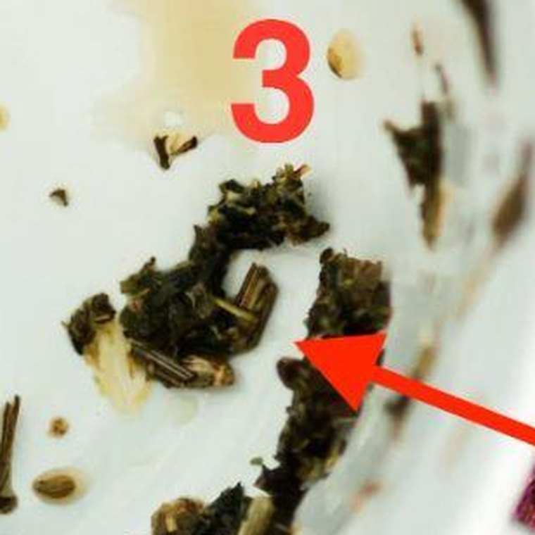
Mark 3, the withering tree: just above your handle, the nearest mark to you.
Just above your handle, closer to you than anything else in the cup: a dark, branching clump with bare stalks sticking out of it, and a thin trail of leaf running down from it toward the base.
A tree with bare stalks and a long root is withering, not dying, and you water it at the root. Water poured over the branches runs off. Water at the root takes days to climb, but it gets there.
The root is the ordinary stuff the two of you had before any of this became a subject. The branches are the subject itself, and you’ve been watering the branches for weeks.
So this is where you make contact, and it’s about nothing. Something you’d have sent him two years ago without thinking. A photo of a dog he’d find funny. A line about the man on the bus eating soup out of a flask. No question in it, or one so small it needs a single word back.
Once, in these three days. Not three times. And don’t wait for a warm day to send it. Waiting for his weather is how the swing has been running you.
What goes wrong here is the line at the end. “Anyway, hope you’re okay.” A kiss you wouldn’t have put there two years ago. Anything about the two of you is water on the branches, and it undoes the six quiet days you’ve just done.
This week: choose the thing on day 7, before you know his mood, and send it on day 8 or 9. If he answers with one word, that’s a good answer.

Days 10–12 · the boat · Ask, don’t tell
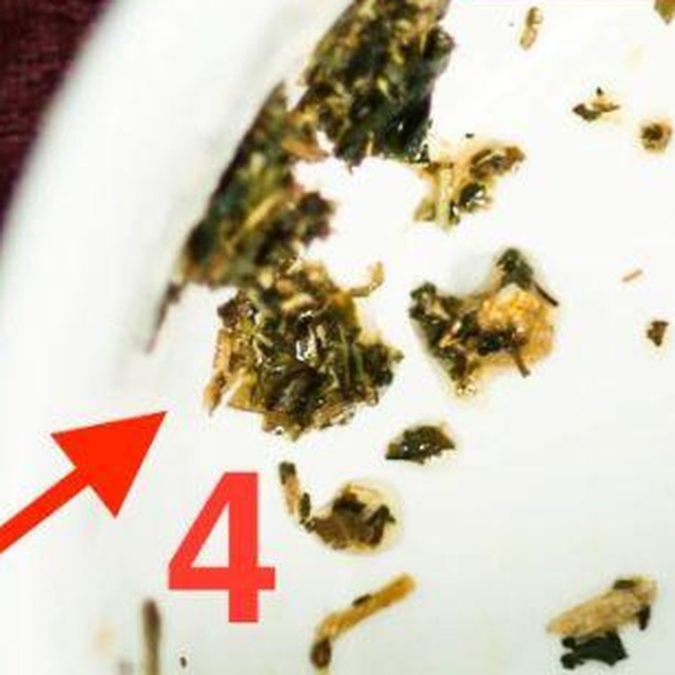
Mark 4, the boat: on the far left wall, the far side from your handle.
On the far left wall, the far side from your handle: a loose group of clumps lying low and spread out, the way a hull sits in the water. It’s halfway down the wall, so the weather you’re both in is about as old as the bird. And the boat’s the only one of the seven that carries two people.
Row a boat with one oar and it goes round in a circle, however hard you pull. You’ve been rowing on your own for weeks. Every long message and every “can we talk” was a stroke with one oar. Now you put your oar in lightly and wait for his.
So you ask, and you don’t tell. The small thing on days 7 to 9 went to the tree, on your side of the cup. This one goes across to his. Ask him something about himself, not about the two of you: whatever the last two months have really been about for him. His work, his family, the flat. Let him answer at his own length, and don’t fill the gaps.
Here’s where you start finding things out. Most women find out it was never about them. A man who runs hot and cold talks about what’s driving it when he’s asked about his week, not his moods.
What goes wrong here is turning his answer into something about you. He says work’s been grim, and you say “is that why you’ve been so distant?” Your oar’s back in on its own, and the boat turns.
This week: one question, on day 10 or 11, about his life. If he answers at length, listen and ask one more. If he answers short, leave it short. Either way, you finish the exchange first.

Days 13–15 · the lighthouse · Go to your fixed point
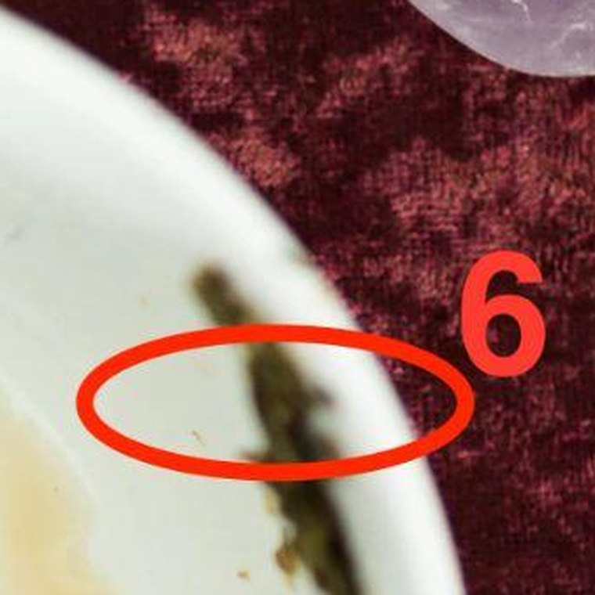
Mark 6, the lighthouse: upper right, on your handle’s side, just under the rim.
Upper right, on your handle’s side of the cup, just under the rim and above the pale tea stain: one thin upright streak of leaf, standing on its own in clean china.
Near the handle is close to you, and just under the rim is now. Your fixed point’s been a few inches from you all along, steady, with nothing touching it.
A lighthouse doesn’t go to ships. It stays where it is, it’s lit, and the ships find their way by it.
The lighthouse is your own fixed point: the friend, the sister, the work, the swimming, whatever held you level before this started. My letter said you’d been navigating by a moving point, and a man who runs hot and cold is the most moving point there is.
These three days are when you go back to it. One real evening, properly, with the person or the thing it is. Not to talk about him. Do it whether or not the boat went well. The lighthouse sits right before the bridge because the bridge goes better from a woman who’s just spent an evening on solid ground.
What goes wrong here is going to the lighthouse and spending the evening talking about him. You’ve used up the one evening that was meant to be yours.
This week: arrange it on day 13 and have it done by day 15. If you can’t think who it is, it’s whoever you’d have rung first a year ago.

Days 16–18 · the bridge · This is the week
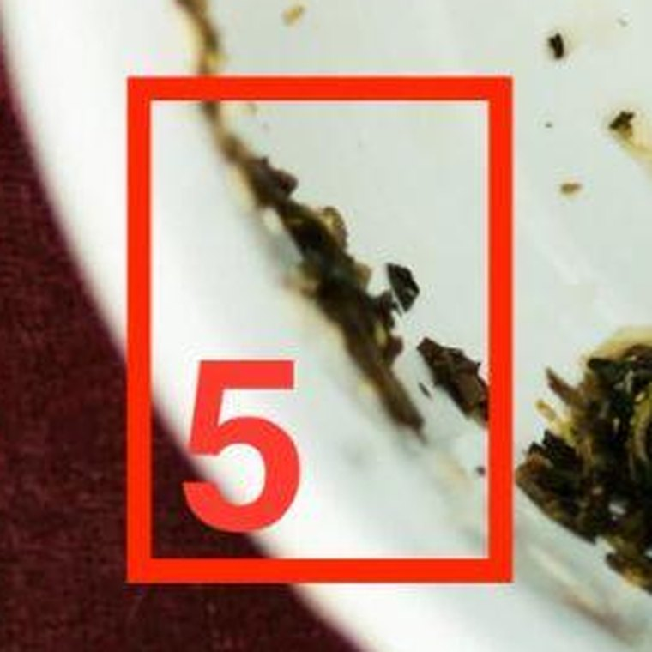
Mark 5, the bridge: lower left, right up under the rim.
Lower left, right up under the rim: a thin line of leaf lying along the edge of the cup. Going round the cup, it sits between your heart and the boat, between your side and his, and higher than either.
The bridge is what you bought. It’s the one stretch where what you say lands as an invitation and not as pressure. A week earlier, the same words are an exit.
A bridge spans a gap, and you can walk it from either end. So you build a short one, and you stand on your side of it. A long bridge is a woman crossing the whole way herself. Yours is thin, one line of leaf, and a thin bridge carries one thing.
In plain terms: one thing, said plainly and briefly. Something true about what you want, with no case attached, no history, and no request for an answer.
Your day is day 17. Send it early in the evening, between six and eight.
A bridge carries its weight at the middle of its span, so of its three days the middle one takes it. And your bridge sits just under the rim, level with your lighthouse on the other side of the cup. Leaves at the same height keep the same hour, and a lighthouse is lit at dusk. So the message goes as the lamps come on. Not after nine: a message that lands at eleven reads as a woman who’s been up composing it.
Day 17 doesn’t move for his weather. Cold that day, it goes. Warm, it goes, and you don’t make it longer because he’s in a good mood.
Say it, and then stop. Don’t add the paragraph that explains it. The explaining paragraph is the bridge he walks away over. If there’s a message you’ve been redrafting for weeks, this is its week. Cut it to a third of its length. Keep the sentence that says what you want, and take out the ones that say why.
What goes wrong here is the follow-up: no answer inside the hour, so at half past nine you send a second message to soften the first. The second message is the long bridge.
This week: write it on day 16 and leave it alone. On day 17, read it once at six, cut anything that’s crept back in, and send it before eight. Then put the phone away. On day 18, answer whatever he’s said, warmly and at his length, and don’t refer back to it.

Days 19–21 · the butterfly · Look at what changed in you
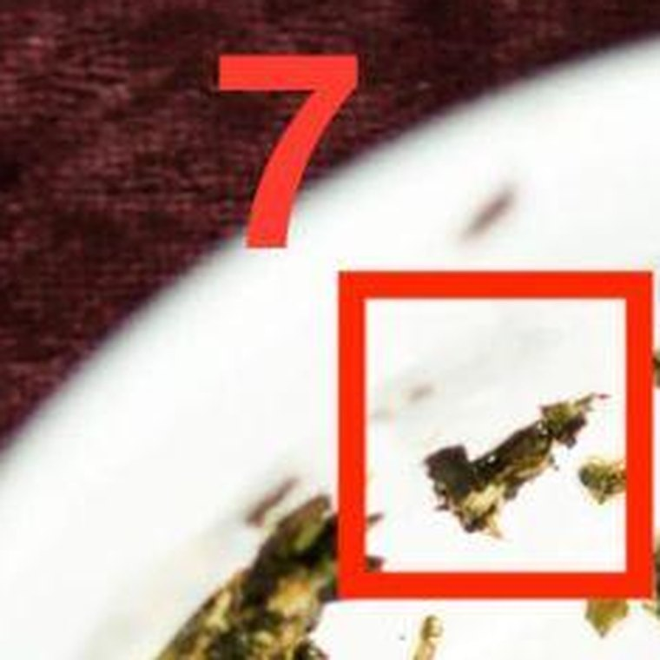
Mark 7, the butterfly: top left, on the rim, the highest leaf in the cup.
Top left, sitting on the rim itself and higher than anything else in your cup: a small fleck with two lobes, two small wings, nearly opposite your handle.
A butterfly’s change happens inside a closed case where nobody can see it. By the time the wings show, the work’s done, and coming out is only the last few minutes of it.
So there’s no instruction toward him in these three days. Whatever he’s said since day 17, answer it the way you’ve answered everything for three weeks.
The butterfly’s yours. Look back over the twenty-one days. You’ll have gone three weeks without composing anything at two in the morning. You’ll have answered a hot day and a cold day the same and found nothing fell apart. The woman who did that is the somebody you hadn’t met.
Whatever he does or doesn’t do, that part’s yours, and it doesn’t reverse.
What goes wrong here is turning day 21 into a deadline: deciding that if he hasn’t done something by tonight it’s over, and sending the message that says so. Day 21 is where the days stop. Nothing’s due on it.
This week: on day 21, take ten minutes and write down three things you did in these three weeks that you couldn’t have done on the evening you bought this. Keep the paper. Don’t send it to anybody.

Three things to expect
One: the quiet will feel like losing. Days 1 to 9 will feel like giving up ground, because doing nothing feels like doing nothing. It isn’t. Those nine days are the only stretch where the swing stops being fed. Women who drop the days drop them here, on day five.
Two: he’ll go cold first, then very warm, once. For the first few days his cold side wins: shorter replies, longer gaps. Then, around day five or six, he’ll send something that sounds exactly like the old him: long, funny, easy. That’s him looking back over his shoulder, checking whether the old answer still comes back. Give it the length you’d give a cold day. The next day he’ll be cold again. Neither one is news about you.
Three: one person’s going to talk you out of this. Somebody close to you, and you already know who, is going to hear that a tea reader has given you a three-week plan and tell you to just be honest with him and say how you feel. They’ll mean it kindly. They’ve watched you be unhappy and they want it over.
Being honest with him is day 17. It’s in the days. What they’re suggesting is doing it tonight, which is the one thing this reading exists to stop, and exactly what the woman in my letter did. She said the right thing on the wrong day, and it cost her four months.
Don’t argue with them. Don’t tell them what you’re doing.

What this reading cannot do
One honest limit, and then I’ll let you go.
Everything above is about what you say and when. Leaves are good for that.
There are marks in your cup I haven’t given you, because they aren’t symbols. Down on the base, below the end of the bird’s tail, there’s a scatter of loose specks, too small and too broken to make a shape. The base is what’s buried.
My letter said the bird doesn’t tell me whether there’s somebody else, and the specks don’t either. If there’s a second presence in this, that’s where she’d be: under everything, too broken up for me to name. If there isn’t, they’re specks.
Either way, the days above work around it. I can tell you the shape of this and what to say. I can’t make anything stop.
Making something stop is different work, and it isn’t this one. I’ll write to you about it another time, if it turns out to matter.

Follow the days, dear, and don’t read ahead to the bridge on day two.
You stopped guessing the moment you had a sequence. Everything after this is just following it. Your calendar’s on the next page.
— Evelyn

And this is yours to put on a door
The reading above is the thing to read. This is the thing to look at.
Print it, or copy it onto a card, and put it where you’ll see it without going to find it. The inside of a kitchen cupboard is where most women end up putting theirs. Not the fridge, where other people read it.

Your twenty-one days
Day 1 is the first evening after you read this. Cross each day off before bed.
○ quiet: you start nothing, and you answer warm and brief, hot day or cold · ● you send one thing
Days | Leaf |  | The word | What it means
1–3 | the broken heart | ○ | QUIET | Send nothing. Answer him warm and short, whatever his mood
4–6 | the bird | ○ | QUIET | Start nothing. If he does, you end it first, no reason given
7–9 | the withering tree | ● | SMALL | One thing about nothing, day 8 or 9. No question. Once
10–12 | the boat | ● | ASK | One question about his life, day 10 or 11. Not about you two
13–15 | the lighthouse | ○ | AWAY | One real evening with your fixed point. Not about him
16–18 | the bridge | ● | SPEAK | Day 17, between six and eight in the evening. One plain thing. No explaining paragraph
19–21 | the butterfly | ○ | LOOK BACK | What changed in you. Nothing owed to him

How to use it on a bad night
There’ll be an evening, around day five, when you’ve decided you’re going to send something. Not on a whim. You’ll have thought it through and it’ll feel reasoned. There’ll be a second one, too: the evening after one of his warm days, when warm feels like an invitation.
On that evening, go and look at the door. Find the day. Read the one word next to it, and do that and nothing more.
If it says QUIET, you send nothing tonight. What you’re feeling is the day it is, and that day feels exactly like this for every woman who’s done these days. It isn’t news about him. It’s an evening with a number on it.
Then go to bed, and cross it off, because you got through it.

One rule
Don’t read ahead to day 17. Drafting on day four is how the thing you send on day 17 turns up carrying everything you felt in the first week. Cross the days off. Don’t work ahead.

On the twenty-second day
Take it off the door. Whatever’s happened by then, the days are finished, and a calendar left up past its last day turns into a monument.

