The Turn
Your cup is turned
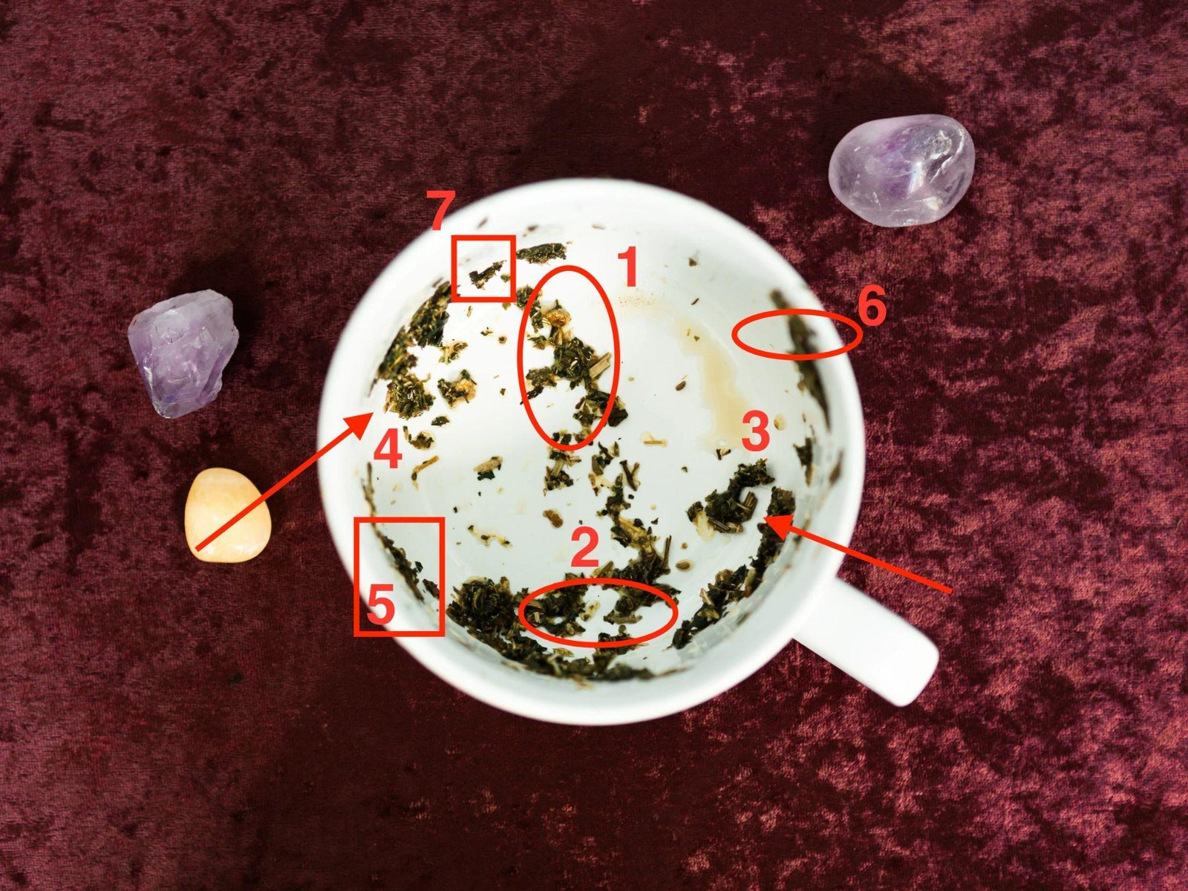
The Sunken Leaf — silence; she starts everything
A tea-leaf reading by Evelyn Cross

Your cup is turned
Your cup, turned and read: the handle, the rim, seven leaves marked in red, and one of them sunk low by the base.
Dear,
Your cup’s turned. Of the three cups, yours is the hardest, and you deserve it read straight, so that’s how I’ve read it. I’ve marked your seven in red and numbered them, so you can find each one on the photo as I go.
Your cup reads as a Sunken Leaf. What runs between you and him has gone quiet from his end. Lately, anything that passes between you starts with you. One of your seven has sunk low, down near the base, and I’ll show you which.
Some of what’s below will go against what you’ve been telling yourself. Read to the end before you decide it’s wrong.

How a cup is read
You’ve seen your seven leaves. Their places are where the timing is, and three things decide it.
The handle is you. Near the handle is near you, and yours. Across the cup is the far side, as far from you as the cup goes: the place for people you haven’t met, and for anything you’ve let slip so far off it’s as good as a stranger’s. Your handle’s at the lower right of the photo.
Height is time, and the base is buried. The rim and the band just under it hold what’s close in time, a fortnight either side of now, just gone or just coming. The further down a leaf runs, the older the thing it’s telling me about. Halfway down is two months. The base is what’s buried: old, settled, there before you noticed. In your cup the bottom of the wall matters more than in most, because one of your seven has sunk down there.
The first light sets the order. Seven leaves at three days a leaf: twenty-one days. The leaves tell me what each stretch is about, whose it is, and how near or far back it sits. They don’t tell me which stretch comes first, because leaves don’t land in a queue. The cup does. When I first turn a cup, I tip it slowly toward the light, and the whole cup reads from the mark that catches the light first. A woman who’s been met with silence has to stop a different thing first from a woman whose man runs hot and cold, so the same seven leaves come to her in a different order. In yours the light went right down the wall into the dark band near the base, and the first mark it caught was mark 2, half lost in the leaf round it. A cup that reads from its lowest leaf is the slowest of the three, and I’ll show you why.
I’ll show my working at every leaf, so none of this rests on you taking my word.

The bird, and how long he’s been going
The bird nearly beat me, and I’ll tell you how, because the way I got it right is the answer.
Your bird is mark 1, across the cup from your handle, toward the top of the photo. His head’s a bright, pale-gold fleck up under the rim, with a dark clump below it for the body. Under that, his tail trails down the wall in smaller and smaller bits, and they run on down into the loose specks scattered across your base.
At midnight, with the lamp low, I turned the cup three times, and each time the tail and the specks looked like one long trail running from the rim right down to the bottom of the cup. Read that way, your bird would have been at the base, and I’d have told you he was going before you’d noticed anything. This morning I took the cup to the window and ran the point of a pencil down the tail. The pieces that are his sit in one line, and the line stops halfway. Below it the bits lie every which way, the same loose specks as the rest of your base. The lamp hadn’t shown me the difference.
A bird’s age is read from its tail. The tail’s the last part of a bird to leave the branch, so it marks where the flying began.
He started going about two months ago, and whatever started it has nothing to do with the last three weeks.
The last three weeks are the silence, and the silence is the head of the bird: where he’s got to. It isn’t where it began. You’ve been going over the last few messages you sent, looking for the one that did it. None of them did it. It was under way before they were written.
And look where he sits: on the far side of your cup, the side that belongs to somebody you haven’t met. He’s gone as quiet as a stranger, and that’s where the cup put him.
A fortnight-old bird and one from the base would have you doing two opposite things this week: speak at once, or leave it be. Two months is in between. Set enough that pushing now lands as pressure, recent enough that it can still be reached on the right day. So your days start quiet. In your cup they stay quiet longer than in any other, and that’s the sunken leaf’s doing, not the bird’s.
Your cup
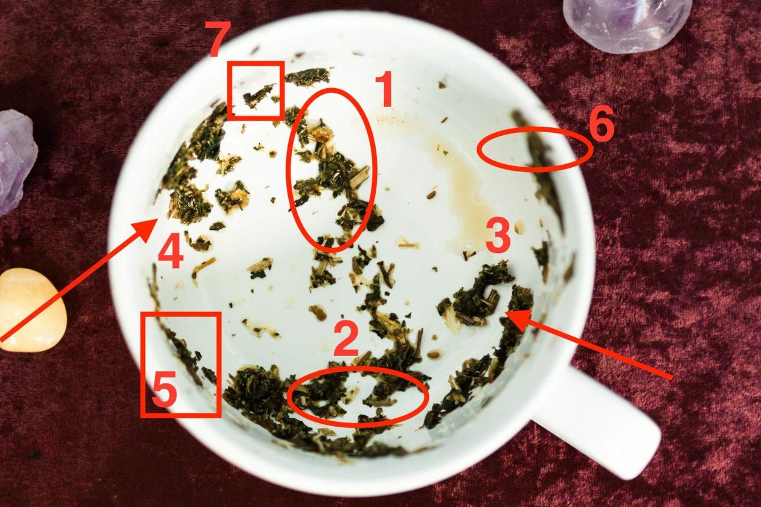
Your cup, the one I read for you, from above: my seven marks numbered in red, and the handle at the lower right.

Where your seven landed
Leaf | Where it sits | Days | What that makes it
2 · The broken heart | low, just left of your handle, in the dark band near the base | 1–3 | You, now. The sunken leaf
1 · The bird | across the cup from your handle; head up under the rim, tail halfway down | 4–6 | Him going. Two months, still going
7 · The butterfly | top left, on the rim, nearly opposite your handle; the highest leaf | 7–9 | Change in you. Already started, and early
3 · The withering tree | just above your handle, the nearest mark to you; mid-wall, a trail running down | 10–12 | What you had before. The first thing you can reach
6 · The lighthouse | upper right, on your handle’s side; just under the rim, on its own | 13–15 | Your fixed point. Close, and not him
4 · The boat | far left wall, the far side from your handle; mid-wall | 16–18 | The two of you as a pair. On his side, sitting still
5 · The bridge | lower left, right up under the rim; between the heart and the boat | 19–21 | The way across. Thin, and last
Read the third row twice, dear. In the other two cups the butterfly comes at the end. In yours it comes straight after the bird, in the middle of the quiet, and it’s the highest leaf you’ve got. The first change in all this is yours, and it starts sooner than anything else.

Your cup: the Sunken Leaf
A sunken leaf is one that’s gone down toward the bottom of the cup, where things get buried. It hasn’t gone under. That’s the whole of your reading in one line, and I want it said before anything else.
Yours is the heart.
Find mark 2, low down and just left of your handle. It sits in the thick dark band of leaf that runs along the bottom of your cup, and you have to look for it: two dark clumps side by side, with a pale gap of china between them, half lost in the leaf round it. Nothing of yours sits lower. And it’s still on the wall, not lying on the base.
The heart’s yours. It’s the turmoil, yours mostly: the state you’ve been in while this hasn’t ended. In your cup that state has sunk. It’s gone down to where old things settle, and it’s sitting there by your handle under a weight of leaf.
Now look at the rest of the cup the way I did. Your side of it, round the handle, is busy: the heart, the tree just above the handle, and the lighthouse a little further round at the upper right. Across the cup sit his two, the bird and the boat, with the butterfly up on the rim between them, and the butterfly isn’t his. I’ll come to it. Neither of his two moves unless he moves it. The bird’s already going. The boat sits on the far left wall, low and spread out, still.
The boat’s the one leaf of the seven that carries two people. It’s the back-and-forth, the weather you were both in, the two of you as a thing that moves. And it’s sitting on his side of the cup. You’ve been rowing it from yours. Every message you’ve started for weeks has been a pull on the oars of a boat that’s over on his side. Nothing moves, however hard you pull, so you pull harder.
Here’s the finding, and it’s harder than the other two cups get. The starting has become the problem. Not how much of it. The fact that it’s all yours. Every exchange you’ve had lately began with you, which means neither of you knows whether he’d come to you on his own. You haven’t been able to stop long enough to find out.
Your days are built to find out, and here’s why they run in the order they do. A silent cup can’t be hurried, and I won’t pretend it can. The heart comes first, because it’s yours and it’s sunk: three silent days. The bird’s next, because his head’s up under the rim and he’s still going: three more. Then the butterfly, which in the other two orders comes last. In yours it comes third, still inside the silence, because the change in you has to happen before you start anything again, and it’s the highest leaf in your cup, sitting on the rim, so it’s already close. Then the tree, the nearest leaf to your handle and the first thing you can reach: a small message about nothing on days 10 to 12. Then the lighthouse, on your side, which matters more in your cup than in any other. Then the boat’s own days, where you see whether he picks up an oar. Then the bridge, last, and thin.

How much is recoverable
The question that settles this isn’t whether there’s somebody else. It’s how long he’s been going, and how much of it can be got back. How long: two months. How much:
The two of you: all of it. You doing all the starting: none of it.
The two of you are recoverable because the boat’s still up on the wall. It’s on the far side and halfway down, and none of it has gone to the base. A boat on the bottom can’t be raised. Yours isn’t on the bottom. Your heart sank, but it stopped short of the base too: low on the wall, and not on it. The tree’s trail runs a long way down the wall, so the ordinary ground you had before is there to stand on. And the bird’s tail stops halfway. Nothing about him has reached the base.
You doing all the starting isn’t recoverable, and you don’t want it back. That version of this ends on day 1, whatever he does, because the days end it.
Recoverable means the boat can move. In your cup, moving it is his job, because the boat sits on his side of the cup and you can’t row it from yours. You’ll know whether he’s doing it by day 16.
And the honest part, because I’d rather you had it from me. Nine days of silence may produce nothing. If it does, that’s information you haven’t had in months and couldn’t have got any other way, and it’s worth more than another six weeks of carrying the whole thing alone and calling it a relationship. The heart’s still on the wall either way. What you find out is whether he picks up an oar.

Your twenty-one days
Day 1 is the first evening after you read this. Not a date on a calendar. This evening.
Every stretch takes its instruction from its leaf, from what the leaf is and where it sits, and the leaf comes first so you can see where the instruction comes from. Your cup has the weeks in it, and one of them has a day and an hour on it.

Days 1–3 · the broken heart · Silent
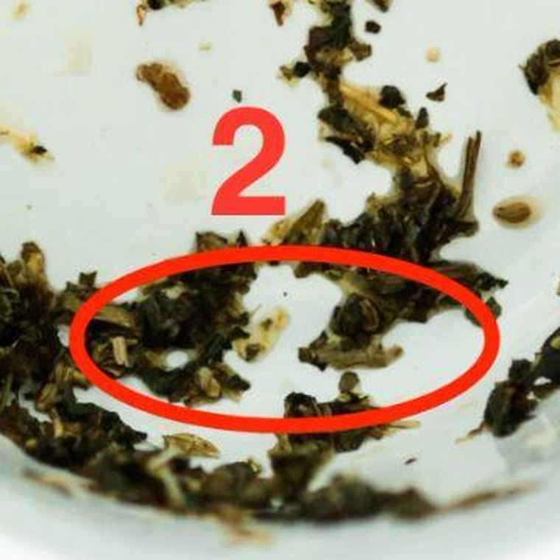
Mark 2, the broken heart: low in the cup, just left of your handle.
Your sunken leaf: two dark clumps with a pale gap of china between them, low down by your handle in the thick band of leaf near the base. By the handle is you, now. Low down is how long you’ve been carrying it.
Push the halves of a broken wet leaf together and they don’t mend. One slips over the other and the shape of both is lost. You leave them where they lie.
You’ve been pushing for weeks. Every message you started was you pressing the halves together from your side, and it hasn’t mended anything.
So these three days are silent. Nothing sent. Not a warm line, not a small ordinary thing, nothing. If he writes, he’s come to you on his own: answer once, warmly and briefly, and don’t start anything new off the back of it.
What goes wrong here is the “just checking in”. After two days of nothing, you send one line to make sure he hasn’t forgotten you. That line tells him the silence was a pause and not a change, and it costs you both days.
This week: archive the conversation with him so it isn’t the first thing you see when you pick up the phone. You’re not deleting anything. You’re leaving the pieces where they fell.

Days 4–6 · the bird · Silent

Mark 1, the bird: across the cup from your handle, head up under the rim.
Across the cup, the bird’s head is up under the rim and the rest of him trails down the wall behind it: the shape of something on its way up and out. He’s in the air.
You can’t call a bird out of the air. You can let it go, or you can chase it, and a bird that hears something coming up behind it keeps going.
In a silent cup, the chasing goes silent too. It’s checking when he was last online. It’s looking through his photos. It’s asking a friend whether she’s heard anything. None of it reaches him, and all of it keeps you running along behind the bird.
So days 4 to 6 are silent on the outside and on the inside. Nothing sent, and no looking.
What goes wrong here is the late-night look. You tell yourself it isn’t contact, because he doesn’t know. It’s chasing with the sound turned off, and you feel it in the morning.
This week: each evening, notice the hour when you’d normally go looking, and be somewhere else in it: the bath, a walk, the neighbour’s kitchen. Day five’s the worst of the three, so plan that one.

Days 7–9 · the butterfly · Silent
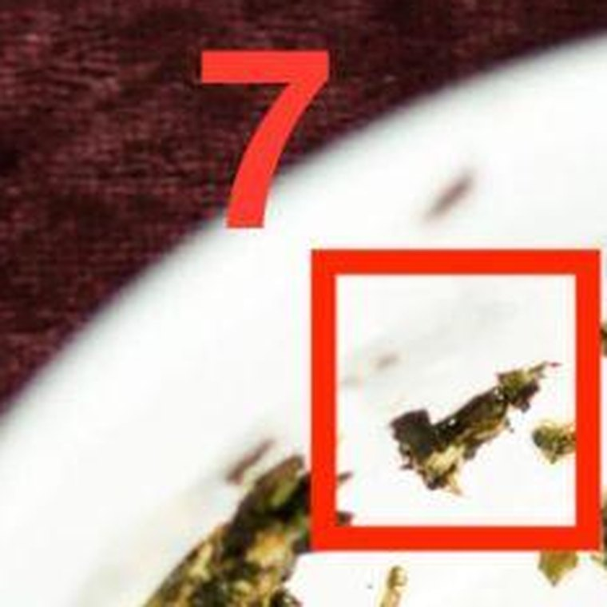
Mark 7, the butterfly: top left, on the rim, the highest leaf in the cup.
Top left, sitting on the rim itself and higher than anything else in your cup: a small fleck with two lobes, wings only just out. It’s nearly opposite your handle, up on the rim between his boat and his bird, and it isn’t his. Across the cup is the place for somebody you haven’t met, and the butterfly’s the woman you’ll be when these days are done.
A butterfly does its changing inside a shut case, and nothing shows from outside while it does. Open the case early and what’s inside dies. It has to come out on its own day.
The butterfly sits in the middle of your quiet because the change it’s carrying is the one you need before you start anything again: becoming a woman who can go nine days without starting a thing and still be standing. The change happens in these three days, out of sight. You’ll feel it as boredom more than strength, and that’s fine.
So the case stays shut. Days 7, 8 and 9 are silent, the same as the six before.
What goes wrong here is day 9. You decide nine days has made the point, and on the evening of day 9 you send something. One day early is the case opened early, and everything in it is lost.
This week: each evening, write down the time you first reached for the phone meaning to start something. By day 9 it’ll be later than it was on day 7.

Days 10–12 · the withering tree · One small thing, no question
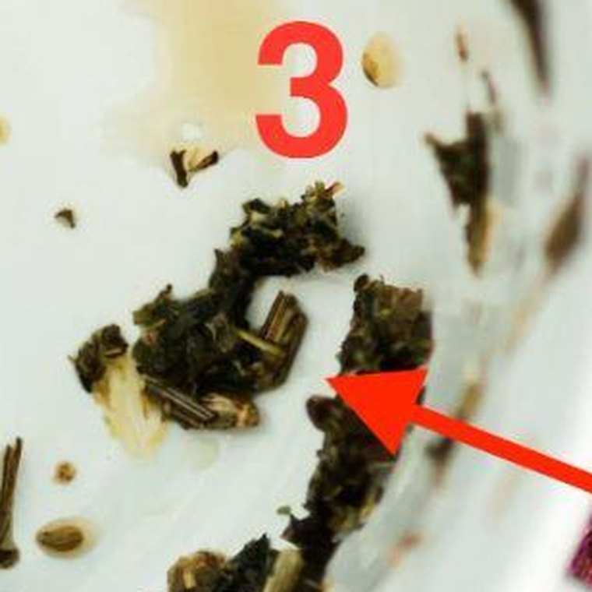
Mark 3, the withering tree: just above your handle, the nearest mark to you.
Just above your handle, nearer to you than anything else in the cup: a dark, branching clump with bare stalks sticking out of it, and a thin trail of leaf running down from it toward the base.
A tree like that is withering, not dying. You water it at the root, not the branches. Water at the root takes days to climb, and it gets there.
The root is the ordinary stuff you had before any of this was a subject. In your cup the tree’s the nearest leaf to your handle, so the ordinary is the first thing you can reach, and the first thing you send.
Days 10 to 12 are the first time anything goes from you to him, and it’s small. One thing about nothing. A photo of the cat asleep in the washing basket. A line about the woman in the post office queue with a ferret. No question. Nothing that needs an answer. You’re opening a door, not knocking on one.
What goes wrong here is the question mark. Even “how are you?” is a knock. A knock asks for an answer, and an answer is exactly what you’ve been asking him for, for weeks.
This week: choose it on day 10, send it on day 10 or 11, once. Then don’t watch for a reply. It isn’t due. If it comes, it’ll come late.

Days 13–15 · the lighthouse · Go to your fixed point, properly
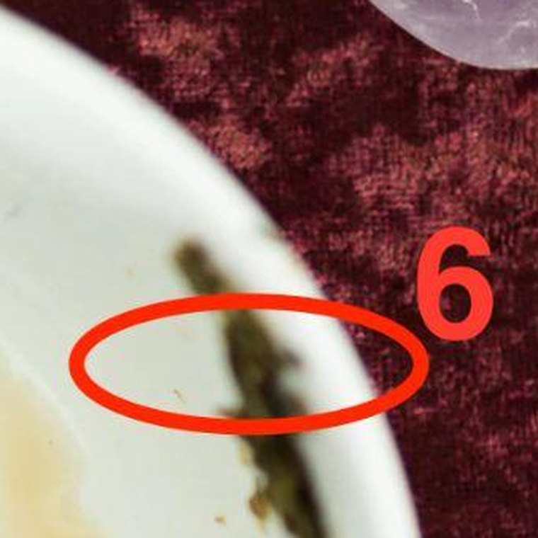
Mark 6, the lighthouse: upper right, on your handle’s side, just under the rim.
Upper right, on your handle’s side and just under the rim, above the pale tea stain: one thin upright streak of leaf, standing entirely on its own in clean china. Close to you, and now. Your fixed point’s been a few inches from your handle all along, and it’s the one leaf on your side that nothing else is touching.
A lighthouse doesn’t go to ships. It stays where it is, it’s lit, and the ships find their way by it.
These days matter more in your cup than in any other. Nine silent days followed by one message he hasn’t answered yet is exactly where a woman on her own decides the whole thing’s finished. So you won’t be on your own. Your lighthouse is the friend, the sister, the work, the allotment, whatever held you level before this.
And in your cup once won’t do it. You go to it twice. Two real evenings, not one. Not to talk about him.
What goes wrong here is telling your fixed point about the days. You’ll spend the evening defending them (“why don’t you just text him?”), and you’ll come home doubting them.
This week: one evening on day 13 and another before day 15 ends. Book them on day 12 so they’re in place before you need them.

Days 16–18 · the boat · Find out whether he rows
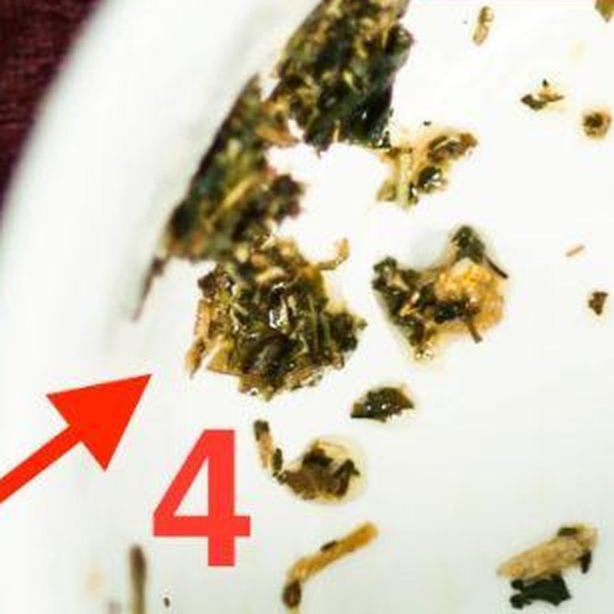
Mark 4, the boat: on the far left wall, the far side from your handle.
On the far left wall, the far side from your handle: a loose group of clumps lying low and spread out, the way a hull sits in the water. It’s halfway down the wall, about as old as the bird, and it’s sitting on his side of the cup.
A boat nobody’s rowing doesn’t go anywhere, and you can’t row it from the bank. A boat on his side moves when he rows it, and these are its days.
These three days are where you find out whether he has. On day 16, ask yourself one question: has he written to you at all since your small message went?
If he has, the boat’s moving. Answer him warmly. Then ask him one thing about himself, about whatever the last two months have really been about for him, and let him answer at his own length. Let him row. You end the exchange first.
If he hasn’t, the boat’s still sitting where it was. You don’t row it. Nothing sent on these three days. The bridge still comes on day 20, and it’s still yours to build.
Either way, these are the days that tell you something you haven’t known in months: what he does when you don’t do it for him.
What goes wrong here is one more pull from the bank: a second message on day 16 because the first wasn’t answered. It puts you straight back where you were on the evening you bought this.
This week: ask yourself the day 16 question once, answer it honestly, and follow the branch it gives you.

Days 19–21 · the bridge · One sentence: day 20
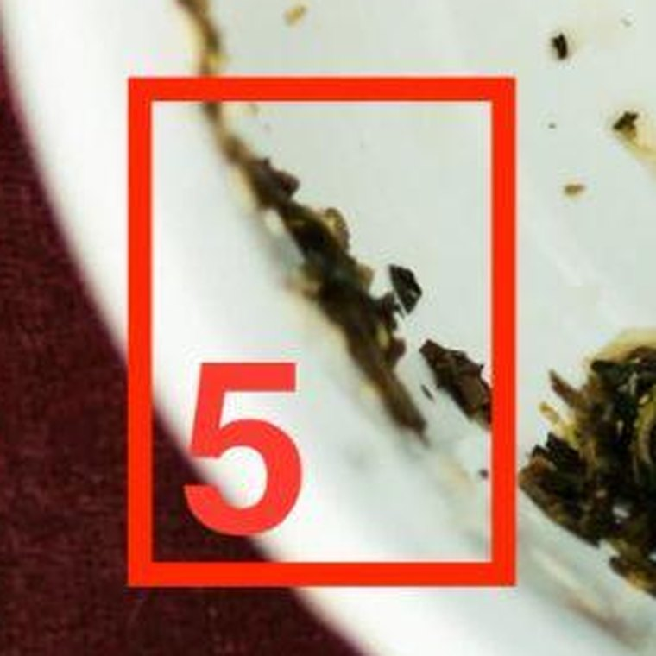
Mark 5, the bridge: lower left, right up under the rim.
Lower left, right up under the rim: a thin line of leaf lying along the edge of the cup. Going round the cup, it sits between your heart and the boat, between your side and his, and higher than both.
A bridge spans a gap and can be walked from either end. So you build a short one and you stand on your side of it. Yours is thin, one line of leaf, and a thin bridge carries one sentence. Not a paragraph.
This is your bridge week, the three days when what you say lands as an invitation and not as pressure. It comes last because a silent cup can’t be hurried, and because of where it sits: halfway round between your heart and his boat. In a cup where you’ve been crossing the whole way yourself, you build the bridge only once you’ve seen whether he’ll row any of the way. And it’s yours to build from your side, whatever the boat did.
The sentence is something true about what you want. No history, no case, no “I know it’s been a while”, and no question at the end.
Your day is day 20. Send it early in the evening, between six and eight.
A bridge carries its weight at the middle of its span, so the middle of its three days is the one. And your bridge sits just under the rim, level with your lighthouse on the other side of the cup. Leaves at the same height keep the same hour, and a lighthouse is lit at dusk, so it goes as the lamps come on. Never after nine.
If the boat moved, the sentence goes into a line that’s moving again. If it didn’t, it’s the same sentence, said once, and then your days are done.
What goes wrong here is the question on the end. “Do you feel the same?” A question asks him to row, and the bridge isn’t the place for rowing. If you add the explaining paragraph as well, you’ve built the long bridge he walks away over.
This week: write the sentence on day 19. On day 20, send it between six and eight, then put the phone away. Day 21 is for leaving it on the far bank. And look back once that evening: the butterfly came early in your cup, and by now you can see what it was. You went nine days without starting a thing, and you’re still here.

Three things to expect
One: the silence will feel like proof it’s over. You’ll feel it on day five, and again on day 9. It isn’t proof of anything. In your cup the proof isn’t due until day 16, and nothing before then counts.
Two: the silence goes both ways at first. Expect nothing from him in the nine silent days. And if he answers day 10’s message, he answers late: not that evening, but somewhere in the lighthouse days, after he’s walked past the open door a couple of times. Don’t sit by it. That’s what the lighthouse evenings are for.
Three: one person’s going to talk you out of this. Somebody close to you, and you already know who, will hear that a tea reader has told you to go silent for nine days, and tell you to just ring him and say how you feel. They’ll mean it kindly. They’ve watched you carry this for months and they want it over.
Telling him how you feel is day 20. It’s in the days. What they’re suggesting is doing it tonight, which is the one thing this reading exists to stop. The right words in the wrong week land as pressure, and they cost you months.
Don’t argue with them. Don’t tell them what you’re doing.

What this reading cannot do
One honest limit, and then I’ll let you go.
Everything above is about what you say and when. Leaves are good for that.
There are marks in your cup that aren’t in the table, because they aren’t symbols. Down on the base, below the end of the bird’s tail, there’s a scatter of loose specks, the ones that fooled me at midnight, too small and too broken to make any shape. The base is what’s buried.
The bird doesn’t tell me whether there’s somebody else, and the specks don’t either. If there’s a second presence in this, that’s where she’d be: under everything, too broken up for me to name. If there isn’t, they’re specks.
Your days work around it either way. I can tell you the shape of this and what to say. I can’t make anything stop. Making something stop is different work, and it isn’t this one. I’ll write to you about it another time, if it turns out to matter.

Keep to the days, dear, and don’t start writing day 20’s sentence on day 2.
You’ve been carrying the starting for weeks. For the next twenty-one days the cup carries the timing, and all you do is follow it. Your calendar’s on the next page.
— Evelyn

And this is yours to put on a door
The reading above is the thing to read. This is the thing to look at, and in your cup you’ll look at it more than anyone.
Print it, or copy it onto a card, and put it where you’ll see it without going to find it. The inside of a kitchen cupboard is where most women end up putting theirs. Not the fridge, where other people read it.

Your twenty-one days
Day 1 is the first evening after you read this. Cross each day off before bed.
○ silent: nothing from you · ● you send one thing · ◐ his move
Days | Leaf |  | The word | What it means
1–3 | the broken heart | ○ | SILENT | Nothing sent. If he writes, answer once, warm and brief
4–6 | the bird | ○ | SILENT | Nothing sent, and no looking at when he was last online
7–9 | the butterfly | ○ | SILENT | The case stays shut. Not even on the evening of day 9
10–12 | the withering tree | ● | SMALL | One thing about nothing, day 10 or 11. No question
13–15 | the lighthouse | ○ | AWAY | Two real evenings with your fixed point. Not about him
16–18 | the boat | ◐ | HIS MOVE | Day 16: has he written since your small message? Yes: answer, ask one thing, let him row. No: nothing
19–21 | the bridge | ● | SPEAK | Day 20, between six and eight in the evening. One sentence. No question

How to use it on a bad night
You’ll have more than one. Day five is the first: you’ll have decided that silence is the same as giving up, and you’ll be sure of it. Day nine is the second, when nine days feels like enough to have made the point. Day twelve is the third, if day 10’s message hasn’t been answered yet.
On each of those evenings, go and look at the door. Find the day. Read the word next to it.
If it says SILENT, you send nothing tonight, and what you’re feeling is day five or day nine. Those days feel exactly like this for every woman who’s done them. If it says SMALL and yours has gone, the answer isn’t due yet. Either way it isn’t news about him. It’s an evening with a number on it.
Then go to bed, and cross it off, because you got through it.

One rule
Don’t read ahead to day 20. One sentence written on day two will be a paragraph by day 20, and it’ll be carrying all nine silent days in it. Cross the days off. Don’t work ahead.

On the twenty-second day
Take it off the door. Whatever the boat did, the days are finished, and a calendar left up past its last day turns into something you keep checking.

