Robert Dieter & Katherine Hancock

Professors Keys & Truby

MECH ENG 240

8 June 2023

Final Bracket Report

# Version 1 Overview

1. The initial design sketch is below:

1. The hand-calculations for our initial design’s deflection are below:

|  |  |  |
| --- | --- | --- |
|  |  |  |

These hand calculations suggest a maximum deflection of approximately 1.351mm (commentary in part b).

1. The deflection line plots from FEA are below:

|  |  |  |
| --- | --- | --- |
|  |  |  |
| X-Direction Displacement | Y-Direction Displacement | Z-Direction Displacement |
|  |  |  |
|  | Close-up deflection heat map near area of concern |  |

The calculated and FEA displacement values are significantly different. The hand-calculated values exceed the (original) maximum displacement of 1 mm at 1.351 mm while the FEA analysis does not exceed the maximum displacement of 1 mm in any direction (at most, deflecting about 0.85 mm in the x direction as a result of the 100N force in the x direction. This is likely because our hand calculations over-simplified the design. Our design is optimized to use curves to disperse forces. However, our math only took into account the thickness at the smallest part of the curve and modeled the legs as four solid bars.

1. We did not create any drastic changes after our first FEA analysis, due to the fact that the bracket performed well in the tests. Looking at the heat maps, we were interested in the amount of stress that concentrated at the bolts. So, in our v1 design we reworked our first model to try to better distribute and account for the high stresses at the bolts that secure the bracket to the CNC’s structure. After our first round of experimental data, we learned that the FEA was a large underestimate of the actual displacement in the x and z direction. In terms of the assignment’s constraints, after discussing our design with our lab section’s teaching assistant, we did change our bracket to account for constraints that we overlooked with the square backings for the bolts that secure the spindle.
2. Accounting for the aforementioned design changes, our bracket design is this:

|  |  |
| --- | --- |
|  |  |
|  |  |

1. The bracket testing data is below:

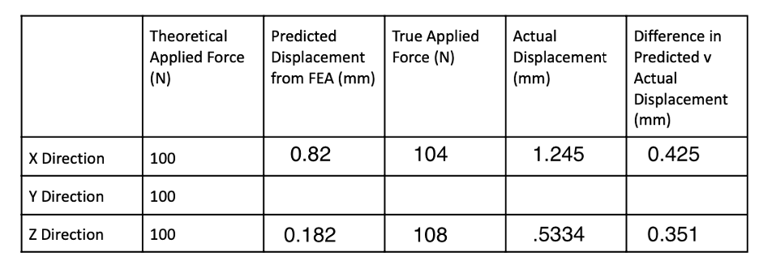

Bracket V1: Actual vs. Predicted (FEA) deflection data in the x, y, and z directions

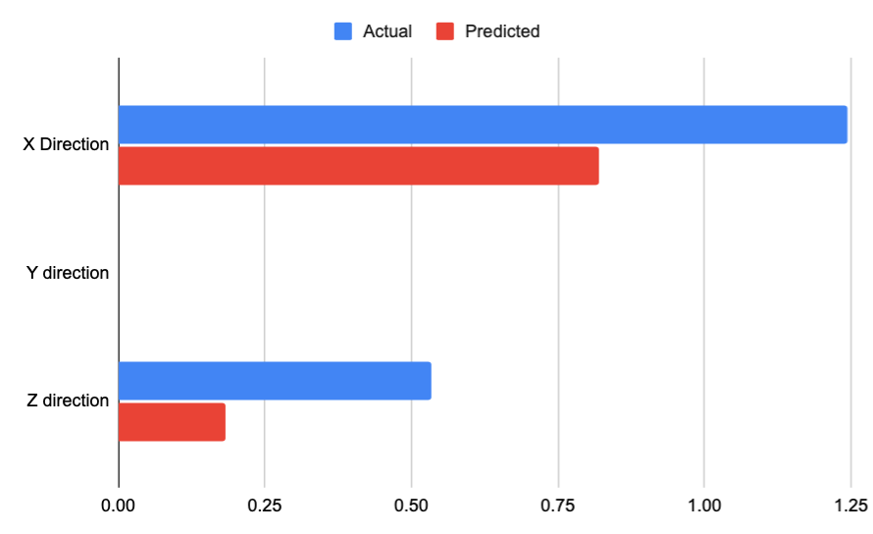

Bracket V1: Bar chart of actual vs. Predicted (FEA) deflection data in the x, y, and z directions

As shown in the comparison chart between the FEA theoretical data, and the experimental data, we learned that the tested bracket data was greater than our theoretical data. In the x direction, the experimental displacement was 0.425 mm greater than the predicted displacement from FEA. In the z direction, the experimental displacement was 0.351 mm greater than the predicted displacement from FEA. This was important information as it revealed either a) error in our testing set up b) need for a better model than the current FEA analysis or c) our need to better understand FEA to create a more accurate model of the experiment.

# Version 2 Overview

|  |  |
| --- | --- |
|  |  |
|  |  |

1.

* 1. The deflection line plots from FEA are shown below:

|  |  |  |
| --- | --- | --- |
|  |  |  |
| X-Direction Deflection | Y-Direction Deflection | Z-Direction Deflection |
|  | | |
| Close-up deflection heat map  near area of concern | | |

* 1. Considering our new constraint of a 2mm displacement and a wider hole for the bracket, we created a thinner circular portion to support the spindle. However, looking at the FEA, and considering the large error between the last set FEA data and the experimental data, we erred on a more conservative estimate. We made our side profile cut slightly smaller to create thicker legs. We also added thickness to the sides of the legs in the top view to support the spindle. Finally, although unrelated to FEA testing, we added additional fillets to two edges.
  2. The bracket testing data for the second version is below:

***Z-Direction Displacement (below)***

***X-Direction Displacement (below)***

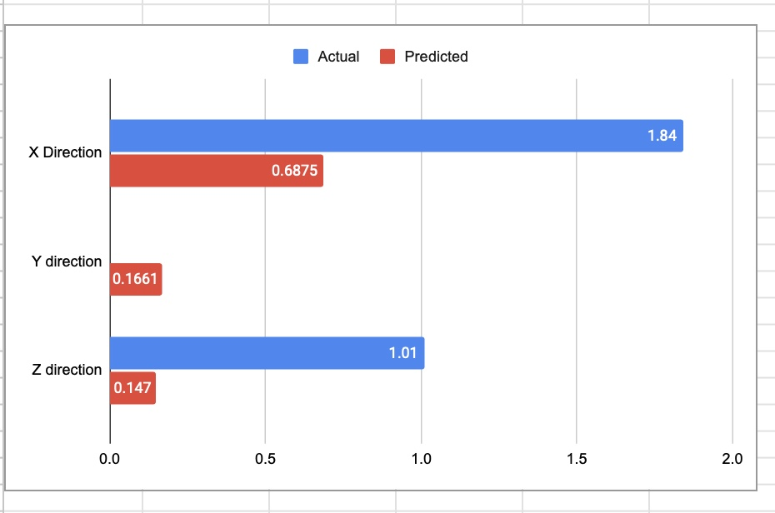

Bracket V2: Actual vs. Predicted (FEA) displacement data in the x, y, and z directions

The actual displacement was much greater than the predicted FEA displacement. For example, the z direction was incorrect by a factor of 6.87. In the x direction, the experimental displacement was 1.153 mm greater than the predicted displacement from FEA. In the z direction, the experimental displacement was 0.863 mm greater than the predicted displacement from FEA. This is extremely large; However, we made our design decisions conservatively accounting for FEA data that served as a great underestimation of the displacement in the x and z direction.

1. We created our model with the concept of mimicking the human body and creating four legs, or four I-beams, with the intention of keeping most of the mass towards the outermost corners of the box we were constrained to in the design process. However, due to the requirement of adding four screws at each corner, we had to curve the legs inward to allow for the screws to nest into our 3D printed bracket. Because the small sensor box only needed to “float” in space and not be supported by our bracket, we cut out additional weight in the middle of the bracket, digging out a oval shape from the side profile. We dug out a similar shape from the top profile. However, the dimensions of the top cut were dictated by the sensor’s dimensions. We cut only curved shapes from our bracket and used fillets on all harsh edges to distribute the stresses and prevent stress concentrations. Finally, we created a place for screws to nest in the front of our bracket to secure the spindle within the spindle holder. While this added additional weight, it was necessary to prevent the spindle from slipping during the testing procedure.

Future Bracket Versions

Our bracket passed the testing with both displacements under 2mm, but it could certainly be improved in future iterations.

1. Our bracket deformed within the acceptable limit - 1.01mm (Z) and 1.84mm (X) – so no additional considerations are necessary to improve compliance. However, our bracket’s weight was on par with the class average, which is to say, fine but not great. Future improvements to the design might consider making the four “legs” slightly narrower to save weight. Shaving off material should be combined with moving the four legs outward (toward the perimeter of the body) to reduce weight without compromising structural rigidity.
2. During the in-lab testing, we performed displacement tests using a static load of 100N in the X and Z directions. Furthermore, our brackets were fresh from the 3D printer. However, this test setup falls short of simulating the full real-world loading and operating conditions for the brackets. On a CNC machine, the brackets experience cyclic loading from the constant movement of the gantry and material. This cyclic loading can cause fatigue for the bracket, eventually wearing the material to a point of inoperability.
3. The only sure-fire way to ensure an infinite lifespan for the part is to make it out of a ferrous alloy like steel. The endurance limit for steel is about 50% its ultimate tensile strength and occurs after many orders () of stress cycles, which should be considered for any steel iterations.
4. Of course, making the bracket out of steel is much easier said than done. A steel bracket will require an entirely different manufacturing process, since FormLabs does not currently offer powdered steel for SLS printers. As such, a milling process – perhaps on a CNC machine much like this – will be necessary. Intricate geometry, like the fillets on the insides of the legs and submerged screw head holes, might not be achievable on a CNC machine. Thus, these geometric features might need to be modified to balance production feasibility with stress-concentration minimization.

THANK YOU for an awesome quarter!