















# 

The major deliverable in ME 340-2 is injection molding a part from scratch. This process entails designing the part in CAD, creating the molds in CAD, machining the molds, and finally, using the molds to injection mold the parts. The purpose of this report is to outline the process we followed from start to finish and provide commentary/calculations to justify our decisions as we brought our idea to life.

If it was not already apparent from the glorious AI-generated image on the title page, our part is the “Cosmic Cone” - a two-scoop ice cream cone with the earth and moon “ice cream scoops” resting atop the waffle cone. After generating this idea, we developed a rough sketch of our part during the first week of lab:

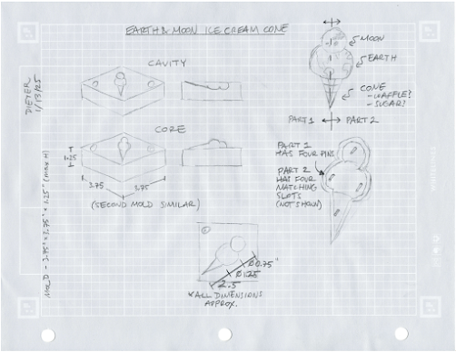

**Figure 1:** Rough sketch of the part and mold

The final design mirrors many aspects of this sketch; for instance, general geometry and features, parting line placement, and the parts’ layouts on the mold are the same. Some changes between this sketch and the final design include the position and number of pins (reduced to three, and located along the outer edge of the part), the proportions of the planets and the cone, and the continents/countries selected to appear.

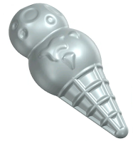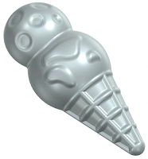

**Figure 2:** The part model split into “America” and “Asia” halves

To avoid undercuts, which are unobtainable on our three-axis mill, only the large continents/countries on earth and large craters on the moon – which lie in machine accessible regions – are included. Images of the CAD files for the model are shown above, and dimensioned versions are available in the appendices. Next, we’ll discuss more about how the part was designed with machining and injection molding in mind.

# 

## Design for Manufacturing

Since the part has mostly radial symmetry, minimal additional draft was required. 2 degrees of draft was added, however, to the vertical sections surrounding our interference fit pins and holes.

We chose a general wall thickness of 0.075”. This includes all the extrusions and sinks to ensure minimal sink marks and shrinkage. The only part with varying thickness is the waffle cone ridges. We deemed the additional thickness of these ridges to have a negligible chance of sink marks due to their size. Additionally, any sink marks that would occur would be internal and not visible in the final product.

As mentioned above in our efforts to avoid undercuts for machining, we designed the waffle ridges, and placement of the continents and craters to avoid undercuts since our injection molding machines lack side pull capabilities.

## 

## Interference

To mate the two halves, we chose to use three pin-in-hole interference fits. The calculations for pin diameter are shown below.

**Table 1:** Parameters used in interference calculations

| **Symbol** | **Term** | **Value** |
| --- | --- | --- |
| Sd | Design stress | 34 MPa |
| D | Outside diameter of hub | 6.985 mm |
| d | Diameter of pin | 3.175 mm |
| Eh | Tensile modulus of elasticity of hub | 68,900 MPa |
| Es | Modulus of elasticity of shaft | 200,000 MPa |
| vh | Poisson’s ratio of hub material | 0.33 |
| vs | Poisson’s ratio of shaft material | 0.28 |

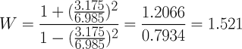





Because the interference is near zero and far below our machine tolerance, the final pin hole diameter we designed for was **3.175 mm**, equal to the diameter of the pin. This negligible interference can be explained by the high stiffness of the materials involved.

## CAD Design

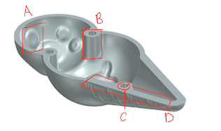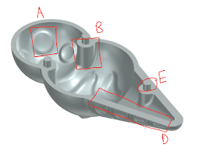

**Figure 3:** Asia and America halves showing labelled design features described below.

**A** is our carefully placed craters and continents on the cones. Each maintains an even wall thickness on the extrusion or the sink and are located high enough on the curve to eliminate overhangs when machining the parts.

**B** is the 2 degrees of draft added to the only vertical parts of the part to design for injection machining.

**C** is the holes for press fits which have been designed as the baseline to fit the pin to.

**D** is the edge of the waffles with the parting line designed for halfway through one of the ridges to avoid overhangs in the molds and for injection molding.

**E** is the pin for press fitting which we used the interference calculations for.

# 

# 

# Manufacturing Considerations

When creating our molds, we determined that splitting the cone in half – from the tip of the cone to the top of the ice cream – was the most logical move for the parting line. This way, the parting line aligns with the largest area of the part and has the same dimensions on both sides. This placement has the added benefit of splitting the waffle cone ridge in half, avoiding any overhangs or undercuts from the ridges.

Since the part contains extrusions and sinks in the surfaces of the ice cream and the waffles cone, the part needed to be laid on its side horizontally on the molds. Were it vertical, it would have sizeable overhangs that would be difficult to solve for.

Since the America and Asia halves are nearly identical, we considered shrinkage risks negligible in our design process. Even after minor shrinkage, the holes and pins are likely to align since the parts shrink at the same rate.

To create holes in the America part for press fit assembly, we planned to use stainless steel dowels press fit into the mold after it was machined. So, in our mold design, we planned to drill holes for the press fits since machining small standing pins is impractical.

## Mold Layout

We decided to position the part diagonally in the molds to maximize the size of our part and avoid the bolt holes and sprue hole in the cavity. We opted for circular runners, since they are the most efficient, and added a 90-degree turn before entering to minimize short shots.

Our gates were placed at the side wall of the earth ice cream since this was the most central area of our part and would be a near vertical wall. This ensured the mold would finish filling evenly and the weld line would not be in an area with any higher stress.

## 

## CAD Design

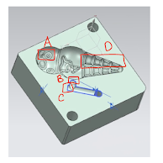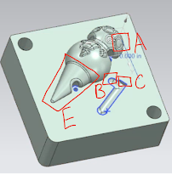

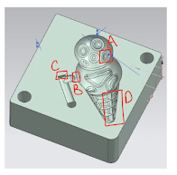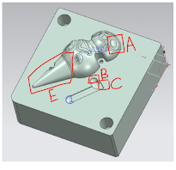

**Figure 4:** America (top) and Asia (bottom) cavity and core CAD models with design features labelled and described below.

**A** shows the craters and the continents for each of the parts. They have been shifted to the center to avoid overhangs when machining due to our 2.5 axis machines. All have also been edge blended to facilitate this.

**B** is the location of our gates, which have been positioned 0.030” from the edge of the part and at the area we deemed best.

**C** are the sharp 90 degree turns added at the ends of the runners to minimize short shot entering the part. This was an additional precaution beyond the 90 degree turn from the sprue. Each of our runners was also designed to be circular and not semicircular to ensure the best flow into the part.

**D** is the waffle section, similar to **A**, the positioning of the waffle and parting line ensured we were able to machine all of it without overhangs through a combination of placement and edge blends.

**E** is the interior of the waffles and the inside face of the parts. During the design process, we deemed the potential for sink marks or shrinkage from not reflecting the waffle ridges to be minimal and therefore did not include them, since it would not have been possible to machine at the size we decided to go with.

# 

## CAM Operations

After designing the mold assemblies in NX, it was then time to machine them on the CNC mills. Because the Asia and America halves are nearly identical in geometry, the CAM operations we utilized to manufacture their respective molds are similar in structure. Below are the operations used to produce the Cavities and the Cores.

**Table 2:** Cavity Mold Operations (total time: 2.5-3 hours)

| **Tool** | **Operation** | **Purpose** | **Preview** |
| --- | --- | --- | --- |
| EM 0.5 | Adaptive milling | Initial roughing operation to clear out material. |  |
| EM 0.25 | Adaptive milling | Roughing with a smaller tool to continue clearing out material. |  |
| BM 0.25 | Planar mill | Cutting the runner. |  |
| EM 3/16 | Cavity mill | Roughing with a smaller tool. |  |
| BM 1/8 | Cavity mill | Roughing with 1/8" tool before finishing operation. Now using a ball mill to get closer to the true (curved) geometry. |  |
| BM 1/8 | Area mill | Finishing operation using 1/8" tool. Stepover → Scallop with 0.0005” max scallop height used. |  |
| BM 1/16 | Area mill | Finishing operation to specifically target the ridges in the waffle cone, clearing up any final stock not removed by the 1/8" tool.  Note: NX would not allow a roughing operation beforehand so we chose to just do finishing. |  |

**Table 3:** Core Mold Operations (total time: 2-2.5 hours)

| **Tool** | **Operation** | **Purpose** | **Preview** |
| --- | --- | --- | --- |
| EM 0.75 | Adaptive milling | Initial roughing operation to clear out material. |  |
| EM 0.75 | Cavity mill | Finishing operation to pass over the mating surface of the mold to ensure it has been machined sufficiently flat. |  |
| EM 0.5 | Adaptive milling | Roughing with a smaller tool to continue clearing out material. |  |
| EM 0.25 | Cavity mill | Roughing with a smaller tool to continue clearing out material. |  |
| EM 3/16 | Cavity mill | Roughing with a smaller tool to continue clearing out material. |  |
| BM 1/8 | Cavity mill | Roughing with a smaller tool to continue clearing out material. Switching to ball mill to achieve a more contoured rough pass. |  |
| BM 1/8 | Area mill | Finishing operation using 1/8" tool. Stepover → Scallop with 0.0005” max scallop height used. |  |
| EM 3/16 | Solid profile 3D | Tracing along the edge where the part meets the mating face to ensure all material around the future holes has been cleared. 0.04” offset. |  |
| EM 3/16 | Solid profile 3D | Tracing along the edge where the part meets the mating face to ensure all material has been cleared. No offset. |  |
| SPOT DRILL | Spot drilling | Spot drill the holes in preparation for the next drilling operation. 0.100” diameter Drill |  |
| STD DRILL | Drilling | Drill the holes for the hole/pin assembly features. 0.250” Drill |  |
| EM 1/8 | Hole milling | Expand and flatten the holes for the hole/pin assembly features. |  |
| BM 0.25 | Planar mill | Cutting the runner. |  |

## CAM Modifications

Regarding the operations, the CAM processes worked perfectly with no additional modifications required after we began machining. However, we still managed to mess up one of the molds. On our longest (3+ hour) cavity, we loaded the stock improperly after misinterpreting the coordinate system in NX. Only after all the operations were complete did we realize that the sprue hole did not align with the runner, as shown below:

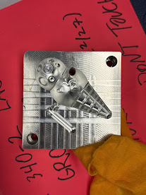

**Figure 5:** Our one mistake

Unfortunately, our TA Jared advised us that filling the sprue hole and re-drilling it on the other side by ourselves would not be an adequate solution. Instead, after double-checking the coordinate system with Jared, we re-zeroed the machine on a new block of stock and re-ran the same operations. This time, we produced the cavity correctly.

## Documentation

Photographing the manufacturing process proved challenging since we utilized the new CNC machine that prohibits users from opening the door during cutting. As such, these were the best images we could take.

|  |  |
| --- | --- |
| (a) | (b) |

**Figure 6:** (a) Cutting in action, and (b) cleaning the coolant

In Figure 6(a), the cutting is shown through the glass window. In addition to its “safety” features, the newest Haas mini mill also has three times the coolant nozzles as the other CNC mills. These nozzles provide a steady stream of coolant, but also obfuscate the tool from view, making it challenging to monitor the tool status mid-cut. All of this coolant also tends to accumulate, especially in the cavity mold. Figure 6(b) shows Robert using the compressed air gun to blow the coolant out of the mold before removing it from the machine. The finished molds are shown below in Figure 7:

|  | | | |
| --- | --- | --- | --- |
| (a) | (b) | (c) | (d) |

**Figure 7:** The finished molds - America cavity (a) and core (b); Asia cavity (c) and core (d)

# 



**Figure 8:** Robert injection molding and Nick timing. Look at those smiles :)

## Molding Parameters

For both parts, we injection molded at **450°F**. The ideal injection time for the America half was **10-12 seconds**, and **8-10 seconds** for the Asia half. We allowed a full **30+ seconds** for cooling before releasing the mold for each part. **No ejection features** were necessary.

## Process Refinement

We began by molding the America half. The melt temperatures had been left by the group before us, and we did not alter them during our production run. Instead, the primary parameter we adjusted was the injection time. For the America half, we began with injecting for 10 seconds. This worked fine for some parts, but we occasionally experienced short shots where the mold did not fill entirely. After increasing the injection time by a few seconds, we consistently produced acceptable results.

Since the Asia half is nearly identical to the America half (save for small features on the earth and moon), we assumed 10-12 seconds would again be ideal. However, this time we experienced the opposite problem: flash. After lowering the injection time by a few seconds, we encountered far fewer problems with flash.

At first, we were stumped. How could two nearly identical parts take such different times to fill? Eventually, we realized one primary difference between the two mold sets is culpable for this difference. Robert filed the gate for the America half, while Nick filed the gate for the Asia half. Upon inspection, Nick’s Asia gate was slightly larger than Robert’s America gate, enabling more material to flow through the gate (and into the part) in a shorter time on the Asia half.

As mentioned previously, the circular symmetry of this part meant that draft is inherently incorporated into the part. Plus, the added draft to the vertical sections supporting the mating pins and holes were sufficient. From the draft and high quality surface finish from machining, the part easily separates from the mold, no ejection pin necessary.

## Assembly

|  |  |  |
| --- | --- | --- |
| (a) | (b) | (c) |

**Figure 9:** (a) the assembled Cosmic Cone, showing the

parting line, and (b-c) the two parts

After molding a few parts, we paused to ensure that the fit was acceptable. Indeed, the interference fit performed exactly as we expected. We finished the production run with no changes to the geometry.

The part assembles beautifully. The three pins and holes slide into each other and hold the two pieces together with nearly no gap between them (Figure 9a). Disassembly (and subsequent reassembly) is possible, but tricky because the concave geometry provides no area for one to grip. However, inserting a fingernail or razor blade into the seam provides enough initial leverage for one to finish pulling the pieces apart unassisted.

## General Difficulties

The injection molding process went very smoothly (we were super lucky). After refining the timing and determining the root cause, no further difficulties were encountered.

# 

# 

## Selected Geometry

We chose to measure and study the minimum distance of the diameter between the Moon and the Earth scoop as shown in Figure 10.

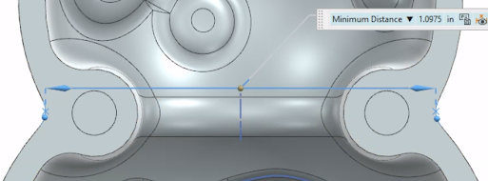

**Figure 10:** Selected geometry to measure

The same geometry (diameter) is present in both parts. The modeled geometry is 1.0975”, which is designed to take into account part shrinkage. Since our plastic part is made of polypropylene, a common injection molding shrinkage factor is estimated to be at 2% with a 0.5% uncertainty range (based on a standard thin wall thickness of 0.075”). With this in mind, our specified part dimension is 1.0975” x (100% – 2%), which is 1.075” in diameter. We estimate that the standard CNC machining tolerance is ±0.005”. We also calculate the tolerance of our shrinkage calibration uncertainty, which is 0.5% of the specified dimension: 1.075” x 0.5% = ±0.005”. With these values, we can assign a reasonable tolerance to the feature:

So our final specified dimension of this geometry is **1.075” ± 0.007”**.

## 

## Run Data

Since the full process is unknown and there is not enough sample data, we can only set our USL and LSL values to be the specified range, meaning that USL = 1.075” + 0.007” = 1.082” and LSL = 1.075” – 0.007” = 1.068”. For the America Cone, the 20 parts and run data are shown in Figures 11 and 12.

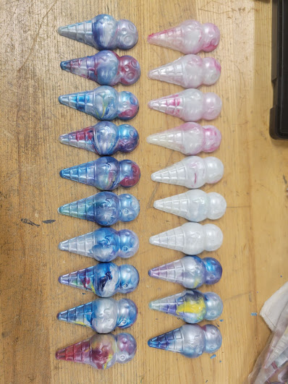

**Figure 11:** 20 parts of the America Cone

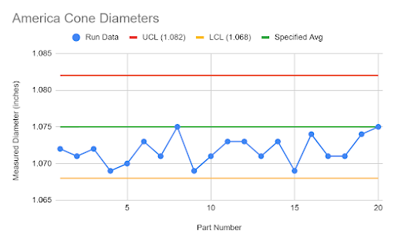

**Figure 12:** Run data of the America Cone

As seen above with the measurements, all parts are within the specified range between UCL and LCL. There is no trend during the run, but it is clear that the run is out of control as all parts fall below the specification average.

For the Asia Cone, the 20 parts and run data are shown in Figures 13 and 14.

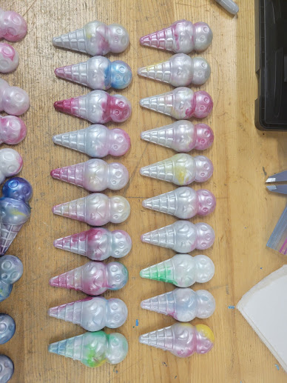

**Figure 13:** 20 parts of the Asia Cone

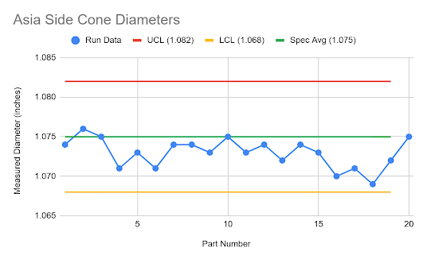

**Figure 14:** Run data of the Asia Cone

Once again, all parts are within the specified range between UCL and LCL. There is no trend during the run, but it is clear that the run is out of control as most parts fall below the specification average. Note that the Asia Cone is closer to the specification average than the America Cone.

## Histogram

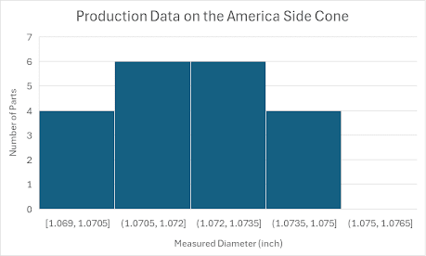

**Figure 15:** Histogram of the measurement distribution of the 20 America cone parts

For the America Cone, the cone diameter roughly represents the normal distribution centered around 1.071”. However, with only 20 parts, the shape is not well defined.

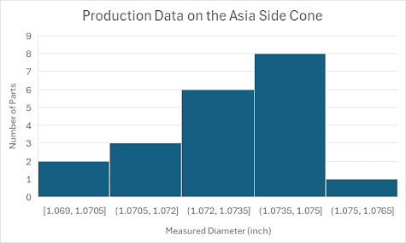

**Figure 16:** Histogram of the measurement distribution of the 20 Asia cone parts

For the Asia Cone, the cone diameter does not form a normal distribution as it is skewed to the right. This can be due to a small sample size of only 20 parts or an inherent bias in the part manufacturing. We can only estimate the reason (see next section).

## Commentary

Overall, the molded parts generally conform to the specified dimensions, as all measurements fall within the acceptable range. However, most parts are slightly undersized relative to the calibrated specification average, likely due to shrinkage. Several factors may contribute to this discrepancy. First, the assumed 2% shrinkage factor may have been underestimated, as actual shrinkage can vary based on the storage environment and specific type of polypropylene used. Second, due to time constraints, the parts were removed from the mold within 15 seconds of injection molding. As a result, they cooled in open air rather than within the mold. Given the semi-spherical geometry, this likely led to inward warping during cooling, further reducing the edge-to-edge distance of the shell. To mitigate this in the future, we can extend the cooling time within the mold to 30 seconds before removal, allowing the part to conform more accurately to the mold’s shape.

Despite these dimensional variations, the parts exhibit smooth and consistent surfaces. While the dimensions are precise but not entirely accurate, several design choices contributed to the high-quality finish. First, the cone design incorporates only smooth transitions (fillets and spheres), avoiding sharp edges that could hinder material flow. Second, the wall thickness is nearly uniform, with a maximum variation of just 0.005” on the planets and 0.025” on the waffle lines. This consistency prevents visible sink marks and minimizes warping. Third, the cylindrical runner design and centrally located gate ensure even material distribution, leading to quicker and more complete filling of the mold.

# 

# 

Overall, this project was a great success. Our parts met both assembly and appearance expectations, maintaining tight tolerances. The injection molding process proceeded smoothly, thanks to the quality of our design and the extensive preparation that ensured an excellent mold finish.

However, the process was not without challenges. During mold creation, we encountered several minor issues with our initial part design, including slight overhangs, wall thickness variations, and hole placement. These required iterative adjustments to our model. Additionally, we struggled to find an efficient method for removing excess material from the waffle channels, which presented some operational difficulties.

The most significant issue we faced was a misinterpretation of the OCS coordinates in NX while machining our mold. This mistake resulted in machining into the sprue, costing us approximately three hours and a cavity blank before we identified the error.

If we were to redesign the mold, we would consider modifying the wall thickness at the tip of the cone to improve uniformity and potentially reduce its size. We observed slight shrinkage in that area, likely due to the excess material causing uneven contraction. Alternatively, adding another pin and hole near the tip could provide additional force, helping maintain a more consistent final shape.

Overall, this project demonstrated our ability to navigate design challenges and refine our process to achieve high-quality results. The lessons learned will strengthen our future work, making us more efficient and precise in both design and manufacturing.



We would like to formally thank Prof. Beltran for offering such a useful and enjoyable class. Furthermore, we are grateful to Jared for being an excellent and infinitely-patient TA.

# Appendix A: Part CAD

# 

**Figure A1:** Dimensioned drawing of the Asia Cone Model

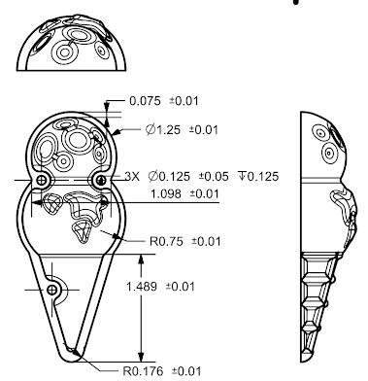

**Figure A2:** Dimensioned drawing of the America Cone Model

# Appendix B: Mold CAD

# 

**Figure B1:** Dimensioned drawing of the America Cone Core Mold

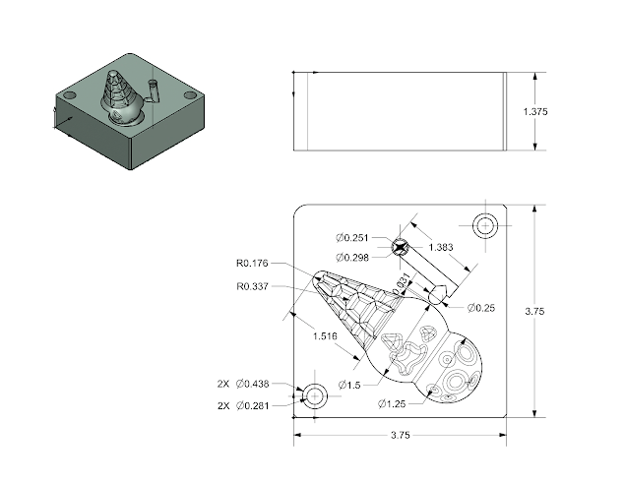

**Figure B2:** Dimensioned drawing of the America Cone Cavity Mold

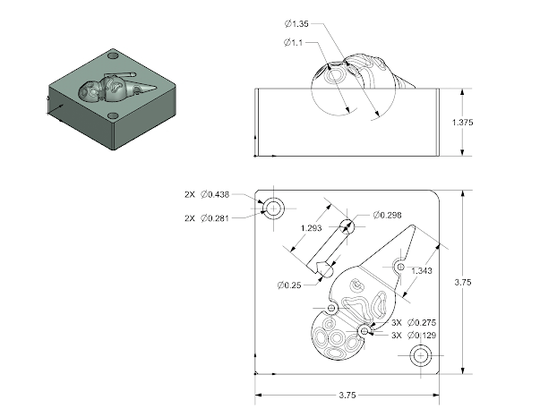

**Figure B3:** Dimensioned drawing of the Asia Cone Core Mold

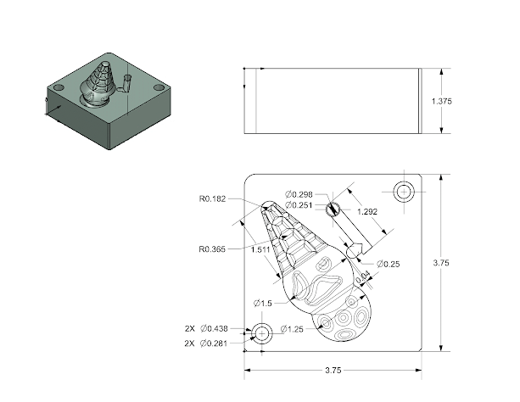

**Figure B4:** Dimensioned drawing of the Asia Cone Cavity Mold