**ENEL102, fall term 2017**

**Assignment 1**

**Review of Matlab Calculations**

**Due date Sept 18**

This assignment is a review of ENEL101 with questions based on material in the Gilat textbook from chapters 1 to 7. Suggest you review some of your ENEL101 notes before answering these questions. Fill in the following template with your answers using Matlab plots and screen shots as necessary. Then submit your Word document on D2L. ………………………………………………………………………………………………………………………………..

**Q1.** Give the Matlab expression to calculate  and the resulting value of x

**(Matlab input)**

x = power(0.2,5.7)*power(tan(0.2),3)*exp(2.7)+sin(0.1)

**(Matlab Response)**

X = 0.0998

……………………………………………………………………………………………………………………………

**Q2** Define the variables and  , and then compute 

**(Matlab input)**

>> x = sqrt(3);

>> z = sqrt(exp(1));

>> y=0.3*power(x,2) + sqrt(x*z);

>> v = sqrt(cos(x*y*z))

**(Matlab Response)**

0.6651

……………………………………………………………………………………………………………………………….

**Q3.** Let x=-2 and y=3. Determine the vector of .

**(Matlab input)**

>> x = sqrt(3);

>> z = sqrt(exp(1));

>> y=0.3*power(x,2) + sqrt(x*z);

>> v = sqrt(cos(x*y*z))

**(Matlab Response)**

4.0000 + 0.0000i -18.0000 + 0.0000i 0.1559 + 0.9878i

………………………………………………………………………………………………………………………………

**Q4.** Determine the magnitude and angle (in degrees) of the array of values z in **Q3**.

**(Matlab input)**

abs(z)

angle(z)

**(Matlab Response)**

4 18 1

0 3.1416 1.4142

…………………………………………………………………………………………………………………………………

**Q5.** The number of combinations  of taking r objects out of n objects is given by . Determine the number of combinations of taking 4 arbitrary cards (without replacement) from a deck of 52 cards. (use the built in function factorial)

**(Matlab input)**

factorial(52)/(factorial(4)*factorial(52-4))

**(Matlab Response)**

270725

……………………………………………………………………………………………………………………………….

**Q6.** A diagonal matrix is all zeros except for the elements along the diagonal. Define the variables x=1 and y=2 and generate a 4x4 diagonal matrix z with diagonal values of x, xy, sin(x) and x/y. Use the function diag() for this purpose.

**(Matlab input)**

>> x=1;

>> y=2;

>> z = diag([x x*y sin(x) x/y])

**(Matlab Response)**

1.0000 0 0 0

0 2.0000 0 0

0 0 0.8415 0

0 0 0 0.5000

……………………………………………………………………………………………………………………………….

**Q7.** Create the same matrix z in Q6 but this time without using diag()

**(Matlab input)**

z = [x 0 0 0; 0 x*y 0 0; 0 0 sin(x) 0; 0 0 0 x/y]

……………………………………………………………………………………………………………………………….

**Q8.** Assume a vector of samples , a vector y calculated as  and a matrix . State the Matlab expression for determining expression for 

**(Matlab input)**

Q = [

**(Matlab Response)**

………………………………………………………………………………………………………………………………..

**Q9.** Assume values of given as . Then calculate the values of a vector  with the ith component given as . Output  as a column vector.

**(Matlab input)**

>> x=-2:1:4;

>> y=power(x,3) + 2*power(x,2) +x

**(Matlab Response)**

Y = -2 0 0 4 18 48 100

………………………………………………………………………………………………………………

**Q10.** Three vectors are given as



Use dot() and cross() to compute the vector of 

**(ans)**

**(Matlab input)**

>> u = [-3 8 -2];

>> v = [6.5 -5 -4];

>> w = [1 -1 -1];

>> q = power(dot(u,v),2)*cross(cross(u,v),w)

**(Matlab Response)**

q =

1.0e+05 *

-0.3183 -2.0953 1.7770

**Q11.**  Use Matlab to numerically show that the sum of the infinite series



Do this by computing the following sums



and comment on results.

**(Matlab input)**

**(Matlab Response)**

………………………………………………………………………………………………………………………

**Q12.** Two matrices are given as

 and 

Determine 

**(Matlab input)**

>> X = [1 2 3; 0 7 7; 1 2 1];

>> Y = [2 2 3; 7 7 0; 1 2 1];

>> Q = inv(X)*(Y + X^2)

**(Matlab Response)**

Q =

0.5000 2.0000 5.0000

0.5000 8.0000 6.0000

1.5000 2.0000 2.0000

………………………………………………………………………………………………………………………

**Q12.** Solve the linear set of equations using the \ operator in Matlab



Let , be a column vector of the results.

**(Matlab input)**

**(Matlab Response)**

………………………………………………………………………………………………………………………….

**Q13.** Fibonacci numbers are the numbers in a sequence in which the first two elements are 0 and 1 and the value of each subsequent element is the sum of the previous two elements. Write a Matlab program that generates the first 25 Fibonacci numbers and places them in a row vector called F.

**(Matlab input)**

F = [0 1];

for i=1:1:23

F = [F, F(i)+F(i+1)]

end

**(Matlab Response)**

Columns 1 through 6

0 1 1 2 3 5

Columns 7 through 12

8 13 21 34 55 89

Columns 13 through 18

144 233 377 610 987 1597

Columns 19 through 24

2584 4181 6765 10946 17711 28657

Column 25

46368

……………………………………………………………………….………………………………………………………………….

**Q14** Plot the log of the Fibonacci sequence of F(2) to F(25) and label the axis.

**(Matlab input)**

F = [0 1];

for i=1:1:23

F = [F, F(i)+F(i+1)];

end

x = 1:1:24;

F(1) = [];

semilogy(x,F);

title('Log of Fibinocci Graph');

xlabel('X axis');

ylabel('Log of Fibonacci');

**(Matlab Response)**

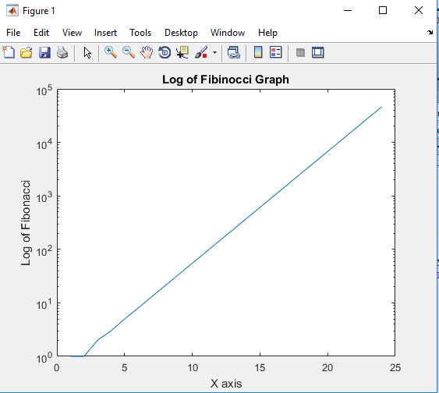

**Q15.** A parametric equation is given by



for a range of t given as . Produce two plots. In the first plot x(t) and y(t) are superimposed. In the second plot assume x along the abscissa and y along the ordinate. Use subplot() to generate the two plots stacked vertically.

**(Matlab input)**

**(Matlab Response)**