**Make Pixel_clk synchronous**

**Make switch inputs synchronous with synchronizer**



**Add debouncing circuit to switch inputs**

1. <https://eewiki.net/pages/viewpage.action?pageId=498075>
2. 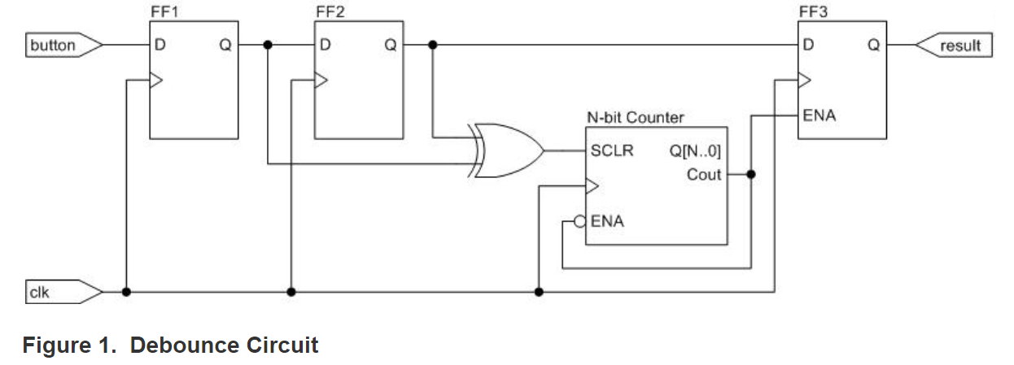

**Implement Change Bouncing box to bouncing letters and back again**