**Quality-driven Poisson-guided Autoscanning**

**This software is a demo for the following paper**

<http://vcc.siat.ac.cn/index/getInfo?title_id=453&id=624&to_path=project>(**SIGGGRAPH ASIA 2014**)

**How to get a nice display:**

You need to open the optimize quality in the graphics card’s option, for example:

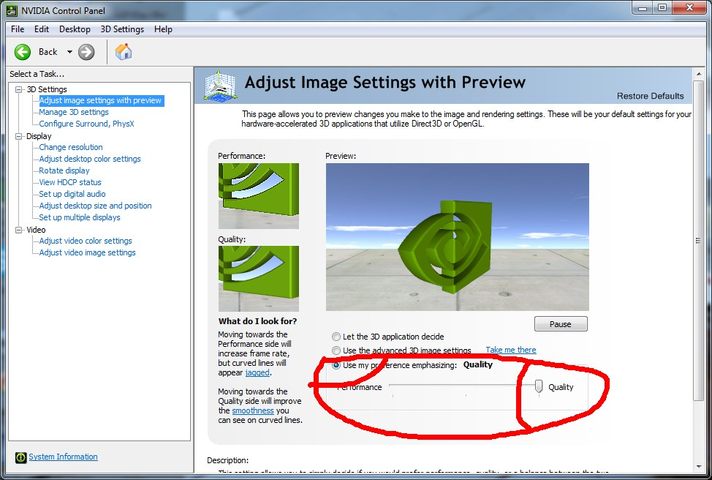

**Icons:**

: algorithm and data see our paper.

C:\Users\wish\Desktop\icon images\3.jpg: randomly down-sample original points into sample points.

**How to use it.**

1. If you want just to use the software, you can download the release version: (<https://github.com/sunwaylive/quality-driven-poisson-guided-autoscanning/tree/master/Release>).
2. In the folder, simply run “Quality-Driven-Poisson-Guided-Autoscanning.exe”.
3. Default you will get the following UI. Left click the “Camera” in the menu, a panel will appear at the right of the UI. 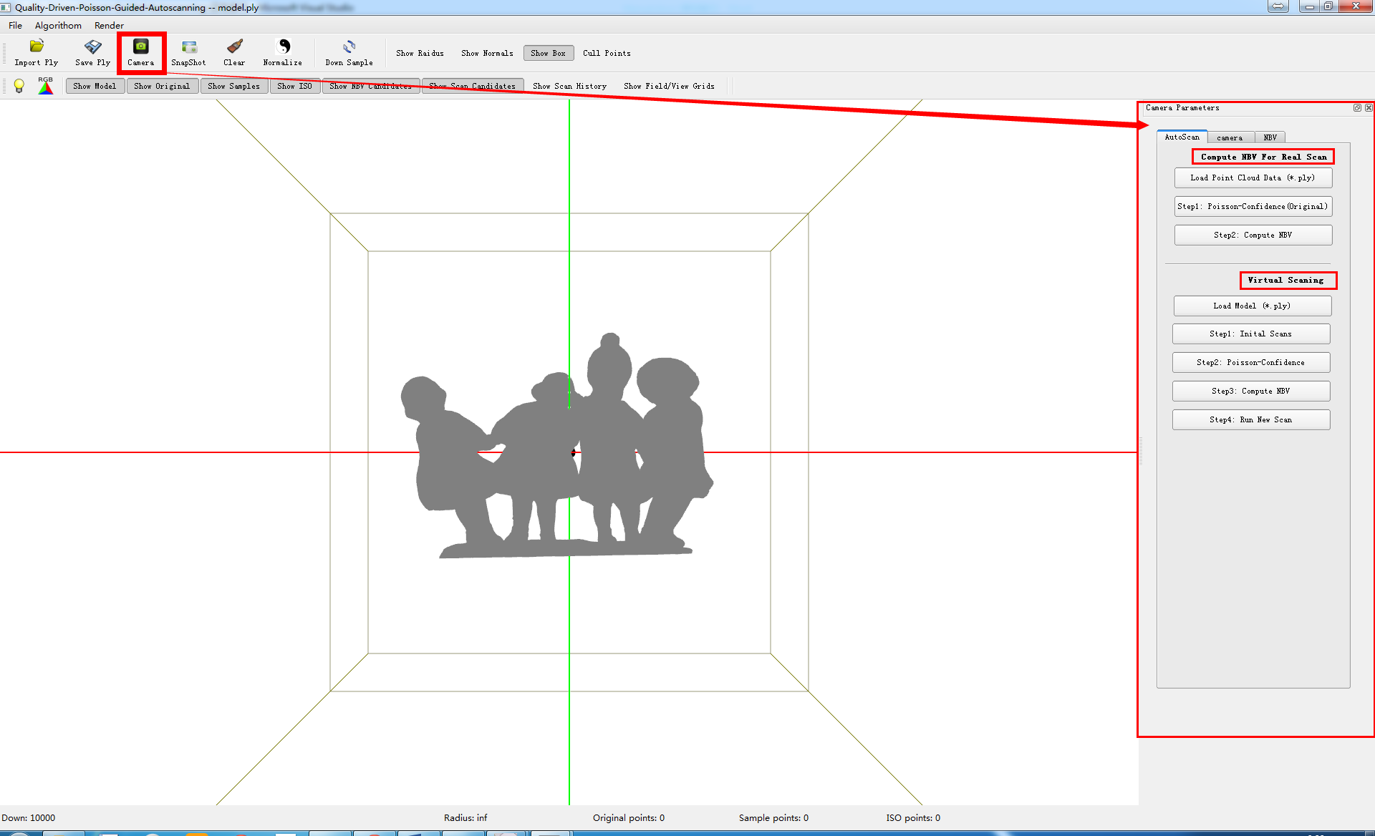
4. As you can see, We provide two ways:

**Way 1: (for real scan)**

Step 1. Click the button to load scanned points, based on which NBV will be computed. Test data is located in folder “./data”



Step 2. Click the button to do the Poisson reconstruction and

extract iso points with confidence.



Step 3. Click the button to compute the NBVs

Step 4. Click the button, save NBV as *.ply

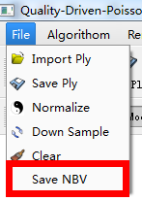

**Way 2: (for virtual scan)**

Step 1. Click the button to the model you want to scan.

Step 2. Click the button to do initial scans.



Step 3. Click the button to do the Poisson reconstruction and extract iso points with confidence.

Step 4. Click the button to compute the NBVs.

Step 5. Click the button to run virtual scans using the NBVs.

**If you’re interested in our source code, you can visit:**

<https://github.com/sunwaylive/quality-driven-poisson-guided-autoscanning>

**Configuration for the source code:**

This code is complied well on Win7(64bit) + Qt4(64bit) + VS2010.

If you are also working in this environment, you just need to make sure your Qt works well.

If you want to use 32bit QT, just make sure your path of QT is correct and use the right dlls(ANN.dll, glut32.dll that we have provided in the “dlls” floder),very simple.

**Any questions or bugs send email to** [**sunwayliving@gmail.com**](mailto:sunwayliving@gmail.com) **please.**

**Hope you have fun.**

**(version 1.0 2014-10-10)**