**Quality-driven Poisson-guided Autoscanning**

**This software is a demo for the following paper**

<http://vcc.siat.ac.cn/index/getInfo?title_id=453&id=624&to_path=project>(SIGGGRAPH ASIA 2014)

**How to get a nice display:**

You need to open the optimize quality in the graphics card’s option, for example:

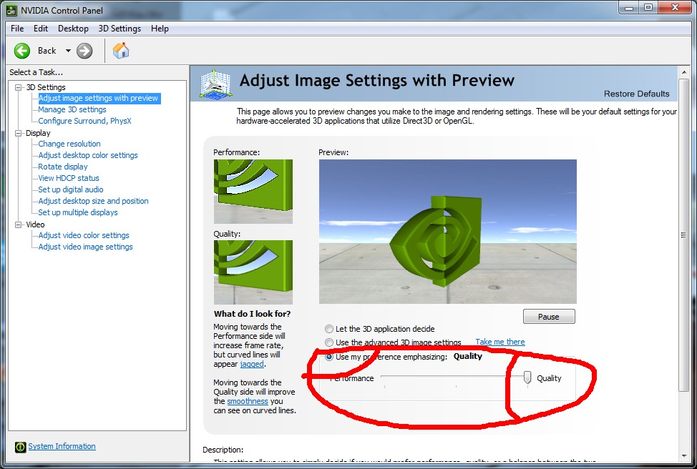

**Icons:**

: algorithm and data see our paper.

C:\Users\wish\Desktop\icon images\3.jpg: randomly down-sample original points into sample points.

: poisson reconstruction.

**How to use it.**

1. If you want just to use the software, you can download the release version: (<https://github.com/sunwaylive/quality-driven-poisson-guided-autoscanning/tree/master/Release>)

**Parameters for skeleton (more see the code of paper please):**

**Initial Radius** (0.0 - 1.0)**:** Set the initial neighborhood size of sample points. (you can also change it by “Alt + Wheel”)

**Radius Growth Rate:** Set the growth rate of neighborhood size for further contraction.

**Repulsion Mu** (0.0 - 0.5)**:** Control the power of repulsion force between sample points.

**Initial Sampling Number**: down sample points number. (you can also change it by “Shift + Wheel”).

*1, How to tune the* ***initial neighborhood size****?*

In our paper, we have provided a formula to estimate the initial neighborhood size h, for arbitrary inputs, according to the bounding box size and points density.

In our experience, the initial neighborhood size should be small enough to capture fine-scale structures. But if it’s too small, it would take more computational time and may produce unnatural branches, like the coral example shown in paper.

*2, How to tune the neighborhood* ***growth rate****?*

The default growth rate is 0.5. It means the enlarged neighborhood size is equal to the previous neighborhood size multiply 1.5.

According to our experience, if the growth rate is too large, it may miss some detail structures.

On the other hand, if the growth rate is too small, it will take more computational time and construct some undesired branches too early.

**(The codes of WLOP and EAR is going to be added to CGAL, more instruction is coming soon.)**

**Configuration for the source code:**

This code complied well on Win7(64bit) + Qt4(64bit) + VS2010.

If you are also working in this environment, you just need to make sure your Qt works well.

If you want to use 32bit QT, just make sure your path of QT is correct and use the right dlls(ANN.dll, glut32.dll that we have provided in the “dlls” floder),very simple.

**Any questions or bugs send email to** [**sunwayliving@gmail.com**](mailto:sunwayliving@gmail.com) **please.**

**Hope you have fun.**

**(version 1.0 2014-10-10)**