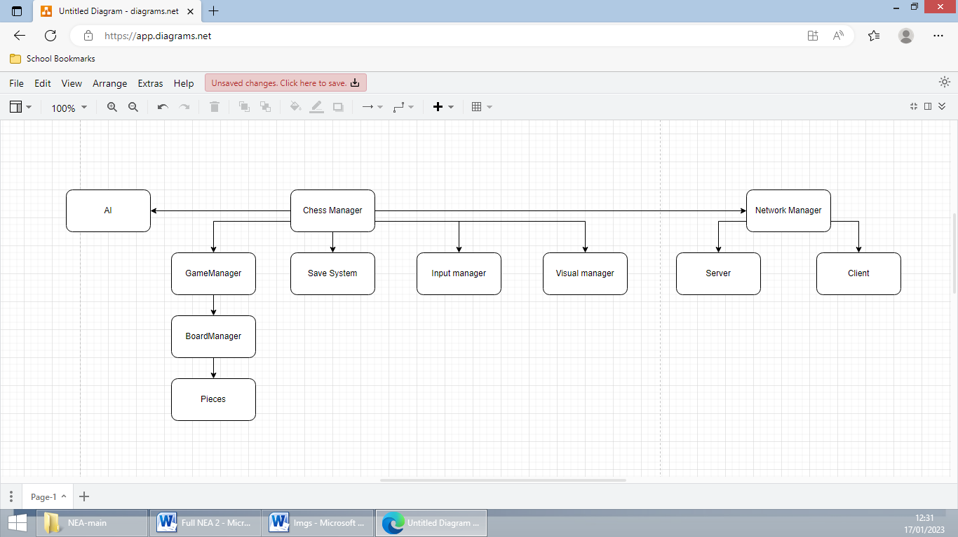

# Chess Manager

Controls everything. Handles logic such as In-Game flow (see below)

# AI

Chess manager provides gamemode and current state and waits for AI to respond with move

# NetworkManager

When playing online, handles player connection, sending savegame data, sending gamemode data. When in game, ChessManager gives it moves to send to the server and NetworkManager informs ChessManager of incoming moves

## Server

Acts as a relay forwarding incoming moves to all other clients

## Client

Sends data to server as requested by ChessManager and notifies ChessManager of incoming moves

# GameManager

Provides an interface for the current game mode and handles game logic such as whose turn it is. Retrieves a list of possible moves from the BoardManager

## BoardManager

Stores all the pieces on the board, the size of the board and provides a list of moves compiled from requesting possible moves from all the pieces

## Piece

Returns a list of the moves it can make

# SaveSystem

ChessManager provides data fetched from GameManager that the SaveSystem then converts to a binary format and saves to a file. Can also de-serialise data. This deserialised data can be give to GameManager to load the save.

# InputManager

Gets inputs from the player such as where they are moving pieces

# VisualManager

Renders the board and updates it based on data from the GameManager given to it by the ChessManager

