# Project one

Members:

SX1816074 毛一鸣

SX1816080 窦晓磊

SZ1816035储含露

SZ1816034朱正一

This paper is our team’s work of project one about Hybrid Renewable Energy Systems. Our aim is to produce power with less costs by adjusting the energy ratio and at the same time reduce the pollution of the environment. In this paper, we present NSGAII and SMPSO for the optimization of the power generated from a Hybrid Renewable Energy Systems (HRES).In the first section, we will introduce some information of renewable power generation and Hybrid Renewable Energy Systems (HRES).In the second section, we will show the algorithm. In the third section, we will show and analyze the result of our algorithm. Finally, we will make a conclusion of our work.

## 1. Introduction

Renewable power generation can help countries meet their sustainable development goals through provision of access to clean, secure, reliable and affordable energy. That is because of scarcity of conventional energy resources, rise in the fuel prices and harmful emissions from the burning of fossil fuels has made power generation from conventional energy sources unsustainable and unviable. An associated with the challenge of the world’s increasing demand for energy is the electrification for approximately two billion people in developing countries that do not currently have access to electricity. Although the world’s population is expected to reach nine billion people in 2050, Most of this expected population growth will take place in developing countries and emerging nations.

The Hybrid Renewable Energy Systems (HRES) are a combination between more than one renewable energy source or at least one renewable source to conventional source and it can be either grid connected or better to be in stand-alone mode due to its advances in renewable energy technologies and power electronics converters which are used to convert the unregulated power generated from renewable sources into useful power at the load end. The most important advantage of HRES is to make best use of the renewable power generation technologies operating characteristics and to obtain efficiencies higher than that could be obtained from if a single power source is used. It can also address limitations in terms of fuel flexibility, efficiency, reliability, emissions and economics.

However, renewable power generation maybe cannot satisfy the need in producing electricity. We need to use non-renewable resources to get more low-price energy. This action will create new some new problems in environment. Therefore, we should take this into consideration to use non-renewable resources rationally.

In this paper, we use the model LCE(Levelized Cost of Energy) and propose a new model PTE(Pollution to the Environment) to do Multi-objective optimization which analyzes how to rationally allocate renewable and non-renewable resources. The detail algorithm will be introduced in next section.

## 2. Proposed Algorithm

### 2.1 LCE evaluation

The most important objective of any renewable energy production project in the current deregulating environment is maximizing the quality of services by reducing the costs for customers, the investments, operation and maintenance. The problem is to determine how much power will be generated from multi hybrid renewable sources in order to cover all the demand loads including the losses and the storage power with the minimum life cycle cost of HRES power generation.

In this paper we use algorithm to minimize the Levelized Cost of Energy (LCE). LCE can be explained as the price that energy has to be sold to break even over the lifetime of the technology. It yields a net present value in terms of, Euros per kilowatt. This is an assessment of the economic lifetime energy cost and lifetime energy production shown in Equations (1) and (2) and can be applied to essentially any energy technology. For computing the financial costs the equations can be embellished to take into account not only system costs, but also factors such as financing, insurance, maintenance, and different types of depreciation schedules [14].

$$LCE=\frac{Life Cycle Cost}{Life Time Energy Production} (1)$$

$$LCE=\frac{\left(CRF×ICC\right)+\left(AOE\right)}{{AEP}_{net}} (2)$$

Where:

**LCE**: Levelized Cost of Energy (€/kW)

**CRF**: Capital Recovery Factor (%)

**ICC**: Installed Capital Cost (€/kW)

**AOE**: Annual Operating Expenses (€/kW)

**AEPnet** : Net Annual Energy Production (kW)

For more details we can get:

$$CRF=\frac{{d\left(1+d\right)}^{n}}{{\left(1+d\right)}^{n}-1} (3)$$

$$AOE=ANN+\left(O\&M×n\right) (4)$$

Where

**d**: interest rate (%)

**n**: operational life (years)

**ANN**: the annualized costs (insurance, other expenses)

**O&M**: Operation & Maintenance Cost (€/kW)

### 2.2 PTE evaluation

As we have motioned before, renewable energy always cost a lot of money and often fails to meet the demand. We also need to make rational use of some non-renewable energy sources. In this paper, we use two kinds of energy, Diesel generator and Lead-acid battery.

We propose PTE(Equations 5) to assess the environmental pollution caused by these two kinds of energy sources.

$$PTE={P_{Lead-acid battery}}^{2}+P_{Diesel generator} (5)$$

### 2.3 Power Generated Constrain

The project should be composed with constraints to obtain the proper objective function. The main constraints in the optimization process in the proposed methodology are the total power. In reality, the annual energy requirement is limited, so the sum of several kinds of energy should be limited to a certain extent.

$$1.1×AEPnet{≥P}_{Photovoltaic}+P_{wind turbine}+P_{Diesel generator}+P_{Lead-acid battery}≥AEPnet$$

### 2.4 Multi-objective optimization equation

In summary, we propose the following equations to describe the whole power system.

$$\left\{\begin{aligned}&minLCE\left(x\right)=\frac{\sum_{i}{\left(CRF×ICC+ANN+\left(O\&M×n\right)\right)×x_{i}}}{{AEP}_{net}} \\ &minPollution(x)={x_{3}}^{2}+{x_{4}}^{3}& \\ &s.t.=\left\{\begin{aligned}x_{1},x_{2},x_{3},x_{4}∈(0,{AEP}_{net}) \\ {1.1×AEPnet≥x}_{1}+x_{2}+x_{3}+x_{4}≥AEPnet\end{aligned}\right.\end{aligned}\right.$$

Here $x_{1},x_{2},x_{3},x_{4}$ Correspond to $P_{Photovoltaic}{,P}_{wind turbine,}P_{Diesel generator}{,P}_{Lead-acid battery}$.

## 3.NSGA-II and SMPSO

### 3.1 NSGA-II

Non-dominated Sorting Genetic Algorithms with Elite Strategy (NSGA-II) is a very famous multi-objective optimization algorithm--a non-dominated sorting-based MOEA[3]. Multi-objective evolutionary algorithms (MOEAs) that use non-dominated sorting and sharing (NSGA) have been criticized mainly for:

1. Their O(MN3) computational complexity (where M is the number of objectives and N is the population size);
2. Their non-elitism approach;
3. The need to specify a sharing parameter.

NSGA-II alleviates the above three difficulties. Specifically, a fast non-dominated sorting approach with O(MN2) computational complexity is presented. Also, a selection operator is presented that creates a mating pool by combining the parent and offspring populations and selecting the best N solutions (with respect to fitness and spread). Simulation results on difficult test problems show that NSGA-II is able, for most problems, to find a much better spread of solutions and better convergence near the true Pareto-optimal front compared to the Pareto-archived evolution strategy and the strength-Pareto evolutionary algorithm - two other elitist MOEAs that pay special attention to creating a diverse Pareto-optimal front.

### 3.2 SMPSO

Particle Swarm Optimization(PSO) algorithm，a population-based search algorithm，is a bio-inspired heuristic mimicking the social behavior of bird flocking or fish schooling[4]. Its individuals, called particles and of which the population consist as swarm，move under a certain velocity vector through hyper dimensional search space. Changes to the position of the particles within the search space are based on the social-psychological tendency of individuals to emulate the success of other individuals. The position of each particle is changed according to its own experience and that of its neighbors to achieve ideal positions which form the optimal solutions.

Nebro et al. proposed that the velocity of the particle trends to become quite high so-called swarm explosion in multi-objectives PSO (MOPSO) [5]. The particles with high speed can reach the boundary easily in the narrow variable space. Speed-constrained Multi-objective PSO (SMPSO) based on PSO, it employs velocity constriction method to produce new effective particle positions in those cases in which the velocity becomes too high. Other features of SMPSO include the use of polynomial mutation as a turbulence factor and crowded distance for uniformity in the fixed-size solution set.

SMPSO has several features in common with NSGA-II. In Pareto dominance theory，keeping the solutions density uniformity by crowding distance, tackling with constraint conditions，and ensuring the diversity of solution by mutation operator. There are some different aspects between them． Firstly， the mechanisms of producing the offspring generation are different. In addition, the elite strategies are extinguishing. NSGA-II keeps the good solutions based on non-dominated sorting procedure in which a mixing pool of parent and offspring generation is made to sort by non-domination rules and crowding distance. By contrast, SMPSO has an external leader archive to store the non-dominated solutions found during the search.

## 4. Experiment and Result

### 4.1 Experiment

Table.1:Economic Parameters[1]

|  |  |  |  |  |  |
| --- | --- | --- | --- | --- | --- |
| Technology | Unit | Photovoltaic | Wind turbine | Diesel generator | Lead-acid battery |
| Investment cost | €/kW | 2,835.00 | 5832.00 | 596.00 | 148.00 |
| Lifespan | Years | 20 | 20 | 20 | 5 |
| Interest rate | % | 10 | 10 | 10 | 10 |
| CRF | - | 0.1175 | 0.1175 | 0.1175 | 0.2638 |
| Annualized | €/kW | 333.00 | 685.02 | 70.01 | 39.04 |
| Investment cost  Maintenance and operation cost | (€/kWh for battery)  % of investment cost | 2 | 2 | 6.4 | 2 |
| Maintenance and operation cost | €/kW  (€/kWh for battery) | 56.70 | 116.64 | 38.08 | 2.96 |

All the experiment data comes from table 1. And we set Net Annual Energy Production (**AEPnet**) to 10,000kW.

We use the JMetalPy framework.

In our NSGAII algorithm, we set population to 100, and the operators we used are Polynomial Mutation、SBX Crossover and Binary Tournament Selection.

In our SMPSO algorithm, as a contrast, we also set population to 100, and the operator we used is also Polynomial Mutation. And the Leader which we used to store the best solution, are selected by Crowding Distance Archive.

### 4.2 Result

As shown in the figure below, we give Pareto graphs of the two algorithms.

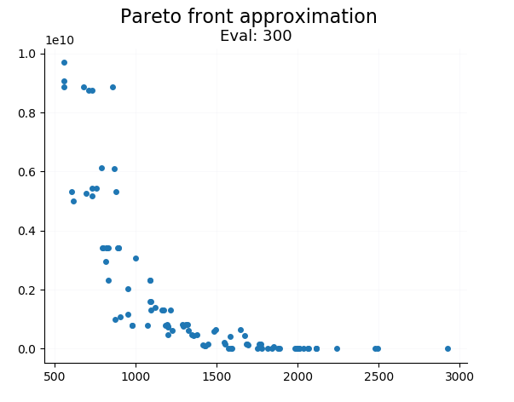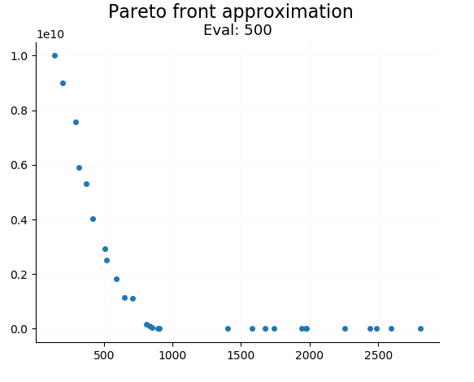

Pic.1 the Pareto front at about 400 evaluations（left-NSGA-II，right-SMPSO）

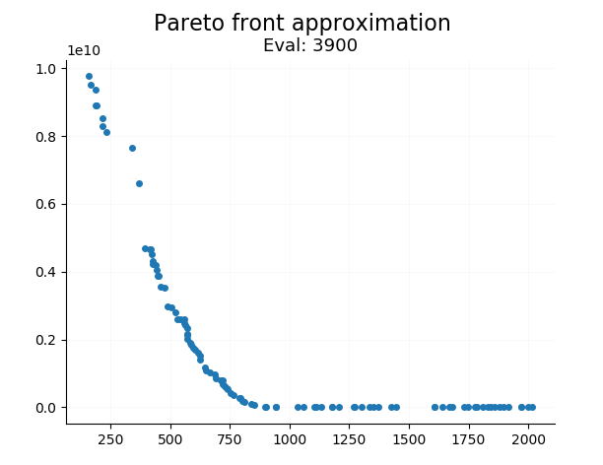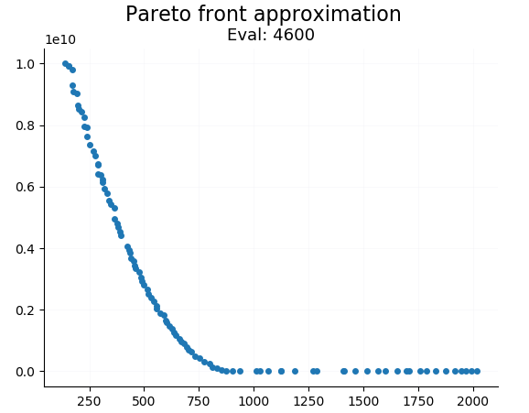

Pic.2 the Pareto front at about 4000 evaluations（left-NSGA-II，right-SMPSO）

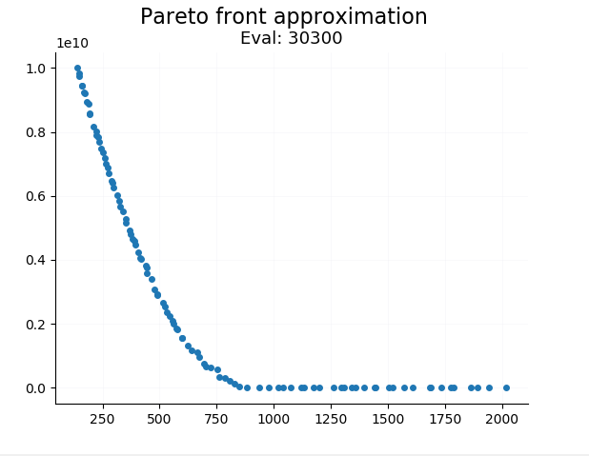 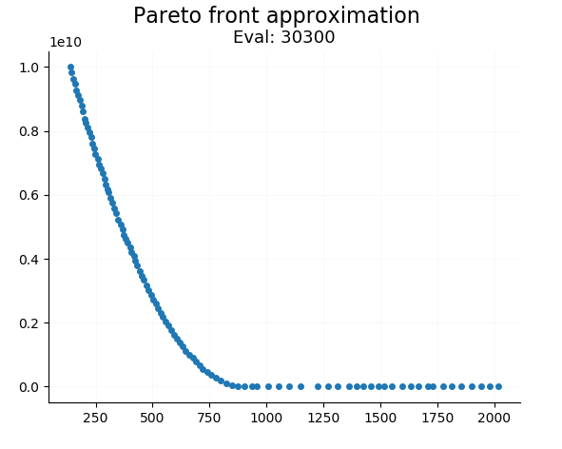

Pic.3 the Pareto front at about 30000 evaluations（left-NSGA-II，right-SMPSO）

The x-axis is the value of LCE and the y-axis is the value of PTE

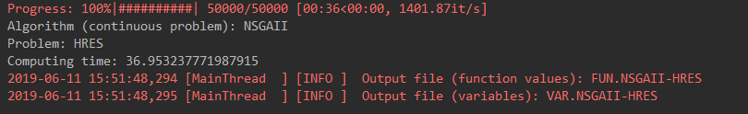

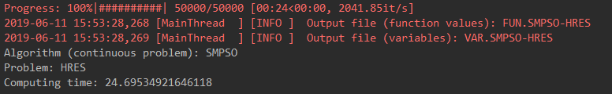

Pic.4\5 The Computing time of two algorithm by 50000 times evaluations（above- NSGA-II，below- SMPSO）

## 5.Conclusion

This paper discusses a simple general approach for the optimal power generated from multi sources in HRES to minimize the LCE and PTE using two algorithm: NSGAII and SMPSO.

Firstly, we obtained the LCE evaluation method widely used in the field of energy to evaluate the economic benefits of mixed energy by referring to relevant literature. Secondly, since HRES contains traditional energy, we add PTE to evaluate the environmental pollution degree of energy. Finally, considering the restriction factor of total energy power, we build a multi-objective optimization problem model about HRES.

The SMPSO and NSGA-II are efficient and effective heuristic algorithms in MOP problems. Two evaluation metrics of algorithm are used to compare convergence and diversity of evolutionary algorithms. SMPSO having more simple computational complexity will spend shorter time in every generation. SMPSO has better diversity with respect to Pareto fronts. Nevertheless，NSGA-II has better convergence compared with SMPSO in the same generation. By analyzing the standard deviation value, it is investigated that the quality of SMPSO solutions is much more stable than NSGA-II. It illustrates that different algorithms are suitable for a certain range of optimization problems.

Finally, we complete the multi-objective optimization problem of HRES and obtain Pareto diagrams related to LCE and PTE. It provides reference basis for the possible solution of HRES problem.

## 6.Team Division

毛一鸣：Team Leader、decide the problem and choose the optimization algorithm、programming

窦晓磊：propose the optimization equation、 programming

储含露：comparing two algorithm、programming

朱正一：measurement、programming

# Reference:

1. Amer M, Namaane A, M'sirdi N K. Optimization of hybrid renewable energy systems (HRES) using PSO for cost reduction[J]. Energy Procedia, 2013, 42: 318-327.
2. Darling S B, You F, Veselka T, et al. Assumptions and the levelized cost of energy for photovoltaics[J]. Energy & Environmental Science, 2011, 4(9): 3133-3139.
3. Deb K , Pratap A , Agarwal S , et al. A fast and elitist multiobjective genetic algorithm: NSGA-II[J]. IEEE Transactions on Evolutionary Computation, 2002, 6(2):0-197.
4. Sahely H R, Kennedy C A, Adams B J. Developing sustainability criteria for urban infrastructure systems. Canadian Journal of Civil Engineering, 2005, 32( 1) : 72－85.
5. Nebro A J, Durillo J, Garci a-Nieto J, et al. Smpso: a new pso-based metaheuristic for multi-objective optimization. Computational intelligence in miulti-criteri a decision-making, 2009. MCDM'09. IEEE Symposium on Nashville. TN: IEEE, 2009. 66－73．