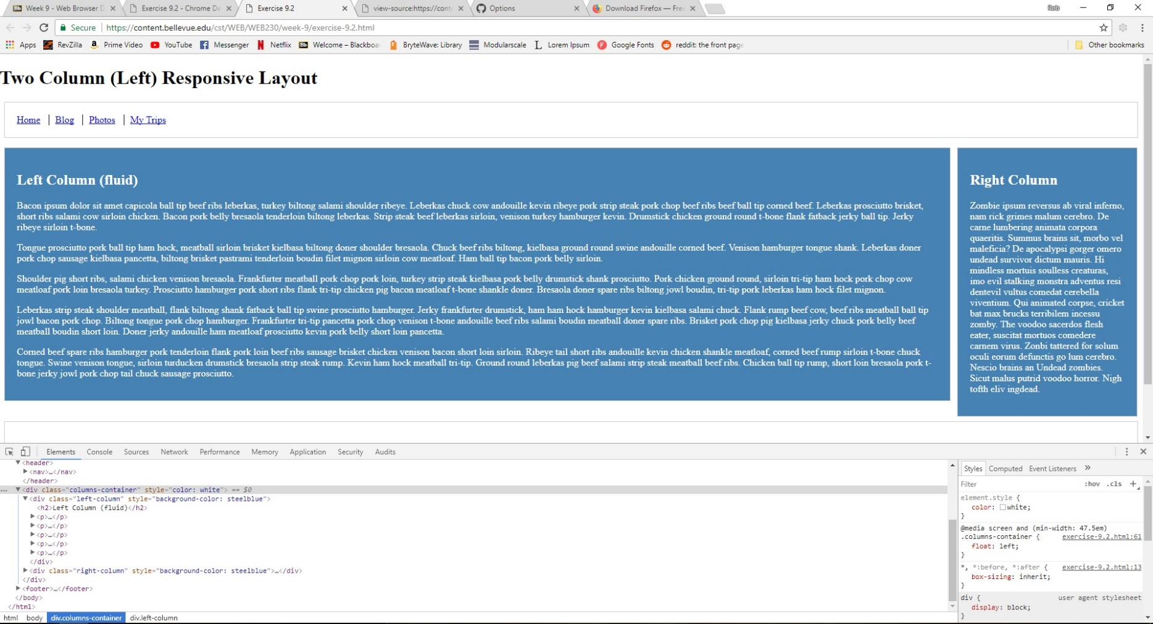

Step-By-Step Directions

1. I clicked on the link [excercise-9.2.html](https://content.bellevue.edu/cst/WEB/WEB230/week-9/exercise-9.2.html)
2. Then I clicked on the link [here](https://content.bellevue.edu/cst/WEB/WEB230/week-9/Exercise%209.2%20-%20Chrome%20Developer%20Tools.pdf) for the instructions
3. Press F12
4. I clicked on the arrow next to <div class="columns-container">
5. Then I right-clicked on “right-column” and clicked Edit as HTML and wrote style="background-color: steelblue;" just to the left of the “>”
6. Then I right-clicked on “columns-container” and clicked Edit as HTML and wrote style="color: white;" just to the left of the “>”
7. Then I right-clicked on “left-column” and clicked Edit as HTML and wrote style="background-color: steelblue;" just to the left of the “>”