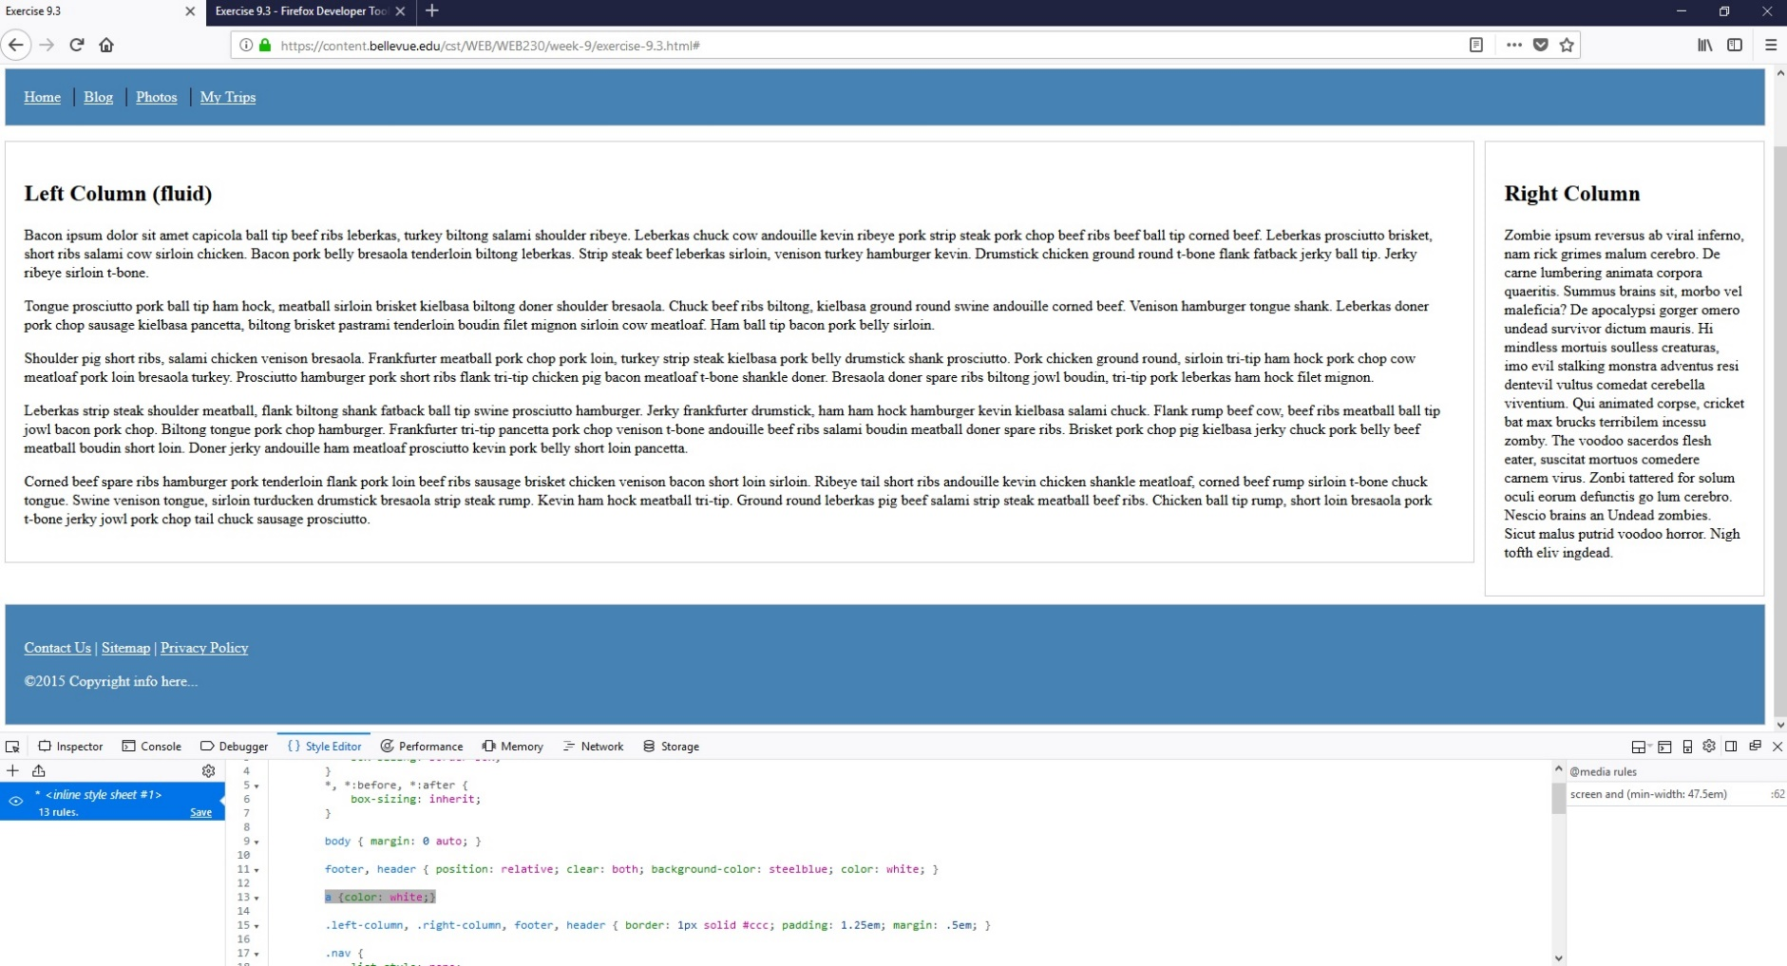

Step-By-Step Directions

1. I clicked on the link [excercise-9.3.html](https://content.bellevue.edu/cst/WEB/WEB230/week-9/exercise-9.3.html)
2. Then I clicked on the link [here](https://content.bellevue.edu/cst/WEB/WEB230/week-9/Exercise%209.3%20-%20Firefox%20Developer%20Tools.pdf) for the instructions
3. Press F12
4. Under “Style Editor” , before the “}” on the same row as “footer, header” , I typed “background-color: steelblue; color: white;”
5. Then I hit Enter twice and then typed “a {color: white;}”