Setting break points

1. Open your file in Firefox
2. Press F12
3. Click debugger
4. Click the line of code you wish to set the break point at

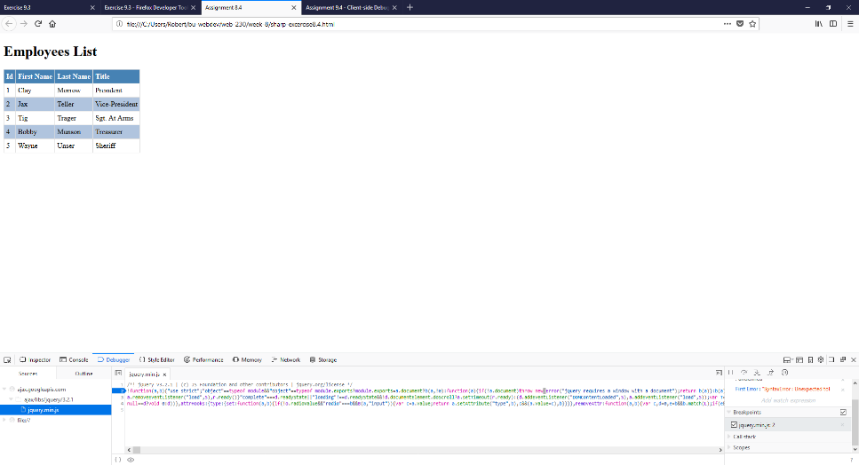

Log and read messages from the JavaScript console window

1. Open file in Firefox and press F12
2. Click on the “Console” button
3. Check all the options under the Filter
4. Display the ‘Get’ command for the Google Fonts

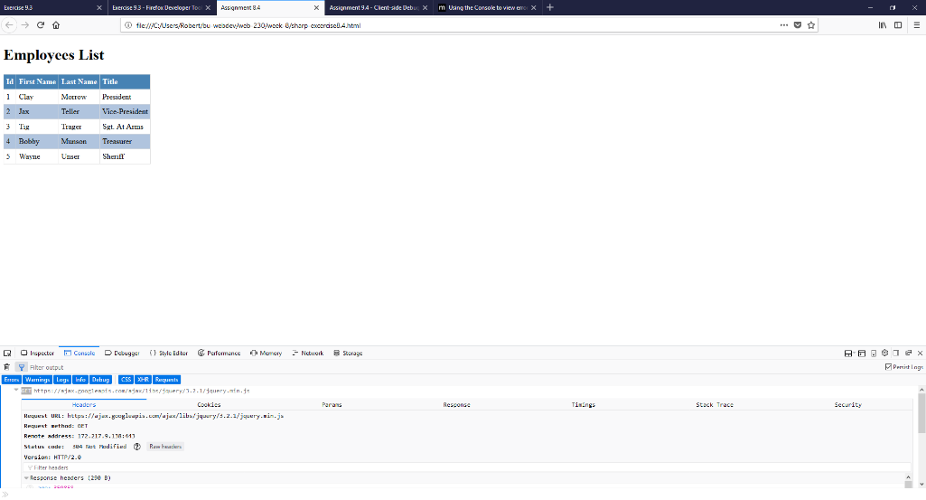

Select HTML elements in the JavaScript console window

1. Open file in Firefox and press F12
2. Click on the “Inspector” button
3. You can click on all the elements to update them, and hover over them to see how much they include

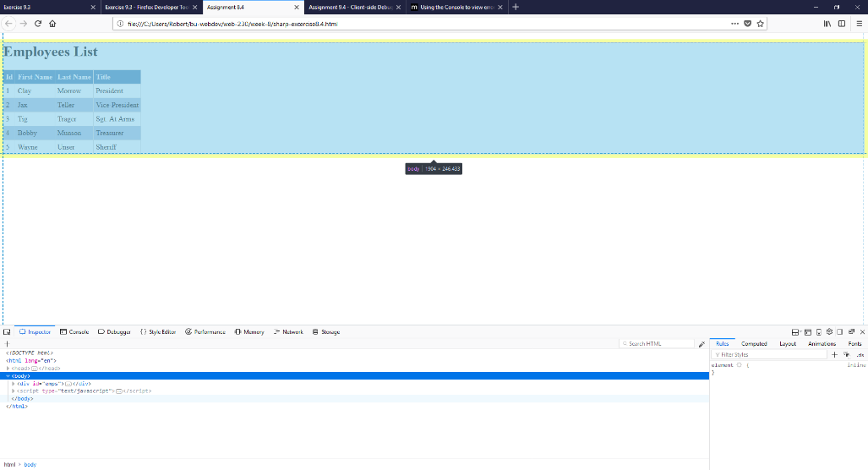

Simulate CSS states (hover, focus) on live HTML elements

1. Open the file in Firefox and press F12
2. Click on “Inspector”
3. Expand menus using the dropdown arrows, until you come to <style type=”text/css”>
4. The example says “tr:hover”, but anything that you set to “:hover” can be edited
5. Within the {} you can edit things like the background color

