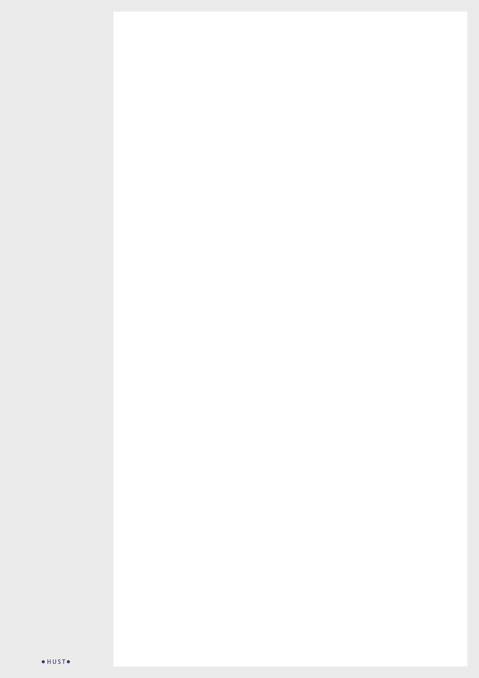

|  |
| --- |
| **个人评价** |
| XXXXXXXXXXXXXXXXXXXXXXXXXXXXXXXXXXXXXXXXXXXXXXXXXXXXXXXXXXXXXXXXXXXXXXXXXXXXXXXXXXXXXXXXXXXXXXXXXXXXXXXXXXXXXXXXXXXXXXXXXXXXXXXXXXXXXXXXXXXXXXXXXXXXXXXXXXXXXXXXXXXXXXX（所获荣誉） |

|  |  |  |  |
| --- | --- | --- | --- |
| **教育背景** | | | |
| **2017-2019** | **华中科技大学** | 理学硕士：XX专业  XXXXXXXXXXXXXXXXXXXXXXXXXXXXXXXX XXXXXXXXXX（所获荣誉） | **GPA:**  **3.67/4.00** |
| **2013-2017** | **华中科技大学** | 理学学士：XX专业  XXXXXXXXXXXXXXXXXXXXXXXXXXXXXXXX XXXXXXXXXX（所获荣誉） | **GPA:**  **3.67/4.00** |

|  |  |  |
| --- | --- | --- |
|  | **语言能力** | |
|  | **English**  **5** | **Arabic**  **4** |
|  | **Persian**  **1** | **Spanish**  **3** |

|  |  |  |  |
| --- | --- | --- | --- |
| **实习经历** | | | |
| **XX公司** | *XX城市*  **XX职位** | XXXXXXXXXXXXXXXXXXXXXXXXXXXXXXXX XXXXXXXXXX（工作内容） | **XXXX.XX** |
| **XX公司** | *XX城市*  **XX职位** | XXXXXXXXXXXXXXXXXXXXXXXXXXXXXXXX XXXXXXXXXX（工作内容） | **XXXX.XX** |
| **XX公司** | *XX城市*  **XX职位** | XXXXXXXXXXXXXXXXXXXXXXXXXXXXXXXX XXXXXXXXXX（工作内容） | **XXXX.XX** |
| **XX公司** | *XX城市*  **XX职位** | XXXXXXXXXXXXXXXXXXXXXXXXXXXXXXXX XXXXXXXXXX（工作内容） | **XXXX.XX** |
| **XX公司** | *XX城市*  **XX职位** | XXXXXXXXXXXXXXXXXXXXXXXXXXXXXXXX XXXXXXXXXX（工作内容） | **XXXX.XX** |

|  |  |  |
| --- | --- | --- |
|  | **个人技能** | |
|  | Photoshop |  |
|  | Illustrator |  |
|  | InDesign |  |
|  | Web Designing |  |
|  | HTML 5 |  |
|  | WordPress |  |
|  | MS Office |  |
|  | SEO |  |

|  |  |  |
| --- | --- | --- |
| **社会活动** | | |
| **XX城市**  *XX工作 XXX / XXX – XXX / XXX* |  | **XX城市**  *XX工作 XXX / XXX – XXX / XXX* |
| XXXXXXXXXXXXXXXXXXXXXXXXXXXXXXXXXXXXXXXXXXXXXXXXXXXXXXXXXXX（基本情况） |  | XXXXXXXXXXXXXXXXXXXXXXXXXXXXXXXXXXXXXXXXXXXXXXXXXXXXXXXXXXX（基本情况） |
| **XX城市**  *XX工作 XXX / XXX – XXX / XXX* |  | **XX城市**  *XX工作 XXX / XXX – XXX / XXX* |
| XXXXXXXXXXXXXXXXXXXXXXXXXXXXXXXXXXXXXXXXXXXXXXXXXXXXXXXXXXX（基本情况） |  | XXXXXXXXXXXXXXXXXXXXXXXXXXXXXXXXXXXXXXXXXXXXXXXXXXXXXXXXXXX（基本情况） |



点击图片

点击“更改图片”



电话：18015201037

邮箱：mkeke@hust.edu.cn

**华小闻**

**XX职位**