**DOCUMENTATION**

-To use the Leveling Desktop Application follow the following steps;

i) Install python in your machine.

ii) Download the source code

iii) If you want to run the application on the command line run the source which has no GUI

i.e type the following in your command line

**python Levelling.py**

Consider an example below;

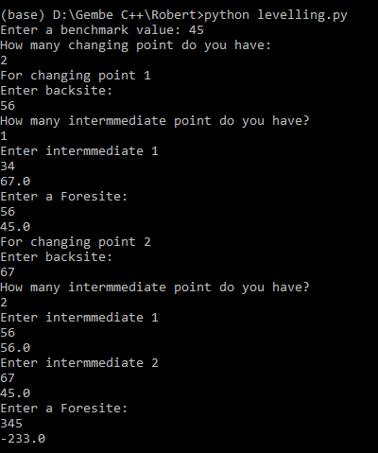

iv)If you want to run the application with an interface (GUI) open the command line and type the following.

**python LevellingGUI_Version-1.py**

After running the above command the interface will appear as below;



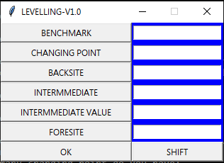

To continue enter the values and click on **BENCHMARK**. The result will be

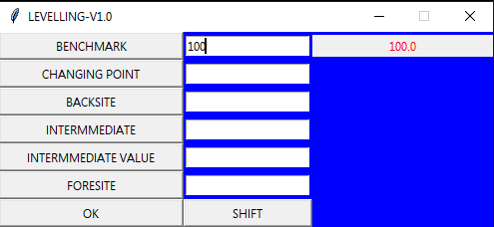

Then Continue entering the value and clicking the button as you done on **BENCHMARK**

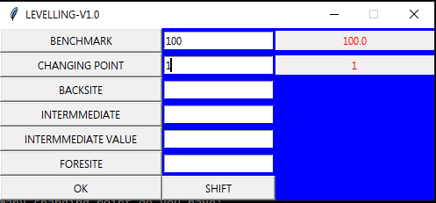

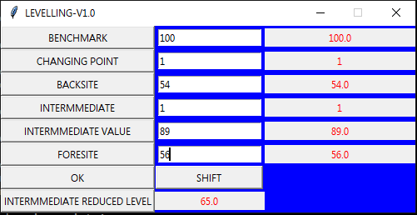

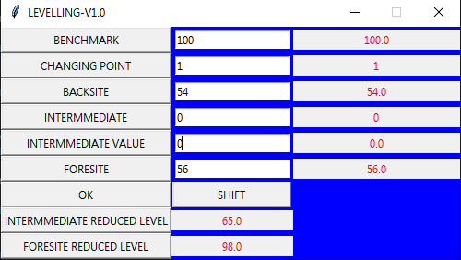

If you want to shift the leveling machine click the **SHIFT** button,

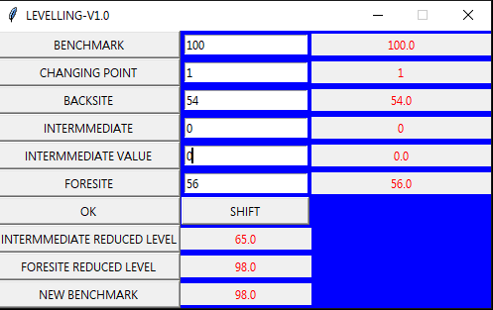

Then copy the NEW BENCHMARK value and enter it to the BENCHMARK and continue as previously.

**NOTE:** The concept behind this application is Leveling using height of collimation method.

**PREPARED BY; ROBERT GEMBE MARCELY**

**CONTACT: +255757685690**

**EMAIL:** [**gemberobert1@gmail.com**](mailto:gemberobert1@gmail.com)