SPELLING BEE
A Gamified, Voice-Only Spelling Practice Web Application
PROJECT REPORT
Student Name:
Owusu Robert
Student ID / Class:
____________________________
Course / Module:
BCT 400 — Project II
Institution:
Kumasi Technical University
Supervisor:
____________________________

September 2026

DECLARATION
I, Owusu Robert, Student ID / Class: ...................................., of Kumasi Technical University, hereby declare that this project report entitled “Spelling Bee: A Gamified, Voice-Only Spelling Practice Web Application” is my own work carried out under supervision during an industrial attachment at Ed Emporia Educational Services, and that all sources used or quoted have been duly acknowledged in the references. This report has not been submitted, in whole or in part, for the award of any other diploma, degree or certificate at this or any other institution.
Signature: ........................................ Date: ..........................

CERTIFICATION
This is to certify that the project report entitled “Spelling Bee: A Gamified, Voice-Only Spelling Practice Web Application”, prepared by Owusu Robert in partial fulfilment of the requirements for BCT 400 – Project II, was carried out under my supervision and is approved for submission to the Department, Kumasi Technical University.
Supervisor: ............................................................
Signature: ........................................ Date: ..........................

DEDICATION
This report is dedicated to my family and to everyone who offered me encouragement and guidance during my industrial attachment and the preparation of this report.

ACKNOWLEDGEMENT
My sincere appreciation goes to my supervisor for the guidance, corrections and encouragement offered throughout this project. I am grateful to the management and staff of Ed Emporia Educational Services for hosting the attachment, for permitting the study of their workflow, and for the feedback that shaped the requirements of this system. I also thank the lecturers of Kumasi Technical University for the preparation that made this work possible, my classmates for the discussions and peer review, and my family for their continued support.

ABSTRACT
Spelling is a foundational literacy skill, yet practice in many Ghanaian basic schools still depends on written dictation and repetitive copying, which assess handwriting more than spelling and give the learner no immediate feedback. This mini-project therefore set out to design, build and verify Spelling Bee, a single-school, full-stack web application in which every word is read aloud with text-to-speech and the learner answers by speaking the letters aloud. The aim was to produce a production-quality system that lets early-grade learners demonstrate spelling by voice rather than by typing, sustains motivation through gamification, and gives parents, teachers and administrators an appropriate view of progress.
The study followed a design-science approach developed in iterative increments. Requirements were drawn from the literature reviewed in Chapter Two, from interviews and observation during the industrial attachment at Ed Emporia Educational Services, and from a comparison of existing spelling applications. The system is built with React 19, TypeScript and Tailwind CSS in the browser, an Express and Prisma REST API on Node.js, and a PostgreSQL database with Row Level Security. Passwords are hashed with bcrypt, sessions are stateless JSON Web Tokens bound to a server-side token version, and every submitted round is re-graded on the server so that progress cannot be manipulated from the client. Account recovery deliberately involves no e-mail: a locked-out user raises an in-app request and the school administrator resets the account to a default password, which the owner then changes from their dashboard.
Verification combined 174 unit tests, 44 end-to-end API scenarios run against a live server and database, static type-checking, linting and a clean production build, all executed automatically by a continuous-integration pipeline. Every test passed, the production bundle builds to approximately 1.1 MB of code-split assets, and data endpoints responded in tens of milliseconds. The results show that voice-only, server-graded spelling practice is technically feasible in an ordinary browser at low cost, and that a school-facing system can combine gamification, role-based dashboards and a reasonable security posture without any e-mail infrastructure. The report concludes with the achievement of the objectives, a comparison with typing-based applications, and recommendations that include a classroom pilot to measure actual learning gains.
Keywords: spelling practice, voice-only interaction, speech recognition, gamification, educational technology, full-stack web application.

Table of Contents

(Right-click the table above and choose “Update Field” in Word to populate page numbers.)

LIST OF FIGURES
Figure 2.1: Conceptual framework — spoken input, server-side grading and gamification, and role-based feedback. –
Figure 3.1: Three-tier system architecture (React SPA, Express API, PostgreSQL). –
Figure 3.2: Use-case diagram of the Spelling Bee system. –
Figure 3.3: Database schema of the project. –
Figure 3.4: Activity diagram of a practice round. –
Figure 3.5: Sequence diagram of a spoken round submission. –
Figure 4.1: Landing page of the deployed application. –
Figure 4.2: Login screen for parents, teachers and administrators. –
Figure 4.3: Practice round with the spoken prompt and voice-only answer. –
Figure 4.4: Parent dashboard showing learner progress. –
Figure 4.5: Administrator overview dashboard. –
Figure 4.6: Administrator accounts screen with a pending password-reset request. –
Figure 4.7: Flow of a practice round. –
Figure B.1: Forgot-password request form as seen by a locked-out user. –
Figure B.2: Administrator reset confirmation showing the default password. –
Figure B.3: Settings screen where the owner changes the default password. –
(Right-click any entry above and choose “Update Field” to insert page numbers.)

LIST OF TABLES
Table 2.1: Mapping of Self-Determination Theory to system design. –
Table 3.1: Functional requirements of the system. –
Table 3.2: Non-functional requirements and how each is verified. –
Table 3.3: Representative user stories. –
Table 3.4: Technologies used, by layer. –
Table 3.5: Main database tables. –
Table 3.6: Input and output design. –
Table 4.1: Key features of the implemented system. –
Table 4.2: Development environment. –
Table 4.3: System modules and the code that implements them. –
Table 4.4: Representative test cases and their results. –
Table 4.5: Testing and verification results. –
Table 4.6: System performance results. –
Table 4.7: Challenges encountered and solutions applied. –
Table 5.1: Achievement of the project objectives. –
Table 5.2: Comparison with existing typing-based spelling applications. –
Table A.1: End-to-end test scenarios and results. –
Table B.1: Index of captured system screenshots. –
Table D.1: Project schedule. –
(Right-click any entry above and choose “Update Field” to insert page numbers.)

CHAPTER ONE: INTRODUCTION

1.1 Background of the Study
Spelling is a foundational literacy skill: it underpins reading fluency, comprehension and confident written communication, and difficulties with it are known to persist well beyond the early grades. In the Ghanaian context, Atatsi and Amoakohene (2019) found that spelling errors remain common even among Technical University students, with omission, insertion, substitution and transposition errors dominating learners' written work. Broader research on literacy in Ghanaian basic schools similarly points to limited access to structured, engaging practice materials as a persistent barrier to stronger reading and writing outcomes.
Traditional spelling instruction in many Ghanaian basic schools still relies heavily on written dictation and repetitive copying. While these methods have a role to play, they place a premium on a learner's handwriting or typing ability rather than on the spelling skill itself, and they rarely provide the learner with immediate, individualised feedback. Emerging evidence from educational technology research suggests that two complementary approaches can help close this gap: gamification, which uses game-like elements such as points, streaks and badges to sustain motivation (Mohammed, Fatemah & Hassan, 2024), and speech-recognition technology, which allows a learner to demonstrate spelling knowledge by speaking rather than typing (Raskind & Higgins, 1999).
This project was undertaken during an industrial attachment at Ed Emporia Educational Services, a STEAM education company based at the Kwame Nkrumah University of Science and Technology (KNUST) in Kumasi, and grew out of a practical need observed in that setting: a way for young learners to practise spelling that does not depend on typing skill, that can be used safely and independently, and that gives parents, teachers and school administrators visibility into a learner's progress.
The Spelling Bee system responds to this need. It is a single-school web application in which every word is read aloud through text-to-speech and the learner answers by speaking the letters aloud; the spoken answer is recognised and graded on the device, making the practice experience genuinely hands-free and voice-only. Parents register and manage their children's profiles, teachers organise learners into classrooms and manage a shared school word bank, an administrator oversees the platform as a whole, and students play practice rounds that earn points, streaks, hearts, badges and daily-challenge bonuses. The system is served as a single website backed by one API, with data stored in a hosted PostgreSQL database on Supabase.

1.2 Statement of the Problem
As Chapter Two sets out in more detail, the spelling applications already in wide use are predominantly typing- or tapping-based. This design choice assumes a level of keyboard or touchscreen fluency that many early-grade learners have not yet developed, and it offers little support to learners who struggle to translate a spoken word into typed letters in the first place. At the same time, the dictation-based practice that is common in Ghanaian classrooms provides no immediate, individualised feedback, and it is difficult for a single teacher to grade the practice of every learner in a class on an ongoing basis.
There is, therefore, a need for a spelling-practice tool that (i) lets an early-grade learner demonstrate their spelling knowledge by speaking rather than typing, (ii) keeps learners motivated over repeated practice sessions through structured, game-like feedback, (iii) cannot simply be self-marked or manipulated by the learner's device, and (iv) gives the different people responsible for a learner's progress — parents, teachers and school administrators — an appropriate view of that progress. The Spelling Bee project was designed and built to address this need.

1.3 Aim and Objectives of the Study
The aim of this project is to design, build and verify a complete, production-quality full-stack web application for voice-based, gamified spelling practice, suitable for use in a single-school setting. The specific objectives are to:
- Build a complete, production-quality full-stack web application for voice-based spelling practice.
- Motivate learners through gamification — difficulty tiers, streaks, hearts, points, badges and a daily challenge.
- Give parents, teachers and administrators clear dashboards over progress, classrooms and the word bank.
- Apply real-world security and data-protection practices (encrypted passwords, secure sessions, Row Level Security).
- Verify the system through automated endpoint testing, type-checking and a clean build.

1.4 Research Questions of the Study
The following questions guided the design and verification of the system; each is answered through the working artefact and the evidence reported in Chapters Three and Four rather than through a statistical study.
- How can voice-only interaction be used to assess the spelling of early-grade learners who are not yet confident typists, while keeping the grading authoritative and free of client-side manipulation?
- To what extent can gamification mechanics — difficulty tiers, a round streak, hearts, points, badges and a deterministic daily challenge — give a learner a sustained reason to practise, as predicted by Self-Determination Theory?
- What architecture and security practices allow a single-school web application to grade every attempt on the server while still giving parents, teachers and administrators role-appropriate views of a learner's progress?

1.5 Significance of the Study
For learners, the system offers a way to practise spelling that does not depend on typing ability, which is particularly valuable for early readers who are still developing keyboard fluency. For teachers and administrators at a school such as Ed Emporia, it offers a shared word bank and classroom-level analytics that would otherwise have to be maintained manually. For parents, it offers visibility into a child's progress without requiring technical expertise. More broadly, the project contributes a working, security-conscious example of how gamification and speech interaction can be combined in an educational technology product built for a Ghanaian setting, at a time when locally grounded research and tooling in this area remains limited (Atatsi & Amoakohene, 2019).

1.6 Scope of the Study
The project covers user authentication (parent, teacher, admin and student-code login), learner management, practice rounds with server-side grading, tier progression, badges, a deterministic daily challenge, class leaderboards, classroom management, and a shared, admin-managed word bank with dictionary lookup and CSV import. The system is scoped to a single school and to English-language spelling practice; multi-school deployment, additional languages and live pronunciation feedback are identified in Chapter Five as directions for future work rather than as part of the current scope.

1.7 Limitations of the Study
The following limitations define how the results in this report should be read:
- The system was verified as a software artefact; no classroom efficacy trial was run, so the report makes no claim about measurable spelling-outcome gains for real learners. That evaluation is recommended as future work in Chapter Five.
- The scope is a single school and English-language spelling only. Multi-school deployment, additional languages and offline use are outside the current scope.
- Speech recognition and text-to-speech rely on browser APIs, so the experience is best on Chromium-based browsers with a working microphone; recognition quality depends on the device, the microphone and background noise.
- No audio is uploaded or stored (see the ethical considerations in Section 3.18), which protects learners' privacy but limits pronunciation-level feedback to whether the whole word was spelled correctly.
- The seeded word bank is deliberately small (43 words across six tiers) so that the word-bank management features can be demonstrated; content growth is an operational task for the adopting school rather than a research contribution.
- Development took place within the period of an industrial attachment, so longitudinal data on learner engagement could not be collected.

1.8 Organisation of the Report
The rest of this report is organised as follows. Chapter Two reviews the literature on spelling and literacy development, gamification, speech-recognition and text-to-speech technology, existing spelling applications, and the methods and algorithms such systems use, and identifies the gaps the project addresses. Chapter Three presents the methodology: the research approach, the functional and non-functional requirements, the tools and technologies, the system design (architecture, use-case, activity and sequence diagrams, database design, input and output design), the grading algorithm, the dataset, the security design, the testing plan and the ethical considerations. Chapter Four reports how the system was implemented and tested, presents screenshots, test cases, results and performance figures, and evaluates them. Chapter Five discusses what the results mean, whether the objectives were achieved, how the system compares with existing products, and what should be done next. The references are followed by appendices containing the full end-to-end test list, a screenshot index, a user manual, the project schedule and the interview prompts used during requirements gathering.

CHAPTER TWO: LITERATURE REVIEW

2.1 Introduction
This chapter reviews existing research relevant to the Spelling Bee project under the headings required for a mini-project report: a conceptual review of spelling, gamification and voice interaction (Sections 2.2 to 2.4), a review of existing systems (Section 2.5), the theoretical and conceptual frameworks that guided the design (Sections 2.6 and 2.7), a review of the methods, algorithms and models such systems rely on (Section 2.8), and an explicit statement of the gaps in existing systems (Section 2.9) before the chapter is summarised (Section 2.10).

2.2 The Role of Spelling in Literacy Development
Spelling competence is widely treated in the literature as closely linked to reading and writing ability rather than as an isolated skill. Atatsi and Amoakohene (2019) studied 275 students across three academic levels at a Technical University in Ghana and found that spelling errors were common at every level, with unfamiliarity with a word, uncertainty about its pronunciation, and a failure to proofread written work identified as the main causes. Their findings, together with the wider Applied Linguistics literature they cite, support the view that spelling difficulties are not confined to early learners and that they can persist into tertiary education when not addressed early. This underlines the value of giving basic-school learners repeated, well-supported opportunities to practise spelling rather than treating it as a skill that is mastered once and then assumed.

2.3 Gamification in Education
Gamification refers to the use of game-design elements — points, badges, streaks and leaderboards among them — in a non-game context such as a classroom or a learning application. A systematic review of gamified learning strategies reports that such elements are widely used to influence student motivation, though the effect can combine genuine engagement with a short-lived novelty effect that fades with repeated exposure. The dominant theoretical lens used to explain why gamification affects motivation is Self-Determination Theory (SDT), which holds that motivation is strongest when an activity satisfies three basic psychological needs: autonomy, competence and relatedness (Deci & Ryan, 1985).
Empirical support for gamification's effect on younger learners in a developing-country setting comes from Mohammed, Fatemah and Hassan (2024), who ran a field experiment with primary-school pupils in Egypt comparing badges against leaderboards as rewards in an educational game. Both reward types produced statistically significant increases in the pupils' cognitive and achievement motivation, with no significant difference between the two, suggesting that the overall design and novelty of a gamified experience matters at least as much as the specific choice of reward mechanic. This finding is directly relevant to the Spelling Bee system, which combines several reward mechanics — points, streaks, hearts, badges and a daily challenge — rather than relying on a single one.

2.4 Review of Related Technologies: Speech Recognition and Text-to-Speech
Two related technologies make voice-only practice possible in a browser. Speech recognition converts the learner's spoken letters into text, and text-to-speech (TTS) reads the prompt word aloud. Speech-recognition technology has a longer history in literacy instruction than gamification does. Raskind and Higgins (1999) studied elementary and secondary students with learning disabilities who used speech-recognition software to write self-selected compositions over sixteen weeks, and found that the group using the technology showed significantly greater improvement in word recognition, spelling and reading comprehension than a control group that received general computer instruction. Their work established that speech-recognition technology, though originally designed as a compensatory writing aid, can also produce genuine gains in spelling and reading.
More recent work has examined voice-enabled spelling tools built specifically for learners outside the well-resourced, native-English-speaking contexts in which most commercial products are designed. Mohammed and Skerrit (2022) describe an exploratory study of Ozzypi, an online spelling tutor built for Caribbean schoolchildren that combines speech-enabled exercises with an intelligent tutoring core; their evaluation with learners and parents from Trinidad and Jamaica found broad engagement, but also surfaced the importance of culturally-situated design choices when introducing speech-enabled features to a new population of learners. This is a useful caution for the present project: the technical feasibility of voice-based spelling practice is well established, but the design and wording of the practice content still needs to be appropriate to the learners it is built for.
Modern browsers expose both capabilities through the Web Speech API, which is central to this project's design (MDN Web Docs, n.d.). Recognition runs inside the browser on the learner's own device, so no audio ever leaves the device and no speech server, subscription or bandwidth budget is required — an important consideration for a school deployment. TTS is used only to pronounce the prompt word, and the graded artefact is the recognised letter sequence, not the audio. Because the API is implemented by the browser rather than by the application, the system degrades gracefully: where recognition is unavailable, the same round can be completed with a keyboard, keeping the assessment usable on older devices.

2.5 Review of Existing Systems: Spelling Applications
A number of commercial and free spelling and early-literacy applications are already in wide use, among them Duolingo ABC, VocabularySpellingCity and ABCmouse. These products share a broadly similar design: a learner is shown or told a word and demonstrates knowledge of it by tapping letter tiles, typing, or selecting from multiple-choice options, with gamified elements such as badges, streaks or a "learning path" used to sustain engagement. Reviews of these products consistently note that they are effective at holding a young learner's attention, but that their interaction model still assumes the learner can type or accurately tap individual letters in sequence.
None of the widely used products reviewed for this project offer voice-only interaction as the primary mode of practice, and few are designed around the specific needs of a single school with distinct parent, teacher, administrator and student roles sharing one word bank. This is the gap the Spelling Bee project addresses: a system in which speaking is not an add-on feature but the primary and, for the student role, the only way of answering, combined with the classroom- and school-level management features that a Ghanaian basic school setting such as Ed Emporia requires.

2.6 Theoretical Framework
The system's gamification design is grounded in Self-Determination Theory (Deci & Ryan, 1985), which explains motivation in terms of three psychological needs. Autonomy is supported by the voice-only interaction itself: a learner who cannot yet type confidently is nonetheless able to complete a full practice round independently, without needing an adult to operate a keyboard on their behalf. Competence is supported by the tier-progression system, the badge criteria, and the points and streak mechanics, all of which give a learner concrete, incremental evidence of improvement. Relatedness is supported by the class-aware leaderboard and by the classroom structure itself, which situates a learner's practice within their own class rather than as an isolated, anonymous activity. This mapping between the theory and the system's concrete features is summarised in Table 2.1.
Table 2.1: Mapping of Self-Determination Theory to System Design
SDT Need | System Feature | How the Need is Supported
Autonomy | Voice-only answering | Learner completes a full round independently, without needing to type.
Competence | Tiers, points, streaks, badges | Concrete, incremental feedback on improving spelling ability.
Relatedness | Classrooms, class-aware leaderboard | Practice is situated within a learner's own class, not isolated.

2.7 Conceptual Framework
Bringing the two theoretical strands together, the system can be described conceptually as an input–process–output loop. The input is a spoken spelling attempt, captured through on-device speech recognition rather than typed text. The process is server-side: the spoken attempt is graded against the authoritative word bank, and the outcome feeds a gamification engine that updates points, streak, hearts, tier and badges according to fixed rules. The output is twofold — immediate feedback to the learner, and updated progress data made available to parents, teachers and administrators through their respective dashboards. This conceptual loop, illustrated in Figure 2.1, is what Chapter Three's system architecture (Figure 3.1) was designed to implement in software.
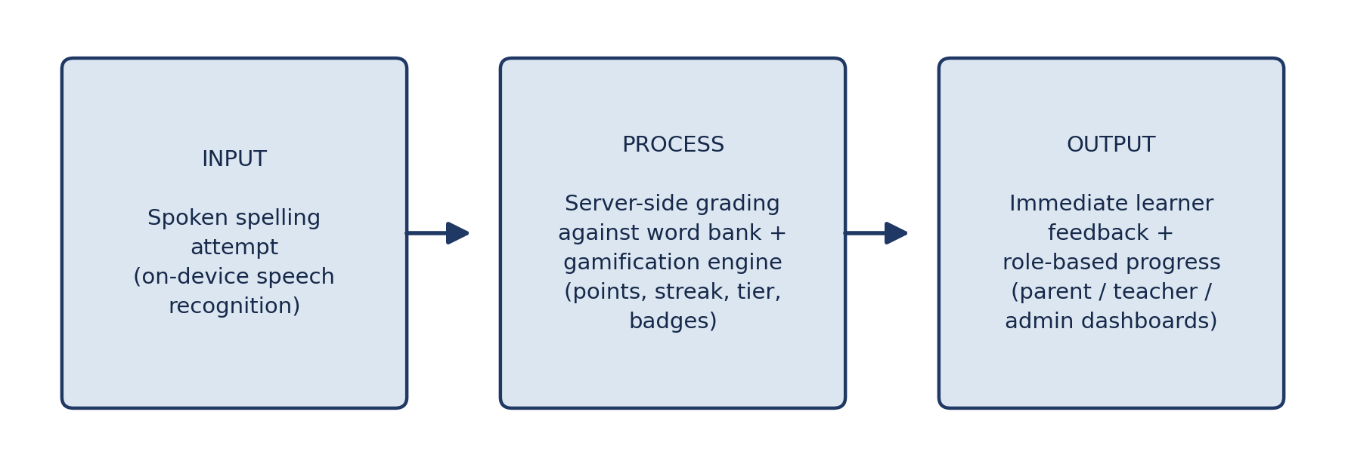
Figure 2.1: Conceptual framework — spoken input, server-side grading and gamification, and role-based feedback.

2.8 Review of Methods, Algorithms and Models
Grading spoken spelling admits several computational approaches. The simplest is exact string equality after normalisation: both the authoritative word and the recognised attempt are lower-cased, stripped of punctuation and have internal whitespace collapsed, and are then compared character by character. The alternative family is fuzzy matching, usually edit distance, which scores how far the attempt is from the target and can award partial credit. Fuzzy scoring is attractive for formative feedback but risks awarding credit to a wrong spelling, which would undermine the assessment the school actually wants. This project therefore uses deterministic exact matching after normalisation, and reports which words were wrong so that feedback can be given at word level rather than letter level.
Adaptive difficulty in intelligent tutoring systems is commonly modelled by estimating learner ability, for example with item-response models or Elo-style ratings, and selecting the next item accordingly. Such models need calibration data that a single school does not have. The system instead uses a transparent mastery rule: a learner who answers a threshold of words correctly in the current tier advances to the next tier, while an incorrect answer spends a heart and keeps the learner in place. The rule is simple enough to explain to an eight-year-old, which matters for the competence need identified in Section 2.6, and it is fully reproducible, which matters for testing.
The daily challenge uses deterministic selection rather than a random draw: the server derives the word of the day from the date, so every learner in the school attempts the same word, the result is reproducible, and the client cannot re-roll it. Gamification updates themselves follow the pattern of a scored, streak-preserving state machine — points = base × tier multiplier × combo multiplier, subject to per-round caps — which is the same shape used by commercial language applications and is evaluated inside a database transaction so that concurrent rounds cannot double-spend a streak.
For authentication, stateless signed tokens were compared with server-side sessions. Stateless tokens scale without a session store but cannot be revoked individually; the chosen design combines the two, signing a token that carries a server-side token version, so that changing a password or resetting an account invalidates every outstanding token at once. This follows common API security guidance on credential storage and session invalidation (OWASP Secure Headers Project, n.d.) and is the property that makes the administrator-driven password reset described in Section 3.16 safe.

2.9 Gaps in Existing Systems
Across the applications reviewed in Section 2.5 and the literature summarised above, six gaps stand out, and each one is addressed by this project:
- Typing- or tapping-first interaction. The commercial products assume keyboard or touchscreen fluency that early-grade learners may not have, and none offers speaking as the primary way of answering.
- No single-school role model. Existing products are built for an individual learner or for a large consumer audience; they do not give a school's parents, teachers and administrators coordinated views of the same learners.
- Assessment integrity. Where practice is marked on the device, a learner (or a modified client) can award themselves credit. Grading on the server, against the authoritative word bank, is not the norm in this product class.
- Context and content. Word lists and examples are typically written for other curricula; Mohammed and Skerrit (2022) show why culturally-situated design matters when speech-enabled tools reach new populations of learners.
- Account recovery by e-mail. Consumer products assume every household reads the e-mail used at sign-up. A school, however, manages its own users, so recovery that depends on private e-mail is a poor fit; the in-app administrator reset in this project removes that dependency.
- Privacy of voice data. Products built around cloud speech recognition must transmit children's voices; recognising speech in the browser keeps that data on the device, which is a materially different privacy position.

2.10 Summary of Literature Review
This chapter has shown that spelling difficulties are well documented at every level of education in Ghana, that gamification has a demonstrated, if sometimes short-lived, positive effect on learner motivation, and that speech-recognition technology has a track record of producing genuine spelling and reading gains rather than simply acting as a convenience feature. It has also shown that existing spelling applications remain predominantly typing-based and are not designed around the multi-role needs of a single school. The Spelling Bee project's combination of voice-only interaction, multi-mechanic gamification grounded in Self-Determination Theory, and school-level role management is intended to address this gap. Chapter Three now turns to how the system was designed and built.

CHAPTER THREE: METHODOLOGY AND SYSTEM DESIGN

3.1 Research Design and Data Collection
This project followed an applied, design-science approach rather than a survey- or experiment-based research design: the primary output is a working software artefact — the Spelling Bee system — built to address the problem set out in Chapter One and informed by the literature and theoretical framework set out in Chapter Two. This is the design commonly used for software-engineering capstone and mini-projects, where the central research question is answered by designing, building and verifying a system rather than by collecting and statistically analysing data from human participants.
Data for the requirements were gathered during the industrial attachment at Ed Emporia Educational Services through informal semi-structured conversations with educators and administrators about how spelling is currently taught and marked, observation of the existing dictation and copying routine, and a review of the school's word lists and lesson material. Because the attachment was a workplace placement rather than a research study with human participants, no questionnaire was distributed and no learner data were collected for research purposes; the findings are reported here as design inputs rather than as survey results. The literature reviewed in Chapter Two supplied the second source of requirements, and the feature-by-feature comparison of existing applications in Section 2.5 supplied the third.

3.2 System Development Methodology
The system was developed iteratively and modularly. Each major subsystem — authentication, learner and account management, practice rounds and grading, the word bank, classroom management, and the administrative and parent dashboards — was developed and verified in turn before the next subsystem was integrated on top of it. This iterative approach made it possible to catch integration issues early and to keep the codebase in a working, testable state throughout development, and it is reflected in the layered testing strategy described in Section 3.17.
The work proceeded in short iterative increments, each ending in a working and tested state: project scaffolding and the REST API; authentication with revocable sessions; learner profiles, placement and the practice round with server-side grading; the word bank, CSV import and classroom management; dashboards, leaderboards and the daily challenge; and finally hardening — rate limiting, security headers, audit logging and the in-app password-recovery flow. No increment was considered complete until its checks passed. The same checks run in a continuous-integration pipeline (GitHub, n.d.) that performs linting, type-checking, a production build, schema validation, a clean database migration and seed, and the full end-to-end suite on every push, so regressions surface immediately instead of at the end of the project.

3.3 Requirements Gathering
The system's requirements were derived from three sources. First, the gap identified in the literature review (Section 2.5): existing spelling applications are typing-based and are not designed for a single-school setting with distinct parent, teacher, administrator and student roles. Second, the scope defined in Chapter One, which fixed the four user roles the system needed to support and the core practice loop (a spoken word, graded server-side, feeding a gamification engine). Third, the baseline feature set common to the existing applications reviewed in Section 2.5 — a tiered word bank, progress tracking and gamified rewards — which was extended with the project's two key differentiators: voice-only interaction as the primary answering mode, and school-level administration and classroom management.

3.4 Functional Requirements
The requirements gathered were refined into the functional requirements in Table 3.1. Each requirement is written so that it can be demonstrated or tested against the running system, and each is traceable to at least one end-to-end scenario in the verification suite reported in Section 4.8.
Table 3.1: Functional Requirements of the System
Ref | Functional requirement | Primary role
FR1 | Create, approve, edit and deactivate parent and teacher accounts | Administrator
FR2 | Create learner profiles carrying a unique learner code (ST-XXXXX) | Parent, Teacher, Administrator
FR3 | Authenticate with email and password, or with a learner code for practice sessions | All roles
FR4 | Recover a forgotten password in-app: the user raises a request, the administrator resets the account to a default password, and the owner then changes it from their dashboard | All roles, Administrator
FR5 | Deliver a practice round in which the word is read aloud and the learner answers by speaking rather than typing | Learner
FR6 | Grade every submitted spelling on the server against the authoritative word bank, ignoring any client-supplied verdict | API
FR7 | Maintain gamification state: points, round streak, hearts with timed regeneration, tiers, badges and a deterministic daily challenge | Learner
FR8 | Publish school-wide and class-scoped leaderboards from the same progress data | All roles
FR9 | Manage the word bank: add, edit and delete words, import in bulk from CSV, enrich definitions through a dictionary lookup | Teacher, Administrator
FR10 | Manage classrooms, enrol learners and view class-level progress | Teacher, Administrator
FR11 | View role-appropriate progress dashboards (points, streaks, badges, hours practised, recent activity) | Parent, Teacher, Administrator
FR12 | Persist accessibility preferences (dark mode, text size, dyslexia-friendly font) per account | All roles
FR13 | Write administrative actions to an audit log for accountability | Administrator
FR14 | Allow exactly one daily-challenge completion per learner per day | Learner

3.5 Non-Functional Requirements
Non-functional requirements describe how the system must behave rather than what it does. Table 3.2 states each one together with the check that demonstrates it, so that a claim of compliance can be followed to evidence.
Table 3.2: Non-functional Requirements and How Each Is Verified
Ref | Non-functional requirement | How it is verified
NFR1 | Security: bcrypt password hashing, revocable JWT sessions, role and ownership middleware, Row Level Security, strict CSP/CORS | Authorization scenarios in the end-to-end suite
NFR2 | Performance: data endpoints answer in tens of milliseconds; login completes in well under a second | Timing measurements reported in Section 4.9
NFR3 | Reliability: scoring runs in a single locked transaction and dictionary enrichment degrades gracefully when offline | End-to-end scenarios for rounds and word import
NFR4 | Usability: mobile-first layout with large touch targets and only a few steps between core tasks | Manual walkthrough documented by the screenshots in Section 4.5
NFR5 | Maintainability: strict TypeScript, layered controllers and services, client scoring utilities that mirror the server | 174 unit tests plus lint and type-check in CI
NFR6 | Portability: one command produces a static build that the API serves on the same host | Production build step in CI
NFR7 | Privacy: no audio is recorded or stored, and only minimal learner data is held | Design review in Section 3.18
NFR8 | Abuse resistance: per-IP and per-account rate limits on sensitive endpoints | Rate-limit configuration and login-lockout scenarios
NFR9 | Accessibility: adjustable text size, high-contrast dark mode and a dyslexia-friendly font | Settings screen checks (Figure B.3 and related captures)

3.6 User Stories
The requirements were also expressed as user stories, which kept the design focused on what each role is trying to accomplish. Table 3.3 lists the representative stories and the condition that makes each one "done".
Table 3.3: Representative User Stories
Role | User story | Done when
Parent | "As a busy parent I want to see at a glance whether my child practised today, so I can encourage them without having to ask." | The dashboard shows fresh points, streak, badges and time practised after every round.
Teacher | "As a teacher I want my class on one board so that I can celebrate progress with them in class." | The class leaderboard updates as soon as rounds are graded.
Administrator | "As an administrator I want to create accounts, and unblock a learner who has forgotten a password, without depending on e-mail infrastructure." | The account is created and approved, or reset to a default password that the owner then changes.
Learner | "As a learner I want to spell by talking rather than typing, and to earn hearts and badges for trying." | A spoken round is graded server-side and points, hearts and badges update immediately.
Teacher | "As a teacher I want words that match what we are teaching this week." | Words can be added one at a time or imported in bulk from a CSV file.
Parent | "As a parent I want to know that my child is safe while using the application." | Only the school's own accounts exist, sessions can be revoked, and no audio ever leaves the device.

3.7 Tools and Technologies Used
The application uses a modern JavaScript/TypeScript stack across three layers: the browser client, the REST API and the database, summarised in Table 3.1.
Table 3.4: Technologies Used, by Layer
Layer | Technology | Purpose
Frontend | React 19 | Component-based user interface
Frontend | Vite 6 + TypeScript 5.8 | Development server and production build with static typing
Frontend | Tailwind CSS 4 | Responsive, mobile-friendly styling
Frontend | react-router 7, lucide-react, recharts, motion | Routing, icons, charts and animations
Backend | Node.js + Express 4 | REST API server (single host)
Backend | Prisma ORM 7.9 | Type-safe database access and migrations
Backend | jsonwebtoken + bcryptjs | Session tokens and password hashing
Backend | compression, cors, dotenv, pg | Performance, security headers and database driver
Database | Supabase (PostgreSQL) | Hosted relational database; Row Level Security is enabled
The frontend and the API are served from the same host in production: the Vite build output is served by Express, with API routes taking precedence and everything else falling back to the app shell.

3.8 System Architecture
The system follows a three-tier architecture, shown in Figure 3.1. The browser runs the React single-page application and talks to the Express API over HTTPS/JSON. The API authenticates every request, validates it against role-based rules, and reads and writes the PostgreSQL database through the Prisma client. There is no direct connection between the browser and the database — all data access flows through the API.
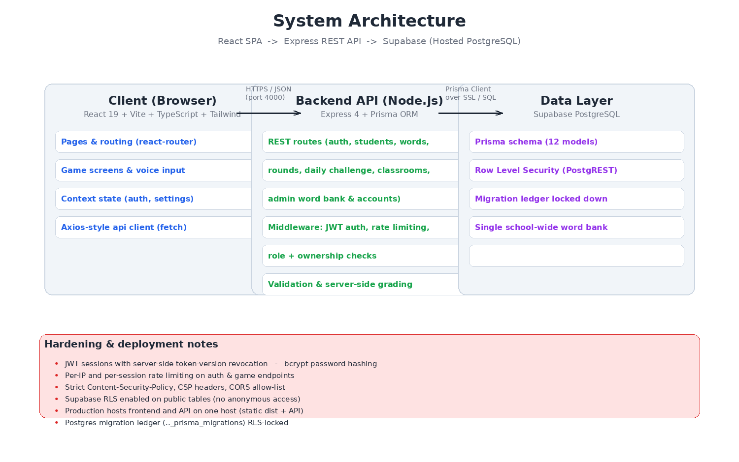
Figure 3.1: Three-tier system architecture (React SPA, Express API, Supabase PostgreSQL).
Every request passes through middleware that checks the JSON Web Token, applies per-IP or per-session rate limits, verifies the account role, and confirms that a learner profile actually belongs to the account making the request. Business rules such as scoring live on the server so that progress cannot simply be edited on a device.

3.9 Use Case Diagram
Figure 3.2 records who uses the system and what each role may do. The four actors — parent, teacher, school administrator and learner — are drawn outside the system boundary, and the use cases inside it are grouped per actor. Every use case shown is implemented: the parent and teacher rows map to the dashboards and management screens of Chapter Four, the administrator row includes the in-app password reset that replaces e-mail-based recovery, and the learner row is the practice loop that Chapter Three's architecture and algorithm implement.
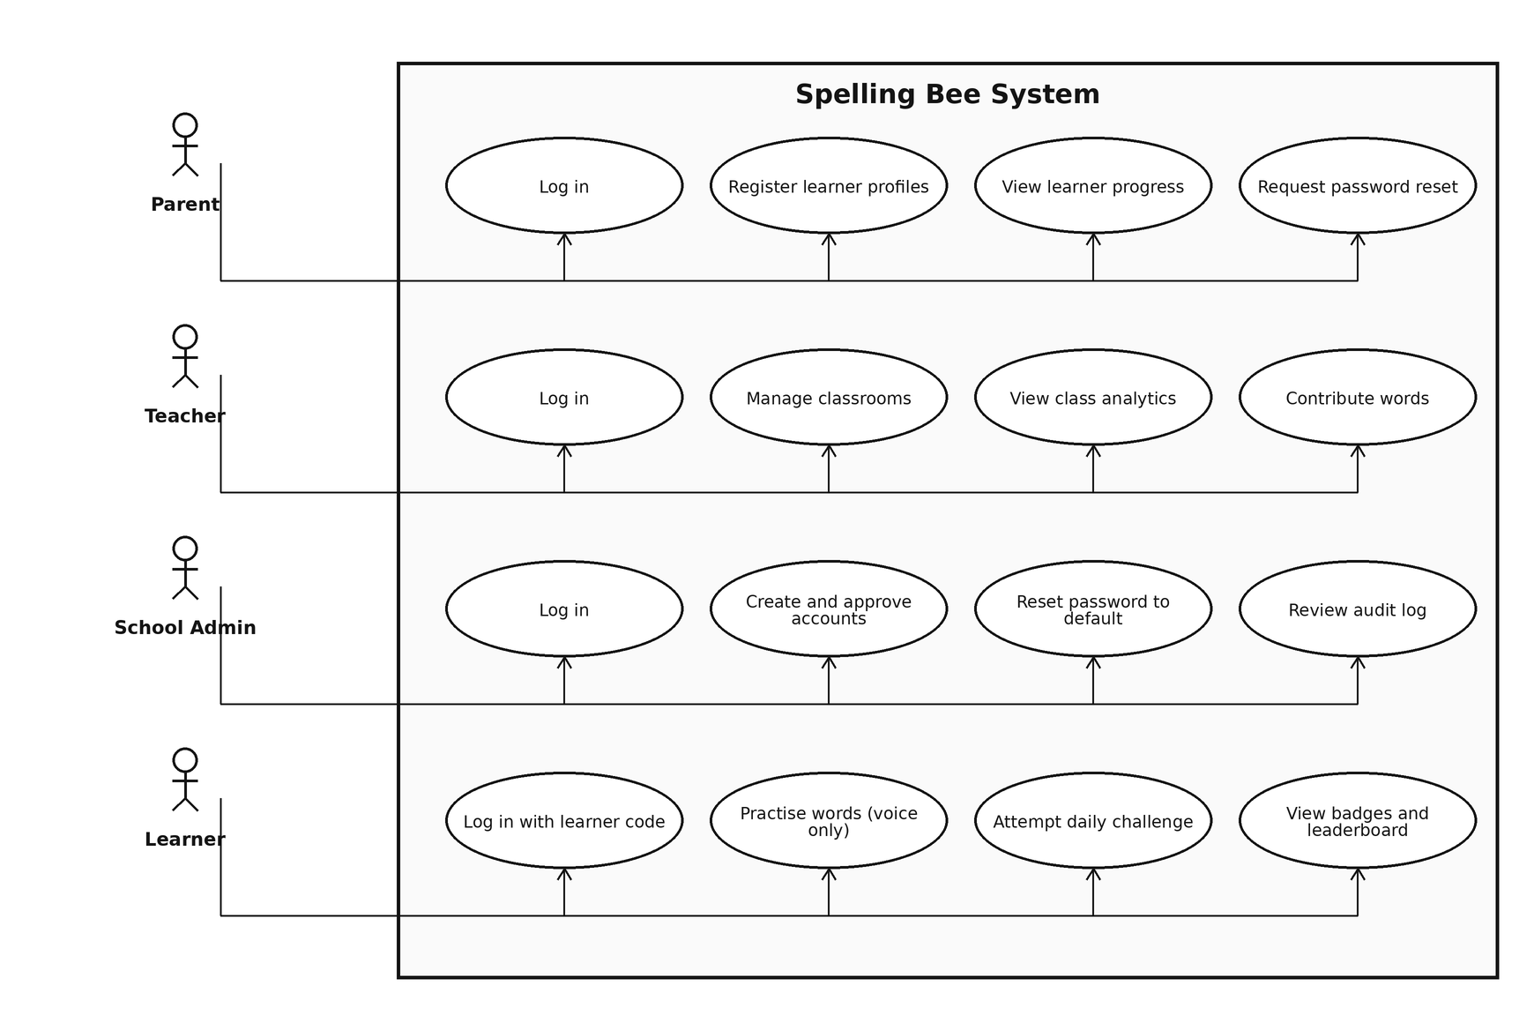
Figure 3.2: Use-case diagram of the Spelling Bee system.

3.10 Database Design
The data model is defined in a single Prisma schema and deployed as one clean migration. It contains twelve related tables covering accounts, learners, words, progress, badges, classrooms, preferences, the daily challenge, audit logs and practice sessions. The schema generated from the hosted database is shown in Figure 3.3, and the main tables are summarised in Table 3.5.
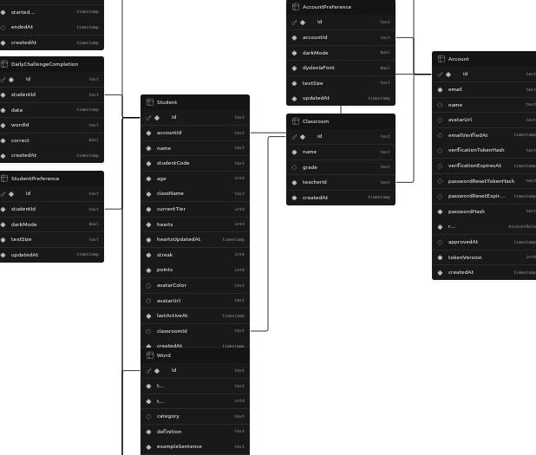
Figure 3.3: Database schema of the project (generated from Supabase).
Table 3.5: Main Database Tables
Table | Stores | Key Fields / Relations
Account | Logins for parents, teachers and administrators | email (unique), passwordHash, role, tokenVersion
Student | A child profile that plays the game | studentCode (unique), currentTier, hearts, streak, points, className
Word | The school-wide word bank (tiers 1–6) | text, tier, category, definition, exampleSentence
Progress | Every stored spelling attempt | correct, attempts, -> Student, -> Word
Badge | Achievement definitions and rules | name, criteria (e.g. streak:7)
StudentBadge | Badges a learner has earned | unique (studentId, badgeId)
Classroom | Classes managed by a teacher | name, grade, teacherId
DailyChallengeCompletion | One attempt per learner per day | unique (studentId, date)
PracticeSession | Time learners spend practising | source, durationSeconds, startedAt, endedAt
AuditLog | Administrative actions trail | accountId, action, target, metadata
StudentPreference / AccountPreference | Personalisation and accessibility settings | darkMode, textSize, dyslexiaFont

3.11 Activity Diagram of a Practice Round
Figure 3.4 expands the core loop into an activity diagram. The two decision points are the ones that matter operationally: whether the learner still has hearts (an empty stock refuses the round with HTTP 423 rather than corrupting state), and whether the submitted spelling was correct (which selects between awarding points and spending a heart). The loop back to the spoken prompt shows that a round repeats word by word until the words are exhausted.
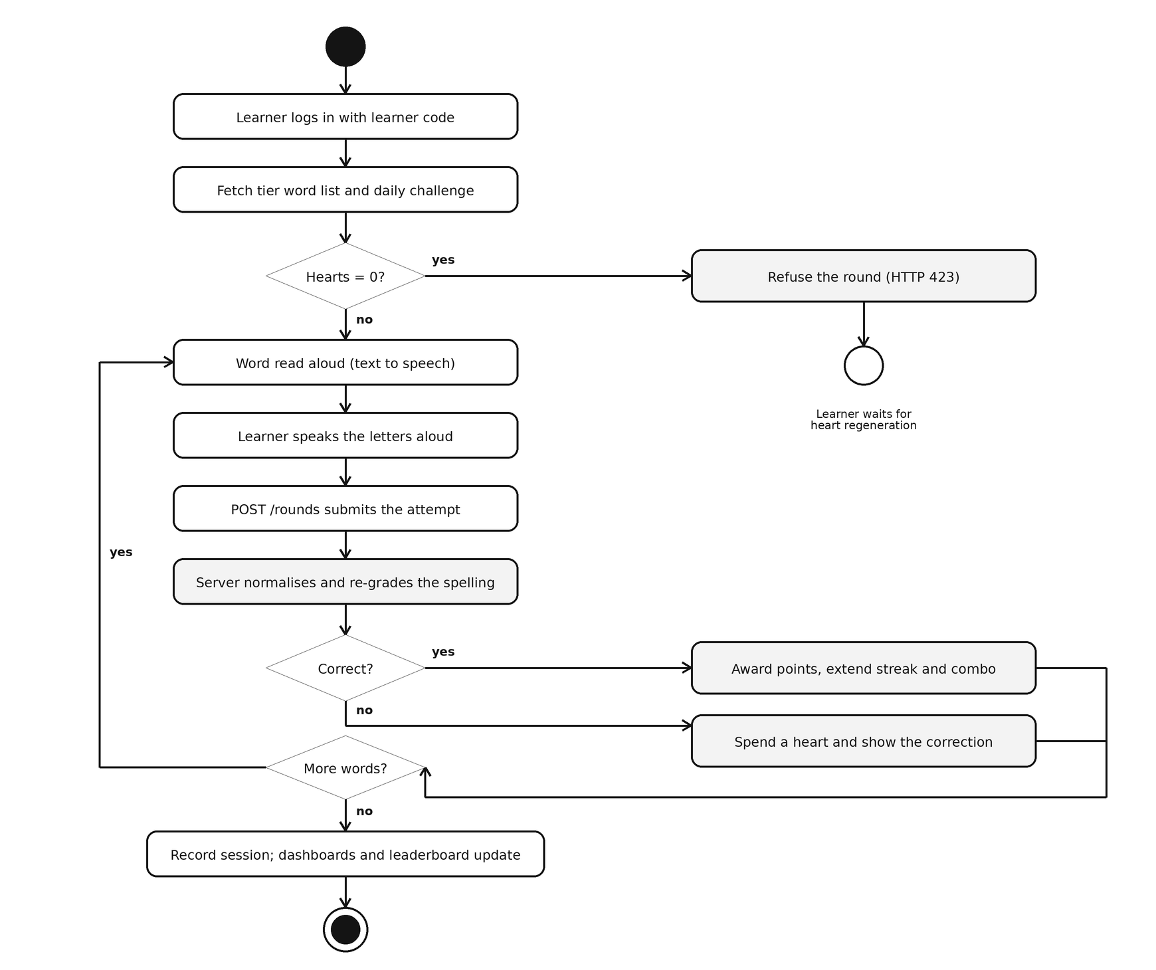
Figure 3.4: Activity diagram of a practice round.

3.12 Sequence Diagram of a Spoken Round
Figure 3.5 traces one round submission across the participants. The important properties visible in the diagram are that recognition happens in the browser before any network call, that the API verifies the token, role, ownership and rate limit before touching data, and that the database is read with a row lock so that the grade, the combo and the hearts are updated as one atomic step. The reply carries the new points, streak, hearts, tier and badges, which is what the result screen renders.
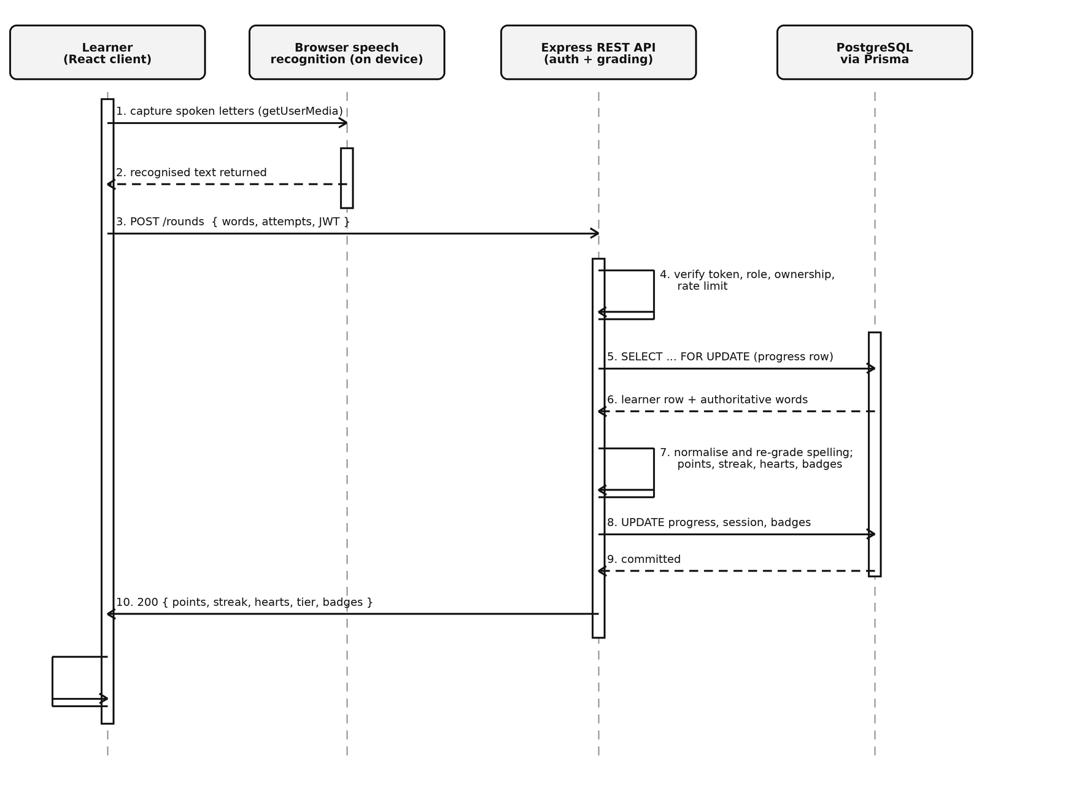
Figure 3.5: Sequence diagram of a spoken round submission.

3.13 Input and Output Design
Input and output design decides what the user supplies at each screen and what the system returns. The design keeps every input explicit and every output actionable: errors name the reason, and success states show the number that changed (points earned, hearts left, rows imported). Table 3.6 summarises the mapping.
Table 3.6: Input and Output Design
Screen or interface | Inputs | Outputs and feedback
Login | Email and password, or learner code | Role-appropriate landing page, or a specific 401/403 error
Forgot password | Email of the locked-out account | Confirmation that an administrator has been notified in-app; no e-mail is sent
Administrator reset | Selected account, two-step confirmation | A default password displayed once for out-of-band sharing; sessions revoked
Settings — change password | Current password and new password | 400 with a clear message if the current password is wrong; a fresh session token on success
Practice round | Spoken letters captured by browser speech recognition | Spoken prompt, per-word result, points earned, hearts remaining, tier and badge changes
Daily challenge | One spoken submission per day | Word of the day, +50 bonus on success, 409 on a second attempt
Parent dashboard | Learner selection | Points, streak, badges, hours practised and recent activity for that learner
Teacher portal | Class and word selections | Class leaderboard, per-learner progress, word-bank contribution tools
Administrator accounts | Search, filters, account form | Pending-reset badge, two-step confirmation, default password display
Word bank manager | Word fields, CSV file | Rows added and skipped, delete-protection messages when progress exists

3.14 Algorithm Design: Normalisation, Grading and Adaptive Difficulty
The grading algorithm is deliberately small enough to audit by eye, because a child must be able to trust it and a marker must be able to verify it. It has four stages: normalisation of both strings, exact comparison, gamification updates under caps, and an adaptive-difficulty check. The pseudocode below mirrors the implementation in the round controller (the client-side mirror of the same rules is unit-tested against it):
grade_round(learner, word, attempt, source):
normalise(s) = lower-case(s), strip punctuation, collapse whitespace
correct = normalise(attempt) == normalise(word.text)
# any 'claimed correct' flag sent by the browser is ignored

# 1. lazy heart regeneration, then the lock check
learner.hearts = min(5, hearts + floor(minutes_elapsed / 15))
if learner.hearts == 0 and source == PRACTICE:
return 423 Locked # the daily challenge is never heart-blocked

# 2. scoring, server-authoritative and capped
if correct:
multiplier = 1 + min(round_combo, 10) * 0.1
earned = round(word.tier * 10 * multiplier)
points = min(points + earned, 2000) # per-round ceiling
round_combo = min(round_combo + 1, 50) # stored combo cap
else:
round_combo = 0
if source == PRACTICE: learner.hearts -= 1

# 3. adaptive difficulty — advance after a strong round in this tier
if played_tier == learner.tier
and every(word.tier == played_tier) # no farming easier words
and round_words >= 5
and correct_words / round_words >= 0.80
and learner.tier < 6:
learner.tier += 1

# 4. badges are re-evaluated from the rules stored in the Badge table
evaluate_badges(learner)
return { points, round_combo, hearts, tier, badges }
Three properties of this design deserve comment. First, exact comparison after normalisation is chosen over fuzzy or edit-distance scoring so that credit can never be granted to a wrong spelling; the trade-off is that partial letter feedback is unavailable, which is acknowledged in the recommendations. Second, every accumulation is capped — hearts at five, the stored combo at 50, the per-round total at 2,000 — so a tampered or buggy client cannot mint unlimited progress even if it bypasses the interface. Third, the adaptive-difficulty rule requires that every word in the round belongs to the tier being claimed; without that condition a learner could farm easy first-tier words while claiming a higher tier and advance without ever playing it.
The daily challenge uses the same grading path with two differences: the word is selected deterministically from the date so that every learner in the school attempts the same word and the client cannot re-roll it, and an empty heart stock never blocks it, because a once-a-day reward should not depend on regeneration timing. Completion is idempotent per learner per day, and a second attempt is refused with HTTP 409.

3.15 Data Description: The Word Bank Dataset
The system's dataset is a curated word bank rather than a scraped corpus. It was assembled during the attachment to match vocabulary an early-grade learner in a Ghanaian basic school is likely to meet, and it is seeded with 43 words distributed across the six difficulty tiers (5, 5, 5, 10, 10 and 8 words respectively) and ten categories — Adventure, People, Animals, Feelings, Nature, School, Adjectives, Life Skills, Fruit and Science. Each row carries the word text, its tier, its category, a definition, an example sentence and a hint used by the hint endpoint, which together give the feedback layer material to work with without exposing the answer.
Words are stored in their canonical form and normalised only at grading time, so the stored data stays readable while comparison stays forgiving of punctuation and spacing. Ingestion happens through the administrator or teacher interface, either word by word or in bulk from a CSV file, with per-row reporting of what was added and what was skipped, unique constraints preventing duplicates, optional dictionary enrichment that degrades to generated definitions when the external service is unavailable, and protection against deleting a word that already has learner progress attached. Seven badge definitions are seeded alongside the words and, like the words, are data rather than code, so the school can extend them without a developer.

3.16 Security Design
The following security measures were designed into the system from the outset:
- Passwords are hashed with bcrypt (cost 12); emails are stored lower-case and unique.
- Sessions use signed JWTs that are verified against a server-side token version, so passwords can be changed or all sessions revoked instantly.
- Role middleware restricts operations: only administrators manage accounts, only teachers and administrators manage the word bank, and classrooms are teacher/admin-only.
- Ownership middleware ensures a parent can only touch their own students; a student-code session can only see that single learner.
- Client-supplied correctness is ignored — every round is re-graded on the server from the learner's actual spelling.
- Row Level Security is enabled on the Supabase public schema, and the Prisma migration ledger is RLS-locked with all grants revoked from anon/authenticated roles.
- Rate limiting protects login, password-reset requests, gameplay and word-import endpoints; a strict Content-Security-Policy, CORS allow-list and a no-sniff/clickjacking header set are applied.
- Administrative actions are written to an audit log for accountability.
- Forgotten passwords never leave the platform: the locked-out user raises an in-app request, the administrator resets that account to a default password, the pending flag is cleared, and every live session for the account is revoked; the owner then changes the password from their dashboard, which revokes sessions again. The flow is shown in Section 4.5 and documented step by step in Appendix B.

3.17 Validation and Testing Plan
Three levels of verification were designed into the development process. First, an automated API audit script was written to exercise end-to-end scenarios against a live database, covering authentication, students, word lists, the daily challenge, rounds, hints, badges, preferences, the leaderboard, classrooms, and admin word and account management. Second, the frontend was type-checked with the TypeScript compiler and put through a production build, and every backend module was syntax-checked. Third, the Prisma schema and database migration state were validated with the Prisma CLI, and the Supabase SQL editor was used to confirm delete-protection and redirect behaviour for signed-out members. The results of applying this testing methodology are presented in Chapter Four.
The plan therefore combines five complementary checks, each chosen because it catches a different class of defect. Unit tests — 174 of them over the scoring, formatting, CSV-import and voice-parsing utilities — run in under two seconds so they can run on every change. End-to-end API tests — 44 scenarios executed against a live server and database — cover happy paths, negative cases and every authorization boundary, including learner-only placement, closed self-registration, teacher approval, ownership refusal and the daily-challenge limit. Static checks cover linting, formatting and tsc --noEmit over the whole client. Build and schema checks produce a production bundle and validate the Prisma schema plus a clean migration and seed against a fresh database. Finally, a manual interface walkthrough documents each role's journey in screenshots. All but the last are automated and run in continuous integration on every push; Chapter Four reports the results.

3.18 Ethical Considerations
Although the project collects no research data from people, it is built for children, so ethical considerations shaped the design directly:
- Informed and controlled use. The system is deployed by the school for its own learners. Parents or guardians create learner profiles, and self-registration is closed, so no child can enter the system unnoticed by an adult.
- Data minimisation. Only a learner's name, age, class, codes and progress are stored. No audio is recorded, transmitted or stored: speech is recognised inside the browser and only the recognised letter sequence is submitted.
- Security of children's data. Passwords are hashed, sessions can be revoked instantly, role and ownership middleware confine every query, Row Level Security guards the hosted database, and administrative actions are audited.
- Fairness and wellbeing. Hearts cap how long a learner can practise in one sitting, leaderboards are scoped to the learner's own class rather than to an anonymous global pool, and adjustable text size, dark mode and a dyslexia-friendly font support learners who need them.
- Honest reporting. This report distinguishes software verification from claims about learning outcomes; it reports what was tested and explicitly states what was not, in line with the institution's submission requirements for the report.

CHAPTER FOUR: SYSTEM IMPLEMENTATION, TESTING AND RESULTS

4.1 Overview of the Implemented System
Following the architecture and design set out in Chapter Three, the system was implemented with the key features summarised in Table 4.1.
Table 4.1: Key Features of the Implemented System
Feature | Description | Who Uses It
Voice-only spelling | Words are read aloud; the learner speaks the answer. No typing input mode exists. | Students
Practice rounds | Points scale with tier and streak combo; incorrect answers cost a heart and reset the streak. | Students
Tier progression | Learning path from Tier 1 to Tier 6; a learner advances after 5+ words at 80% accuracy. | Students
Daily challenge | One deterministic word of the day for everyone, worth a +50 point bonus. | Students
Badges | Badges are evaluated automatically from real progress rules. | Students
Leaderboard | School-wide, class-aware points leaderboard. | Students, Parents
Parent dashboard | Create and track students; view progress, badges and hours spent. | Parents
Supervisor dashboard | Classrooms, learner tiers, analytics, and moderation of students. | Teachers, Admin
Word bank manager | Add, edit, delete words; dictionary lookup; bulk CSV import with concurrency limits. | Teachers, Admin
Account management | Create, approve, edit and delete parent/teacher accounts, and reset a forgotten password to a default value in-app. | Admin
Accessibility | Dark mode, text sizes and dyslexia-friendly font, persisted in preferences. | Everyone

4.2 Development Environment
The system was developed and verified on the environment summarised in Table 4.2. Nothing in the toolchain is exotic: a stock Node.js runtime, a text editor, a browser with microphone support and a local or hosted PostgreSQL instance are enough to reproduce the entire build, which matters for a project that a school or a successor student must be able to maintain.
Table 4.2: Development Environment
Component | Tool | Notes
Development host | Ubuntu Linux with Node.js 22 | Same runtime the API is deployed on
Editor and quality tooling | Visual Studio Code, ESLint, Prettier | Lint gate also runs in CI
Frontend toolchain | Vite 6, React 19, TypeScript 5.8, Tailwind CSS 4 | Dev server on port 3000; production build ≈1.1 MB
Backend framework | Express 4 with Prisma 7.9 | REST API; no /api prefix, health check at /health
Database | PostgreSQL 16 (local) and Supabase (hosted) | Migrations and seed executed with the Prisma CLI
Testing | Vitest and a Node end-to-end runner | 174 unit tests; 44 end-to-end scenarios
Version control and CI | Git, GitHub, GitHub Actions | Lint, type-check, build, migrate, seed, e2e on every push
Browsers and capture | Chrome/Edge (Web Speech API), 1440 × 900 captures | Microphone required for voice answering

4.3 Database Implementation
The data model was designed first in the Prisma schema and then deployed as migrations, so schema and code cannot drift: the API is typed against the schema, and the migration file is the record of what changed. The migration history includes the early audit fixes (renaming and dropping insecure or unused credential columns) and, most recently, the migration that removed the e-mail verification columns when account recovery moved in-app — evidence that the schema evolved with the requirements rather than being written once at the start.
Seeding is idempotent and runs as part of setup and of continuous integration: it loads the 43-word bank across six tiers, the seven badge definitions and a demonstration account, and it skips the demonstration account in production. Row Level Security remains enabled on the hosted database's public schema with the migration ledger locked, connections are pooled, and destructive operations are guarded — a word that already has learner progress cannot be deleted, which protects the history the dashboards display.

4.4 System Modules and Major Code Modules
The codebase is organised as a thin routing layer over controllers, with shared services for the state rules that must behave identically everywhere. Table 4.3 maps the modules to the files that implement them; the architecture in Section 3.8 and the algorithm in Section 3.14 are realised by the rounds, middleware and scoring rows.
Table 4.3: System Modules and the Code That Implements Them
Module | Main files | Responsibility
Authentication and sessions | backend/src/controllers/authController.js | Email/password and learner-code login, session tokens bound to a token version, change-password
Account administration | backend/src/controllers/adminAccountController.js | Create, approve, edit and delete accounts; reset a password to the default value; audit the action
Rounds and grading | backend/src/controllers/roundController.js | Row-locked re-grading of a round: points, combo, hearts, tier advancement, caps
Learner state | backend/src/services/studentStateService.js | Placement, tier rules, lazy heart regeneration, daily streak
Word bank | backend/src/controllers/adminWordController.js, backend/scripts/seedWords.js | CRUD, CSV import with per-row reporting, dictionary enrichment, delete protection
Classrooms and leaderboards | backend/src/controllers/classroomController.js, leaderboardController.js | Enrolment, class-scoped and school-wide rankings
Daily challenge | backend/src/controllers/dailyChallengeController.js | Deterministic word of the day, +50 bonus, one completion per day
Cross-cutting middleware | backend/src/middleware/*.js | JWT verification, rate limiting, role checks, learner-ownership checks
API surface | backend/src/routes/index.js | 41 endpoints, health check, SPA fallback to the built client
Client API layer | src/api/client.ts, src/context/AuthContext.tsx | Typed requests, automatic logout on 401, token refresh after password change
Practice and game screens | src/pages/*Practice*, *Round*, *Trail*, src/components/VoiceSpellingParser | Text-to-speech prompt, speech capture, result screen
Administration screens | src/pages/admin/* | Account list with pending-reset badge, two-step reset confirmation, word bank
Shared scoring utilities | src/utils/scoring.ts | Client mirror of the server rules, kept identical by unit tests

4.5 Interface Design and Screenshots
The interface follows two rules. First, every screen answers the question "what do I do next?" with a single primary action, which matters for early readers and for adults using the dashboard between other duties. Second, the same visual language is used across roles, so a parent, a teacher and an administrator learn the system once; only the navigation and the data change with the role. The screens below were captured from the running application at 1440 × 900.
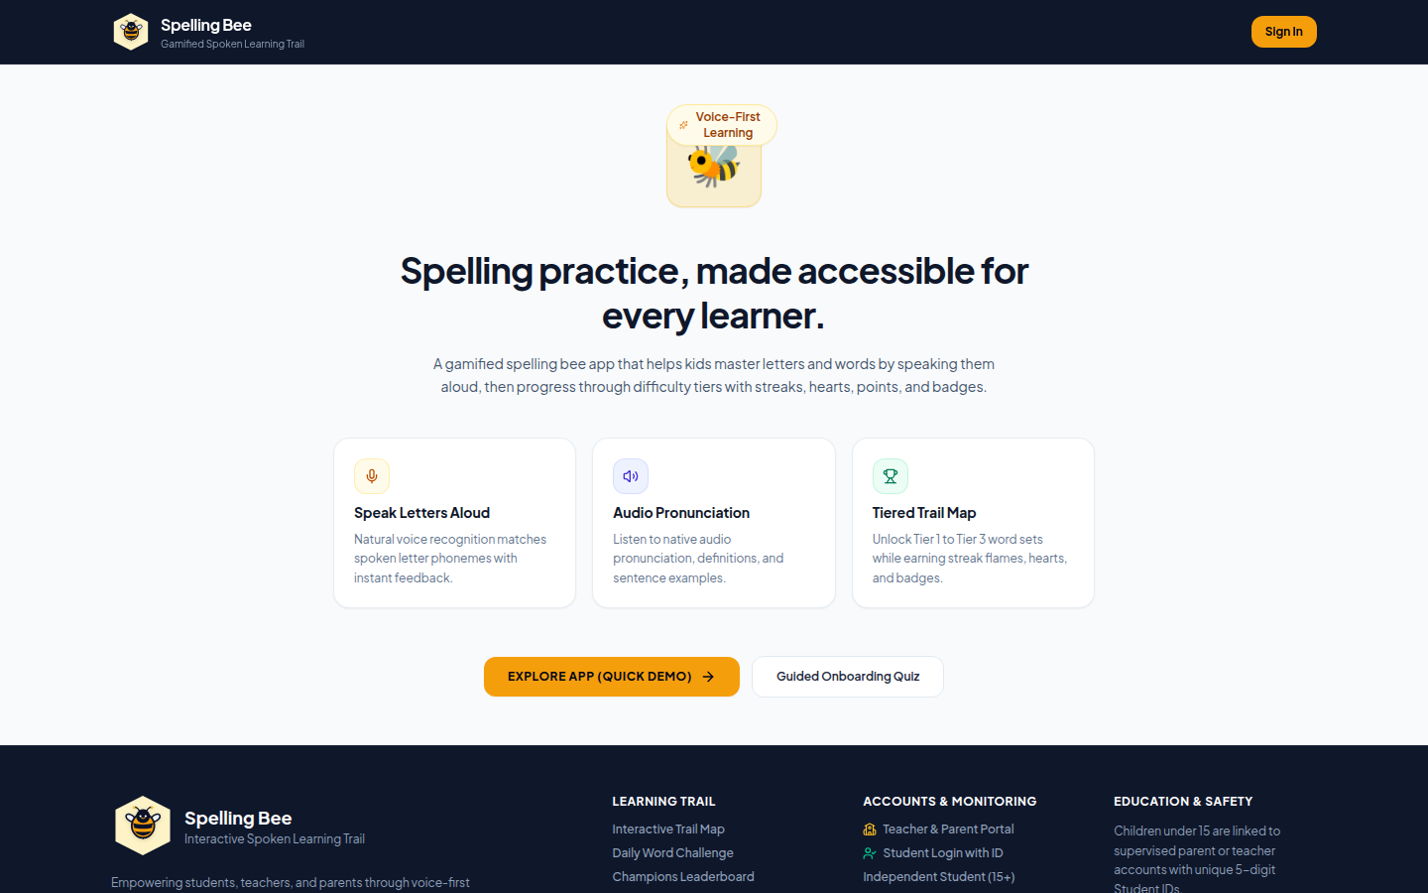
Figure 4.1: Landing page of the deployed application.
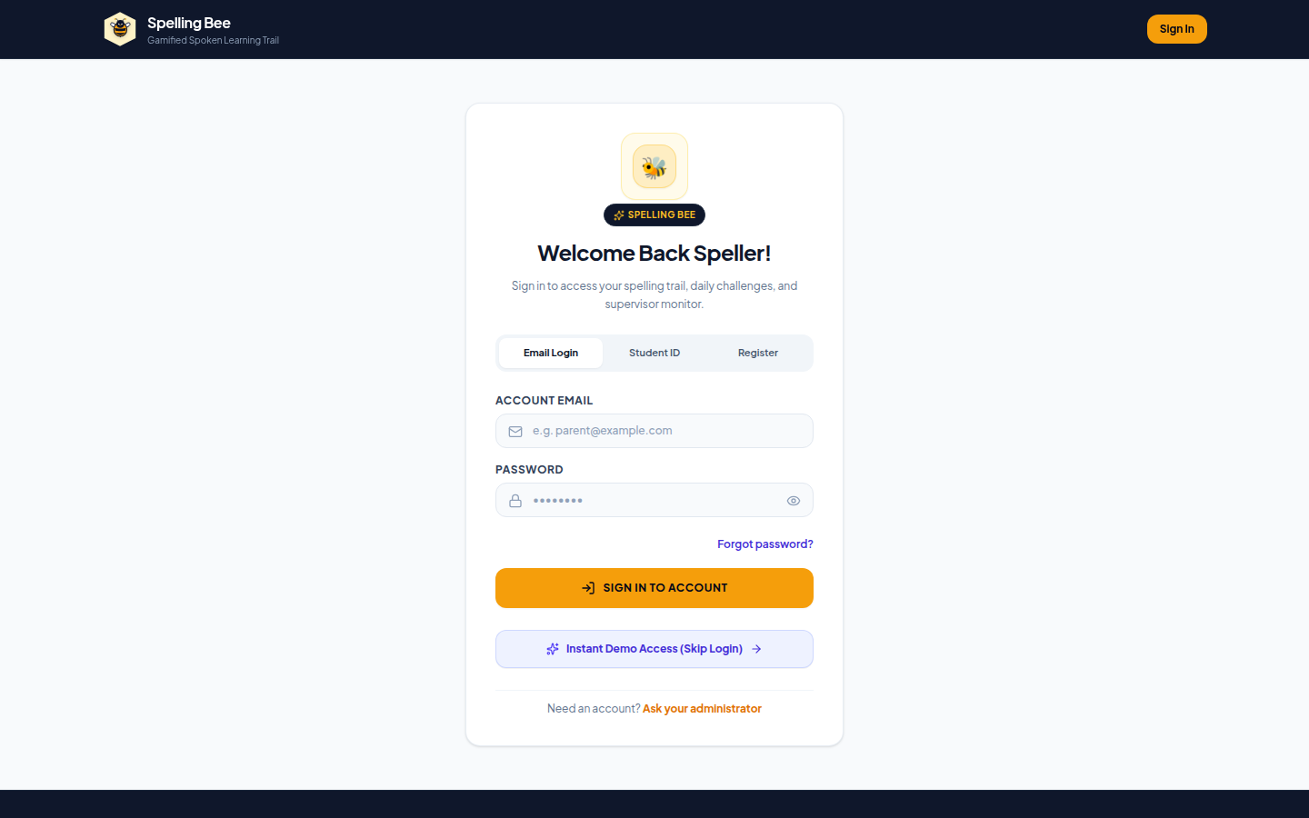
Figure 4.2: Login screen for parents, teachers and administrators.
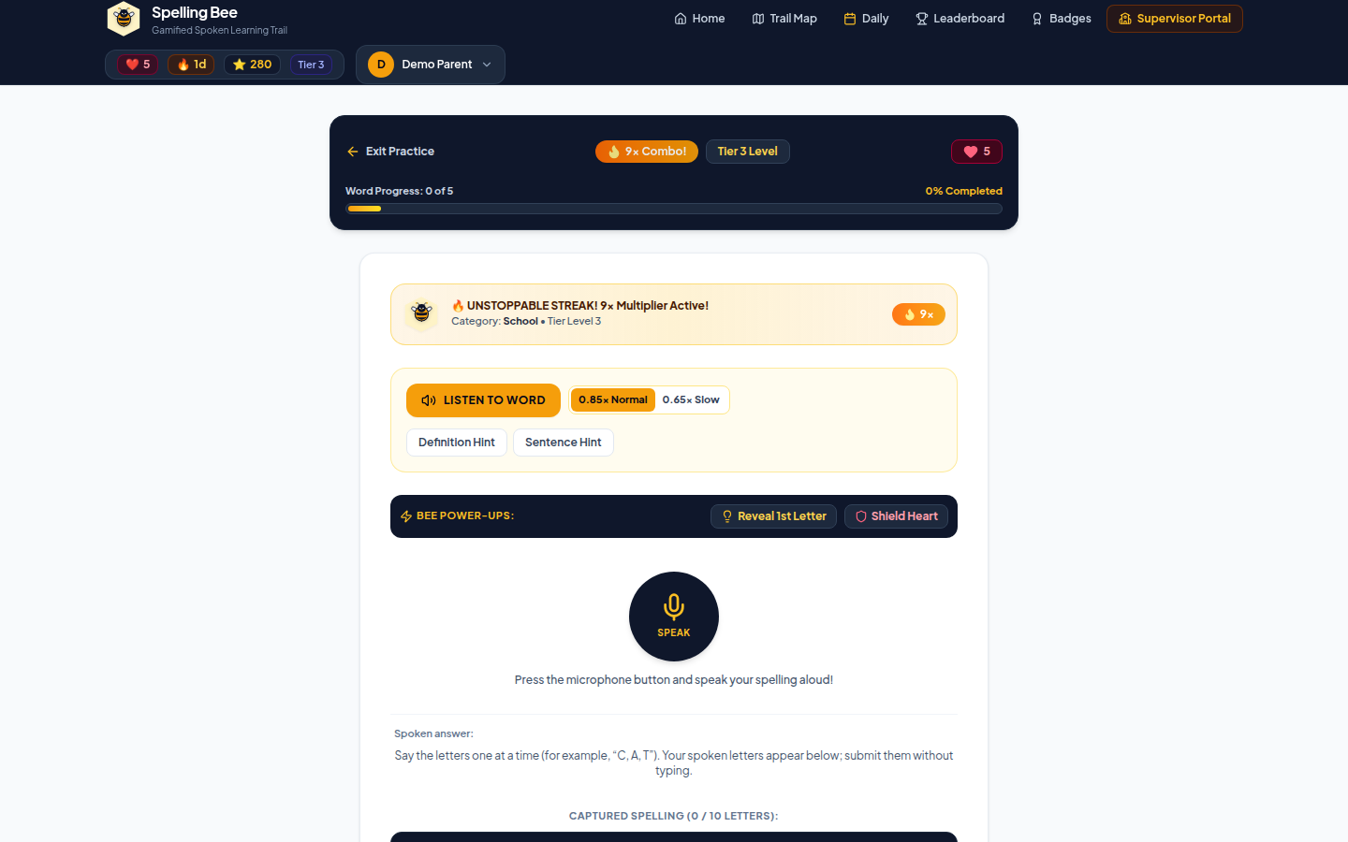
Figure 4.3: Practice round with the spoken prompt and voice-only answer.
The practice screen (Figure 4.3) is the heart of the product: the word is spoken by the browser, the learner answers aloud, and the feedback card reports the points, the hearts remaining and any badge earned, all values computed by the server. The dashboards that follow consume the same progress data, so a parent sees exactly what the learner's last round wrote.
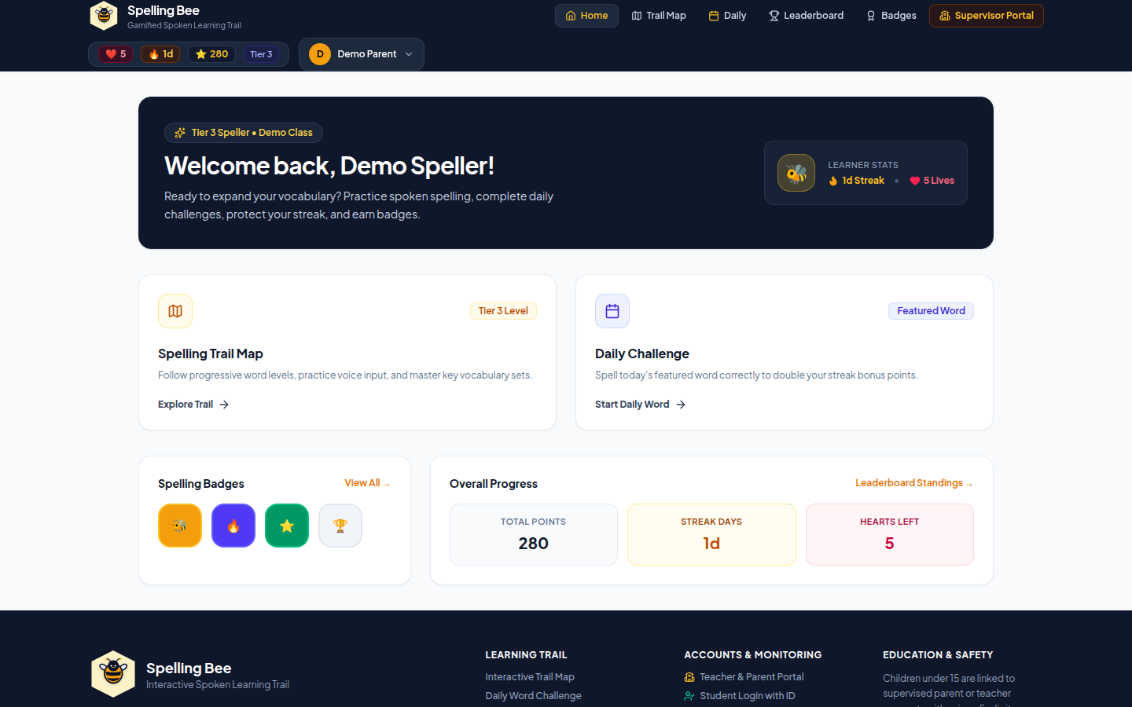
Figure 4.4: Parent dashboard showing learner progress.
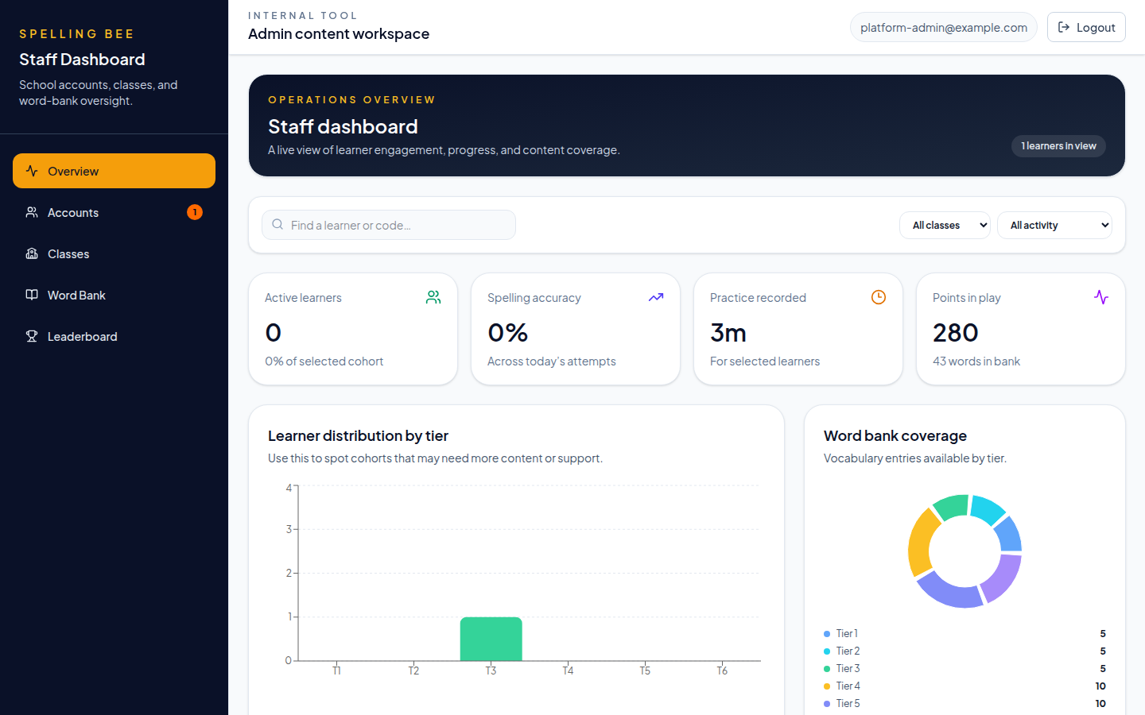
Figure 4.5: Administrator overview dashboard.
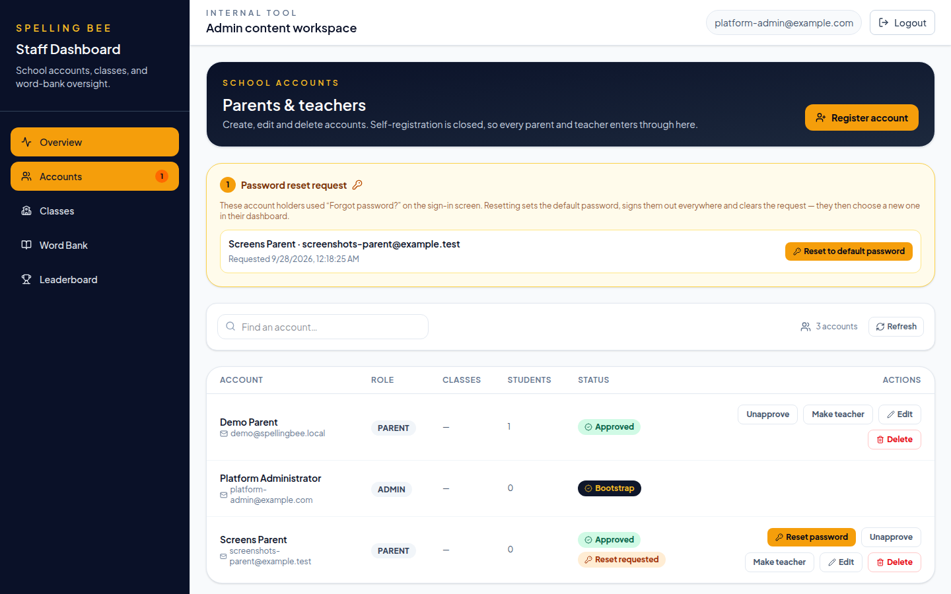
Figure 4.6: Administrator accounts screen with a pending password-reset request.
Figure 4.6 shows the in-app recovery flow that replaced e-mail verification and e-mail resets: the accounts screen raises a badge when a user has requested help, the administrator confirms the reset, the default password is displayed once to be passed on out of band, and the owner changes it from Settings after logging in. The remaining captures, including this flow step by step, are indexed in Appendix B.

4.6 System Workflow of a Practice Round
Figure 4.7 illustrates the flow of a practice round, which is the core loop through which the features in Table 4.1 come together. The learner logs in with their code, a word is spoken, the learner spells aloud, and the client submits the round. The API grades each spelling against the authoritative word bank, updates points, streak and hearts, checks for tier advancement, awards badges and records practice time before showing the result screen.
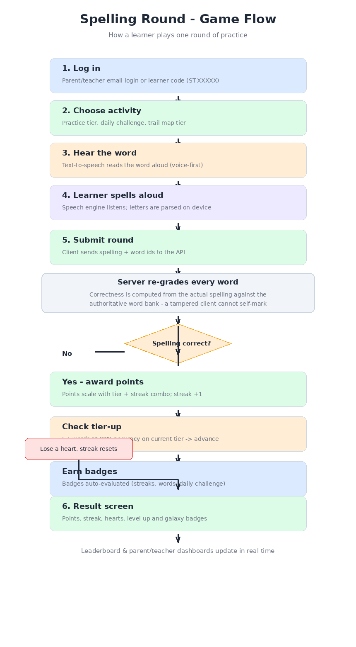
Figure 4.7: Flow of a practice round.

4.6.1 Example Walk-Through
- A parent logs in with email and password; the API returns their approved account and learner profiles.
- The learner enters the app with their unique code (e.g. ST-10001), or is selected by the parent.
- The app fetches the word list for the learner's current tier and a daily challenge word.
- After a round of spoken answers, POST /rounds grades each word server-side and replies with points, streak, hearts, tier changes and earned badges.
- The result screen and the leaderboard/dashboards update immediately.

4.7 Test Plan and Test Cases
The test cases in Table 4.4 are the representative subset of the verification suite; each is executed against a live API with a real database, not against mocks, so failures reflect what a deployment would actually do. The full list of 44 scenarios, including every authorization boundary, is given in Appendix A.
Table 4.4: Representative Test Cases and Their Results
Test case | Expected result | Result
Health endpoint requested | 200 with status ok | Pass
Self-registration attempted by a member of the public | 403 registrationClosed — accounts are created by the school | Pass
Platform administrator logs in | Token issued with the administrator role | Pass
Administrator creates and approves a parent account, who then logs in | Approved account is returned together with its learners | Pass
Parent creates a learner profile | Unique ST-XXXXX learner code is assigned | Pass
Placement quiz submitted twice | First run fixes the starting tier; the second returns 409 | Pass
Tier word list requested | Only words belonging to that tier are returned | Pass
Daily challenge fetched and completed | Deterministic word of the day; +50 bonus awarded | Pass
Daily challenge completed a second time the same day | 409 already completed | Pass
Correct spelling submitted in a round | Points, streak and combo updated by the server | Pass
Client claims an incorrect spelling as correct | Claim ignored — the server re-grades from the attempt | Pass
Unapproved teacher attempts login | 403 pending approval | Pass
Parent tries to claim a teacher's classroom | 403 role/ownership refusal | Pass
Word with learner progress deleted; untouched word deleted | 409 protected, then 204 deleted | Pass
Round submitted with an empty heart stock | 423 Locked with the regeneration message | Pass
Forgotten password handled end to end | Request flagged; administrator resets to the default; owner changes it in Settings | Pass

4.8 Testing Results
Table 4.5 presents the results of applying the testing methodology described in Section 3.17.
Table 4.5: Testing and Verification Results
Check | Tool | Result
End-to-end API scenarios | Node e2e runner (backend/scripts/e2eTest.js) | 44 / 44 passed
Frontend type check | tsc --noEmit (npm run typecheck) | No errors
Production frontend build | vite build | Built successfully (code-split chunks)
Backend syntax check | node --check (all files) | OK
Prisma schema / database | prisma migrate status + validate | Schema up to date, valid
Database delete-protection redirect | Supabase SQL editor | Passed — members-not-signed-out
Unit tests | Vitest (npm test) | 174 / 174 passed
Lint and format | ESLint + Prettier | Clean
Continuous integration | GitHub Actions (ci.yml) | Green on every push
The audit also confirmed the intended access-control boundaries: learner-only placement, closed self-registration (accounts are created by the school), and the requirement that teachers be approved by an administrator before first login.

4.9 System Performance Results
Performance was measured on a local development stack so that the numbers reflect the application rather than a particular hosting plan; Table 4.6 reports what was observed. The dominant cost in any protected request is password verification, which is intentionally expensive, while ordinary data reads stay in the tens of milliseconds.
Table 4.6: System Performance Results
Metric | Result | Notes
Unit test suite | 174 tests in ≈1.7 s | Fast enough to run on every save
End-to-end suite | 44 scenarios in ≈40 s | Live API and database, including setup and teardown
Production build | ≈1.1 MB of code-split assets | Served by Express with gzip compression
GET /health | ≈30 ms average | No database round trip; used by the deployment check
POST /auth/login | ≈0.6 s average | bcrypt cost 12 dominates and is a deliberate trade-off
Round submission | One locked transaction | Row lock serialises points, combo, hearts and tier updates
Database | 12 tables, pooled connections (size 10) | Prisma client with a driver adapter
Voice interaction | Recognition on the device | No audio uploaded; latency is browser- and hardware-dependent

4.10 Challenges Encountered and Solutions Applied
Table 4.7: Challenges Encountered and Solutions Applied
Challenge | Solution
Cheating-proof scoring (a client could self-mark words correct) | Correctness is re-graded server-side from the learner's spelling against the word bank; client flags are ignored.
Concurrent rounds could clobber points/streak | A row-level lock (SELECT ... FOR UPDATE) serialises gamification updates inside a transaction.
Voice data and privacy | Speech is recognised on the device; no audio is uploaded or stored by the server.
Tampered clients minting points | Per-round point ceilings and hard caps on total points and streak bound any damage.
Database exposed to PostgREST/anon roles on a hosted platform | Row Level Security was enabled and the migration ledger's grants were revoked from anon/authenticated.
External dictionary lookup may be offline during word import | Imports degrade gracefully to generated definitions so a school can always import.
Dev-Tunnel and LAN hosting misconfiguration | Vite host allow-list and a dev-origin CORS allow-list were added without weakening production rules.
Password recovery assumed e-mail the school does not manage | Replaced with an in-app flow: the user raises a request, the administrator resets to a default password, and the owner changes it in the dashboard

4.11 Evaluation and Discussion
Taken together, the results in Sections 4.1 to 4.10 show that the objectives set out in Chapter One were met at the level of a working, verified software system: a full-stack voice-based spelling application was built (Objective 1), gamification mechanics spanning tiers, streaks, hearts, points, badges and a daily challenge were implemented (Objective 2), role-specific dashboards were delivered for parents, teachers and administrators (Objective 3), the security measures listed in Section 3.16 were implemented and, where testable, verified (Objective 4), and the system was verified through automated endpoint testing, type-checking and a clean build (Objective 5).
Read against the theoretical framework in Section 2.6, the design decisions taken can be seen as a direct attempt to satisfy the three needs identified by Self-Determination Theory: the voice-only interaction supports autonomy in a way that a typing-based competitor could not for a learner who is not yet a confident typist; the tier, points, streak and badge mechanics supply the frequent, concrete feedback that Mohammed, Fatemah and Hassan (2024) found effective at raising cognitive and achievement motivation among primary-school learners; and the class-aware leaderboard supports relatedness by situating a learner's progress within their own classroom rather than an anonymous, school-wide pool.
It is important to be precise about what the testing in Section 4.8 does and does not demonstrate. The 44/44 passing end-to-end scenarios, the 174 passing unit tests, the clean type-check and build, and the database validation checks demonstrate that the system functions correctly and securely as specified — they are a verification of the software artefact, not a classroom efficacy trial. Whether the system produces measurable spelling-outcome improvements for real learners, in the way Raskind and Higgins (1999) demonstrated for speech-recognition-based writing instruction, is a separate question that would require a follow-up study with actual pupils over time; this is identified as a recommendation in Chapter Five rather than a claim made here. Similarly, Mohammed and Skerrit's (2022) finding on the importance of culturally-situated design when introducing speech-enabled tools to a new population of learners is a caution rather than a settled result for the present system: the underlying grading and gamification logic has been verified, but how well the specific word lists, phrasing and voice interaction land with Ghanaian basic-school learners in practice is best established once the system is piloted with real classrooms, which is also noted as future work.

CHAPTER FIVE: DISCUSSION, CONCLUSION AND RECOMMENDATIONS

5.1 Summary of Findings
This report has described the design, implementation and verification of Spelling Bee, a gamified, voice-only spelling-practice web application built during an industrial attachment at Ed Emporia Educational Services. The literature review in Chapter Two established that spelling difficulties are well documented in the Ghanaian context, that gamification has a demonstrated positive effect on learner motivation, and that speech-recognition technology has a track record of improving spelling and reading outcomes — while also showing that existing spelling applications remain predominantly typing-based. Chapter Three described a three-tier architecture, a twelve-table relational data model, and a security design covering password hashing, revocable sessions, role- and ownership-based access control, and Row Level Security. Chapter Four showed that the resulting system passed all 44 automated end-to-end test scenarios and all 174 unit tests, built and type-checked cleanly, and had its database schema and access-control boundaries validated, while also reporting measured performance figures and the eight practical challenges encountered during development with the solution applied to each.

5.2 Interpretation of Results
The results are best read as evidence about feasibility and correctness rather than about learning. They show that a voice-only answering mode can carry a complete spelling product: every round in the suite was graded by the server from the learner's actual spelling, the gamification state advanced under its caps, and the dashboards reflected the same numbers the learner saw — that is, the loop illustrated in Figure 2.1 and designed in Chapter Three works in practice rather than only on paper.
They also show that the security posture is not decorative. The scenarios that matter most are the refusals: closed self-registration, an unapproved teacher kept out, a parent unable to reach another parent's learner, a student session unable to create profiles, a daily challenge that cannot be collected twice, and a client verdict that the server simply ignores. Those results indicate that role and ownership checks are enforced at the boundary where requests enter, which is precisely where a school-facing application is most exposed.
Finally, the numbers clarify the costs. Login is the slowest common request at roughly 0.6 seconds because password hashing is intentionally expensive — a trade-off accepted for a system holding children's accounts — while data reads stay in the tens of milliseconds, so the dashboards remain responsive. The implication is that the design decisions taken in Sections 3.14 and 3.16 behave as intended under real measurement, and that the remaining uncertainty is not technical but empirical: whether learners actually spell better, which this report does not claim.

5.3 Achievement of the Objectives
Table 5.1 restates the objectives set out in Section 1.3, the evidence for each and its status. All five objectives were achieved at the level of a working, verified software artefact; the evaluation of learning outcomes remains outside their scope, as stated in the limitations (Section 1.7).
Table 5.1: Achievement of the Project Objectives
Objective | Evidence | Status
Build a complete, production-quality full-stack application for voice-based spelling practice | Deployed client and API; 15,690 lines of first-party code; production build served from the same host | Achieved
Motivate learners through gamification (tiers, streaks, hearts, points, badges, daily challenge) | All mechanics implemented and exercised by scenarios 10–18 of the end-to-end suite | Achieved
Give parents, teachers and administrators clear dashboards over progress, classrooms and the word bank | Role-specific screens (Figures 4.4 to 4.6) and class-scoped leaderboards verified by scenarios 23–31 | Achieved
Apply real-world security and data-protection practices | bcrypt, revocable sessions, role and ownership middleware, Row Level Security, rate limits and an audit log, each with a passing refusal scenario | Achieved
Verify the system through automated endpoint testing, type-checking and a clean build | 174/174 unit tests, 44/44 end-to-end scenarios, clean tsc, lint and build, all green in CI | Achieved

5.4 Comparison with Existing Systems
Table 5.2 compares the system with the typing-based applications reviewed in Section 2.5. The comparison is limited to capabilities that are documented publicly by those products and to features that could be verified in this project; it is a comparison of design intent, not a benchmark study, and it carries no claim that Spelling Bee teaches better than any commercial product.
Table 5.2: Comparison with Existing Typing-Based Spelling Applications
Capability | Spelling Bee | Comparable typing-based applications
Primary answering mode | Speaking the letters aloud; no typing mode in practice | Typing or tapping the letters
Grading authority | Re-graded on the server from the attempt; client verdict ignored | Commonly decided on the device
Roles in one system | Parent, teacher, administrator and learner in a single school | Learner-centric, with separate teacher tools if any
Classroom and word-bank management | Enrolment, class leaderboards, CSV word import with delete protection | Publisher-controlled word lists; limited school tooling
Account recovery | In-app administrator reset to a default password; no e-mail required | E-mail-based reset, which assumes household e-mail access
Daily challenge | Deterministic word of the day shared by the whole school, once per learner | Personalised learning path rather than a shared daily word
Accessibility | Dark mode, adjustable text size and a dyslexia-friendly font, persisted per account | Varies; often limited to sound or hint controls
Voice data | Recognised on the device; no audio uploaded or stored | No voice interaction, so the question does not arise

5.5 Advantages of the System
- It assesses the skill it claims to assess: a learner who cannot yet type can still demonstrate spelling knowledge by speaking, and the answer is graded by the server rather than by the browser.
- It needs no e-mail infrastructure or household e-mail addresses, so a school can run account recovery entirely through the administrator dashboard.
- It runs in an ordinary browser on existing hardware, with recognition performed on the device, which keeps both the bandwidth cost and the privacy exposure low.
- It is transparent to learners and to teachers: the scoring rules are small, capped and written down, the tier rule is explainable, and badges derive from recorded progress rather than from hidden probabilities.
- It is verifiable by construction — 174 unit tests and 44 end-to-end scenarios run in continuous integration — so a future change can be proven not to have broken the rules the school relies on.
- It is maintainable by a successor: one schema, layered controllers, seeded reference data and documented setup, with no proprietary services required beyond a PostgreSQL instance.

5.6 Challenges Encountered
The eight challenges met during development and the solution applied to each are recorded in Table 4.7. Two of them shaped the design more than the others. The first was making scoring cheat-resistant: because the client must show the result immediately, the temptation is to let the client decide correctness, and the fix was to make the server re-grade every round inside a locked transaction with explicit caps. The second was account recovery: an e-mail-based flow assumed infrastructure and household addresses the school does not have, and replacing it with an administrator-driven in-app reset changed both the schema and the administrator interface, which is why the migration in Section 4.3 exists.

5.7 Implications of the Study
For schools, the practical implication is that a spelling-practice tool does not require an IT department: accounts are created and approved by an administrator, recovery is handled in-app, and the word bank is maintained by teachers through the same interface they use for classrooms. Because the application is a single hosted web app, it also fits the device reality of most classrooms — an ordinary browser and a microphone.
For educational-technology practice in Ghana, the project demonstrates that a voice-first interaction pattern, which the literature associates with gains for struggling readers, can be implemented and operated without cloud speech services or per-seat licensing. For data protection, the design shows how children's accounts can be handled with minimal data, no stored audio, revocable sessions and an audit trail — a defensible baseline for any school deploying similar systems.

5.8 Contribution of the Project
The contribution is a working, documented and tested reference implementation of a single-school spelling platform: approximately 15,700 lines of first-party code across a typed React client and an Express API, a twelve-table relational schema, two automated test suites (174 unit tests and 44 end-to-end scenarios), a continuous-integration pipeline, a security audit note and this report. Beyond the artefact itself, the project contributes three reusable design decisions that other school-facing tools can adopt directly: server-side re-grading of client-submitted learner work, administrator-driven in-app password recovery that removes the e-mail dependency, and a capped, explainable gamification rule set whose client and server implementations are held identical by tests.

5.9 Conclusion
The Spelling Bee project demonstrates that a complete, secure and accessible full-stack product can be built around voice-only interaction, making spelling practice possible for learners who are not yet confident typists. The gamification design, grounded in Self-Determination Theory, gives children a structured reason to practise every day, and the three-tier architecture keeps client, server and database responsibilities clear. The security measures — from password hashing and session revocation to server-side grading and Row Level Security — make the system reasonably safe to run on a hosted database in a school setting. The verification results reported in Chapter Four give confidence that the application works end to end as designed, and the discussion in Section 4.11 has been careful to distinguish this software verification from a classroom efficacy claim.

5.10 Recommendations and Directions for Future Work
Building on the discussion in Section 4.11, the following recommendations are made for future work and for any organisation considering deploying or extending the system:
- Conduct a follow-up pilot study with real classrooms at Ed Emporia or a partner school to measure actual spelling-outcome gains over time, rather than relying on the software-verification results in Chapter Four alone.
- Extend the speech-recognition feature with live letter-by-letter feedback, so a learner can see or hear where a misspelling occurred rather than only whether the whole word was correct.
- Extend the system to support multiple schools and, in time, multiple languages, building on the culturally-situated design lesson noted in Section 2.4.
- Introduce class-specific daily challenges, so that a teacher can align the daily challenge word with what is currently being taught in a particular classroom.
- Develop richer teacher analytics, giving teachers more detailed visibility into which words or tiers a class is struggling with, to better target classroom instruction.
- Add letter-level feedback by comparing the recognised attempt with the target word only after grading, so that the learner can see where a misspelling occurred without weakening the exact-match rule that protects the assessment.

REFERENCES
Atatsi, E. A., & Amoakohene, B. (2019). An analysis of students' knowledge in spelling: A case of a Technical University in Ghana. Language, Discourse & Society, 6(1), 239–257.
Deci, E. L., & Ryan, R. M. (1985). Intrinsic motivation and self-determination in human behavior. Springer US.
Express.js. (n.d.). Express — fast, unopinionated, minimalist web framework for Node.js. https://expressjs.com
GitHub. (n.d.). GitHub Actions. https://docs.github.com/en/actions
MDN Web Docs. (n.d.). Web Speech API. https://developer.mozilla.org/en-US/docs/Web/API/Web_Speech_API
Mohammed, M., Fatemah, A., & Hassan, L. (2024). Effects of gamification on motivations of elementary school students: An action research field experiment. Simulation & Gaming, 55(4). https://doi.org/10.1177/10468781241237389
Mohammed, P., & Skerrit, P. (2022). The importance of culturally-situated design on children's interaction with speech-enabled features in an online spelling tutor. In HCI International 2022 – Late Breaking Papers (Lecture Notes in Computer Science). Springer. https://doi.org/10.1007/978-3-031-05434-1_7
OWASP Secure Headers Project. (n.d.). https://owasp.org/www-project-secure-headers
Prisma. (n.d.). Prisma ORM documentation. https://www.prisma.io
Raskind, M. H., & Higgins, E. L. (1999). Speaking to read: The effects of speech recognition technology on the reading and spelling performance of children with learning disabilities. Annals of Dyslexia, 49, 251–281. https://doi.org/10.1007/s11881-999-0026-9
React. (n.d.). React — the library for web and native user interfaces. https://react.dev
Supabase. (n.d.). Supabase documentation. https://supabase.com
Tailwind CSS. (n.d.). https://tailwindcss.com
TypeScript. (n.d.). https://www.typescriptlang.org
Vite. (n.d.). https://vite.dev

APPENDIX A: END-TO-END TEST CASES
Table A.1 lists every scenario executed by the verification suite against a live API and database, in execution order. All 44 scenarios passed; the numbering corresponds to the scenario numbers in backend/scripts/e2eTest.js, so any result in this report can be reproduced by running that suite.
Table A.1: End-to-End Test Scenarios and Results
No. | Scenario | Result
1 | health endpoint reports ok | Passed
2 | self-registration is closed (admin-created accounts only) | Passed
3 | platform admin login | Passed
4 | admin creates and approves a parent account | Passed
5 | parent login returns the account and its learners | Passed
6 | parent creates a learner with an ST-XXXXX code | Passed
7 | parent lists their learners | Passed
8 | a parent cannot run the placement quiz for the learner (403) | Passed
9 | student-code login is scoped to the learner and refresh keeps the scope | Passed
10 | learner placement sets a starting tier once (then 409) | Passed
11 | tier word lists return only that tier's words | Passed
12 | daily challenge returns today's deterministic word | Passed
13 | daily challenge completion is graded and awards the +50 bonus | Passed
14 | a learner can only complete the daily challenge once (409) | Passed
15 | completedToday is reported and the seeded tier-1 words exist | Passed
16 | a round with a correctly spelled word is graded and scores points | Passed
17 | a multi-word round extends the streak and triggers a badge rule | Passed
18 | the client's correct flag is ignored — the server re-grades the spelling | Passed
19 | a round referencing an unknown word is rejected (404) | Passed
20 | hint endpoint returns a hint from the word | Passed
21 | learner accessibility preferences persist | Passed
22 | account preferences and profile updates persist | Passed
23 | the parent leaderboard is scoped to their own learners | Passed
24 | admin creates and approves a second parent account | Passed
25 | admin creates, lists and assigns learners to classrooms | Passed
26 | admin creates a teacher account | Passed
27 | an un-approved teacher cannot log in (403) | Passed
28 | admin approves the teacher and assigns the classroom | Passed
29 | the approved teacher can log in | Passed
30 | teacher lists and creates own classrooms | Passed
31 | teacher sees the learners in their class | Passed
32 | admin creates and updates a word in the shared word bank | Passed
33 | dictionary lookup / import degrades gracefully when the service is unavailable | Passed
34 | CSV import returns per-row results (added / skipped) | Passed
35 | the admin word list contains the managed words | Passed
36 | a word with learner progress is protected (409) while an untouched word deletes (204) | Passed
37 | another parent cannot act on someone else's learner (403) | Passed
38 | password reset runs through the administrator in-app | Passed
39 | a student session cannot create profiles (403) | Passed
40 | a student session cannot edit its profile and its leaderboard stays scoped | Passed
41 | a parent cannot claim a teacher's classroom (403) | Passed
42 | a parent can enrol a learner in an admin-owned classroom (201) | Passed
43 | a learner at 0 hearts is locked out of practice rounds (423) | Passed
44 | hearts regenerate over time and GET /students reports the current value | Passed

APPENDIX B: SYSTEM SCREENSHOTS
Table B.1 indexes the screenshots captured from the running application at 1440 × 900. The captures cover every role and the complete password-recovery flow, and the three screens most often asked about are reproduced below the table.
Table B.1: Index of Captured System Screenshots
File | Screen | Primary user
01-landing.png | Landing page and product overview | Everyone
02-login.png | Login with email and password | Everyone
03-forgot-password-form.png | Forgot-password request form | Locked-out user
04-forgot-password-filled.png | Request form completed | Locked-out user
05-forgot-password-submitted.png | Request submitted confirmation | Locked-out user
06-admin-overview.png | Administrator overview dashboard | Administrator
07-admin-accounts-reset-request.png | Accounts screen with a pending reset request | Administrator
08-admin-reset-confirm-step.png | Two-step reset confirmation | Administrator
09-admin-reset-done.png | Reset completed, default password displayed | Administrator
10-settings-change-password.png | Settings change-password form | Account owner
11-settings-change-password-filled.png | Change-password form completed | Account owner
12-settings-password-updated.png | Password updated confirmation | Account owner
13-parent-dashboard.png | Parent dashboard with learner progress | Parent
14-learner-profiles.png | Learner profiles list | Parent, Teacher
15-trail-map.png | Practice trail map across tiers | Learner
16-leaderboard.png | Class-aware leaderboard | Everyone
17-badges.png | Badge collection | Learner
18-daily-challenge.png | Daily challenge screen | Learner
19-settings-parent.png | Settings with accessibility options | Account owner
20-supervisor-portal.png | Teacher / supervisor portal | Teacher, Administrator
21-practice-round.png | Practice round with spoken prompt | Learner
22-student-login.png | Learner code login | Learner
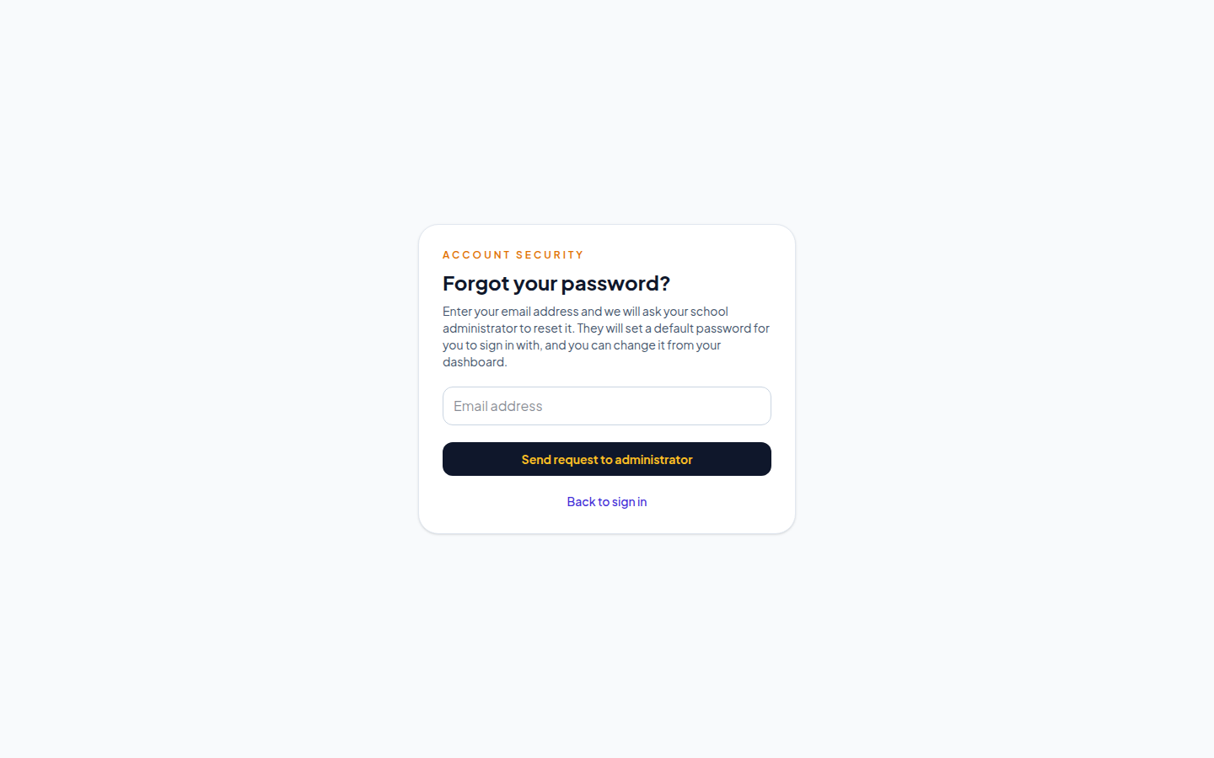
Figure B.1: Forgot-password request form as seen by a locked-out user.
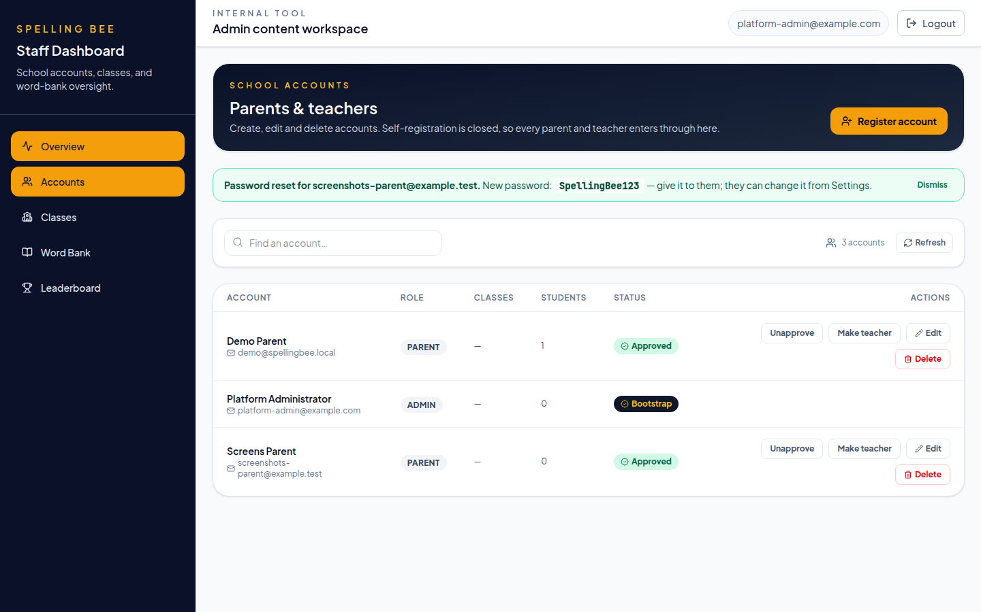
Figure B.2: Administrator reset confirmation showing the default password.
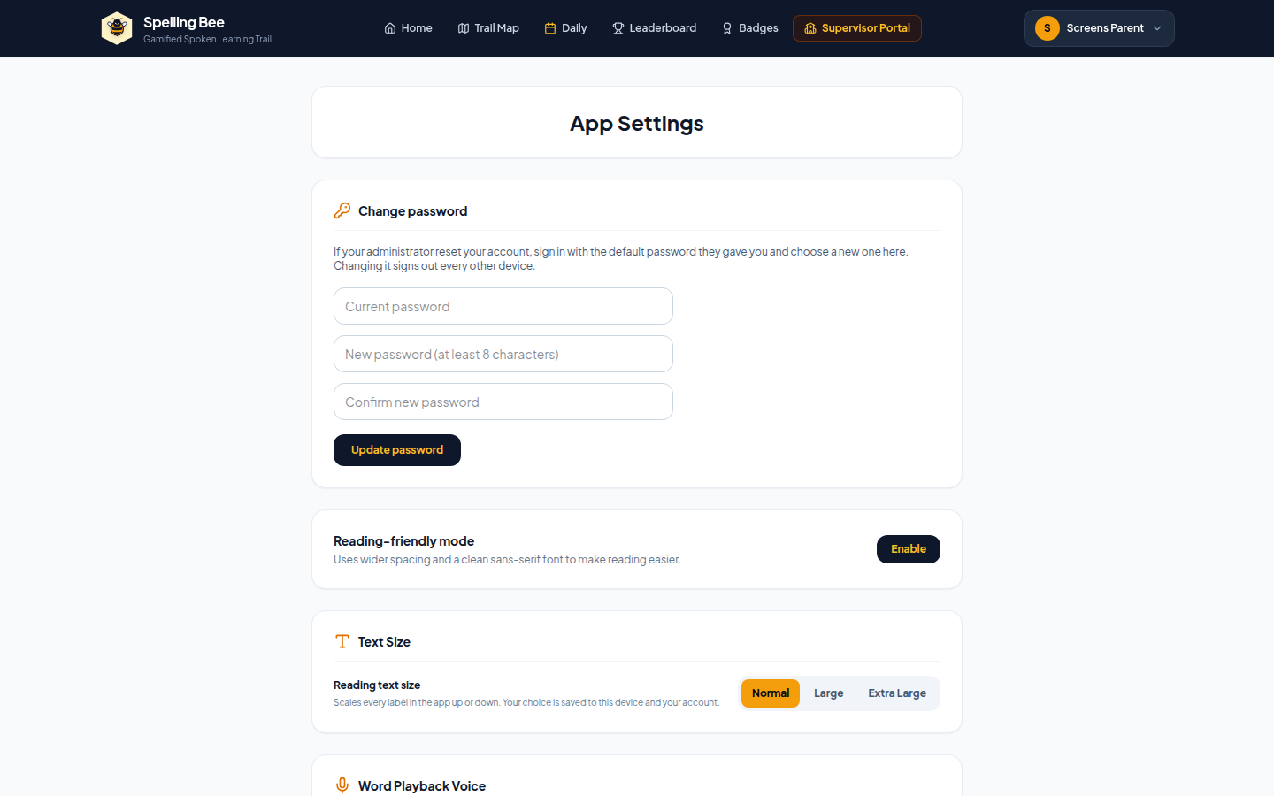
Figure B.3: Settings screen where the owner changes the default password.

APPENDIX C: USER MANUAL AND SYSTEM SETUP

C.1 Running the System
- Prerequisites: Node.js 22 or newer, PostgreSQL 16 (local) or a hosted Supabase project, Git, and a Chromium-based browser with microphone access for voice answering.
- Client: run npm ci, then npm run dev for the development server (port 3000), or npm run build to produce the static bundle served in production.
- Backend: run npm ci inside backend/, copy backend/.env.example to backend/.env and set DATABASE_URL, JWT_SECRET, PORT, PLATFORM_ADMIN_EMAIL, PLATFORM_ADMIN_PASSWORD and (optionally) DEFAULT_RESET_PASSWORD, then run npm run db:migrate in development or npm --prefix backend run prisma:deploy in production.
- Seed the database with npm --prefix backend run seed, then start the API with npm --prefix backend start; the health check is served at /health with no /api prefix.
- Verification: npm test runs the 174 unit tests, npm run typecheck and npm run lint run the static checks, and DATABASE_URL=... API_BASE_URL=... npm run test:e2e runs the 44 end-to-end scenarios. Continuous integration runs all of these on every push.

C.2 Using the Application
- Administrator: sign in with the platform-admin account, create and approve parent and teacher accounts, manage classrooms and the word bank, and handle password requests — the accounts screen raises a badge when a user asks for help; confirm the reset and pass the displayed default password to the user out of band.
- Parent: sign in with the approved email and password, create learner profiles (each receives a unique ST-XXXXX code), and follow points, streaks, badges and hours practised from the dashboard.
- Teacher: sign in once an administrator has approved the account, create and manage classrooms, enrol learners, follow class progress on the leaderboard, and add or import words for the week's lessons.
- Learner: sign in with the learner code, choose a trail map stage or the daily challenge, listen to the word and spell it aloud, then watch points, hearts and badges update on the result screen.
- Changing a password: open Settings, enter the current and new passwords, and save; the current sessions are refreshed so the user is not logged out of the screen they are on.

APPENDIX D: PROJECT SCHEDULE
The project was executed over eight weeks alongside the industrial attachment, with each phase ending in something demonstrable. Table D.1 records the plan that was followed.
Table D.1: Project Schedule
Phase | Activities | Deliverable
Week 1 — Inception | Problem framing, literature review, requirements conversations during the attachment | Chapters One and the requirements draft
Week 2 — Design | Architecture, data model, use-case, activity and sequence diagrams, algorithm design | Chapter Three design sections
Week 3 — Core build | Project scaffolding, REST API, authentication, roles and revocable sessions | Working login and role middleware
Week 4 — Learner loop | Learner profiles, placement, practice rounds, server-side grading | A playable round end to end
Week 5 — Engagement | Word bank and CSV import, classrooms, leaderboards, badges, daily challenge | Gamification and administration complete
Week 6 — Dashboards and recovery | Parent, teacher and administrator dashboards; account management; in-app password reset | Role screens and the recovery flow
Week 7 — Hardening | Rate limits, security headers, audit logging, unit and end-to-end suites, continuous integration | 174 unit tests and 44 scenarios green in CI
Week 8 — Reporting | Screenshots, performance measurements, report writing and appendices | This report

APPENDIX E: INTERVIEW PROMPTS USED IN REQUIREMENTS GATHERING
Requirements were gathered through informal semi-structured conversations rather than a formal questionnaire (Section 3.1). The prompts below were used to keep those conversations consistent; no learner or personal data was recorded from them.
- How is spelling taught and marked today, and how long does marking take?
- Which words do learners most often get wrong, and why do you think that is?
- What devices and browsers do learners actually have access to at school and at home?
- Is there a reachable e-mail address for every family, or would account problems have to be solved by the school itself?
- What would you want to see on a parent dashboard to know your child is making progress?
- How is effort rewarded today — would points, badges and a class board fit the way you already teach?
- What data would you be comfortable the school holding about a child, and what should never be stored?

