🔀
Ingress — Lab
Path-based Routing · Host-based Routing · PathType
⏱ 50 minutes 📊 100 points 📋 6 tasks 🎯 CKA Level
Lab Rules
✓ Enable Ingress Controller before starting — minikube addons enable ingress
✓ Apply 01-deployments-and-services.yaml first — it creates all backend apps
✓ Use curl --resolve to test without modifying /etc/hosts
✓ Verify every rule — test ALL paths/hosts in each task

🚀 Part 1 — Setup & First Ingress | 20 pts

1 | Enable Ingress Controller & Deploy Backend Apps | Easy ⭐

Before creating any Ingress, you need an Ingress Controller running and 3 backend apps deployed.

📌 Note: On minikube, the Ingress Controller is available as an addon. On other clusters, it must be installed separately.

Requirements:
a | Enable the Ingress Controller:

minikube addons enable ingress

b | Wait until the controller pod is Running:

kubectl get pods -n ingress-nginx

c | Verify the IngressClass exists:

kubectl get ingressclass

d | Apply the 3 backend apps + ClusterIP Services:

kubectl apply -f 01-deployments-and-services.yaml

e | Confirm all 3 deployments and 3 services are ready:

kubectl get deploy,svc

✅ Verify with:
kubectl get pods -n ingress-nginx
kubectl get ingressclass
kubectl get deploy,svc

✍️ What is the name of the IngressClass? The name of the IngressClass is nginx.

Why are the backend Services ClusterIP and not NodePort? Because NoadPort for external communication outside cluster and this is the Ingress Controller role. It handles external traffic and routes it internally, so the backend services only need ClusterIP for internal communication inside the cluster.

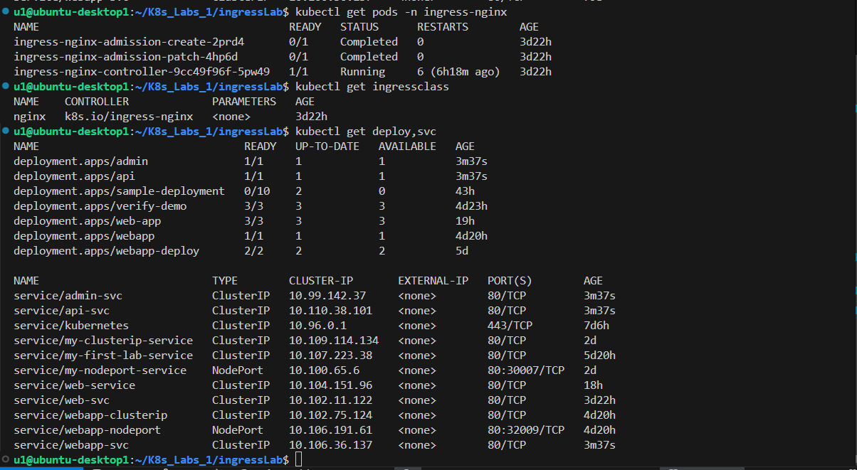
🔀 Part 2 — Path-based Routing | 40 pts

2 | Create a Path-based Ingress | Easy ⭐

Create an Ingress that routes traffic to 2 services based on the URL path — both under the same domain.

Field | Value
File to apply | 02-ingress-basic-path.yaml
Ingress Name | basic-ingress
Host | myapp.local
Path / | → webapp-svc:80 (Prefix)
Path /api | → api-svc:80 (Prefix)
ingressClassName | nginx

💡 Hint:
After applying, get the Ingress ADDRESS (Controller IP) with:
kubectl get ingress

Test with curl --resolve to fake DNS — no /etc/hosts change needed:
curl --resolve "myapp.local:80:<ADDRESS>" http://myapp.local/
curl --resolve "myapp.local:80:<ADDRESS>" http://myapp.local/api

Requirements:
a | Apply 02-ingress-basic-path.yaml

b | Run kubectl get ingress and note the ADDRESS (Controller IP)

c | Run kubectl describe ingress basic-ingress — show the routing rules table

d | Test path / — confirm you reach webapp-svc

curl --resolve "myapp.local:80:<ADDRESS>" http://myapp.local/

e | Test path /api — confirm you reach api-svc

curl --resolve "myapp.local:80:<ADDRESS>" http://myapp.local/api

f | Explain: why does one Ingress replace 2 NodePort Services here?

✅ Verify with:
kubectl get ingress
kubectl describe ingress basic-ingress
curl --resolve "myapp.local:80:<ADDRESS>" http://myapp.local/
curl --resolve "myapp.local:80:<ADDRESS>" http://myapp.local/api

✍️ ADDRESS from kubectl get ingress: 192.168.58.2

Why does one Ingress replace 2 NodePort Services? Because Ingress exposes a single entry point (IP/domain) and routes traffic internally to multiple services based on rules like path or host.

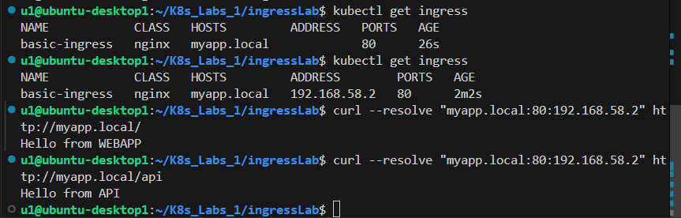

3 | Add a Third Route — /admin Path | Medium ⭐⭐

Apply the full lab Ingress that adds /admin routing to admin-svc alongside the existing routes.

Field | Value
File to apply | 06-ingress-full-lab.yaml
Ingress Name | lab-ingress
Path / | → webapp-svc:80 (Prefix)
Path /api | → api-svc:80 (Prefix)
Path /admin | → admin-svc:80 (Prefix)

Requirements:
a | Delete the previous ingress first: kubectl delete ingress basic-ingress

b | Apply 06-ingress-full-lab.yaml

c | Test all 3 paths — confirm each goes to the correct service

curl --resolve "myapp.local:80:<ADDRESS>" http://myapp.local/

curl --resolve "myapp.local:80:<ADDRESS>" http://myapp.local/api

curl --resolve "myapp.local:80:<ADDRESS>" http://myapp.local/admin

d | Test a path that has NO rule (e.g. /random) — what response do you get?

curl --resolve "myapp.local:80:<ADDRESS>" http://myapp.local/random

✅ Verify with:
kubectl describe ingress lab-ingress
curl --resolve "myapp.local:80:<ADDRESS>" http://myapp.local/admin
curl --resolve "myapp.local:80:<ADDRESS>" http://myapp.local/random

✍️ What response did /random return? /random returned Hello from WEBAPP. Because it didn’t find a specific rule to rout it to a defined path so it goes to prefix / (WEBAPP)

How many rules does the routing table show in kubectl describe? The routing table shows 3 path rules.

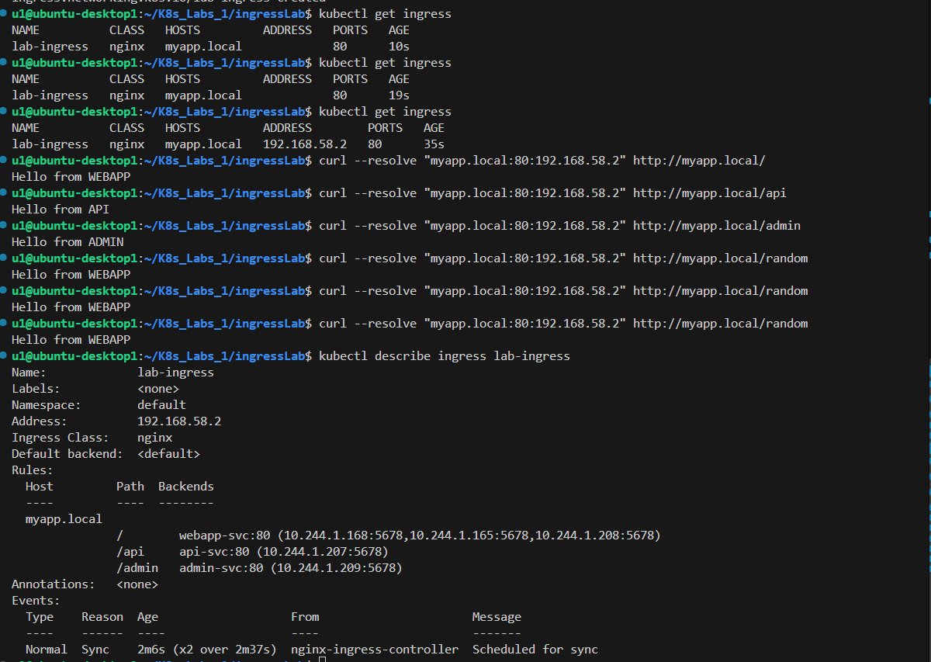
🌐 Part 3 — Host-based Routing & PathType | 40 pts

4 | Host-based Routing — 3 Subdomains | Medium ⭐⭐

Create an Ingress that routes 3 different subdomains to 3 different services — all through one Ingress object.

Field | Value
File to apply | 03-ingress-host-based.yaml
Ingress Name | host-ingress
myapp.local / | → webapp-svc
api.myapp.local / | → api-svc
admin.myapp.local / | → admin-svc

💡 Hint:
Test each subdomain with a separate --resolve flag:
curl --resolve "api.myapp.local:80:<ADDRESS>" http://api.myapp.local
curl --resolve "admin.myapp.local:80:<ADDRESS>" http://admin.myapp.local

Or add all 3 to /etc/hosts at once:
echo '<ADDRESS> myapp.local api.myapp.local admin.myapp.local' | sudo tee -a /etc/hosts

Requirements:
a | Delete lab-ingress first, then apply 03-ingress-host-based.yaml

b | Run kubectl describe ingress host-ingress — how many Host entries appear? 3

c | Test myapp.local — confirm webapp-svc responds

d | Test api.myapp.local — confirm api-svc responds

e | Test admin.myapp.local — confirm admin-svc responds

f | Try accessing with an unknown host (e.g. other.myapp.local) — what happens?

curl --resolve "other.myapp.local:80:<ADDRESS>" http://other.myapp.local

✅ Verify with:
kubectl describe ingress host-ingress
curl --resolve "myapp.local:80:<ADDRESS>" http://myapp.local
curl --resolve "api.myapp.local:80:<ADDRESS>" http://api.myapp.local
curl --resolve "admin.myapp.local:80:<ADDRESS>" http://admin.myapp.local

✍️ How many Host entries in describe output? There are 3 host entries.

What happened with the unknown host? The unknown host returned a 404 Not Found response.

Difference between path-based (Task 2) and host-based routing (this task):
Path-based routing uses different URL paths on the same host, while host-based routing uses different hostnames (domains) to route to services.

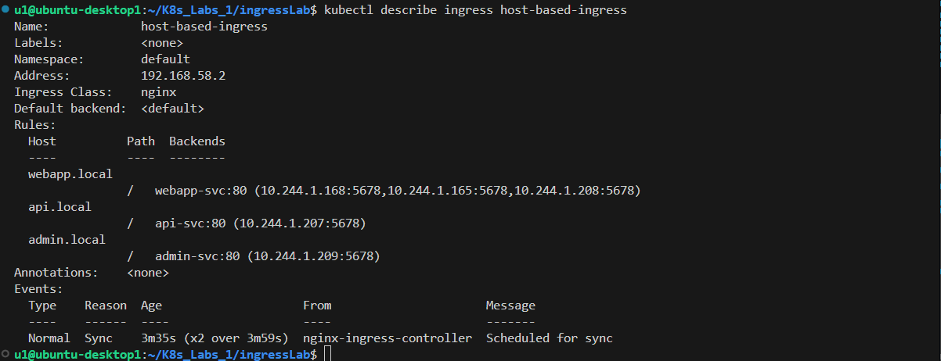

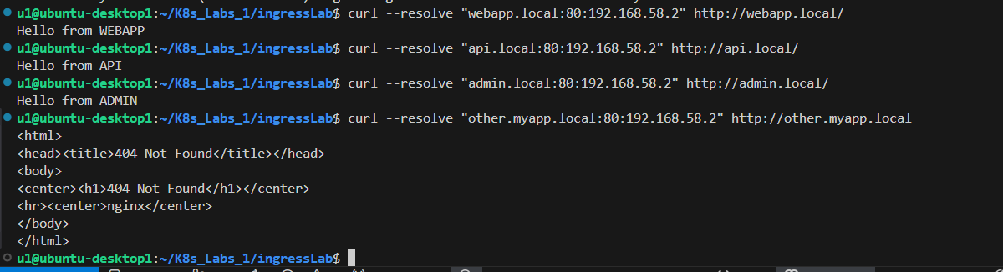

5 | PathType — Exact vs Prefix | Medium ⭐⭐

Apply the PathType demo Ingress and test both Prefix and Exact matching.

Field | Value
File to apply | 05-ingress-path-types.yaml
Ingress Name | pathtype-demo
/api (Prefix) | → api-svc (matches /api, /api/users, /api/v2)
/admin (Exact) | → admin-svc (ONLY matches /admin)
/ (Prefix) | → webapp-svc

Requirements:
a | Delete host-ingress first, then apply 05-ingress-path-types.yaml

b | Prefix test — test /api/users — does it reach api-svc? (Prefix should match)

curl --resolve "myapp.local:80:<ADDRESS>" http://myapp.local/api/users

c | Exact test — test exactly /admin — does it work?

curl --resolve "myapp.local:80:<ADDRESS>" http://myapp.local/admin

d | Exact fail test — test /admin/settings — should it work? What happens?

curl --resolve "myapp.local:80:<ADDRESS>" http://myapp.local/admin/settings

e | Explain: when would you use Exact instead of Prefix?

✅ Verify with:
curl --resolve "myapp.local:80:<ADDRESS>" http://myapp.local/api/users
curl --resolve "myapp.local:80:<ADDRESS>" http://myapp.local/admin
curl --resolve "myapp.local:80:<ADDRESS>" http://myapp.local/admin/settings

✍️ Did /api/users work? (yes/no)
Yes
Did /admin/settings work? (yes/no) — why?
No, because /admin uses pathType: Exact, so it only matches /admin exactly and not /admin/settings.

When would you use pathType: Exact?
You use Exact when you want the request to match only a specific path and not its subpaths.

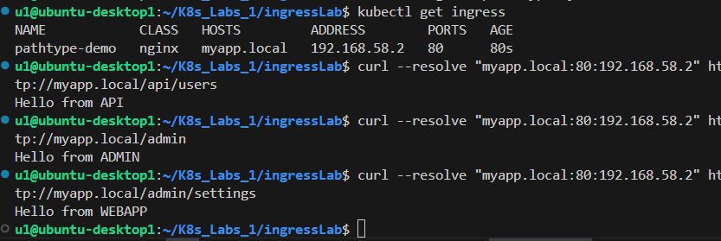

6 | Default Backend — Catch-all Route | Hard ⭐⭐⭐

Apply the Ingress with a defaultBackend and verify it catches all unmatched requests.

Field | Value
File to apply | 04-ingress-default-backend.yaml
Ingress Name | ingress-with-default
Path /api | → api-svc
Path /admin | → admin-svc
defaultBackend | → webapp-svc (catch-all)

Requirements:
a | Delete pathtype-demo first, then apply 04-ingress-default-backend.yaml

b | Test a defined path: /api — confirm api-svc responds

c | Test a defined path: /admin — confirm admin-svc responds

d | Test an unknown path: /anything — confirm defaultBackend (webapp-svc) responds

curl --resolve "myapp.local:80:<ADDRESS>" http://myapp.local/anything

e | Test with no path at all: http://myapp.local — which service responds?

f | Explain: what is the real-world use case for defaultBackend?

✅ Verify with:
curl --resolve "myapp.local:80:<ADDRESS>" http://myapp.local/api
curl --resolve "myapp.local:80:<ADDRESS>" http://myapp.local/anything
curl --resolve "myapp.local:80:<ADDRESS>" http://myapp.local
kubectl describe ingress ingress-with-default

✍️ Which service responded to /anything? webapp-svc

Which service responded to http://myapp.local (no path)? webapp-svc

Real-world use case for defaultBackend: It is used to handle unmatched requests by sending them to a fallback service, such as a default page, custom error page, or safe catch-all application.

