⚙️ ConfigMap & Secret — Lab Session 6 · CKA Level
ConfigMap & Secret — Lab
Env Vars · Volume Mounts · Combined Pattern
⏱ 50 minutes 📊 100 points 📋 7 tasks 🎯 CKA Level
Lab Rules
- Use kubectl and YAML files only
- Default namespace unless stated otherwise
- Apply the ConfigMap and Secret BEFORE creating any Pod
- Verify every task with kubectl exec or kubectl logs

⚙️ ConfigMap & Secret — Lab | Session 6 · CKA Level
🗂️ Part 1 — ConfigMap | 50 pts

1 | Create a ConfigMap — Imperative | Easy ⭐

Create a ConfigMap named app-config using the imperative method — no YAML file needed.

Field | Value
ConfigMap Name | app-config
Key 1 | APP_ENV = production
Key 2 | APP_PORT = 8080
Key 3 | APP_COLOR = blue
Key 4 | MAX_CONNECTIONS = 100

💡 Hint:
kubectl create configmap <name> --from-literal=KEY=value --from-literal=KEY2=value2 You can chain multiple --from-literal flags in one command.

Requirements:
a | Create the ConfigMap using | --from-literal | for all 4 keys

b | Run | kubectl describe configmap app-config | and confirm all 4 keys appear

c | Run | kubectl get configmap app-config -o yaml | — what does the output look like?

d | What is the difference between a ConfigMap and a regular variable you hardcode in a Pod?

✅ Verify with:
kubectl get configmap
kubectl describe configmap app-config kubectl get configmap app-config -o yaml

✍️ What is the difference between ConfigMap and a hardcoded variable?
A ConfigMap stores configuration separately from the application, allowing it to be updated without rebuilding or modifying the container image.

A hardcoded variable is defined directly inside the application or Pod configuration, making it less flexible and harder to change.

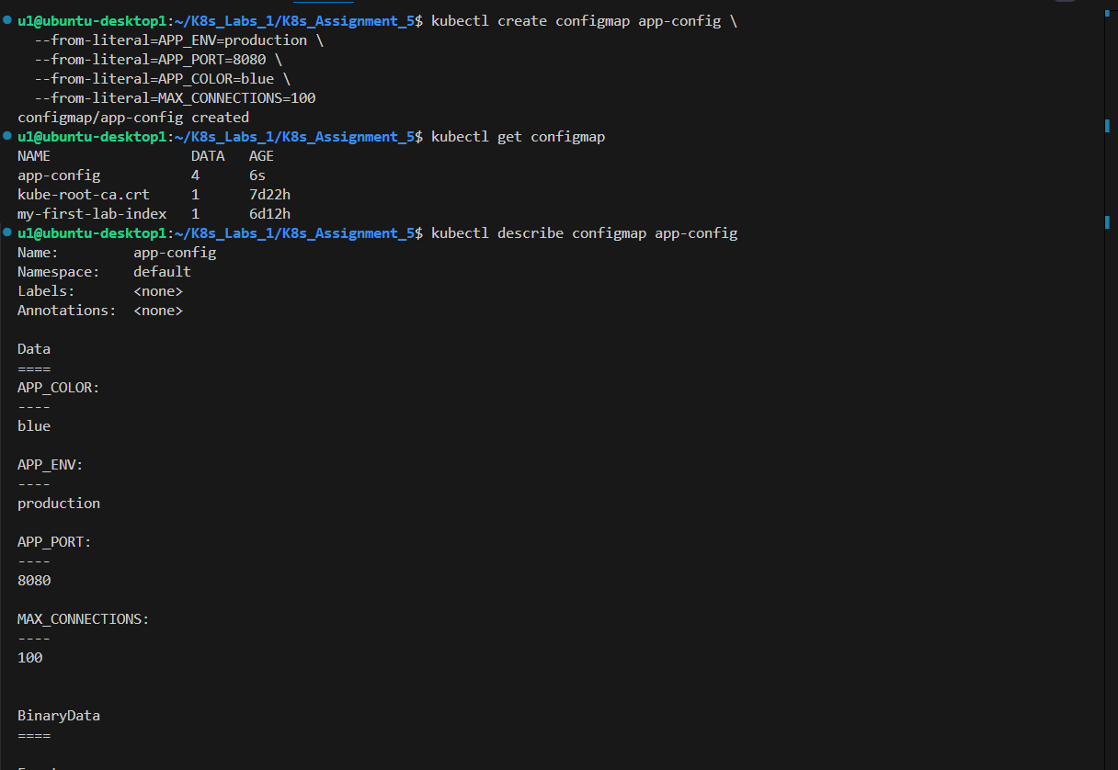

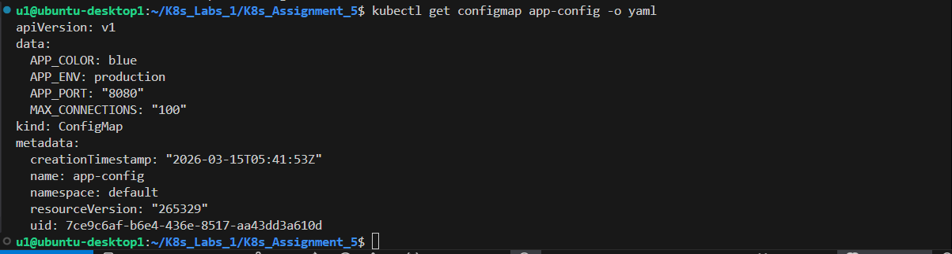

2 | Inject ConfigMap as Environment Variables | Easy ⭐

Create a Pod that injects all keys from the ConfigMap as environment variables using envFrom.

Field | Value
⚙️

ConfigMap & Secret
—

Lab

Session 6 · CKA Level

File to apply

02
-
configmap
-
as
-
envvars.yaml

Pod Name

env
-
pod

Image

busybox

Injection method

envFrom → configMapRef: app
-
config

Command

env && sleep 3600

Requirements:
a | Apply | 02-configmap-as-envvars.yaml

b | Run | kubectl logs env-pod | and find the 4 ConfigMap keys in the output

c | Run | kubectl exec -it env-pod -- env | grep APP | — what do you see?

d | Explain: what does | envFrom | do differently than writing each | env: | key manually?

✅ Verify with:
kubectl logs env-pod kubectl exec -it env-pod -- env | grep APP kubectl exec -it env-pod -- env | grep MAX

✍️ What did you see from grep APP?
The command showed the environment variables that were injected from the ConfigMap, such as:
APP_ENV=production
APP_PORT=8080
APP_COLOR=blue
This confirms that the ConfigMap values were successfully loaded as environment variables inside the Pod.

Difference between envFrom and individual env: keys: envFrom imports all keys from the ConfigMap at once as environment variables.
Individual env: keys allow you to select specific variables one by one, giving more precise control.

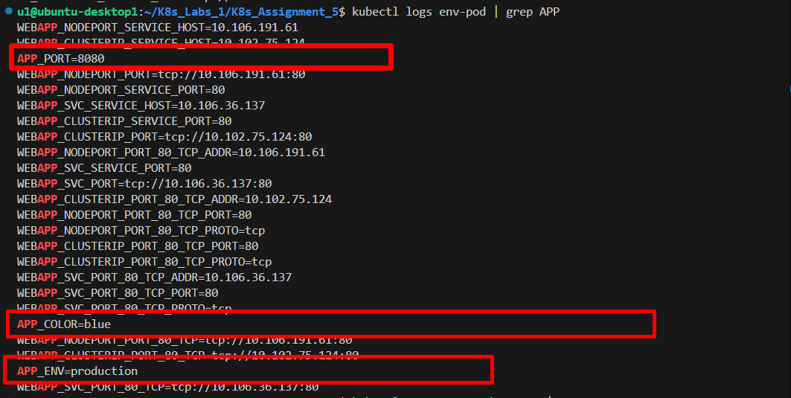

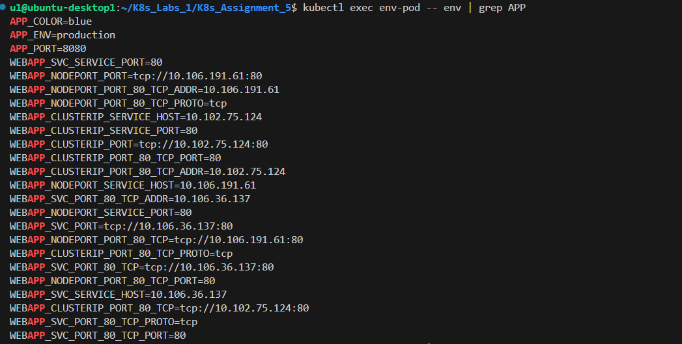

3 | Inject Specific Keys with Custom Names | Medium ⭐⭐

Create a Pod that injects specific keys from the ConfigMap with custom variable names inside the container.

Field | Value
File to apply | 03-configmap-selective-env.yaml
Pod Name | selective-pod
Image | busybox
Env var name | COLOR ← from APP_COLOR
Env var name | PORT ← from APP_PORT

📌 Note: The variable name inside the container can be different from the ConfigMap key name.

Requirements:
⚙️ ConfigMap & Secret — Lab |  |  | Session 6 · CKA Level
a | Apply | 03-configmap-selective-env.yaml

b | Check logs — the pod prints | Color=blue | and | Port=8080

c | Run | kubectl exec -it selective-pod -- env | — is | MAX_CONNECTIONS | visible? Why not?

d | When would you use selective injection instead of | envFrom | ?

✅ Verify with:
kubectl logs selective-pod
kubectl exec -it selective-pod -- env

✍️ Is MAX_CONNECTIONS visible? Why not? No, MAX_CONNECTIONS is not visible because the Pod uses selective injection with individual env entries, so it only loads the specific keys APP_COLOR and APP_PORT as COLOR and PORT. Other ConfigMap keys are not injected.
When to use selective injection instead of envFrom: Use selective injection when the container needs only a few specific variables, when you want better control, or when you want to rename ConfigMap keys inside the container. envFrom is better when you want to import everything at once.

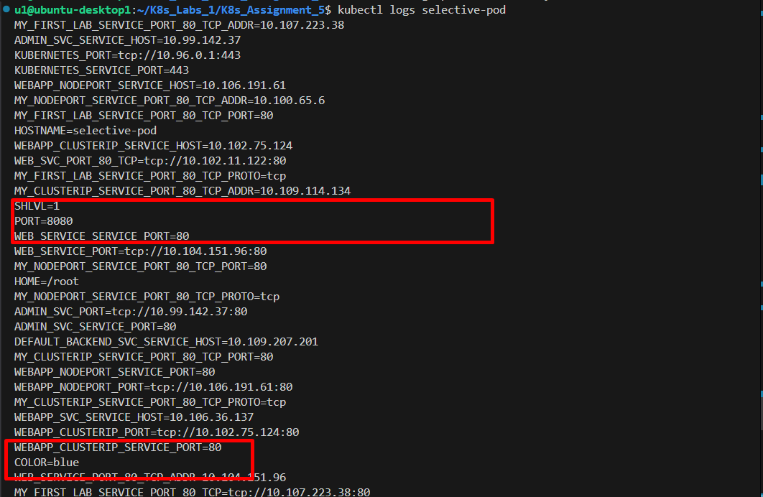

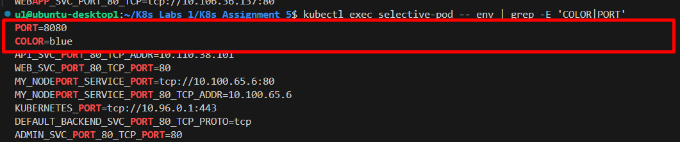
⚙️ ConfigMap & Secret — Lab | Session 6 · CKA Level
🔐 Part 2 — Secret | 30 pts

4 | Create a Secret and Inspect It | Easy ⭐

Create a Secret named db-secret to store database credentials.

Field | Value
Secret Name | db-secret
Type | Opaque (generic)
Key 1 | DB_USER = admin
Key 2 | DB_PASSWORD = p@ssw0rd123
Key 3 | DB_NAME = myapp

💡 Hint:
Use the imperative method — kubectl handles base64 encoding for you:
kubectl create secret generic <name> --from-literal=KEY=value

If using YAML (05-secret-basic.yaml), values must be pre-encoded: echo -n "admin" | base64 → YWRtaW4=

Requirements:
a | Create the Secret using the imperative method

b | Run | kubectl describe secret db-secret | — are the values visible?

c | Run | kubectl get secret db-secret -o yaml | — how are the values stored?

d | Decode DB_USER: |  |  | kubectl get secret db-secret -o jsonpath='{.data.DB_USER}' |
 |  | base64 -d

e | Explain: why is base64 NOT the same as encryption?

✅ Verify with:
kubectl get secret
kubectl describe secret db-secret kubectl get secret db-secret -o yaml kubectl get secret db-secret -o jsonpath='{.data.DB_USER}' | base64 -d

✍️ How are values stored in the Secret YAML? Values are stored as Base64-encoded strings inside the data field of the Secret YAML.

Why is base64 NOT encryption?
Because Base64 is only an encoding method, not a security mechanism. Anyone can easily decode it back to the original value without a key.

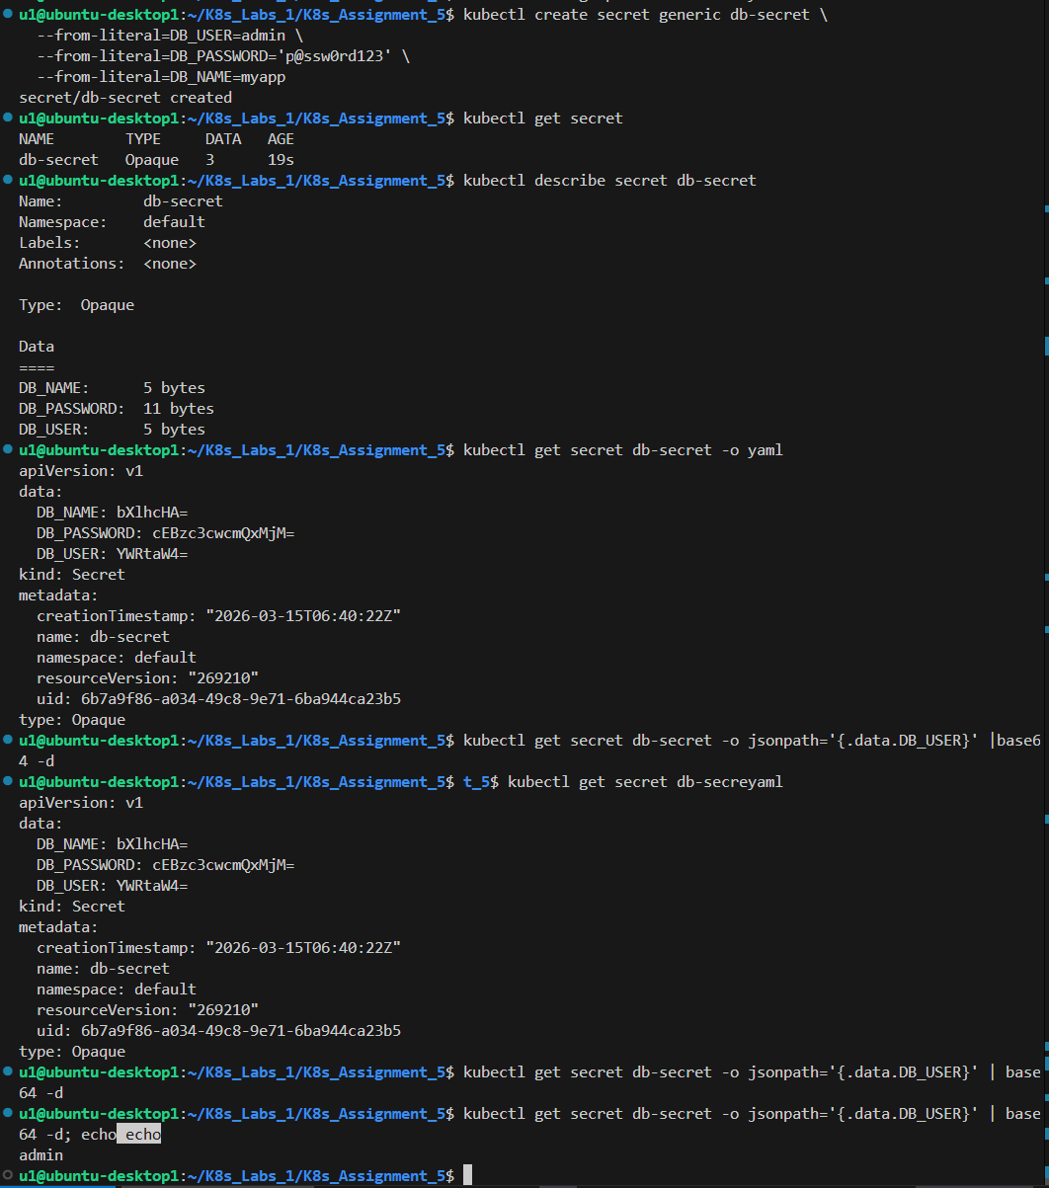

⚙️ ConfigMap & Secret — Lab Session 6 · CKA Level

5 | Inject Secret as Environment Variables | Medium ⭐⭐

Create a Pod that injects the db-secret values as environment variables and verify they are decoded automatically.

Field | Value
File to apply | 06-secret-as-envvars.yaml
Pod Name | db-pod
Image | busybox
Injection method | envFrom → secretRef: db-secret
Command | echo User=$DB_USER && echo DB=$DB_NAME && sleep 3600

Requirements:
a | Apply | 06-secret-as-envvars.yaml

b | Run | kubectl logs db-pod | — are the values decoded?

c | Run | kubectl exec -it db-pod -- env | grep DB | — can you see DB_PASSWORD?

d | Run | kubectl describe pod db-pod | — can you see the Secret values there?

✅ Verify with:
kubectl logs db-pod kubectl exec -it db-pod -- env | grep DB kubectl describe pod db-pod

✍️

Are values decoded in logs? What did you see? Yes, the values appear decoded in the logs because the container prints them as environment variables.

Are values visible in kubectl describe pod? No, the actual secret values are not visible in kubectl describe pod. It only shows the variable names or references to the Secret, not the real values.

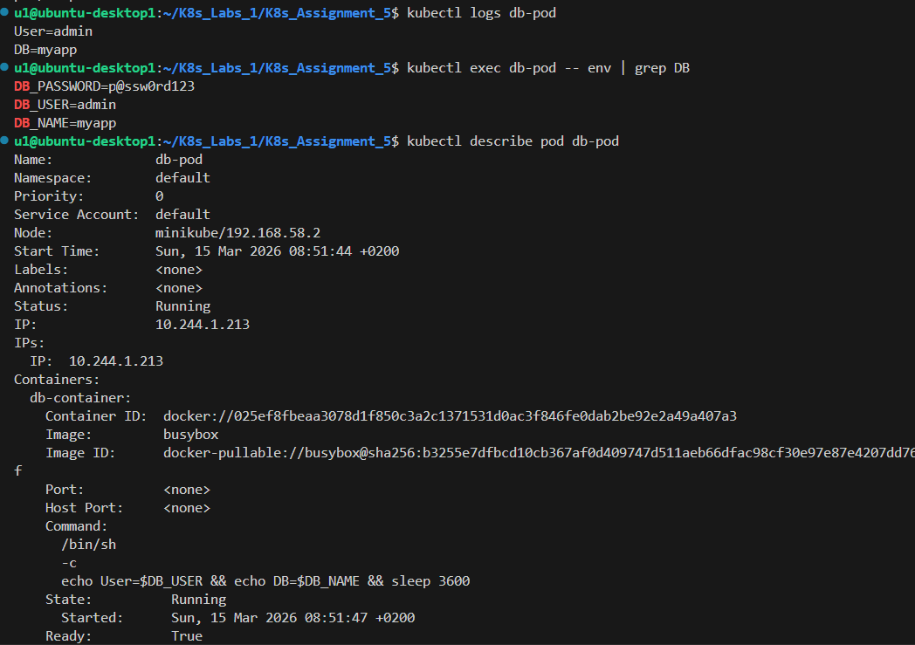

⚙️ ConfigMap & Secret — Lab | Session 6 · CKA Level
🔗 Part 3 — Combined Pattern | 20 pts

6 | Inject ConfigMap + Secret Together | Medium ⭐⭐

Create a Pod that uses both app-config (ConfigMap) and db-secret (Secret) — injecting both into the same container.

Field | Value
File to apply | 08-combined-cm-and-secret.yaml
Pod Name | fullapp-pod
Image | busybox
ConfigMap inject | envFrom → configMapRef: app-config
Secret inject | envFrom → secretRef: db-secret

Requirements:
a | Apply | 08-combined-cm-and-secret.yaml

b | Run | kubectl logs fullapp-pod | — verify both sections print correctly

c | Run | kubectl exec -it fullapp-pod -- env | sort | — count how many env vars come from
 |  | ConfigMap vs Secret

d | Explain: which vars should go in ConfigMap and which in Secret?

✅ Verify with:
kubectl logs fullapp-pod kubectl exec -it fullapp-pod -- env | sort kubectl exec -it fullapp-pod -- env | grep -E 'APP|DB'

✍️ ConfigMap vars (non-sensitive): APP_ENV, APP_PORT, APP_COLOR, MAX_CONNECTIONS

Secret vars (sensitive): DB_USER, DB_PASSWORD, DB_NAME

Rule: how do you decide which goes where?
Put non-sensitive configuration in a ConfigMap, such as app settings, ports, colors, and limits.
Put sensitive data in a Secret, such as passwords, usernames, tokens, API keys, and private credentials.

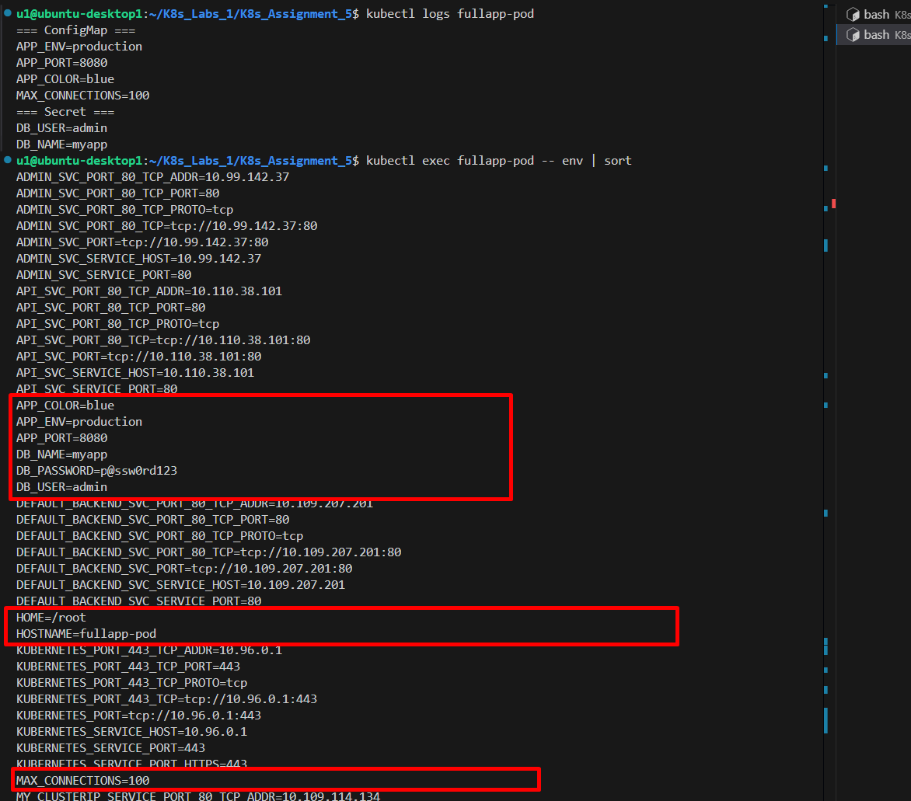
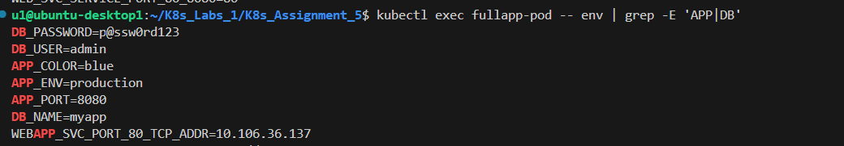

7 | Deployment with ConfigMap + Secret | Hard ⭐⭐⭐

Apply the Deployment that uses both ConfigMap and Secret. Verify that all 3 pods automatically get the same configuration.

Field | Value
File to apply | 09-deployment-with-config.yaml
Deployment Name | webapp-configured
Replicas | 3
ConfigMap key used | APP_ENV
Secret keys used | DB_USER, DB_PASSWORD

Requirements:
a | Apply | 09-deployment-with-config.yaml

b | Confirm all 3 pods are Running: | kubectl get pods -l app=webapp-configured

c | Pick any pod and verify it has the env vars: |  | kubectl exec -it <pod> -- env | grep -E
 |  | 'APP_ENV|DB_USER'
⚙️ ConfigMap & Secret — Lab |  |  | Session 6 · CKA Level

d | Pick a DIFFERENT pod and run the same check — do all pods have the same vars?

e | Explain: what is the advantage of using ConfigMap + Secret with a Deployment vs hardcoding values in the YAML?

✅ Verify with:
kubectl get pods -l app=webapp-configured kubectl exec -it <any-pod> -- env | grep -E 'APP_ENV|DB_USER' kubectl describe pod <any-pod>

✍️ Did both pods have the same vars? (yes/no)
Yes

Advantage of ConfigMap + Secret over hardcoding values:
They separate configuration and sensitive data from the application code, making it easier to update, manage, and reuse settings without rebuilding or modifying the container image, while keeping sensitive information more secure.

