Prof James Woodcock

This is a good paper and addresses an important issue.

Thank you, we are pleased it is useful.  
  
While there has been insufficient attention to this topic I am not sure that it is quite right to say “*this is the first time that the effect of changing the shape of the dose response relationship has been analyzed by replicating the outputs of a widely used model*”, but  I would refer them to my article in 2013 that included comparisons of the dose response relationship using HEAT assumptions against ITHIM (which uses non-linear relations).[1](https://wellcomeopenresearch.org/articles/7-7/v1#rep-ref-47911-1)

I said “*To summarise the comparison, if using both tools with the recommended values (and combining results from changes to cycling and walking in HEAT) there were higher numbers of premature deaths averted with HEAT than with ITHIM if summing individual diseases in ITHIM but typically a smaller number of deaths averted with HEAT than with ITHIM if directly modelling all-cause mortality with ITHIM. However, due to the exclusion of impacts on older age groups with HEAT the premature deaths averted would be at an older average age in ITHIM compared with HEAT, and hence would tend to correspond to fewer years of life lost.”*

*Action:*

From:

Although previous analysis has shown the importance of estimating changes in the distribution of physical activity, rather than categorizing activity levels[10](https://wellcomeopenresearch.org/articles/7-7/v1#ref-10), this is the first time that the effect of changing the shape of the dose response relationship has been analyzed by replicating the outputs of a widely used model.

*To:*

*“Although previous analysis has shown the importance of estimating changes in the distribution of physical activity, rather than categorizing activity levels*[*10*](https://wellcomeopenresearch.org/articles/7-7/v1#ref-10) *this is the first time that the effect of the shape of the dose response relationship has been analysed within a single health economic model, with all other structural assumptions held constant. Woodcock et al (2013) estimated the difference in the number of deaths averted between the ITHIM and HEAT tools when modelling all-cause mortality, and when modelling several diseases individually. Since the ITHIM model uses a non-linear power transformation, the difference between the ITHIM and HEAT does in part reflect differences associated with the dose-response function. However, there are other differences between the ITHIM and HEAT which make it impossible to isolate the effect of the shape of the dose-response relationship for physical activity on model outcomes. This study aims to isolate this effect, to investigate how sensitive the HEAT model is to the assumed dose response relationship ”*

*Woodcock J, Givoni M, Morgan AS: Health impact modelling of active travel visions for England and Wales using an Integrated Transport and Health Impact Modelling Tool (ITHIM).PLoS One. 2013; 8 (1): e51462*[*PubMed Abstract*](http://www.ncbi.nlm.nih.gov/pubmed/23326315)*|*[*Publisher Full Text*](https://doi.org/10.1371/journal.pone.0051462)

The authors compare a linear versus a power-transformed exposure. The estimation of the power transformation is taken from my paper (Woodcock *et al.* 2011).  However, meta-analytic methods have moved on and I would now recommend  cubic spline based approaches where available e.g.  Smith *et al.* 2016,[2](https://wellcomeopenresearch.org/articles/7-7/v1#rep-ref-47911-2) n.b. this paper is only for diabetes)

The advantage of this approach is it allows a more flexible shaped curve. The transformed curves produce implausibly large benefits at lowest exposure levels (below 1 MET h/wk) and correspondingly produce smaller benefits beyond that. This means the transformed approach is overly sensitive to how many people are assumed to be doing zero activity. Given that PA survey design can lead to notably different results, including considerable variation in the proportion of the population who are active, care is needed.

I support the authors approach to modelling PA distributions. However, careful consideration is needed to harmonise responses to different questionnaires. Such harmonisation should also consider the questionnaires used as part of generating the dose response meta-analyses.

**Acton: Note this in the paper.**

Discussion after paragraph 3:

…. It is also worth noting that in this study, as in many other studies relying upon secondary data, the assumption is made implicitly that the same survey methods for physical activity are utilised in the estimation of the dose-response function, and for the purposes of calculating relative risk. Any differences in the survey methods will generate a bias in the estimation of relative risk.

We also note that the comparison between the linear dose response function currently used by the HEAT, and a non-linear function based on Woodcock et al. 2011 is a false dichotomy. It is likely that non-parametric regression techniques, such as spline regression will yield a dose response relationship that is more appropriate, avoiding implausibly large benefits for particularly inactive individuals, which is apparent at low levels of Weekly MET-mins in Figure 3.

Walking and cycling vs broader measures of PA:

* When generating the PA distributions if I understand correctly these are not just walking or cycling, but a broader measure (probably non-occupational PA)?

Yes, we have taken the responses in the HSE which includes all leisure time physical activity including active commuting.

**Action: Have changed self-reported physical activity levels to: self-reported non-occupational (leisure time and commuting) physical activity levels.**

* The RRs from HEAT and from Woodcock *et al.*2011 are for walking alone. These should not be used in combination with prevalence estimates based on broader measures of PA.

**Action: Look for other RR values**

* Moving to a broader measure of PA has advantages as there are more studies to inform the DRF and thus it can be estimated for a wider range of diseases and not just all-cause mortality (which has problems about transferability).

Agreed

* I would like to see more information in the main text on the PA distributions, and the data used to parametrise them. While having the supplementary tables on Github has advantages, it is not clear where to look for what.

**Action: Add supplementary tables to the appendix of the paper. Add a few distributions as a figure in the main text…**

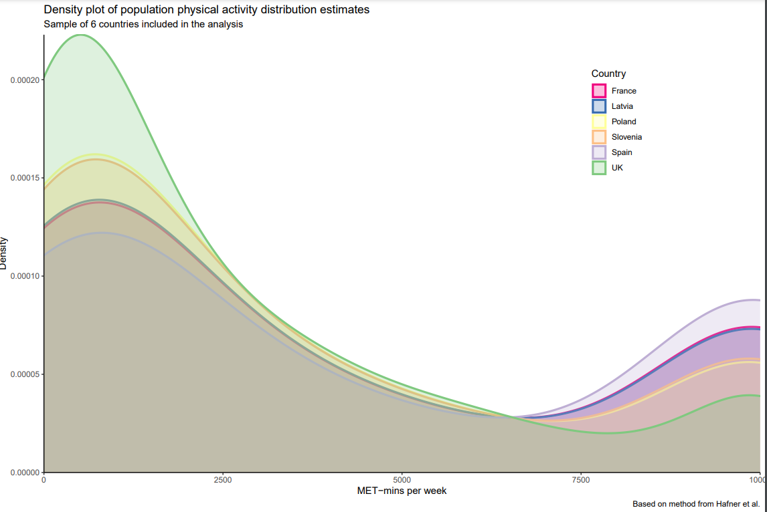

We have also included the distributions of physical activity in the supplementary materials.

Usability:

* While I support the idea of modelling PA distributions the user of a tool like HEAT would then need to know who's PA is being changed, the active or the inactive people, alternatively the tool would need to be able to estimate this in some way based on the type of intervention. In ITHIM we use stochastic matching based on demographics and other variables between PA and travel survey distributions, but additional approaches would be needed depending on the use case.

**Response: I do not believe we need to know specifically whose PA is being changed, unless we seek to incorporate a temporal element to the model.** I do agree that this means that users would need to understand which types of intervention shift the baseline distribution of activity in different ways.

Figure 3:

* In Figure 3 the linear dose response function looks wrong, 168 minutes per week of walking should equate to a RR of 0.89 but in the figure it seems to equate to RR 0.7

**Action: Updated figure 3 below, error in the code.**

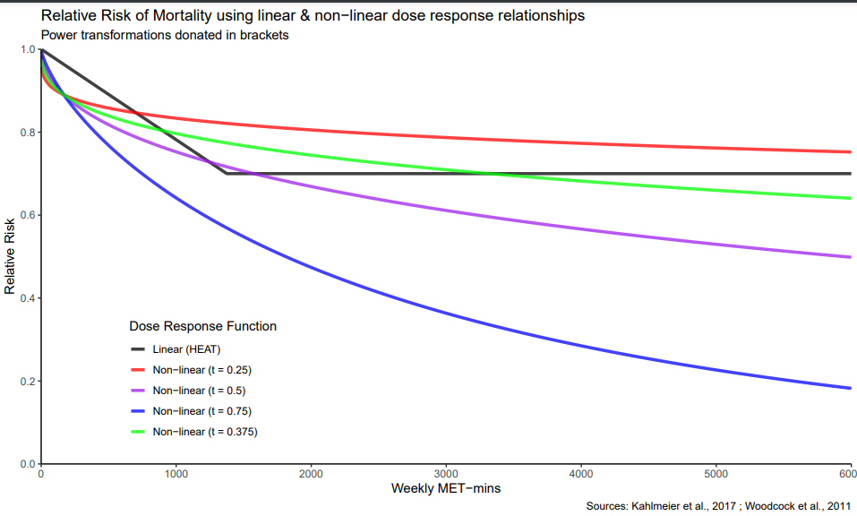

* **Is the work clearly and accurately presented and does it cite the current literature?**

Partly

* **Is the study design appropriate and is the work technically sound?**

Yes

* **Are sufficient details of methods and analysis provided to allow replication by others?**

Yes

* **If applicable, is the statistical analysis and its interpretation appropriate?**

Yes

* **Are all the source data underlying the results available to ensure full reproducibility?**

Partly - We have added as supplementary tables all of the country specific LTPA distributions.

* **Are the conclusions drawn adequately supported by the results?**

Yes

**References**

1. Woodcock J, Givoni M, Morgan AS: Health impact modelling of active travel visions for England and Wales using an Integrated Transport and Health Impact Modelling Tool (ITHIM).*PLoS One*. 2013; **8** (1): e51462 [PubMed Abstract](http://www.ncbi.nlm.nih.gov/pubmed/23326315) | [Publisher Full Text](https://doi.org/10.1371/journal.pone.0051462)  
2. Smith AD, Crippa A, Woodcock J, Brage S: Physical activity and incident type 2 diabetes mellitus: a systematic review and dose-response meta-analysis of prospective cohort studies.*Diabetologia*. **59** (12): 2527-2545 [PubMed Abstract](http://www.ncbi.nlm.nih.gov/pubmed/27747395) | [Publisher Full Text](https://doi.org/10.1007/s00125-016-4079-0)

**Marco Hafner**, RAND Europe, Cambridge, UK

This study aims to improve an existing WHO model by introducing a non-linear dose-response between physical activity and mortality. The existing model only assumes a linear relationship between physical activity and all-cause mortality which has been introduced for parsimonious reasons but nevertheless is based on a very strong (and non realistic) assumption. The study makes clear that it relies on the quality of the existing WHO HEAT model and does not try to challenge the simplicity of that model but tries to show that a non-linear dose-response in the relationship between activity levels and mortality leads to more accurate findings. Based on the HEAT model's framework, the study converts avoided deaths into monetary benefits based on the value of a statistical life.   
  
In my view, this study makes a very important contribution by showing that a non-linear dose-response is very important when we try to consider the benefits of a more active population. Especially given the heterogeneous costs and benefits of aiming to improve the activity levels of the least active population this is an important improvement of the existing model. The study references the relevant existing literature and discusses clearly the limitations of the study (and to some extent those of the HEAT model).   
  
One element I would like to add is perhaps a discussion around the value of a statistical life. The study makes a reference to a study where the value of the statistical life is taken from, but the actual value chosen doesn't seem to be discussed in more detail. Also, is that value of statistical life uniformly applied to all countries or have they been adjusted for a country-specific context? Also, as the VSL is a somewhat contested metric, have the authors thought to apply sensitivity ranges for the value? I understand that was not the main intention of the study, but given the study findings are relevant, it would be great to add some sensitivity ranges.

Thank you for taking the time to review the paper. We are glad that you feel it makes an important contribution. We agree that adding more content to the discussion of the VSL is necessary so added the following (see below) to the paper. In summary, each country has had a country specific VSL included. However, we have not added sensitivity ranges as this is beyond the scope of the study. However, our previous paper on the use of the Value of a Statistical Life Year may be of interest:

Smith, R., Thomas, C., Squires, H., Götschi, T., Kahlmeier, S. and Goyder, E., 2021. The price of precision: trade-offs between usability and validity in the World Health Organization Health Economic Assessment Tool for walking and cycling. *Public Health*, *194*, pp.263-269.

In ‘Comparison’ we changed:

In each of the three scenarios, the number of deaths averted per 100,000 persons aged 20–74 and monetary benefit was estimated for 44 HEAT countries using the linear (HEAT) and non-linear dose response functions.

To

For each of the 44 countries included in the analysis, for each of the three scenarios, and for each of the four dose response functions, we calculated two metrics:

- the number of deaths averted per 100,000 persons aged 20–74.

- the monetary benefit associated with mortality reduction, using the HEAT VSL estimates for each country (14).

A comparison of the number of deaths averted under different modelling methods are displayed using simple scatter plots with a 45-degree line of equality, and monetary benefit estimates are shown, in Euros, on choropleth maps of Europe.

In discussion we changed:

In paragraph 2:

As noted by our previous work (5), since countries with higher GDP tend to have a higher Value of a Statistical Life ([14](https://wellcomeopenresearch.org/articles/7-7/v1#ref-14)) and higher prevalence of insufficient physical activity ([11](https://wellcomeopenresearch.org/articles/7-7/v1#ref-11)), the estimated net monetary benefit tends to be higher in western Europe than eastern Europe.

* **Is the work clearly and accurately presented and does it cite the current literature?**

Yes

* **Is the study design appropriate and is the work technically sound?**

Yes

* **Are sufficient details of methods and analysis provided to allow replication by others?**

Yes

* **If applicable, is the statistical analysis and its interpretation appropriate?**

Yes

* **Are all the source data underlying the results available to ensure full reproducibility?**

Yes

* **Are the conclusions drawn adequately supported by the results?**

Yes

Competing Interests

*No competing interests were disclosed.*

Reviewer Expertise

Health economics, Econometrics

**I confirm that I have read this submission and believe that I have an appropriate level of expertise to confirm that it is of an acceptable scientific standard, however I have significant reservations, as outlined above.**