Incorporating a Value of a Statistical Life Year approach into the WHO Europe HEAT Walking and Cycling tool

Smith R1, Thomas C1, Squires H1 Gotschi T2, Kahlmeier S2,3, Goyder E1

05/02/2020

1. University of Sheﬃeld, School of Health and Related Research
2. University of Zurich, Physical Activity and Health Unit
3. Swiss Distance University of Applied Science, Department of Health

# Abstract

There is a growing recognition of the importance of considering the health impact of decisions made in all sectors. The World Health Organization’s Health Economic Assessment Tool allows those from other sectors to easily incorporate, among other things, the benefits of increased physical activity on health. The current tool does this by assigning a monetary value to deaths averted. However, this approach is generally not used in health economic evaluation because it does not account for duration of life lost. We show that a new method, which we call the Value of a Statistical Life Year method, requires minimal additional user input and generates similar results, but is more sensitive to age.

# Introduction

There has been an increasing awareness of the need to incorporate Health in All Policies (HiAP) to ensure that non-health government agencies work in partnership to incorporate considerations of health and wellbeing when developing policy (WHO and the Government of South Australia, 2010). One simple way in which HiAP is often facilitated is through Health Impact Assessments (HIA) (WHO, 2000).

The WHO-Europe’s Health Economic Assessment Tool (HEAT) is an example of a Health Impact Assessments (HIA) method which has been designed specifically for a HiAP purpose, allowing transport planners to incorporate the health implications of walking and cycling into economic appraisals. The HEAT has four modules: physical activity, air pollution, crash risk and carbon emissions. The estimated benefits of reductions in mortality risk associated with increases in physical activity generally dwarf the other three modules of the model (Mueller et al., 2015). Within the physical activity module, the estimated net mortality risk change is monetised using the Value of a Statistical Life (VSL), an estimate of the willingness to pay for reductions in mortality risk commonly used in transport planning (Viscusi & Aldy, 2003). Using this framework all deaths averted are monetised at a single willingness to pay, regardless of age.

This paper outlines an alternative method of estimating the monetary benefit of increased population level physical activity, by monetising life years gained as a result of reductions in mortality using the estimated willingness to pay for (the value of) a statistical year of life (VSLY) (Schlander et al., 2017). The method, referred to henceforth as the VSLY method, relies on demographic data, country specific lifetables and VSL estimates to predict life years gained (lost) and the associated monetary benefit (cost). This method is closer to those used in health economic evaluation (Drummond et al. 2015).

This paper describes the methodology developed to calculate the VSLY for each country and compares the results using the current (VSL), and alternative (VSLY) methods for 51 countries within the WHO-Europe area. All data and code is provided on an open access online repository (<https://github.com/RobertASmith/heat_vsly_public>).

# Material and Methods

## Data & measures

This study relies on data currently used in the HEAT model and described in Kahlmeier et al. (2017), that is: WHO country names, country ISO3 codes, VSL estimates from Lindhjem et al. (2011), mortality rates for HEAT age-groups (20-74, 20-44 & 45-74) and a dose response relationship from Kelly et al., (2014). This study also makes use of several additional datasets: The Global Burden of Disease Study population estimates described in detail in Murray et al. (2018) and available from the Disease Collaborative Network (DCN, 2018), and the GBD life tables for 2017 (Dicker et al. 2017). Table 1 shows the variables used in the analysis.

**Table 1. Variables used in the analysis, descriptions and sources.**

|  |  |  |
| --- | --- | --- |
| Variable | Description | Source |
| **Currently used in the HEAT model and described in Kahlmeier et al. (2017):** | | |
| MRVSL (1/2 age-groups) | HEAT age-group mortality rates (20-44,45-74,20-74) | European Mortality Database 2017 |
| VSL | Value of a statistical life (mean age of elicitation of 50). | Lindhjem et al. 2011 |
| RR | Relative Risk of mortality assuming linear dose response function. | Kelly et al., 2014 |
| **Additional data sources for this study:** | | |
| pop | Population estimates by individual year | GBD 2017 Mortality Collaborators (2018) |
| MRVSLY (individual ages) | Mortality rates by individual year | GBD 2017 Mortality Collaborators (2018) |

## Analysis

The analysis begins by estimating, for each country, the Value of a Statistical Life Year. It then goes on to compare the results of the VSLY method with the VSL method currently used by the HEAT.

Estimating the Value of a Statistical Life Year

The VSL estimates used in the HEAT model are based on a stated preference study conducted by the OECD (Lindhjem et al., 2011) in which individuals were asked how much they were willing to pay for small reductions in mortality risk. They vary considerably between countries, ranging from approximately 143,000 EUR (2015) in Tajikistan to almost 7m EUR (2015) in Luxembourg. The mean age of participants within the studies in HEAT countries was 50. By making the assumptions that the VSL at age of elicitation is the value derived from future life years until death, and all years are valued equally, but with some discount rate for future life years, we can estimate the VSLY using the equation below:

The VSLY for each year from 50 is equal to the VSL at age 50 divided by the discounted expected life years remaining between age 50 and 109 - the maximum age in our data. The discounted expected life years remaining are calculated for each age , using the probability of survival - denoted px in lifetables - to the next birthday, as well as the discount rate for the year, . The VSLY increases as: VSL, survival rates decrease, or discount rates increase.

There is considerable heterogeneity in estimated VSLY between WHO-Europe countries, ranging from 5,828 EUR in Kyrgyzstan to 216,838 EUR in Luxembourg, with higher values in western Europe than in the east. A full table of the VSLY estimates used is provided in the appendix.

VSLY Method

With an estimated VSLY for each country, it is now possible to estimate the net monetary benefit associated with a change in physical activity using a new approach ’The VSLY method’. The VSLY method estimates the monetary benefit of an intervention in a specific country for a specific age population using the equation below, which estimates monetary benefit as discounted life years saved by an intervention multiplied by the value of a statistical life year.

Discounted life years saved can be estimated by multiplying the absolute difference in the relative risk of death (ADRR), estimated using a relative risk function from Kelly et al. (2014), by the age specific mortality rates to estimate changes in mortality for the population in each age-group . These changes are then multiplied by discounted expected life years remaining (itself estimated from GBD lifetables) for each group.

Since the absolute difference in relative risk is constant between age groups this can be factorised, giving the below equation in the case of an intervention affecting 20-74 year olds.

Inputting this back into our original equation gives:

Where i has 55 values representing each age from 20-74

Models compared:

In order to compare the proposed VSLY model with the current HEAT models, we estimate the annual, per capita monetary benefit using four different methods: 1) **VSL-1** uses the current HEAT model with a single mortality rate (the population weighted mean) for all age-groups (20-74), 2) **VSL-2** uses the current HEAT model with two mortality rates based on weighted population means (Walking: 20-44, 45-74; Cycling: 20-44, 45-64). 3) **VSL-55** groups adapts the existing HEAT model methodology to include mortality risk for 55 age-groups (each age from 20-74) separately but still values deaths averted using the VSL, and finally, 4) the **VSLY** model described above with the same 55 age-groups as in (3) but valuing life years lost using the VSLY estimates derived above. In all cases the discount rate was set to zero to enable comparison.

Scenarios compared

The valuations, and the differences between them, will vary depending on the user input. Therefore, we test six scenarios using a representative sample of the country specific populations: 1) Population aged between 20 and 74 doing an additional 10 minutes of walking per week, 2) Population aged between 20 and 64 doing an additional 10 minutes of cycling per week. 3) Population aged between 20 and 44 doing an additional 10 minutes of walking per week. 4) Population aged between 20 and 44 doing an additional 10 minutes of cycling per week. 5) Population aged between 45 and 74 doing an additional 10 minutes of walking per week. 6) Population aged between 45 and 64 doing an additional 10 minutes of cycling per week.

The results from scenarios 1, 3 and 5 (walking for different ages) are described in the results section below. The results from the cycling scenarios (2,4 & 6) were similar to that of the walking ones (1,3 & 5) and can be found in the supplementary material.

# Results

In the first simple scenario, an extra 10 minutes walking per week for every person aged 20-74, the VSLY method results in lower estimated beneﬁts than using the current HEAT method with either one or two age-groups. The effect is not simply due to more precise mortality rate estimates, the HEAT method applied to a population categorized in one-year age bands (VSL55) results in similar estimates to the HEAT model with one and two groups. Table 2 below shows these results for France, Germany, Luxembourg, Romania, Latvia and Poland. These countries are selected as a mix of eastern and western European countries.

Table 2. Estimated Monetary Beneﬁt (2017 Euro) of 10minutes additional weekly walking for six countries.

|  |  |  |  |  |
| --- | --- | --- | --- | --- |
| **Country** | **VSLY** | **VSL-1** | **VSL-2** | **VSL-55** |
| France | 124.88 | 81.55 | 89.87 | 175.83 |
| Germany | 153.79 | 91.31 | 104.71 | 228.08 |
| Luxemburg | 231.39 | 157.71 | 160.66 | 322.64 |
| Romania | 59.3 | 36.12 | 39.73 | 85.33 |
| Latvia | 115.29 | 68.96 | 75.36 | 159.12 |
| Poland | 74.33 | 50.59 | 52.06 | 105.27 |
| VSLY: Value of a Statistical Life Year method (new method)  VSL-1: Value of a Statistical Life method with 1 age group (used by HEAT)  VSL-2: Value of a Statistical Life method with 2 age groups (used by HEAT)  VSL-55: Value of a Statistical Life method with 55 age groups (NOT used by HEAT) | | | | |

Figure 1 below displays the results from the same scenario graphically, but for all 51 countries. The current HEAT method with two age-groups (HEAT2) is shown on the x axis, and all other methods are depicted in a color-coded scatterplot. A 45-degree line is used to depict equity, such that points below (above) the line represents a lower (higher) estimate than that generated by HEAT2. The monetary benefits estimated by the VSLY (blue) are generally lower than those estimated by the current VSL-2 model (black line), HEAT-1 (red) and VSL-55 model (green), though the extent differs by country.

Figure 1. Estimated Annual Monetary Beneﬁt per Capita (in 2017 Euro) in Scenario 1, Comparing Alternative Methods to VSL-2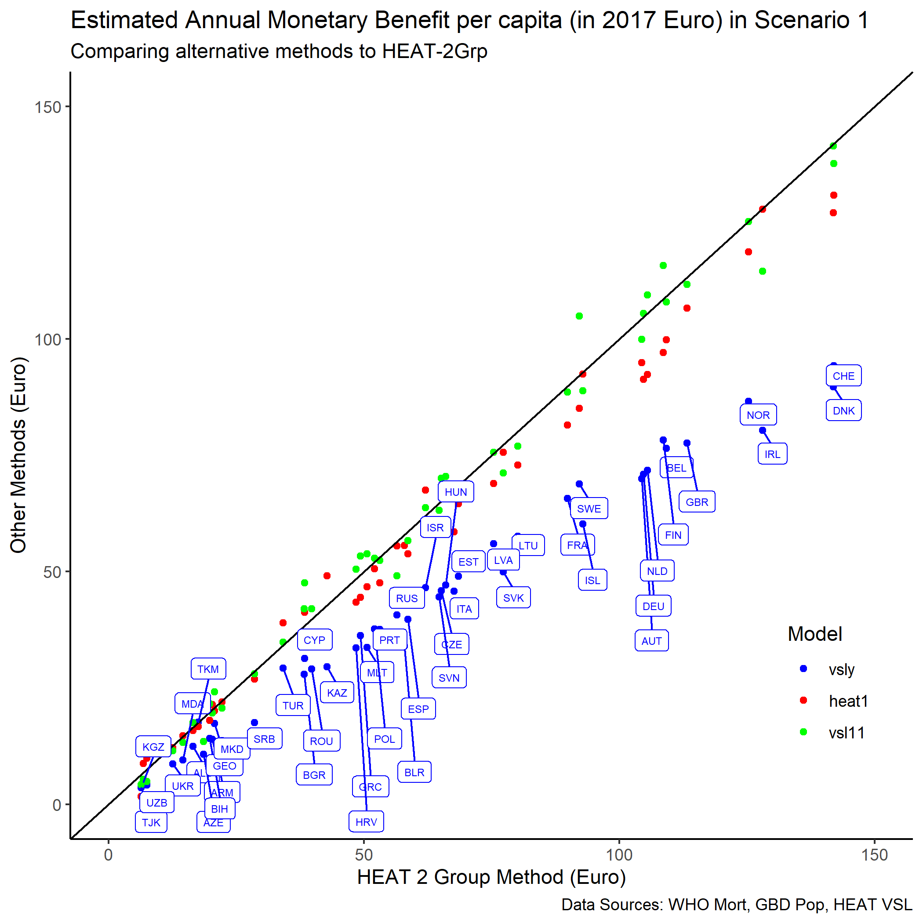

Figure 1 above showed the estimates generated by increased activity in the population aged 20-74. However, this masks differences between the approach for the two age-groups (20-44,45-74). Figure 2 depicts the estimates generated by restricting the analysis to the population aged 20-44 (left) and 45-74 (right). In both cases the VSL-55 (green) estimates are very similar. The VSL-1 (red) method results in higher (lower) values when restricting the analysis to younger (older) people. The VSLY (blue) estimates tend to be higher in younger people and lower in older people.

Figure 2. Estimated Annual Monetary Beneﬁt (in 2017 Euro) per capita from 10mins additional weekly walking using country speciﬁc population age distributions from 20-44 (left) and 45-74 (right), VSLY vs current HEAT models.

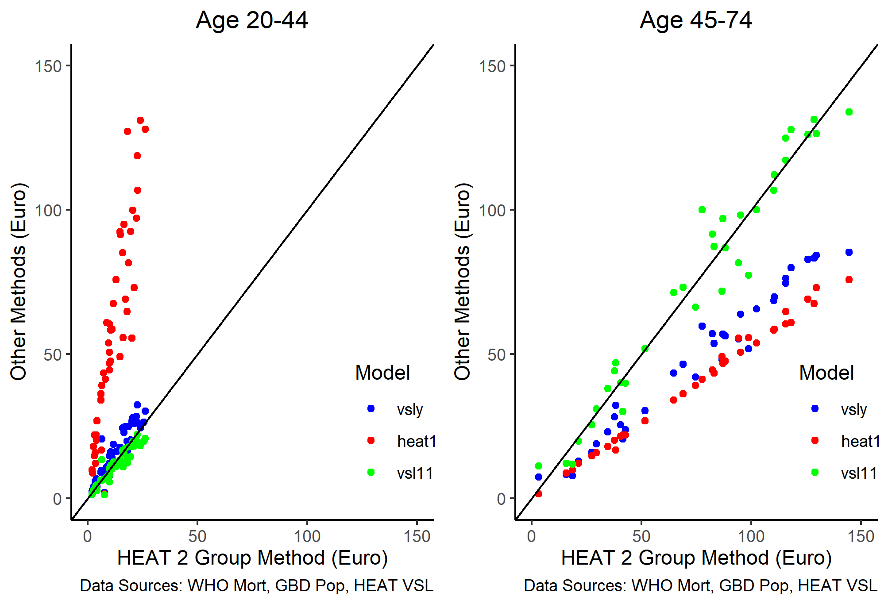

Since there are clear difference in the values generated by different methods, and these differences vary between older and younger populations, it seems relevant to look at how the valuation methods differ over the life course in an exemplar country.

Figure 3 below shows a comparison of annual monetary benefits per capita (2017 Euro) associated with 10mins/week of additional walking, for each individual age from 20 to 74 for the Latvian population using the four different models: VSL-1 (red), VSL-2 (black), VSL-55 (green), VSLY (blue).

Figure 3. Annual monetary beneﬁt per capita (in 2017 Euro) from 10mins additional weekly walking for each age of Latvian population, using each method.

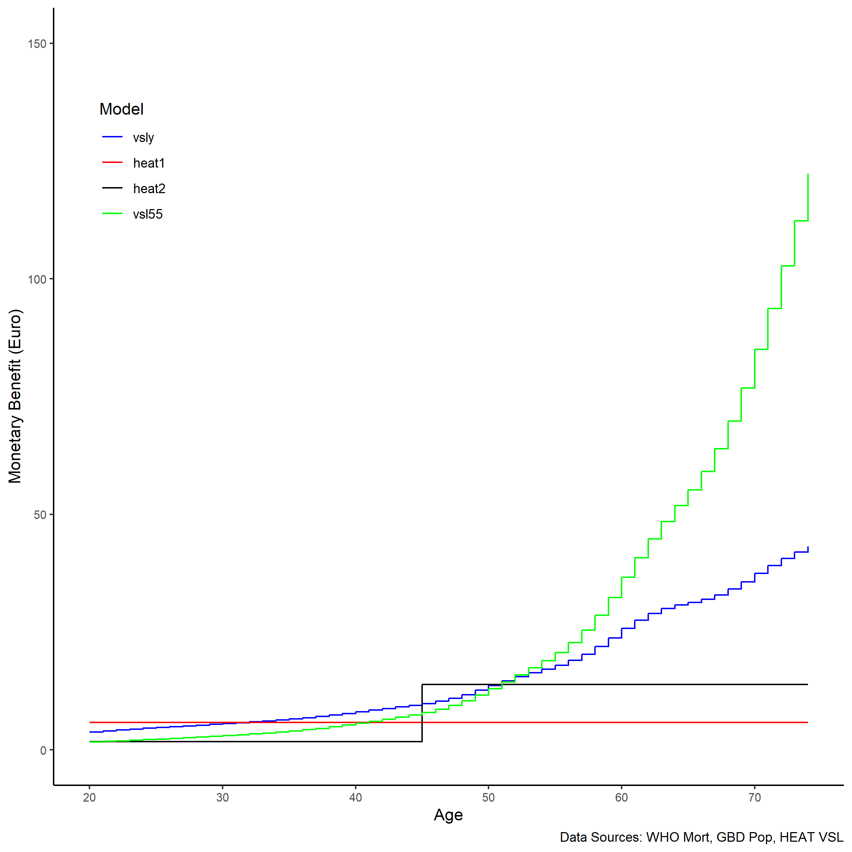

The VSL-1 method generates the same results regardless of age, since there is a single mortality risk and VSL applied. The VSL-2 method generates different results for the population aged 20-44 to those aged 45-74, as the populations have different baseline risks and the same VSL. The VSLY (blue) and VSL-55 (green) results are similar, with monetary benefit increasing as age, and therefore mortality rates, increase. However, the VSLY model does not increase as quickly with age since life years remaining are falling with age also - this is particularly stark from age 60.

Finally, it was interesting to observe the differences in results between countries when using the VSLY methods. Figure 4 shows the estimated per capita annual monetary benefit of an additional 10 minutes of walking per week per person aged 20-74 for the HEAT countries on a choropleth map. The differences are in the same order to those observed in the VSLY estimates. Differences in VSL and mortality rates between countries mean that there are large differences in estimated monetary benefit per capita within HEAT countries.

Figure 4. Map of estimated per capita annual monetary beneﬁt (2017 Euro) of an additional 10 minutes of walking per week per person aged 20-74.

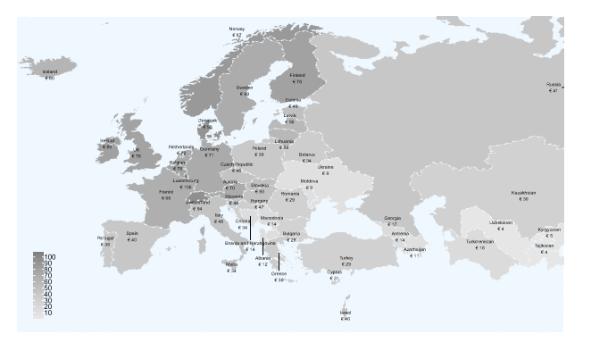

# Discussion

In order to incorporate the benefits of physical activity into the decision-making process for other sectors, it is useful to have a common metric. By monetizing the mortality reductions associated with increased physical activity the HEAT allows transport planners to incorporate health considerations into their decision-making process. It is a good example of a health impact assessment tool used to encourage Health in All Policies and has been used widely, including in Kuopio (Finland), Parnu (Estonia), Brighton & Hove (UK), Modena (Italy) and Viana do Castelo (Portugal) all of which were included in a review of the early applications of HEAT (WHO, 2013).

However, the current HEAT model values reductions in mortality equally regardless of the age of the individual. Taken at its extreme this means that the monetary benefit associated with increasing physical activity for those with lower mortality rates but longer life years remaining (e.g. those aged 20-44) is less than 1/6th that of a group with a higher mortality rate but fewer life years remaining (e.g. those aged 45-74).

The VSLY method attempts to bring the HEAT model toward the methods used by health economists which incorporate not only the number of deaths averted but the estimated additional life years lived as a result of the intervention (Drummond et al., 2015). It falls short of considering quality of life, although it could be adapted to incorporate quality adjusted life years by estimating expected quality adjusted life years remaining at each age (Janssen & Szende, 2014).

The VSLY method differs from the current HEAT method in two fundamental ways. Firstly, the current HEAT model has at most two age groups (20-44, 45-74) while the VSLY model has 55 age groups, individual age bands from 20-74. Secondly, the HEAT model applies the country specific Value of a Statistical Life regardless of age. This model calculates life years saved due to an intervention and applies the country specific Value of a Statistical Life Year. The result of these two differences is that the VSLY model is more sensitive to the age of those affected by an intervention. Interventions which affect young (old) people will have small (large) mortality rate reductions but lives saved will be long (short). This helps to mitigate the extreme differences between the estimated benefit of increasing activity levels in young and older people in the current HEAT model.

The main limitation of the method is that it can require an additional user input. In the current HEAT the user specifies how many people are in the two age groups (20-44, 45-74 for walking; 20-44, 45-64 for cycling). The VSLY approach could use the distribution of age in the general population as a default, requiring no user input… but if the user wanted to change this, they would be required to inter some values to change the distribution. If the intervention is targeted at a specific age group the user could simply state the minimum, maximum and median age which could be used to create a triangular distribution. The latter may be an additional burden on the user, and therefore provides a trade-off between accuracy and ease of use.

An additional issue for accurate estimation of benefit, unrelated to the use of the HEAT-2 or VSLY methods, remains that the VSL estimates used are derived from a stated preference study with a median age of 50. There are numerous limitations of stated preference studies when estimating the VSL (Doucouliagos et al., 2012), but particular to this case is the limitation that VSL has been shown to peak around age 50 (Aldy & Viscusi, 2008) and therefore calculating the value of a life year from this figure may lead to overestimates.

# Conclusion

This study comparing the use of the existing HEAT methodology and an adapted method, referred to as the ‘VSLY method’ has shown that the VSLY method is more sensitive to age than the current HEAT model, incorporates a consideration of length of life lost, and allows users to use the default country age distributions. The VSLY method is an approach which can be used to value mortality reductions, with limited additional user inputs. The differences in model results may be particularly important for programs targeted at specific age-groups, such as middle-aged commuters or investments around schools (young people) or improving ease of access (elderly people). Prior to implementing the change, it is recommended that tests are undertaken to ensure users can deal with the additional, albeit minimal, inputs required.

# Bibliography

Aldy, J.E. and Viscusi, W.K., 2008. Adjusting the value of a statistical life for age and cohort effects. *The Review of Economics and Statistics*, *90*(3), pp.573-581.

Disease Collaborative Network, Global Burden of. 2018. “Population Estimates 1950-2017.”

Dicker, D., Nguyen, G., Abate, D., Abate, K.H., Abay, S.M., Abbafati, C., Abbasi, N., Abbastabar, H., Abd-Allah, F., Abdela, J. and Abdelalim, A., 2018. Global, regional, and national age-sex-specific mortality and life expectancy, 1950–2017: a systematic analysis for the Global Burden of Disease Study 2017. *The lancet*, *392*(10159), pp.1684-1735.

Drummond, M.F., Sculpher, M.J., Claxton, K., Stoddart, G.L. and Torrance, G.W., 2015. *Methods for the economic evaluation of health care programmes*. Oxford university press.

Doucouliagos, C., Stanley, T.D. and Giles, M., 2012. Are estimates of the value of a statistical life exaggerated?. *Journal of health economics*, *31*(1), pp.197-206.

Janssen, B. and Szende, A., 2014. Population norms for the EQ-5D. In *Self-reported population health: an international perspective based on EQ-5D* (pp. 19-30). Springer, Dordrecht.

Drummond, M.F., Sculpher, M.J., Claxton, K., Stoddart, G.L. and Torrance, G.W., 2015. *Methods for the economic evaluation of health care programmes*. Oxford university press.

GBD 2017 Mortality Collaborators. **Global, regional, and national age-sex-specific mortality and life expectancy, 1950–2017: a systematic analysis for the Global Burden of Disease Study 2017**. The Lancet. 8 Nov 2018;392:1684-735. doi: <http://dx.doi.org/10.1016/S0140-6736(18)31891-9>.

Kahlmeier, Sonja, Thomas Götschi, Nick Cavill, Alberto Castro Fernandez, Christian Brand, David Rojas Rueda,JamesWoodcock,etal. 2017. “Health Economic Assessment Tool (Heat) for Walking and for Cycling. Methods and User Guide on Physical Activity, Air Pollution, Injuries and Carbon Impact Assessments.”

Kelly, P., Kahlmeier, S., Götschi, T., Orsini, N., Richards, J., Roberts, N., Scarborough, P. and Foster, C., 2014. Systematic review and meta-analysis of reduction in all-cause mortality from walking and cycling and shape of dose response relationship. International journal of behavioral nutrition and physical activity, 11(1), p.132.

Lindhjem, Henrik, Ståle Navrud, Nils Axel Braathen, and Vincent Biausque. 2011. “Valuing Mortality Risk Reductions from Environmental, Transport, and Health Policies: A Global Meta-Analysis of Stated Preference Studies.” Risk Analysis: An International Journal 31 (9): 1381–1407.

MDB (European detailed mortality database) [online database]. Copenhagen: WHO Regional Office for Europe; 2017 (http:// data.euro.who.int/dmdb, accessed 18 October 2017).

Mueller, Natalie, David Rojas-Rueda, Tom Cole-Hunter, Audrey de Nazelle, Evi Dons, Regine Gerike, Thomas Goetschi, Luc Int Panis, Sonja Kahlmeier, and Mark Nieuwenhuijsen. 2015. “Health Impact Assessment of Active Transportation: A Systematic Review.” Preventive Medicine 76: 103–14.

Murray, Christopher JL, Charlton SKH Callender, Xie Rachel Kulikoﬀ, Vinay Srinivasan, Degu Abate, Kalkidan Hassen Abate, Solomon M Abay, et al. 2018. “Population and Fertility by Age and Sex for 195 Countries and Territories, 1950–2017: A Systematic Analysis for the Global Burden of Disease Study 2017.” The Lancet 392 (10159): 1995–2051.

Schlander, M., Schaefer, R. and Schwarz, O., 2017. Empirical studies on the economic value of a statistical life year (VSLY) in Europe: what do they tell us?. *Value in Health*, *20*(9), p.A666.

WHO and the Government of South Australia, 2010. The Adelaide Statement on Health in All Policies: moving towards a shared governance for health and well-being.

World Health Organization, 2000. Health impact assessment: main concepts and suggested aproach-Gothenburg consensus paper.

World Health Organization. 2013. Using the Health Economic Assessment Tools (HEAT) for walking and cycling: lessons learnt. Final Report, Jan 2013. Regional Office for Europe of the World Health Organization. Accessed: 13/02/2020 <http://www.euro.who.int/__data/assets/pdf_file/0006/241728/USING-THE-HEALTH-ECONOMIC-ASSESSMENT-TOOLS-HEAT-FOR-WALKING-AND-CYCLING,-LESSONS-LEARNT.pdf?ua=1>