Title: Reducing socioeconomic inequalities in access to and participation in community-based running and walking activities: a longitudinal ecological study of parkrun events 2010 to 2019

Potential Journals:

1. Health & Place
2. Journal of Epidemiology and Community Health
3. International Journal of Behavioral Nutrition and Physical Activity
4. Journal of Physical Activity and Health
5. SSM Population Health
6. ~~BMC Public Health~~
7. Wellbeing, space & society

Authors: Robert Smith*1, Paul Schneider*1, Rami Cosulich1, Helen Quirk1, Alice Bullas3, Steve Haake2,3, Elizabeth Goyder1.

*Equal Contributors.

Institutions:

1. School of Health and Related Research, University of Sheffield, Regents Court, Sheffield, S1 4DA, UK.
2. Advanced Wellbeing Research Centre, Sheffield Hallam University, Olympic Legacy Park, Sheffield, S9 3TU, UK
3. Sports Engineering, Sport and Physical Activity Research Centre, Sheffield Hallam University, S10 2LW

Keywords: parkrun, Physical Activity, Ethnic Density, Deprivation, Longitudinal ecological study, Relative Index of Inequality.

Author Roles:

Smith R: Conceptualization, Data Curation, Formal Analysis, Investigation, Methodology, Project Administration, Software, Visualization, Writing – Original Draft Preparation, Writing – Review & Editing;

Schneider P: Conceptualization, Data Curation, Formal Analysis, Investigation, Methodology, Project Administration, Software, Visualization, Writing – Original Draft Preparation, Writing – Review & Editing;

Quirk H: Writing – Review & Editing, Writing – Original Draft Preparation

Cosulich R: Writing – Review & Editing,

Bullas A: Project Administration, Resources;

Haake S: Project Administration, Resources, Writing – Review & Editing,

Goyder E: Supervision, Writing – Review & Editing

Competing Interests: R.S. and P.S. have no competing interests. S.H. is chair, A.B. and H.Q are deputy chairs, and L.G. is a member of the parkrun research board. The views, thoughts, and opinions expressed in the manuscript belong solely to the authors, and do not necessarily reflect the position of parkrun or the parkrun research board.

Grant information: R.S., P.S. & R.C. are joint funded by the Wellcome Trust Doctoral Training Centre in Public Health Economics and Decision Science [108903] and the University of Sheffield. H.Q. is funded by an NIHR School of Public Health Research (SPHR) post-doctoral launching fellowship. The funders had no role in study design, data collection and analysis, decision to publish, or preparation of the manuscript.

Data Availability:

Underlying Data: < INSERT ZENODO LINK >.

Software availability: <INSERT ZENODO LINK>

Acknowledgements: We would like to thank Mike Graney (Head of Analysis at parkrun) and Chrissie Wellington (Global Head of Health and Wellbeing at parkrun) for providing area level parkrun participation data.

# 

# Abstract

Objectives

To conduct a longitudinal ecological analysis of the geographic access to and participation in free weekly outdoor physical activity events (“parkrun”) in England from 2010 to 2019, and the socioeconomic and ethnic inequalities therein, to inform policies which encourage participation in physically active community events.

Methods

We use distance to the nearest operational parkrun event as a proxy for geographic access, and calculate this for each English Lower Layer Super Output Area (LSOA) each month from January 2010 to December 2019. We then report the trends in geographical access to and participation in parkrun by Index of Multiple Deprivation quintile. We also report trends in the Relative Index of Inequality (RII) by deprivation for participation and access. We go on to investigate trends in LSOA level determinants (e.g. deprivation & ethnic density) of parkrun participation between the years 2010 and 2019, using multivariable Poisson regression models.

Results

Mean distance to the nearest parkrun event decreased from 34.1 km in the year 2010, to 4.9 km in 2018. Throughout the period, parkrun events tend to be situated closer to deprived areas compared to less deprived areas . Participation rates increased superlinearly (greater than linear increase) from 2010 to 2013 before slowing to a linear growth. Participation over the period exhibits a clear socioeconomic gradient, with people from deprived areas having consistently lower participation rates over the period. parkrun participation rates became more equitable between 2010 to 2013 (RII improved from 189 to 39), before stabilising at an RII between 32.9 and 39.6 from 2014 to 2019. The results of the Poisson regression model validate this finding; the coefficients on IMD score initially increased from -0.047 in 2010 to -0.037 in 2013, and then remained relatively stable to 2019 (-0.035).

Conclusions

Access to and participation in parkrun events has increased over the past 10 years. The period can be split into two distinct phases: from 2010 to 2013 increases in participation and improvements in access were superlinear, and inequality in participation fell dramatically. From 2013 to 2019 increases in participation were linear, and inequality in participation remained stable. Despite parkrun’s ambitions of creating inclusive events and engaging with deprived communities, the socioeconomic gradient in participation rates remained high and stable since 2013. Gaining a better understanding of the reasons why parkrun grew so quickly may be useful for other physical activity movements, while further analysis of the relatively lower participation rates by those from areas with higher socioeconomic deprivation is important for developing initiatives to encourage physical activity in these communities.

# Introduction

In 2004, a group of runners started a small 5 km event called the ‘Bushy Park Time Trial’ in London. The event grew into ‘parkrun’, a ‘community-based recreational running initiative’ [@hindley2020more] (p.6) which now has over 1,400 free weekly events in 22 countries worldwide. At the time of writing 6.3 million people have taken part, many of whom were not previously engaged in running, or even physically active, prior to parkrun (@reece2019bright, @stevinsonhickson, @haake_quirk_bullas_2018). Early research showed that regular participants in parkrun experienced increases in weekly physical activity levels, improved fitness, and reported health benefits such as better weight control and mental wellbeing (@stevinsonhickson). This has led to parkrun being identified as an exemplar intervention in the WHO Global Action Plan on Physical Activity 2018–2030 (@world2019global), and by the Royal College of General Practitioners (RCGP) as a form of social prescribing aimed at increasing patient physical activity (@royalparkrun).

As a grass-roots, citizen led community organisation, parkruns have generally been established by enthusiastic volunteers in their local community (@wiltshire2018exploring). As a result there is a risk that, as with other public health interventions, parkrun events may not be as available, or as well attended by people living in deprived areas as in less deprived areas (@bull2014interventions). In 2018, Sport England announced funding to help create 200 new parkrun events in England, with a core aim to improve participation among women and girls and those from socioeconomically deprived areas. Our previous work used determinants of access to and participation in parkrun (<access paper ref>, @smith2020) to determine the optimal location of these new events. This work showed that, despite similar geographical access to parkrun events, people from more deprived areas and areas with higher ethnic density had lower participation rates than less deprived areas with lower ethnic density. However, as a cross-sectional study with data from a single year, it was not possible to understand how access to and participation in parkrun had changed over time. Therefore, parkrunUK made additional data available with the specific objective of improving understanding of the trends in access and participation.

This paper utilises this rich dataset, which contains the number of parkrun finishers from each of the 32,844 Lower layer Super Output Areas (LSOAs) in England for each of the 522 weeks over the ten year period from 2010 to 2019. It combines this with data from the Office for National Statistics (ONS) data on LSOA characteristics and parkrun event data from the parkrunUK website, to better understand the trends in access to and participation in parkrun. We then repeat our previous analysis of the socioeconomic determinants of parkrun participation (previously for 2018) for each year from 2010 to 2019.

# Methods

## Ethical statement

Ethical approval was obtained from the Sheffield Hallam University Ethics Committee (ER10776545). We did not collect any personal information, but only used aggregate secondary data at the Lower layer Super Output Area level from parkrun and publicly accessible data from the Office for National Statistics. It is therefore not possible to identify individuals. The parkrun Research Board approved this research project, and three of its members (AMB; EG, SSJH) were actively involved in it.

## Data Sources and variables

Data on the number of finishers from each of the 32,844 LSOAs on the 522 Saturdays in the years from 2010-2019 inclusive was obtained from parkrunUK. The geographical location and start date for each parkrun event was obtained from the parkrunUK website. The rest of the data was obtained from the ONS. Descriptions of variables and sources are provided in Table 1 below. All underlying data is provided open source (link github). In the open source data number of finishers is provided aggregated by month, as used in the remainder of the analysis.

#### Table 1. Variables & sources of data in analysis

|  |  |  |
| --- | --- | --- |
| Variable | Description | Source |
| run_count | number of finishers per month/year from each LSOA in England from 1st January 2010 to 31 December 2019. | parkrunUK |
| run_rate | derived from run_count and LSAO populations | derived |
| imd | Index of Multiple Deprivation scores for each LSOA | [ONS, 2015] (<https://opendatacommunities.org/data/societal-wellbeing/imd/indices>) |
| total_pop | total number of individuals in each LSOA | [ONS, 2017] (https://www.ons.gov.uk/peoplepopulationandcommunity/populationandmigration/populationestimates/datasets/lowersuperoutputareamidyearpopulationestimates) |
| pop_density | population density for each LSOA | [ONS, 2017] (https://www.ons.gov.uk/peoplepopulationandcommunity/populationandmigration/populationestimates/datasets/lowersuperoutputareapopulationdensity) |
| perc_bme | Ethnic Density: percentage of population non-white-british | [ONS, 2011] (https://www.ons.gov.uk/peoplepopulationandcommunity/culturalidentity/ethnicity/datasets/2011censussmallpopulationtablesforenglandandwales) |
| mn_dstn | distance from LSOA centroid to nearest parkrun (derived) | derived from [ONS] (<http://census.ukdataservice.ac.uk/get-data/boundary-data.aspx>) & parkrunUK. |
| perc_non_working_age | derived from ONS data on age-groups in each LSOA | [ONS, 2015] (https://www.ons.gov.uk/peoplepopulationandcommunity/populationandmigration/populationestimates/datasets/lowersuperoutputareamidyearpopulationestimates) |

LSOA, Lower layer Super Output Area; ONS, Office for National Statistics.

### Access

Access to parkrun was defined as the geodesic distance (direct linear distance) from the LSOA’s population-weighted centroid to the nearest event. For each of the 32,844 LSOAs, we computed the geodesic distances between its population- weighted centroid and all parkun events that were in operation on the 15th of the respective month, and then selected the shortest distance. ‘Better’ access was defined as a shorter distance while ‘worse’ access was defined as a longer distance.

### parkrun participation

Participation for a given LSOA was measured as the number of times anyone living in the LSOA finished a parkrun event in England in the respective month. Four finishers could therefore be the result of one individual finishing four events, or four individuals finishing one event each.

### Index of multiple deprivation (IMD) & Ethnic Density

The socioeconomic deprivation of LSOAs was measured using the 2015 Index of Multiple Deprivation (IMD), a measure of relative deprivation. The IMD combines 37 indicators from seven domains (income, employment, education and skills, health and disability, crime, housing and services, and living environment) into a single score. The score ranges from 0 (least deprived) to 100 (most deprived). Ethnic Density, the percentage of the population reporting as non-White-British, was estimated as one hundred minus the percentage reporting as White British and was obtained from the ONS dataset.

## Data Analysis

The open source dataset contains data for all 32,844 English LSOAs for each month from January 2010 to December 2019, including only events which took place on Saturdays. As an ecological study, all analyses are conducted at the level of the LSOA, and results are not weighted by population size.

### Descriptive statistics

We investigate longitudinal trends in geodesic distance (access) and participation by IMD quintile using descriptive statistics and charts. We report both the number of finishers per 1,000 persons and the mean distance to nearest event for each of the IMD Quintiles by month and year.

### Relative Index of Inequality

The relative index of inequality (RII) is a strictly non-negative regression-based index which is commonly used to describe the size of the effect of socioeconomic status on an outcome (@mondor2018income). It is the ratio of the predicted outcome in the least deprived area compared to the predicted outcome in the most deprived area. Since it is a regression-based index it takes account of all the data-points and is less sensitive to outliers at the extremes. A RII of 1 indicates no socioeconomic gradient in the outcome of interest, a value higher than 1 indicates a higher predicted value for less deprived groups, while a RII lower than 1 indicates a higher predicted value for more deprived groups.

We calculate the RII, for both geodesic distance (access) and participation. The RII for geodesic distance was computed as the ratio of the predicted distance to the nearest parkrun event from the least compared to the most deprived LSOA, using a linear regression model with IMD as the only predictor. The latter was calculated as the ratio of the predicted number of finishers from the least compared to the most deprived LSOA, using a univariable Poisson regression model with a log link with total population as the offset variable. For geodesic distance, a RII > 1 indicates that less deprived areas are further from their nearest parkrun, while for participation an RII > 1 indicates that less deprived areas have a higher parkrun participation rate.

### Determinants of access and participation over time

We conclude by replicating our previous analysis of the determinants of community level parkrun participation, using a log-link pseudo-Poisson regression model for aggregate data for each year from 2010 to 2019. As control variables we use: population density, ethnic density, distance to nearest event and percent of the population of non-working age. Total population was used as an offset. We report mean coefficient estimates and 95% confidence intervals for each year.

All analyses was undertaken in R version 4.0.2 (2020-06-22). All code is available online here: <INSERT ZENODO LINK>

# Results

## Descriptive Statistics

Table 1 shows a summary of the monthly dataset which contains 3,547,152 rows, one row for each unique LSOA each month with a mean IMD score of 21.7 (IQR = 9.7 - 30.1), mean total population 1,627 (IQR = 1,437 - 1,750), mean percent non-working age of 41.5% (IQR = 38.3-46.0%) mean ethnic density of 13.8% (IQR = 2.3% - 16.7%) mean population density of 4,423 persons per square kilometer (IQR 1,266 - 5,865) & mean distance to nearest event of 12.2 km (IQR 2.9 km - 13.4 km).

**Table 1. Descriptive Statistics for time invariant LSOA characteristics (N = 32,844)**

|  |  |  |  |  |  |  |
| --- | --- | --- | --- | --- | --- | --- |
| Variable | Mean | Min | Pctl(25) | Median | Pctl(75) | Max |
| IMD score | 21.7 | 0.5 | 9.6 | 17.4 | 30.0 | 92.6 |
| Ethnic density (%) | 13.8 | 0 | 2.3 | 5.2 | 16.7 | 99.3 |
| Population | 1,666 | 934 | 1,437 | 1,572 | 1,750 | 7,976 |
| Pop density (pop/km2) | 4,423 | 2.5 | 1,288 | 3,551 | 5,924 | 99,024 |
| Non-working-age (%) | 42.4 | 0 | 38.3 | 42.4 | 46.0 | 71.8 |

Figure 1 shows the mean geodesic distance to the nearest parkrun event (access) for each of the IMD quintiles (and overall in black) over time. A table containing the numeric values can be found in Table A1 in the supplementary material. The mean distance decreased superlinearly in the first four years (from 34 km in 2010 to 10 km in 2013), and took another six years to reduce to less than 5 km. Geodesic distance to the nearest event had no clear socioeconomic gradient from 2010 to 2013, but from 2013 onwards was generally better in more deprived areas.

#### **Figure 1. Mean geodesic distance to the nearest parkrun event on the 15th of each month from January 2010 to December 2019, by IMD quintile.**

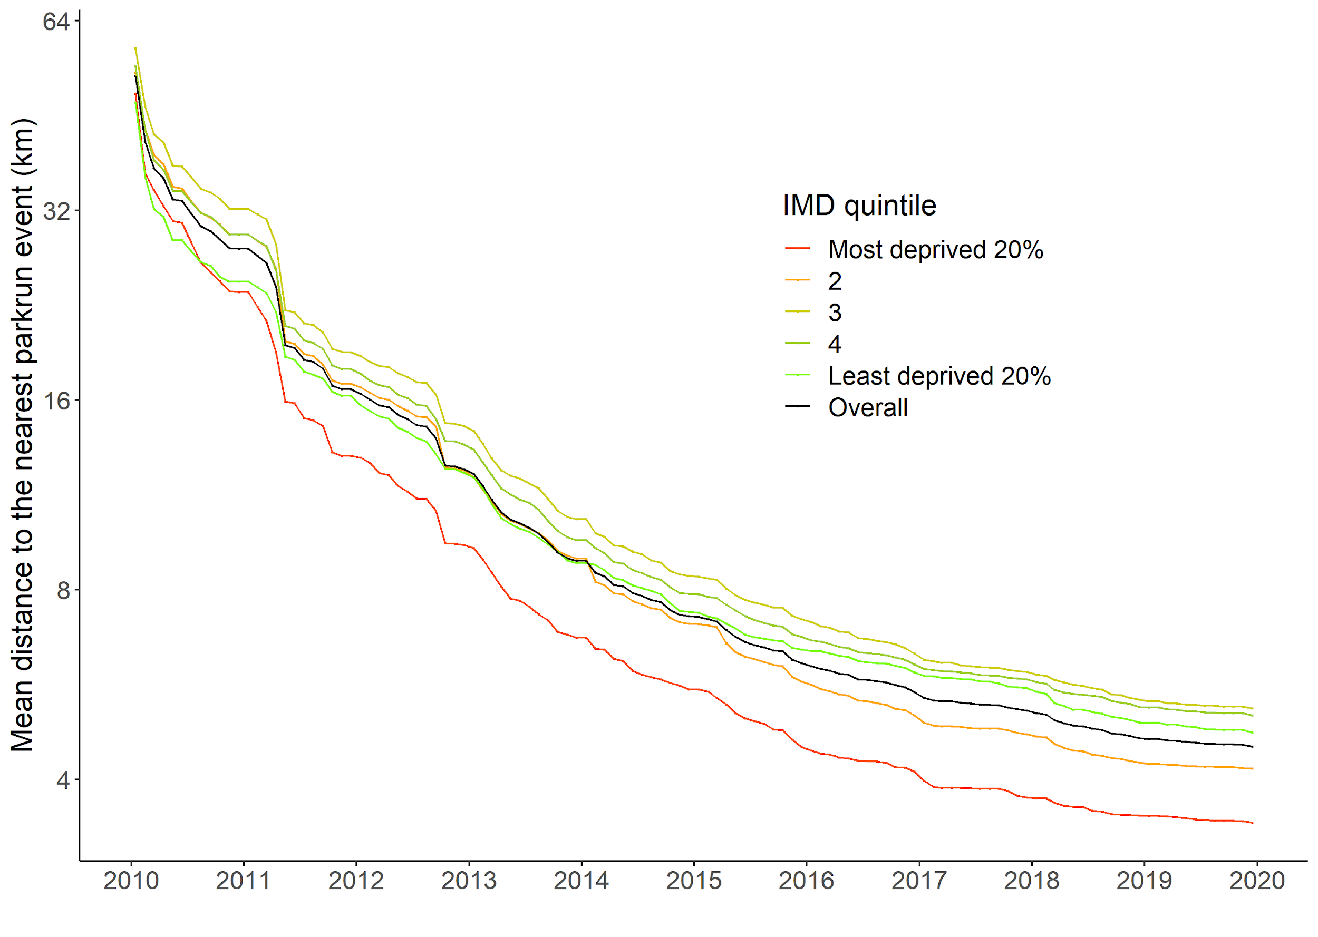

Figure 2 shows the number of finishers per 1,000 persons for each IMD quintile, and overall, for each month in the study period. A table of the numeric values can be found in Table A2 in the supplementary material. The participation rate showed a general positive trend (ignoring seasonal fluctuations) in all deprivation quintiles. In all cases participation can be seen to increase exponentially from 2010 to 2013, before exhibiting linear growth from 2014 to 2019. There is a clear difference between the participation rates for different IMD deprivation quintiles, with the most deprived 20% of LSOAs having participation rates that have been between 87% and 78% lower than that of the least deprived 20% of LSOAs. By 2019 the most deprived quintile of the population had similar participation rates as the least deprived did in 2013, six years earlier.

#### Figure 2. Mean monthly parkrun finishers per 1,000 persons from January 2010 to December 2019, by IMD quintile.

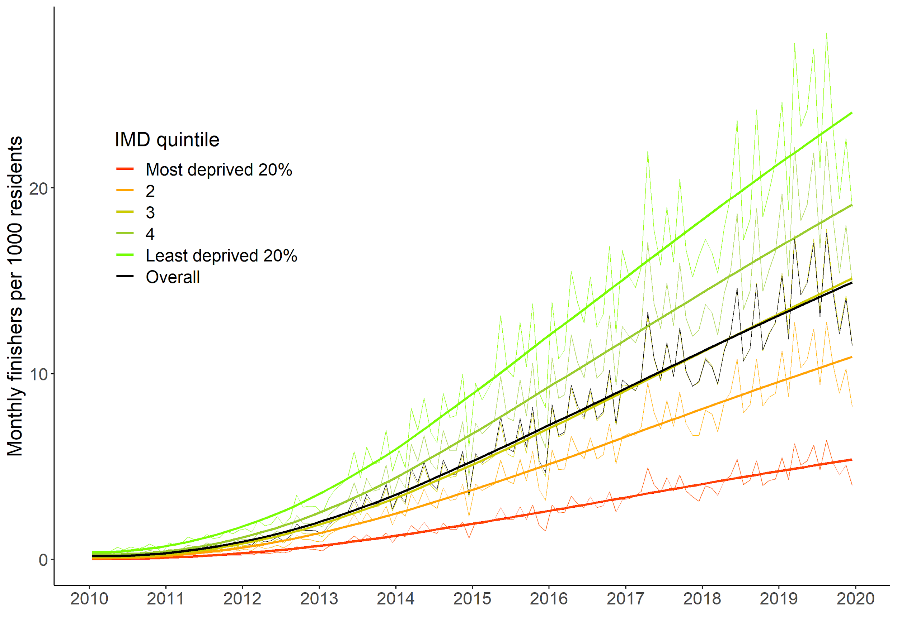

## Trends in Relative Index of Inequality in Access

Figure 3 below shows the RII for access, measured as the geodesic distance to the nearest parkrun event, over the period. An RII of 1 represents equality of geodesic distance for more and less deprived areas, while an RII above 1 means that less deprived areas had greater geodesic distances to their nearest parkrun event than more deprived areas. We can see that the distance to nearest event was equitable in 2010 but became increasingly inequitable, in favour of more deprived areas, until 2017 (i.e., new parkrun events were situated nearer to more deprived areas and further away from less deprived areas). By 2017 the **least deprived** LSOA had almost 3.5 times the predicted geodesic distance to the nearest parkrun event compared to the most deprived LSOA. This fell to approximately 2.71 by the end of 2019.

#### Figure 3. Relative Index of Inequality in geodesic distance to nearest parkrun event by month from January 2010 to December 2019.

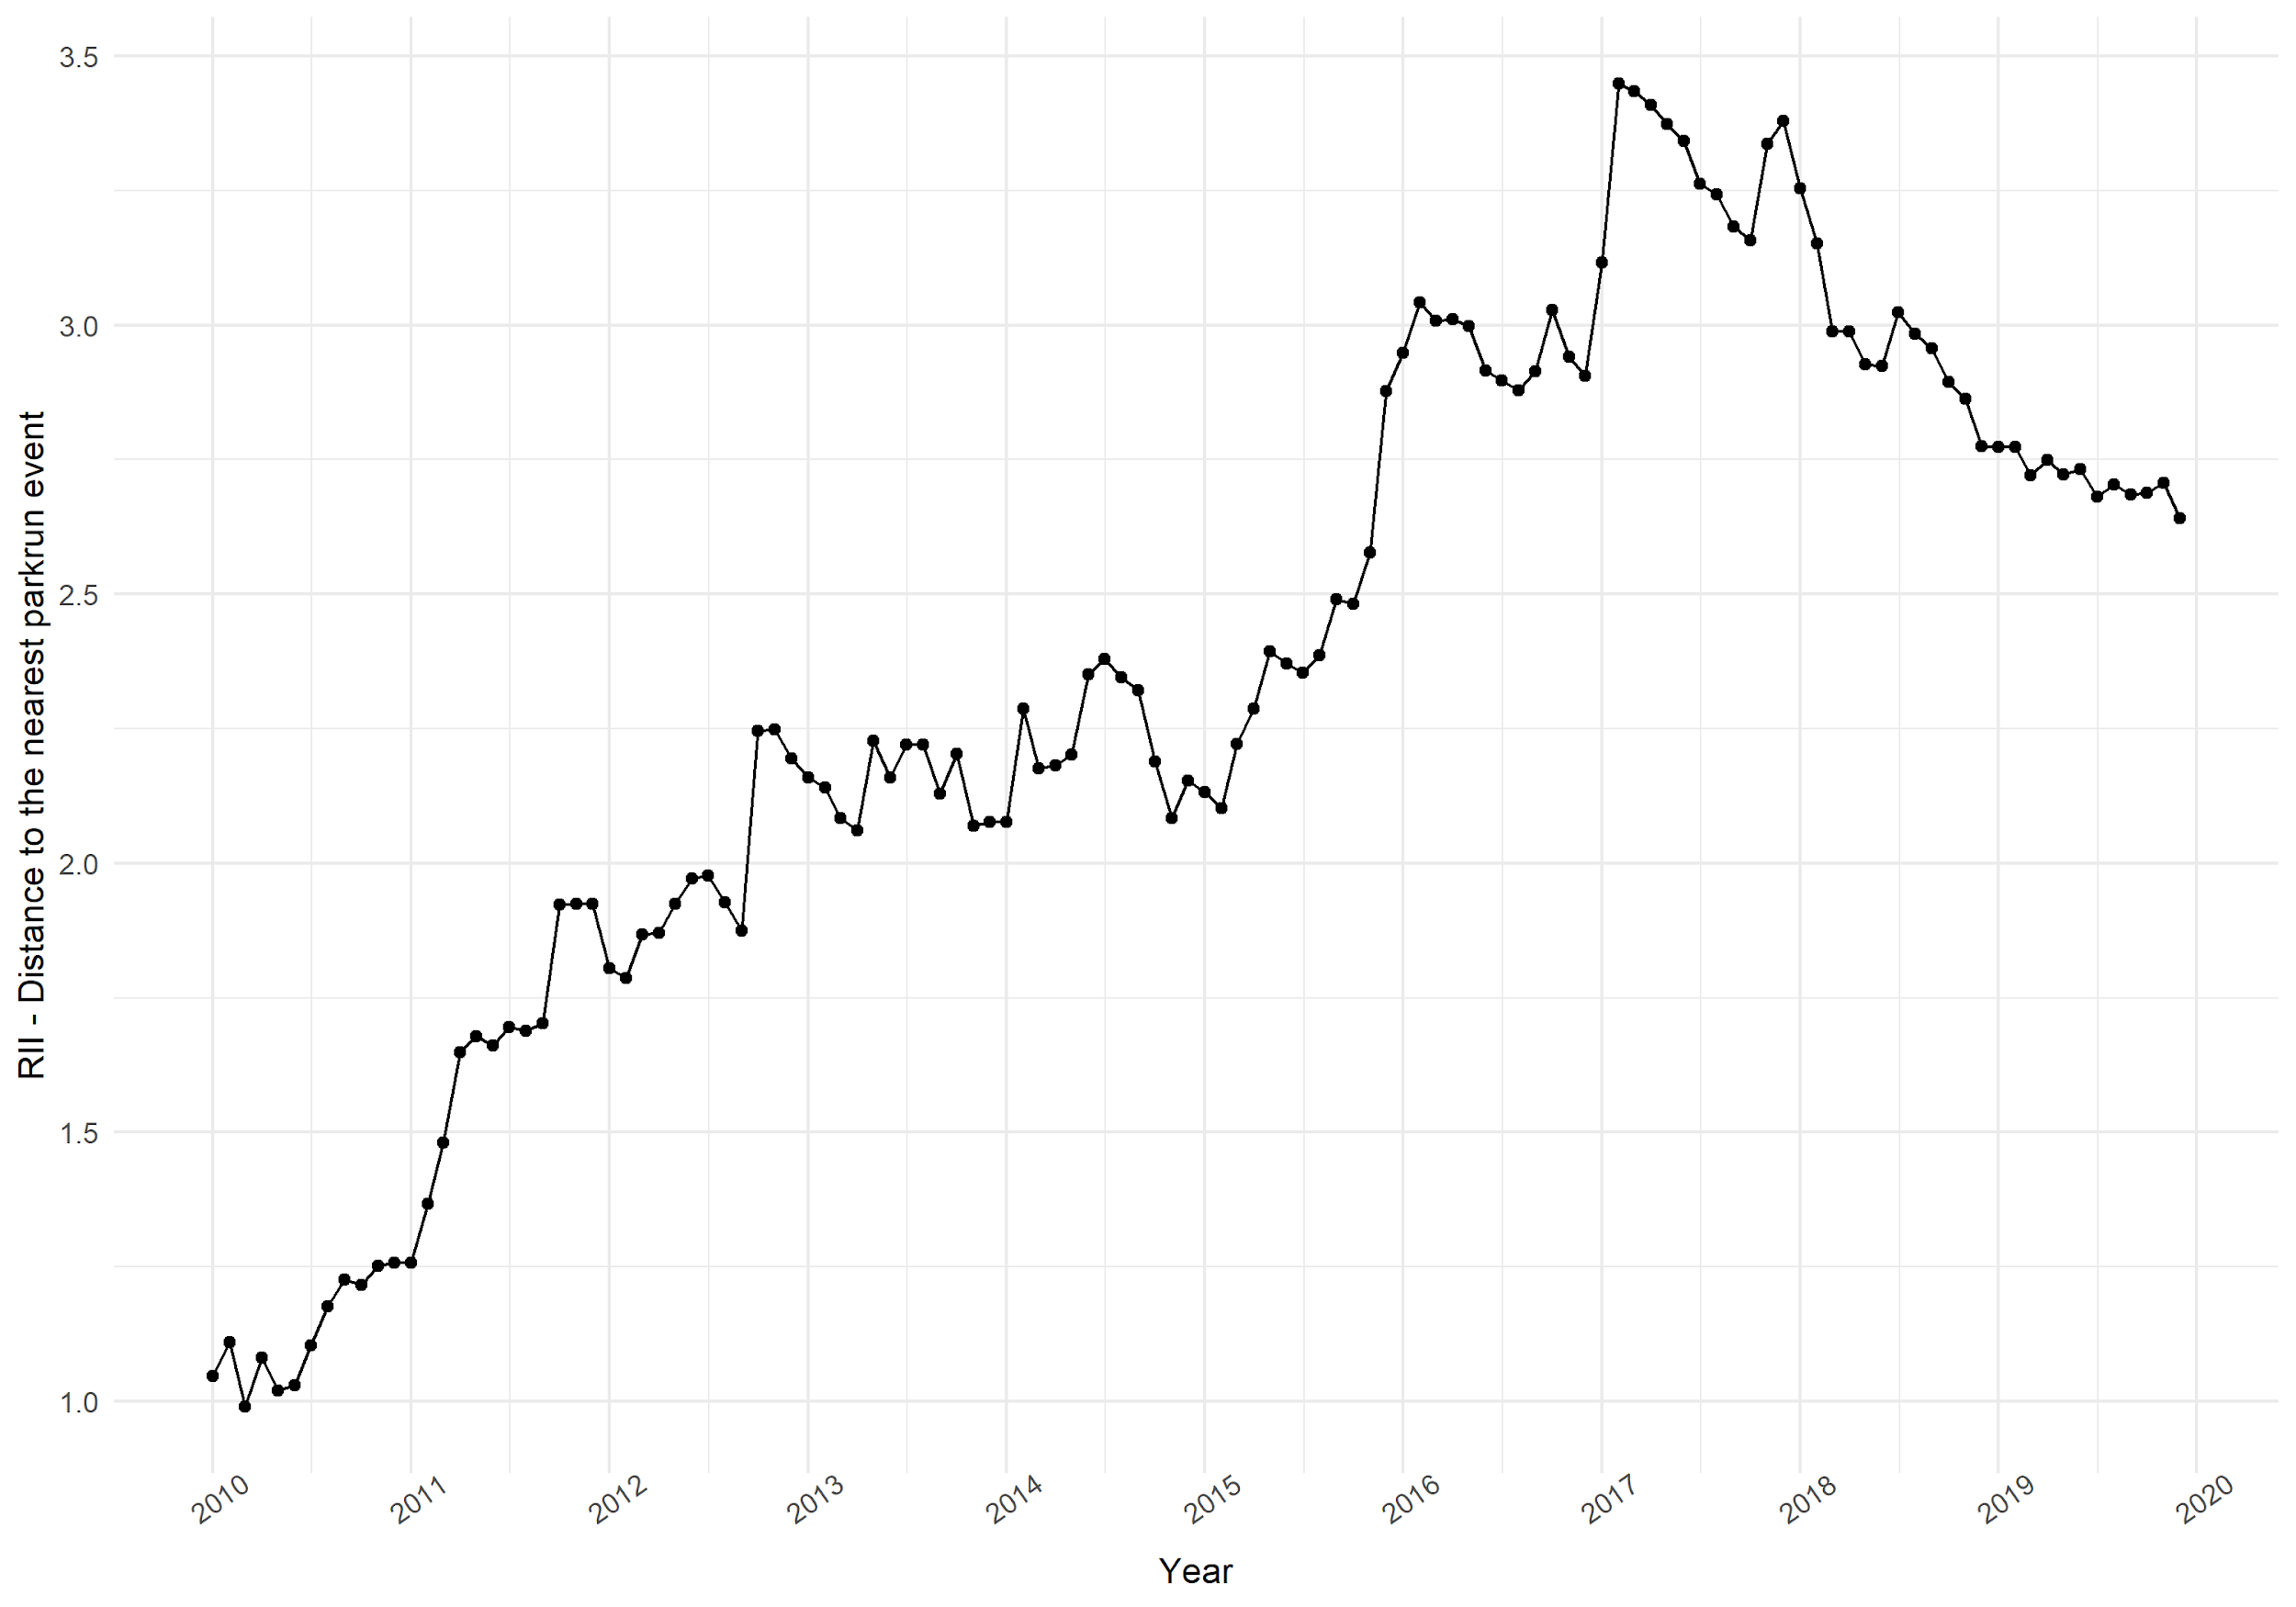

|  |  |  |  |  |  |  |  |  |  |  |
| --- | --- | --- | --- | --- | --- | --- | --- | --- | --- | --- |
| Year | 2010 | 2011 | 2012 | 2013 | 2014 | 2015 | 2016 | 2017 | 2018 | 2019 |
| RII | 1.11 | 1.60 | 1.95 | 2.15 | 2.22 | 2.37 | 2.96 | 3.30 | 2.98 | 2.71 |

Figure 4 shows the RII for monthly parkrun participation. An RII of 1 represents equality of participation between more and less deprived areas, while an RII above 1 means that less deprived areas have higher participation rates than more deprived areas. Initially in 2010, the socioeconomic gradient of parkrun participation was extremely steep, regression based predictions of participation rates (RII) were 189 times higher in the least deprived LSOA compared to the most deprived LSOA. Subsequently, the RII fell from 2010 to 2013, at which point the measure stabilised such that the least deprived area had around 35 times the predicted number of finishers as the most deprived area. We also found that the relationship exhibits yearly seasonality from the year 2013 onwards, with December being the most inequitable and January the most equitable months.

#### Figure 4. Relative Index of Inequality in monthly parkrun participation by month from January 2010 to December 2019.

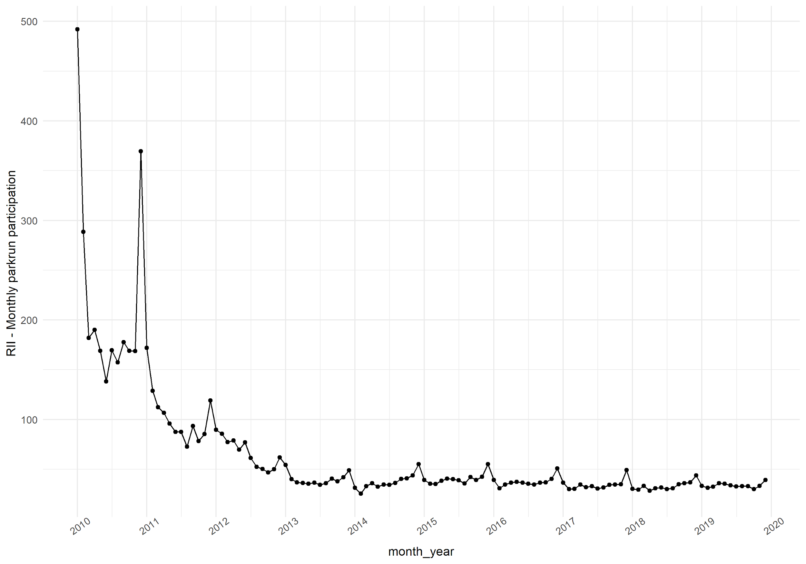

|  |  |  |  |  |  |  |  |  |  |  |
| --- | --- | --- | --- | --- | --- | --- | --- | --- | --- | --- |
| Year | 2010 | 2011 | 2012 | 2013 | 2014 | 2015 | 2016 | 2017 | 2018 | 2019 |
| RII | 189.3 | 97.3 | 61.8 | 39.0 | 36.5 | 39.6 | 37.5 | 33.9 | 32.9 | 33.5 |

## Poisson regression model of the determinants of participation from 2010 to 2019.

The results of the Poisson regression models, one for each year from 2010 to 2019, are displayed in Table 2 below. The dependent variable is number of finishers, and the independent variables include the LSOA IMD score, ethnic-density (%), population density (per-square km), distance to nearest event (in km) and percent of the population non-working age (%).

The Index of Multiple Deprivation regression coefficient is negative in every year over the ten year period (i.e. more deprived areas have lower parkrun participation). However the coefficient on IMD has increased throughout from -0.047 in 2010 to -0.035 in 2018, meaning the effect of a single unit increase in IMD score (controlling for covariates) changed from -4.7% in 2010 to -3.5% in 2018. Most of this change occurred between 2010 to 2013. It is also worth noting that the coefficient on the Ethnic Density variable has also increased over time. The effect of a 1% increase in ethnic density decreased, from a 2% reduction in participation in 2010 to a 1.3% reduction in 2018. (i.e. the effect of ethnic density, the percentage of non-white-british persons in the community, on parkrun participation has fallen over time).

#### Table 2. Results of the Poisson log-link generalised linear model for each year from 2010 to 2019.

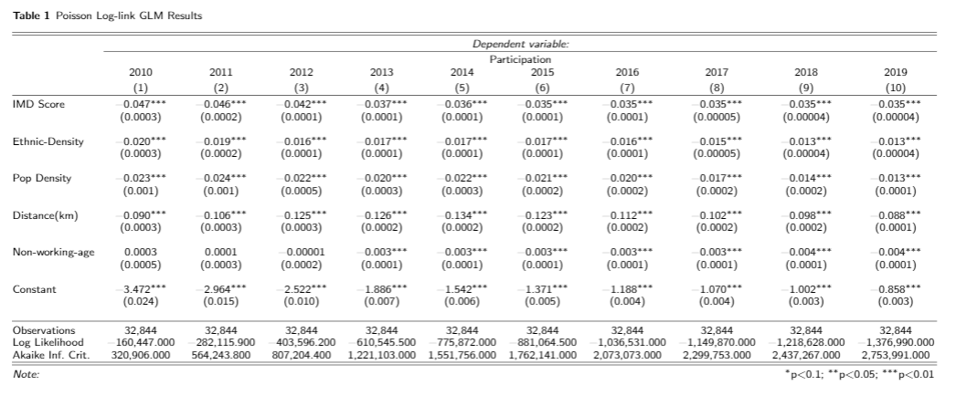

# Discussion

This article aimed to investigate the trends in community level access to and participation in parkrun, a community running and walking event, in England between 2010 and 2019. This fills an important gap in the literature as an exemplar of how community events to increase physical activity can grow, and adds to our understanding of how that growth occurs in different communities. The incredibly rich dataset provided by parkrun shows that access and participation improved over the ten year period. However these improvements exhibited diminishing returns (initial improvements were bigger than later improvements).

Geographic access to parkrun events was equitable in 2010; parkrun events were situated at similar geodesic distances from more deprived areas and less deprived areas . However, as parkrun grew, more events were launched in areas with higher deprivation (e.g. cities) than in less deprived areas such as rural village locations (note in Table 2 the coefficient for population density decreased, suggesting more participation in rural areas). Perhaps because of these disproportionate improvements in access for people from more deprived areas, participation among these communities also increased disproportionately until 2013.

Despite parkrun events being situated closer to more deprived areas, we found a strong socioeconomic gradient in parkrun participation rates. Throughout the study period, LSOAs in the least deprived quintile had between 4.5 and 7 times higher parkrun participation rates than the most deprived quintile, and after a dramatic improvement between 2010 and 2013, the RII for participation remained at a stable level of 35. This result was confirmed by the multivariable analysis of the determinants of parkrun participation, which showed only marginal changes in the relationship between IMD and parkrun participation after 2013. Despite the continous growth of parkrun in England, in 2019, the population residing in the least deprived quintile have over four times the participation rate of the population residing in the most deprived quintile.

In our previous paper, we showed that in 2018, areas in England with higher deprivation, and areas with higher ethnic density had lower parkrun participation rates (@smith2020). In this paper we replicated this analysis for each year from 2010 to 2019. We found that, as with the descriptive statistics and univariate analysis (RII), the period can be split into two distinct phases: from 2010 to 2013 the effect of deprivation (IMD) reduced, and from 2013 to 2019 the effect remained stable. However, the effect of ethnic density appears to have declined over the entire period. Nevertheless the results for 2016, 2017 and 2019 are similar enough to validate our findings for 2018.

parkrun is commonly held up as an example of a movement which is effective at increasing physical activity in the community (@reece2019bright; @stevinson2015facilitating; @stevinsonhickson). The events themselves have been perceived to be inclusive and sociable (@sharman2019health; hindley2020more), and parkrun as an organisation has been particularly focused on making events accessible to everyone regardless of background and ability (@reece2019bright). One way in which parkrun has attempted to improve accessibility is through the creation of new events. This culminated in a partnership with Sport England in 2018 which aimed to create 200 new events targeted specifically towards socioeconomically deprived communities. Our previous work suggested that improved geographic access to parkrun, while likely to increase overall participation, may also widen pre-existing inequalities in participation (@schneider2019should, @smith2020). This study validates these findings: geographical access to parkrun has consistently been better and has improved faster in more deprived areas, yet participation remains substantially lower compared to less deprived areas. It therefore seems unlikely that more events will substantially reduce inequalities in participation.

Further research is necessary to better understand why some communities are more engaged in parkrun than others. Understanding why engagement differs more or less at different times of the year may be a simple first step in this analysis, but a more robust mixed-methods approach to identifying modifiable factors which influence participation is more likely to generate feasible interventions. This could have a wider impact than just parkrun, since the mechanisms which affect participation in parkrun are also likely to influence physical activity participation and/or engagement in community events in general.

These findings have several implications for policy. Firstly, creating new events is likely to continue to increase overall participation in parkrun, but is unlikely to reduce the inequalities in participation that have been stable for the past 6 years. Strategies to encourage engagement with socioeconomically deprived communities (such as considering transport methods for non-car users as suggested in Fullagar et al., (2019) @fullagar_2019), could be incorporated into the creation of new events in order to maximize their impact, especially in socioeconomically deprived communities. Secondly, there does appear to be a trend of increasing engagement from areas with higher ethnic density. This is encouraging because it suggests that parkrun is becoming more successful at engaging with culturally diverse communities. parkrun could continue to promote participation in these communities (for example previous research has suggested engaging with community leaders or translating promotional materials into other languages @fullagar_2019).

## Limitations

The coefficients for 2018 do not perfectly match the coefficients of our previous paper (@smith2020). There are several reasons for this; firstly this analysis includes the full year, whereas the 2018 study included only the period to 10th December, secondly parkrun updated their database, which led to some (seemingly) random variation between the two datasets, and finally we only include events held on a Saturday in this analysis, whereas in the previous analysis we included all parkrun events. This has no material impact on the findings or the implications for policy.

The measure of access used in this study, geodesic distance, does not measure the ability of different groups to attend events. A 5 km distance may be more difficult to transverse in a city than for those with a car in rural areas. A model which uses estimates of travel time using travel distance and predicted transport mode may yield a better proxy for travel access, and adding a consideration of other forms of perceived access (e.g. travel expense, safety) may improve our understanding of the determinants of participation.

The use of ethnic density in this analysis does not allow us to determine variation in participation by areas with higher percentages of specific ethnic groups. Future analysis could use more detailed ONS data on the LSOAs to better understand whether the effect is similar for all minority ethnic groups. All data & code is available open source to enable others to build upon this work.

There are also several limitations that are similar from our previous analysis for 2018 (@smith2020). Firstly, the data provided by parkrun gives the number of finishes by LSOA. The number of finishes tells us nothing about the number of unique runners, and one runner undertaking 5 runs is counted the same as five runners undertaking 1 run each. We feel confident this is a satisfactory simplification. Also important is that this is an ecological study at the level of the LSOA. As before we have been careful to state that effects exist at the level of the community, not necessarily the individual, so as not to commit an ecological inference fallacy.

# Conclusion

Geographic access to and participation in parkrun events has improved over the past 10 years. The period can be split into two distinct phases: from 2010 to 2013 participation and geographical access increased exponentially and inequality in participation fell dramatically, and from 2013 to 2019 participation increased linearly, and inequality in participation remained stable.

The findings of this study suggest that prior to Covid-19 parkrun had reached a steady (linear) rate of growth in participation and the share of participation by different socioeconomic groups (e.g. quintiles of IMD). While increases in participation are likely to continue to increase for all socioeconomic groups, closing the gap in participation between the most and least deprived communities is likely to require careful intervention.

Mixed methods research combining the power of the rich participation dataset provided by parkrun with a deeper understanding of the issues on the ground is essential for shaping effective interventions to boost participation overall, but particularly in socio-economically deprived communities.

# References

Bibtex link:

@article{schneider2019should,

title={Where should new parkrun events be located? modelling the potential impact of 200 new events on socio-economic inequalities in access and participation.},

author={Schneider, Paul P and Smith, Robert A and Bullas, Alice M and Bayley, Thomas and Haake, Steve SJ and Brennan, Alan and Goyder, Elizabeth},

journal={MedRxiv},

pages={19004143},

year={2019},

publisher={Cold Spring Harbor Laboratory Press}

}

@article{sharman2019health,

title={Health and broader community benefit of parkrun—An exploratory qualitative study},

author={Sharman, Melanie J and Nash, Meredith and Cleland, Verity},

journal={Health promotion journal of Australia},

volume={30},

number={2},

pages={163--171},

year={2019},

publisher={Wiley Online Library}

}

@article{fullagar_2019,

title={Action research with parkrun UK volunteer organizers to develop inclusive strategies}, DOI={10.1093/heapro/daz113},

journal={Health Promotion International},

author={Fullagar, Simone and Petris, Sandra and Sargent, Julia and Allen, Stephanie and Akhtar, Muhsina and Ozakinci, Gozde},

year={2019}}

@misc{haake_quirk_bullas_2018,

title={UK & Ireland parkrun Health & Wellbeing survey 2018}, url={https://awrcparkrunresearch.wordpress.com/2018/10/20/uk-ireland-parkrun-health-wellbeing-survey-2018-✓-output-available/}, journal={Advanced Wellbeing Research Centre Parkrun Research},

publisher={Sheffield Hallam University},

author={Haake, Steve and Quirk, Helen and Bullas, Alice},

year={2018},

month={Oct}}

@article{schneider2019should,

title={Where should new parkrun events be located? modelling the potential impact of 200 new events on socio-economic inequalities in access and participation.},

author={Schneider, Paul P and Smith, Robert A and Bullas, Alice M and Bayley, Thomas and Haake, Steve SJ and Brennan, Alan and Goyder, Elizabeth},

journal={MedRxiv},

pages={19004143},

year={2019},

publisher={Cold Spring Harbor Laboratory Press}

}

@article{hindley2020more,

title={“More than just a run in the park”: An exploration of parkrun as a shared leisure space},

author={Hindley, David},

journal={Leisure Sciences},

volume={42},

number={1},

pages={85--105},

year={2020},

publisher={Taylor \& Francis}

}

@article{wiltshire2018exploring,

title={Exploring the role of social capital in community-based physical activity: qualitative insights from parkrun},

author={Wiltshire, Gareth and Stevinson, Clare},

journal={Qualitative Research in Sport, Exercise and Health},

volume={10},

number={1},

pages={47--62},

year={2018},

publisher={Taylor \& Francis}

}

@article{schneider2019should,

title={Where should new parkrun events be located? modelling the potential impact of 200 new events on socio-economic inequalities in access and participation.},

author={Schneider, Paul P and Smith, Robert A and Bullas, Alice M and Bayley, Thomas and Haake, Steve SJ and Brennan, Alan and Goyder, Elizabeth},

journal={MedRxiv},

pages={19004143},

year={2019},

publisher={Cold Spring Harbor Laboratory Press}

}

@article{bull2014interventions,

title={Are interventions for low-income groups effective in changing healthy eating, physical activity and smoking behaviours? A systematic review and meta-analysis},

author={Bull, Eleanor R and Dombrowski, Stephan U and McCleary, Nicola and Johnston, Marie},

journal={BMJ open},

volume={4},

number={11},

year={2014},

publisher={British Medical Journal Publishing Group}

}

@article{stevinsonhickson,

title={Facilitating participation in health-enhancing physical activity: a qualitative study of parkrun},

author={Stevinson, Clare and Wiltshire, Gareth and Hickson, Mary},

journal={International journal of behavioral medicine},

volume={22},

number={2},

pages={170--177},

year={2015},

publisher={Springer}

}

@book{world2019global,

title={Global action plan on physical activity 2018-2030: more active people for a healthier world},

author={World Health Organization},

year={2019},

publisher={World Health Organization}

}

@article{smith2020,

title={Does ethnic density influence community participation in mass participation physical activity events? The case of parkrun in England},

author={Smith, Robert and Schneider, Paul and Bullas, Alice and Haake, Steve and Quirk, Helen and Cosulich, Rami and Goyder, Elizabeth},

journal={Wellcome Open Research},

volume={5},

year={2020},

publisher={The Wellcome Trust}

}

@article{schneider2019,

title={Where should new parkrun events be located? modelling the potential impact of 200 new events on socio-economic inequalities in access and participation.},

author={Schneider, Paul P and Smith, Robert A and Bullas, Alice M and Bayley, Thomas and Haake, Steve SJ and Brennan, Alan and Goyder, Elizabeth},

journal={MedRxiv},

pages={19004143},

year={2019},

publisher={Cold Spring Harbor Laboratory Press}

}

@article{reece2019bright,

title={Bright Spots, physical activity investments that work: Parkrun; a global initiative striving for healthier and happier communities},

author={Reece, Lindsey J and Quirk, Helen and Wellington, Chrissie and Haake, Steve J and Wilson, Fiona},

journal={British journal of sports medicine},

volume={53},

number={6},

pages={326--327},

year={2019},

publisher={BMJ Publishing Group Ltd and British Association of Sport and Exercise Medicine}

}

@article{stevinson2015facilitating,

title={Facilitating participation in health-enhancing physical activity: a qualitative study of parkrun},

author={Stevinson, Clare and Wiltshire, Gareth and Hickson, Mary},

journal={International journal of behavioral medicine},

volume={22},

number={2},

pages={170--177},

year={2015},

publisher={Springer}

}

@article{mondor2018income,

title={Income inequalities in multimorbidity prevalence in Ontario, Canada: a decomposition analysis of linked survey and health administrative data},

author={Mondor, Luke and Cohen, Deborah and Khan, Anum Irfan and Wodchis, Walter P},

journal={International journal for equity in health},

volume={17},

number={1},

pages={90},

year={2018},

publisher={Springer}

}

@misc{royalparkrun,

title={Parkrun practice initiative. 2018},

author={Royal College of General Practitioners and others}

}

# Appendix

Table A1 - Mean geodesic distance to the nearest parkrun event by IMD quintile for each year from 2010 to 2019.

|  |  |  |  |  |  |  |  |  |  |  |
| --- | --- | --- | --- | --- | --- | --- | --- | --- | --- | --- |
| Year | 2010 | 2011 | 2012 | 2013 | 2014 | 2015 | 2016 | 2016 | 2018 | 2019 |
| Overall | 34.09 (0.06) | 20.79 (0.04) | 14.53 (0.03) | 10.21 (0.02) | 7.93 (0.01) | 6.66 (0.01) | 5.79 (0.01) | 5.27 (0.01) | 4.85 (0.01) | 4.58 (0.01) |
| Most deprived 20% | 30.57 (0.13) | 16.84 (0.08) | 11.21 (0.05) | 7.72 (0.03) | 6.02 (0.02) | 5.03 (0.02) | 4.29 (0.01) | 3.86 (0.01) | 3.60 (0.01) | 3.46 (0.01) |
| 2 | 35.64 (0.17) | 21.52 (0.11) | 14.86 (0.07) | 10.19 (0.05) | 7.72 (0.03) | 6.36 (0.02) | 5.35 (0.02) | 4.82 (0.02) | 4.43 (0.02) | 4.2 (0.02) |
| 3 | 38.82 (0.15) | 23.94 (0.1) | 16.9 (0.07) | 11.95 (0.04) | 9.18 (0.03) | 7.77 (0.03) | 6.73 (0.02) | 6.05 (0.02) | 5.61 (0.02) | 5.25 (0.02) |
| 4 | 35.52 (0.13) | 22.2 (0.08) | 15.7 (0.06) | 11.12 (0.04) | 8.61 (0.03) | 7.29 (0.02) | 6.39 (0.02) | 5.88 (0.02) | 5.44 (0.02) | 5.13 (0.01) |
| Least deprived 20% | 29.92 (0.1) | 19.46 (0.06) | 13.98 (0.04) | 10.09 (0.03) | 8.11 (0.02) | 6.85 (0.02) | 6.18 (0.02) | 5.73 (0.02) | 5.16 (0.01) | 4.84 (0.01) |

*1 = most socioeconomically deprived quintile , 5 = least socioeconomically deprived quintile,

Standard errors in parentheses.

Table A2 - Mean monthly parkrun finishers per 1,000 persons by IMD quintile for each year from 2010 to 2019.

|  |  |  |  |  |  |  |  |  |  |  |
| --- | --- | --- | --- | --- | --- | --- | --- | --- | --- | --- |
| Year | 2010 | 2011 | 2012 | 2013 | 2014 | 2015 | 2016 | 2016 | 2018 | 2019 |
| Overall | 0.26 (0) | 0.6 (0) | 1.23 (0) | 2.71 (0.01) | 4.38 (0.01) | 6.13 (0.01) | 8.26 (0.02) | 10.43 (0.02) | 11.8 (0.02) | 14.43 (0.02) |
| Most deprived 20% | 0.07 (0) | 0.18 (0) | 0.42 (0) | 1 (0.01) | 1.61 (0.01) | 2.21 (0.01) | 2.97 (0.01) | 3.82 (0.02) | 4.3 (0.02) | 5.22 (0.02) |
| 2 | 0.15 (0) | 0.37 (0) | 0.81 (0.01) | 1.93 (0.01) | 3.14 (0.02) | 4.32 (0.02) | 5.85 (0.03) | 7.53 (0.03) | 8.66 (0.03) | 10.52 (0.04) |
| 3 | 0.21 (0) | 0.52 (0.01) | 1.1 (0.01) | 2.54 (0.02) | 4.24 (0.02) | 5.89 (0.03) | 8.12 (0.03) | 10.37 (0.04) | 11.83 (0.04) | 14.59 (0.05) |
| 4 | 0.34 (0.01) | 0.77 (0.01) | 1.55 (0.01) | 3.37 (0.02) | 5.58 (0.03) | 7.87 (0.03) | 10.65 (0.04) | 13.35 (0.04) | 15.08 (0.05) | 18.51 (0.06) |
| Least deprived 20% | 0.54 (0.01) | 1.17 (0.01) | 2.28 (0.02) | 4.69 (0.03) | 7.35 (0.03) | 10.36 (0.04) | 13.72 (0.05) | 17.07 (0.05) | 19.14 (0.05) | 23.32 (0.06) |

*1 = most socioeconomically deprived quintile , 5 = least socioeconomically deprived quintile, Standard errors in parentheses.

To do:

* Clarify RII, can we make this easier to follow?
* More of a story (Helen/Liddy to help?)

From discussion with Helen:

1. parkrun ***is*** attracting those from the most deprived communities (woop, v. important!). Nowadays, parkruns tend to be situated closer to deprived communities compared to less deprived communities. (refraining from saying access is 'better'- because I don't think that's necessarily true)
2. but... participation rates are much higher in less deprived communities (or lower in more deprived communities - whichever lens you want to take!)
3. that said...deprivation status has become less influential on participation rate over time (especially between 2010 and 2013) i.e., more equitable; the gap in participation rates between those from more and less deprived communities reduced
4. In more recent times, the influence/effect of deprivation status on participation rates has become more stable - parkrun isn't getting more inequitable, but it's also not getting more equitable.
5. If we want parkrun to be more equitable (which we do if it's going to be considered a viable public health intervention), then we need to do something about it (i.e., intervene) because the data is showing that it's not going to correct itself.
6. That 'something' needs to be about exploring the barriers to participation among people living in more deprived areas.... perhaps looking at the potential value of the parkrun practice initiative in reaching these communities and referring people to parkrun who might benefit the most.

From Steve:

Findings

1. The median IMD of the parkrunners was 17.6 (IQR 9.9 – 29.6) [How does this compare to the population? This seems low]
2. The median ethnic density of the parkrunners was 5.2% (IQR 2.3 – 16.7%) [How does this compare to the population?]
3. Between 2010 and 2013, the mean distance to parkrun dropped rapidly from 35 to 10 km; after this it dropped to less than 5 km over the next 6 years.
4. Between 2010 and 2103, the mean distance for Q1 and Q5 were similar with a maximum for Q3; by 2019, Q1 was consistently lower than Q5. [see attached graphs]
5. The number of finishers increased exponentially between 2010 and 2103; in 2010 Q1 was 5.3% of total, Q5 was 41.2% of total i.e. 8 times more from Q5 than Q1.
6. The number of finishers increased linearly between 2014 and 2109; in 2019 Q1 was 7.2% of total, Q5 was 32.3% of total i.e. 4 times more from Q5 than Q1.
7. The reason for this might be that parkruns now favour lower IMD i.e. RII for access favouring deprived communities [we need to ask parkrun how their policies changed over this period]
8. Participation has lower dependence on ethnic density, i.e. in 2010 the IQR range would have decreased participation by 28.8%, by 2019 this decrease would have been 18.7%
9. There is a similar effect with population density.
10. Parkrun attracts fewer from deprived communities, but has improved over 10 years
11. Access has improved, favouring deprived communities
12. There were two phases of growth, exponential 2010 to 2013 and linear thereafter – this was a consequence of parkrun development policy (was it?!)

From Liddy:

1. checking we do have the right ethics and governance to use this for research (as well as for doing useful analysis for parkrun) and

2. that we clarify what the research question(s) is that we are addressing with this analysis. That would obviously help with choice of journal, and identifying the relevant wider contextual material for introduction and discussion as suggested.

There are some really interesting findings but I do think we just need a much clearer rationale to publish them. At the moment these observations of expected/unexpected findings and what they might tell us are scattered through the draft paper and I am struggling to generate the "message" (from which we could work back to the "question").

Better understanding the determinants of engagement with parkrun, and how these changed over time. Despite the fact that access