**CAUS Reconciliation Instructions**

University Reconciliation Procedures may be found at[**http://www.co.vt.edu/Procedures/10305a.pdf**](http://www.co.vt.edu/Procedures/10305a.pdf)**.**

**Monthly Reconciliations:**

* Organization transaction reconciliation
  + VT funds
  + VTF funds
* Salary/wage position reconciliations
* CASHNet reconciliation
* P-card reconciliation
* CNS user and usage reconciliation
* CNS ICR requests
* Leave submission and overtime compensation reconciliation

**Organization transaction reconciliation**

1. On the first business day of each month, access Web Report Submissions at: <https://webapps.es.vt.edu/webreport/submit>.
2. 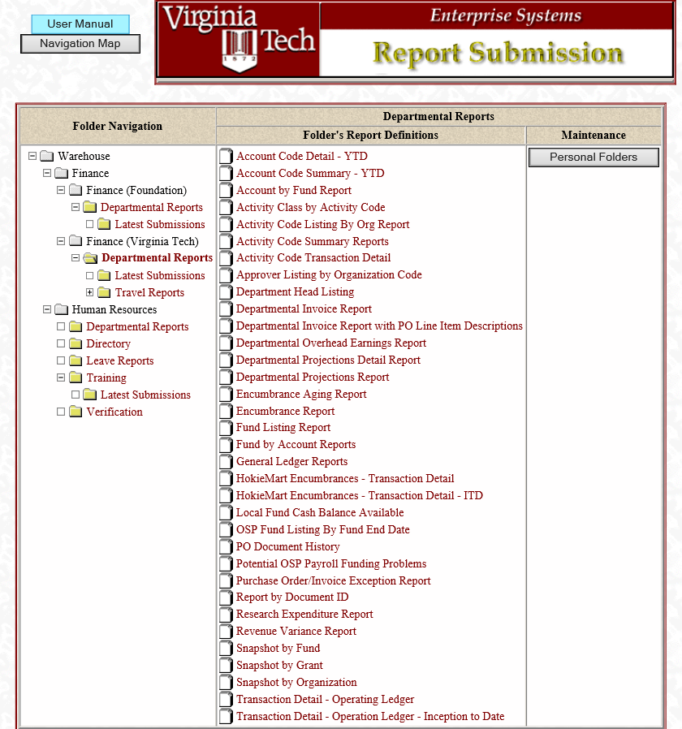On the left side, select Departmental Reports under Finance (Virginia Tech) and Snapshot by Organization from the list on the right. For VTF reports, click Departmental Reports under Finance (Foundation) and run the VTF Operating Ledger Transactions report.
3. After choosing Snapshot by Org, complete the required Parameters:

Calendar Month: Prior

Required Org codes

Revenues/Expenditure (blank for both)

Specific funds if necessary

Create data (Excel) file: optional

1. Click submit to run the report.
2. Next, run the Transaction Detail – Operating Ledger with the same parameters.
3. Click submit to run the report.
4. An email will be received to access each report from Web Report Distribution, or you can directly access the reports at: <https://webapps.es.vt.edu/webdist/webviewer>
5. A reconciliation should be completed for each organizational transaction.

*Verify that transactions were properly initiated and authorized.

*Verify that transactions were initiated and posted in a reasonable period.

*Review all transactions for accuracy and agree amounts back to the department’s originating documentation.

*Scan for unusual amounts or vendors.

*Contact the Controller’s Office for supporting documentation if you have no documentation.

1. Document those items that do not agree to your originating documents and follow-up with the proper personnel in order to resolve the item within 60 days.
2. Use tick marks or highlight items that are reconciling items. This shows evidence of reconciliation.
3. Start with one fund at a time and check off each transaction as you reconcile it to backup documentation. You should find Purchase Orders in HokieMart; invoices either in CAUS electronic documentation and/or as an attachment in Banner (FOIDOCH).
4. Budget entries with the PID: ‘msimpso’ are transactions performed by made by Marty Simpson. Supporting documentation is maintained in her files.
5. Initial the transaction report after your review is complete.
6. Print the Snapshot by Organization reconciliation certification page (second to last page of the report). List all orgs or funds reconciled, sign, and have reviewed and approved by the Department head within 30 days of the close of the reconciled period.
7. The report and certification statement must be retained in the department’s files for 3 years.

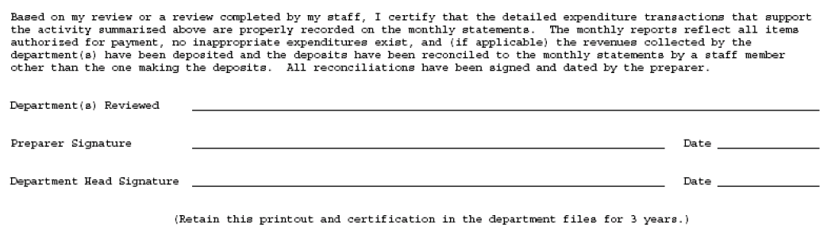

**Salary transaction reconciliations**

1. This reconciliation is completed using the Snapshot by Organization and Transaction Detail – Operating Ledger reports run in the previous Organization transaction reconciliation. Compare this information to the Salary Verification or the Wage-1500 Hour Report, which are run in Web Report Submission, Human Resources.
2. Review salary transactions for reasonableness and be familiar with the employee’s names.
3. Contact the Payroll Office for additional information for names that need further information or clarification.
4. Use tick marks or highlight items that are reconciling items. This shows evidence of reconciliation.
5. Initial the transaction report after your review is complete.
6. Print the Snapshot by Organization reconciliation certification page (second to last page of the report). List all orgs or funds reconciled, sign, and have reviewed and approved by the Department head within 30 days of the close of the reconciled period.
7. The report and certification statement must be retained in the department’s files for 3 years.

 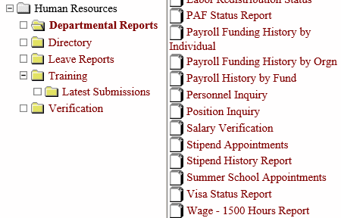

**Wage transaction reconciliations**

1. Print the Wage Reconciliation Reports that the Payroll Office sends by email to the reconciler. The Payroll Office sends the reports a few days after the end of each pay period.
2. Print the TCP Payroll Summary Report for each org for the corresponding pay period. These are found in the TimeClock Plus system under Reports. (<https://timeclock.vt.edu/menu/>) User information for TimeClock Plus can be found at <http://www.co.vt.edu/accounting_operations/Payroll/Timeclock.html>.
3. If the wage hours are not found for an employee on the TCP Payroll Summary Report, print and check the Time Card Entry Verification web report for the wages in question. This report may be found under Human Resources, verification in the Report Submission system. (<https://webapps.es.vt.edu/webreport/submit>)
4. Compare the reports. If discrepancies are found, work with the department approver to resolve the issues.
5. Sign, date and file the Wage Reconciliation Report and file it with the TCP Payroll Summary Report and the Time Card Entry Verification report if needed.
6. The reconciliation should be completed promptly after the reports are received.





**CASHNet reconciliation**

1. Access the university cashier system, CASHNet, using Internet Explorer, through Hokie Spa ([www.hokiespa.vt.edu](http://www.hokiespa.vt.edu)).
2. 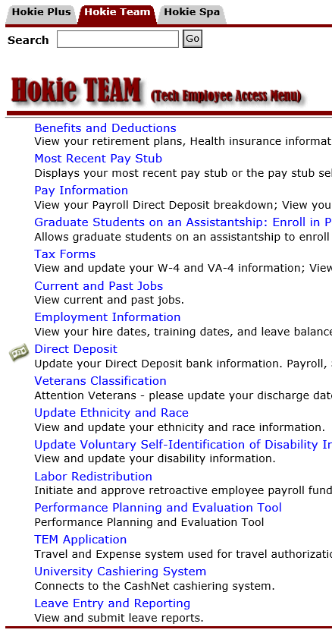Click the Hokie Team tab and select the link for the University Cashiering System from the list.
3. Begin by clicking Reports at the top of the CAHSNet page and select the Departmental Deposits Open. Enter the dates for the previous fiscal period.
4. 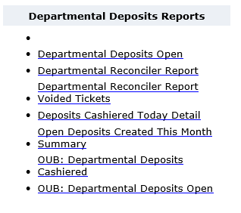A report of all open deposits will then display for the specified date range. These are deposits that were entered during the time period that have not yet been receipted for your department (not yet tendered by the Bursar’s Office). For reconciliation purposes, print this report.
5. Any items showing in the report ‘Departmental Deposits Open’ would be considered as outstanding reconciling items because they have not yet been entered on the finance system. These reconciling items should clear the following month and would then appear on the next month’s CASHNet report titled ‘Departmental Reconciler Report’ as well as the monthly finance report.
6. Access the departmental reconciler report by clicking Reports at the top of the CASHNet page and select the Departmental Reconciler Report link. Enter the dates for the previous period.
7. A report of all tendered deposits will then display for the specified date range. These are deposits that were receipted for your department during the time period (tendered). For reconciliation purposes print this report.
8. Each item shown on the ‘Departmental Reconciler Report’ should be matched to entries on monthly finance reports for each G/L fund which you are reconciling. Should there be a discrepancy, it will be necessary for you to make the correction through the University Controller’s Office.
9. The Business Manager conducting the monthly CASHNet reconciliation should include or attach supporting documentation for the deposited items on the Departmental Deposits Open report and the Departmental Reconciler Report. Supporting documentation includes notes, emails, documents from vendors. It is the responsibility of the CASHNet enterer to provide or include the area Business Manager with the supporting documentation at the time of the CASHNet entry.

**P-card reconciliation**

**Reconciling Charges:**

* The monthly billing cut off is the 15th of the month. Cardholders will receive a hard copy of the statement. The Payment Certification Form and the original P-Card statement must be submitted to the Controller's Office by the 10th of the following month.
* If an incorrect charge or credit appears on the P-Card statement, it should be treated like any other charge or credit for reconciliation purposes as the statement must be paid each month in its entirely. See [Returns, Credits, Disputed Items](http://www.procurement.vt.edu/Department/Procedures/ge.html#return) instruction on how to handle incorrect charges.

1. Once the P-Card statement is received, compare the log and/or the itemized receiving file documentation provided by the vendor to the P-Card statement to assure the charges are accurately listed on the P-Card statement.
2. If a purchase does not appear on the P-Card statement, make a note in the log or on the file documentation. Maintain this documentation so it can be used when reconciling a subsequent statement.
3. If the payment is being placed on the default fund, select the "All charges and credits are correct and should be posted to the default fund" box on the P-Card Payment Certification Form.
4. If the payment is being distributed to multiple funds, write the corresponding fund and account codes on the P-Card statement or P-Card log for each transaction (log must be in Statement order).
5. You may use up to four different funds and/or account codes for a single charge. If using log, the items must be in Statement order.
6. P-Card reconciliations should be saved as an electronic document per cardholder in the CAUS share drive.

**Reconciling Credits:**

1. Compare the credit documentation provided by the vendor to the P-Card statement to assure credits are accurately listed on the P-Card statement. Retain all credit documentation in the file.
2. If a credit does not appear on the P-Card statement, make a note in the log or on the file documentation. Keep this documentation so it can be used when reconciling a subsequent statement.
3. If the credit is being placed on the default fund, select the "All charges and credits are correct and should be posted to the default fund" box on the P-Card Payment Certification Form.
4. If the credit is being distributed to multiple funds, write the corresponding fund and account on the P-Card statement or P-Card log for each credit.
5. You may use up to four different funds and/or account codes for a single charge. If using log, the items must be in Statement order.

**Payment Certification Form**

1. Complete following sections of the [P-Card Payment Certification Form](http://www.procurement.vt.edu/Department/Forms/gee.doc):   
   - Department Number   
   - Department Name   
   - Card Number  
   - Cardholder's Name  
   - Cardholder's 9 digit employee ID#   
   - Statement Closing Date   
   - Balance Outstanding   
   - Method of fund distribution - (Select either "All charges are correct and should be posted per the attached sheets" or "All charges are correct and should be posted to the default fund")
2. Sign and date the Cardholder Signature section.

**NOTE:** This block should be signed by the cardholder. If, on rare occasions, the cardholder is unavailable for several days, have another person that is familiar with the purchases sign the form. **Attach a note of explanation when someone else signs for the cardholder**.

1. Obtain payment approval signature from the Department Head or employee with signature authority. Two signatures are required on this form, therefore the cardholder (or person signing for the cardholder) cannot sign again as the approver.

**NOTE:** The person signing to approve the payments must review their responsibilities on page two of the [P-Card Payment Certification Form](http://www.procurement.vt.edu/Department/Forms/gee.doc) and is signing to validate that all charges are correct or that action is being taken to correct incorrect charges.

1. Make copies of the completed P-Card Payment Certification Form, the P-Card statement, and if necessary any [documentation from airline ticket purchases](http://www.procurement.vt.edu/Department/Procedures/ge.html#travel) for the departmental files.
2. Send the Payment Certification Form, P-Card statement, and all original documentation for airline ticket purchases if required ([see procedure below for complete requirements](http://www.procurement.vt.edu/Department/Procedures/ge.html#travel)) to the following address by the **10th** of the following month:

Controller's Office (0312)   
North End Center, Suite 3300   
300 Turner Street   
Blacksburg, VA 24061

**NOTE:** Additional documentation for airline ticket purchases (see [www.controller.vt.edu/Procedures/20335e.pdf](http://www.controller.vt.edu/Procedures/20335e.pdf) ) must be attached to the P-Card Payment Certification form if the Department Head or the designee approving the monthly certification form has travel expenses in the monthly statement, the cardholder must attach a copy of the Department Head’s travel approval form (approved by the Dean or Vice President) to meet the university’s requirement that anyone receiving anything of value using public funds must have that approved by the “next higher level of supervision.” Additionally, if the Department Head’s designee approves the certification form AND has travel expenses in the monthly statement, the cardholder must attach a copy of the approved TEM authorization (approved by the Department Head) to the certification.

**NOTE:** If this date is not met, the Controller’s Office will post the charges on the P-Card Statement to the default fund (as indicated on the P-Card Employee Agreement form). Subsequently, any fund and/or account code transfers will be the responsibility of the departments. Any finance/late charge assessed due to the Controller’s Office inability to secure the proper documentation from the departments will also be charged to the department. Failure to reconcile may result in card cancellation. Additionally, if an invalid fund and or account is submitted, the Controller’s Office will post charges to the default fund.

1. Retain the following documents: The P-Card statement, the Payment Certification Form, any airline ticket documentation, any Sponsored Program approval forms, the vendor's itemized receiving and credit documentation that pertains to that statement, and any other documentation generated to support the business purpose for the expenditure in the departmental files for 3 years.

**CNS user and usage reconciliation**

1. CNS Reports can be downloaded at <https://cola.cns.vt.edu/apps/classmenu.action> by clicking Departmental Manager.
2. Select the check box to the left of each fund to check for CNS activity for activity details. The transaction detail report and the telecommunication charge activity details should be printed and reconciled to one another. Sample of CNS screen below.
3. Review each CNS report for users vs. phone line accuracy.
4. Wireless Mobile Communication Device users will need to review, sign, and return the prior month bill to certify accuracy and appropriate use.
5. Print the fund listing below to use as a reconciliation cover page. This document should be signed and dated by the reconciler and the approver.
6. The report reconciliation and certification must be retained in the department’s files for 3 years.

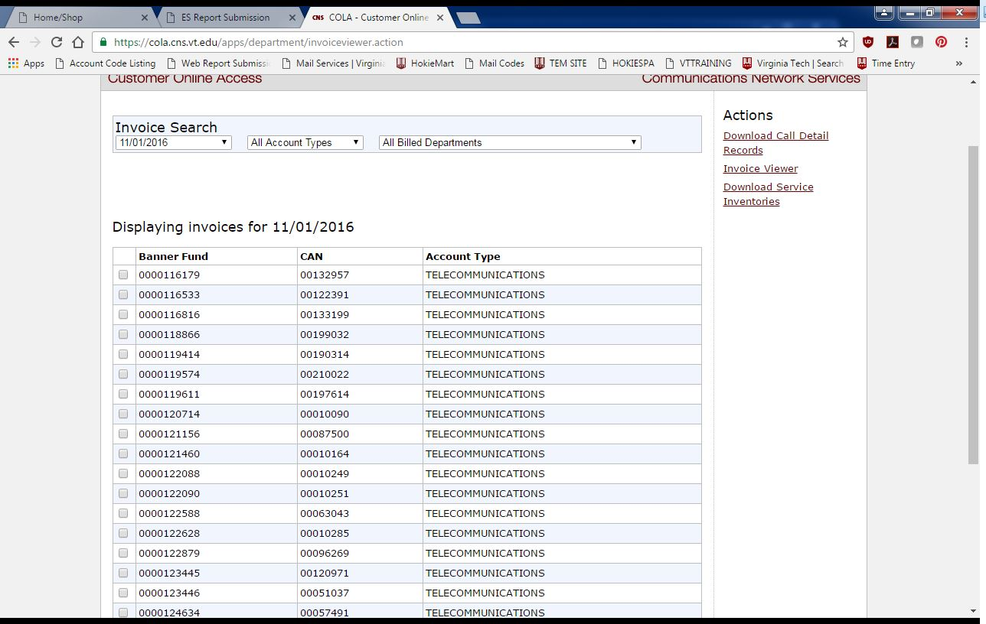

**Communications Network Services – ICR Requests**

1. An ICR (Interdepartmental Communications Request) <https://cola.cns.vt.edu> is a request to CNS to move, change, disconnect existing services, or add new services. Note – a move is a transition from one office or department to another. This is critical for 911 response (COOP) and departmental billing.
2. If an employee action needs to occur as noted in step 1, the employee should contact their supervisor or fund manager via email stating the request and the justification for the request.
3. It is the responsibility of the supervisor or fund manager to approve or deny the request. If the request is approved, the supervisor or fund manager will forward the approved correspondence to the Communication Liaison in their area. <http://www.cns.vt.edu/CommunicationsLiaisons.html>
4. Upon completion of the request, the Communication Liaison will follow-up with the requestor to inform them of the processing status.

**Leave submission and overtime compensation approval reconciliation**

**College of Architecture and Urban Studies**

**Leave Reporting Requirements**

Calendar year faculty and all staff employees are responsible for accurately tracking, recording, and reporting leave usage following any direction from the Virginia Tech leave administrator (Claudia Cornwell) and/or forwarded emails from the Dean’s executive assistant (Chriss Mattsson Coon) regarding any authorized closings, holidays, etc. Leave usage is submitted online through the [*Leave Entry and Reporting System*](http://hokiespa.vt.edu/pls/vtprod/hrwwwid.leave.entry).

Academic year faculty submit leave reports during a payroll period where leave is used such as sick leave. Department heads may require leave reports to be submitted monthly by all faculty.

**Employee and Supervisor Responsibilities**

Leave periods begin on the 10th of the month and go through the 9th of the following month.  Employees (including Dean’s, directors, A/P and CY faculty) should enter the leave usage online beginning **on the 10th of each month** and **approved by the 16th**.

* Employees also are responsible for submitting their leave report to their supervisor for approval.
* Supervisors also are responsible to ensure the accuracy of the entered leave usage.

Each department has a designated Leave Representative (the administrative assistant to the director of the school, department, or center) responsible ensure leave reports are submitted and approved by the **16th of each month**.

If corrections are need, the leave report is returned to the employee with notes indicating the changes that need to be made. Once the leave report is updated, the employee will resubmit for supervisor review and approval.

If corrections are needed after the 16th, they must be submitted to the CAUS Human Resources personnel. They will contact the Central HR Leave Department for correction.

The CAUS Business Manager will run the Leave Entry Checklist report for the College on the of 14th of each month to ensure leave reports were submitted. Reminders will be sent accordingly. The name of an employee who did not submit their leave report by the deadline will be forwarded to the Director and Dean.

**Overtime Reporting Requirements** <http://www.hr.vt.edu/compensation/compmgt/overtime/>

Non-exempt employees who work above the standard forty-hour work week are to be compensated at a time and one-half rate for all hours worked above forty. The standard Virginia Tech work week is normally Friday at midnight to the following Friday at midnight. Overtime compensation may be in the form of time and one-half pay or time and one-half leave (overtime leave). Which form of compensation is granted is at the discretion of the employer.

Virginia Tech ultimately retains the overtime liability for all non-exempt employees that it payrolls. For more details please see [Hours of Work](http://www.policies.vt.edu/4300.html) (Policy 4300) and [Guidelines for the Fair Labor Standards Act](http://www.policies.vt.edu/4320.pdf) (Policy 4320).

Staff employees **should request approval of overtime** work within a reasonable amount of time prior to the expected date of overtime work. Supervisors should **only authorize overtime in exceptional instances** of an emergency or temporary nature. In all instances, the duration, nature, and scope of the overtime work should be clearly articulated and freely agreed upon by both the supervisor and employee.

If an employee submits overtime on their leave report, they are **required** to provide supervisor approval documentation to the Leave Representative for retention.