**Business Managers Meeting September 20, 2017**

Monthly Reconciliations – Google

1. Approved snapshot by org & transaction detail reports

Show the reports loaded to the drive for the Dean’s Office.

On/off-boarding

1. Procedures
2. College vs. School responsibilities

Fixed Assets

1. Current status

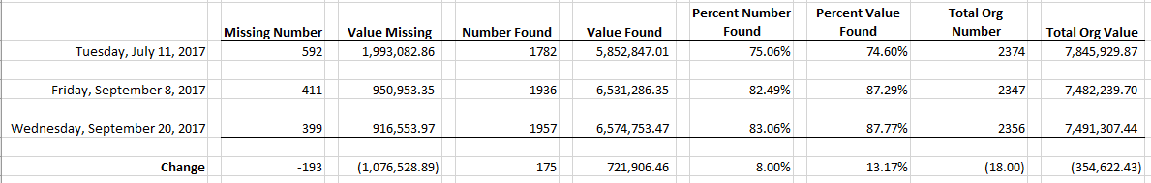

1. Procedures

Destination Area Funds

1. Leslie/Jackie

Other