# Microstrategy - Sponsored Programs Data

# Useful links

Please cut and paste the Microstrategy login. Due to how the site is designed it can’t be linked directly from this document.

Microstrategy Login - http://webapps.es.vt.edu/microstrategy

Training Site - <https://webapps.es.vt.edu/confluence/display/IWA/MicroStrategy>

Orientation Videos - <https://www.youtube.com/playlist?list=PL_6zM-6LFHJB9cSOqF0Jfq4TZXafmKoE5>

Contact: [ovprreports@vt.edu](mailto:ovprreports@vt.edu)

# Available Reports for Reporters

Users granted Reporter access to the Sponsored Programs data set will see the following Sponsored Programs Reporting Menu and the Sponsored Programs FY Snapshot Reporting Menu within the **Shared Reports->Sponsored Programs** folder within Microstrategy. Below is an example of what the menus look like:

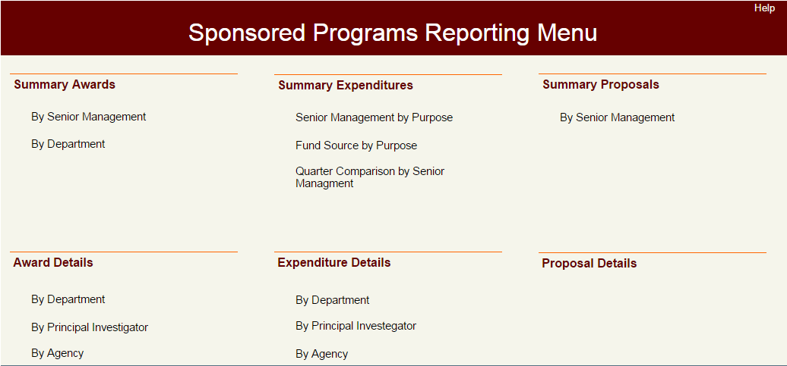

Data is provided in a report view, allowing pivoting, drilling and summarizing data. For more information on basic usage of the report view in Microstrategy, please reference the YouTube training videos and other material available at <https://webapps.es.vt.edu/confluence/display/IWA/MicroStrategy>

## Summary Reports

The top half of the OSP menu shows the available Summary Reports. Summary Reports show data across all organizations at the university, regardless of your fund/org security level. Since these report provide university-wide data they are built at a summary level designed to protect sensitive grant and sponsor information. These reports are useful for high level metrics, trend analysis, and general department overview. You can report on individual researchers, any university organization level, as well as various categories and project details, but titles, sponsors and similar data is removed.

## Detail Reports

The bottom half of the OSP menu shows the available Detail Reports. Detail Reports show specific information on awards and expenditures, which include potentially sensitive title, sponsor and other project details. **These reports run at your fund/org security level and will only show information on projects that you are authorized to see.** Please use the [Online Banner Access Form](https://banweb.banner.vt.edu/vt/prod/vtirm.irm_forms_main.entry) to request finance access to the necessary funds or orgs. These reports are useful for gathering data on sponsors related to your projects and reviewing project titles, funding sources, or other detailed attributes related to your department.

# Regarding Current vs End of Year Data

There are two main reporting menus available, the Sponsored Programs Reporting Menu and the Sponsored Programs FY Snapshot Reporting Menu, which provide a matching set of reports. ***In general, the Sponsored Programs FY Snapshot Reporting Menu should be used for all award and expenditure reporting unless you need to pull data from prior to FY2014.*** Proposal data is currently only available in the Sponsored Programs Reporting Menu at the summary level.

The Sponsored Programs Reporting Menu is based off a “current” view of the data, meaning reports are based on the *most recent change to any data element related to the sponsored project*. So a title change, updates to PI percent credit, changes in department by a PI, or other changes to project attributes overwrite old data. A report done this year on a project that started four years ago would show the data as of this year, regardless of prior values in prior years.

Obviously this presents a problem with reproducing reports and providing consistent metrics year over year for trend analysis. In order to limit this problem, sponsored programs data has been captured in “End-of-Year (EOY)” snapshots starting with fiscal year 2014. While the snapshots won’t capture all changes within a single year, they do provide a consistent set of data based on the state of the project at the end of the fiscal year. **The Sponsored Programs FY Snapshot Reporting Menu provides both live data for the current fiscal year as well as snapshot data for prior years and therefore should also be used for current fiscal year reporting**. However, for long term trends prior to or spanning FY2014, it is necessary to use the Sponsored Programs Reporting Menu and to understand the potential changes in PI and department credit, as well as other discrepancies, which may result.

# Different Data Views

## Credit Organization

This view of data is pivoted to the organizations that are listed by the PI's and Co-PI's as 'receiving credit' on the submission to the Office of Sponsored Programs. Credit can be allocated in any proportion to a PI in any organization. It is possible for a PI to allocate “credit” for research expenditures to a department, institute or center that is neither the submitting or home organization. A PI’s credit can also be split between multiple organizations. Credit is based on the faculty’s estimation of the contribution of value toward the project. These percentages are captured in Banner on the personnel screens on the FRAPROP and FRAGRNT forms. Credited expenditures allow research award and expenditure data to be used as a proxy measure of the scholarly effort shared between co-PI’s in the conduct of the research program. Overhead distribution is not affected by assignment of credit. Percentage credit is captured during the proposal phase and can be modified during the award and post-ward phases. However, changes in credit assignment over the life cycle of a project are only modified by request.

## Funding Organization

This view is driven by the organization responsible for the fund, and reconciles to Banner Finance and reports where the expense actually resides in Banner (Fund/Org). Overhead distributions are made according to the funding organization assignment. Interdisciplinary research activities can best supported by using sub-orgs in the home department of partnering co-PI’s. The use of sub-orgs allows overhead to flow automatically, and for PI’s to be granted access to view expenditure activity in related sub-orgs.

## Home Organization

This view of data is presented by the home organization of the principal investigator. The 'home org' is derived from the department holding the PI's faculty position. The assignment of the Home Org uses HR data based on primary organization assigned in Banner.

## Submitted Organization

View of data is presented by the organization submitting the proposal. The 'submitting org' is obtained from the individual submitting the proposal to the Office of Sponsored Programs. It is then captured in Banner as the Responsible Org on the FRAPROP & FRAGRNT forms top right data field. The Responsible Org in the Grant Dimension is equivalent to the Submitted View. This field is located on the main screen of FRAGRNT in Banner. A PI can submit a proposal under any submitting organization, including department, institute or center. The submitting organization is usually the org responsible for the coordination of the proposal, building the faculty team, submitting the proposal, and managing the allocation of awarded funds to collaborators.

## College Academic Discipline (CAD)

The purpose of the College Academic Discipline is to attribute research expenditures to the colleges for PIs who do not reside in an academic department. OVPRI is responsible for maintaining the College Academic Discipline data. The CAD does not take credit away from the institutes but rather it enables a more complete picture of research activity by academic disciplines and reflects a measure of the contributions of non-academic programs and institutes to the traditional academy.

## Ad-Hoc Reporting for Analysts

As of fall 2017, our metrics are now working accurately for general ad-hoc reporting. Please contact [ovprreports@vt.edu](mailto:ovprreports@vt.edu) to discuss analyst level access to the data.

## Customizing Existing Report Views

Microstrategy allows you to save a customized view of any of the provided reports. This allows you to add and remove attributes, change how a report looks, close unneeded windows, and modify view and page-by controls in order to focus in on just the data you need. To save your current view of a report, select the arrow next to the Report Home menu and click on “Create Personal View”. You can name it anything you want, and the saved view will only be available to you.

Your personal views are available in the My Subscriptions folder on the left hand menu of the main Microstrategy screen. The view saves whatever answers you provide for the report prompts, so the report should run immediately based on the saved answers. To force your report view to re-run the prompts, open the report view then select Re-prompt from the Data menu.

You can save multiple views of the same report, and if you make changes to a saved view you must create a new view and delete the old one to store the changes.

# Publicity Concerns

The university has specific obligations to protect project information in compliance with law as well as in compliance with contractual requirements. These obligations are increasingly more stringent and relevant than they have been in the past. This is one of the primary reasons the Summary Reports provide a limited set of details about specific projects, and the details are restricted to being viewed at your fund/org security level.

## Your Obligations

As employee of the university it is your responsibility to protect university data to which you have access from unintended release. As such, **you must ensure all information you store, gather, transmit or share has been vetted for contractual publicity requirements as well as legal release requirements in compliance with export control laws, and that storage and transmission of data is protected as required via encryption or redaction as necessary**. Please contact your OSP representative at any time for assistance or if you are unsure of the requirements of your project.