[Summary of Process](https://graduateschool.vt.edu/funding/funding-information-for-departments/tuition-remission.html" \l "vt-item-vtmultitab_18189983_1517845441716-0)

There are two steps to the tuition remission process:

(1) awarding the amount of tuition to a student using Banner form TZATRAW, which creates a corresponding credit on the student's account, and then

(2) funding the award on Banner form TZATRAF, which encumbers the funds from the designated source.

These steps cannot be performed on the same day.

[Step 1: Award Entry on Banner (TZATRAW)](https://graduateschool.vt.edu/funding/funding-information-for-departments/tuition-remission.html#vt-item-vtmultitab_18189983_1517845441716-1)

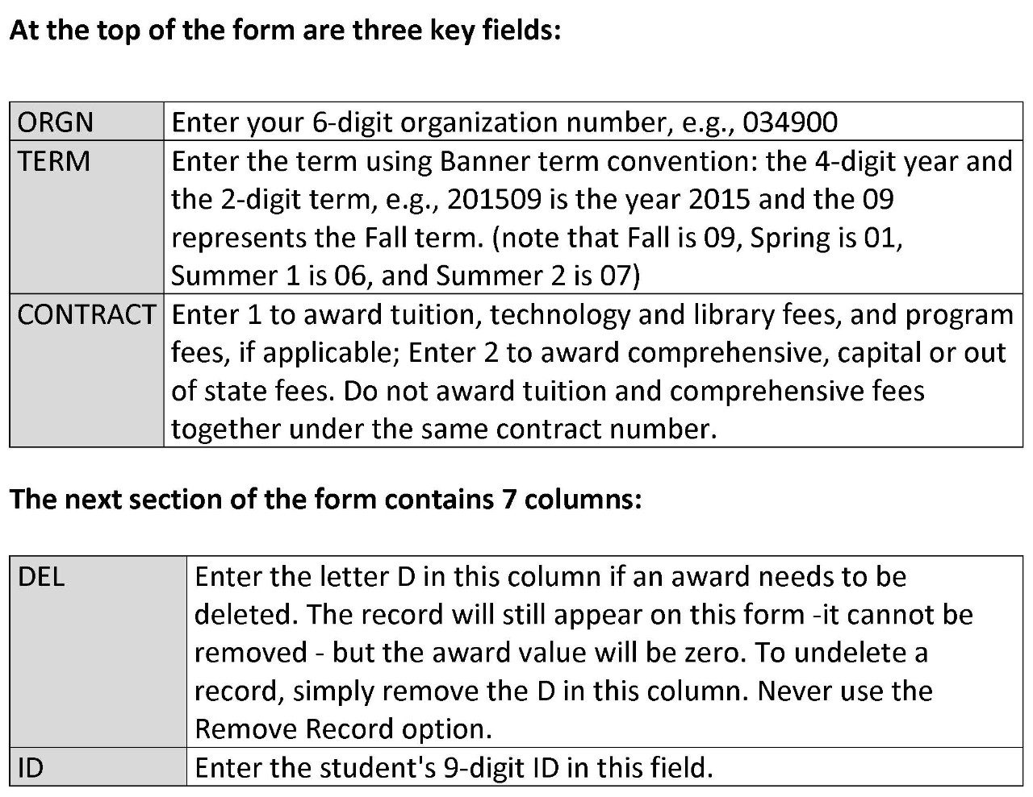

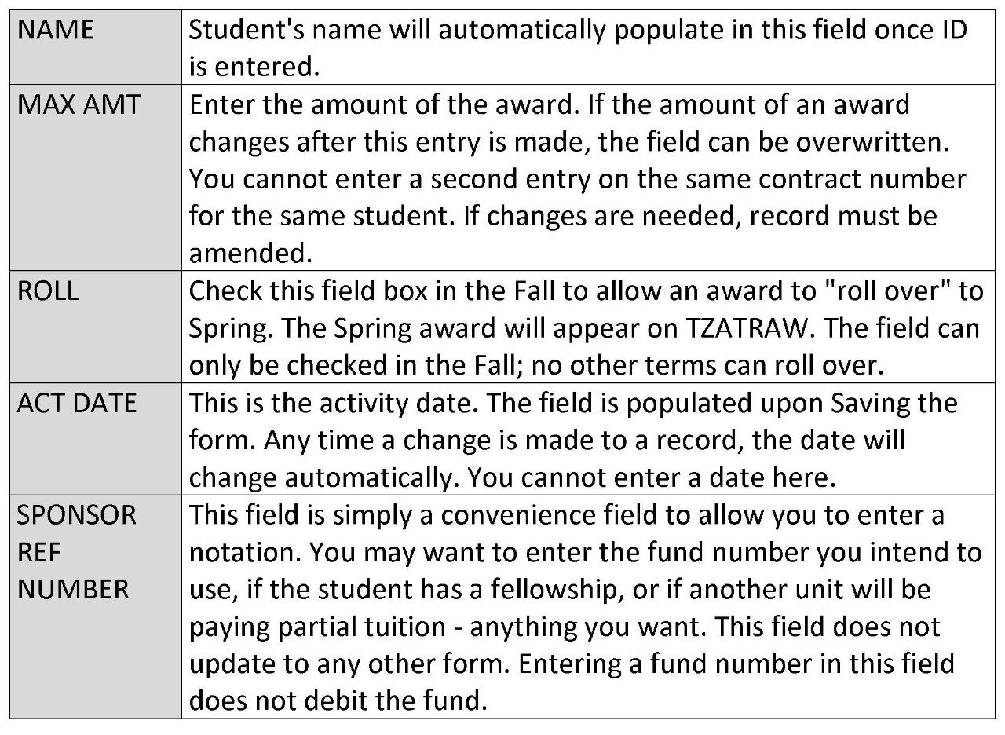

To download a copy of this chart, please [click here.](https://graduateschool.vt.edu/content/dam/graduateschool_vt_edu/assistantships_and_funding/Step%201%20printable.pdf)

[When to Enter Award](https://graduateschool.vt.edu/funding/funding-information-for-departments/tuition-remission.html#vt-item-vtmultitab_18189983_1517845441716-2)

**Terms for the upcoming academic year are opened on May 1 of each year.** Awards can be made at this time (using TZATRAW) for any of these terms.

**Once a student is identified to receive tuition, it should be awarded as soon as possible on TZATRAW.** When entering awards for fall term, the ROLL box can be checked if you want to have the same award amount automatically entered for the spring term as well. Help at the bottom of the form reads "check to roll tuition remission award from fall to spring."

A process will run daily that will actually roll the awards. When entering awards for any other, the ROLL box is visible but not updateable, since no award can roll from Spring.

**If necessary, a Spring award that has been rolled forward on TZATRAW can be changed.** The amount can be changed or the award can be deleted.

**There is no negative consequence to awarding tuition early,** and, if necessary, it is very easy to delete or amend an award. If a department has been instructed to award tuition to students but has not been informed which fund to use, this step can still be completed.

This form simply records the intention of a department to pay an award to a student. The OUB will record the award as a credit to the student from a department, although no fund number will be debited at this point.

**This step informs the OUB and the student that the department will be responsible for the awarded portion of a student's tuition.**

A late fee will not be assessed by the OUB for tuition that has been awarded, but not yet funded. Departments are encouraged to enter tuition awards before the Fall and Spring billing deadlines.

[Step 2: Tuition Funding Entry on Banner (TZATRAF)](https://graduateschool.vt.edu/funding/funding-information-for-departments/tuition-remission.html#vt-item-vtmultitab_18189983_1517845441716-3)

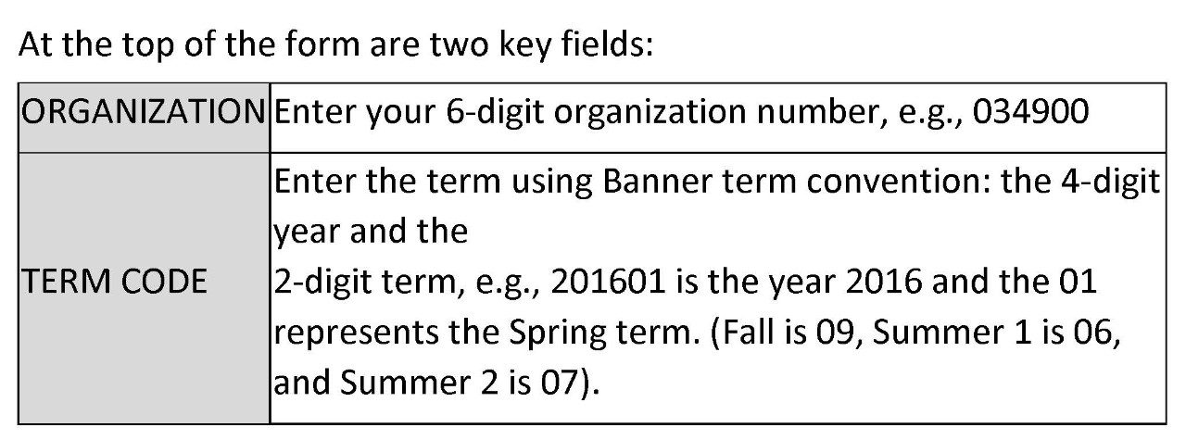

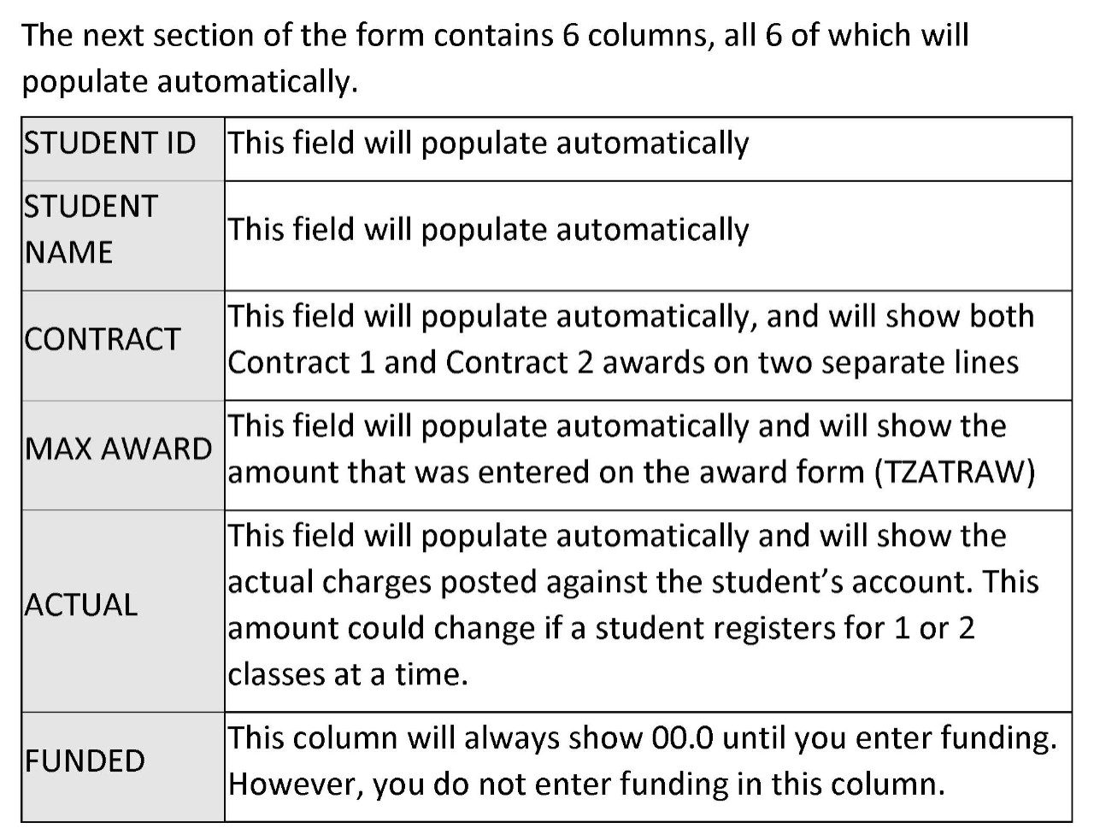

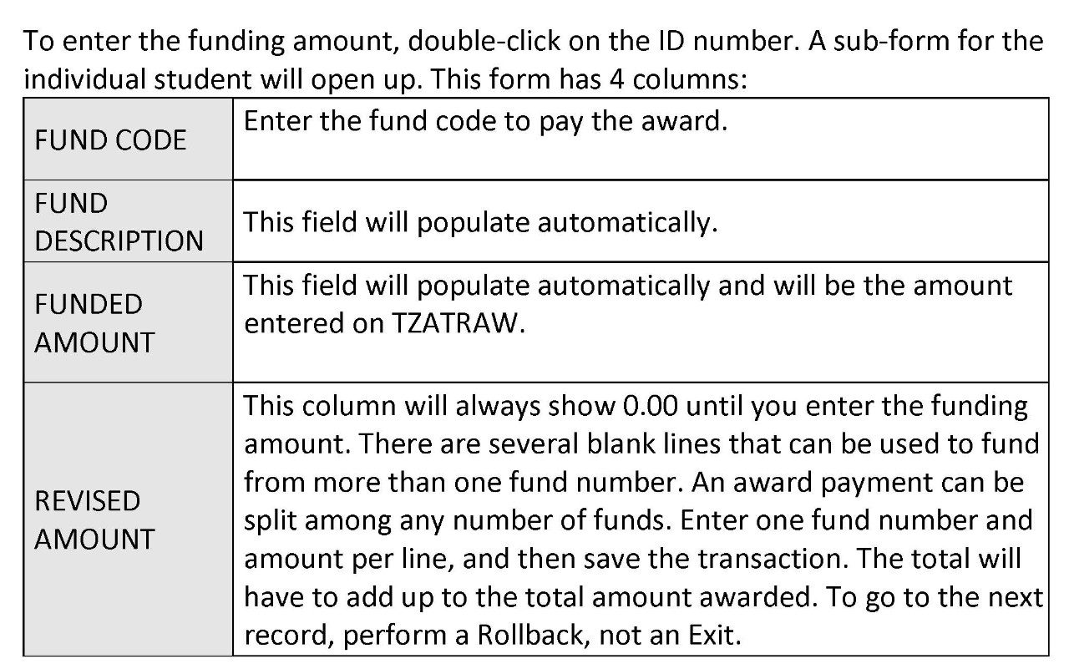

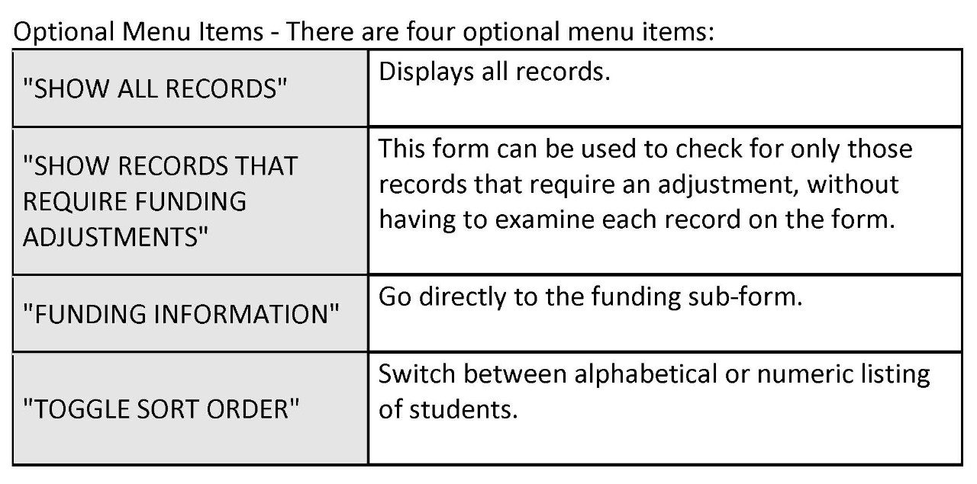

[When to Enter Funding Information](https://graduateschool.vt.edu/funding/funding-information-for-departments/tuition-remission.html#vt-item-vtmultitab_18189983_1517845441716-4)

Once you have completed an award entry using TZATRAW, you must wait overnight before funding the award using TZATRAF.

**The funding on terms for the upcoming academic year can begin after July 1 (using TZATRAF).** Funding cannot be provided prior to July 1 because expenses for tuition remission for these terms are recorded in the upcoming fiscal year that begins on July 1.

Departments should provide funding for awards from 997xxx or 999xxx funds by the following dates:

**1st Summer:        July 15 - August 30**

**2nd Summer:      July 15 - August 30**

**Fall:                       September 1 - December 30**

**Spring:                 February 1 - May 10**

Funding from accounts other than 997xxx, 998xxx, and 999xxx can be entered until May 31st. The tuition remission system will be open for all terms of the academic year from May 1, 2016 through May 31, 2017 (i.e., terms 201606, 201607, 201609, 201601 will be opened on 5/1/16 and will be closed on 5/31/17. No awards or funding changes can be made after 5/31/17 for these terms).

All funding charges for tuition remission expenditures should be made by using the TZATRAF form (Do not send journal vouchers to the controller's office to move tuition remission expenses between funds. All transfers should be made using the TZATRAF form. Once a term is closed, funding changes cannot be made after that date.)

**FUNDING RULES**

[Funding Sources](https://graduateschool.vt.edu/funding/funding-information-for-departments/tuition-remission.html#vt-item-vtmultitab_111139799_1517845441852-0)

This chart can be downloaded by following [this link.](https://graduateschool.vt.edu/content/dam/graduateschool_vt_edu/assistantships_and_funding/Funding%20Sources.pdf)

[Tuition Remission Fund Source Rules](https://graduateschool.vt.edu/funding/funding-information-for-departments/tuition-remission.html#vt-item-vtmultitab_111139799_1517845441852-1)

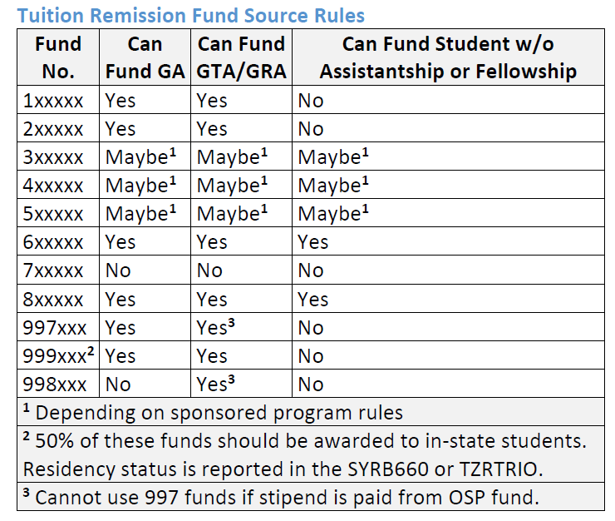

This chart can be downloaded by following [this link.](https://graduateschool.vt.edu/content/dam/graduateschool_vt_edu/assistantships_and_funding/Fund%20Source%20Rules.pdf)

[Tuition Fund Restrictions](https://graduateschool.vt.edu/funding/funding-information-for-departments/tuition-remission.html#vt-item-vtmultitab_111139799_1517845441852-2)

Awards on TZATRAW are entered as either Contract 1 or Contract 2 and will appear as Contract 1 or Contract 2 charges on TZATRAF.

**Contract 1 i**s reserved for tuition, technology and library fees, added together and entered on one line, and program fees (i.e., Engineering, Architecture, etc.).

**Contract 2** is reserved for paying fees other than tuition, such as comprehensive and capital fees or out-of-state tuition differential fees.

Departments may receive an allocation of 999xxx and 997xxx funds to be used for graduate tuition each year. **When using 997xxx and 999xxx tuition fund numbers, always enter them as a Contract 1 entry.**

The 999xxx funds can be used for students who have a GA, GTA or GRA appointment provided that the student's stipend is not funded by a sponsored program fund.  997xxx funds can be used for graduate assistants who earn more than $4,000 per year (at least $2,000 per semester), and whose stipend is not being paid by a sponsored program fund.

The Tuition Remission System (i.e., Banner form TZATRAF) was updated in February 2015 to enforce existing tuition remission funding rules.  The system rules apply to unfunded tuition remission waiver (997XXX) funds as well as all federal, private, and state sponsored funds.  The rules ensure the portion of tuition charged to the fund is in alignment with the assistantship positon funding.

For example, if an assistantship is paid fifty percent from an education and general fund and fifty percent from a sponsored fund, the system would allow up to fifty percent of the student's tuition to be funded by the department's tuition remission waiver (997XXX) fund and up to fifty percent to be charged to the sponsored fund.  Variances of up to three percent are deemed reasonable and are allowed by the system.

[Online Programs](https://graduateschool.vt.edu/funding/funding-information-for-departments/tuition-remission.html#vt-item-vtmultitab_111139799_1517845441852-3)

Tuition for online programs (i.e., MIT, PSALS, LGMC, and MNR) cannot be awarded through the tuition remission system.  The awarding program or department must submit a "[Request to Pay Funds to a Student Accoun](https://www.bursar.vt.edu/content/dam/bursar_vt_edu/forms/Request_to_Pay_Funds.pdf)t" form available from the Office of the University Bursar.

**FUNDING TROUBLE SHOOTING**

[Funding entered before a student is fully registered](https://graduateschool.vt.edu/funding/funding-information-for-departments/tuition-remission.html#vt-item-vtmultitab_1093848657_1517845441909-0)

**If funding is entered before a student is fully registered, only a portion of the award is applied to the student's account.** The remainder of the funds is unapplied and will remain that way until the billing cycle catches up with the activity of the student.

For example, if a department enters funding for full tuition and the student has only signed up for six hours, Banner will only apply the amount to pay for six hours. The additional funds will not be recognized even though they have been awarded. When the student later adds six more hours, he may receive a bill for partial tuition because the award process (TZATRAW) has already updated its information to the funding process (TZATRAF).

The TZATRAF form may contain this information:

|  |  |  |
| --- | --- | --- |
| **Max Award** | **Actual** | **Funded** |
| 6,129.50 | 3,064.75 | 3,064.75 |

If the department tries to change the “Funded” column to $6,129.50, an error message will report "No funding needed" because the cycle hasn't yet updated even though the student has more charges. If the problem is not resolved in the next billing cycle the department will need to contact the OUB to have the payment applied manually.

[Funding Entry Errors](https://graduateschool.vt.edu/funding/funding-information-for-departments/tuition-remission.html#vt-item-vtmultitab_1093848657_1517845441909-1)

**If a department tries to enter tuition on TZATRAF that is paid from a sponsored research account (4xxxx, 5xxxxx), an error message may appear** that reads "student must be on a GTA or GRA to receive funding from this account" even when this is not true, or even when the student does have a GTA or GRA. Check with the sponsored research officer in charge of that fund to get the flag removed so that tuition funding can be entered. The officer can be identified on the FRAGRNT form.

[Changing a Fund Number/Deleting an Award](https://graduateschool.vt.edu/funding/funding-information-for-departments/tuition-remission.html#vt-item-vtmultitab_1093848657_1517845441909-2)

**To change a fund number on TZATRAF,** open the sub-form and enter zero in the revised amount column; on the next line enter the revised amount using the new fund number. More than one fund number can be used to pay an award. The system will not allow a fund number to be deleted, but it can change the amount charged to the fund to $0.00.

In the example shown below, the department wants to change the original fund 999595 and use two other funds to pay the award. It must first change the amount under the original fund to zero, and then enter the new fund information. The funded amount must equal the awarded amount. Then the transaction can be saved.

|  |  |  |  |
| --- | --- | --- | --- |
| **Fund Code** | **Fund Description** | **Funded Amount** | **Revised Amount** |
| 999595 | State General Fund Tuition Fellowships | 6,129.50 | 0.00 |
| 997395 | Unfunded Tuition Scholarship | 2,129.50 | 2,129.50 |
| 555555 | Extra Tuition Resources | 4,000.00 | 4,000.00 |

**To delete an award,** go to form TZATRAW. Enter a D (for delete) in the far left column. The deletion will update overnight. The student's name will still appear, but there will not be an award associated with it.

[Exceptions](https://graduateschool.vt.edu/funding/funding-information-for-departments/tuition-remission.html#vt-item-vtmultitab_1093848657_1517845441909-3)

Departments can request an exception to the tuition remission waiver funding rules, which require a transfer of 997xxx funds to a 998xx funds, by submitting a request to the Graduate School.

Common exceptions include

(1) split appointments for GRAs who are partially funded on sponsored program funds;

(2) GRAs being paid on sponsored program funds that do not allow tuition awards; and

(3) when a sponsored program requires cost sharing.

Please prepare and submit an Exception Request form (click on link below)  to Will Walton ([wwalt00@vt.edu](mailto:wwalt00@vt.edu)) stating the reason for the request, the name and ID of the student, and the amount of tuition to be awarded. All requests will be reviewed by the Vice President and Dean for Graduate Education.

Departments can also request an exception to the sponsored program funding rules by submitting a request to the Office of Sponsored Programs (OSP).

If an exception is granted, OSP will assign an attribute to the grant which will allow the additional funding to be processed on the TZATRAF form. Once the funding has occurred, OSP will remove the attribute.

Exceptions are granted on a case by case basis. Only OSP can assign the attribute to the grant.  If no exception is granted, the department may elect to cover the tuition cost from returned overhead funds (i.e., 2xxxxx), education and general funds, or foundation funds.

E&G funds (start with 1xxxxx) and returned overhead (start with 2xxxxx) can only be used for all students on assistantship, regardless of type (GA/GTA/GRA), who have earned over $4,000 ($2,000 per semester) on their graduate assistantship.

Banner report TZRTRFR (Tuition Remission vs. Payroll Funding Review/Reconciliation Report) is available to assist departments in reconciling payroll funding percentages to tuition funding percentages.

TZRTRFR provides the tuition and assistantship funding percentages for each student.  At the end of the semester, departments can use the report to determine if tuition needs to be reallocated based on payroll funding changes made after tuition was posted.

*[Exception Request Form.pdf](https://graduateschool.vt.edu/content/graduateschool_vt_edu/en/funding/funding-information-for-departments/tuition-remission/_jcr_content/content/vtmultitab_1093848657/vt-items_3/download/file.res/Exception%20Request%20Form.pdf)

**TUITION REMISSION AND FUNDING REPORTS**

[About Tuition Remission Reports](https://graduateschool.vt.edu/funding/funding-information-for-departments/tuition-remission.html#vt-item-vtmultitab_101426020_1517845441935-0)

Departments can track their spending or check tuition entries that need funding adjustments at any time by running the TZRTRAW, TZRTRAF, or TZRTRFR reports from the Banner system. Reports are sent to the user by email. Instructions for running the reports are as follows:

Departmental Tuition Remission reports are submitted by using the Banner Finance job submission process. The reports are viewed and printed using the Virginia Tech Webviewer system (same system used for printing reports from the Finance Web Reports system).

There are two Tuition Remission reports available to departments. Each report has a summary and detail report (there are four different report formats that can be printed from the two reports listed below).

***TZRTRAW - Tuition Remission Award Report***  
The TZRTRAW (Award) report provides information by student and contract (tuition or fees) for a specified organization and term. The report provides the amount awarded, actual amount (amount of award applied to student's charges), funded amount (amount of actual amount that department has provided a Banner Finance fund to charge the award), and a difference amount (difference between actual and funded). The report can be requested for any level of the organization hierarchy (senior management, department, organization, etc.).

***TZRTRAF - Tuition Remission Funding Report***  
The TZRTRAF (Funding) report provides information by fund by feed date (to Banner Finance) for a specified organization for a specified feed date range. The report provides the amount funded by student. This report can be used to reconcile between the Tuition Remission system and the Banner Finance system. The report can be requested for any level of the organization hierarchy (senior management, department, organization, etc.).

***TZRTRFR - Tuition Remission vs. Payroll Funding Review/Reconciliation Report***  
The TZRTRFR report is available to assist departments in reconciling payroll funding percentages to tuition funding percentages. TZRTRFR provides the tuition and assistantship funding percentages for each student.  At the end of the semester, departments can use the report to determine if tuition needs to be reallocated based on payroll funding changes made after tuition was posted.

[Submitting the TZRTRAW Report](https://graduateschool.vt.edu/funding/funding-information-for-departments/tuition-remission.html#vt-item-vtmultitab_101426020_1517845441935-1)

The following provides step by step procedures for submitting the report.

1. Enter the report name (TZRTRAW) in the direct access box on the main menu form in Banner. Press the enter key afterwards. You will be taken directly to the GJAPCTL form (Process Submission Control Form).
2. The Virginia Tech Webviewer system and an email will be sent to the user notifying him/her that the report is ready for viewing or printing.
3. Perform a next block function. Tab to the value field for organization. Enter the organization code. Multiple organization codes can be entered by selecting "record" on the menu bar and then select "insert". This puts a blank line in the parameter section. Enter a "01" and tab to the value field to enter the second organization number.
4. Use the down arrow key to move to the value field for the term code parameter. Enter the desired term (i.e. fall = 201509, spring = 201601, 1st summer = 201606, 2nd summer = 201607). Multiple terms can be entered if desired (using the method described in item 3 above).
5. Use the down arrow key to move to the value field for the "Only Adjustments Required" parameter. The value should remain "N" in this field if the user desires a report that includes all students awarded for the term. If the user desires a report of only students that need funding provided, change the value in this field to "Y".
6. Use the down arrow key to move to the value field for the "Report Type" parameter. The value should remain a "D" in this field if the user wants a detail report that lists individual students. If the user wants a summary report, change the value in this field to "S".
7. Perform a next block function. To submit the report, single click on the save icon on the icon bar at this point.
8. Exit the form and wait for the email that will be sent for notification that the report is ready for viewing or printing.

[Submitting the TZRTRAF Report Tuition](https://graduateschool.vt.edu/funding/funding-information-for-departments/tuition-remission.html#vt-item-vtmultitab_101426020_1517845441935-2)

The following provides step by step procedures for submitting the report.

1. Enter the report name (TZRTRAF) in the direct access box on the main menu form in Banner. Press the enter key afterwards. You will be taken directly to the GJAPCTL form (Process Submission Control Form).
2. Perform a next block function. Enter "webdist" as the printer. This will cause the report to go to the Virginia Tech Webviewer system and an email will be sent to the user notifying him/her that the report is ready for viewing or printing.
3. Use the down arrow key to move to the value field for the term code parameter. Enter the desired term (i.e. fall = 201509, spring = 201601, 1st summer = 201606, 2nd summer = 201607). Multiple terms can be entered if desired (using the method described in item 3 above).
4. Perform a next block function. Tab to the value field for organization. Enter the organization code. Multiple organization codes can be entered by selecting "record" on the menu bar and then select "insert". This puts a blank line in the parameter section. Enter a "01"and tab to the value field to enter the second organization number.
5. Use the down arrow key to move to the value field for the fund. Tab to the value field for fund code. Enter the fund code (ONLY ENTER THE ORGANIZATION CODE OR THE FUND CODE -NOT BOTH). Multiple fund codes can be entered by selecting "record" on the menu bar and then select "insert". This puts a blank line in the parameter section. Enter a "02" and tab to the value field to enter the second fund number.
6. Use the down arrow key to move to the value field for the "Date Range Start" parameter. The format is DD-MMM-YYYY.
7. Use the down arrow key to move to the value field for the "Date Range End" parameter. The format is DD-MMM-YYYY.
8. Use the down arrow key to move to the value field for the "Report Type" parameter. The value should remain a "D" in this field if the user wants a detail report that lists individual students. If the user wants a summary report, change the value in this field to "S".
9. Perform a next block function. To submit the report, single click on the save icon on the icon bar at this point.
10. Exit the form and wait for the email that will be sent for notification that the report is ready for viewing or printing.

[Submitting the TZRTRFR Report](https://graduateschool.vt.edu/funding/funding-information-for-departments/tuition-remission.html#vt-item-vtmultitab_101426020_1517845441935-3)

The following provides step by step procedures for submitting the report.

1. Enter the report name (TZRTRFR) in the direct access box on the main menu form in Banner. Press the enter key afterwards. You will be taken directly to the GJAPCTL form (Process Submission Control Form).
2. Perform a next block function. Enter "webdist" as the printer. This will cause the report to go to the Virginia Tech Webviewer system and an email will be sent to the user notifying him/her that the report is ready for viewing or printing.
3. Use the down arrow key to move to the value field for the term code parameter. Enter the desired term (i.e. fall = 201509, spring = 201601, 1st summer = 201606, 2nd summer = 201607). Multiple terms can be entered if desired (using the method described in item 3 above).
4. Perform a next block function. Tab to the value field for organization. Enter the organization code. Multiple organization codes can be entered by selecting "record" on the menu bar and then select "insert". This puts a blank line in the parameter section. Enter a "01"and tab to the value field to enter the second organization number. If report is for a specific fund number, leave organization code blank.
5. Use the down arrow key to move to the value field for the fund. Tab to the value field for fund code. Enter the fund code (ONLY ENTER THE ORGANIZATION CODE OR THE FUND CODE -NOT BOTH). Multiple fund codes can be entered by selecting "Record" on the menu bar and then select "Insert". This puts a blank line in the parameter section. Enter a "02" and tab to the value field to enter the second fund number. To duplicate the parameters, use the Record Menu at the top of the form, select “Duplicate”.
6. Error Checking: When producing a report, you can identify potential errors when the payroll and tuition percentages are not in alignment. “Y” includes review messages and “N” does not include review messages.
7. Use the down arrow key to move to the value field for the "Report Type" parameter. The value should remain a "D" in this field if the user wants a detail report that lists individual students. If the user wants a summary report, change the value in this field to "S".
8. Data File Indicator: To generate a data file, select “Y” to create a data file and “N” to not create a data file.
9. Perform a next block function. To submit the report, single click on the save icon on the icon bar at this point.
10. Exit the form and wait for the email that will be sent for notification that the report is ready for viewing or printing.

**OTHER PROCEDURES**

[Reviewing Student Account Information](https://graduateschool.vt.edu/funding/funding-information-for-departments/tuition-remission.html#vt-item-vtmultitab_1490410611_1517845441959-0)

**Verifying Tuition Award on TSAAREV**  
Departments can check the student account form TSAAREV, to verify that the tuition has been awarded.

**Verifying Tuition Award on TZIAREV**  
From the TSAAREV form, go to Options menu and select TZIAREV. When the form opens, it will show all charges. DO a roll back and then enter the semester you want to view – this form is easier to use and understand than TSAAREV.

**Verifying Department Charge on TSAACCT**  
Departments can verify whether a student's tuition has been paid by their own or another department by checking this form.

Enter the student ID, and then select "EXEMPTIONS/CONTRACT" from the menu options to the left of the form. Details of the transaction may be viewed on TSADETL.

[Tuition Refunds](https://graduateschool.vt.edu/funding/funding-information-for-departments/tuition-remission.html#vt-item-vtmultitab_1490410611_1517845441959-1)

**Tuition Already Paid by Student**

When departments award tuition to a student who has already paid tuition, the student will receive a refund from the OUB.  Refunds are payable to the student by Direct Deposit.

**Out-of-state Fee Already Paid by Student**

If a student has already paid the out-of-state fee portion (UF Differential) of tuition and then qualifies for the waiver, this amount will be refunded in the same way as tuition refunds. The out of state fee is waived automatically when the student's assistantship appointment (PAF) has been entered in Banner, the student meets the earnings eligibility criteria, and the student is enrolled for the semester.

**Withdrawal for Medical Reasons**

A student withdrawing for medical reasons will be charged a daily tuition rate for each day enrolled. Withdrawal for medical reasons must be accompanied by a statement from the Student Health Services at Virginia Tech indicating that the student is unable to continue in school due to medical reasons.

**Comprehensive fees**

Comprehensive fees are nonrefundable unless it is a complete withdrawal and all charges are cancelled. A withdrawal means the student has not been in attendance during any part of the term and the effective date is always the first day of class or before for a term. These rules are for fall and spring terms. Summer terms are different and departments should refer to the OUB website.

[Tuition Obligation When Students Leave Assistantship](https://graduateschool.vt.edu/funding/funding-information-for-departments/tuition-remission.html#vt-item-vtmultitab_1490410611_1517845441959-2)

This table is based upon the university refund policy and will be used in calculating tuition obligations for students who leave the assistantship appointment before day 38 of the semester.

The comprehensive, technology and capital fees are non-refundable and no reduction will be made after the beginning of classes.

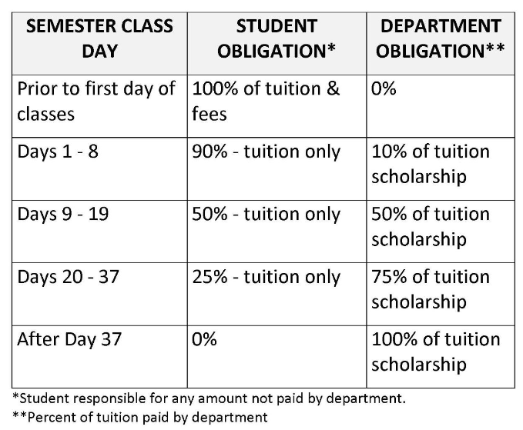

[Removal of Late Fee Charges](https://graduateschool.vt.edu/funding/funding-information-for-departments/tuition-remission.html#vt-item-vtmultitab_1490410611_1517845441959-3)

If a late fee charge has already been assessed due to an out of state fee or tuition award not being entered on time and it is clearly not the fault of the student, and, provided that the student has no other charges outstanding, the department must fill out and submit a Accounts Receivable Adjustment Form signed by a department head.

The OUB must process these requests manually.  To request this form, email the OUB ([bursar@vt.edu](mailto:bursar@vt.edu)) providing your name and mail code.  Questions can be directed to Kelly Perkins ([kmstout@vt.edu](mailto:kmstout@vt.edu)) or Debbie Huff ([dhuff@vt.edu)](mailto:dhuff@vt.edu).